Rhys Gilmartin, Leigh McGuinness, Stephen Meehan, Abdul Rahman Saif al Adhubi

Cradle-Care Baby Monitor

IoT Year 1 Minor Project

DECIDE ON A COVER PAGE

IoT Baby Monitor

MINOR PROJECT REPORT

Rhys Gilmartin

S00213013@maiLitsligo.ie

leigh mcguinness

[S00183063@MAIL.ITSLIGO.IE](mailto:S00183063@MAIL.ITSLIGO.IE)

Stephen Meehan

S00….@mail.itsligo.ie

abdul rahman saif al adhubi

S00….@mail.itsligo.ie

01/03/2021

# TABLE OF CONTENTS

TABLE OF FIGURES 6

LINKS TO GITHUB & TRELLO 2

LINK TO RESEARCH DATA 2

OUTLINE OF THE PROBLEM 3

SUMMARY OF PROBLEM SOLUTIONS 3

REQUIREMENTS 3

1. RESEARCH 3

1.1 EXTERNAL SURVEY 3

1.2 USER SURVEY 3

1.3 RESEARCH ANALYSIS 3

1.3.1 SURVEY ANALYSIS 3

1.3.2 CONCLUSION 3

2. INITIAL DESIGN 3

2.1 INITIAL CONCEPTUAL SKETCHES 3

2.2 PROPOSED CODE DESIGN 3

2.3 HARDWARE SETUP 3

2.4 HARDWARE SCHEMATICS 3

3. IMPLEMENTATION PLAN 3

3.1 EQUIPMENT NEEDED 3

3.2 PARTS LIST 3

3.3 CODE SAMPLES 3

4. TESTING 3

4.1TESTING APPROACH 3

4.2.1 TEST DATA 3

4.2.1.1 TEST DATA - MOVEMENT 3

4.2.1.2 TEST DATA - SOUND 3

ETHICS & SECURITY ANALYSIS 3

IOT, BRIEF TECHNOLOGY OVERVIEW 3

ETHICS & SECURITY IN A BABY MONITORING DEVICE 3

FUTURE IMPROVEMENTS 3

ROLES AND RESPONSIBILITIES 3

REFERENCES 6

BIBLIOGRAPHY 6

# TABLE OF FIGURES

INSERT TABLE HERE WHEN ALL FIGS ADDED

CHECK IF NORMALLY APPEARS BEGINNING / END

# LINKS TO GITHUB & TRELLO

[GitHub Project Repository](https://github.com/LeighMcG83/Arduino-IoT-projectBabyMonitor)

[Team Project Trello Board](https://trello.com/b/WPP4Ebdd/iot-project)

# LINKS TO RESERCH DATA

[Baby sleep Survey - Google Docs](https://docs.google.com/forms/d/1SgEr8XRSmZtLHh8sDCJoe2gv4oWSCZ6ZpbeG1d4LPZE/edit%23responses)

[Research Data Folder](https://github.com/LeighMcG83/Arduino-IoT-projectBabyMonitor/tree/main/research)

(Do we need to reorganize all data from design and research into this before submission?)

# OUTLINE OF THE PROBLEM

The problem our team has set out to solve is a problem faced by people of all race, creed, and social standing in lla parts of the world. There are very few things as universally important to humankind as the care of our children. In the technological age of today, people are increasingly turning to gadgets and tech to help solve our everyday problems.

Parents worldwide are using baby monitors as they can provide peace of mind around the comfort of their children, easing parental anxiety (Harwell, 2021). ­This anxiety leads to parents experiencing broken sleep patterns, due to getting out of bed to check on their children. An effect of this is circadian rhythm disruption,

“Insufficient sleep and circadian rhythm disruption are associated with negative health outcomes, including obesity, cardiovascular disease, and cognitive impairment” (Möller-Levet *et al.*, 2013).

In light of mental health having implications on physical health, such as BMI, further highlighted in a report on Social Jetlag and Obesity by Roenneberg *et al.*, 2012, the use of a baby monitor can reassure, and lead to lower levels of anxiety in parents increased physical health.

Another negative effect of disrupted sleep are elevated levels of tiredness, reducing people’s productivity in the workplace, leading to more stress and anxiety and a repeat of the cycle.

As a solution to the above-mentioned problems, our group propose the installation of an IoT baby monitor featuring a crying-alert, night-light and a speaker which will play a lullaby. These components of the device will be triggered by a sound and movement sensors.

The peace of mind provided by having this device can lead to a reduction in anxiety and a reduced need to get up to check on a child, thus alleviating some of the negative physical and metal health effects experienced by people.

Should I work in some of our own research findings???

While not a new development, baby monitors are still a useful tool used by many, and with the rise of the Internet of Things, they can now take on a new dimension. The ability to produce a report on nightly activity of a child through the use of an API will allow a parent or career to monitor the child nightime behaviour, further enforcing their comfort in not always rising to check on the child.

# SUMMARY OF PROBLEM SOLUTIONS

DO WE EVEN NEED THIS SECTION?

# REQUIREMENTS

1. The device has to detect sound.

Using the Grove sound-sensor the device will detect when a child is crying and alert parent if required to do so.

1. Device will be able to detect a child’s movement.

Using the Grove’s PIR, the device will detect movement in a cot.

1. Print sensor data to Arduino serial monitor.

The device will send data read from all sensors to the serial monitor for analysis.

1. Activate a nightlight.

If the sound-threshold value in our code is breached, the monitor will activate a Night Light in a initial attempt to sooth te child.

1. Play sound / lullaby / white noise.

Baby monitor will play sound / lullaby / white noise to comfort the child

when both the code’s sound and movement threshold values are broken.

# 1.RESEARCH

## 1.1 EXTERNAL SURVEY

As part of our secondary research process, the group decided to complete some surveys online to get a feel for the type of questions that we could ask in our own survey of parents and baby monitor owners. We noted the most frequently asked questions and pooled our research findings to populate our own survey

[Link to survey research analysis](https://docs.google.com/document/d/1X5mCKldsCBvVHQidKqP2ac1tUgatLovcxw8Flll2gJQ/edit?ts=60310f9e)

## 1.2 USER SURVEY

For our project we broke our research down into two parts, the first was to research articles and papers online, this provided us with a base of knowledge in the market our project would be present in. We also looked up and completed surveys for babies sleeping patterns and baby monitoring devices and noted the most frequently asked questions. We combined this information to then write our own survey. We got 15 responses in total. One of our team members also translated the survey into Arabic, to diversify the data we ended up with. The responses we received gave us the hard, firsthand data we needed to inform our design ideas.

## 1.3 RESEARCH ANALYSIS

### 1.3.1 SURVEY ANALYSIS

**Q1.**

Users name

* This question just asks the user to fill out their name.

**Q2.**

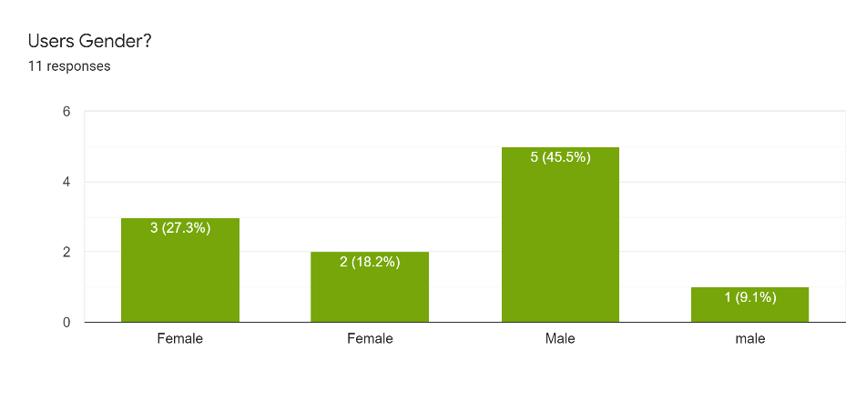

Figure 1.1

* As you can see from the above bar chart, we have 5 female and 6 male responses.

**Q3.**

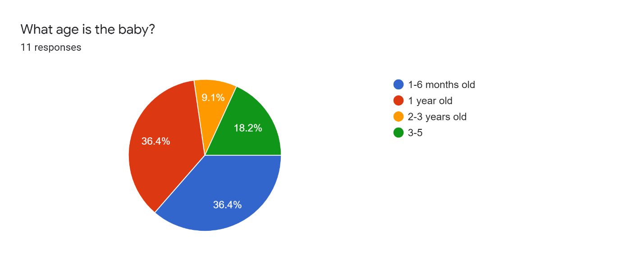

Figure 2.1

* This was a vitally important question, as outlined in the above section. A baby’s sleeping pattern changes rapidly as they get older. The age of the babies add context to the rest of the answers in the survey.

**Q4.**

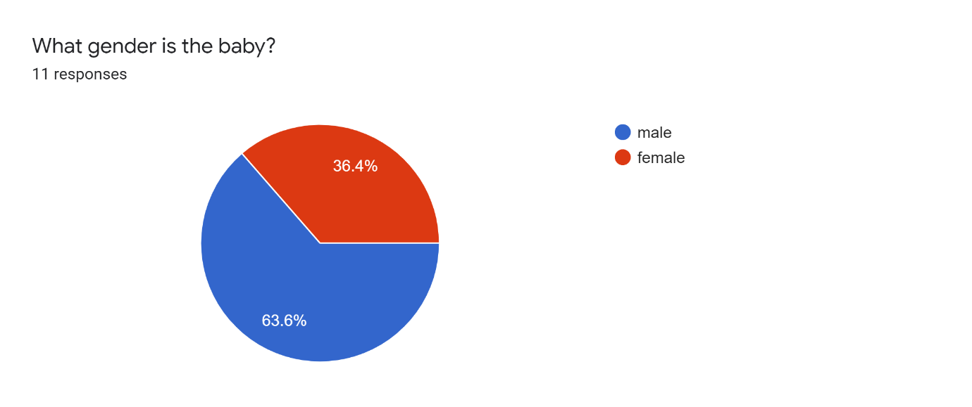

Figure 3.1

* Most of the people who answered this survey had male babies.

**Q5.**

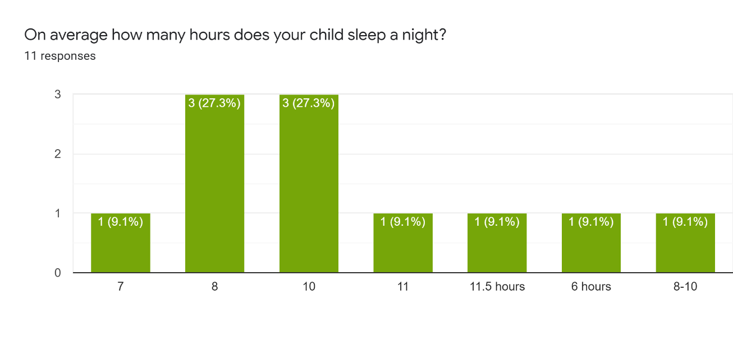

Figure 4.1

HAVE I DELETED OR MOVED INFO FOR HERE?

**Q6.**

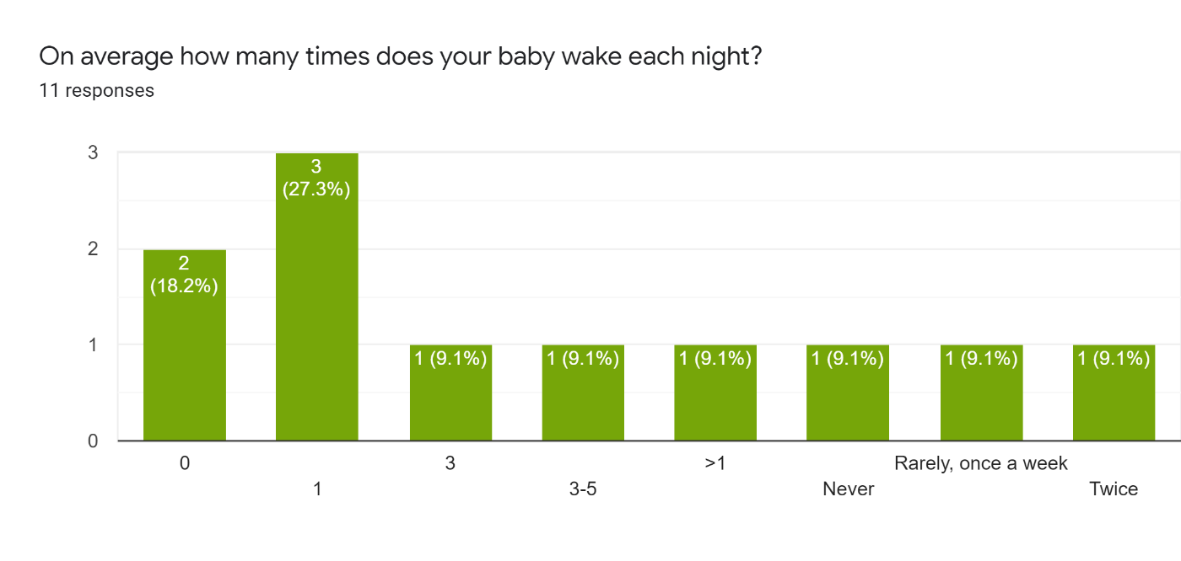

Figure 5.1

* As seen from the above graph there is a huge variation in the amount of sleep each child is getting per night and the number of times they wake. A factor in this is the individuality of the child resulting in some babies sleeping more than others. This primary research also highlighted that another factor to be examined is the age of each baby. Breaking this down to the different age ranges we can examine this information more accurately.
* 1–6-month age range
  + The average number of hours sleep per night for the babies in this age range is 7.6, With each baby waking on average 1.6 times per night.
* 1 year old
  + The average sleep for babies at this range is 8.75 hours per night with each baby waking up on average 1 time per night.
* 2-3 years
  + Babies on average slept for 10 hours per night with waking during the night being a very rare occurrence.
* 3-5
  + The sleeping pattern on average matches very closely to that of the 2–3-year age range with babies sleeping for about 10 hours, and waking up during the night being a rare occurrence.

**Q7.**

Is your house usually noisy?

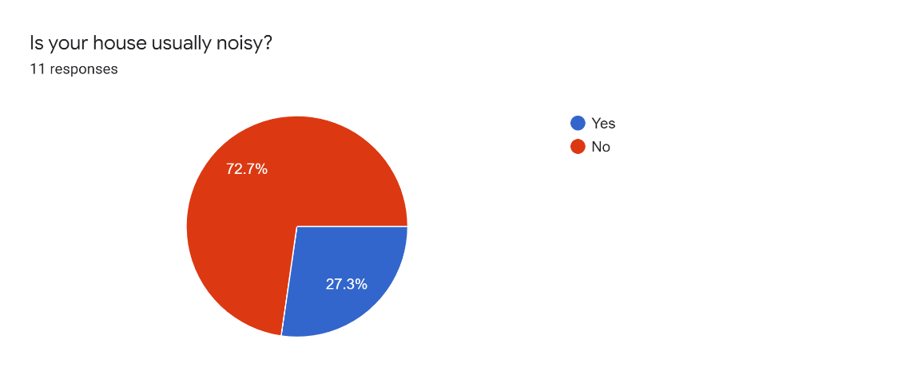

Figure 6.1

CHECK HAVE I DELETED OR MOVED INFO FOR HERE

**Q8.**

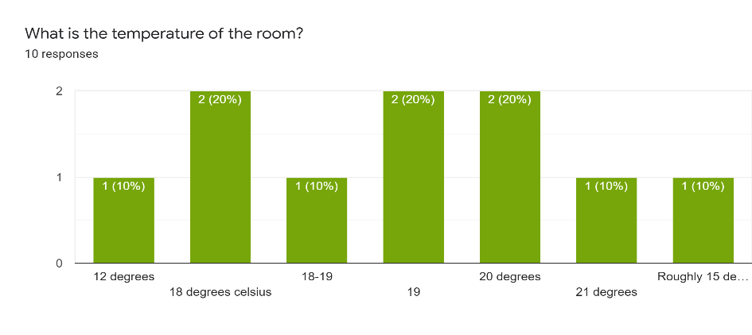

Figure 7.1

* During our survey research, we discovered that the noise levels and temperatures in a house may affect how well a baby sleeps. Examining the data, it is difficult to draw a clear conclusion as the sample size of answers is too small. They may be something we examine further for a major project.

**Q9.**

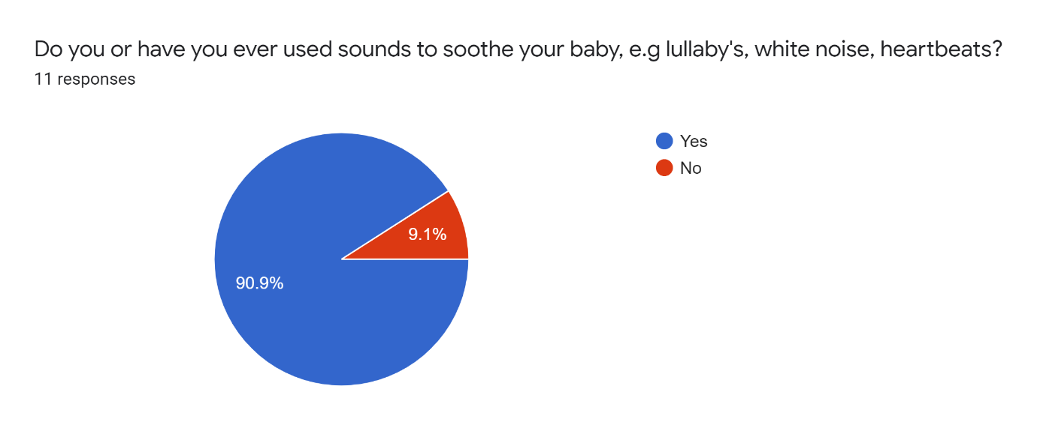

Figure 8.1

* As you can see from the above graph the number of parents who use sounds/lullabies to soothe their babies is very high, this confirms the research we carried out.

**Q10.**

Can you tell us what do you usually use to stop your child from crying?

* holding their hand, soother
* White noise machine
* Rocking
* walk her in my arms, sing, dance gently.
* lift and sooth if necessary but will allow a certain amount of crying when getting used to getting themselves to sleep.
* Lift and soothe, check for anything wrong - nappy etc...
* Technique called verbal reassurance.
* Cuddles
* Pick up the baby and comfort her. Breast feed if very unsettled
* Sing
* Her mother’s breast, alternatively some bobbing and gentle shaking while whispering or singing soothing noises to her.

Above you can see a list of ways parents comfort their babies, again an audio function is highlighted. Both white noise and singing are listed as ways of soothing their babies. Confirming the need for this feature on our project.

**Q11.**

If your baby wakes briefly during the night how often will he/she fall back asleep without being picked up/comforted?

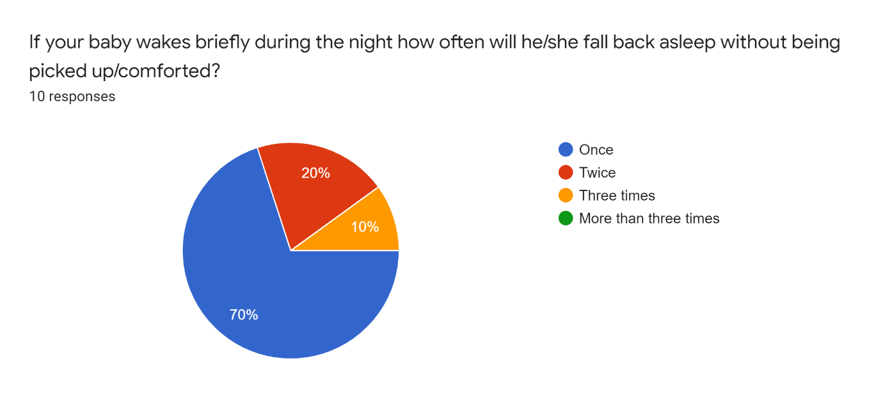

Figure 9.1

* As you can see 70% of parents confirmed that their baby will fall back to sleep the first time after waking, with some babies falling back to sleep two or three times without being comforted. This is very important data, the tolerances for our sensors will have to be set very carefully. If they trigger a response too early, they may wake the baby further.

**Q12.**

Do you use a baby monitor, if so what features of it do you find most valuable/What features do you wish it had?

* No
* the base board that monitors the child's heartbeat and sound
* Ability to talk to into the monitor to comfort baby, also has music and video
* a movement alert if it cannot feel heartbeat or breathing or weight it alarms.
* Yes - music option.
* yes – music.
* We used the projector and timed music. We were able to put the music on from parent handset.
* Audio
* Temperature of room talk features. I would rather it had a mat to monitor breathing.
* Wonderful for hearing every sound.

Several features are outlined here both relevant to our minor project and some we may choose to research and develop for our major project.

* Again audio/music function is mentioned heavily.
* A sensor to monitor the baby’s heartbeat and breathing.
* A video or projector function which could play soothing shapes, pictures.
* A way to communicate with the baby.

**Q13.**

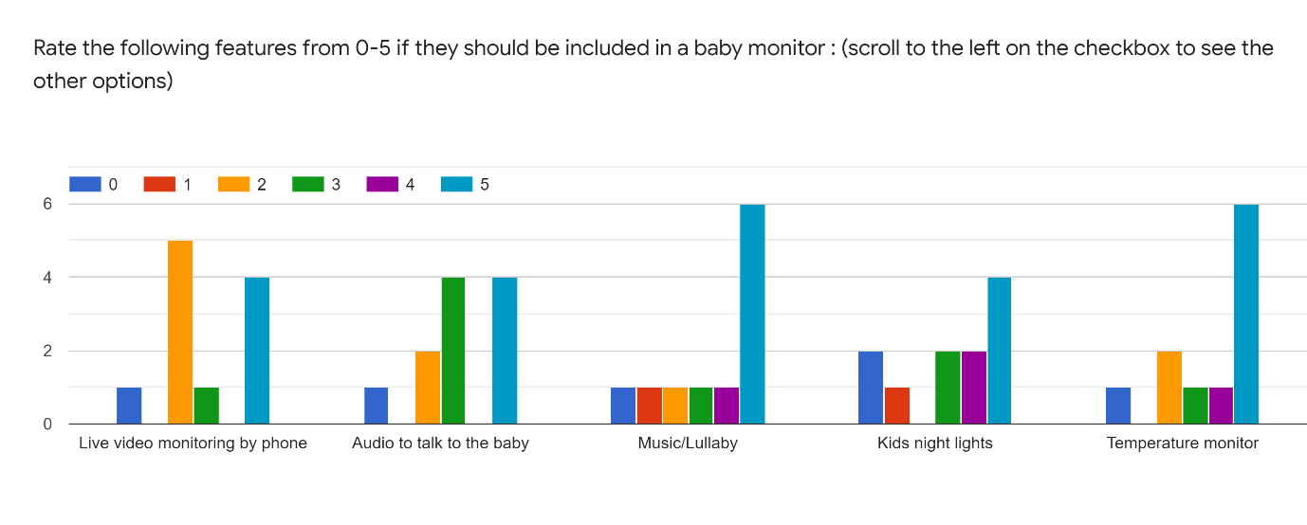

Figure 10.1

* Outlining what features are most important to parent we can see that again a music and nightlight function rank very highly, temperature monitoring also is ranked and important.
* Two-way audio function is something we may look at in a further iteration of our project. After discussion we feel for security reason and live video function would not be possible to do safely (outlined further in security analysis).

**Q14.**

Other thoughts or comments?

* the angel base monitor was a huge reassurance especially during the first 6 months.
* Hard to have definitive answer with younger baby as sleep patterns can change form one night to the next.
* Is it possible that any breathing difficulty could be detected? colourful reflections in the room/ceiling would be good?
* The movement alert was amazing, would rate over all other features.
* The batteries gave up and we had to replace them.
* Would be great if a monitor could give the child a bottle.
* Babies are cool.
* Although entertaining, ignoring the humorous answers we can see in our further taught and comments section again some interesting areas are highlighted.
* The ever-changing sleep cycle of babies is highlighted again.
* A breathing monitoring function and ability to project colourful shapes in the room is also mentioned again.

### 1.3.2 Conclusion

One over-sight in the survey was not asking how many hours each child sleeps during the day and asking for a combined total, if this were done, I feel the total hours of sleep per 24hour period would closer resemble the average number of hours sleep per child outlined in our online research. As outlined above newborn babies will sleep for large parts of the day, as they get older, they do more of their sleeping at night, this change in their sleeping cycle as they get older is recording accurately in the data we gathered. Our survey did however highlight many areas which went on to inform both or physical and conceptual design ideas. Limiting this to what is feasible for our minor project. The main features outline by the parents are.

* A sound/movement sensor
* A night light with patterns/shapes
* An ability to play sounds/lullaby’s/white noise.

Each of these features were mentioned multiple times with a sound/lullaby function ranking the most important among them. Using both our online research and our survey we were able to bring these functions forward to the design stage and begin to conceptually put together our prototype.

## 1.4 Online Research of Babies Sleep Cycles.

### 1.4.1 Sleep-movement and Noise

Over a 24-hour period a baby can sleep for 14-15 hours, this is broken up into 2-to-3-hour periods, as you can see from the below graph the sleep cycle of a child changes rapidly as they get older. Soon after being born the child will sleep almost equally through the night and day. As they get older there sleeping cycle will closer resemble a normal pattern, that being sleeping mostly during the night.

Newborn babies are very active sleepers. The move and wake up a lot, this is down to the fact that that they spend half their sleep in REM (Rapid Eye Movement) or active sleep when the baby’s eyes move around. They move their arms and legs and open and close their mouths. The other half of their sleep is spent in NREM (Non-rapid Eye Movement) or quiet sleep. This is where the baby is fully asleep and does not move and make noise as frequently. As they get older there sleeping becomes sounder and they sleep better through the night.

Parallel to movement Newborn babies are also quite noisy sleepers, their breathing can be irregular, and they may wake up briefly and whimper. It is recommended by doctors to wait out the babies first whimpers without lifting or comforting the child. It is very likely that the baby is still in a light sleep. The child should only be picked up and comforted if it’s clear that they are awake.

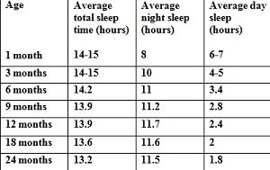

Figure 11.1

Baby sleep chart based on Swiss study (Iglowstein et al 2003)

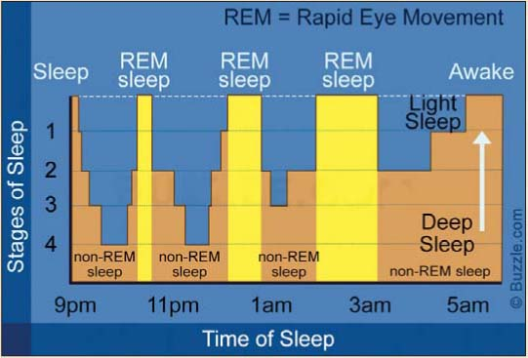

Figure 12.1

### 1.4.2 Music / White noise

As a newborn baby is still getting used to the world, they may not be used to silence. Before they are born, they were constantly hearing noises made by their mother most importantly her heartbeat. Newborn babies may find silence mildly distressing.

Studies have shown that, the hum of a fan/ soft music or white noise being immitted through a speaker may ease this discomfort.

Again, as with movement and noise this eases as they get older, as their sleeping pattern becomes more regular.

### 1.4.3 Applying research to the scope of our project

Our research has highlighted areas which may prove to be problematic.

* There are big differences in the sleep cycles of newborn babies and babies as they get older. This will need to be considered when designing rue prototype, A one size fits all strategy will not work.
* There are also quite varied differences between one baby to the next. A configuration that accurately monitors and comforts one baby may not be suitable for another.
* For example, as outlined in the research I have read, soft music or playing a lullaby may comfort some babies whilst hindering another child’s sleep. This can also be said for white noise, this may aid or damage a newborn’s ability to fall asleep, depending on the specific baby.
* Differentiating between a baby that is in a very light REM sleep and a baby that is awake will prove very difficult as while in light sleep, they baby may move around and make noise.

### 1.4.4 Possible solutions

* The main takeaway from the research was that there is a great need to be able to adjust the device and its responses based on both the babies age and individuality.
* We could do this by having two are three different configurations built into the device, with the tolerances for the sensors tailored to specific age groups.

E.g., Greater tolerances for newborns as not to trigger the responses while the baby is still lightly sleeping, and tighter tolerances for when the baby gets older as he or she will not be moving around as much nor make as much noise.

* The noise that should be played when the baby wakes up should be able to be changed. The parents may then choose the noise that souths their baby the most. Lullaby’s / heartbeats and white noise all could be included in the device.
* A further iteration of the device could include a report of the baby’s night sleep, similar to a smart watch, giving information on how long the child slept for, when the baby was in REM or EREM sleep, what noise soothed that child most. This would help inform the parents decision of what configuration would suit their child. Using data analytics, over time the device may also be able to suggest the optimal setting based on the sleeping data over a period.

Sources: MOVE TO BIBLIOGRAPHY

[Amy O’Connor, medically reviewed by Marvin Resmovits (01/05/20), “Newborn and baby sleep basics”, Viewed 13/02/21, <https://www.whattoexpect.com/first-year/newborn-sleep.aspx>]

[Danielle Pacheco (17/12/20), “How your baby’s sleep cycle deferrers from your own”, viewed 13/02/21, <https://www.sleepfoundation.org/baby-sleep/baby-sleep-cycle>]

[Author unknown, (date unknown), “What is white noise and how can it help your baby sleep?” viewed 13/02/21, <https://www.motherandbaby.co.uk/first-year/baby/sleep/white-noise-baby>]

[Emily DeJeu (28/09/19), “Your Baby’s Changing Sleep Patterns: Birth-12 Months”, viewed 16/02/20, <https://www.babysleepsite.com/baby-sleep-patterns/baby-sleep-patterns-birth-to-12-months/>]

## 2. INITIAL DESIGN

### 2.1 INITIAL CONCEPTUAL SKETCHES

Figure 13.1 – Sketch of Baby monitor in-situ

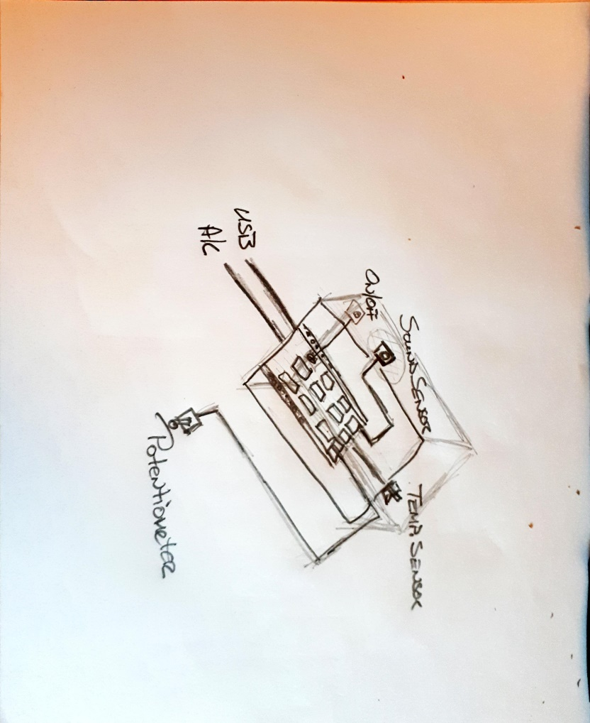

Figure 14.1 – Proposed layout of Arduino Yun and components

Figure 15.1 – Early schematic sketch

### 2.2 PROPOSED CODE DESIGN

PASTE FLOWCHART HERE

### 2.3 HARDWARE SETUP

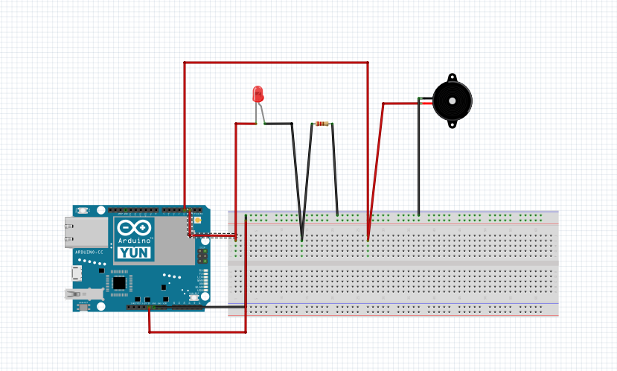

Figure 16.1 – Led and Buzzer connected to the Arduino Yun

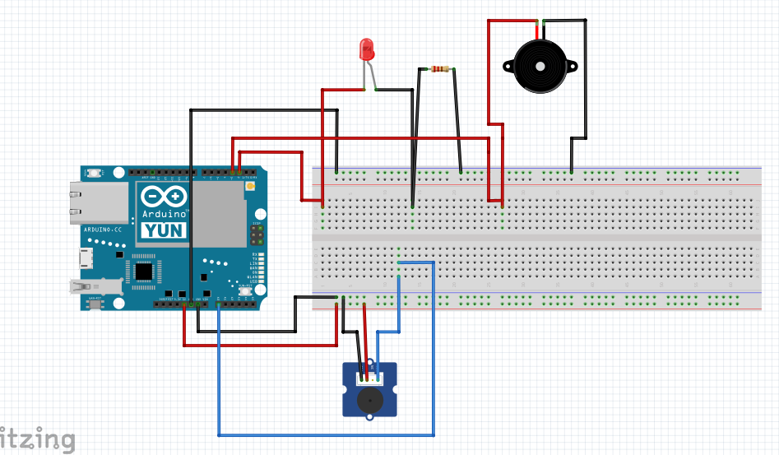

Figure 17 – Led, Buzzer and ……. connected to the Arduino Yun

Figure 18 – Led, Buzzer, ….. and …… connected to the Arduino Yun

### 2.4 HARDWARE SCHEMATIC

Figure 19 – Schematic diagram of LED, and Buzzer connected to The Yun via a breadboard.

Figure 20 – Schematic diagram of LED, and Buzzer connected to The Yun via a breadboard.

Figure 21 – Schematic diagram of LED, Buzzer, Mic and Vibration sensor connected to The Yun via a breadboard.

# 3. IMPLEMENTATION PLAN

## 3.1 EQUPIMENT USED

## 3.2 PARTS LIST

## 3.3 CODE SAMPLES

# 4. TESTING

## 4.1 TESTING APPROACH

Agile testing approach

Bit of speil about the Agile Development Process

* After each stage we discussed findings, planned next step, assigned task to group members for design layout, schematic, build, test etc.

Leading into how we implemented this approach

* Tested sensors individually by running code to activate the outputs
  + Led
  + movement
  + sound
  + buzzer
* Iteration1 configuration:
  + LED and buzzer
* Iteration2 configuration
  + LED, Buzzer & vibration sensor
* Iteration 3
  + LED, Buzzer & PIR sensor

## 4.2 TEST DATA

### 4.2.1 INITIAL INPUT / OUTPUT TESTING

#### 4.2.1.1 TEST DATA - MOVEMENT

Figure 22 – Grove Rptary Angle Sensor horizontal movement test data

Figure 23 - – Grove Rptary Angle Sensor vertical movement test data

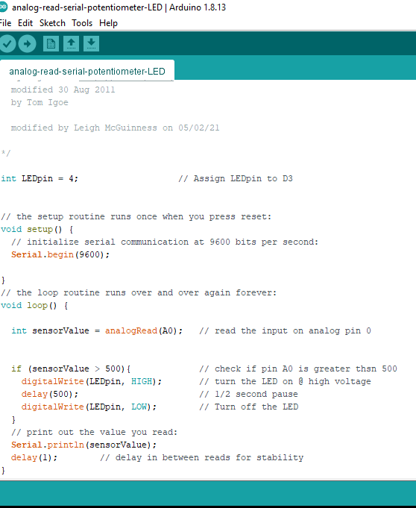

Figure 24 – Potentiometer Test code Would this look better typed in???

#### 4.2.1.2 TEST DATA - SOUND

RE-RUN BASIC SOUND SENSOR TEST

* INSERT SCREENSOTS OF SERIAL MONITOR

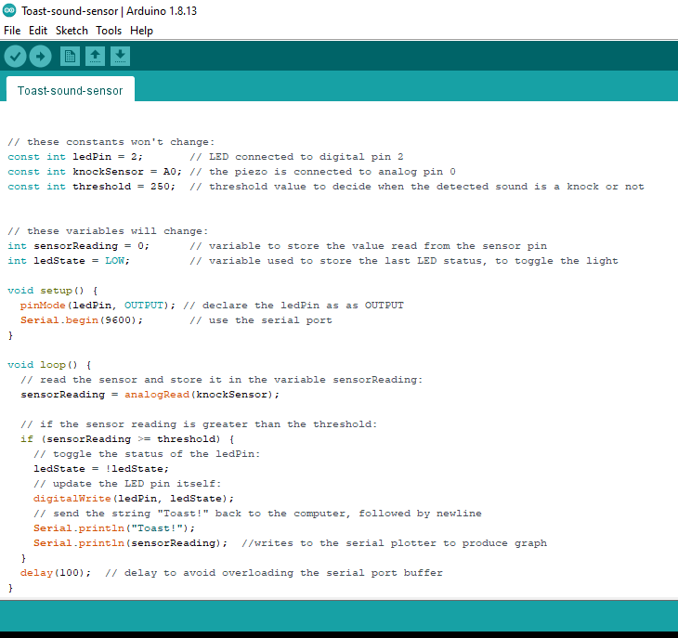

Figure 25 – Sound Sensor Test code

# ETHICS AND SECURITY ANALYSIS

## Internet of Things, Brief Technology Overview

The benefits of internet of things technology are obvious, across every industry applying these technologies could revolutionize how they operate, be it through means of automation or machine learning. For example, a baby monitoring system taking advantage of internet of things technology may bring peace of mind to new parents during the night, knowing that their baby is safely asleep. Use of the internet through a video or audio function may also help connect distant family members with the new member of their family. The dangers of such technologies from an ethical or security standpoint however may prove quite worrying.

The ability of systems to function independently from humans while connected to the .,security and privacy standards. For example, A health device while connected to the internet could be a target for a cyberattack, which could obviously have serious consequences for the user. Patching known security flaws in such devices may also prove difficult. Even though it is the connection to a network that makes these devices useful, it is very difficult to deliver patches using this connection in a safe and reliable way. Once these devices leave the factory the flaws or oversights made by the production team often prove detrimental down the road as computing technology improves and these mistakes become more obvious.

Data collection is the other pitfall of internet of things technology. In a world where already, we offer up so much of our personal data to search engines and social media companies, and we have a computer which can monitor what we say and where we go already in our pockets, the idea of having another device gathering our data may not be that attractive of a concept. Users’ data is a gold mine in todays market with big tech company’s making vast sums of money selling it to third party companies and advertisers. It is this same data that proves to be an IoT technology-based device’s biggest asset, as this data through modeling and statistics can feed machine learning or AI. This has the potential to improve the functionality and potential use for this device greatly.

So, our data is an asset that can be sold for huge sums of money or can be used to improve technology. This decision is controlled completely by the manufacturer. The trust therefore needed in these manufactures by the public is great. Using recent history as a marker, the money which can be generated from this data may prove to be too attractive to companies moving into the internet of things space.

## Ethics and security in a baby monitoring device

As our first iteration of this device, for our minor project, will not be connected to the internet, a lot of these concerns are not valid until we incorporate this functionality. During our meetings, ethics and security concerns have come up many times. While focused on this first proof of concept design, we are looking ahead to what a future iteration of this device may look like and what problems we may encounter.

Examining our chosen project idea with the issues outlined in the above paragraphs in mind, there are some definite areas which may cause us alarm.

* In the survey, in which we gathered information from our target market, many parents reported that they would find a live camera a beneficial feature of a baby monitoring device. While its benefits are obvious, we as a team, discussed the risks from an ethical and security standpoint and decided that we would not be able to implement a camera in our project on the grounds of safety.
* We have discussed having real time alerts and information on how the baby’s level of activity whilst sleeping being sent to the parent’s phone via email and text. This data may prove very powerful in improving the device further and provide information to the parents on possible setting and configuration adjustments which could improve the effectiveness of the device. However, like any device connected to the internet, moving this information across of network may prove to be a security risk. This is something we will have to examine in detail before implementing this functionality.

In conclusion, the greater the amount of research and discussion we complete as a team, the clearer it becomes that while internet of things technology is a very exciting and an inevitable evolution for computing it throws up a huge number of ethical questions. How these technologies are used is based completely on the moral compass of the companies that are creating them and may prove to become an area of great challenge for governments and authorities to police. Going through the various stages of developing our idea concerns have been raised and going forward we will be trying to address this issue and create a project which is balanced from and ethical and security standpoint. Our hope is that the companies moving into this expanding space will do likewise.

Sources:

[Xu Zou, (unknown), “IoT devices are hard to patch: Here's why—and how to deal with security” viewed 02/3/21, https://techbeacon.com/security/iot-devices-are-hard-patch-heres-why-how-deal-security]

[Sci-force, (28/02/19), “How Does the Internet of Things Work?”, viewed 02/03/21, <https://www.iotforall.com/what-is-the-internet-of-things>]

[Mark Stanislav & Tod Beardsley, (09/15), “Hacking IOT: A Case Study on Baby Monitor Exposures and Vulnerabilities”, viewed 02/03/21, <https://media.kasperskycontenthub.com/wp-content/uploads/sites/63/2015/11/21031739/Hacking-IoT-A-Case-Study-on-Baby-Monitor-Exposures-and-Vulnerabilities.pdf>]

[author unknown, (14/02/20), “Ethics in the World of the Internet of Things”, viewed 02/03/21, <https://iotscoe.att.com/stories/ethics-in-the-world-of-the-internet-of-things/>]

# FUTURE IMPROVEMENTS

# ROLES AND RESPONSIBILITIES

| NAME | ROLE | RESPONSIBILITIES |
| --- | --- | --- |
| Rhys Gilmartin |  |  |
|  |  |  |
| Leigh McGuinness |  |  |
|  |  |  |
| Stephen Meehan |  |  |
|  |  |  |
| Abdul Rahman Saif al Ahdubi |  |  |

# TECHNOLOGIES USED

| NAME | Source |
| --- | --- |
| GitHub | [www.github.com/](https://github.com/) |
| Trello | [www.trello.com/](https://trello.com/) |
| Fritzing | [www.fritzing.org/](https://fritzing.org/) |
| Arduino IDE | Available from [www.store.arduino.cc/digital/create](http://www.store.arduino.cc/digital/create) |
| Pushing Box | [www.pushingbox.com/index.php](https://www.pushingbox.com/index.php) |
| Bonitasoft | [www.bonitasoft.com/](https://www.bonitasoft.com/) |
|  |  |

# REFERENCES

# BIBLIOGRAPHY