Testing LED

Our testing began by running sketches on the Arduino using the different sensors, I done this to get a general idea of the Arduino functionality and how the device could potentially work.

In the below screenshots you can tests that I conducted on the Arduino. Uploading a basic blink sketch, you can see the Blink every second.

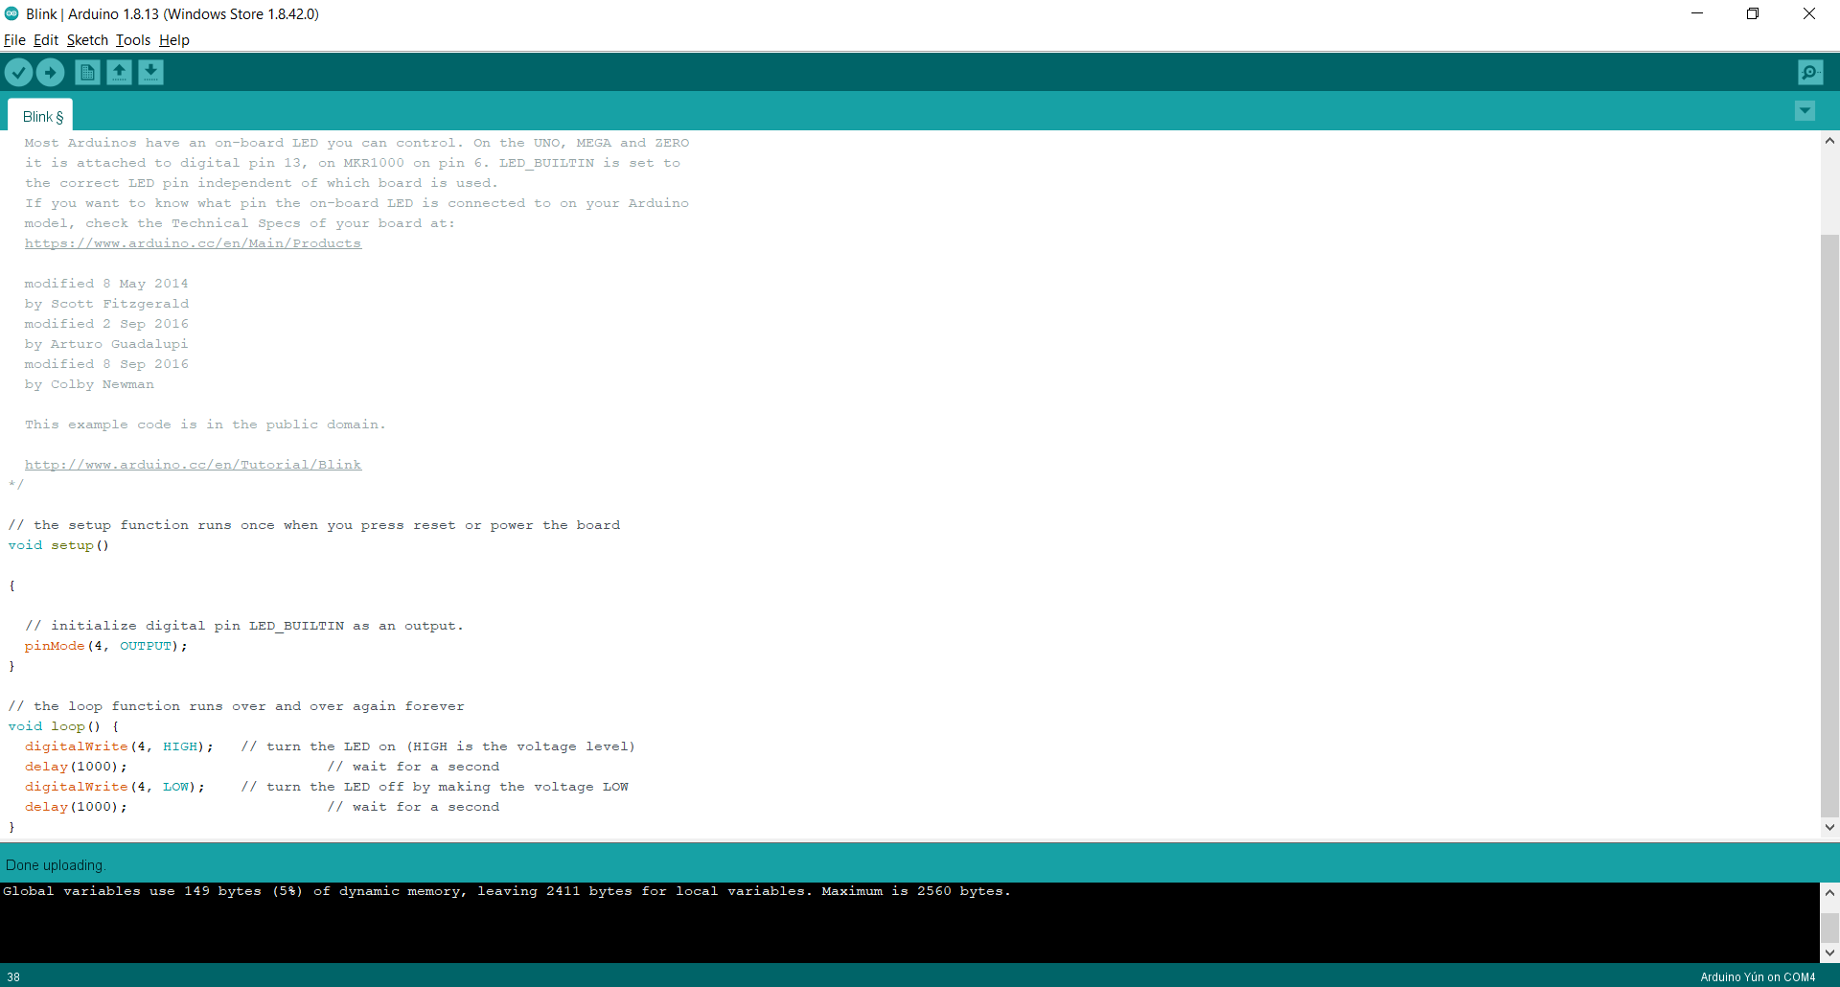

Testing sound sensor/Led.

The second test I conducted was using the sound sensor with the LED. As you can see from the code, every time the sound sensors gets a value greater than 100 the LED will turn on.

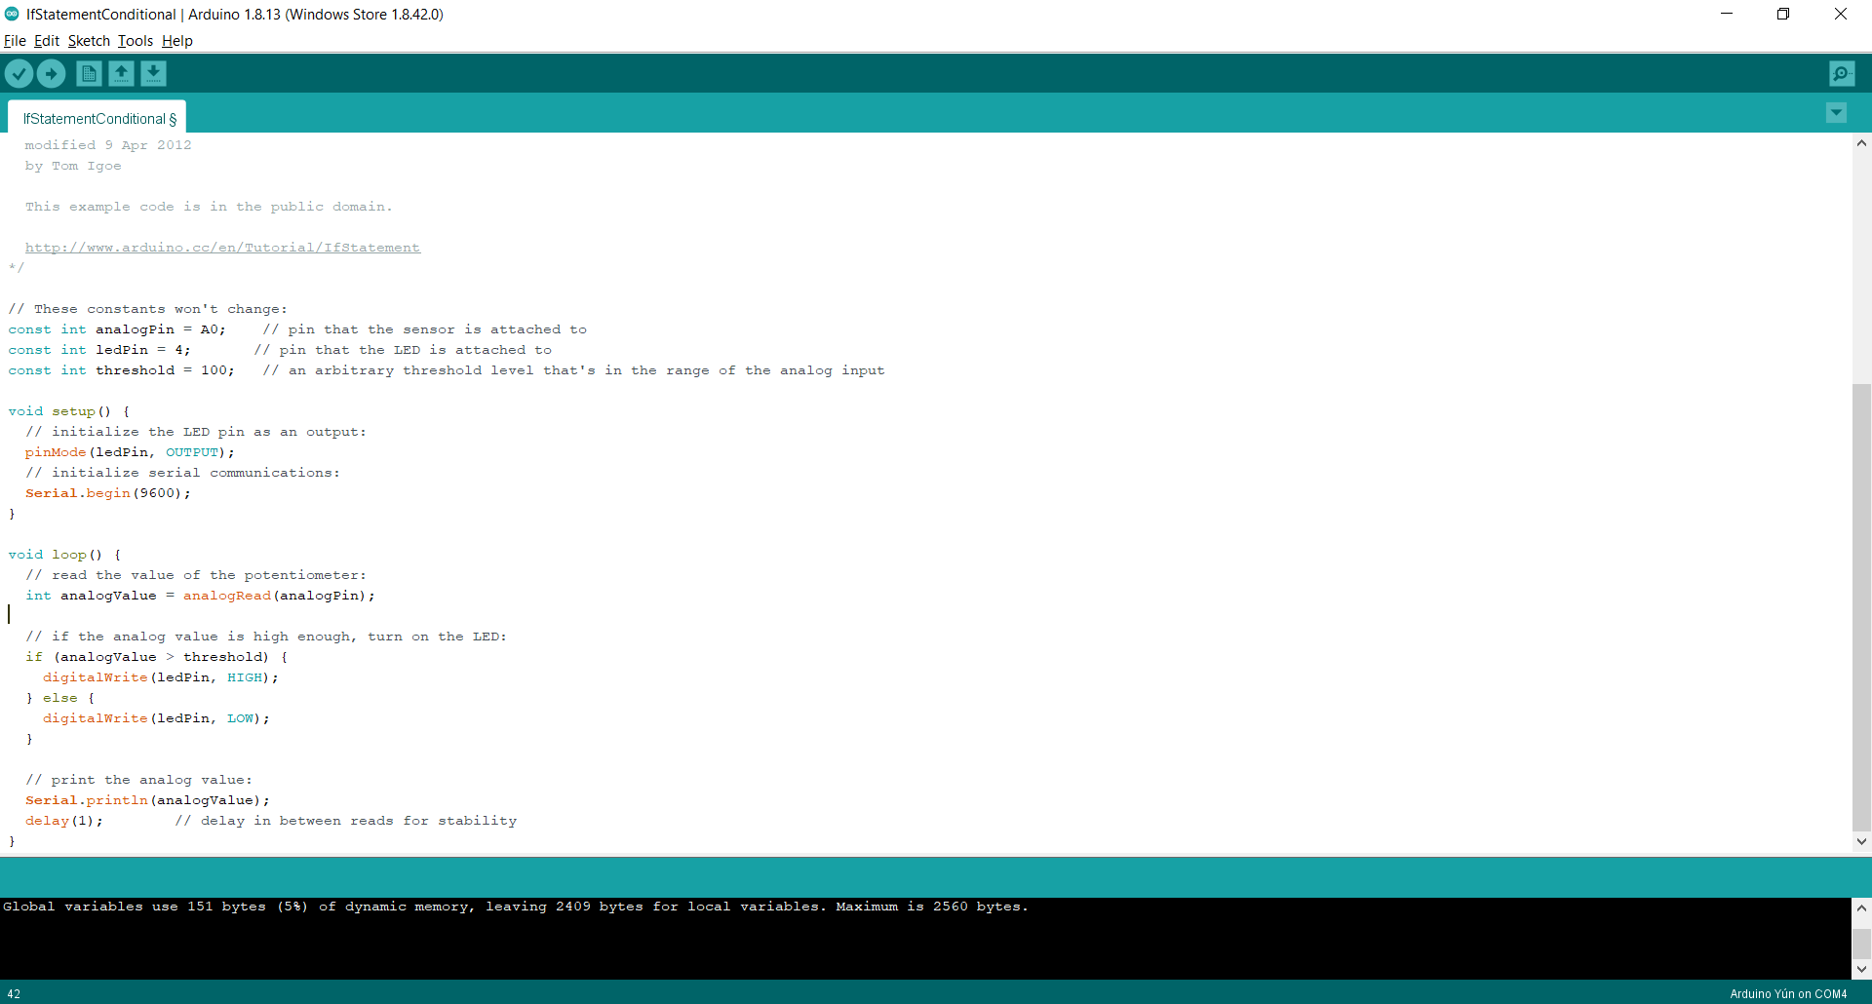

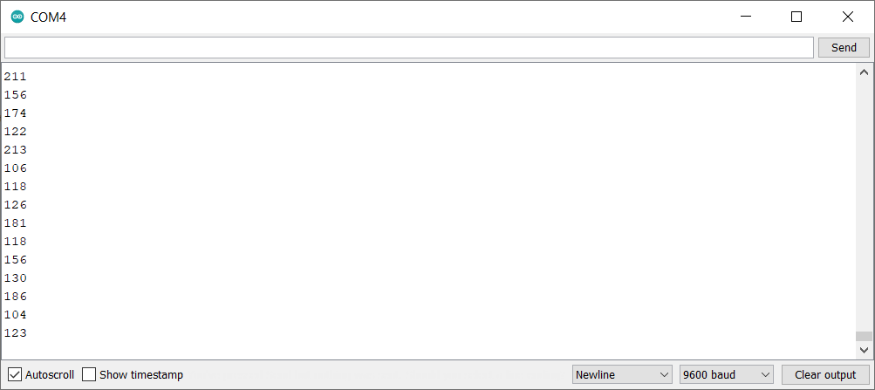

Testing sound sensor/movement sensor with buzzer

The third test I carried out was the sound sensor and the buzzer, like the sketch including the LED, every time the sound sensor had a value greater then 200 the buzzer would sound.

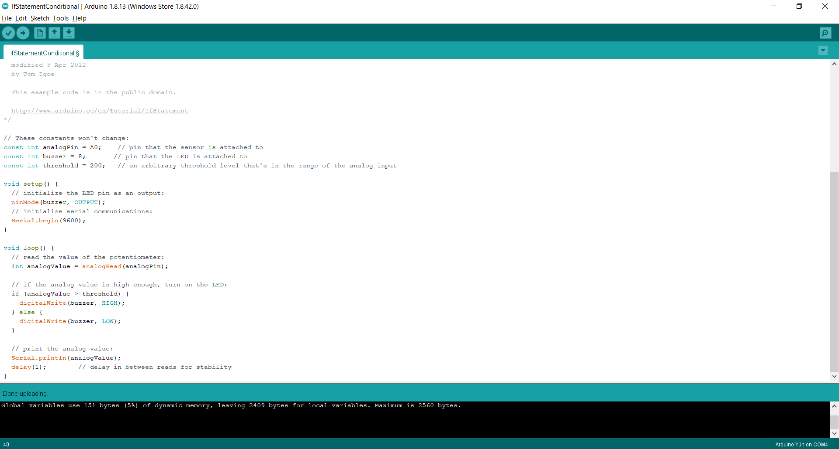

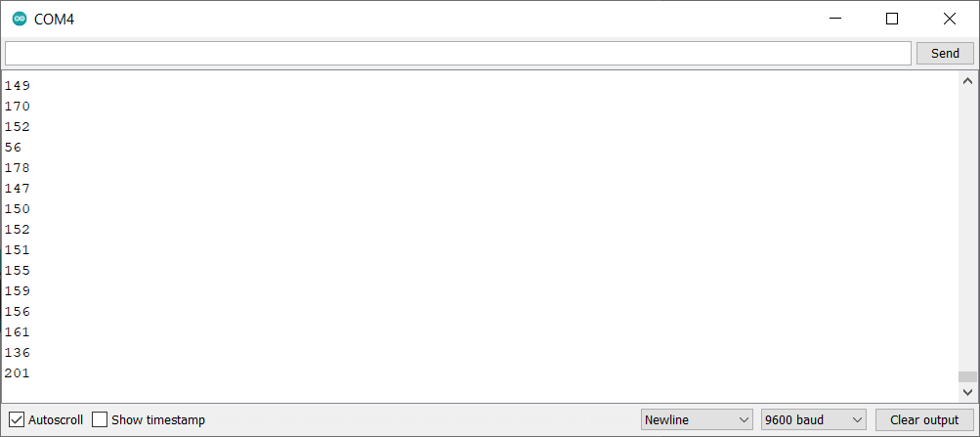

An identical test was also carried out for the movement sensor, using a very similar script the led would light when the movement sensor got a value greater than 200.