Tasks for the course “Algorithms and data structures”

1.

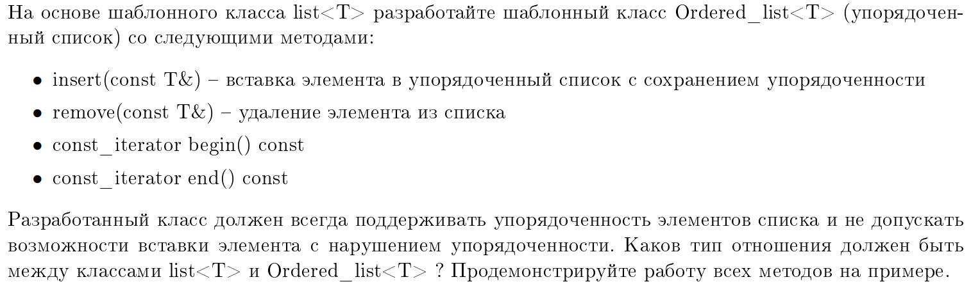

2.

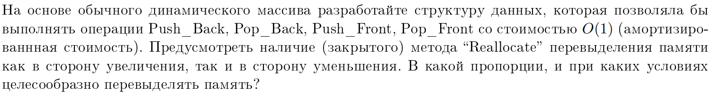

3.

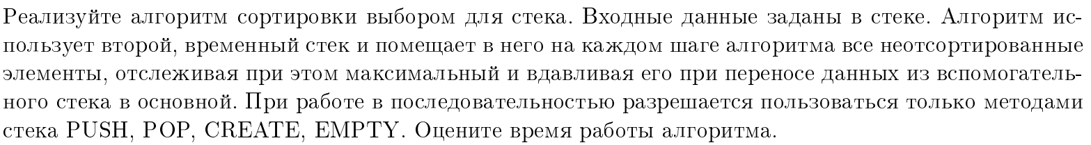

4.



5.

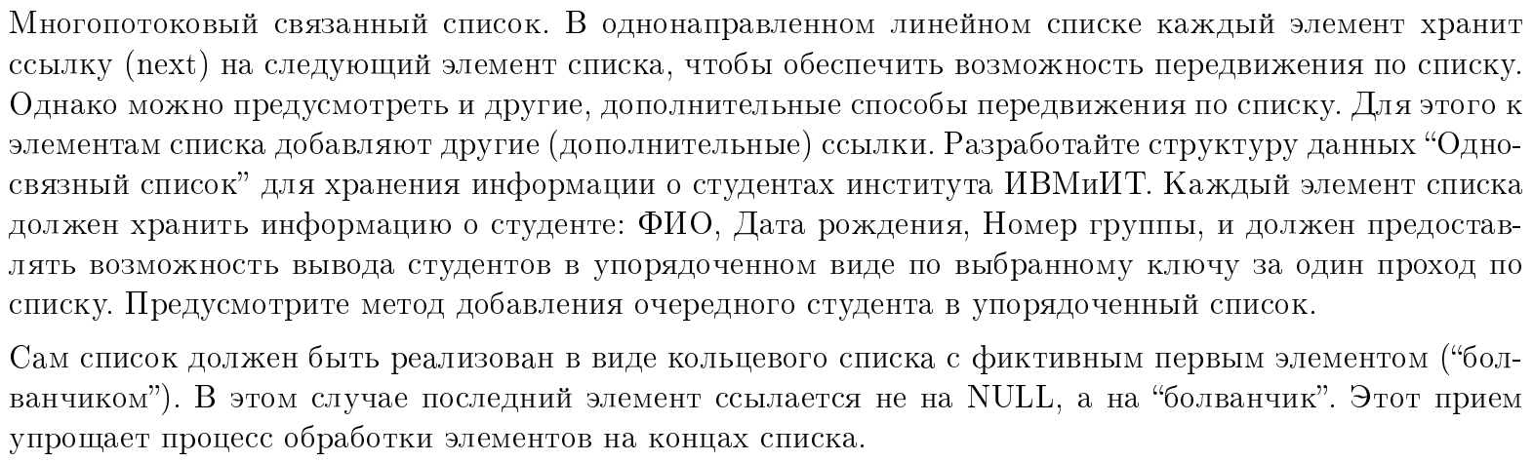

6.

