Project: UTel Subscriber Intelligence & Usage Analytics Platform
Part A: Database Design
ENTITIES:
- Subscriber
- Call
- SMS
- Airtime Sale
- Internet bundle sale
- Fibre Subscription
ATTRIBUTES:
- Subscriber: Subscriber ID, MSISDN, Subscriber name, gender, region, activation date, status
- Call: Call ID, Call MSISDN, Destination MSISDN, Call date, Duration seconds, Charge amount, Call type
- SMS: SMS ID, Source MSISDN, Destination MSISDN, SMS date, Direction, Message type, Charge amount
- Airtime sale: Sale ID, MSISDN, Purchase date, amount, Channel
- Internet bundle sale: Bundle sale ID, MSISDN, Bundle name, Purchase date, Amount, Validity days
- Fibre subscription: Subscription ID, MSISDN, Package name, Subscription date, Monthly fee, status

ENTITY RELATIONSHIP DIAGRAM
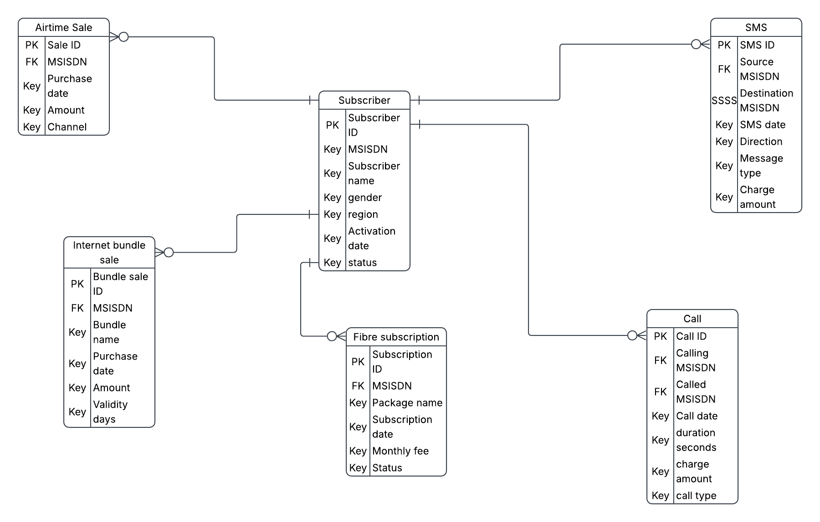

Primary key is an attribute that uniquely identifies every record within a certain table.
Foreign key is a primary key within another place.

