|  |  |  |  |  |  |  |  |  |  |  |  |  |  |  |
| --- | --- | --- | --- | --- | --- | --- | --- | --- | --- | --- | --- | --- | --- | --- |
| Hypertension confusion matrix (without IC*) | | | | | | |  | Hypertension confusion matrix (with IC*) | | | | | | |
| Predicted | | 0000 | 0011 | 0111 | 1111 | 0001 |  | Predicted | | 0000 | 0011 | 0111 | 1111 | 0001 |
| Real | | 1 | 2 | 3 | 4 | 5 |  | Real | | 1 | 2 | 3 | 4 | 5 |
| 0000 | 1 | 11 | 0 | 0 | 1 | 0 |  | 0000 | 1 | 12 | 0 | 1 | 2 | 0 |
| 0011 | 2 | 1 | 0 | 1 | 1 | 0 |  | 0011 | 2 | 1 | 0 | 0 | 3 | 0 |
| 0111 | 3 | 0 | 0 | 0 | 0 | 0 |  | 0111 | 3 | 0 | 0 | 2 | 14 | 0 |
| 1111 | 4 | 2 | 0 | 2 | 82 | 0 |  | 1111 | 4 | 2 | 0 | 0 | 65 | 0 |
| 0001 | 5 | 1 | 0 | 0 | 1 | 0 |  | 0001 | 5 | 0 | 0 | 0 | 1 | 0 |
| 93% |  |  |  |  |  |  |  | 94% |  |  |  |  |  |  |
| 5% |  |  |  |  |  |  |  | 3% |  |  |  |  |  |  |
| 2% |  |  |  |  |  |  |  | 0% |  |  |  |  |  |  |

|  |  |  |  |  |  |  |  |  |  |  |  |  |  |  |
| --- | --- | --- | --- | --- | --- | --- | --- | --- | --- | --- | --- | --- | --- | --- |
| Liver confusion matrix (without IC*) | | | | | | |  | Liver confusion matrix (with IC*) | | | | | | |
| Predicted | | 0000 | 0011 | 0111 | 1111 | 0001 |  | Predicted | | 0000 | 0011 | 0111 | 1111 | 0001 |
| Real | | 1 | 2 | 3 | 4 | 5 |  | Real | | 1 | 2 | 3 | 4 | 5 |
| 0000 | 1 | 75 | 0 | 0 | 0 | 0 |  | 0000 | 1 | 81 | 0 | 0 | 0 | 0 |
| 0011 | 2 | 0 | 0 | 0 | 0 | 0 |  | 0011 | 2 | 0 | 0 | 0 | 0 | 0 |
| 0111 | 3 | 6 | 0 | 2 | 1 | 0 |  | 0111 | 3 | 0 | 0 | 2 | 1 | 0 |
| 1111 | 4 | 1 | 0 | 0 | 16 | 0 |  | 1111 | 4 | 1 | 0 | 0 | 16 | 0 |
| 0001 | 5 | 1 | 1 | 0 | 0 | 0 |  | 0001 | 5 | 1 | 1 | 0 | 0 | 0 |
| 92% |  |  |  |  |  |  |  | 97% |  |  |  |  |  |  |
| 8% |  |  |  |  |  |  |  | 2% |  |  |  |  |  |  |
| 0% |  |  |  |  |  |  |  | 0% |  |  |  |  |  |  |

|  |  |  |  |  |  |  |  |  |  |  |  |  |  |  |
| --- | --- | --- | --- | --- | --- | --- | --- | --- | --- | --- | --- | --- | --- | --- |
| Retinopathy confusion matrix (without IC*) | | | | | | |  | Retinopathy confusion matrix (with IC*) | | | | | | |
| Predicted | | 0000 | 0011 | 0111 | 1111 | 0001 |  | Predicted | | 0000 | 0011 | 0111 | 1111 | 0001 |
| Real |  | 1 | 2 | 3 | 4 | 5 |  | Real |  | 1 | 2 | 3 | 4 | 5 |
| 0000 | 1 | 68 | 0 | 0 | 0 | 0 |  | 0000 | 1 | 73 | 1 | 0 | 0 | 0 |
| 0011 | 2 | 2 | 1 | 1 | 0 | 0 |  | 0011 | 2 | 1 | 1 | 0 | 0 | 0 |
| 0111 | 3 | 1 | 0 | 2 | 0 | 0 |  | 0111 | 3 | 0 | 0 | 3 | 0 | 0 |
| 1111 | 4 | 2 | 0 | 2 | 21 | 0 |  | 1111 | 4 | 0 | 0 | 2 | 21 | 0 |
| 0001 | 5 | 3 | 0 | 0 | 0 | 0 |  | 0001 | 5 | 1 | 0 | 0 | 0 | 0 |
| 90% |  |  |  |  |  |  |  | 95% |  |  |  |  |  |  |
| 8% |  |  |  |  |  |  |  | 1% |  |  |  |  |  |  |
| 2% |  |  |  |  |  |  |  | 2% |  |  |  |  |  |  |

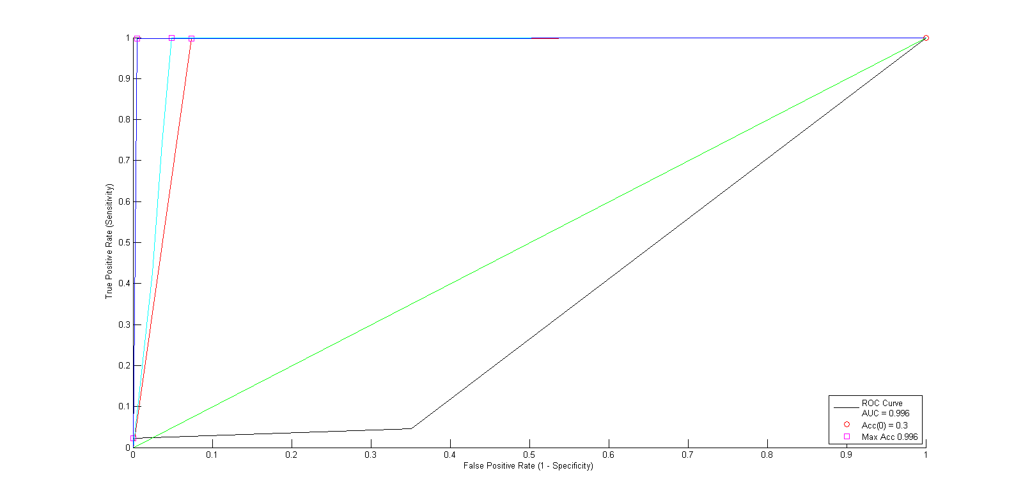

Figure 8 Retinopathy ROC curves in blue, red, Cyan, Black shows ROC With IC*, Without Latent, With K2 and Unbalanced

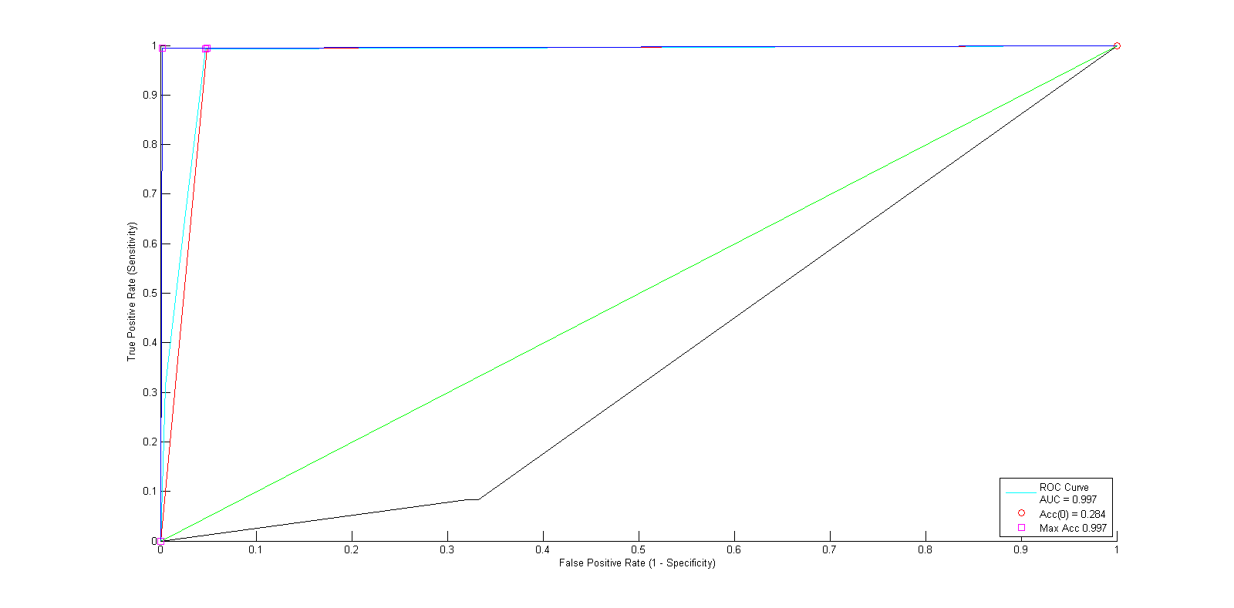

Figure 2 Liver ROC curves in blue, red, Cyan, Black shows ROC With IC*, Without Latent, With K2 and Unbalanced

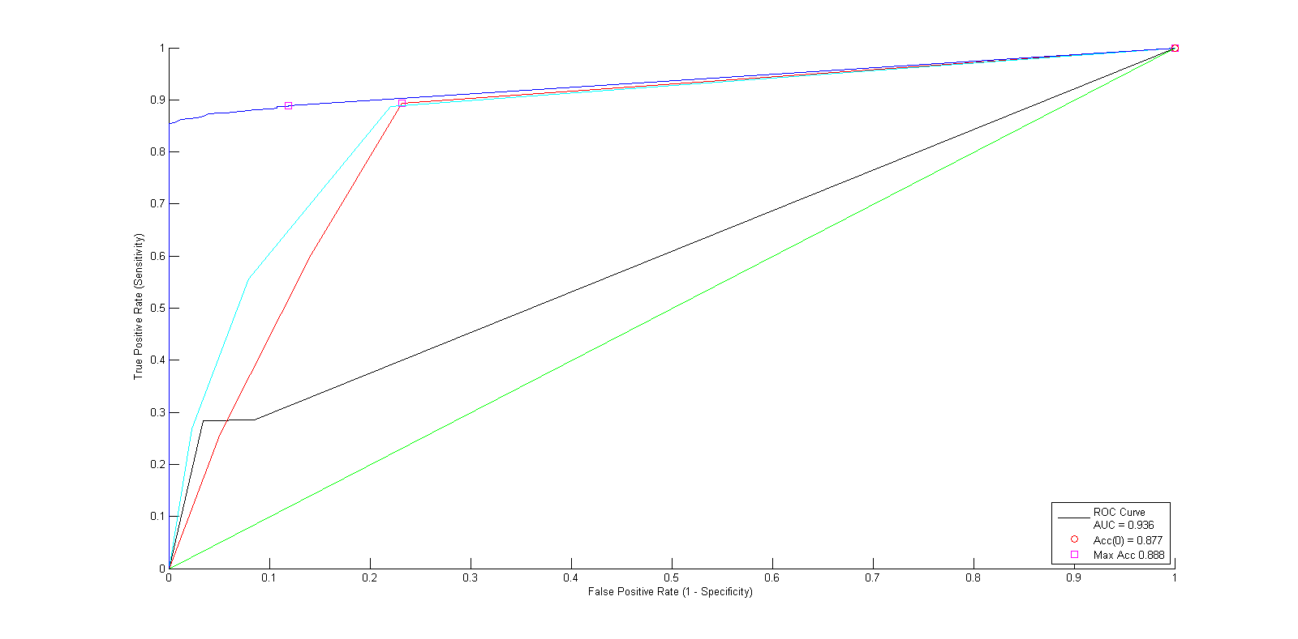

Figure 3 Hypertension ROC curves in blue, red, Cyan, Black shows ROC With IC*, Without Latent, With K2 and Unbalanced

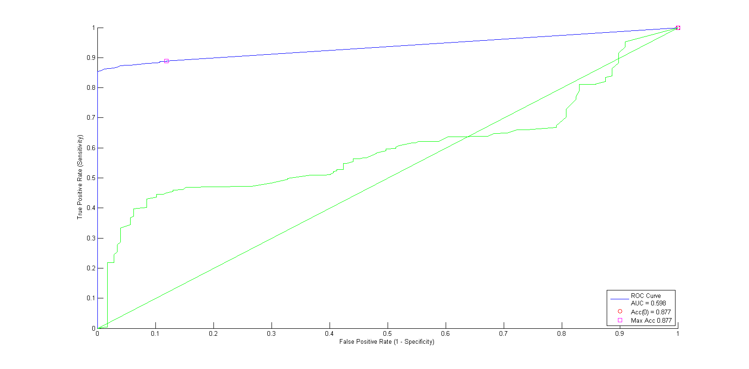

Figure 4 Hypertension comparing with IC* and LS in blue curve and with only using IC* in green curve

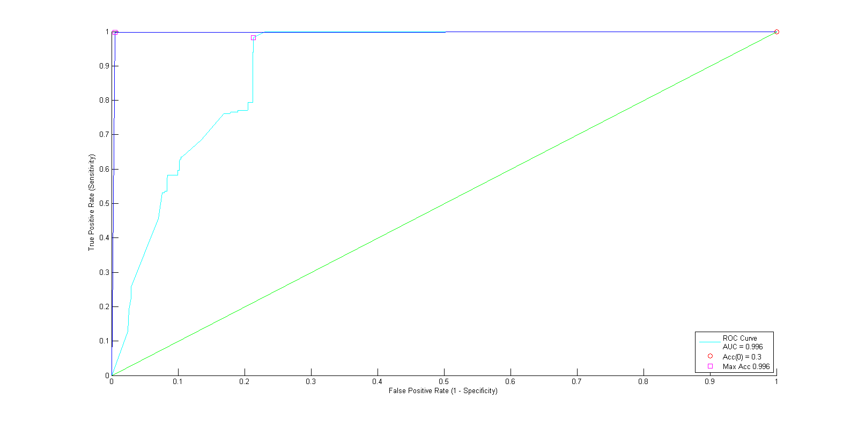

Figure 10 Retinopathy comparing with IC* and LS in blue curve and with only using IC* in green curve

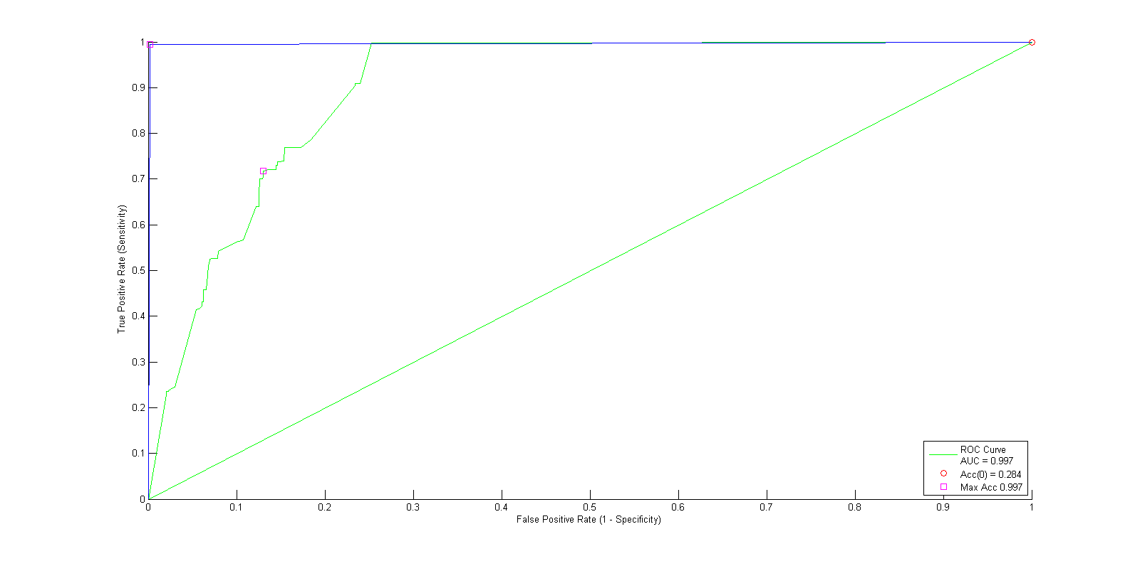

Figure 1 Liver disease comparing with IC* and LS in blue curve and with only using IC* in green curve

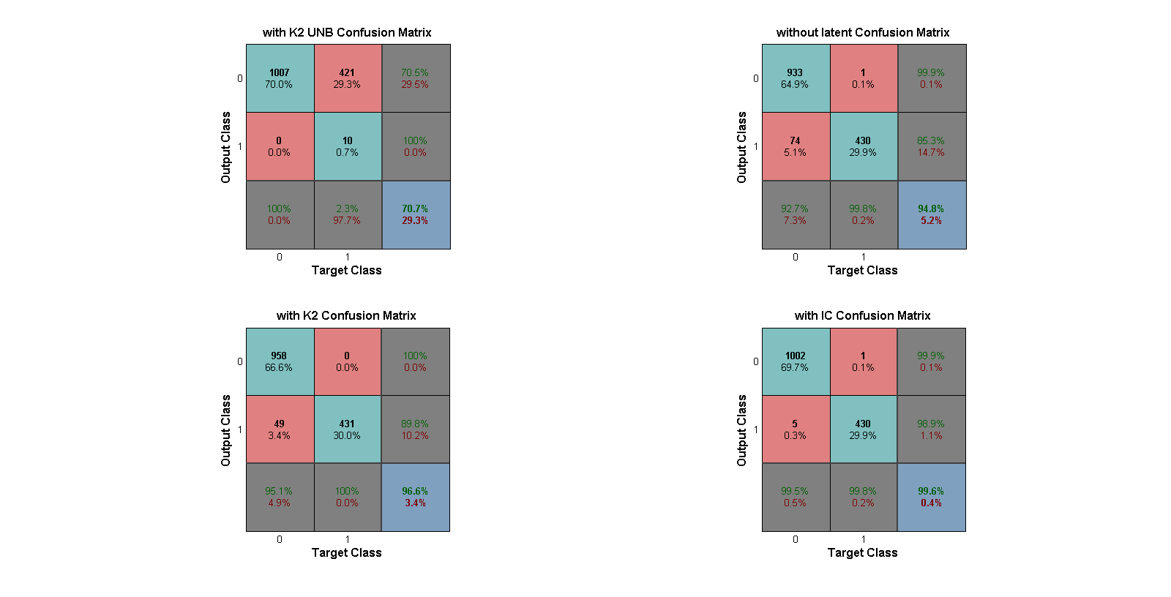

Figure 5 Retinopathy Confusion Matrices

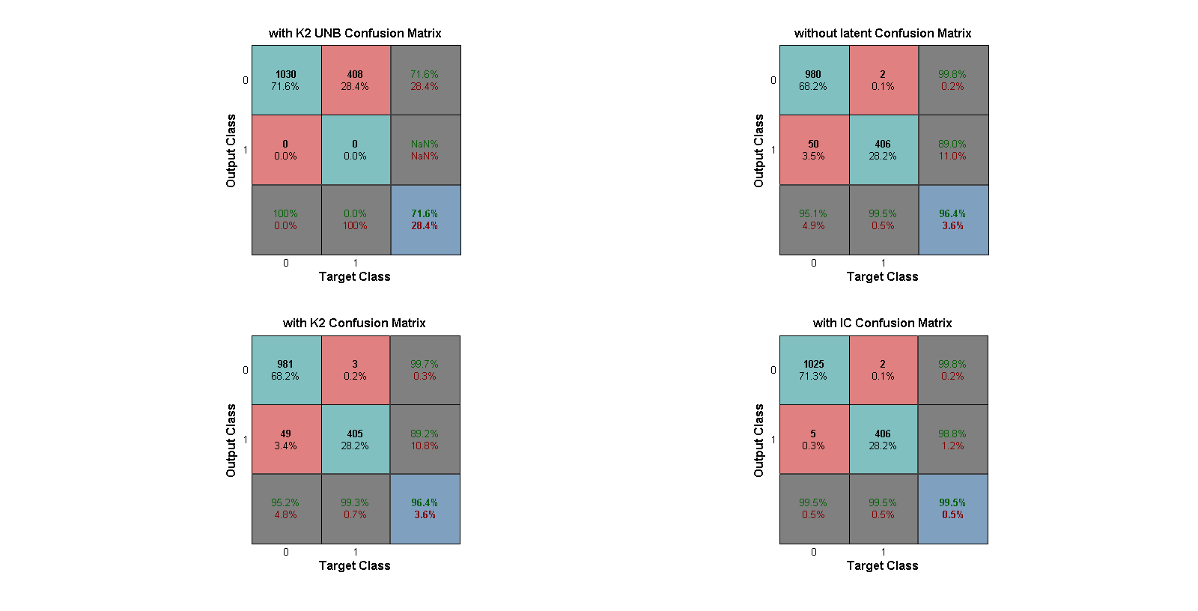

Figure 6 Liver disease Confusion Matrices

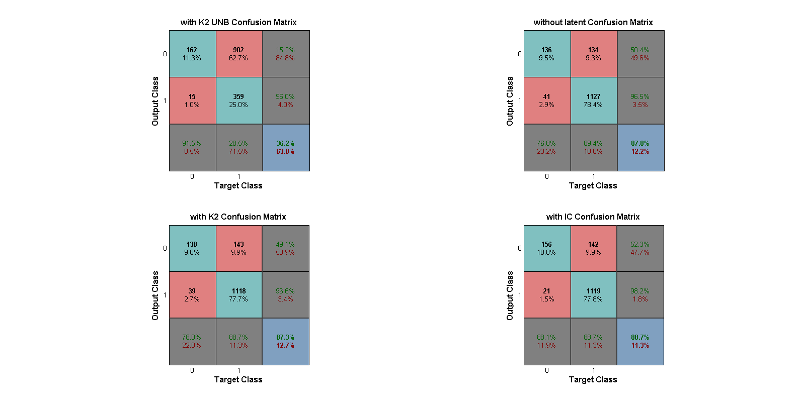

Figure 7 Hypertension Confusion Matrices

Table 1 the IC* algorithm adjecement matrix



Table 2 The Link Strength probabilities of the edges which are learned from the IC* algorithm; Those edges in IC* adjecement matrix are represented in the our final structure which have higher probabilities than 40 % in Link Strength( highlighted LSTA%).

|  |  |  |  |  |  |  |  |  |  |  |  |
| --- | --- | --- | --- | --- | --- | --- | --- | --- | --- | --- | --- |
| Regarding IC* there is a link between two variables P(i, j) = -2 if there is a marked directed i-*>j edge. | | | | | | | | | | | |
| -2 | Retinopathy |  |  |  | LSTA% | LSBA% |  |  |  | LSTA% | LSBA% |
| 3 | 5 | 2 | 4 |  | 17.20% | 43.90% | 17 | 19 |  | 0.30% | 54.80% |
| 7 | 4 | 6 | 3 |  |  |  | 21 | 18 |  |  |  |
| 4 | 6 | 3 | 5 |  | 12.20% | 49.20% | 18 | 20 |  | 15.30% | 67.40% |
| 5 | 6 | 4 | 5 |  | 9.50% | 49.90% | 19 | 20 |  | 11.20% | 66.90% |
| 6 | 8 | 5 | 7 |  | 8.10% | 58.50% | 20 | 22 |  | 10.20% | 72.80% |
| 3 | 9 | 2 | 8 |  | 4.80% | 66.00% | 17 | 23 |  | 1.50% | 78.50% |
| 6 | 10 | 5 | 9 |  | 11.50% | 83.70% | 20 | 24 |  | 12.70% | 87.40% |
| 4 | 11 | 3 | 10 |  | 13.30% | 90.90% | 18 | 25 |  | 18.80% | 94.90% |
| 5 | 11 | 4 | 10 |  | 8.50% | 91.20% | 19 | 25 |  | 11.60% | 95.00% |
| 8 | 11 | 7 | 10 |  | 40.60% | 93.40% | 22 | 25 |  | 42.40% | 96.50% |
| 9 | 11 | 8 | 10 |  | 56.60% | 93.40% | 23 | 25 |  | 61.20% | 96.40% |
| 10 | 11 | 9 | 10 |  | 46.90% | 93.40% | 24 | 25 |  | 52.40% | 96.50% |
| 3 | 12 | 2 | 11 |  | 11.10% | 96.50% | 17 | 26 |  | 8.10% | 97.70% |
| 4 | 12 | 3 | 11 |  | 23.70% | 97.00% | 18 | 26 |  | 37.50% | 97.60% |
| 8 | 12 | 7 | 11 |  | 61.30% | 98.10% | 22 | 26 |  | 60.10% | 98.40% |
| 10 | 12 | 9 | 11 |  | 40.00% | 98.00% | 24 | 26 |  | 51.30% | 98.40% |
| 5 | 13 | 4 | 12 |  | 40.50% | 99.30% | 19 | 27 |  | 43.60% | 99.20% |
| 8 | 13 | 7 | 12 |  | 47.50% | 99.60% | 22 | 27 |  | 57.80% | 99.50% |
| 12 | 13 | 11 | 12 |  | 74.80% | 99.60% | 26 | 27 |  | 58.70% | 99.50% |
| 5 | 14 | 4 | 13 |  | 65.00% | 99.50% | 19 | 28 |  | 61.50% | 99.80% |
| 10 | 14 | 9 | 13 |  | 69.60% | 99.70% | 24 | 28 |  | 85.70% | 99.90% |
| 11 | 14 | 10 | 13 |  | 22.60% | 99.70% | 25 | 28 |  | 0.00% | 99.90% |
| 5 | 7 | 4 | 6 |  | 9.20% | 73.30% | 19 | 21 |  | 16.10% | 78.50% |
| 4 | 14 | 3 | 13 |  | 73.50% | 99.50% | 18 | 28 |  | 45.90% | 99.80% |
| 6 | 14 | 5 | 13 |  | 63.70% | 99.50% | 20 | 28 |  | 84.40% | 99.80% |
| Regarding IC* there is a link between two variables P(i,j) = P(j,i) = 2 if there is a latent variable L such that i<-L->j. | | | | | | | | | | | |
|  |  | 2 |  |  |  |  |  |  |  |  |  |
| 12 | 3 | 11 | 2 |  | 11.10% | 96.50% | 26 | 17 |  | 8.10% |  |
| 6 | 7 | 5 | 6 |  | 7.20% | 71.00% | 20 | 21 |  | 5.60% | 76.50% |
| Regarding IC* there is a link between two variables P(i,j) = -1 if there is either a latent variable L such that i <-L-> j. | | | | | | | | | | | |
|  |  | -1 |  |  |  |  |  |  |  |  |  |
| 2 | 3 | 1 | 2 |  | 6.10% | 5.60% | 16 | 17 |  | 10.30% | 20.00% |
| 2 | 4 | 1 | 3 |  | 8.90% | 13.10% | 16 | 18 |  | 3.50% | 34.10% |
| 2 | 7 | 1 | 6 |  | 8.30% | 72.30% | 16 | 21 |  | 7.90% | 79.00% |
| 2 | 8 | 1 | 7 |  | 17.40% | 64.40% | 16 | 22 |  | 10.20% | 76.70% |
| 2 | 10 | 1 | 9 |  | 41.50% | 87.60% | 16 | 24 |  | 23.70% | 90.90% |
| 2 | 11 | 1 | 10 |  | 39.60% | 93.20% | 16 | 25 |  | 28.70% | 96.60% |
| 3 | 4 | 2 | 3 |  | 1.60% | 10.40% | 17 | 18 |  | 0.30% | 28.20% |
| 3 | 8 | 2 | 7 |  | 2.80% | 56.20% | 17 | 22 |  | 1.30% | 74.80% |
| 3 | 10 | 2 | 9 |  | 9.00% | 81.10% | 17 | 24 |  | 3.40% | 87.30% |
| 9 | 10 | 8 | 9 |  | 41.60% | 87.20% | 23 | 24 |  | 39.70% | 90.40% |
| 9 | 12 | 8 | 11 |  | 60.80% | 98.00% | 23 | 26 |  | 64.60% | 98.40% |
|  |  |  |  |  |  |  |  |  |  | 98.40% | 98.40% |