磁性材料磁场成型 发展史手动压机

发展史手动压机 Development History of Manual Presses

磁性材料磁场成型　Magnet press for ferric materials

magnets were prepared via a powder metallurgy method

1.手动称料 Manual weighing

2.手动装料 Manual feed

3.磁场取向取向磁场800KA/M

Magnetic field orientation

orientation magnetic field 800KA/M

4.手动控制模压和脱模 压胚 3.8g/cm

Manual fill and release of the press mold: magnet blocks 3.8g/cm

5.油压等静压 至4.5g/cm 以上

Oil pressure isostatic pressure to 4.5g/cm or more

缺点：设备效率低、受人为因素影响比较严重、性能稳定性差、适合低性能材料。

半自动压机

Disadvantages: low equipment efficiency, more seriously affected by human factors, poor performance stability, suitable for low performance materials.

1.自动称料 Automatic weighing

2.自动装料 Automatic feed

3.磁场取向 Magnetic field orientation 1600KA/M

取向磁场发展到: applied magnetic field 1600KA/M

4.手动/半自动控制模压和脱模 压胚 3.8g/cm

Manual/semi-automatic containment pressure and mold release:

magnet blocks: 3.8g/cm

5.油压等静压 至4.5g/cm 以上

hydraulic isostatic pressure over 4.5g/cm

缺点：无法一次成型、中间过程控氧难度大、性能稳定性受氧含量影响大。

Disadvantages:

Cannot be formed in one step,

difficult to control oxygen in the intermediate process,

the stability of performance is greatly affected by the oxygen content.

RIP橡皮膜 RIP rubber mold

1. 全自动脉冲磁场取向近等静压机

Fully automatic pulsed magnetic field oriented near isostatic presses

magnetized in a pulsed ﬁeld with a strength of up to

1. 采用6.5T以上的高脉冲磁场取向

Highly pulsed magnetic field orientation of 6.5T or more is used

1. 粉末平均粒度5um，松装密度2.8-3.0g/cm

Powder average particle size 5um, bulk density 2.8-3.0g/cm

1. 压坯密度4.5g/cm

Density of briquettes 4.5 g/cm

1. 高剩磁，高磁能积实现

realization of High Remanence, high Coercivity

6.对于相同成分和相同工艺的磁体，由于模压过程中模腔内壁与粉末间不产生相

对运动，所以橡皮膜压磁体可以获得高取向度。

isostatic rubber pressed magnets obtain a high degree of alignment because as pressure is applied equally in all directions relative motion between the mold’s inner wall and the powder is prevented, resulting in good alignment.

缺点：材料成型形状品相差、加工损耗大。

Disadvantages: poor material molding shape quality, high processing losses

全自动压机

Fully automatic presses

1. 全自动称料，装料（100ppm氧含量情况下）

Fully automatic weighing and loading (at 100 ppm oxygen)

1. 磁场发展到2400KA/m

Allied field: 2400KA/m

1. 全闭环控制模压，脱模精密控制一次成型 4.3g/cm

Fully closed-loop controlled die pressing system

Precise single stage control of mold release @ 4.3g/cm

1. 无须等静压,可直通连续烧结炉

No required isostatic pressure,

Continuous feed sintering furnace.

1. 节省材料降低消耗

reduce material consumption.

1. 适合高性能材料压制

Suitable for pressing high performance materials.

全自动无氧压制码放送炉流水线

Full-automated Furnace Process Line: Oxygen-free Sintering

1. 在全自动压机的基础上，增加全自动取料，码放、输送连续烧结炉通道

Achieving a fully automated press process, with automatic material handling, stacking, and a continuous conveying system for the furnace.

1. 氧含量低于50PPM

Oxygen levels below 50PPM

1. 全过程可控可追溯，连接工厂MES系统以适应工业互联。

System is also fully traceable and compatible with MES systems.

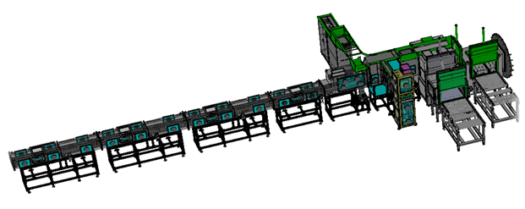



**国际现金设备介绍**

Introduction of international cash equipment

**全自动无氧成型码放、输送连续烧结炉流水线**

**Fully automatic anaerobic molding, Conveyorized continuous sintering furnace line**

低氧压型烧结智能无人化工艺实现

压型部分 -----高效 省料

全自动称料，装料（氧含量50ppm以下）

磁场发展到2400KA/m

全闭环控制模压，脱模精密控制一次成型 4.3g/cm

无须等静压,直通连续烧结炉

取料码放送炉部分----去人工化

减少中转工序，实现无人操作

全过程可控可追溯，减少人为因素干扰，满足高端客户产品全生产周期追 溯需求。

超低氧工艺实现，全过程50ppm以下

提高磁石的磁性能和一致性

国内成型压机现状

Current status of domestic molding presses  
https://bdn.135editor.com/files/images/editor_styles/d6272996f58fc4ab4cba03d5001cec88.jpg行业现状

Industry status

我国是采用两步压制成型的方式，取向时用小压力垂直模压成型，然后采用准等静压成型，大部分生产企业自动化程度落后。

China is the use of two-step compression molding, orientation with small pressure vertical molding, and then quasi-isostatic pressure molding, most of the production enterprises backward degree of automation.

https://bdn.135editor.com/files/images/editor_styles/d6272996f58fc4ab4cba03d5001cec88.jpg市场发展

market development

以中科三环为代表的企业已经实现一次成型，取消等静压，对实现全过程的可控和自动化有极大意义，其他知名企业也在朝这一方向努力。

Enterprises represented by Zhongke Sanhuan have already realized one-shot molding and eliminated isostatic pressure, which is of great significance in realizing controllability and automation of the whole process, and other well-known enterprises are also working in this direction.

https://bdn.135editor.com/files/images/editor_styles/d6272996f58fc4ab4cba03d5001cec88.jpg**需求现状**

demand

1. 压制一次成型，取消等静压

Single step die press process, with low isostatic pressure

1. 提高自动化程度，提升磁性能和一致性

Increased automation for consistent performance

1. 整合前后道工艺，完善控氧技术

Total integration of front and rear processes,

Adoption oxygen of control technology

1. 节省材料

Reduce material consumption.

https://bdn.135editor.com/files/images/editor_styles/d6272996f58fc4ab4cba03d5001cec88.jpg技术现状

On Going Challenges

专利，制粉，添加剂，设备精度，模具设计加工能力等现状制约了一次成型技术的普遍应用，而一次成型的发展缓慢又制约了自动化程度的提高。

The universal adoption of signal stage die pressing technologies is being constraint by intellectual property issues, the quality of powder & their additives, and the accuracy of installed equipment. The suitability of your mold design and capabilities of your process will also need to be considered.

取向成型研制方向及未来发展

Development Trends for controlling mold alignment and future development.

控氧技术

Oxygen Control Technology (OCT)

由于稀土价格上涨，为制造低成本高性能的S-NdFeB，各企业一般将稀土金属总量控制在31.5%以下，通过控氧技术的发展和应用，使磁体对氧含量不那么敏感，整体性能稳定一致，力学性能好。

The price of rare earths has been rising. To manufacture high-performance S-NdFeB magnets at a low-cost, manufactures need to keep the total content of rare earth (RE) elements under 31.5%. Here, the development of oxygen control technology (OCT) makes a major difference.

Through the application of OCT, the magnetic materials become less susceptible to oxidation. This results in more stable and consistent overall performance with good mechanical properties.

辐射取向与多极取向

Radial and Multipolar Field Alignment

应用于永磁电机比例阶梯式增长，有力推动永磁电机发展，应用前景广阔，目前较大的问题还是容易开裂，成品率低，要通过2：14：1相晶粒的取向匹配来解决。

The permanent magnet motors segment is seeing steady growth, but the magnet’s tendency to crack and low yield are major obstacles that may be solved by alignment matching of 2:14:1 for the phase grains.

凝胶注膜成型

Gel Injection Molding

将S-NdFeB磁粉与一种液体混合成悬浊液，加入一种核心的有机单体溶剂和催化剂，注入模具中，取向时，模具内有机单体发生聚合反应形成网络状结构，将合金粉末颗粒包裹为坯体，经干燥，排胶，烧结得到致密永磁体。

04

S-NdFeB magnetic powder is suspended in a liquid consisting of an organic solvent and then injected into a mold. During the alignment, the monomers in the solvent undergo a polymerization to form lattice structures. The coated alloy powder particles coated, dried, bonded, and sintered to form dense permanent magnets.

NPLP量产化实现

Bring NPLP into mass production.

由于重稀土的稀缺性和高昂的价格，为了减少其使用量，所以使用的粉粒度已经发展到低于3.8um（D50），传统ADP/TDP模压机已经无法成型，需使用新的专利工艺----。

Although advance in traditional ADP/TDP molding process have reduced particle size they use down to 3.8um (D50), they seem to have reached their limit. NPLP – a new patented process – aims to address the scarcity and high price of heavy rare earths.

专注于高性能钕铁硼磁石的取向成型

Field Alignment: Dedicated high-performance molds

Specialized in Alignment molding of high-performance

取向 alignment 取向成型　配向装置

NdFeB magnets

钕铁硼　NdFeB　　　　专注于　Dedicated to

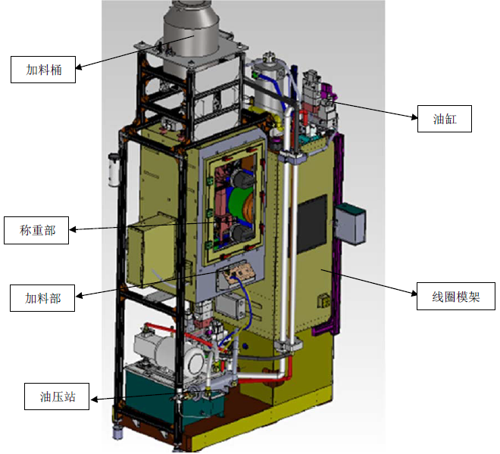

线圈模架-solenoid box　油缸-Hydraulic cylinders

hydraulic pump

material feed

feed port

weighing scale

1、液压系统采用日本制造油泵，双压双流量控制，保证压制精度，并且体积小，占地少。

油圧システム　Dual pressure and dual flow control、Guaranteed pressing accuracy、small size、small footprint

2、通过高效率的横、纵、辐射状磁场等磁回路;全封闭氮气充填、自动加料方式，能够成型高性能稀土类等磁石。

By means of high-efficiency magnetic circuits such as transverse, longitudinal and radial magnetic fields; fully enclosed nitrogen gas filling and automatic charging, it is capable of molding high-performance rare-earth magnets and other magnets.

3、压机的设计与结构，简单直接，使得压机运行可靠、精度高，并减少了在压制复杂零件时的机器故障。

The design and construction of the press, simple and straightforward, allows for reliable and accurate press operation and reduces machine breakdowns when pressing complex parts.

4、精密的成型方式，可达到一次成型，减少磁石制作工序，从而达到减少设备投资及人工成本的。

Precision molding method, can achieve one-time molding, reduce the magnet production process, so as to achieve the reduction of equipment investment and labor costs.

5、采用四柱式框架结构，上、下部均装有日本制液压油缸，精度模架进行成型和分离，实现了小型化，节约资源的目的。

Adopting four-column frame structure, the upper and lower parts are equipped with hydraulic cylinders made in Japan, and the precision mold frame is used for molding and separating, which realizes the purpose of miniaturization and resource saving.

6、压机的驱动及主要主机框等安装于压机的底盘上，使压机结构紧凑重心低、占地少、运行可靠。

The drive and main frame of the press are mounted on the chassis of the press, resulting in a compact press with a low center of gravity, a small footprint, and reliable operation.

7、全部机型采用触摸屏、PLC控制方式。

All models adopt touch screen and PLC control.**特点All models adopt touch screen and PLC control.**

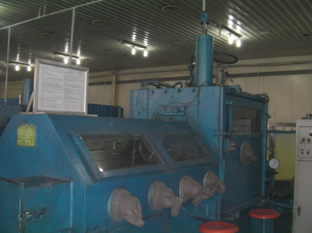他社压机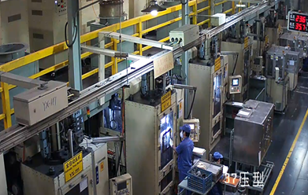我社压机

压机整体结构紧凑，设计合理；占用地面及空间面积比国内同类 压机要少很多。

The overall structure of the press is compact and reasonably designed; it occupies much less floor and space area than similar presses in China.

在全密闭的生产环境下进行生产，密封度为：100PM以下 ，对磁粉的抗氧化起到了很好的保护作用，同时对粉尘有了很好的抑制作用，改善了工厂环境，提升了用户工厂的形象。

Production in a fully enclosed production environment, the sealing degree is: 100PM or less, the antioxidant of the magnetic powder has played a very good protective effect, while the dust has a very good inhibition effect, improve the factory environment, enhance the image of the user's factory.

操作简单、节约人工成本。Simple operation, saving labor costs.

原先需要几个人管理一台的设备，现在一个人能够轻松管理两台，有效的节约了用人成本，给用户带来更加直观的效益。

The original need for several people to manage a device, now a person can easily manage two, effectively saving the cost of manpower, to bring more intuitive benefits to the user!

01技术优势：浮动压制原理

Technical Advantages：free-floating Compression Principle

上冲在模腔内与模套按不同速度同时同向运动，压制动作通过程序控制，可随不同产品自行设置参数调整，来达到压坯上、中、下密度均匀性要求。

The upper punch moves simultaneously in the same direction with the die sleeve at different speeds in the die cavity, and the pressing action is controlled by a program achieving the requirement of uniformity of density at the top, middle and bottom of the press blanks.

从而保证了压坯的质量，操作简单便利。

So as to ensure the quality of the magnet blocks, the operation is simple and convenient.

02技术优势：全自动加料

Technical Advantage: Automatic Powder Feed System

我司针对客户称粉工序多、人工投入多的情况，针对性的设计了全自动加料系统，实现了在密闭环境下自动完成称量，确保每一模材料的一致性。

In view of the situation that customers have many weighing processes and manual inputs, our company has designed a full-automatic charging system, which realizes automatic completion of weighing in a closed environment and ensures the consistency of materials in each mold.

节约了原材料和人工，为企业带来了更直观的效益。有控制加粉精度的电磁振荡器和准确称量的电子秤及均匀加料的料盒等组成的加料系统，保证加料的克重在规定的范围内，并且能通过程序自动监控、调整重量的平衡和变化。使压机的全自动操作变为可能。

Saving raw materials and labor brings more intuitive benefits to the business.

There is a feeding system composed of electromagnetic oscillator which controls the precision of adding powder, electronic scale which weighs accurately and material box which adds material evenly, etc. It ensures that the gram weight of the added material is within the specified range, and it can monitor and adjust the balance and change of the weight automatically through the program.

Fully automatic operation of the press is possible.

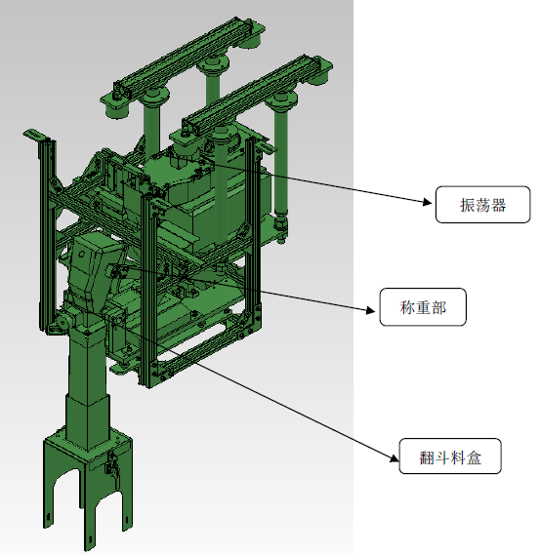

03技术优势：自动取料

Technical Advantage: Automatic material pickup

采用机械手将脱模位的压坯从模腔上方自动取出放到输送带上，再由输送带送到人工包装码料位置。既保障了人身安全，又稳定了压坯的质量。

Adopting robot to take out the press blanks from the top of the mold cavity automatically and put them on the conveyor belt, and then the conveyor belt will send them to the manual packing and yardage position.

It guarantees personal safety and stabilizes the quality of the press blanks.

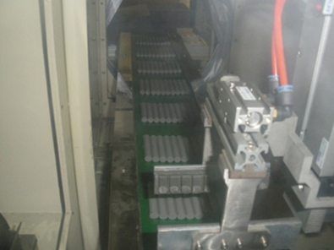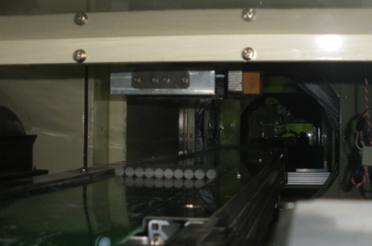

04技术优势：油压系统

Technical Advantage: Hydraulic System

油泵采用的是日本不二越生产的柱塞泵，采用双压双流量控制，即快速大流量时，用小压力，用高压压制时少量供油，降低了能耗，体积小，噪音低。压制中，压力和流量可根据压制过程需要，通过比比例压力阀和比例额流量阀，经过PLC程序自动可控可调。保证压制精度。阀块和油缸采用日本不二越，太阳铁工的产品，精度高，泄漏勺，动作准确，安全可靠。整个油压系统构造比国内传统同吨位压机小，大大缩小了占地空间。

The oil pump is a plunger pump produced by Japan FUJIKOSHI, which adopts dual-pressure dual-flow control, i.e., small pressure is used for fast and large flow, and a small amount of oil is supplied for high-pressure pressurization, which reduces energy consumption, small volume and low noise.

During pressing, the pressure and flow rate can be controlled and adjusted automatically by PLC program through proportional pressure valve and proportional flow rate valve according to the need of pressing process. Ensure the precision of pressing.

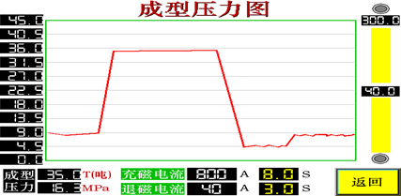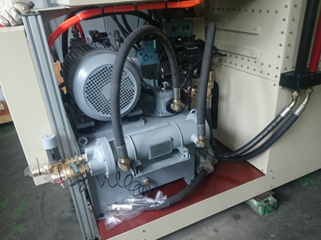

05技术优势：机架构建精度高

均超过国内同类压机的精度标准，其中模架 安装在框架内测试垂直≤20μm/100mm，相当于日本同类压机O级水平。

All of them exceed the precision standard of similar presses in China, among which the verticality of the die holder installed in the frame is ≤20μm/100mm, which is equivalent to the O level of similar presses in Japan.

这样就为使用高精度模具提供了可能，单边间隙可做到25μ m，有了模具精度的保证，减少了压制过程中模具间隙过大所产生的漏粉现象，压坯成型 后几乎没有飞边。

This provides a possibility for the use of high-precision molds, single-sided gap can be achieved 25μ m, with the mold accuracy to ensure that the press process to reduce the mold gap is too large generated by the phenomenon of powder leakage, the press blanks after molding almost no flash.

飞边 = flash

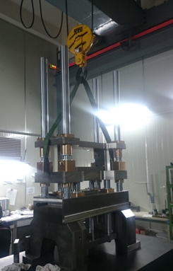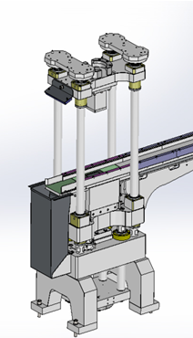

06技术优势：压胚特点

06Technical Advantage:

在磁粉压机制造的同行业中我司的压机，通过程序控制方法采用超前的浮动加料方式，保证了加料的均匀性，使压坯在烧结成 品后，收缩率均等、外形变形小等优点。给后道加工大幅度减少了加工余量，大大降低了原材料和人力成本， 也减少了飞尘污染。而国内传统压机所使用的模具的单边间隙大都超过100μm，有些甚至达500μm。有些厂家使用我公司的压机生产压 坯，在有些规格的项目上成功的取消了等静压工序，压坯直接码盘进入烧结炉烧结。

In the same industry of magnetic powder press manufacturing our press, through the program control method using the floating charging method ahead of schedule, to ensure the uniformity of charging, so that the press blank in the sintered product, shrinkage rate is equal, shape deformation is small and other advantages.

It reduces the amount of machining allowance for subsequent processing, greatly reduces the cost of raw materials and labor, and also reduces the pollution of flying dust.

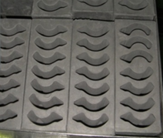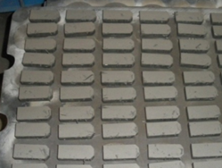

07技术优势：磁场均匀度

提高取向磁场的均匀度。我司目前为止做到的磁场是2.3T以上，在连续工作的状态下确保该磁场能够稳定的保持在这一强度下。

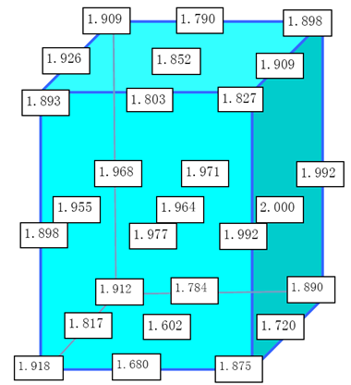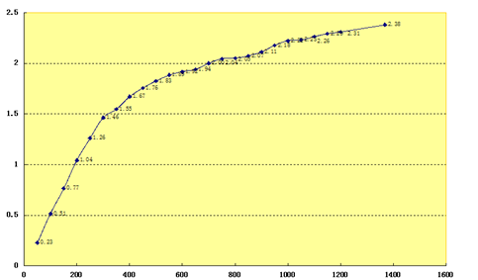

08技术优势：线圈

特制的线圈构造和磁场充磁电源，配以规定的冷却系统，能保证线圈 始终在恒定的温度下工作，大大降低了电耗能源的成本，同时所需磁场不会像国内大多数同类压机那样随工作时间的延长而升高温度，从而逐步降低磁场强度，进而影响到压坯的磁场性能。

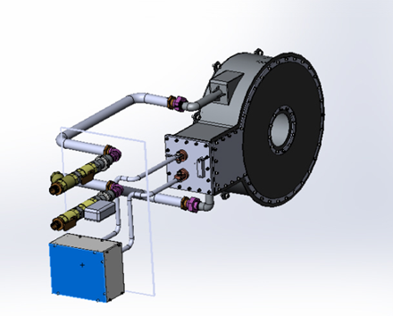

09技术优势：网络安全监控

实行触摸屏管理，操作简单方便。PLC控制方式。 网络监控。我司在现有的压机设备上面安装了网络通讯模块， 方便用户通过互联网能够实时监控设备运转状态。便于用户的生产及设备管理。

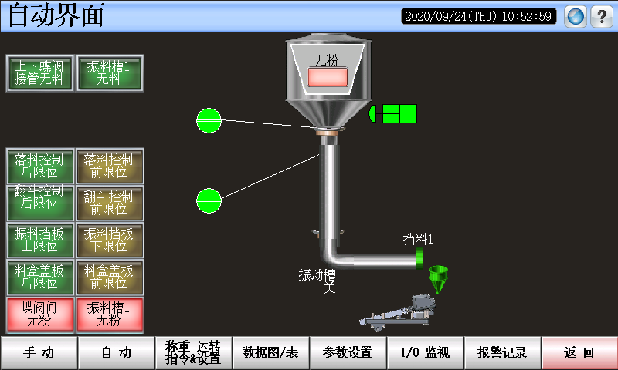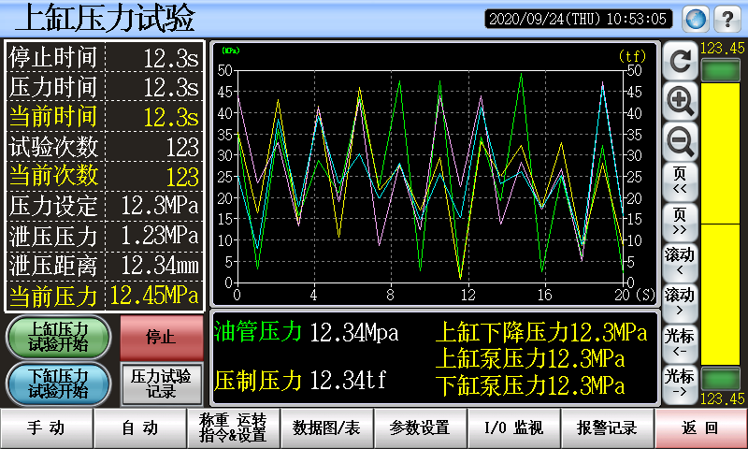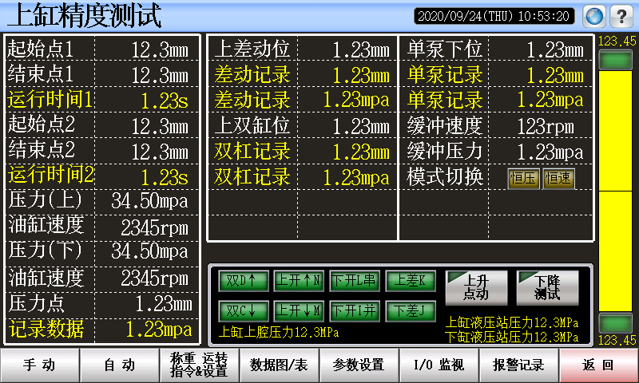

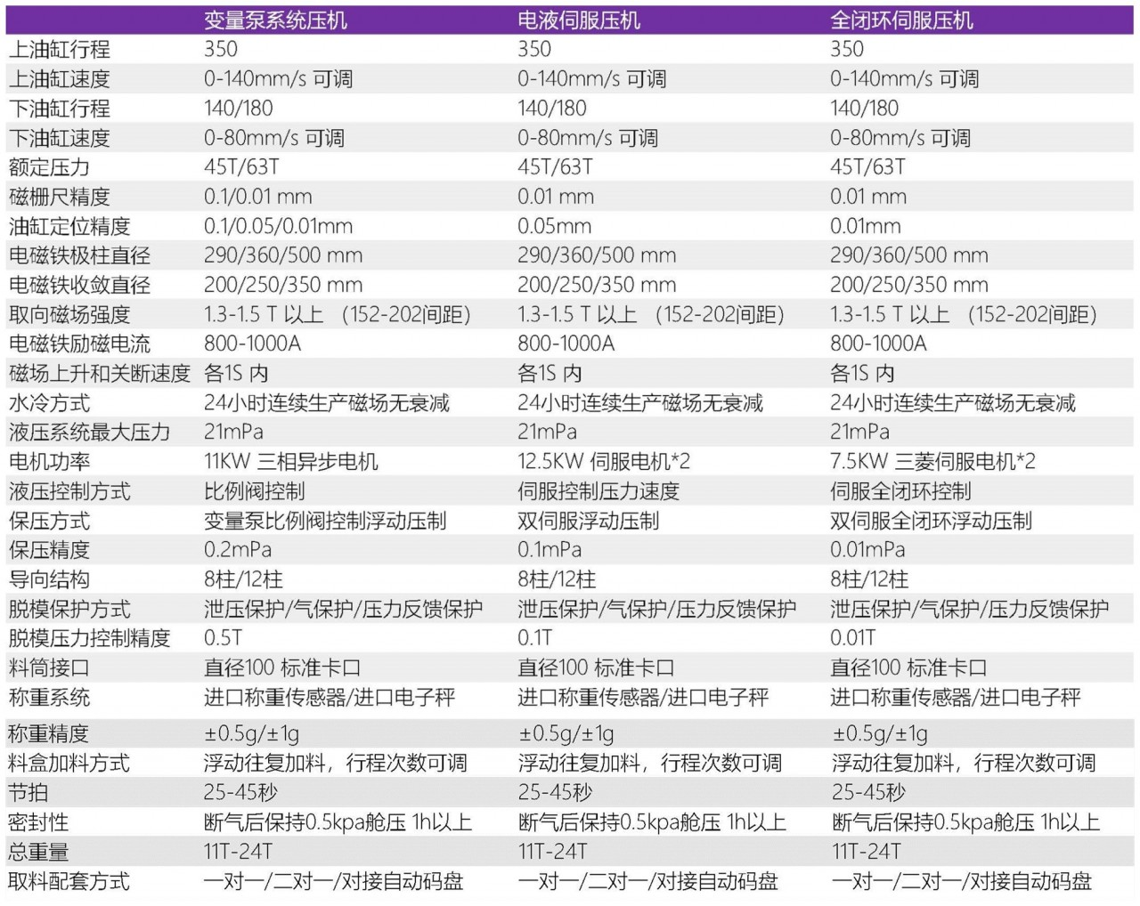

全自动取料码盘装置设备特色

本设备是我公司完全独立自主开发、设计、生产。拥有多项发明专利，并在客户处连续24小时工作无故障验证。

1、连接多台成型压机，突破了国内稀土永磁材料低氧生产过程中一直无法解决的压型和烧结炉之间无缝对接。

2、完好的密闭性，使维系运行的惰性气体成本可控。

3、视觉监控系统的应用，关键环节的实时状态能及时汇总到集控中心，便于管理体系的远程观察。

4、完善的输送机械设计和伺服系统应用，使每一个运动环节的稳定和顺畅，确保了物料在运输过程中完好无损。

5、选用高端国际知名品牌的电控系统，确保了整套设备的稳定运行。

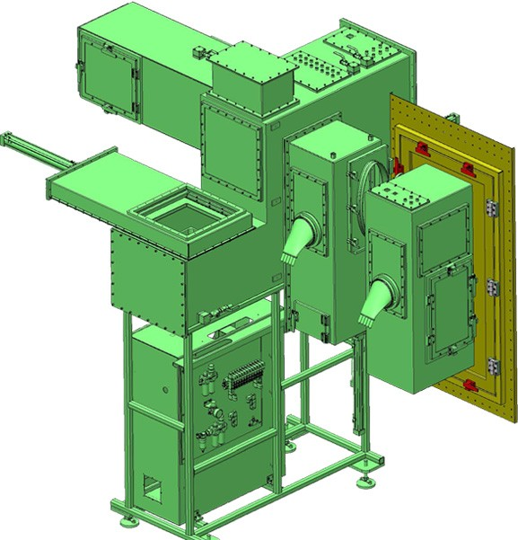

NPLP 超细粉无压力成型设备

高性能的实现历程 RIP—PLP---NPLP

为配合D50=1.1um的超细粉，将类似于RIP的装置放入密闭的氧含量低于0.0001%的环境下，将磁粉与润滑剂混合装入铁模 ，通过振实机构得到3.2-3.6g/cm的充填密度，用5T脉冲磁场取向，经烧结后制备的样品密度d=7.52g/cm，与传统工艺比，Hcj提高显著。 例如：Br=1.4T Hcj=19.98KOe，Bhmax=48MGOe

优势

钕铁硼超细粉成型的实现

近终成型实现

无镝化高剩磁、高矫顽力实现

开发现状和前景

颠覆传统工艺，实现无镝（Dy）工艺，大幅提高磁性能降低成本。

上海平野制

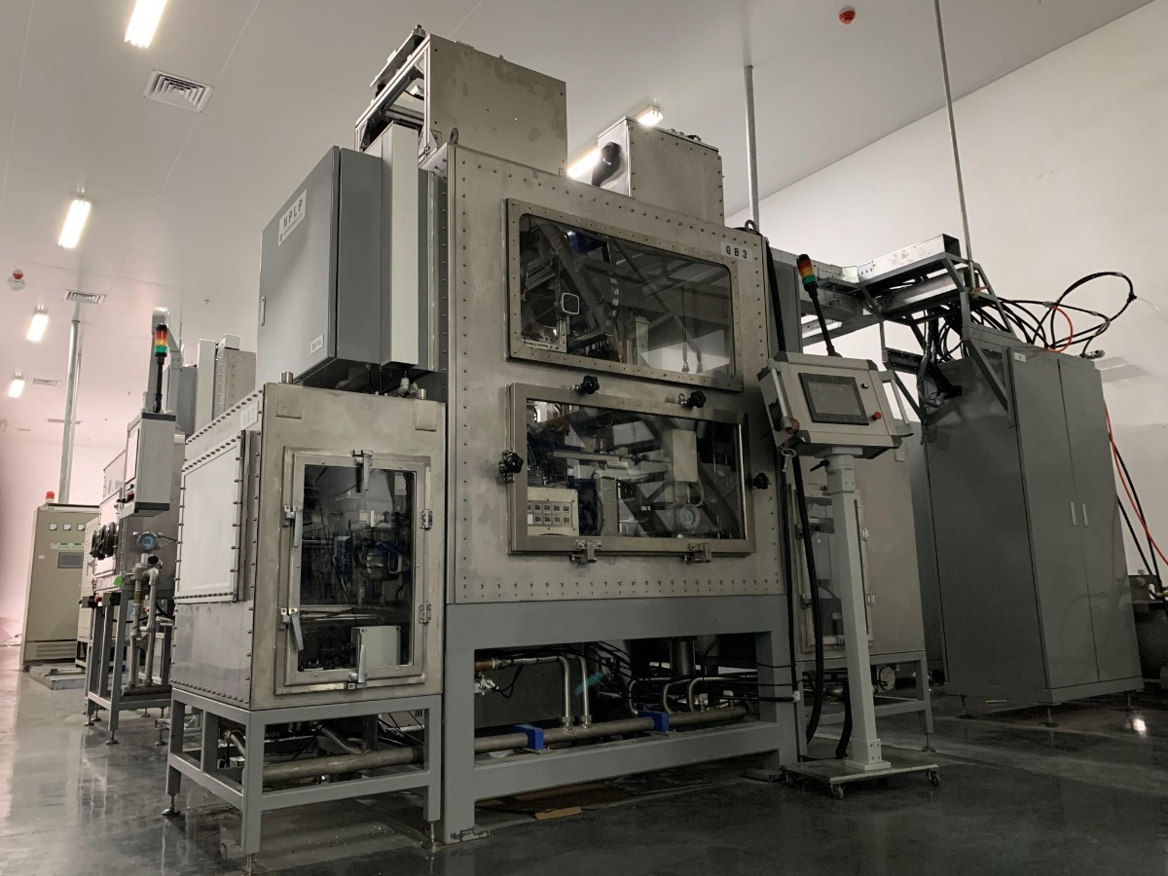

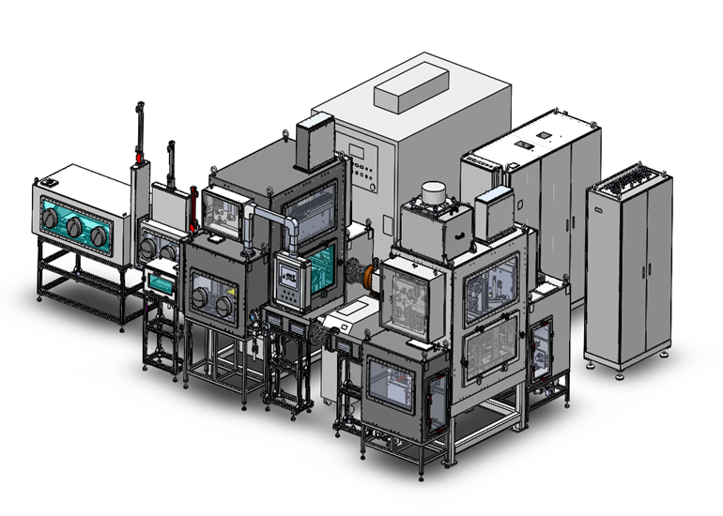成型磁片NPLP  
