  - NARRATIVE GAME DESIGN DOCUMENT

Ultima VII: The Eighteen Months
A post–Black Gate adventure bridging Britannia’s recovery, the events of Ultima Underworld II, and the opening of Serpent Isle.
Version 1.0 | 12 October 2026 | Story / continuity / player experience only
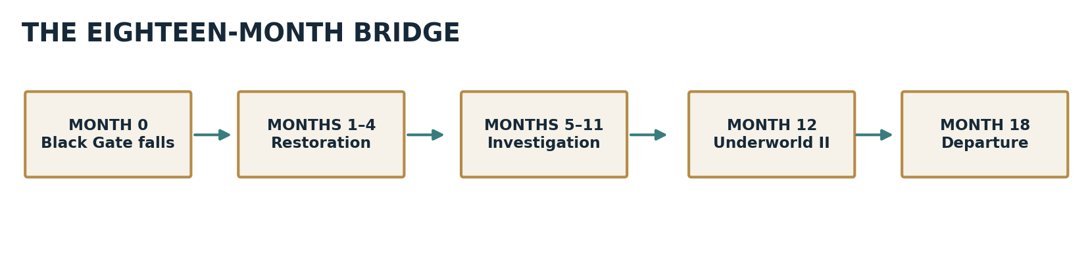
Figure 1. Canon-fixed milestones and proposed playable intervals.

Design mandate
The player must feel that saving Britannia mattered, that rebuilding it is morally difficult, and that the Guardian’s next design reaches beyond the Black Gate. The bridge must be a complete short adventure rather than a protracted Serpent Isle tutorial.
Pillar | Creative requirement
Consequences | Show the economic, personal and political aftermath of the Fellowship’s collapse.
Investigation | Let the player piece together Batlin’s expedition through objects, testimony and travel.
Companions | Give Iolo, Shamino, Dupre and departing friends distinct roles.
Mystery | Preserve uncertainty about the Pillars and the Guardian’s next move until the finale.
Canon restraint | Do not preempt Serpent Isle revelations or invent answers to its central mysteries.

Document navigation
1. Premise and boundaries
2. Canon ledger and chronology
3. Player experience and pacing
4. Cast and character arcs
5. Full narrative walkthrough
6. Quest specifications
7. Choices and consequence matrix
8. Exploration and optional content
9. Dialogue and cinematic treatments
10. Presentation and graphic direction
11. Narrative validation and sources

1. Premise and boundaries

1.1 Logline
Eighteen months pass between the destruction of the Black Gate and the Avatar’s voyage to Serpent Isle. As Britannia dismantles the Fellowship, the Avatar follows a trail of blackrock shipments and an old pirate’s map, while Iolo worries over Gwenno’s absence. A brief respite is shattered by the Guardian’s attack during the events of Underworld II. At last, a hidden message proves that Batlin’s journey is part of the Guardian’s contingency plan.

1.2 Player promise
Return to a recognizable Britannia; see consequences of victory; make modest but consequential moral choices; solve an evidence-based maritime mystery; enjoy reunion and farewell scenes; conclude with an urgent, canon-faithful departure. Target: approximately 3 hours on the main path, up to 4 hours with optional material.

1.3 Boundaries and anti-goals
- No new truth about Serpent Isle’s Ophidian cosmology, its future antagonists, or Gwenno’s ultimate fate.
- No playable retelling of Ultima Underworld II; a text interlude and short aftermath scene represent its consequences.
- No unavoidable combat gauntlet, repeated long-distance errands, or forced moral “correct answer.”
- No new route that supersedes Gwenno’s copy of the map or the Guardian’s enchanted scroll.
- No technical, engine, save-system or asset pipeline requirements in this document.

1.4 Canon labels
CANON — established in the original games or manuals. INFERRED — plausible reading consistent with the originals, not established beyond doubt. NEW — deliberately authored bridge material. PROVISIONAL — needs direct verification against game text before dialogue lock.

2. Canon ledger and chronology
Fact / constraint | Status | Narrative treatment
Batlin escapes after the Black Gate | CANON | Never apprehended in the bridge.
Gwenno departs before BG concludes; map copy with British | CANON | Discovery is retrospective, never shown as a new voyage.
Fellowship halls are dismantled over intervening months | CANON | Restoration is visibly underway.
UW2 occurs about one year after BG | CANON | Month-12 interlude.
Serpent of Blackrock comes from UW2 | CANON | Not awarded by bridge quests.
Guardian scroll directs Batlin after Gwenno | CANON | Climactic revelation; do not reveal beforehand.
SI begins approximately 18 months after BG | CANON | Departure month 18.
Obelisk as magical arrival anchor | INFERRED | Rudyom’s hypothesis, not revealed as absolute truth.
Winter dawn as Pillars window | NEW / INFERRED | Research-based navigational judgment, not universal law.
Calendar note: month numbers are authoritative for this outline; casual seasonal references in early acts should be avoided unless reconciled against a chosen in-world calendar. Winter at departure can remain a staged atmospheric choice.

2.1 Spoiler boundary
The new adventure may reveal Batlin’s route, his blackrock shipment and the Guardian’s contingency message. It must not explain the teleport storms, the Banes, the Wall of Lights, the Order/Chaos conflict or the deeper purpose of the Serpent of Blackrock. Those revelations belong to Serpent Isle.
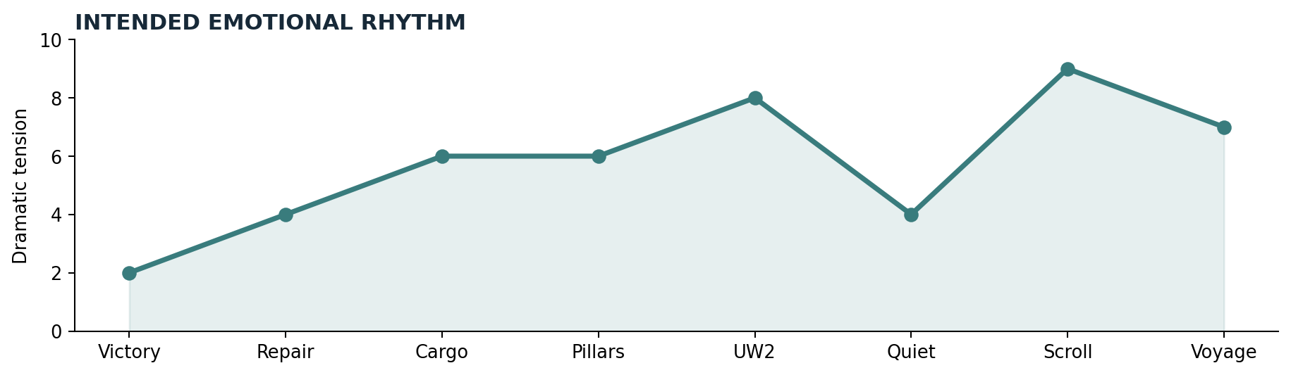
Figure 2. Pacing reference: moments of tranquility must offset high-stakes revelations.

3. Player experience and pacing
Segment | Main activity | Intended feeling | Approx.
Prologue | Audience, homecoming, gathering | Relief / nostalgia | 15–20 min
Act I | Social repair, headquarters inquiry, Paws choice | Compassion / ambiguity | 45–55 min
Act II | Cargo reconstruction, pirate adventure, navigation | Curiosity / discovery | 65–80 min
UW2 aftermath | Short epilogue to omitted adventure | Loss / determination | 10–15 min
Act III | Final clue, Guardian message, equipment, farewell | Urgency / resolve | 25–35 min
Departure | Boarding and transition to SI introduction | Awe / anticipation | 5–10 min
Pacing safeguards: every major mandatory location must offer a different verb; the main mystery must provide an inference before it grants a destination; no dialogue should exhaustively explain a conclusion the player can discover from evidence.

4. Cast and character arcs
Character | Motivation / conflict | Resolution in bridge
Avatar | Hero after victory; what does responsibility require now? | Chooses how to leave a recovering Britannia.
Iolo | Concern for Gwenno versus respect for her agency | Chooses to pursue her as a partner, not rescue a passive victim.
Shamino | Experienced traveler and reader of forgotten history | Connects old Sosarian traditions without spoiling SI.
Dupre | Knightly duty tempered by practical compassion | Champions humane treatment of former Fellowship dependants.
Lord British | Political recovery under renewed supernatural threat | Authorizes expedition after discovering scroll.
Rudyom | Magical curiosity, especially blackrock | Offers a falsifiable hypothesis, not omniscience.
Nelson | Scholarship and civic responsibility | Contributes pre-UW2 research; absence afterwards has weight.
Old pirate | Lives by reputation and debts | Witness to map sale; helps decode ambiguous navigation.
Former Fellowship adherents | Grief, denial, guilt and economic insecurity | Several distinct reactions, not a monolithic villain group.

4.1 Gwenno’s agency
Gwenno must remain the initiator of her own expedition: she bought the map, arranged its safeguarding and independently pursued discovery. Iolo fears for her, but dialogue must never frame her as a helpless captive or assume she requires permission to travel.

4.2 Companion farewell vignette
Optional evening at a Britain inn. Spark tries to appear older than he is; Sentri offers practical warnings; Jaana speaks of rebuilding trust; Julia wonders what will endure. No companion receives knowledge of future SI events. The gathering is affectionate, lightly humorous and under ten minutes.

5. Full narrative walkthrough

Prologue — After the Gate
Opening image: a repaired street or small civic celebration, not an elaborate triumphal parade. Lord British speaks privately with the Avatar: Batlin escaped, the Fellowship is prohibited, and an inquiry is required. The player is free to walk outside, hear ambient reactions, and meet the future SI companions. A guard mentions inventories being taken from the Fellowship headquarters.
Core beats: (1) recognize the victory; (2) establish incomplete recovery; (3) offer a voluntary gathering with former party members; (4) place the player at the headquarters with a legitimate investigative mandate.

Act I — The Fellowship’s Legacy
Britain headquarters: the site remains largely intact but its symbols are being removed. A sealed desk contains a ledger recording maritime payments and heavy cargo dating from before the Gate’s destruction. The clerk disputes the fairness of confiscating records belonging to innocent donors. Player resolves access through persuasion or cooperation rather than mandatory theft.
Paws: the shelter relies on Fellowship funds but served genuine needs. The player meets a caregiver, a former initiate, and a family that relies on the kitchen. None tells the whole story. The player chooses between closure, conditional continuation, or transfer of stewardship. The outcome alters a later visit: staffing, dialogue and local mood. It cannot change Serpent Isle canon.
Act I close: the ledger’s Minoc cargo and Buccaneer’s Den maritime payments suggest a purposeful overseas operation. Iolo recognizes Gwenno’s name on a passenger document and voices concern without asserting that Batlin abducted her.

Act II — The Lost Expedition
Minoc: the Avatar pieces together who prepared the heavy blackrock object and when. A workshop trace, a payment receipt and one reluctant witness point to Buccaneer’s Den. The object’s exact magical function remains unknown. An optional search of a disused staging area rewards close observation, not combat.
Buccaneer’s Den: the old pirate claims to have sold Gwenno a chart. He will speak fully only after a small, locally flavored adventure: recover his logbook from a disputed vessel, expose a forged shipping entry, or negotiate with a rival crew. The player may solve it by evidence, diplomacy or a short confrontation. The log confirms prior passage and explains that the chart identifies an area, not a guaranteed opening time.
Castle British: Lord British presents Gwenno’s preserved copy of the map, honoring the condition in her earlier request. Iolo is grateful and unsettled. The map and ledger together point toward the Great Ocean.
Cove and Lycaeum: Rudyom hypothesizes that blackrock may have anchored Batlin’s spell. Lycaeum research supplies historical accounts of the Serpent Pillars, including contradictory timing traditions. The player infers a plausible winter dawn with both moons visible, but neither scientist nor document claims certainty.
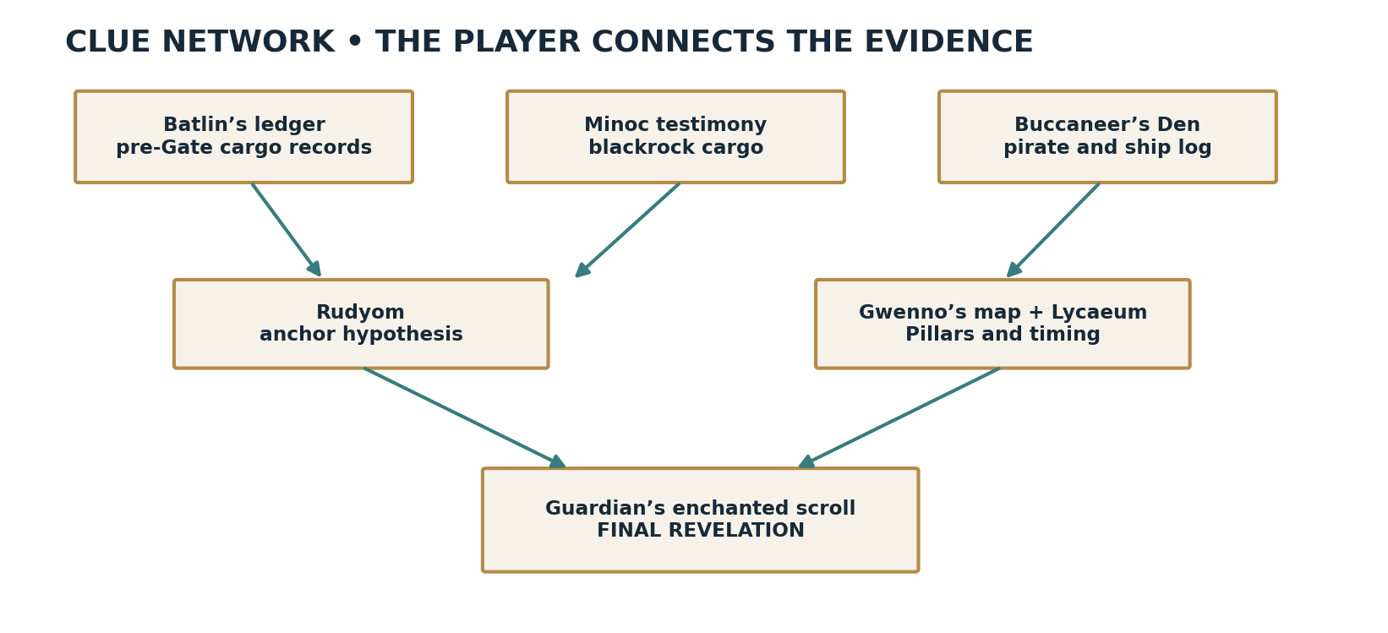
Figure 3. Evidence converges on a route, but the Guardian’s motive is deliberately withheld.

Interlude — Labyrinth of Worlds
Text sequence: one year after the Black Gate, Castle Britannia is enclosed in the Guardian’s blackrock dome; the Avatar escapes through other worlds, breaks the imprisonment and returns bearing the Serpent of Blackrock. A playable aftermath at the castle makes the cost visible: subdued servants, missing Nelson and Lady Tory, the death of Patterson, and British’s weary recognition that the Guardian is not finished. Do not reenact UW2 scenes as if they occurred inside this bridge.
A short optional visit to Nelson’s work may present a previously prepared research note. The note is NEW connective material, not a newly discovered claim about the events of Underworld II.

Act III — The Guardian’s Message
Time has passed and winter conditions make the inferred Pillars window plausible. A late inventory of Batlin’s belongings produces an enchanted scroll whose nature had prevented ordinary reading. In Lord British’s presence it reveals the Guardian’s recorded command to follow Gwenno to Serpent Isle and prepare the next attack on Britannia. The dialogue must preserve the substance of the SI introduction; the bridge may stage the setup but must not alter the command’s meaning.
British commissions the voyage. The Avatar gathers Iolo, Shamino and Dupre. An armoury scene reproduces the substance of the equipment listed in SI’s opening letter, with the Serpent of Blackrock already carried from UW2. The party acknowledges uncertainty about the Pillars rather than treating the astronomical inference as proof.

Epilogue — The Farewell
At the harbor, Iolo looks west toward the unknown. Optional last words with companions refer to Britannia’s recovery. The old pirate may serve as advisor or pilot without becoming an extra canonical SI party member. The player boards the ship; a transition into Serpent Isle’s established introduction depicts passage through the Pillars. Do not stage a duplicate passage in gameplay.

6. Quest specifications
Each required quest uses observable evidence, a location-specific interaction, and a narrative payoff. A single recovered document must never complete an entire act without interpretation.

Q01 · The Quiet After Victory
Location: Castle British / Britain.
Player action: Receive decree; speak with at least one affected citizen.
Payoff: New mandate; atmosphere established.
Design safeguard: No hidden fail state.

Q02 · The Ledger
Location: Fellowship headquarters.
Player action: Inspect office; reconcile two contradictory entries.
Payoff: Gwenno voyage and cargo lead.
Design safeguard: Clerk can authorize access.

Q03 · The Shelter
Location: Paws.
Player action: Hear three perspectives; choose disposition.
Payoff: Visible local aftermath.
Design safeguard: Three non-punitive solutions.

Q04 · Blackrock Freight
Location: Minoc.
Player action: Gather workshop clue, receipt and testimony.
Payoff: Port route and unusual cargo.
Design safeguard: Flexible clue ordering.

Q05 · The Old Pirate
Location: Buccaneer’s Den.
Player action: Recover/verify ship log by preferred approach.
Payoff: Chart provenance.
Design safeguard: Nonviolent path always possible.

Q06 · A Map Kept in Trust
Location: Castle British.
Player action: Converse with British and Iolo.
Payoff: Map is entrusted to party.
Design safeguard: Gwenno autonomy emphasized.

Q07 · Two Moons and a Dawn
Location: Lycaeum / Cove.
Player action: Compare astronomical traditions and Rudyom’s theory.
Payoff: Plausible passage window.
Design safeguard: No exact cosmological certainty.

Q08 · A Castle Remembering
Location: Castle British.
Player action: Witness UW2 aftermath; optional Nelson note.
Payoff: Guardian’s continued danger.
Design safeguard: Not a retelling of UW2.

Q09 · The Enchanted Command
Location: Castle British.
Player action: Attend scroll unveiling.
Payoff: Guardian’s contingent plan exposed.
Design safeguard: Original SI stakes preserved.

Q10 · The Last Voyage
Location: Armoury / harbor.
Player action: Assemble party, supplies and say farewells.
Payoff: Canonical Serpent Isle entry.
Design safeguard: No extra SI companions.

6.1 Puzzle: reading a navigational tradition
Three testimonies describe the Pillars differently: (A) two moons together, (B) a faint sun on the horizon, and (C) a winter passage. The map fixes the region; a dated journal suggests these descriptions may concern one rare window. The player chooses when to prepare departure. A mistaken inference prompts a dialogue correction or another observation; it does not strand the player for months. The solution is a credible hypothesis rather than an absolute universal rule.

6.2 Pirate encounter: three valid approaches
Approach | Play | Outcome
Investigation | Find contradictions in a vessel manifest and confront the forger. | Logbook recovered; witness retains pride.
Diplomacy | Settle a disputed share of an old voyage. | Logbook loaned voluntarily.
Confrontation | Survive a brief hostile encounter and secure the book. | Same necessary clue; different local reaction.

7. Choices and consequence matrix
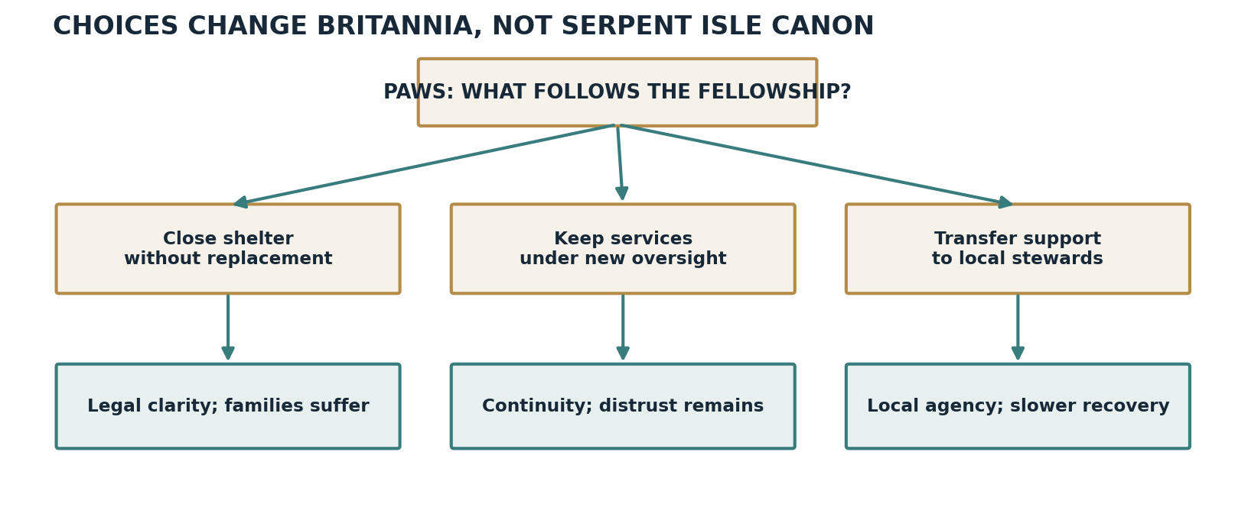
Figure 4. Consequences are local and perceptible, with no branch contradicting later canon.
Choice | Immediate consequence | Later payoff | Virtue tension
Close Paws shelter | Formal break with Fellowship | Food queue and bitter reactions | Justice vs Compassion
Retain it with oversight | Services continue under scrutiny | Reluctant trust among former members | Honor vs Prudence
Transfer to local stewards | Community assumes responsibility | Slow improvement; new local leader | Sacrifice vs Justice
Help clerk voluntarily | Records shared in confidence | Clerk offers final observation | Honesty vs Expediency
Pressure witnesses | Quicker information | Less helpful dockside allies | Valor vs Compassion
Moral choices should not be scored or color-coded as inherently good or evil. A later revisit must register the actual choice through one meaningful scene or environmental change. No hidden endings are needed.

8. Exploration, optional scenes and reward design
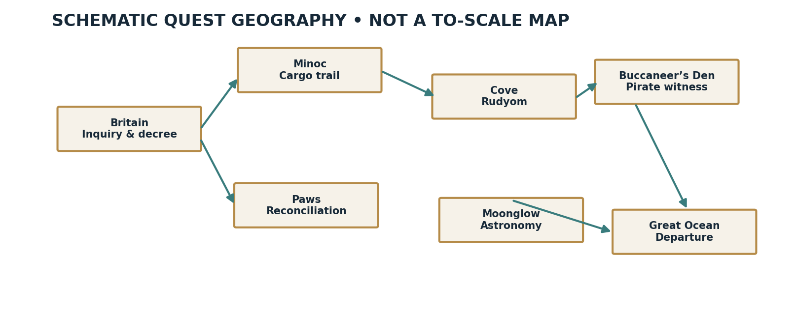
Figure 5. Conceptual quest routing only; geography is schematic, not a replacement for Britannia’s canonical map.

8.1 Optional encounters
- A farewell supper with former companions, offered after Act I.
- A former Fellowship adherent defending Batlin with sincerity rather than malice.
- A small errand to reconnect a family separated during a crackdown.
- An old navigator’s marginal notes that make the moon puzzle easier but are not mandatory.
- A return to the Paws shelter to observe the result of the player’s decision.
- A castle memorial interaction following the Underworld II interlude.

8.2 Rewards
Prioritize knowledge, changed relationships, environmental transformation and memorable scenes. Gold, combat loot and equipment should be incidental because the later Serpent Isle transition will not preserve a normal BG inventory. A concise journal summary at each act’s end may help players returning after a break, while remaining diegetic in tone.

8.3 Difficulty and player freedom
The mainline is not dependent on perfect recall of previous Ultima games. Every mystery has redundant clues; mandatory dialogue can be revisited; plausible wrong interpretations lead to corrective information, not permanent failure. Optional scenes reward fans familiar with the wider Ultima continuity without penalizing new players.

9. Dialogue and cinematic treatments
All dialogue below is NEW illustrative writing, not a quotation from a game or a claim of canonical wording. Final scripts should follow the voice of the original games while remaining readable.

9.1 First audience with Lord British
“Thou hast cast down the Gate, yet the shadow it raised remains among my people. I ask not that thou chase every rumor. I ask that those deceived by the Fellowship not be made to suffer again for having believed.”

9.2 Iolo discovers Gwenno’s name
“Gwenno has sailed farther than I ever dared, Avatar. I would not begrudge her the journey. Yet to find her name in Batlin’s accounts—there is a difference between trusting her and trusting him.”

9.3 Rudyom’s hypothesis
“A stone need not be a gate to mark the place at which a spell shall end. But if that obelisk were the mark, then something arrived with such violence that even blackrock could not bear it. A conjecture, mind thee—not a conclusion.”

9.4 Paws disagreement
“The sign upon the door was theirs, aye. But the bread was baked by our own hands. If thou tear down the sign, who shall bake tomorrow?”

9.5 Final harbor scene
“The map promises a place, not safe passage. Still, Gwenno would not turn back for fear of an uncertain horizon. Nor shall I.”

9.6 Guardian message staging
Stage the discovery with restraint: a scroll sealed among Batlin’s effects, a brief disturbance, British recognizing the voice and the immediate shift from research to urgent action. Preserve the known content of the Serpent Isle message rather than inserting a wholly new warning. Where an original cutscene is retained, avoid restaging the same revelation twice.

10. Art direction and document graphics

10.1 Visual mood
Phase | Colors / atmosphere | Scene emphasis
Prologue | Warm daylight, familiar inns, cleaner streets | People returning to everyday life
Act I | Faded Fellowship colors, repurposed interiors | Ambiguity and rebuilding
Act II | Sea blues, worn manuscripts, lamplight | Discovery and the distant unknown
UW2 aftermath | Cold stone, sparse light, grieving castle | The cost of continued conflict
Act III | Winter silver, blackrock, deep red accent | Revelation and resolve
Departure | Open ocean, pale horizon, storm light | Uncertainty and awe

10.2 Key illustrations / scene briefs

Fellowship headquarters after closure
The same architecture but emptied of certainty: a removed emblem, guarded door, a clerk preserving records, ordinary possessions left behind.

Paws shelter at meal time
No visual shorthand of good and evil; the room is busy, hungry people are identifiable individuals, former insignia is quietly removed.

The ship’s log and chart
Tactile parchment, tide marks, corrected ink, an aged route whose meaning requires human interpretation.

Rudyom’s blackrock discussion
Strange stone, familiar eccentric surroundings, nothing visually proving his theory as fact.

The farewell at the harbor
Four travelers dwarfed by a ship and horizon; friends stay behind in a world worth protecting.

10.3 Music and sound direction
Reuse Britannia’s familiar tonal vocabulary rather than attempting to outdo Serpent Isle’s opening. Begin with peace and familiar environmental sound; introduce unresolved harmonic tension in the shipping investigation; let the UW2 aftermath have silences; keep the last harbor scene understated. Avoid recognizable future Serpent Isle motifs before the transition unless already justified by the originals.

11. Narrative acceptance tests and editorial gates
- The player can explain both why Batlin’s earlier voyage matters and why the Guardian’s message changes the stakes.
- A first-time player can finish without remembering the original U7 shipping dialogue.
- Gwenno is consistently presented as an active explorer.
- The events of UW2 remain prior canon, not falsely represented as a bridge quest.
- No person killed in UW2 speaks in post-UW2 scenes.
- No bridge scene reveals SI’s later mysteries or predetermines Batlin’s ultimate fate.
- At least one optional return visit registers an earlier moral choice.
- Each required location delivers distinct gameplay rather than another unchallenged exposition conversation.
- The ending reaches the Serpent Isle intro without redundant revelation or repeated voyage spectacle.

11.1 Narrative risks needing direct game-text review
- Exact contents and discovery timing of the Guardian’s scroll and map as presented in SI introduction.
- Survival and whereabouts of each proposed Fellowship branch leader following possible BG outcomes.
- Whether Nelson-related pre-UW2 research is plausible at the chosen location and in the chosen period.
- Exact phrasing and inventory contents of British’s SI equipment letter.
- Astronomical language and degrees of certainty in Erstam’s manual account.

11.2 Editorial decision log
Decision | Status
UW2 represented by short text and castle aftermath | Proposed design choice
Four required restoration/investigation centers | Proposed; final NPC casting still open
Guardian scroll held as last major revelation | Recommended; preserve SI intro continuity
Serpent Pillars shown by original SI intro | Recommended to avoid duplicate passage
Actual Pillars activation as uncertain research | Recommended tone
Companion farewell supper | Optional content

Reference notes
Primary design basis: user-supplied proposal “The eighteen months: from the Black Gate to the Serpent Pillars,” dated 12 October 2026, and subsequent narrative audit and revision discussion.
External continuity cross-checks (secondary):
- The CRPG Addict, “Ultima VII: Part Two – Serpent Isle” (2023): https://crpgaddict.blogspot.com/2023/02/game-483-ultima-vii-part-two-serpent.html
- Codex of Ultima Wisdom, “Ultima VII Part Two: Serpent Isle”: https://wiki.ultimacodex.com/wiki/U7.5
- Ultima VII: Serpent Isle walkthrough: https://bootstrike.com/Ultima7si/Online/walk5.php
- Ultima VII Part Two synopsis: https://en.wikipedia.org/wiki/Ultima_VII_Part_Two%3A_Serpent_Isle
Source-status policy: secondary references orient the design; exact canon dialogue should be checked against BG/SI original usecode and manuals before final script lock. All added quests, character dialogue, clue placements and choice outcomes are new authored content.

