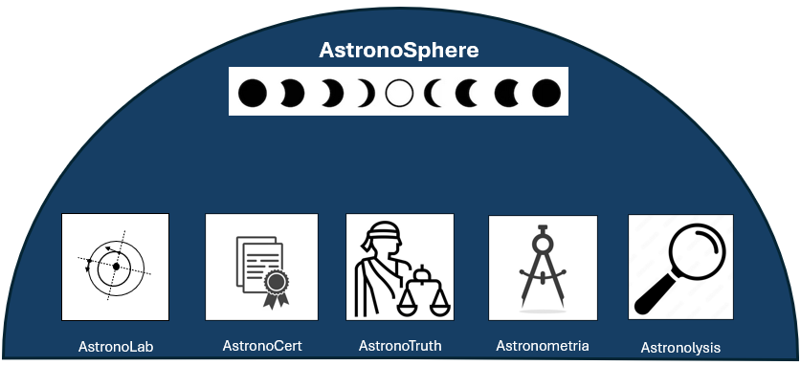
AstronoSphere – Philosophy
AstronoSphere is not a tool. It is not a pipeline. It is a closed scientific universe.
It represents a complete epistemological system – a structured environment in which knowledge is created, measured, validated, and refined.
The enclosing dome symbolizes the totality of this system. Every scenario, every dataset, every computation, and every validation step lives within this sphere.
At the top, the lunar cycle represents the rhythm of scientific discovery:
- New Moon – The unknown. A hypothesis emerges.
- Waxing Moon – Structure forms. The scenario is defined.
- Full Moon – Truth becomes visible through measurement.
- Waning Moon – Analysis reveals discrepancies.
- Return to New Moon – New questions arise.
This cycle is not linear. It is perpetual.
Within this universe, five fundamental roles exist:
- AstronoLab – The Eye: The place where observation becomes definition. Chaos becomes a structured experiment.
- AstronoCert – The Authority: The instance that decides what is valid. It establishes trust and scientific integrity.
- AstronoTruth – The Balance: The act of measurement. Reality is captured as neutrally as possible.
- Astronometria – The Compass: The realm of pure theory. Mathematical construction without external influence.
- Astronolysis – The Lens: The critical observer. It searches for differences, for errors, for truth beyond assumption.
Together, they form a closed loop:
Experiment Certification Measurement Theory Analysis New Experiment
AstronoSphere is therefore not software.
It is a scientific instrument.

