🧠 Group Worksheet: Logical Operators & Equality
📆 Week 7: Logical Expressions and Short-Circuiting
🕒 Time Allotted: 3 Hours
🎯 Learning Outcome:
By the end of this session, your interpreter will support ==, !=, <, >, <=, >=, logical and, or, and not, including short-circuit evaluation.

✅ Section 1: Warm-Up Discussion (20 minutes)
As a group, discuss and answer:

1.1 What do logical operators do?
✏️ Answer: 邏輯運算子用來組合布林值，形成更複雜的條件判斷。
(They combine boolean values to form more complex conditions.)

1.2 What is "short-circuit evaluation"?
✏️ Answer: 在 a and b 中，如果 a 為 false，則不再計算 b，結果直接是 false 。
在 a or b 中，如果 a 為 true，則不再計算 b，結果直接是 true。
(In a and b, if a is false, b is never evaluated. In a or b, if a is true, b is never evaluated.)

1.3 How should equality comparisons behave for different types (numbers, strings, booleans)?
✏️ Answer: 5 == "5" → false
(Define your language’s behavior when comparing different types — should 5 == "5" be false?)

🛠️ Section 2: Implementing Comparison Operators (60 minutes)

2.1 Update your AST nodes
You probably already have a BinaryExpression node from arithmetic (+, -, etc.).
Extend it to handle:
Operator | Example Syntax | Meaning
== | 5 == 5 | Equality 等於
!= | 5 != 3 | Inequality 不等於
< | 2 < 3 | less than 小於
<= | 2 <= 2 | less than or equal 小於等於
> | 4 > 3 | greater than 大於
>= | 4 >= 4 | greater or equal 大於等於

2.2 In the Interpreter:
def evaluate_BinaryExpression(self, expr):
left = self.evaluate(expr.left)
right = self.evaluate(expr.right)

self.check_number_operands(expr.operator, left, right)

if expr.operator == "==":
return "TTT" if left == right else "FFF"
elif expr.operator == "!=":
return "TTT" if left != right else "FFF"
elif expr.operator == "<":
return "TTT" if left < right else "FFF"
elif expr.operator == "<=":
return "TTT" if left <= right else "FFF"
elif expr.operator == ">":
return "TTT" if left > right else "FFF"
elif expr.operator == ">=":
return "TTT" if left >= right else "FFF"
else:
raise RuntimeError(f"Unknown operator: {expr.operator}")🔵 Helper function to ensure valid types:
# 確保比較操作數是數字
self.check_number_operands(expr.operator, left, right)

2.3 Testing comparisons:
print(3 == 3); // true
print(3 != 4); // true
print(5 > 2); // true
print(2 >= 2); // true
print(7 < 1); // false
print(9 <= 10); // true

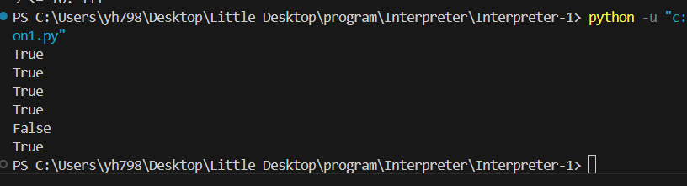
✏️ Notes on tests:

🔥 Section 3: Implement Logical and, or, and not (60 minutes)

3.1 AST Nodes:
- Logical expressions can reuse BinaryExpression or use a separate LogicalExpression class if you want.
- not can be handled as a UnaryExpression.

3.2 Interpreter:
class Interpreter:
def evaluate(self, expr):
if isinstance(expr, LogicalExpression):
return self.evaluate_LogicalExpression(expr)
elif isinstance(expr, UnaryExpression):
return self.evaluate_UnaryExpression(expr)

def evaluate_LogicalExpression(self, expr):
left = self.evaluate(expr.left)
right = self.evaluate(expr.right)

if expr.operator == "and":
return "TTT" if self.is_truthy(left) and self.is_truthy(right) else "FFF"
elif expr.operator == "or":
return "TTT" if self.is_truthy(left) or self.is_truthy(right) else "FFF"邊🔵 Unary NOT:
def evaluate_UnaryExpression(self, expr):
right = self.evaluate(expr.right)
if expr.operator == "not":
return "TTT" if not self.is_truthy(right) else "FFF"

3.3 Helper: Truthiness check
def is_truthy(self, value):

if value == "true":
return True
elif value == "false":
return False
return bool(value)

3.4 Testing logical operators:
print(true and false); // false
print(true or false); // true
print(not true); // false
print(not false); // true
print(1 and 0); // 0
print(0 or "fallback"); // "fallback"
print(interpreter.evaluate(LogicalExpression("true", "and", "false")))
print(interpreter.evaluate(LogicalExpression("true", "or", "false")))
print(interpreter.evaluate(UnaryExpression("not", "true")))
print(interpreter.evaluate(UnaryExpression("not", "false")))
print(interpreter.evaluate(LogicalExpression("1", "and", "0")))
print(interpreter.evaluate(LogicalExpression("0", "or", "fallback")))
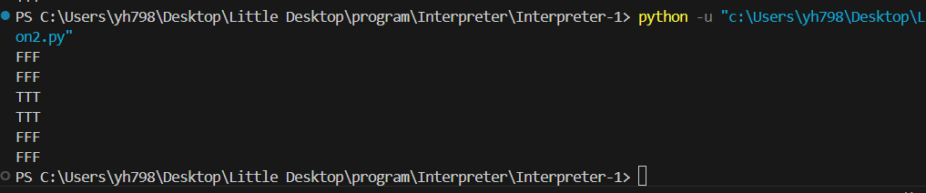
✏️ Notes on weird behavior or edge cases:

🧪 Section 4: Combined Tests (30 minutes)
Test multiple operators together!
let x = 5;
let y = 10;
if (x < y and x != 0) {
print("x is less and nonzero");
}

if (x == 5 or y == 5) {
print("One of them is five");
}
Expected output:
x is less and nonzero
One of them is five

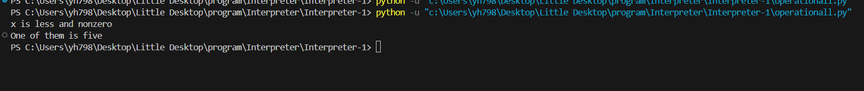

🧠 Section 5: Reflection and Planning (10–15 minutes)

5.1 What was the trickiest part about logical operators?
✏️ Answer:
邏輯運算子（例如 and、or、not）的處理最棘手的部分是正確處理短路評估（short-circuit evaluation）。在運算式中，當一個條件已經確定結果時，如何避免不必要的運算非常重要，尤其是在 and 和 or 運算中。

5.2 How did short-circuit evaluation affect your interpreter?
✏️ Answer:
短路評估讓解釋器在運算時能夠提高效率。例如，在 and 運算中，如果左邊的條件為 false，右邊的條件就不需要計算；而在 or 運算中，如果左邊的條件為 true，右邊的條件就不需要計算。這樣的處理能有效減少運算時間，避免不必要的計算。

5.3 What could improve in your type-checking or error messages?
✏️ Answer:
在類型檢查和錯誤訊息方面，可以加入更多的詳細錯誤處理，尤其是當運算的兩個操作數類型不符時。

5.4 Homework (Optional):
Task | Description
Extend and/or to handle lazy evaluation more cleanly | Avoid evaluating right-hand side unnecessarily 沈緯郡
Add chained comparisons | 1 < 2 < 3 should work correctly 黃逸萱
Customize error messages | Improve runtime type errors 黃雁汝

📌 End of Worksheet!

