Group Worksheet: Interpreting the AST
📅 Estimated Time: 3 Hours
🎯 Goal: Implement an interpreter that evaluates the Abstract Syntax Tree (AST) and executes the program.

Section 1: Understanding Interpretation (30 Minutes)
🔹 Discussion Questions: (Discuss with your group and write your answers below.)
- What is the difference between parsing and interpreting?
  - Answer:
Parsing 將 token 序列轉換為 AST，檢查語法結構是否合法；Interpreting 則是直接執行 AST，計算表達式並產生結果。例如：Parser 確認 x + 1 符合語法，Interpreter 實際計算 x + 1 的值。
- Why do we need an AST for interpretation?
- Answer:
AST 提供結構化的程式表示法，明確表達運算優先順序（如 3 + 5 * 2 的乘法節點會先被計算）、控制流程（如 if 分支）和變數作用域，比直接處理 tokens 更高效且易於維護。
- What are the main steps an interpreter follows to evaluate an AST?
  - Answer:
遞迴遍歷 AST：從根節點開始，深度優先訪問子節點。
執行節點邏輯：根據節點類型（如數字、運算、變數存取）執行對應操作。
管理環境：維護變數和函式的儲存空間（如 Environment 類別）。

- Compare different execution models: Tree-Walking vs. Bytecode Interpreters.
  - Answer:
Tree-Walking: 直接遍歷 AST 執行，簡單但較慢（如 Python 早期版本）。
Bytecode: 先將 AST 編譯為虛擬機器指令，再執行（如 CPython）。後者效能更好，但實作複雜。

Section 2: Defining the Interpreter Structure (45 Minutes)
🎯 Objective: Define how your interpreter will process the AST nodes.

2.1 Identify AST Node Types
📌 Fill in the table with the AST node types your language will support.
AST Node Type | Description
Number | Represents numerical literals (e.g., 42, 3.14)
String | Represents string literals (e.g., "hello")
BinaryExpression | Handles operations like +, -, *, /
VariableDeclaration | Defines variables (let x = 5;)
Assignment | Assigns values to variables (x = 10;)
IfStatement | Handles conditional execution (if (x > 5) { print(x); })
WhileLoop | Implements loops (while (x > 0) { x = x - 1; })
FunctionCall | Calls functions (print("Hello");)
ANS:
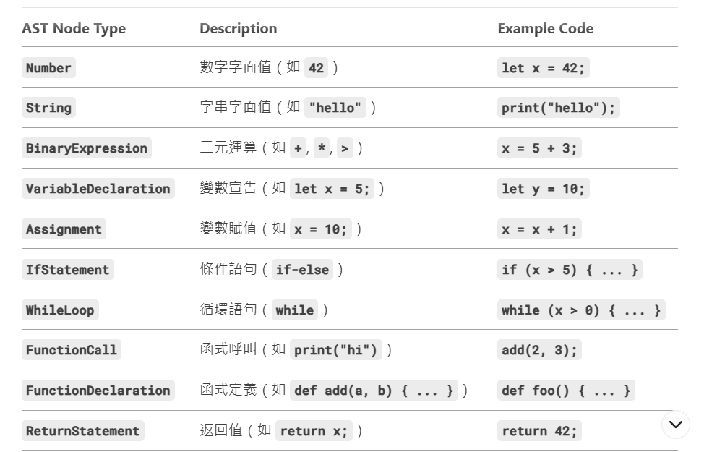
✏️ Modify or expand the table based on your language features.

Section 3: Implementing the AST Interpreter (1 Hour)
🎯 Objective: Build an interpreter that evaluates the AST.

3.1 Define the Interpreter Class
💻 Create an Interpreter class that evaluates AST nodes recursively.
class Interpreter:
def __init__(self):
self.environment = {} # Stores variable values

def evaluate(self, node):
if isinstance(node, Number):
return node.value
elif isinstance(node, String):
return node.value
elif isinstance(node, BinaryExpression):
left = self.evaluate(node.left)
right = self.evaluate(node.right)
if node.operator == '+':
return left + right
elif node.operator == '-':
return left - right
elif node.operator == '*':
return left * right
elif node.operator == '/':
return left / right
elif isinstance(node, VariableDeclaration):
self.environment[node.name] = self.evaluate(node.value)
elif isinstance(node, Assignment):
if node.name in self.environment:
self.environment[node.name] = self.evaluate(node.value)
else:
raise Exception(f"Variable {node.name} not declared")
elif isinstance(node, IfStatement):
condition = self.evaluate(node.condition)
if condition:
return self.evaluate(node.then_branch)
elif node.else_branch:
return self.evaluate(node.else_branch)
elif isinstance(node, WhileLoop):
while self.evaluate(node.condition):
self.evaluate(node.body)
elif isinstance(node, FunctionCall):
if node.name == "print":
print(self.evaluate(node.arguments[0]))
else:
raise Exception(f"Unknown AST Node: {node}")

def interpret(self, ast):
for node in ast:
self.evaluate(node)

Ans:
class Interpreter:
def __init__(self):
self.environment = {}
self.functions = {
"print": lambda x: print(x)
}

def evaluate(self, node):
if isinstance(node, Number):
return node.value
elif isinstance(node, String):
return node.value
elif isinstance(node, Variable):
value = self.environment.get(node.name)
if value is None:
raise NameError(f"變數未定義: {node.name}")
return value
elif isinstance(node, BinaryExpression):
left = self.evaluate(node.left)
right = self.evaluate(node.right)
if node.operator == "+": return left + right
elif node.operator == "-": return left - right
elif node.operator == "*": return left * right
elif node.operator == "/":
if right == 0:
raise ZeroDivisionError("除數不能為零")
return left / right
elif node.operator == ">": return left > right
elif node.operator == "<": return left < right
elif node.operator == "==": return left == right
else:
raise ValueError(f"不支援的運算符: {node.operator}")
elif isinstance(node, VariableDeclaration):
self.environment[node.name] = self.evaluate(node.value)
elif isinstance(node, Assignment):
if node.name not in self.environment:
raise NameError(f"變數未定義: {node.name}")
self.environment[node.name] = self.evaluate(node.value)
elif isinstance(node, IfStatement):
if self.evaluate(node.condition):
return self.evaluate(node.then_branch)
elif node.else_branch:
return self.evaluate(node.else_branch)
elif isinstance(node, WhileLoop):
while self.evaluate(node.condition):
self.evaluate(node.body)
elif isinstance(node, Block):
for stmt in node.statements:
self.evaluate(stmt)
elif isinstance(node, PrintStatement):
value = self.evaluate(node.expression)
print(value)
elif isinstance(node, FunctionCall):
func = self.functions.get(node.name)
if func is None:
raise NameError(f"函數未定義: {node.name}")
args = [self.evaluate(arg) for arg in node.arguments]
return func(*args)
else:
raise TypeError(f"未知節點類型: {type(node)}")

def interpret(self, ast):
for node in ast:
try:
result = self.evaluate(node)
if result is not None and not isinstance(node, (PrintStatement, FunctionCall)):
print(f"Result: {result}")
except Exception as e:
print(f"執行錯誤: {e}")
break

Section 4: Testing & Debugging (30 Minutes)
🎯 Objective: Test the interpreter with different ASTs and refine it.

4.1 Test Cases
📌 Write test cases and run your interpreter on them.
✅ Test 1: Basic Arithmetic
AST Input:
BinaryExpression(Number(5), "+", Number(3))
Expected Output:
8
✅ Test 2: Variable Declaration & Assignment
AST Input:
[VariableDeclaration("x", Number(10)), Assignment("x", BinaryExpression(Number(10), "+", Number(5)))]
Expected Output:
x = 15
✅ Test 3: If Statement
AST Input:
IfStatement(BinaryExpression(Number(5), ">", Number(3)), PrintStatement(String("Condition met")))
Expected Output:
Condition met
✅ Test 4: While Loop
AST Input:
[VariableDeclaration("x", Number(3)), WhileLoop(BinaryExpression(Variable("x"), ">", Number(0)), [PrintStatement(Variable("x")), Assignment("x", BinaryExpression(Variable("x"), "-", Number(1)))])]
Expected Output:
3
2
1

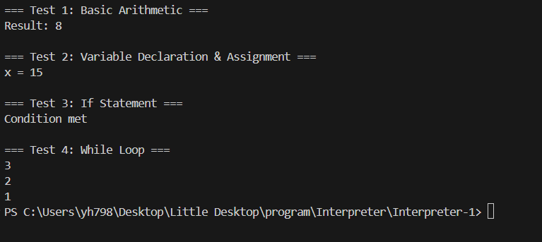

Section 5: Team Reflection & Next Steps (15 Minutes)
- What challenges did you face while implementing the interpreter?
  - Answer: 把程式碼整合再一起
- What improvements can be made to the interpreter?
  - Answer: 改用 Environment 類別鏈（parent 屬性）支援作用域層級。
- What will you work on before the next session? (Each member should write their next task.)

沈緯郡: 實作 Environment 類別支援嵌套作用域。
黃雁汝: 擴充內建函式（如 input(), math 運算）。
黃逸萱: 設計更多測試案例（如遞迴函式）。

✅ Homework:
- Expand the interpreter to support user-defined functions and return values.
- Research error handling techniques in real-world interpreters.
- Prepare for the next session: Adding Scope and Functions! 🚀

