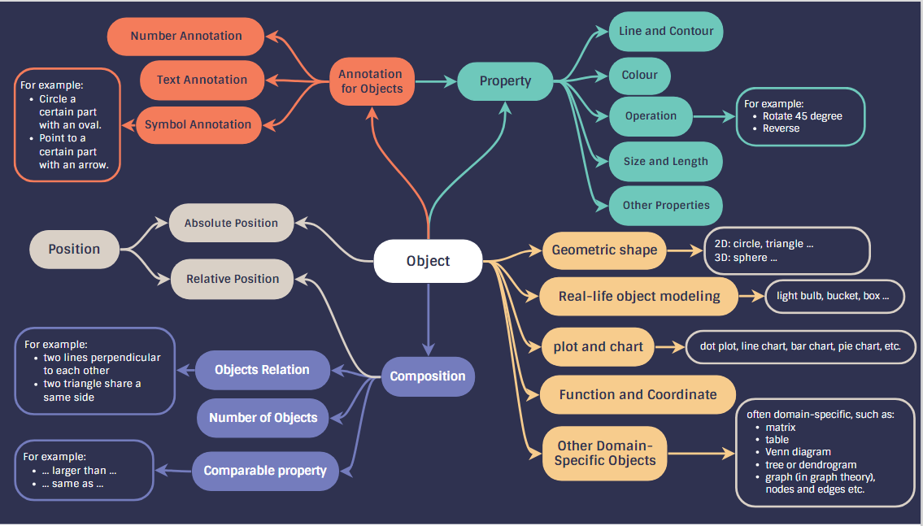

In a scientific graph containing a single object, such as a circle or a square, we assume that the image meets the requirements of the caption if the following factors are well controlled:

1. The object’s **shape**: Ensuring the shape is accurately represented according to the scientific standards required.
2. The **properties** of the object: This includes color, line and contour, size, and other relevant physical attributes.
3. The **position** of the object in the image

In a word, a correct scientific graph with a single object should meet the shape x properties x position requirement.

Additionally, **annotations** are often necessary to provide clarity or emphasize specific features. These may include textual annotations, marks a certain part of the graph, or arrows pointing to particular details.

**Composition**: For graphs that combine two or more objects, the number of objects, their arrangement (the way of composition), and their comparative properties are crucial for accurate scientific representation.

Beyond individual and composite objects, there are **complex object** types that are often specific to a particular field or discipline, such as binary trees, neural networks, or process diagrams. In forming a complex graph, the specific shapes making up the objects (e.g., circles or ovals) or the exact number of each shape may not be unique, although the overall concept of the complex structure is more significant.