CINEMA 1 – 2 - 3
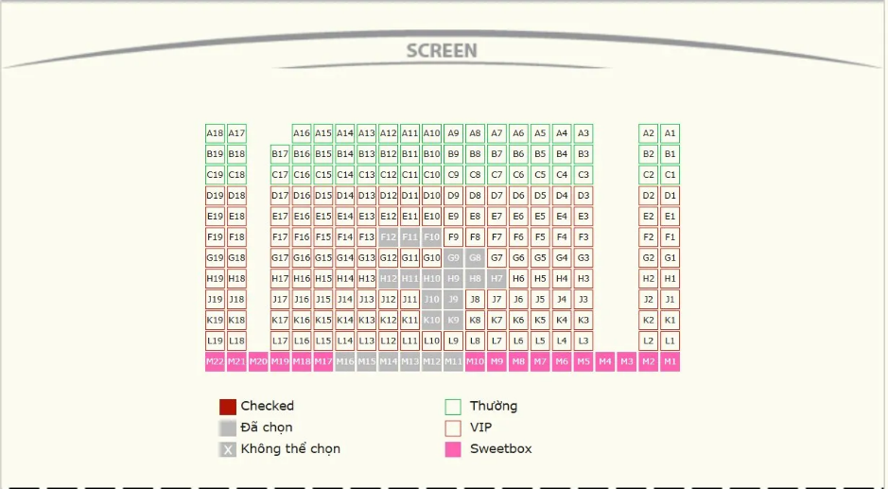

CINEMA 4 – 5 - 6
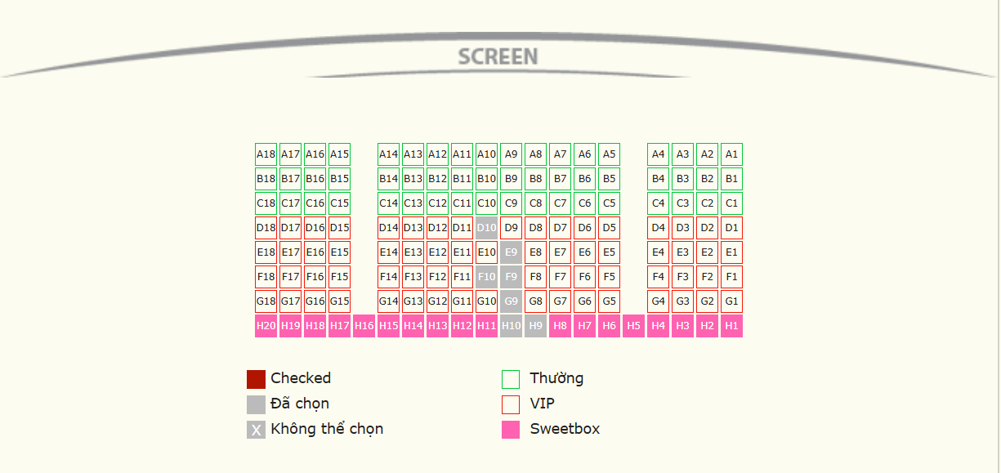

CINEMA 7 : STARIUM
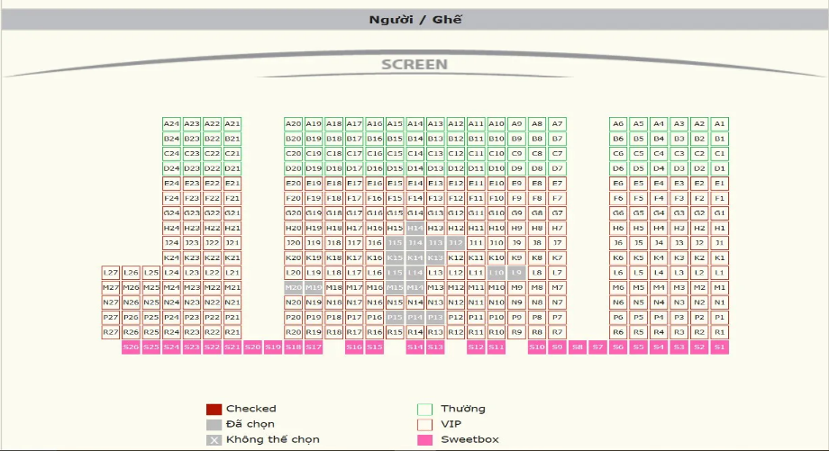

CINEMA 8 - 9 : SweetBox


CINEMA 10 : 4DX
