Post book: add a book
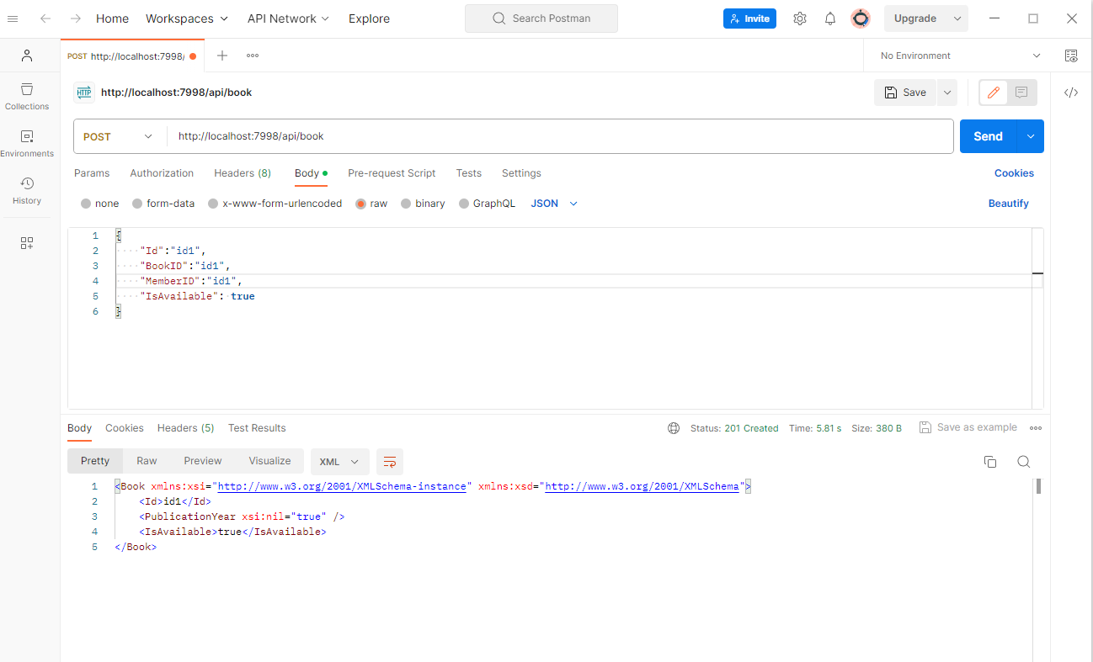
Book GetAll: get all books
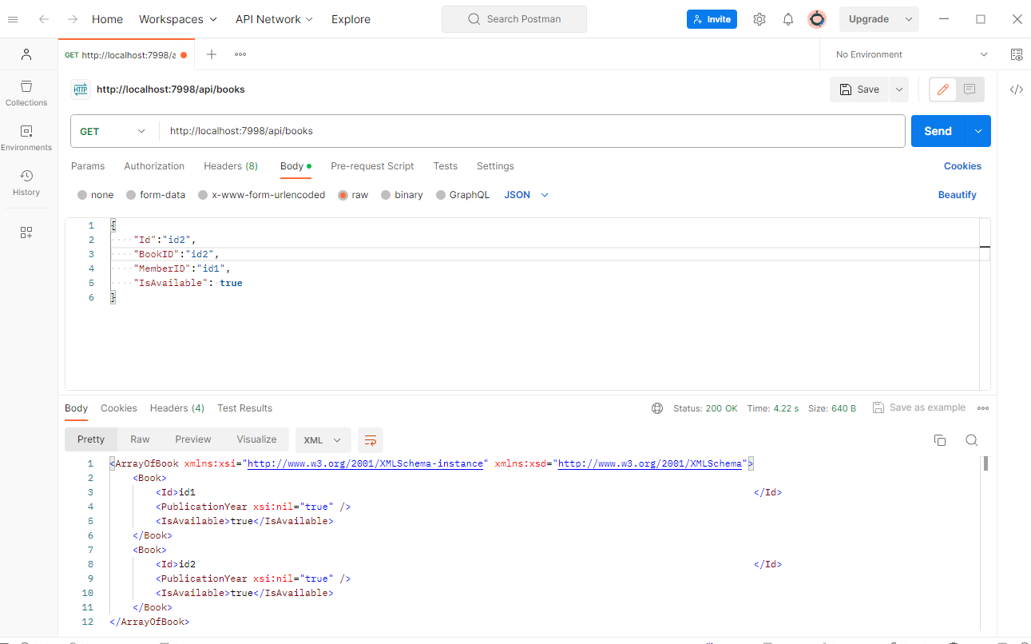
Book putBook: update a book information
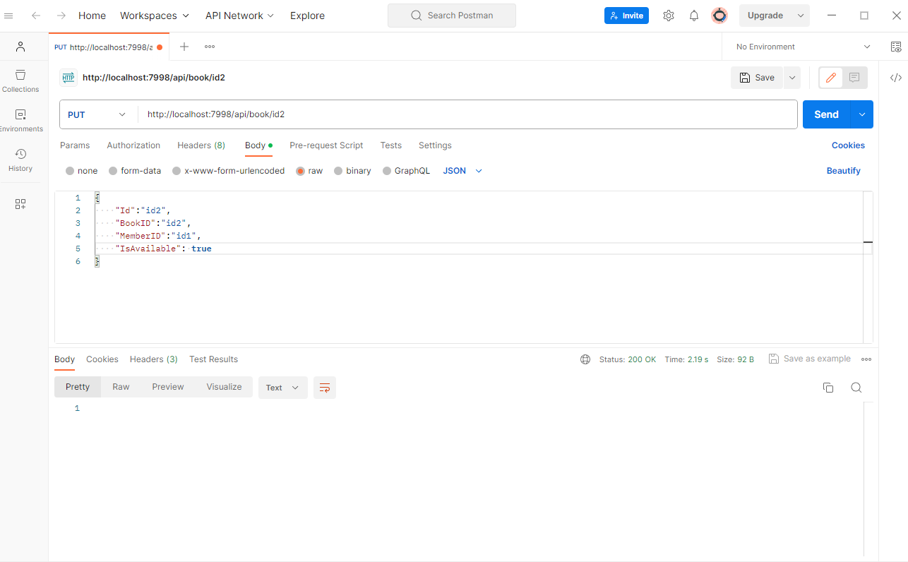
Member getAll: get all members
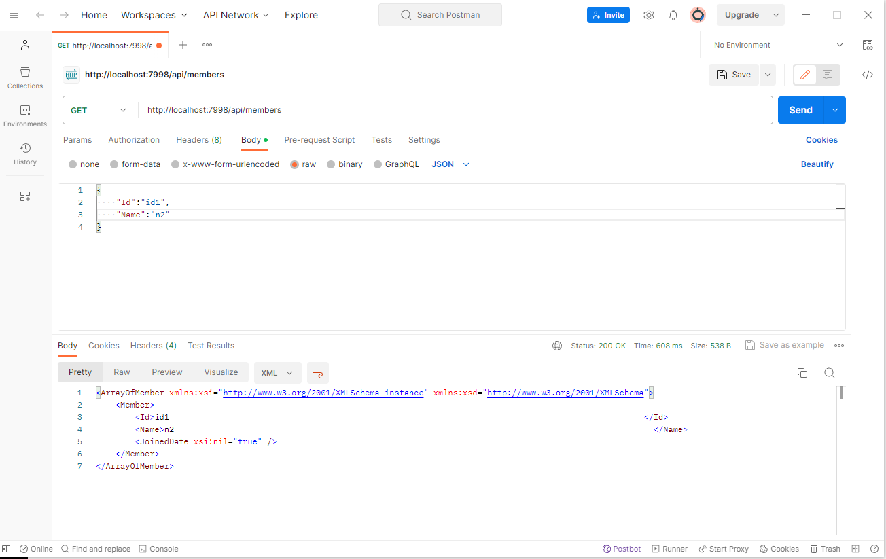
BorrowTransaction BorrowBook; borrow a book, create a borrow transaction
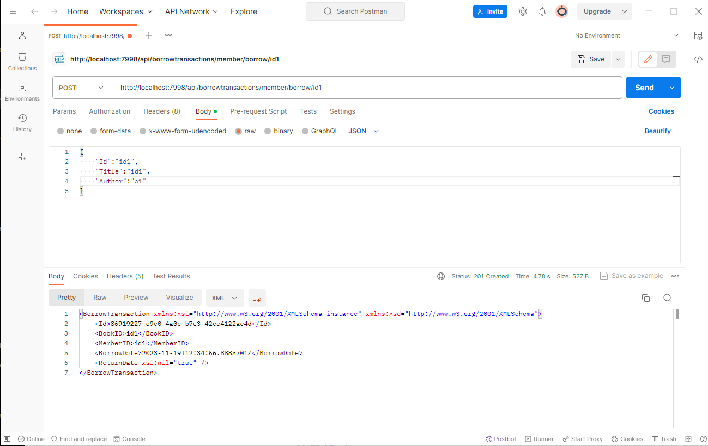

BorrowTransaction GetByMemberId: Get a borrow transaction list for the member
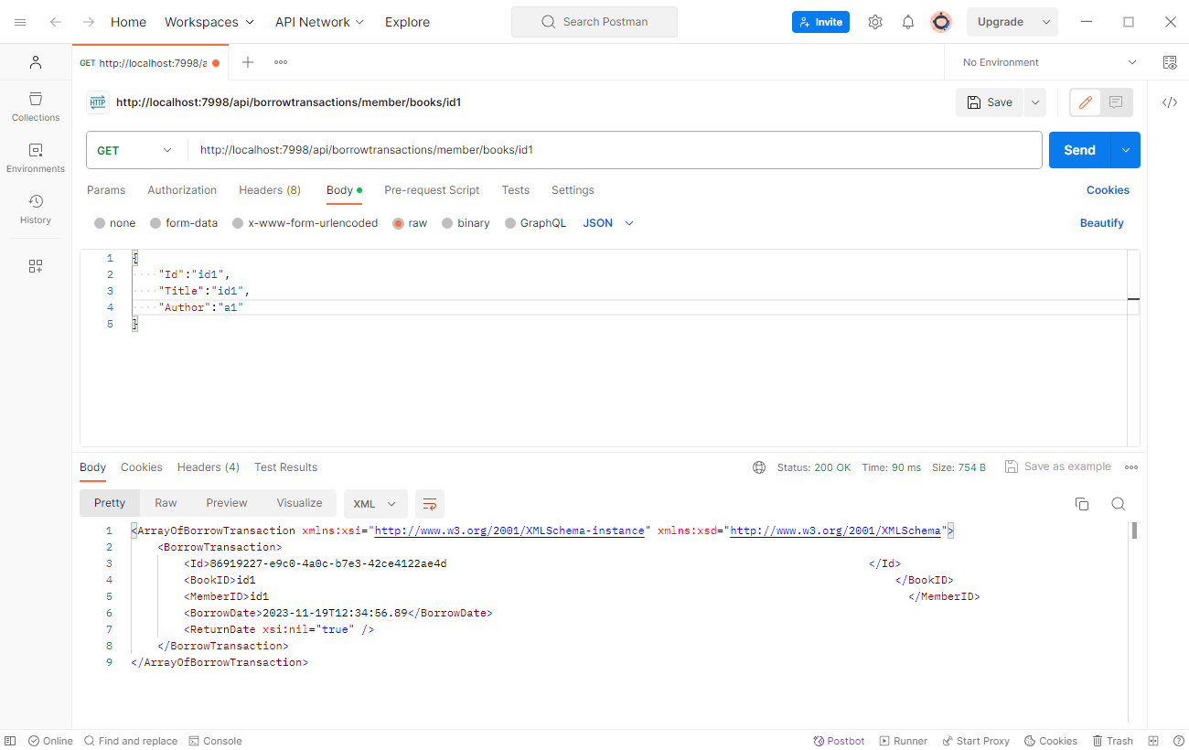
BorrowTransaction ReturnBook: update a borrow transaction
