Container:
What is a container?
Simply put, containers are isolated processes for each of your app's components. Each component - the frontend React app, the Python API engine, and the database - runs in its own isolated environment, completely isolated from everything else on your machine.
Here's what makes them awesome. Containers are:
- Self-contained. Each container has everything it needs to function with no reliance on any pre-installed dependencies on the host machine.
- Isolated. Since containers are run in isolation, they have minimal influence on the host and other containers, increasing the security of your applications.
- Independent. Each container is independently managed. Deleting one container won't affect any others.
- Portable. Containers can run anywhere! The container that runs on your development machine will work the same way in a data center or anywhere in the cloud!

Here, I use welcome-to-docker image to create a container.
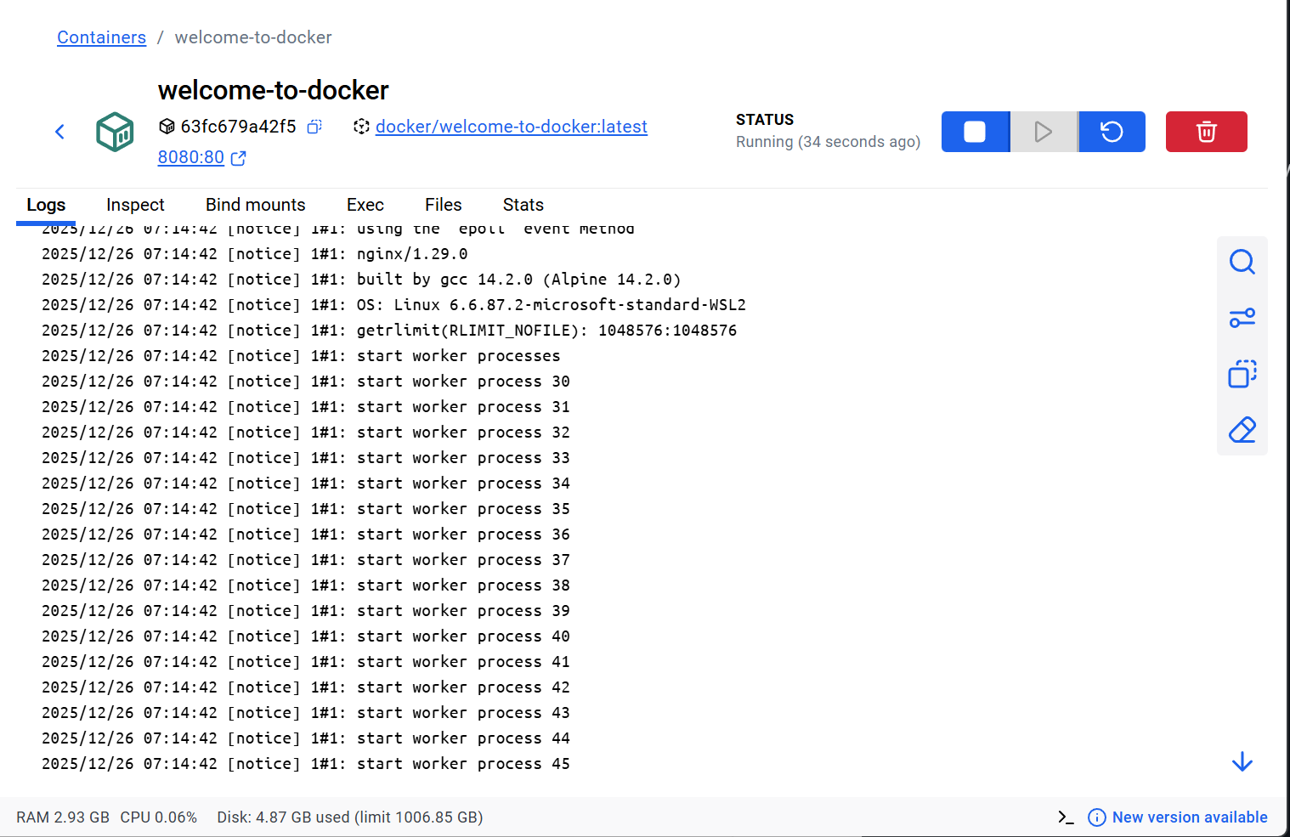
You can access it using web browser, using the localhost port that you set:
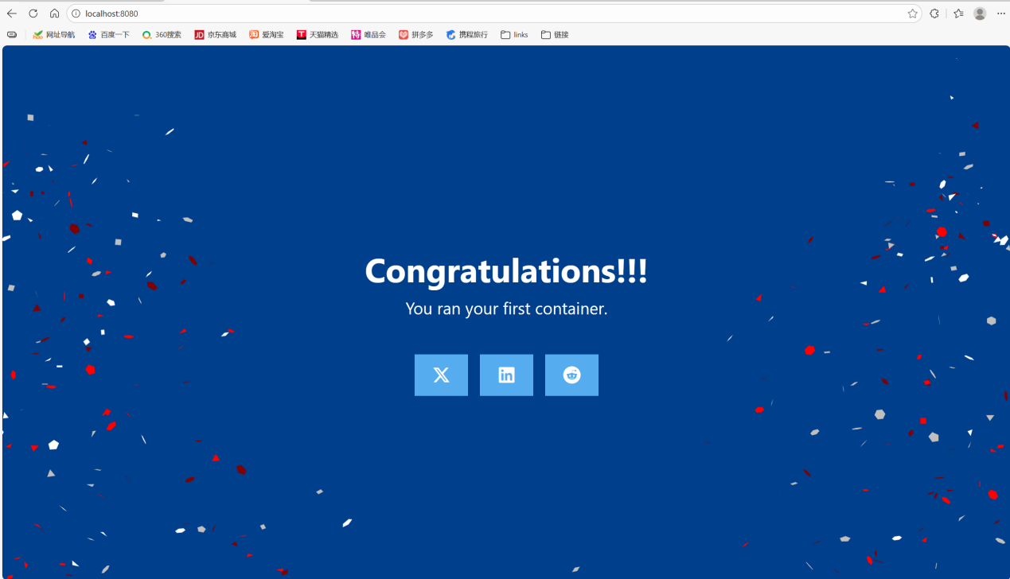

Through the GUI, you can also view the file system of your container:
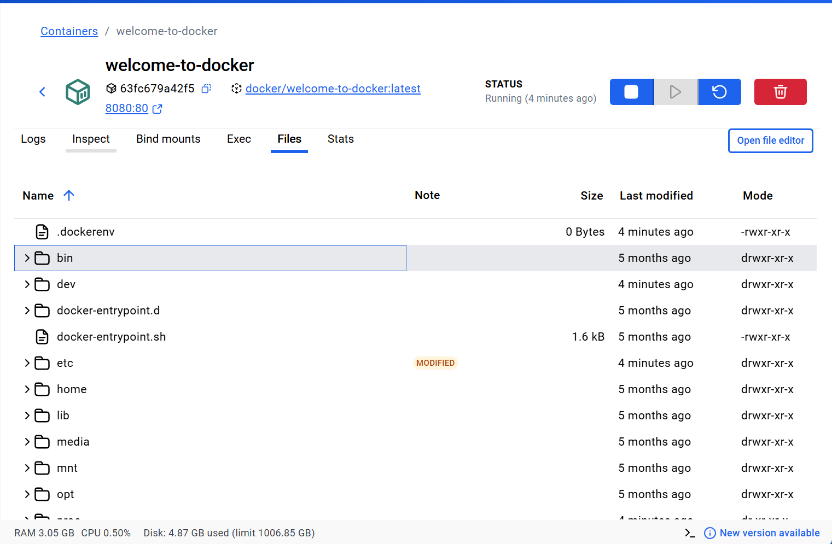

The docker/welcome-to-docker container continues to run until you stop it. Press this bottom can stop your container:
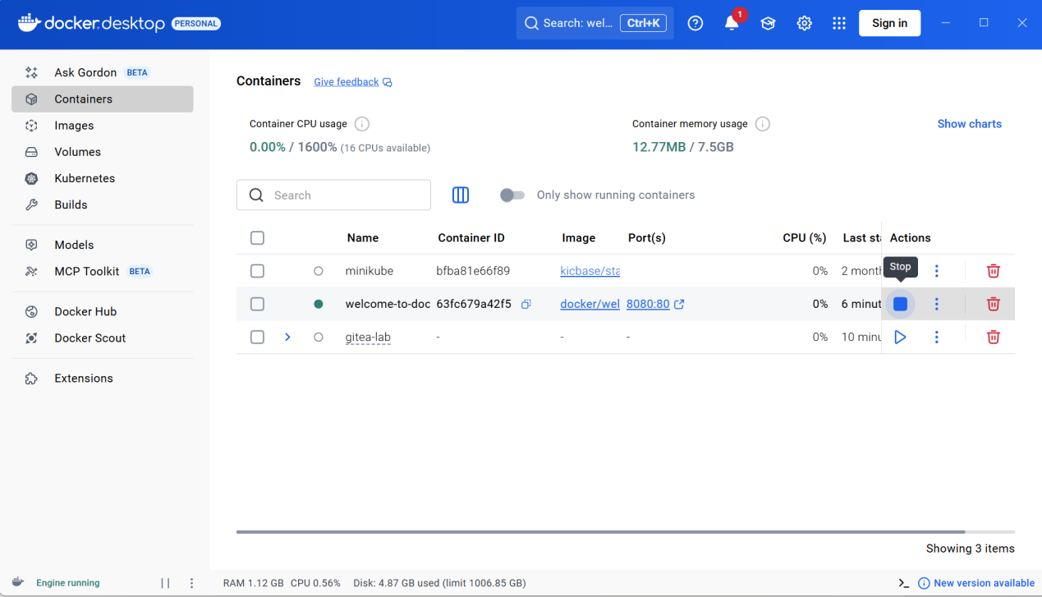

Image:
What is a image?
Explanation
Seeing as a container is an isolated process, where does it get its files and configuration? How do you share those environments?
That's where container images come in. A container image is a standardized package that includes all of the files, binaries, libraries, and configurations to run a container.
For a PostgreSQL image, that image will package the database binaries, config files, and other dependencies. For a Python web app, it'll include the Python runtime, your app code, and all of its dependencies.
There are two important principles of images:
- Images are immutable. Once an image is created, it can't be modified. You can only make a new image or add changes on top of it.
- Container images are composed of layers. Each layer represents a set of file system changes that add, remove, or modify files.
These two principles let you to extend or add to existing images. For example, if you are building a Python app, you can start from the Python image and add additional layers to install your app's dependencies and add your code. This lets you focus on your app, rather than Python itself.

You can select the global search bar at the top of the screen to search the image you want in docker hub. Here I choose welcome-to-docker image:
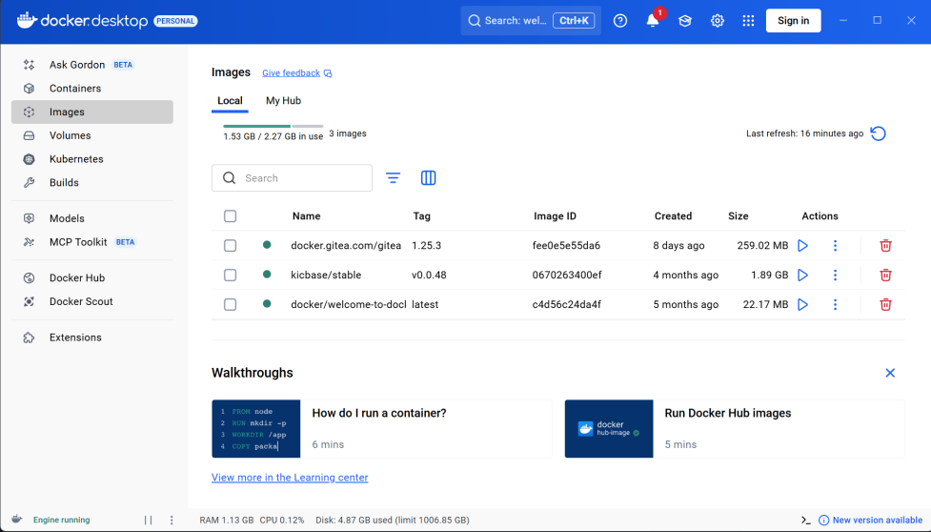
Once you have an image downloaded, you can learn quite a few details about the image either through the GUI or the CLI:
The image details page presents you with information regarding the layers of the image, the packages and libraries installed in the image, and any discovered vulnerabilities: 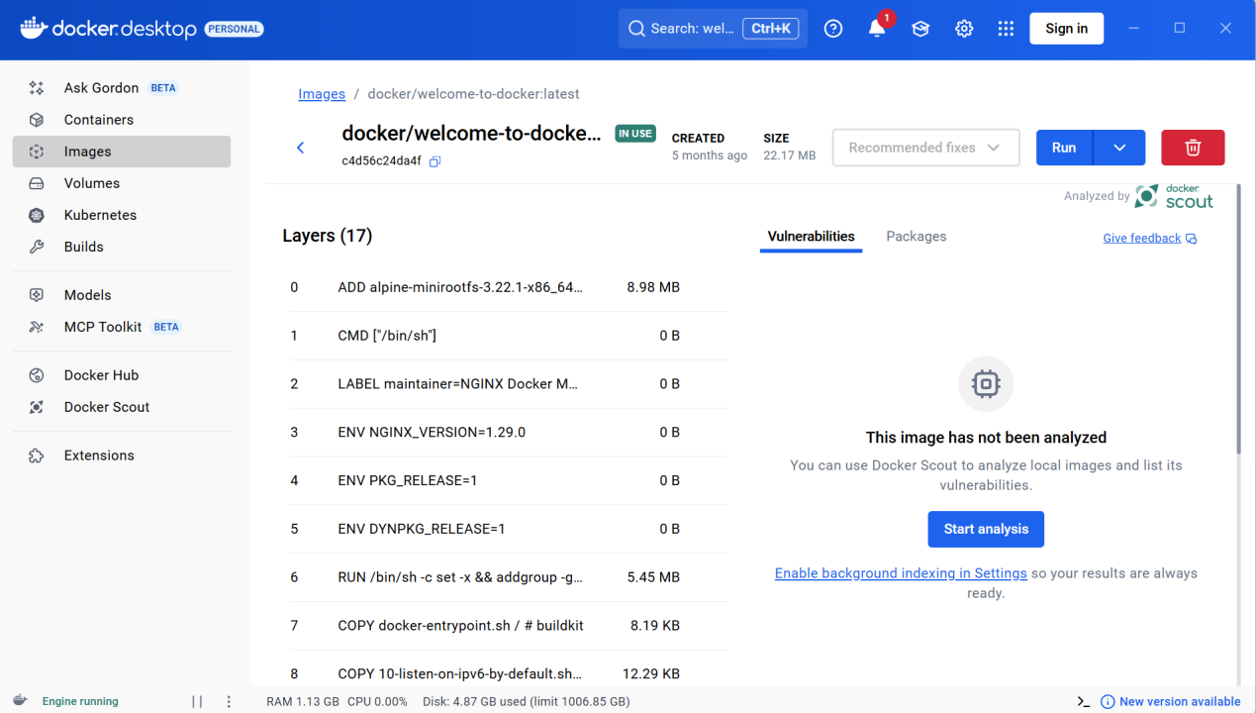

Docker Compose:
What is Docker Compose?
One best practice for containers is that each container should do one thing and do it well. While there are exceptions to this rule, avoid the tendency to have one container do multiple things.
You can use multiple docker run commands to start multiple containers. But, you'll soon realize you'll need to manage networks, all of the flags needed to connect containers to those networks, and more. And when you're done, cleanup is a little more complicated.
With Docker Compose, you can define all of your containers and their configurations in a single YAML file. If you include this file in your code repository, anyone that clones your repository can get up and running with a single command.
It's important to understand that Compose is a declarative tool - you simply define it and go. You don't always need to recreate everything from scratch. If you make a change, run docker compose up again and Compose will reconcile the changes in your file and apply them intelligently.

Using Docker Compose:
Open a terminal and clone this sample application:
git clone https://github.com/dockersamples/todo-list-app
Navigate into the todo-list-app directory. There’s a file end with .yaml, open a terminal and navigate into the todo-list-app directory, use the docker compose up command to start the application.
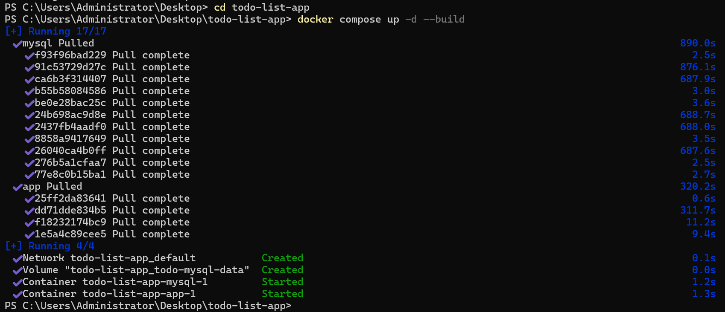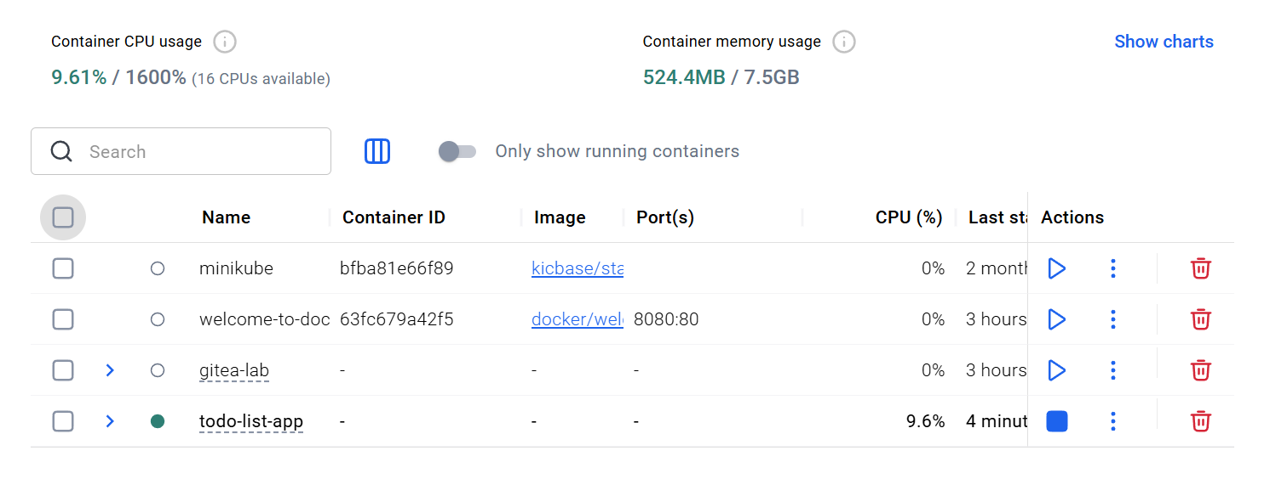

If you don’t want to use this app anymore, using docker compose down command to stop it.

Run a container and publish its port using the Docker CLI:
First way:
The first 8080 refers to the host port. This is the port on your local machine that will be used to access the application running inside the container. The second 80 refers to the container port. This is the port that the application inside the container listens on for incoming connections. Hence, the command binds to port 8080 of the host to port 80 on the container system.


Create a file named compose.yaml: 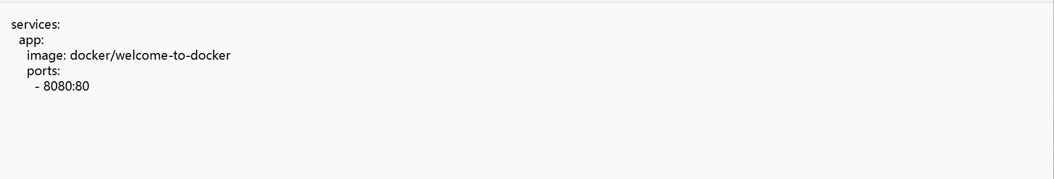

Then navigate to this directory in terminal and run docker compose up:
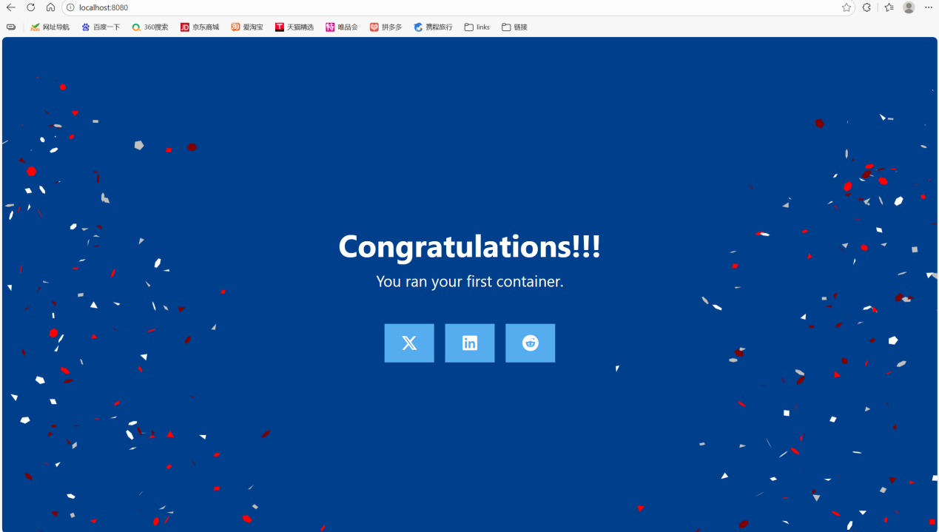

Persisting container data:
Volumes are a storage mechanism that provide the ability to persist data beyond the lifecycle of an individual container. Think of it like providing a shortcut or symlink from inside the container to outside the container.

Practice with PostgreSQL:
Start a container using the Postgres image with the following command:
docker run --name=db -e POSTGRES_PASSWORD=secret -d -v postgres_data:/var/lib/postgresql postgres:18 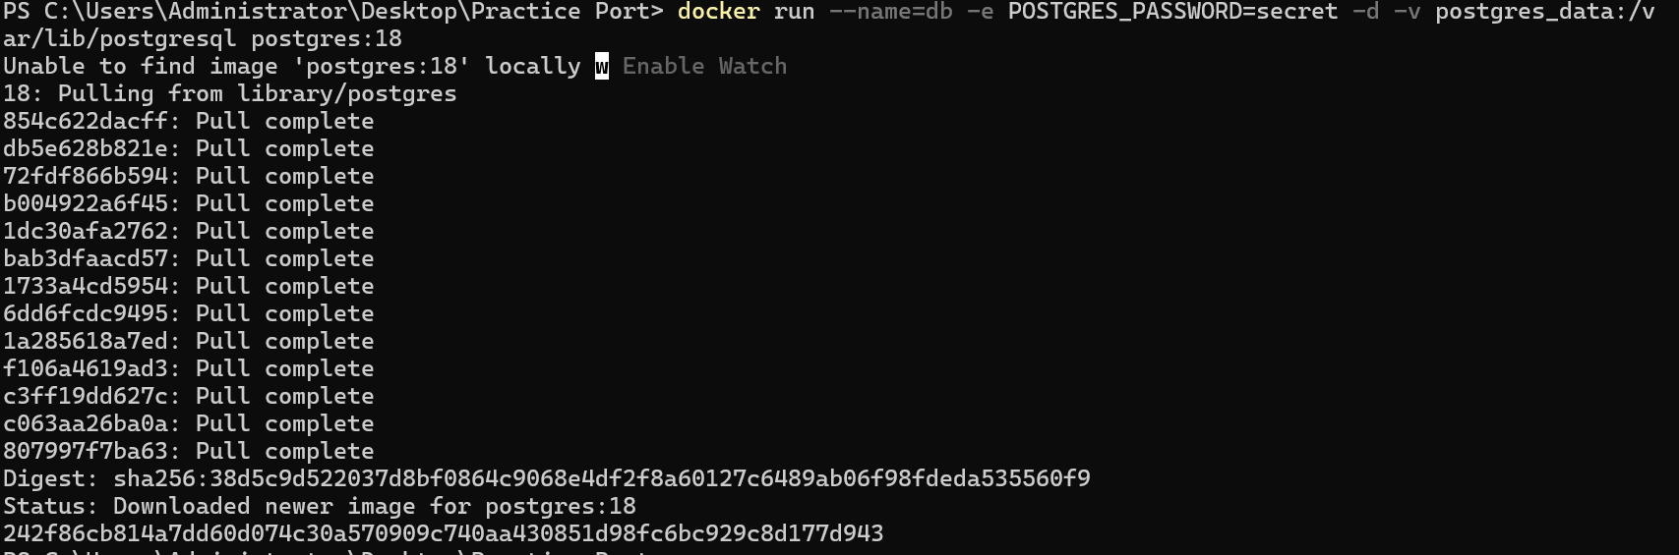

Link to database:

Insert data and query data:
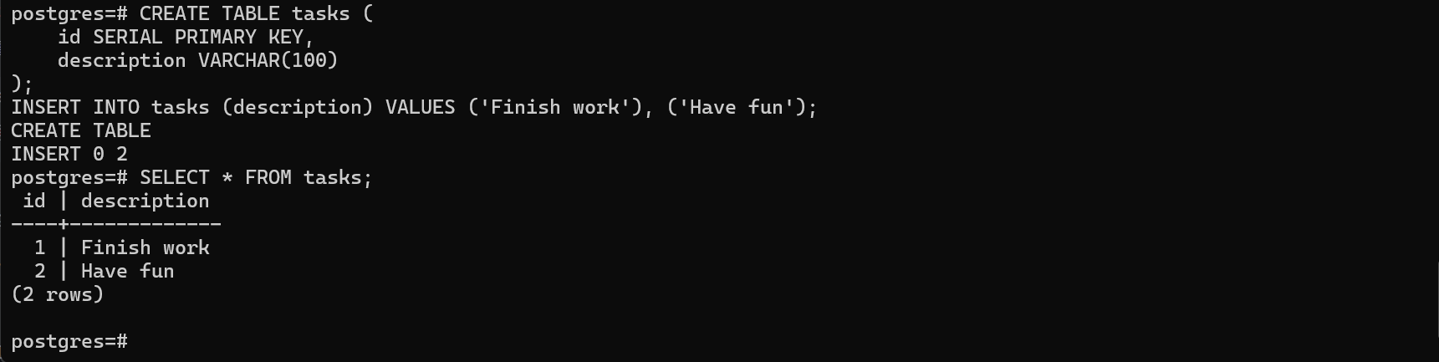

Stop and remove the db container:
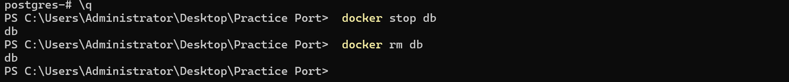

Start a new container by running the following command, attaching the same volume with the persisted data, verify the database still has the records by running the following command:
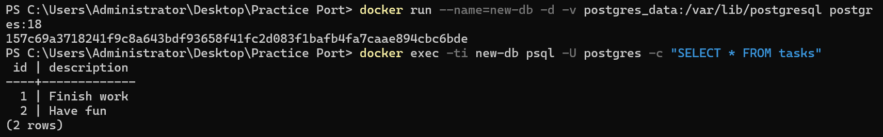
Remove volumns:

Sharing local files with containers:
Each container has everything it needs to function with no reliance on any pre-installed dependencies on the host machine. Since containers run in isolation, they have minimal influence on the host and other containers. This isolation has a major benefit: containers minimize conflicts with the host system and other containers. However, this isolation also means containers can't directly access data on the host machine by default.
Consider a scenario where you have a web application container that requires access to configuration settings stored in a file on your host system. This file may contain sensitive data such as database credentials or API keys. Storing such sensitive information directly within the container image poses security risks, especially during image sharing. To address this challenge, Docker offers storage options that bridge the gap between container isolation and your host machine's data.
Docker offers two primary storage options for persisting data and sharing files between the host machine and containers: volumes and bind mounts.

Try:
Start a container using the httpd image with the following command:
docker run -d -p 8080:80 --name my_site httpd:2.4
Then use curl command to check if you can visit this web through 8080 port:
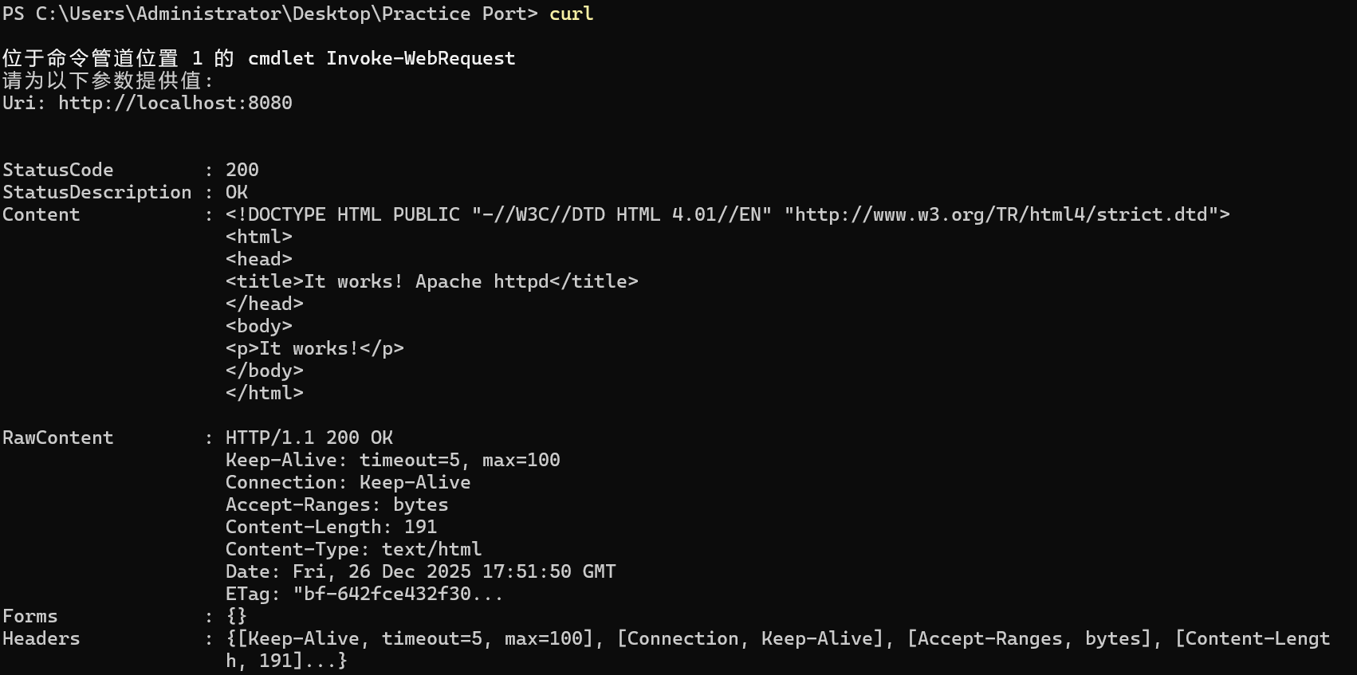

Using a bind mount:
Delete the container that you created in latest step.
Create a new directory called public_html on your host system.
mkdir public_html
Then create a html file in this directory, here’ the content in the html file: 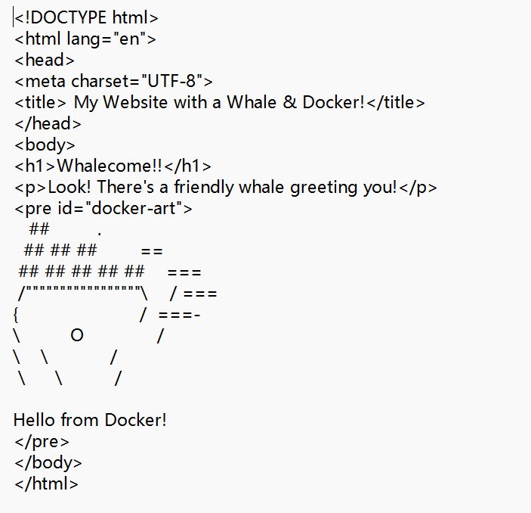
Then use this command to mount this directory to your container and run the container:
docker run -d --name my_site -p 8080:80 --mount type=bind,source=./,target=/usr/local/apache2/htdocs/ httpd:2.4
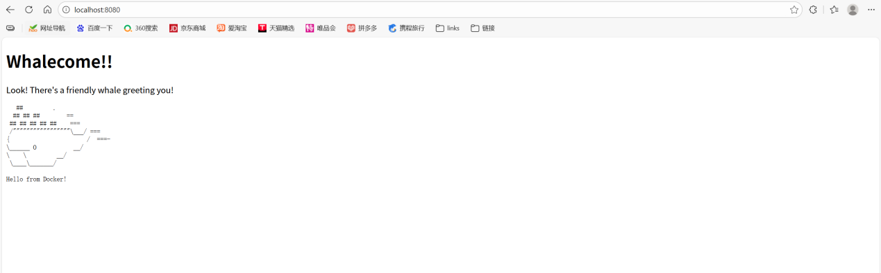

Using the GUI, you can also find out which file had been mount:
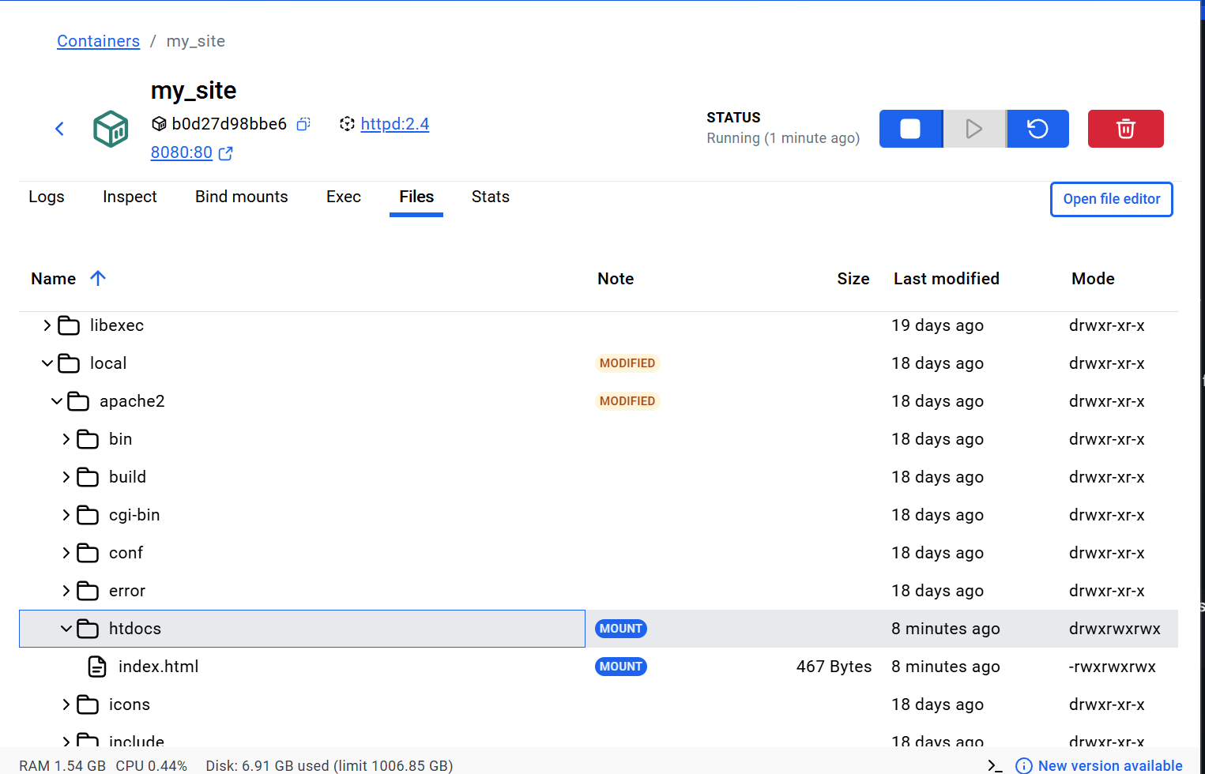
Once you delete these file in your computer, it will also be removed from container: 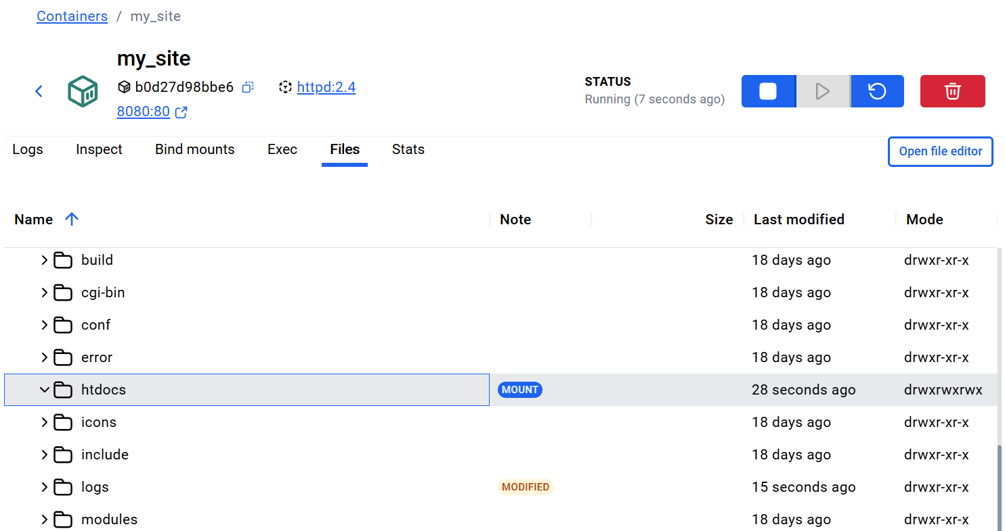
Create another html file in the directory you mount, here’s the content in it:
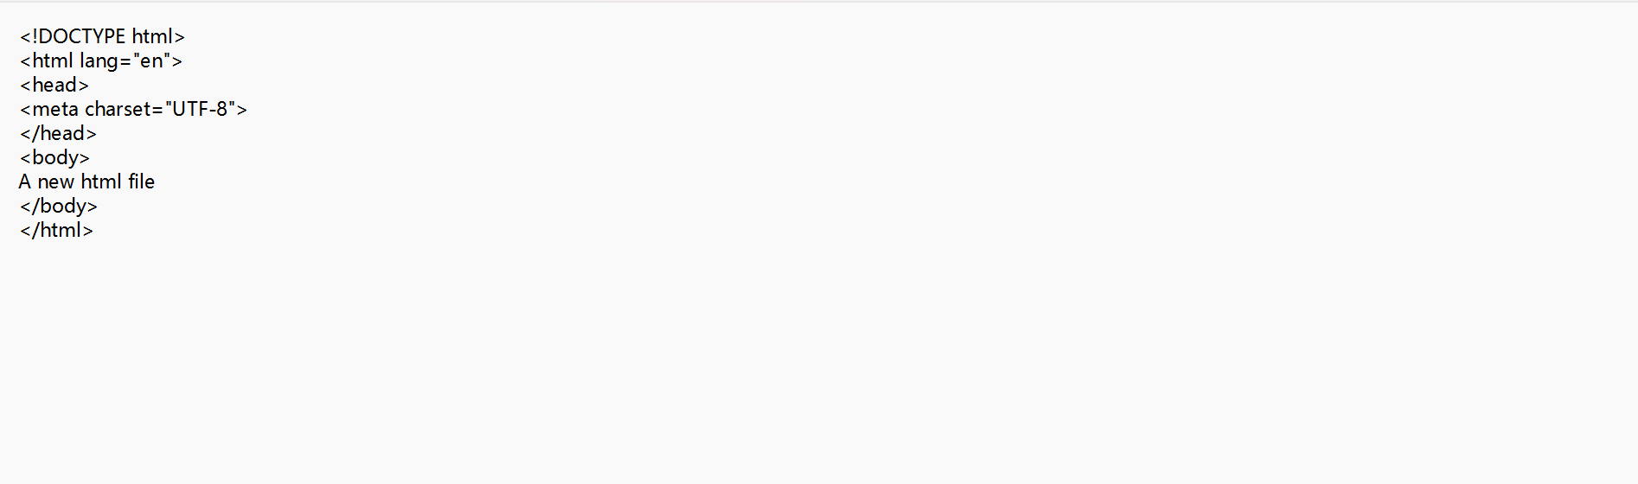
Then you can see, the new html file will be mount to the container: 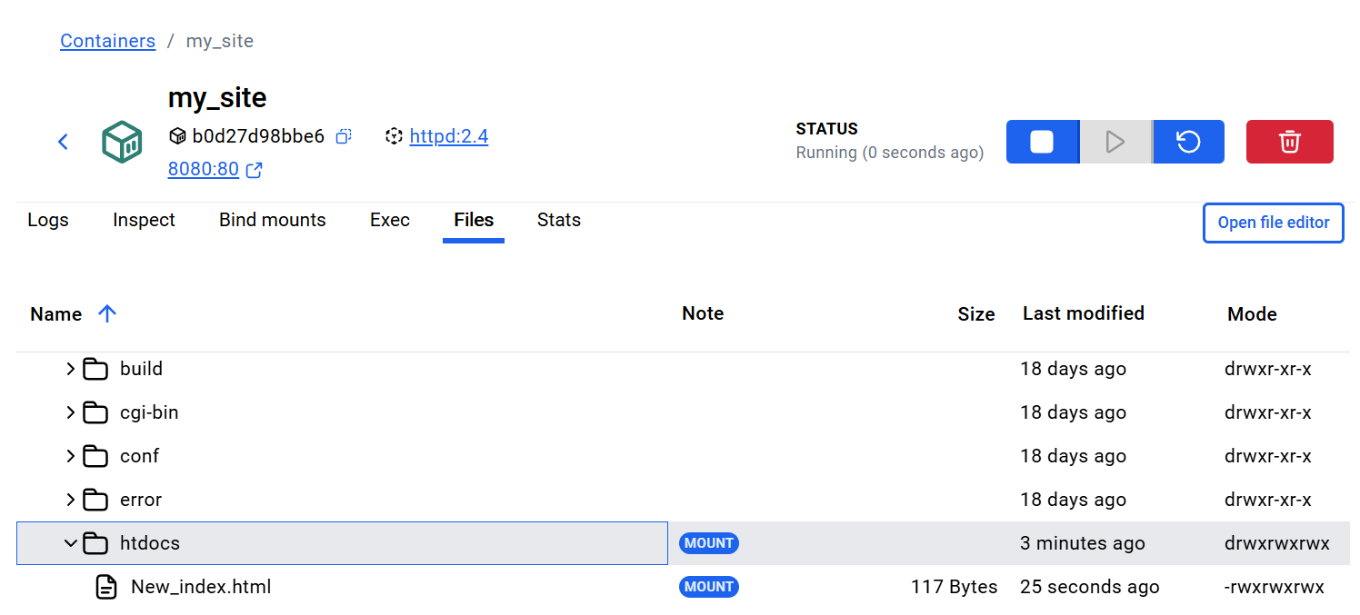 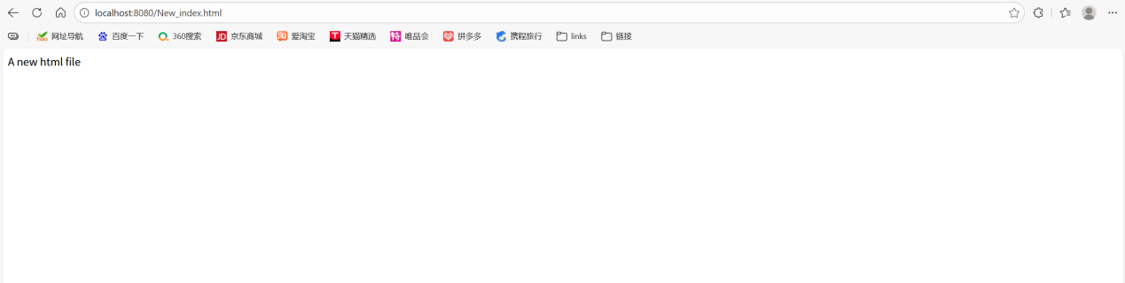

Multi-container applications
First download sample application:
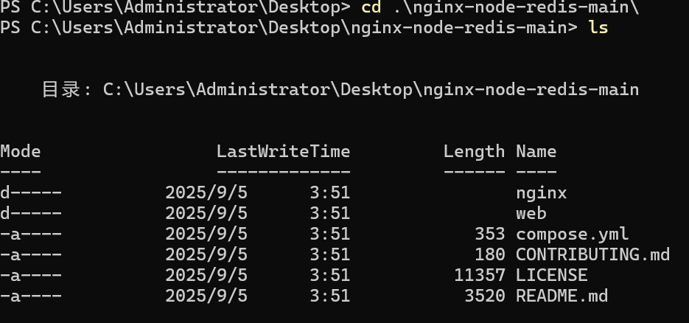
Navigate into the nginx directory to build the image by running the following command:
docker build -t nginx
Navigate into the web directory and run the following command to build the first web image:
docker build -t web
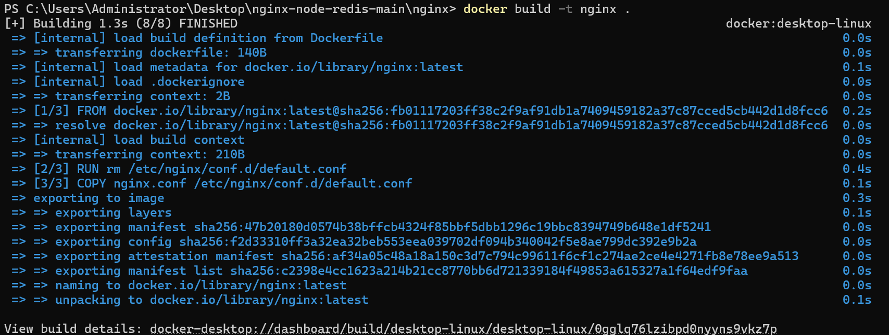
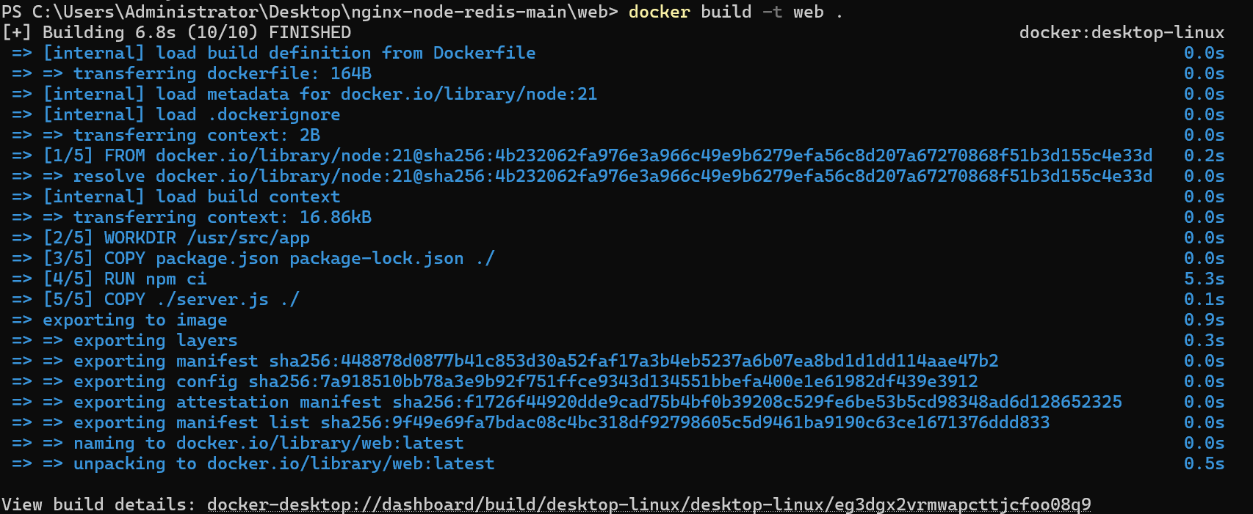

Before you can run a multi-container application, you need to create a network for them all to communicate through. You can do so using the docker network create command:
docker network create sample-app

Start the Redis container by running the following command, which will attach it to the previously created network and create a network alias (useful for DNS lookups):
docker run -d --name redis --network sample-app --network-alias redis redis

Start the first web container by running the following command:
docker run -d --name web1 -h web1 --network sample-app --network-alias web1 web

Start the second web container by running the following:
docker run -d --name web2 -h web2 --network sample-app --network-alias web2 web

Start the Nginx container by running the following command:
docker run -d --name nginx --network sample-app -p 80:80 nginx
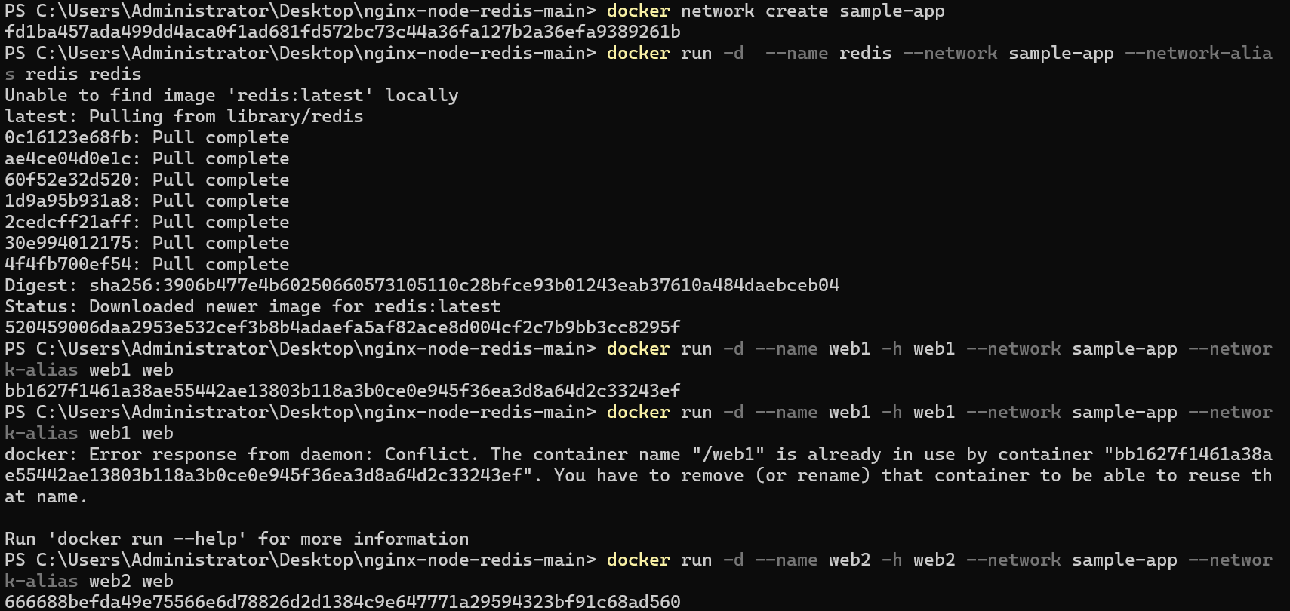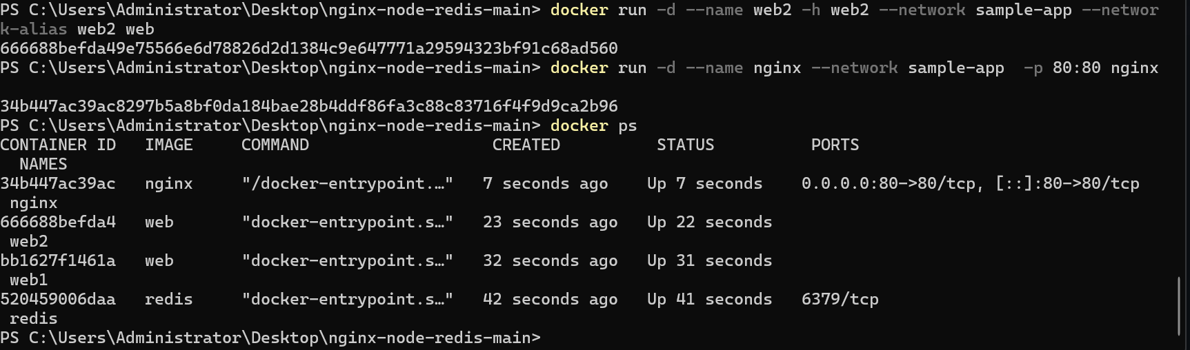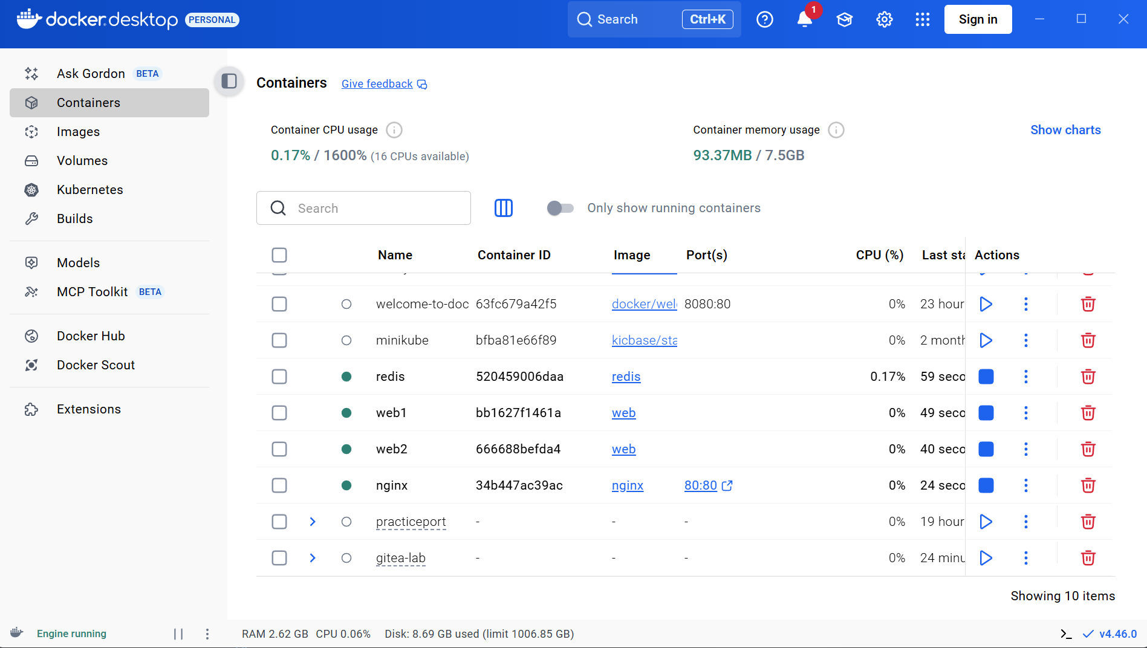
And then visit localhost port that the container used, you can see following information:
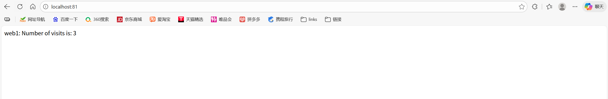
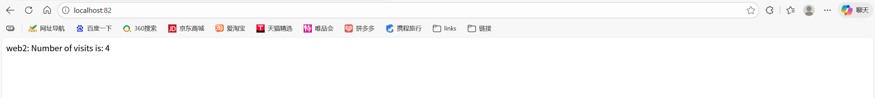
Simplify the deployment using Docker Compose:
Navigate to the root of the project directory. Inside this directory, you'll find a file named compose.yml. This YAML file is where all the magic happens. It defines all the services that make up your application, along with their configurations. Each service specifies its image, ports, volumes, networks, and any other settings necessary for its functionality.

Use the docker compose up command to start the application:
docker compose up -d --build
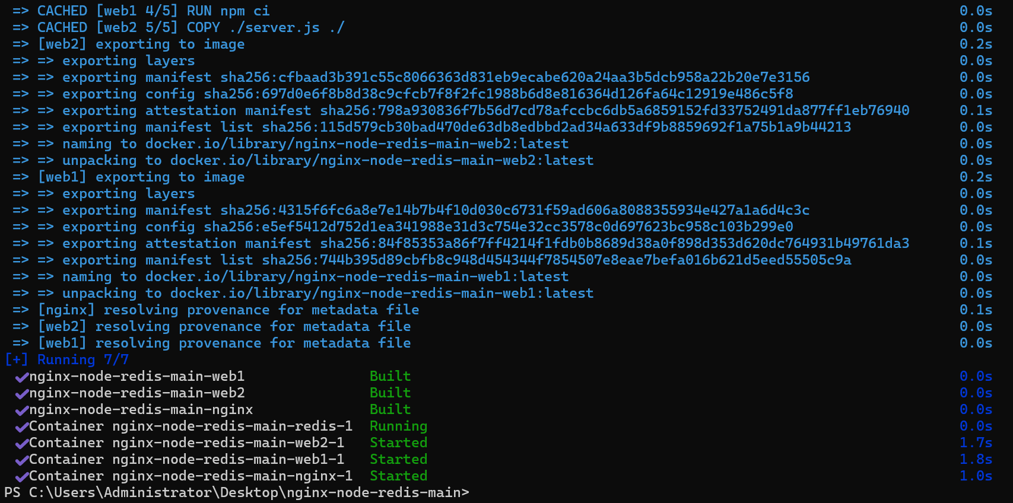

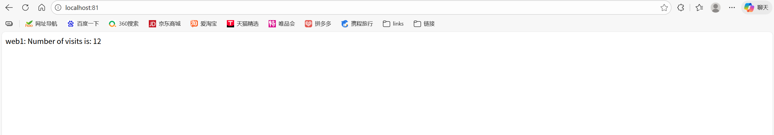
You can also see the same information in the website.

