Start minikube and install kserve components.
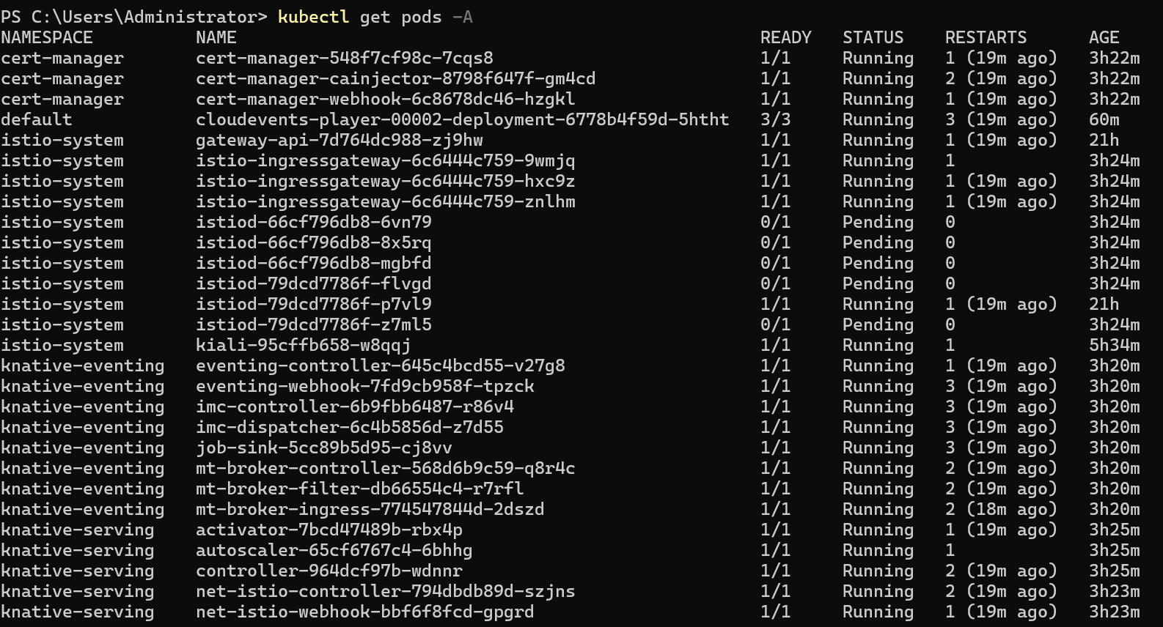
Here, I installed the Kserve CRD and other necessary components. See the image below for details.
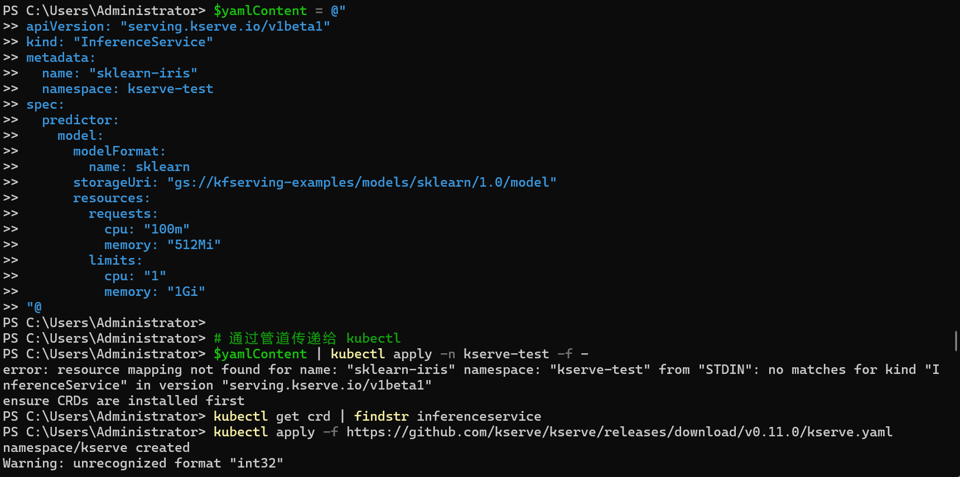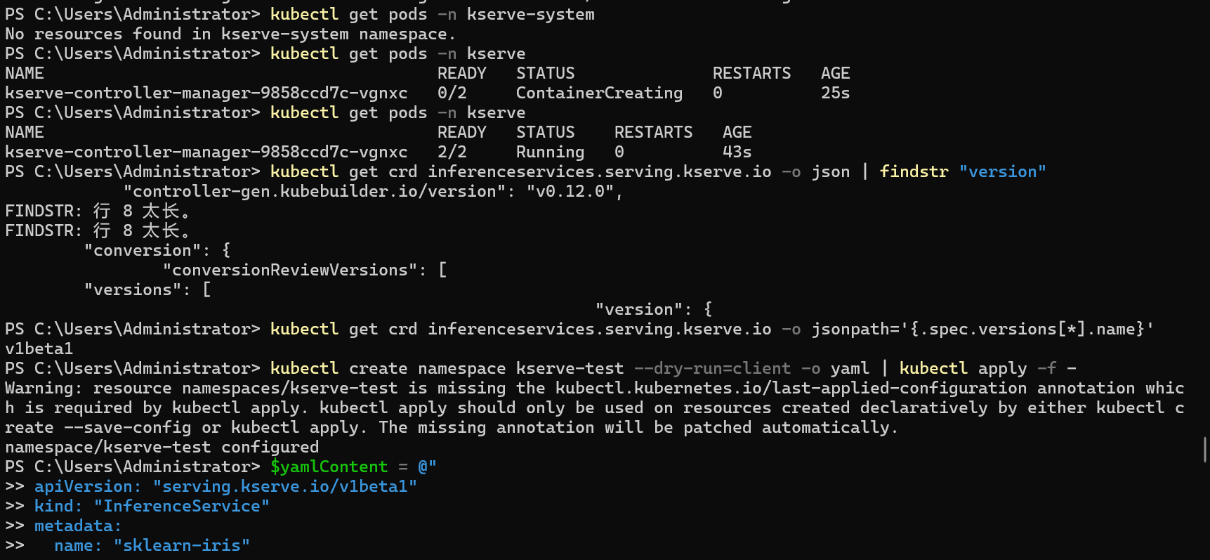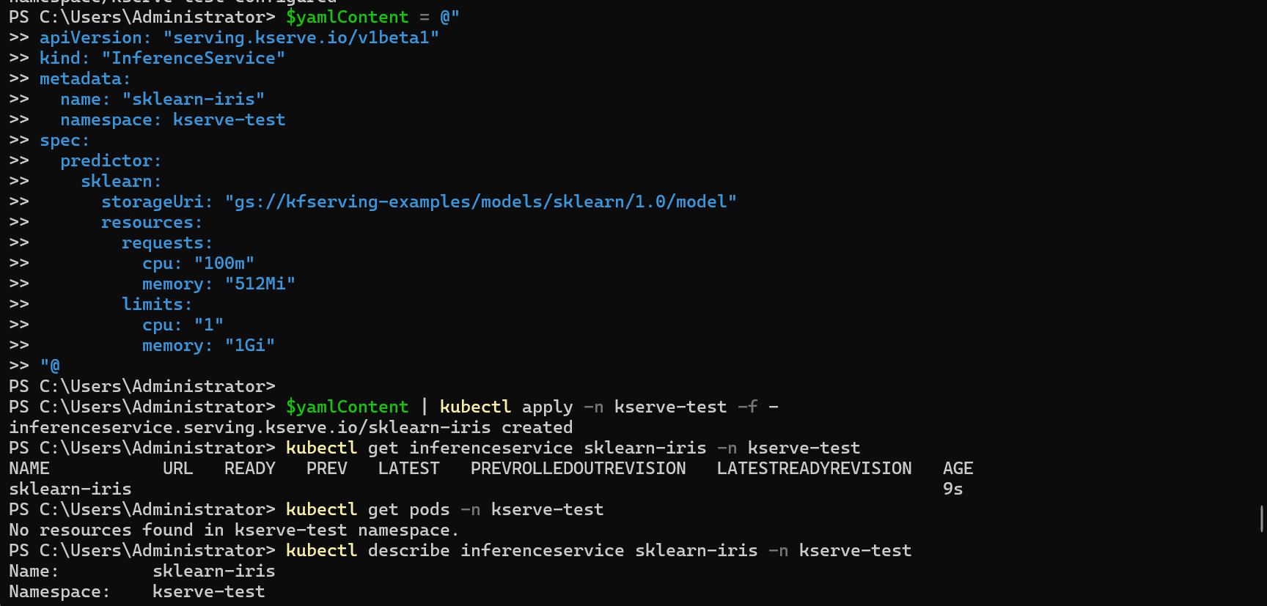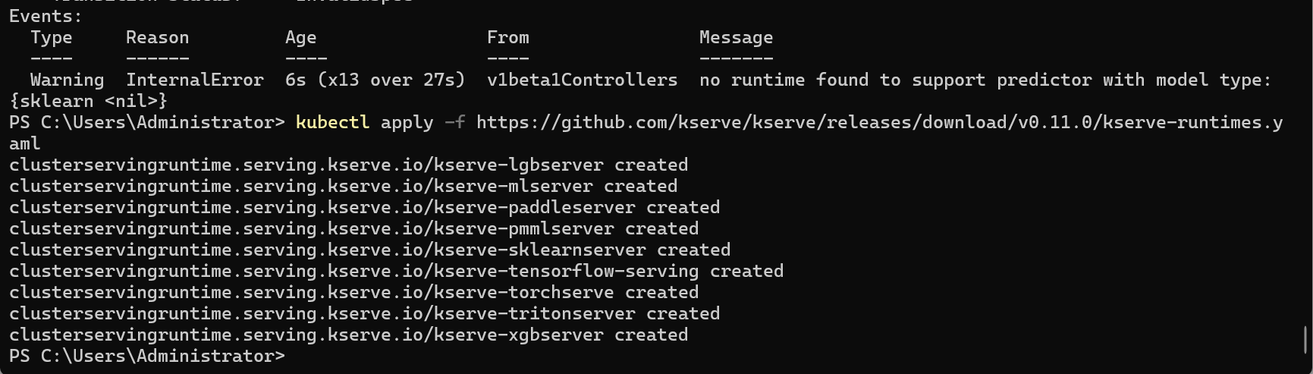

Here I find some named rules to change, so I change the yaml file.
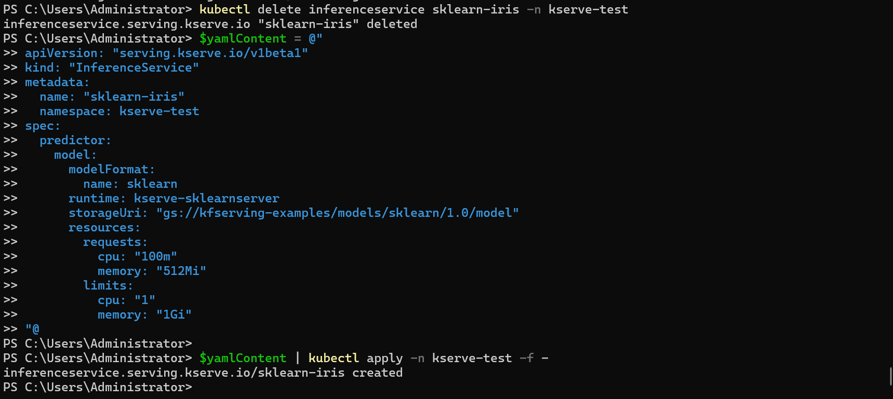

Finally you can see I deploy the model.
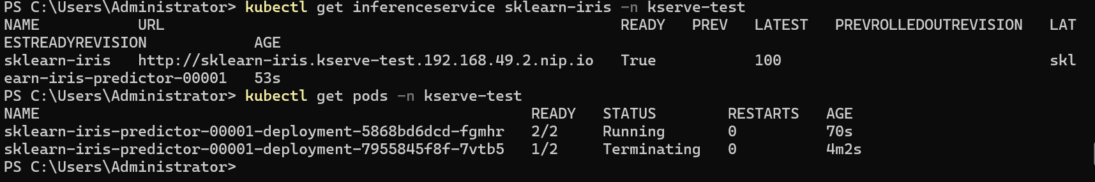
Here, I first send the prediction request inside the Pod (to avoid network issues).
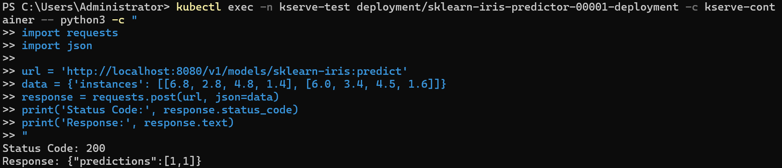

Then I used the Invoke-RestMethod function in PowerShell to send a prediction request and got the same response.
