Istio
First download istio from github and release it. Then move to the Istio package directory. Add the istioctl client to your path. Then install istio.
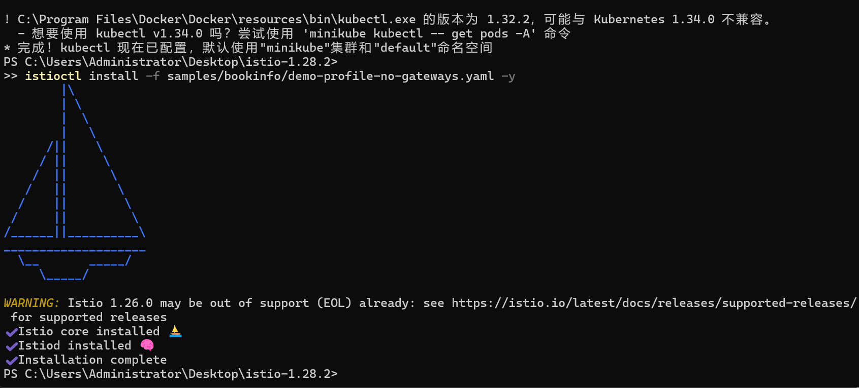
Then verify installing.
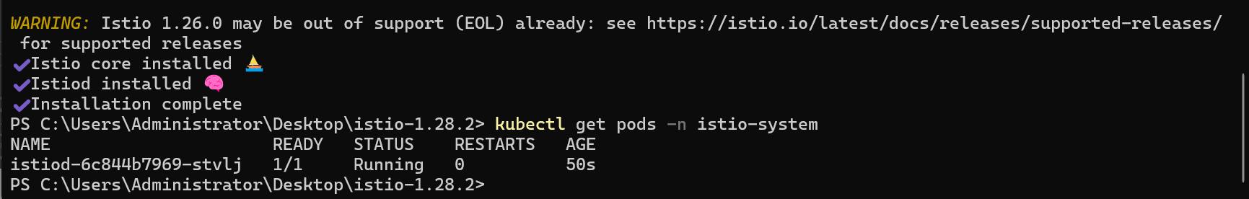

Next, deploy Bookinfo Application.
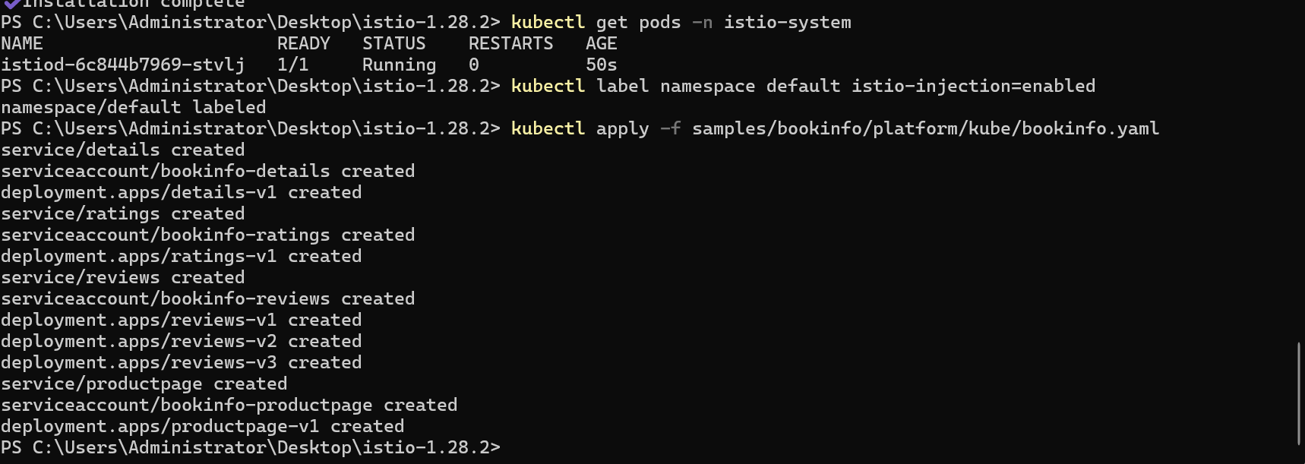

After deployed, we need to verify if the application is running.
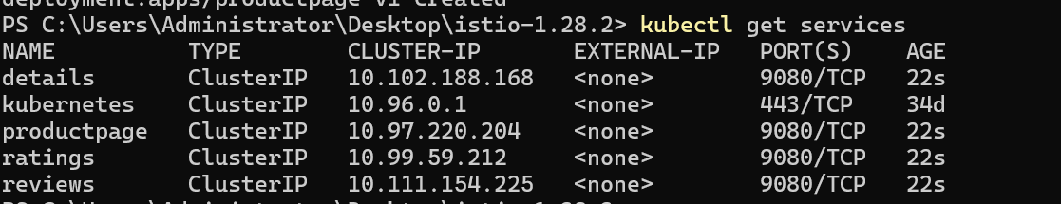
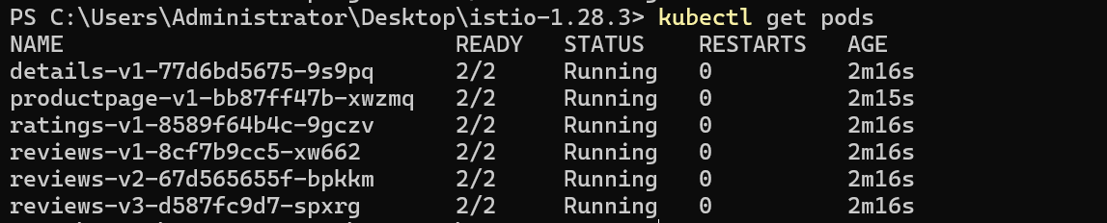

Open the application to outside traffic
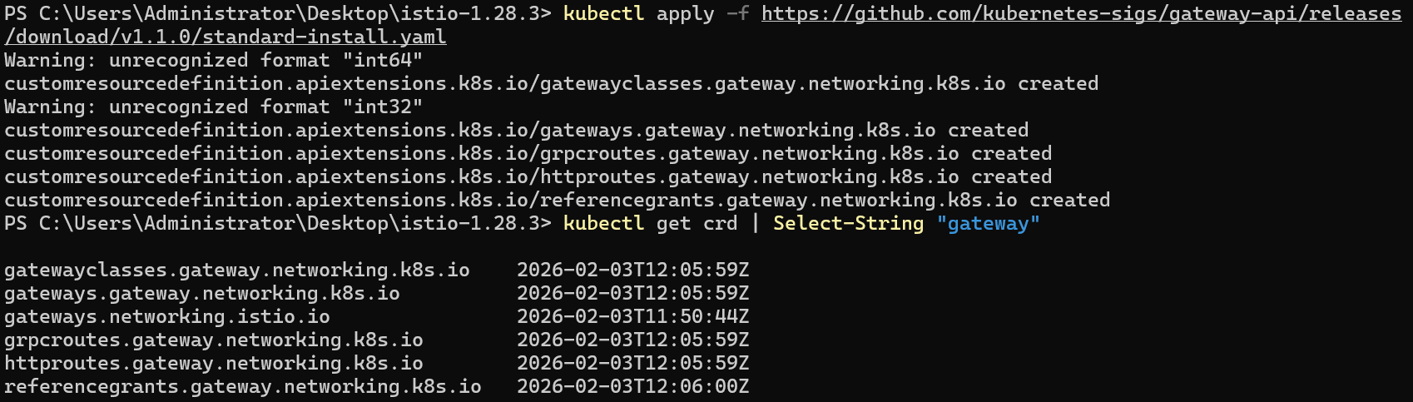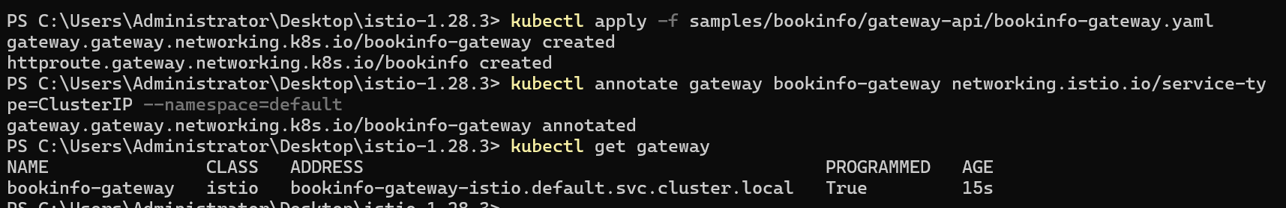

Then you can open your browser and navigate to http://localhost:8080/productpage to view the Bookinfo application.
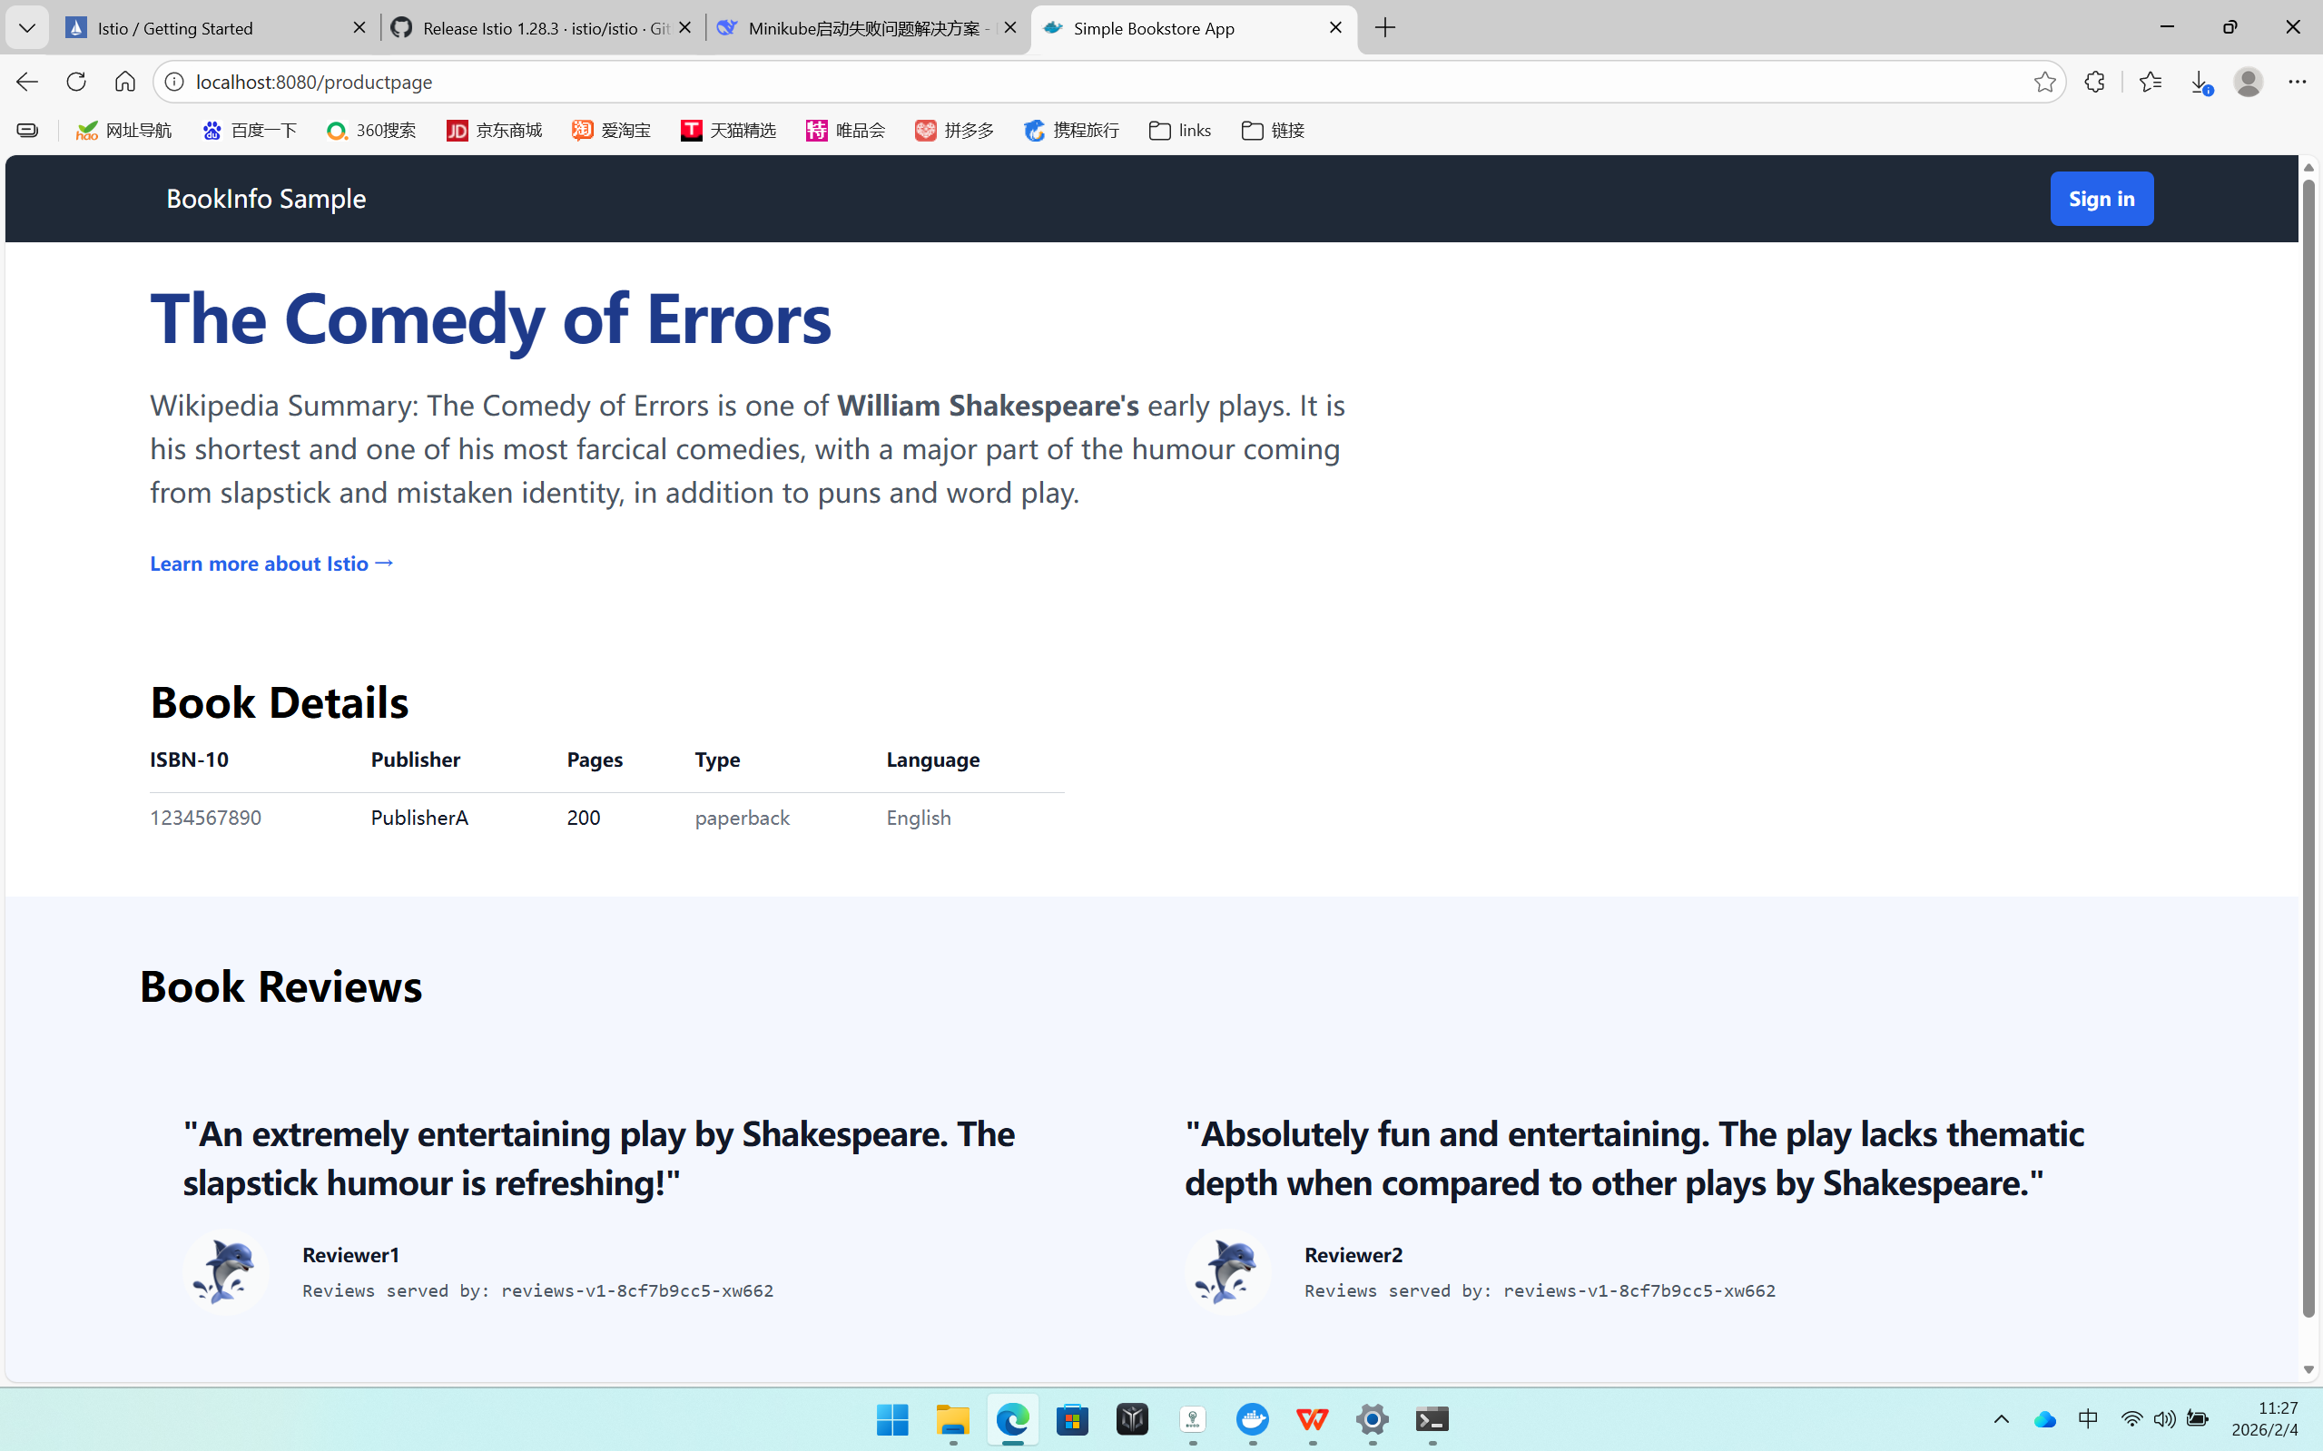

View the dashboard
Install Kiali and the other addons and wait for them to be deployed.