Traffic Shifting
1. First restore all traffic to v1.
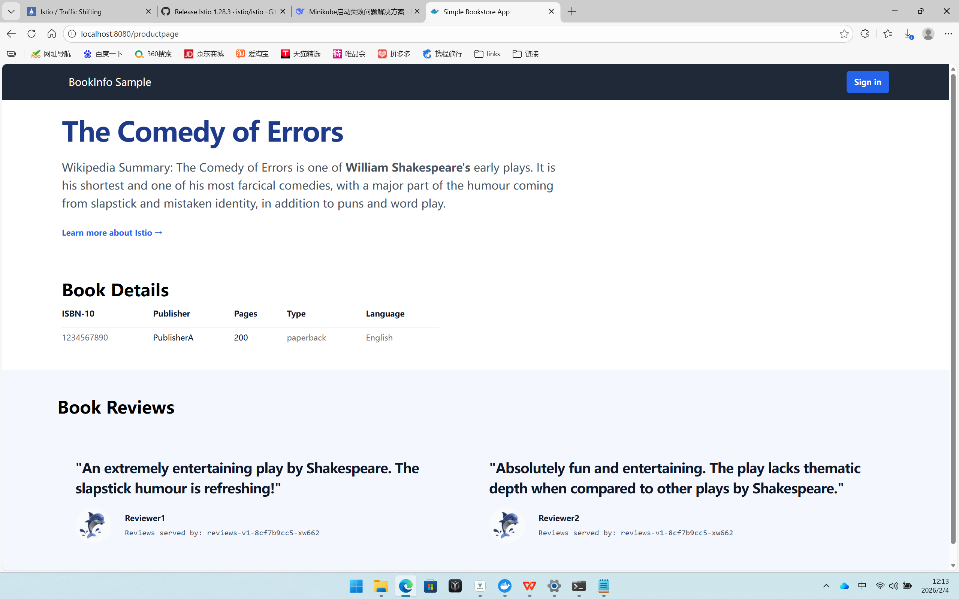
2. 50% v1 / 50% v3 traffic allocation
Verification: Refresh the page more than 10 times; occasionally, no avatars appear in the comments section (v1), and occasionally, red avatars appear (v3).
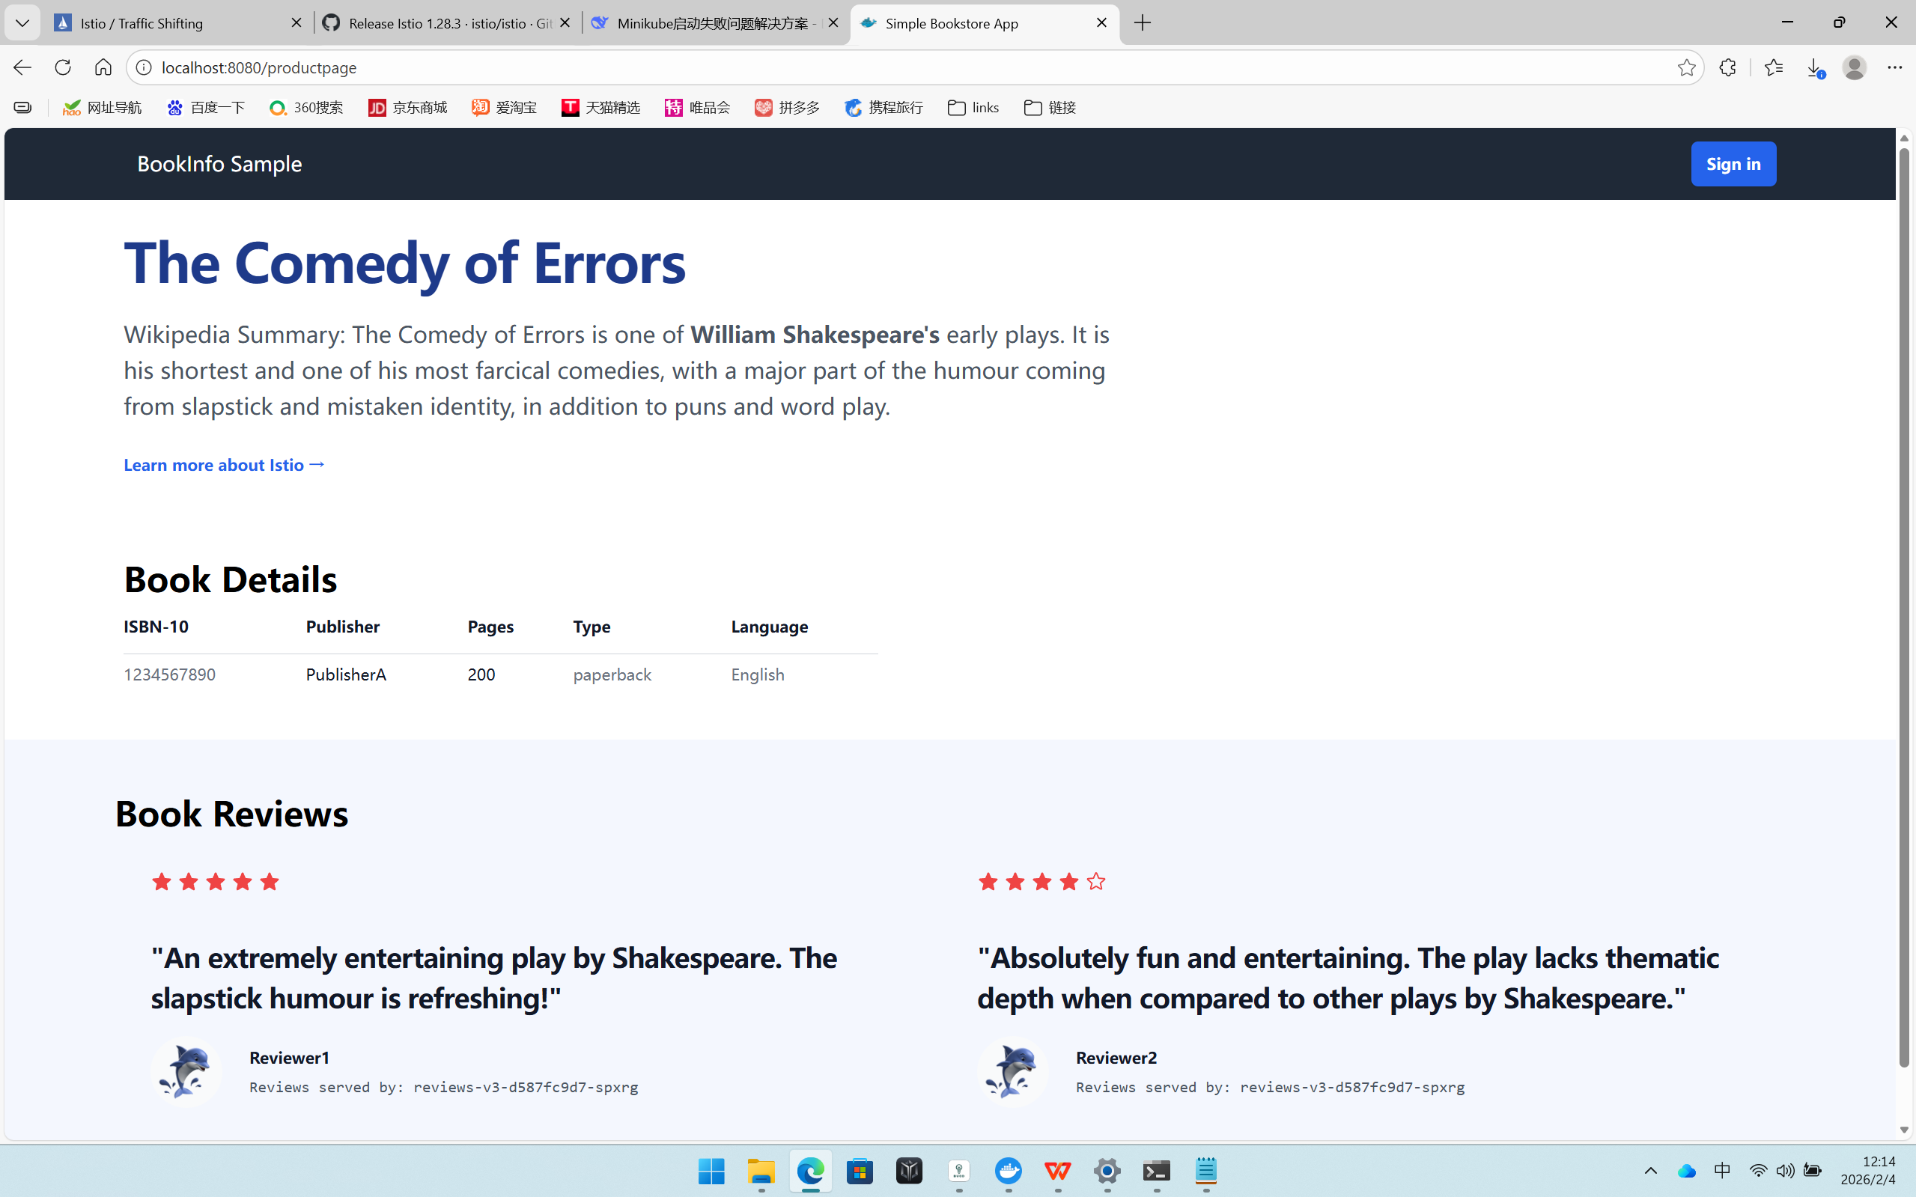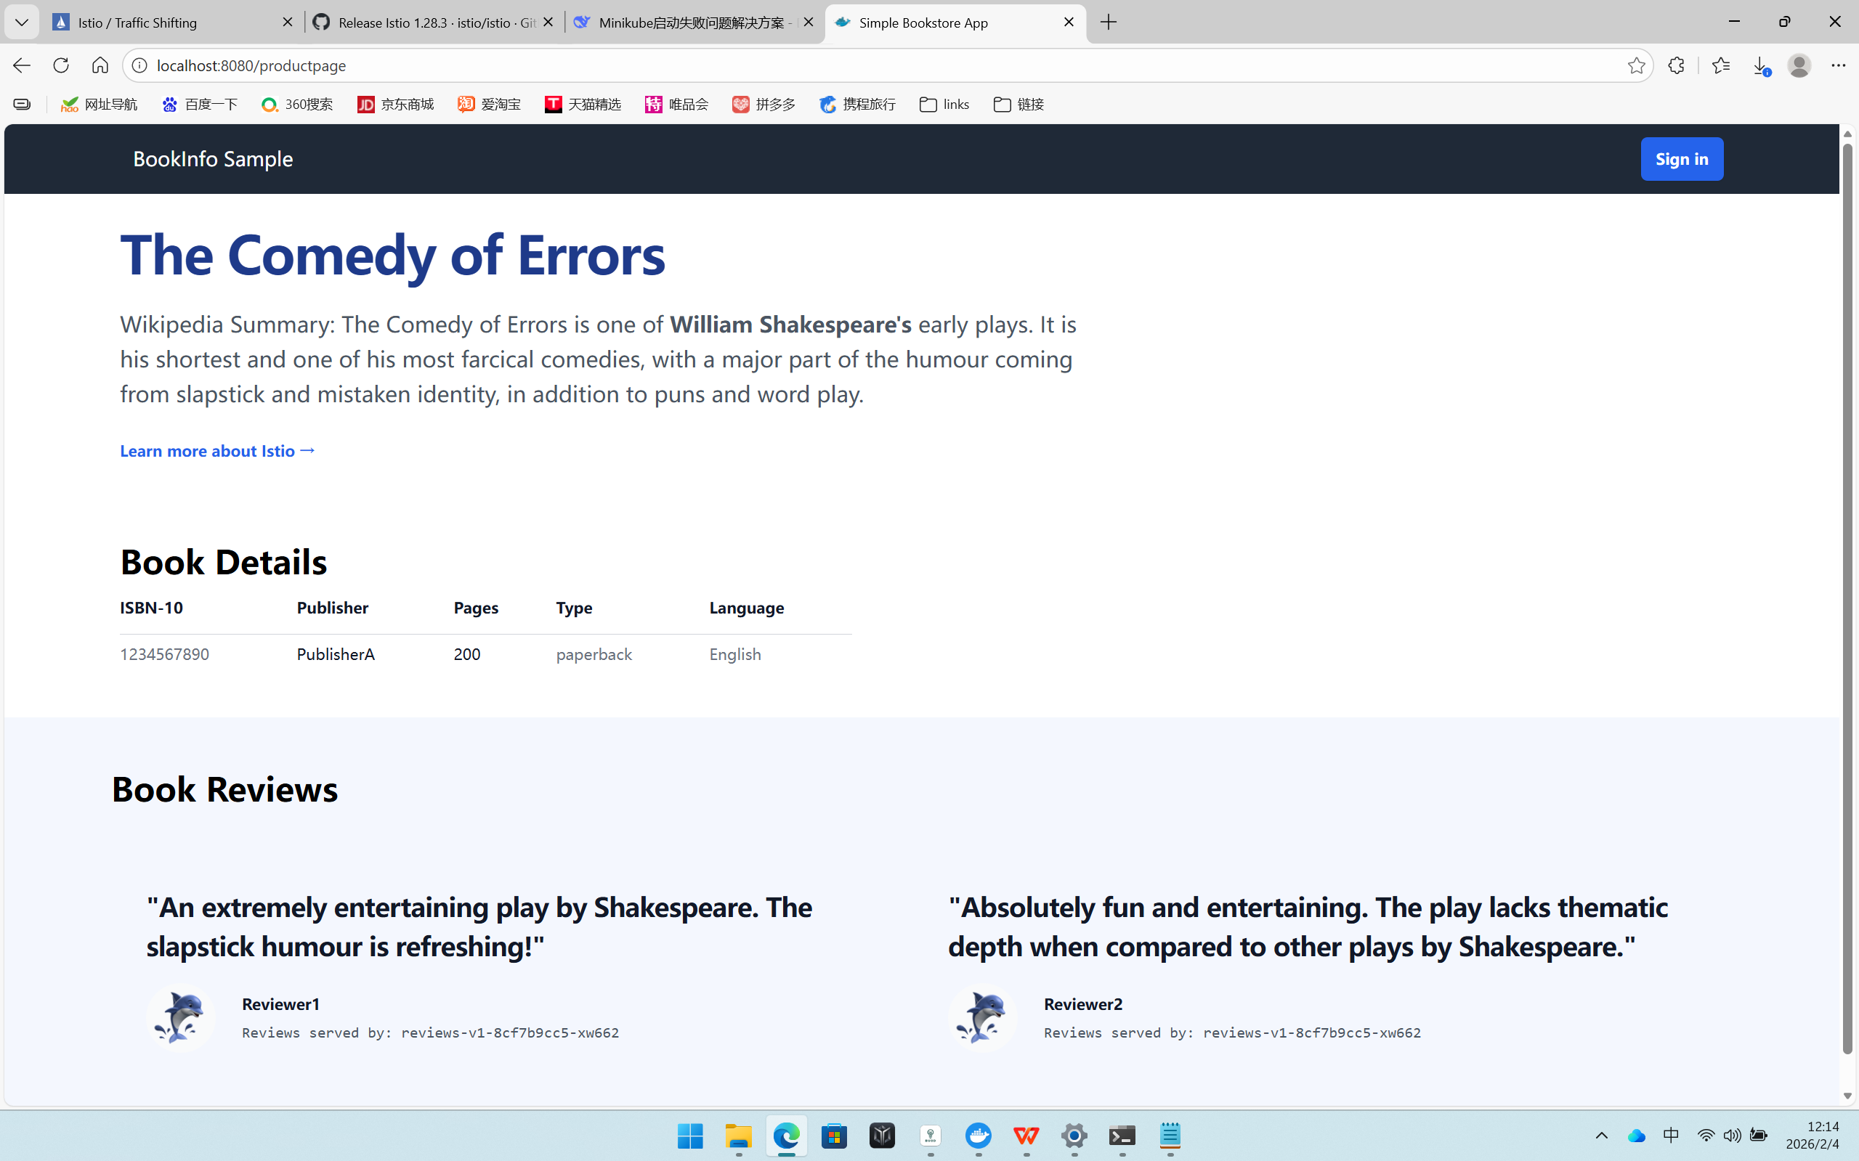
3. 100% traffic migration to v3
Verification: Refresh the page; the comment section will now display a fixed red avatar (v3).
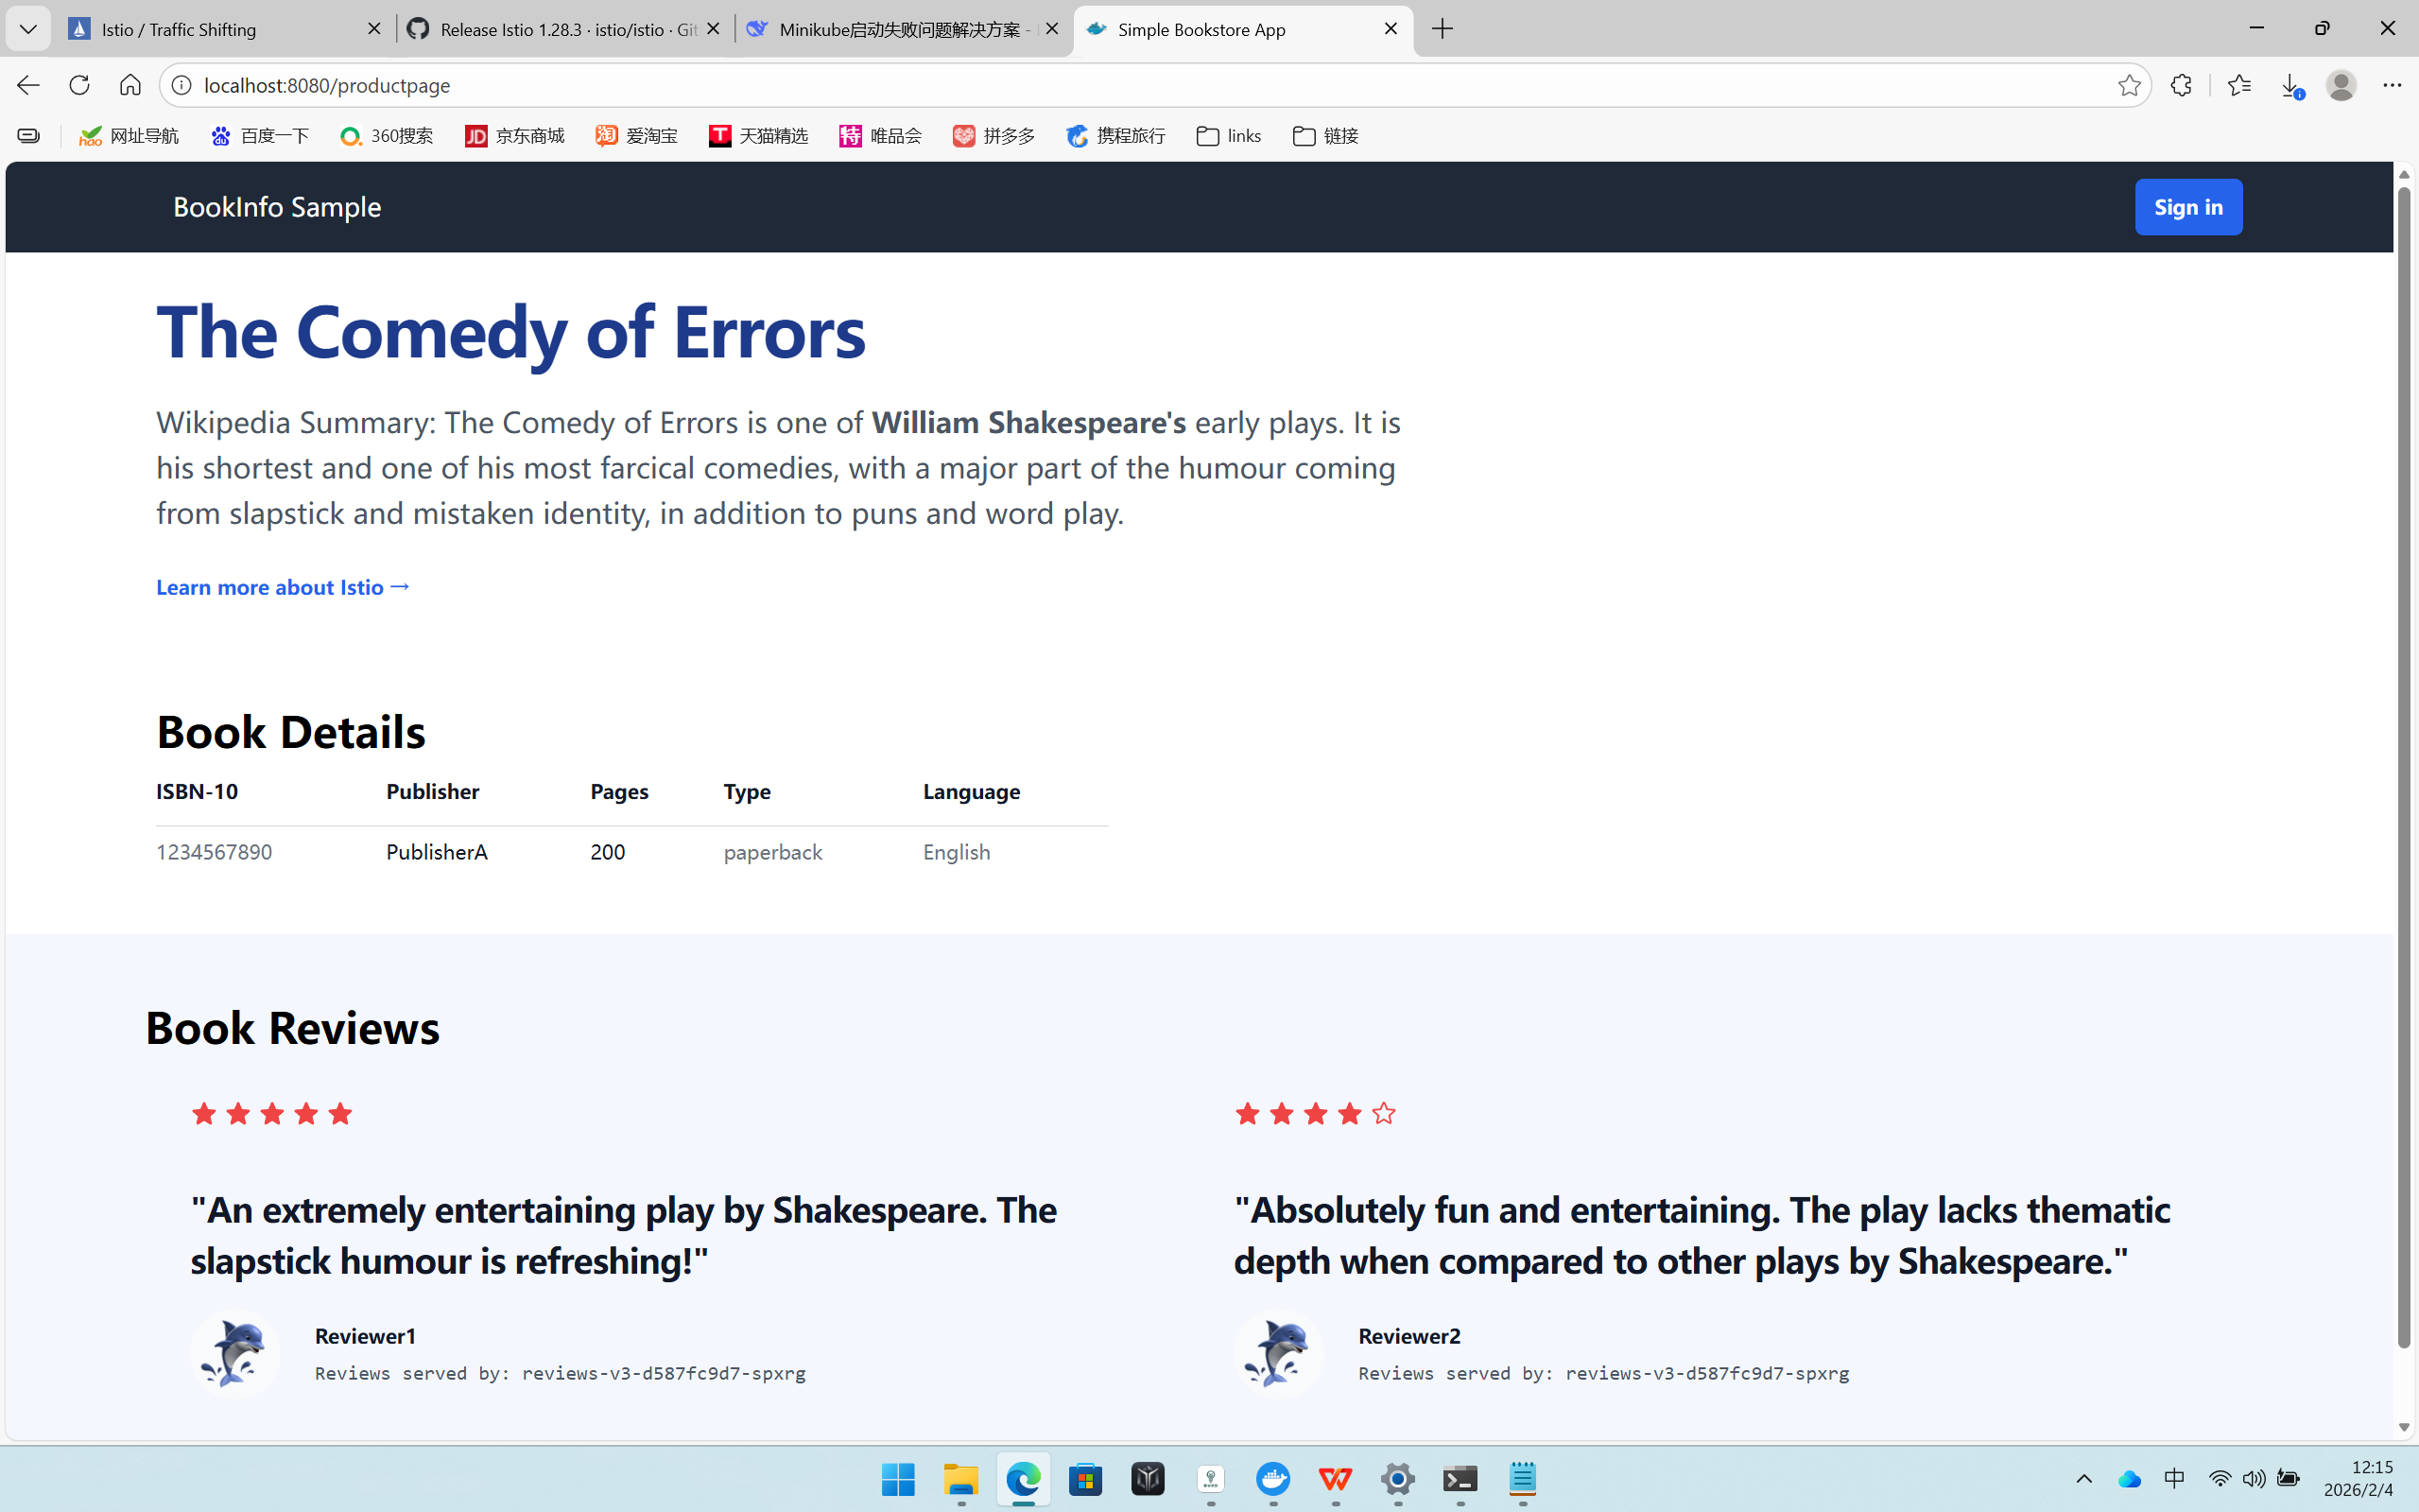

Request Routing
Route to version 1
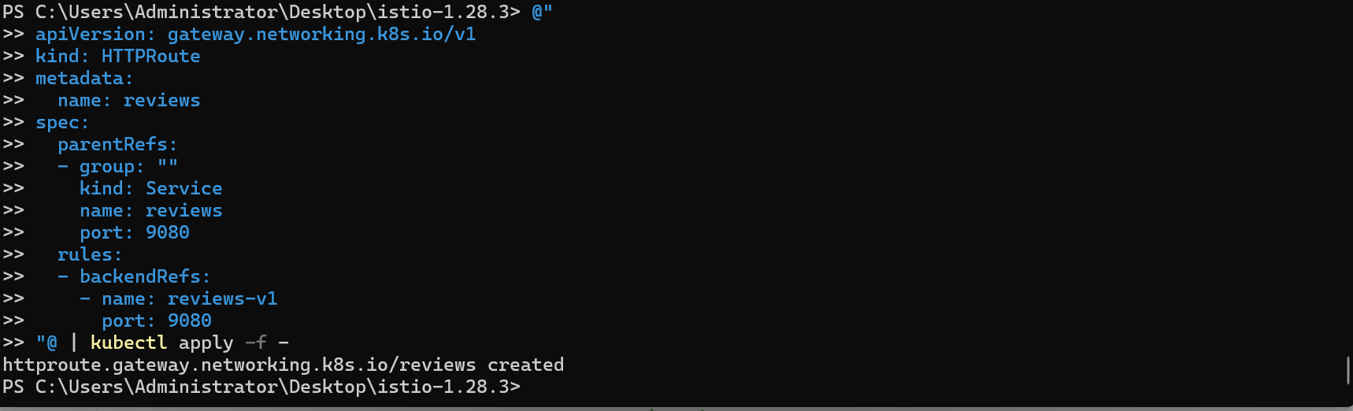
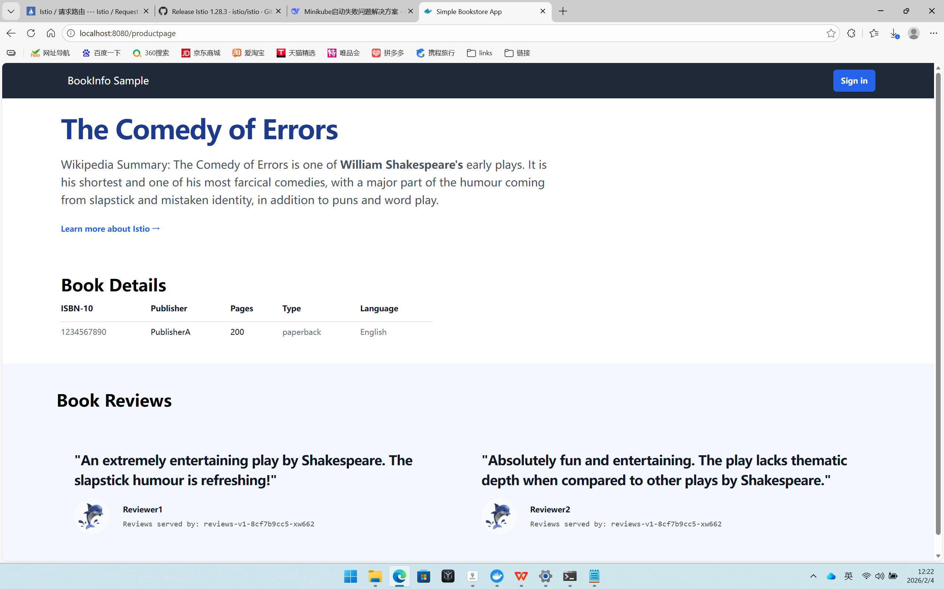
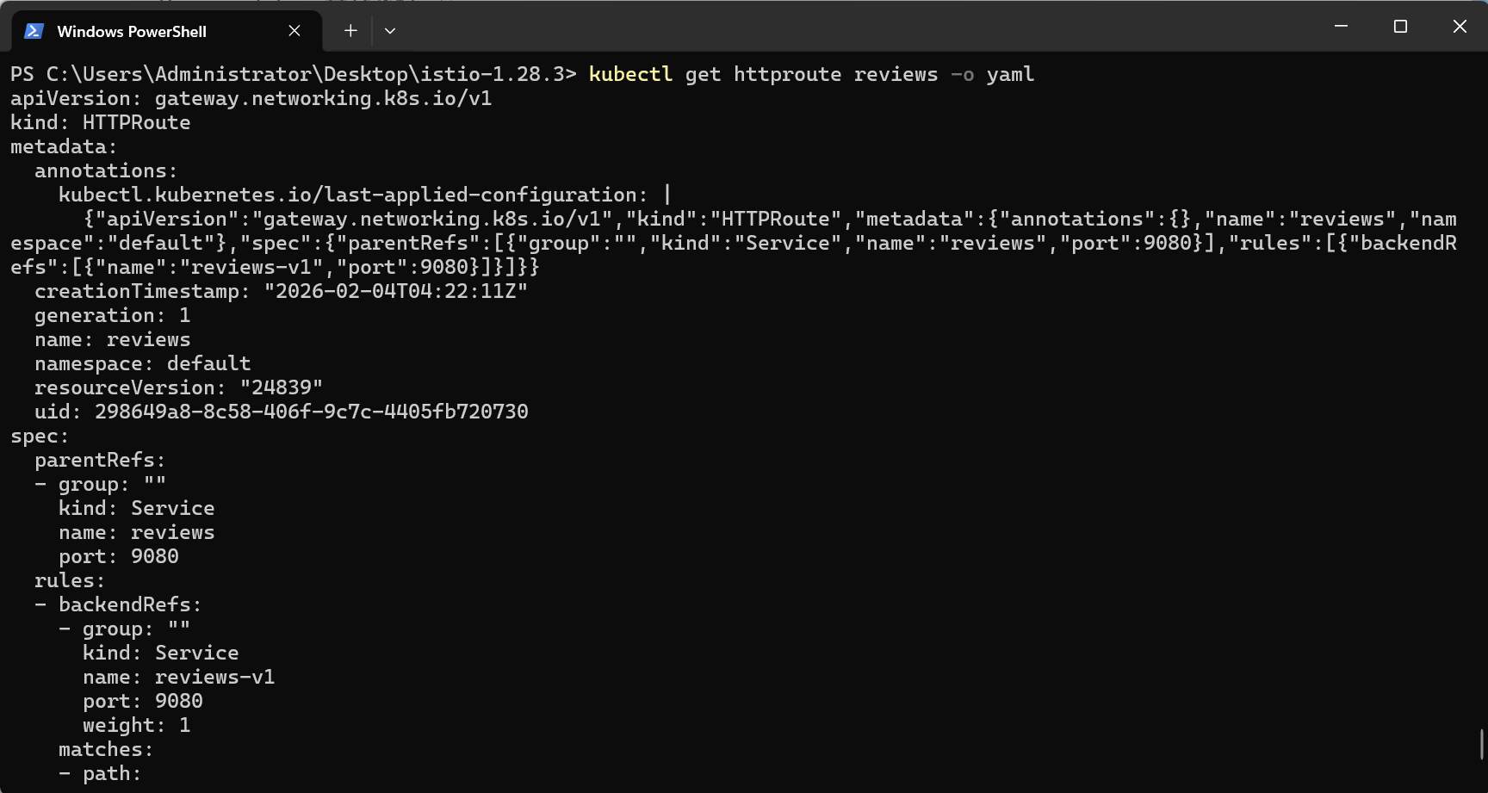

Set the rule for user jason:
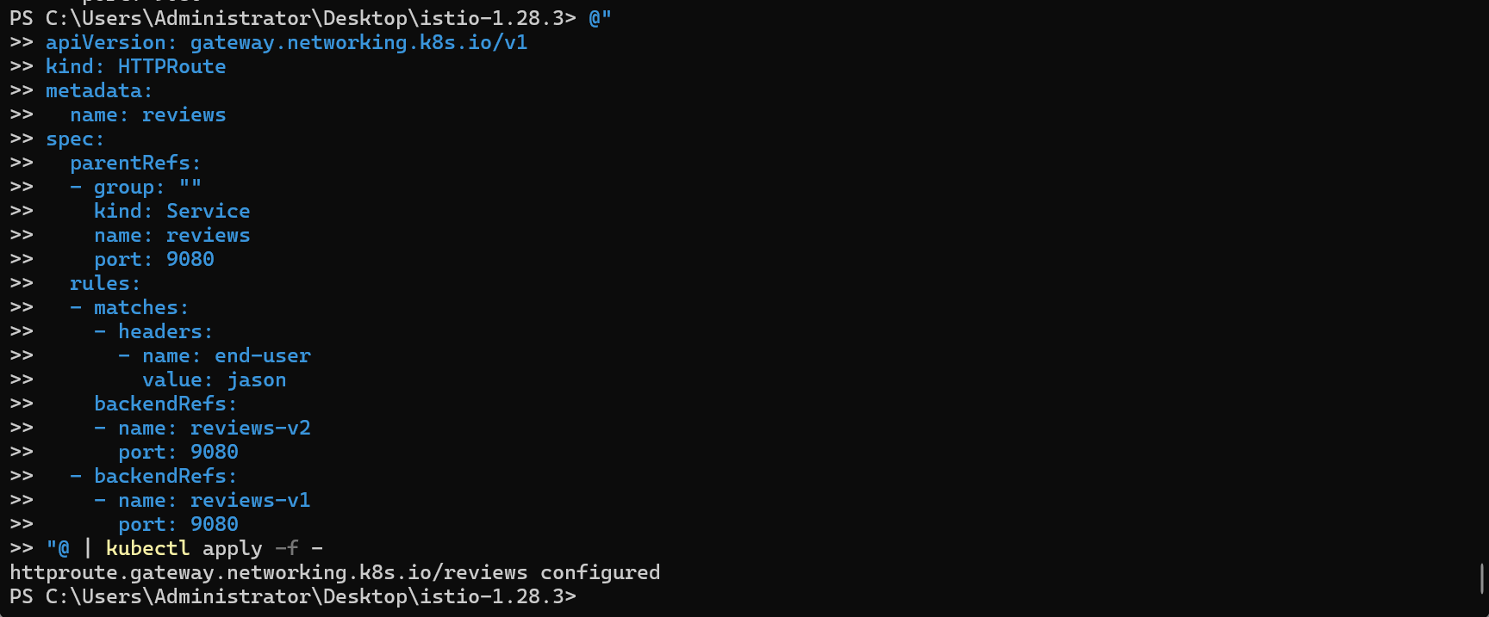
Then login as jason:
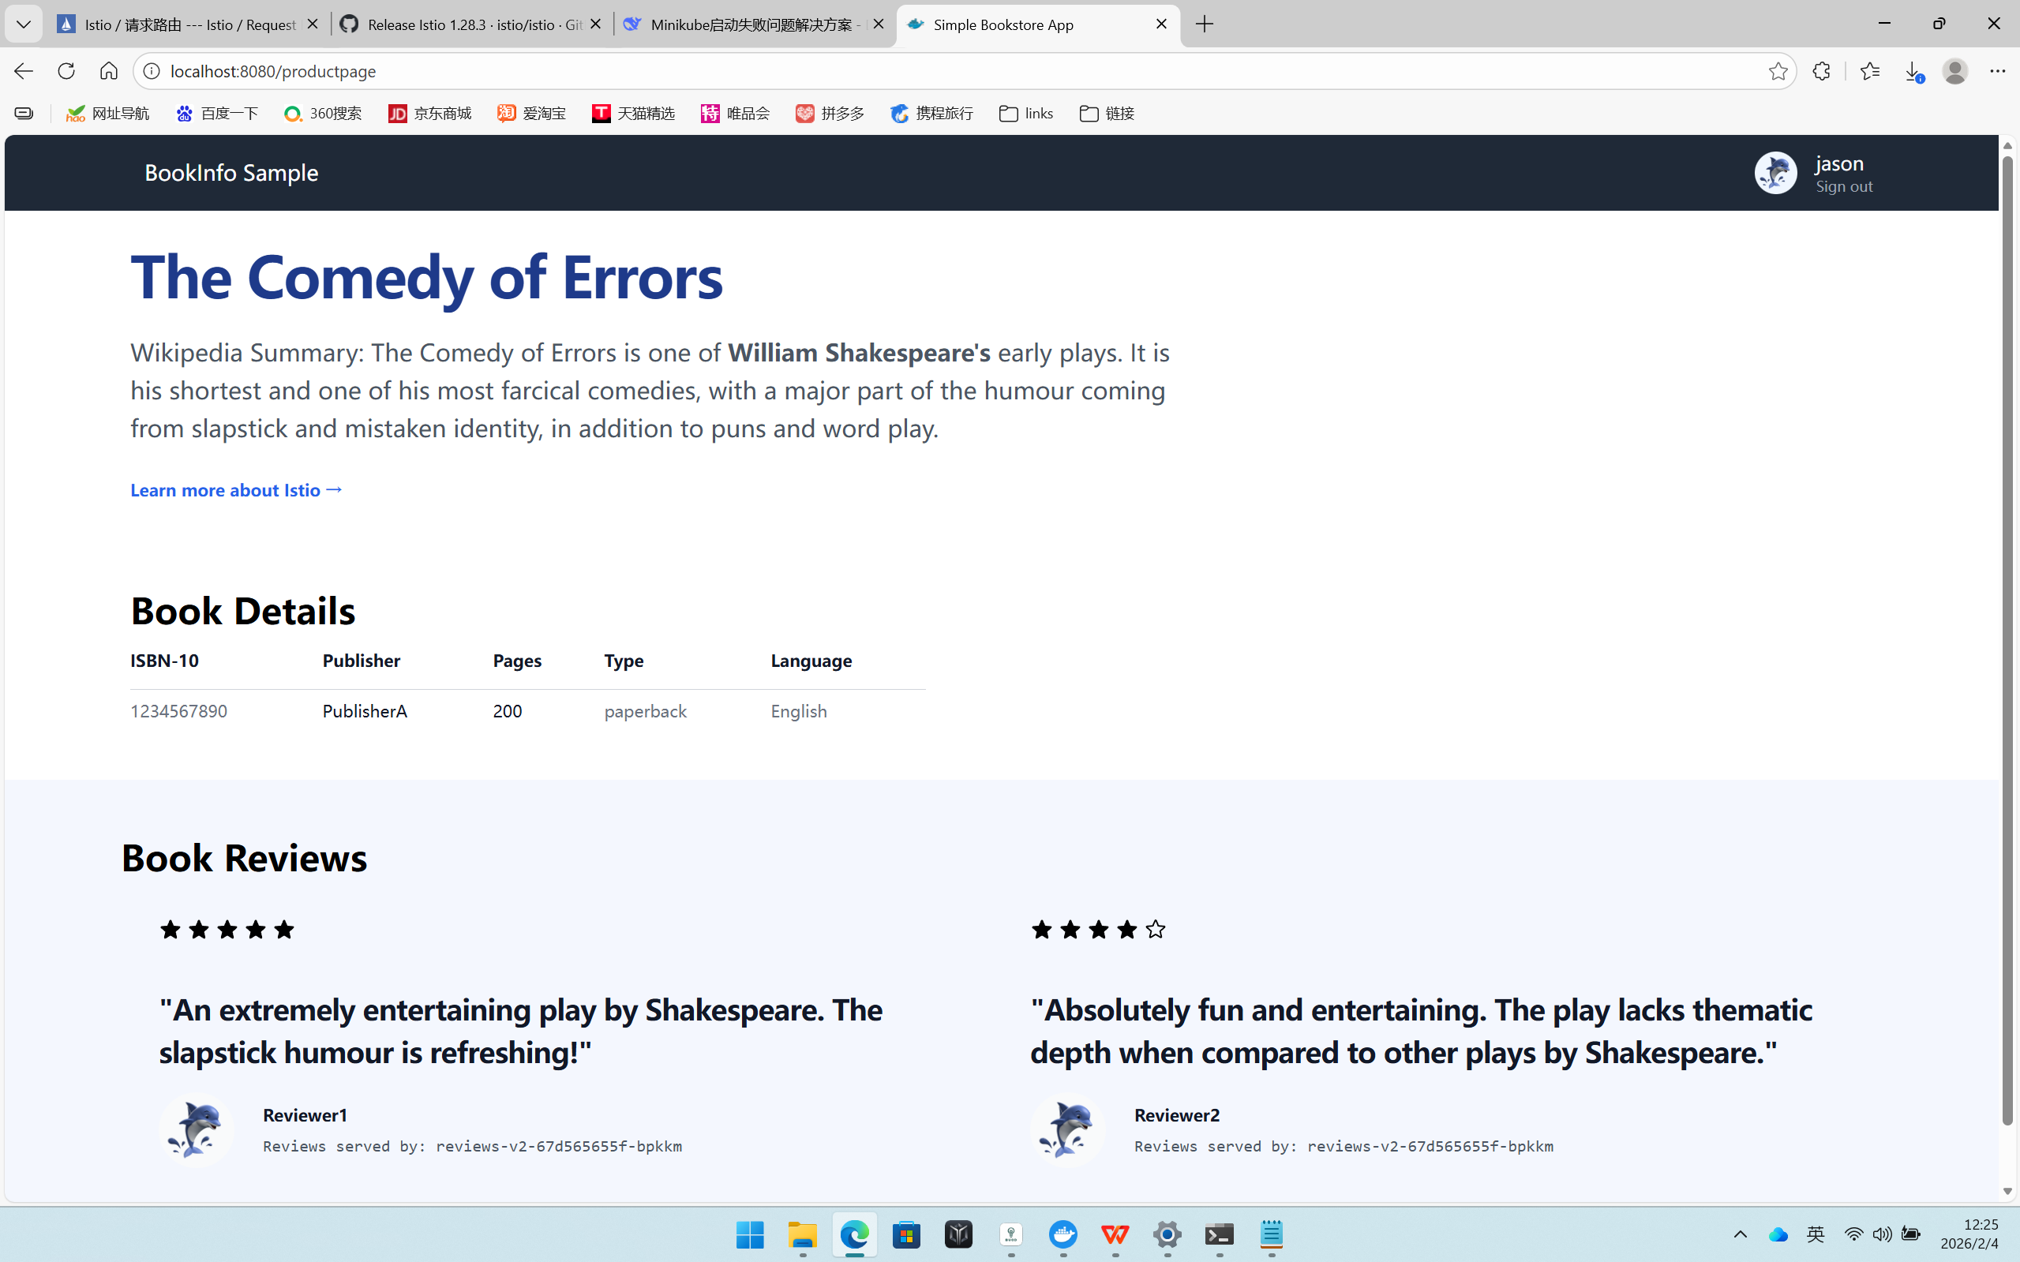

Login as other user(Here I am anson):
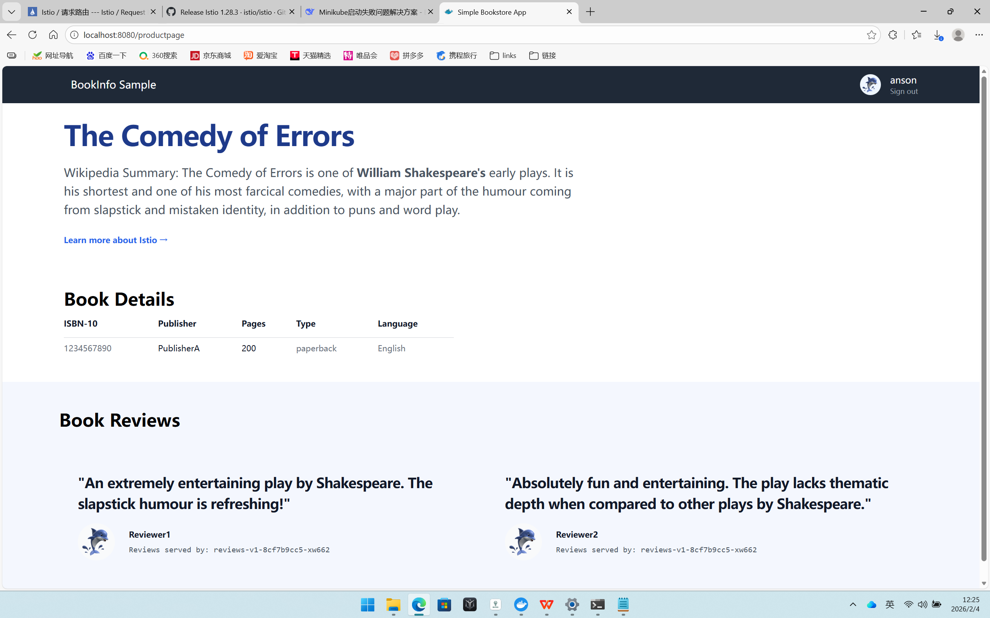

Only when you are jason, you can see stars on the reviews.

Fault Injection
Apply application version routing by either performing the request routing task or by running the following commands: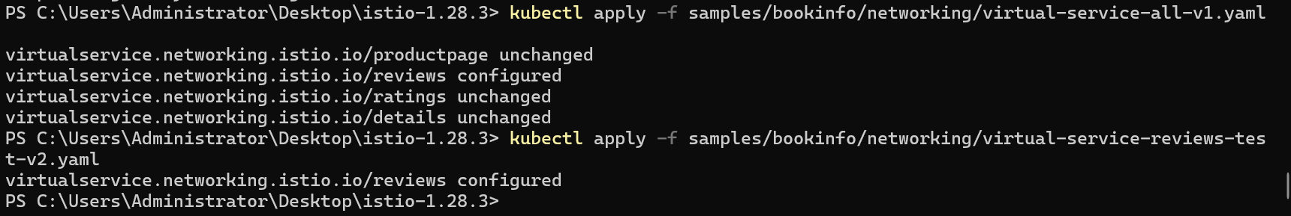
With the above configuration, this is how requests flow:
productpage → reviews:v2 → ratings (only for user jason)
productpage → reviews:v1 (for everyone else)
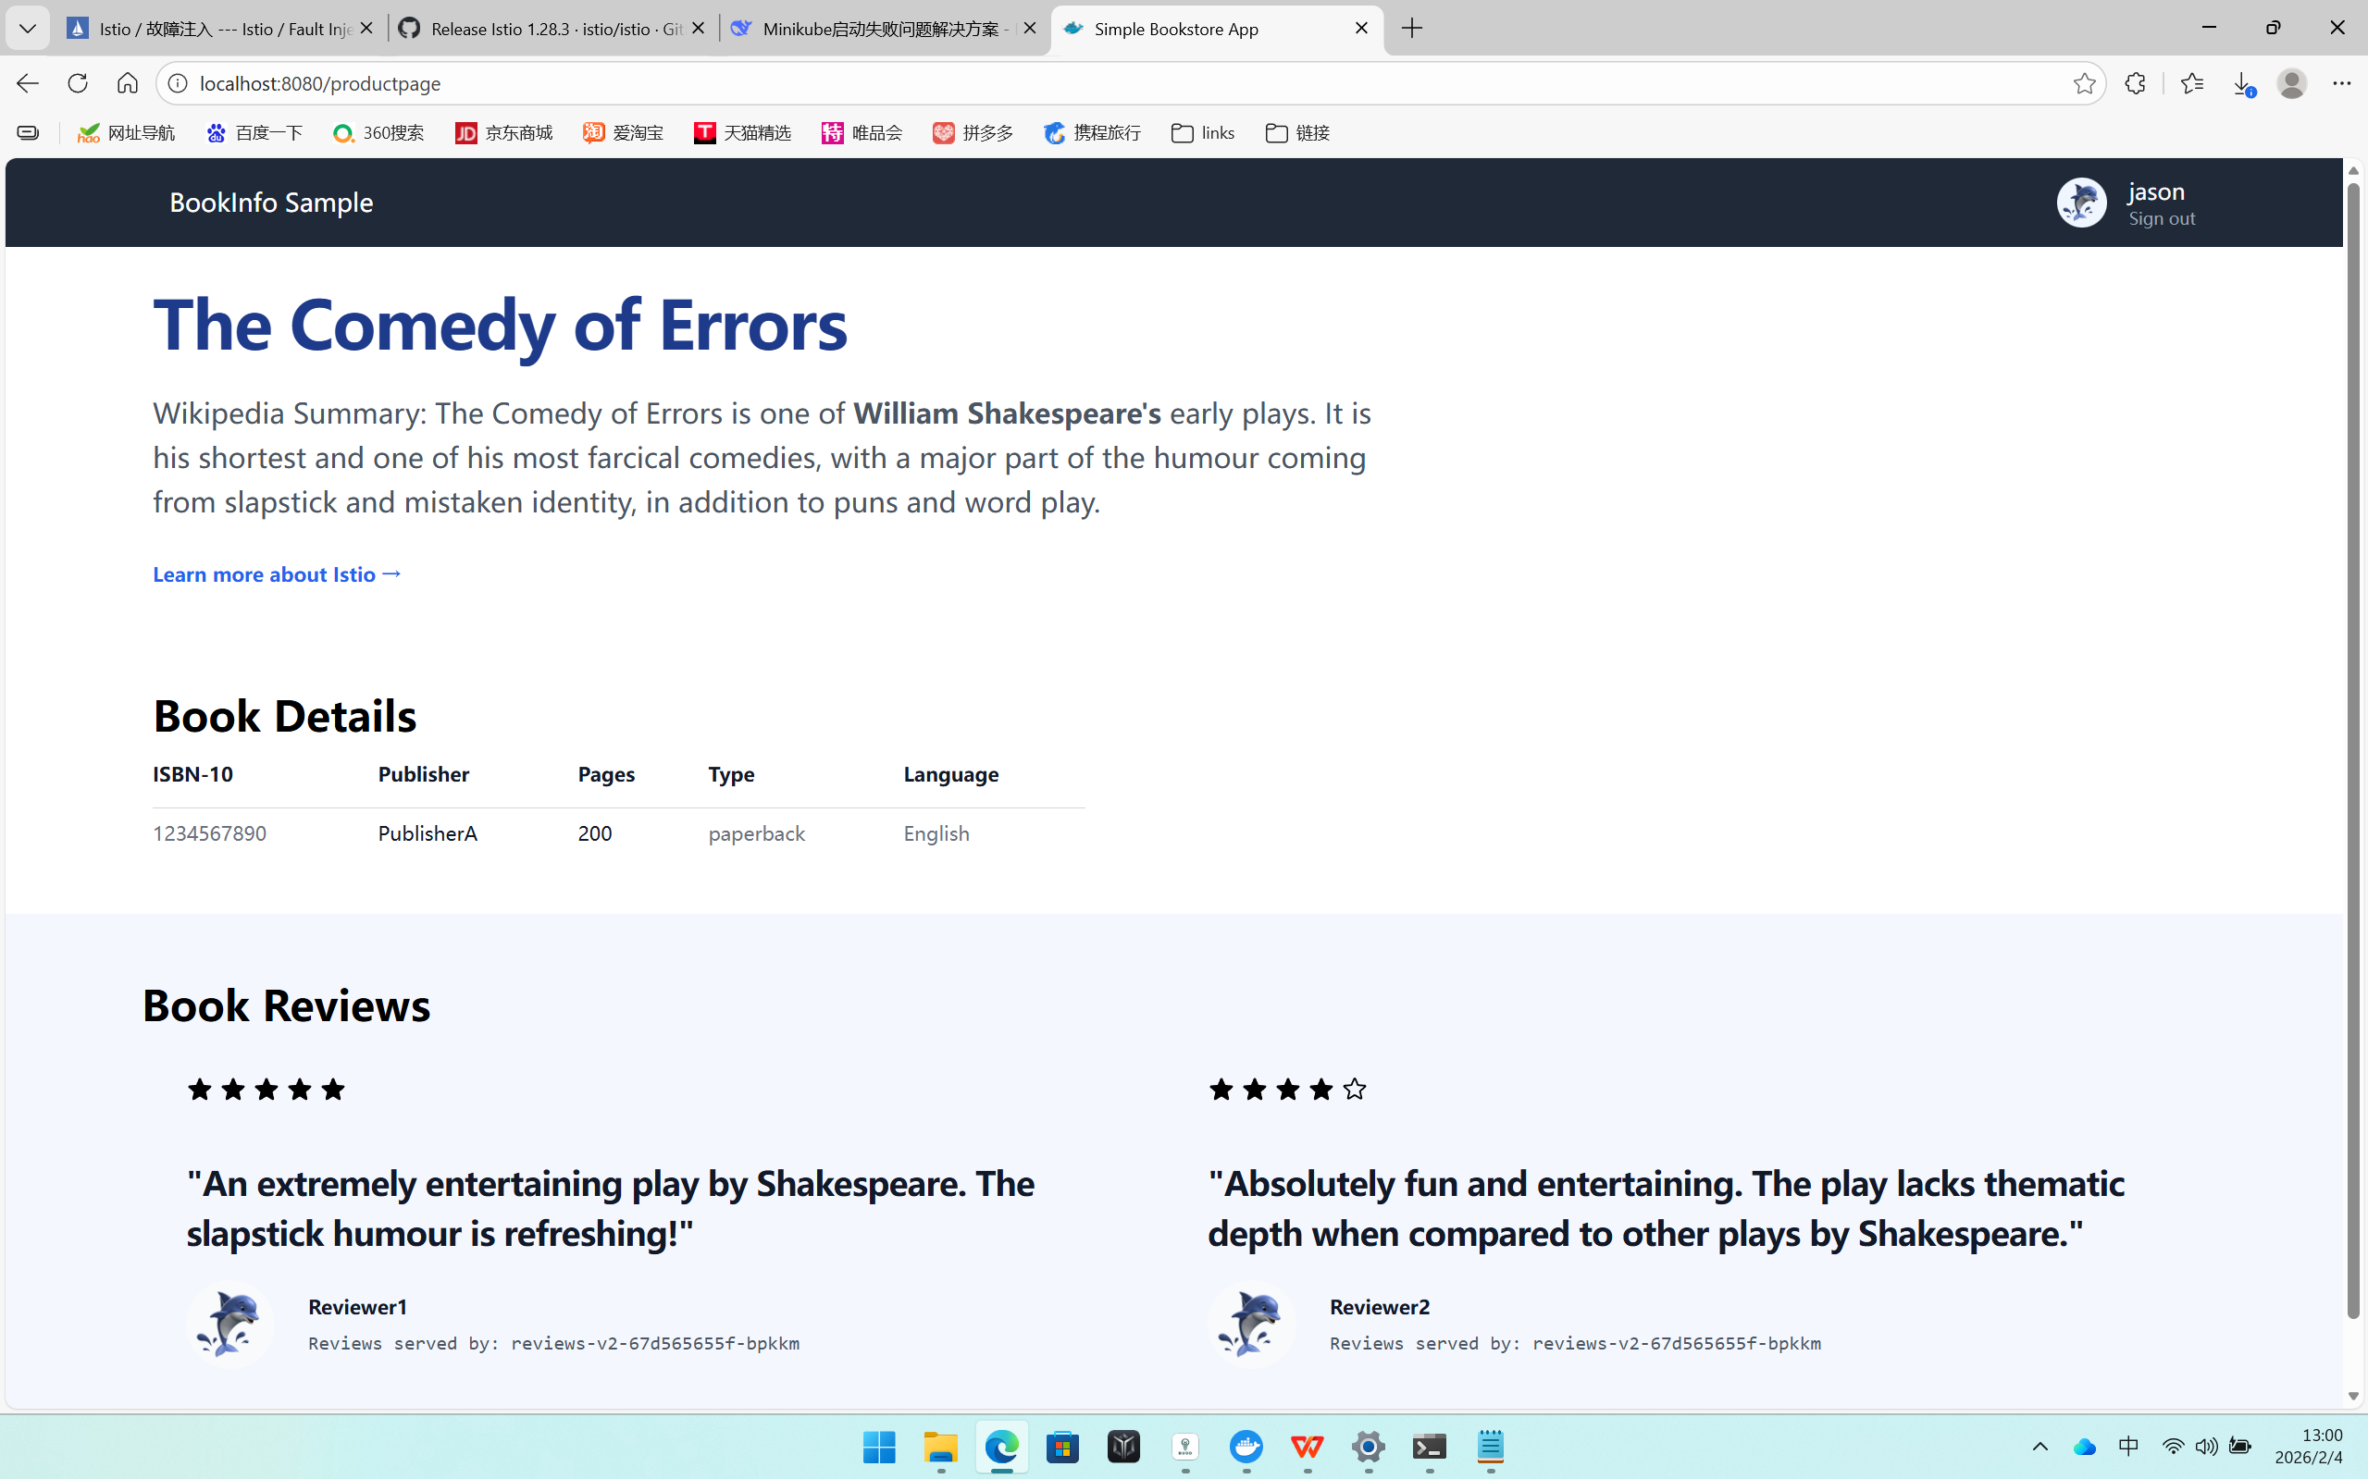
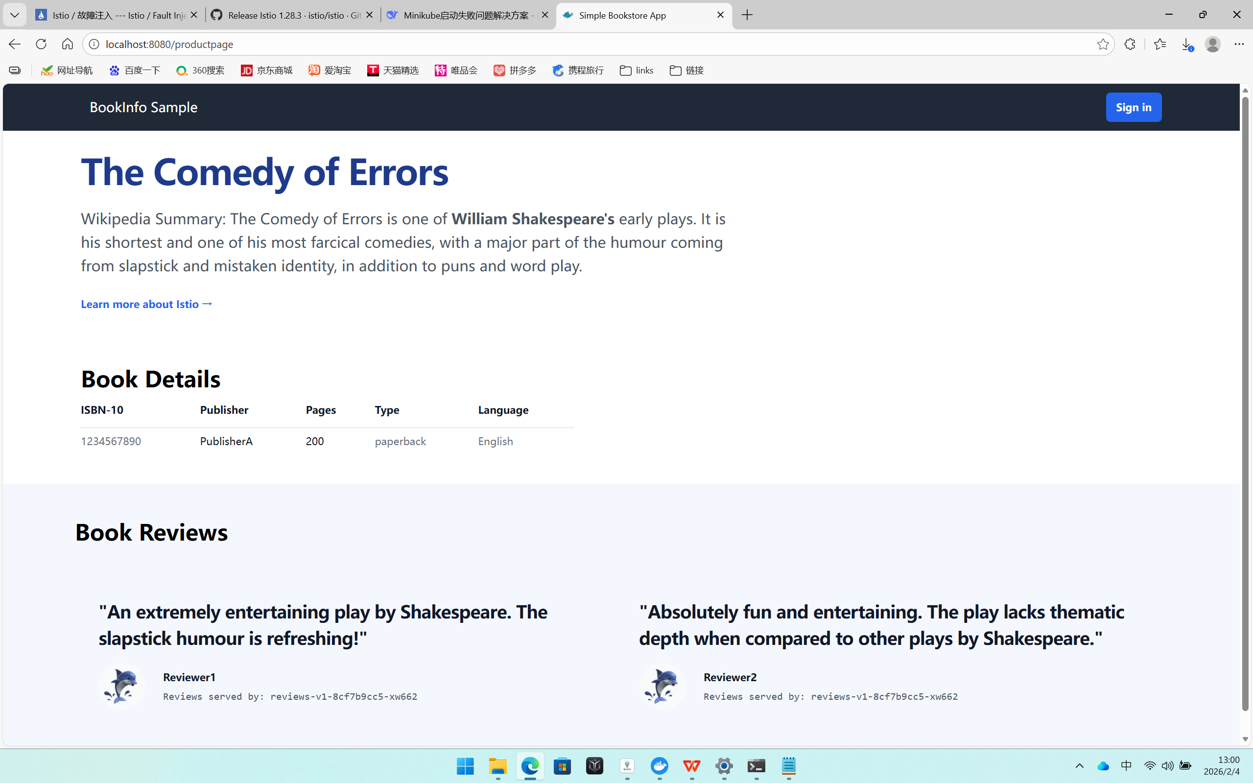
So you can see only when login as jason, there are stars rating in reviews.

Injecting an HTTP delay fault:

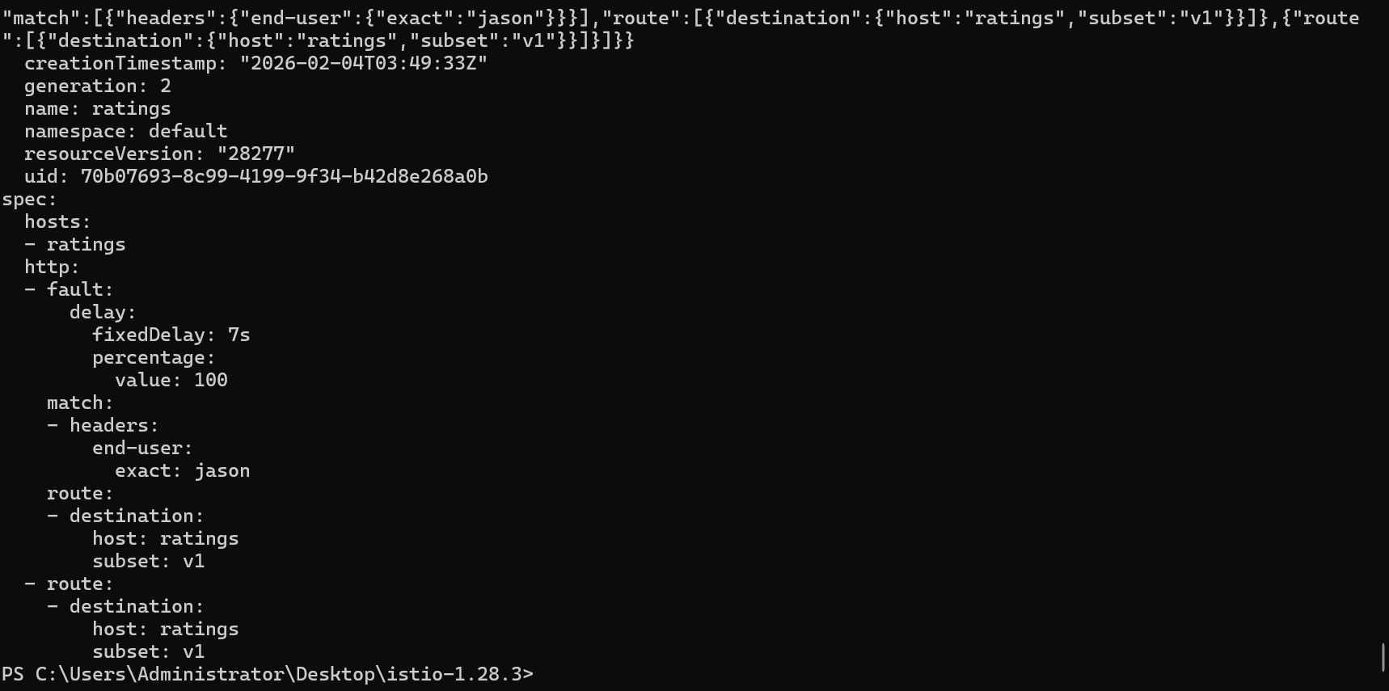
After that when you login as jason, you expect the Bookinfo home page to load without errors in approximately 7 seconds. However, there is a problem: the Reviews section displays an error message:
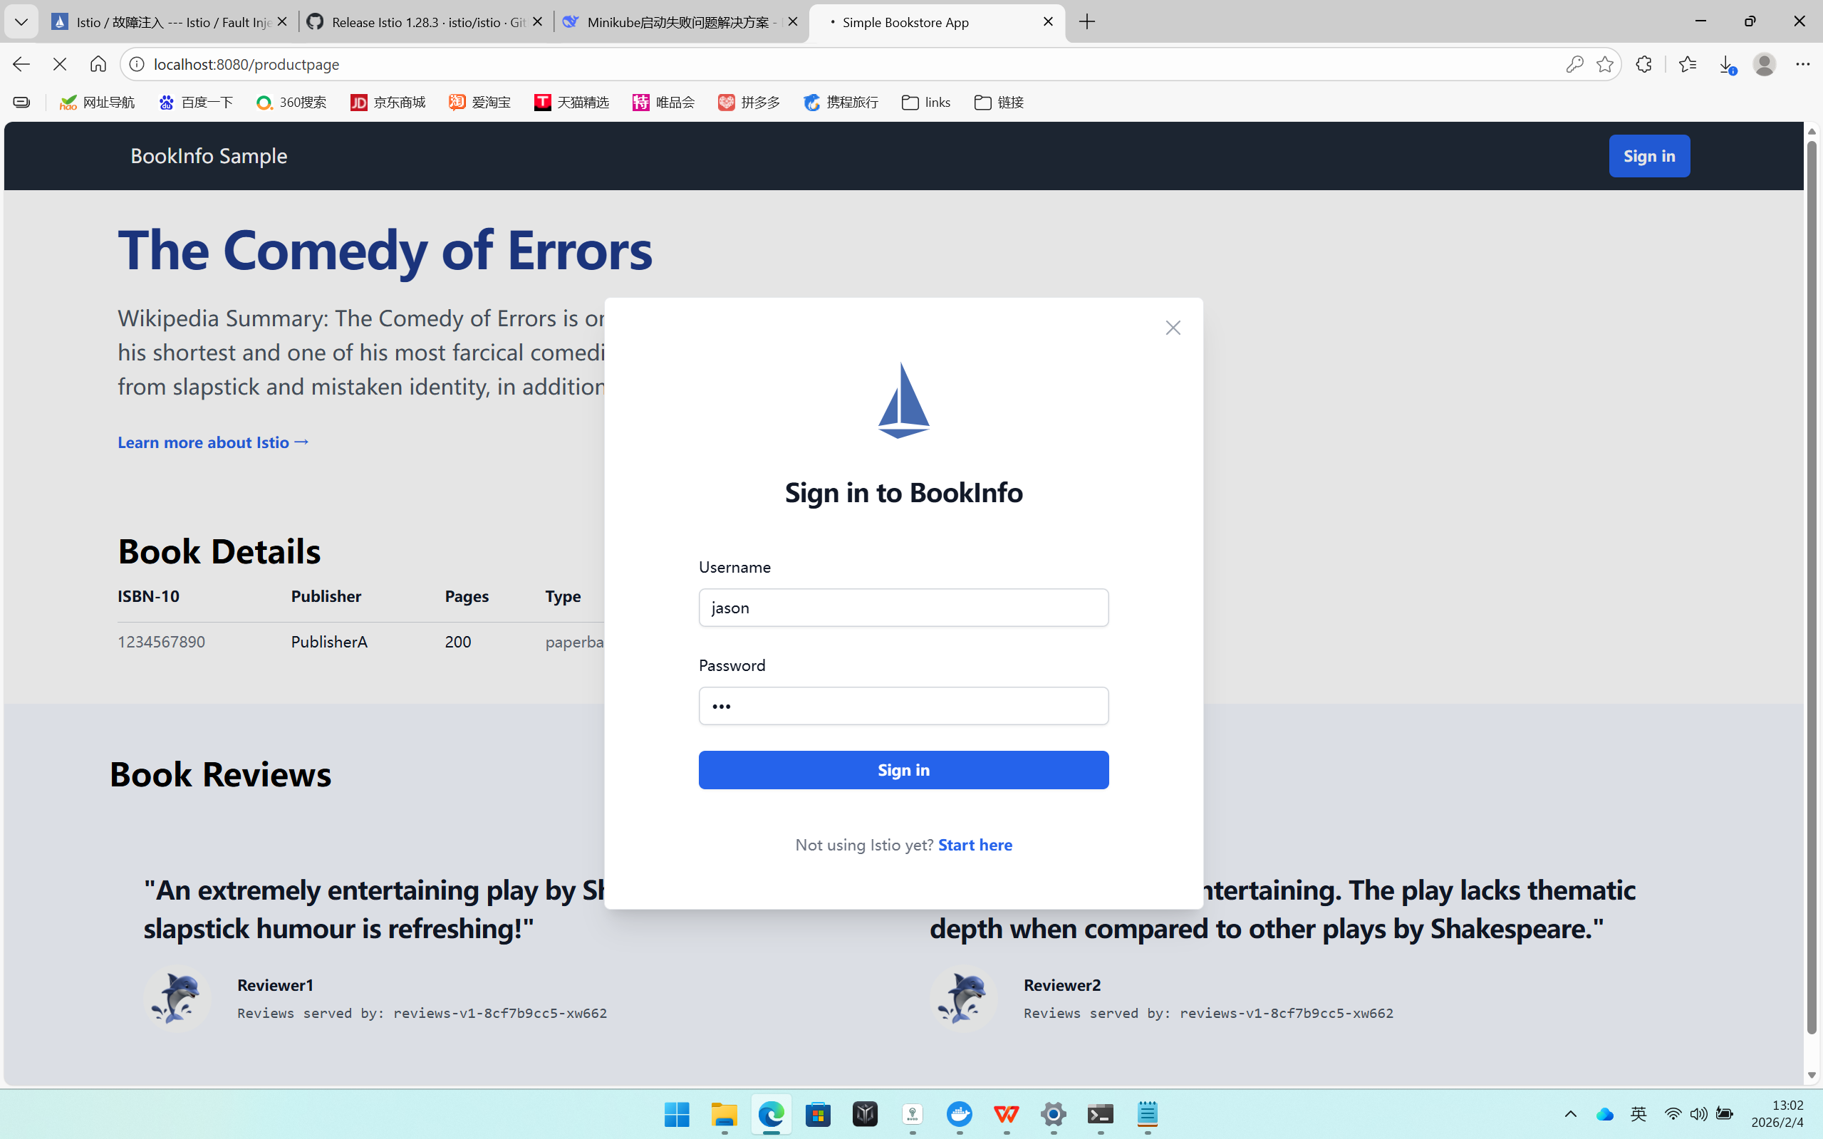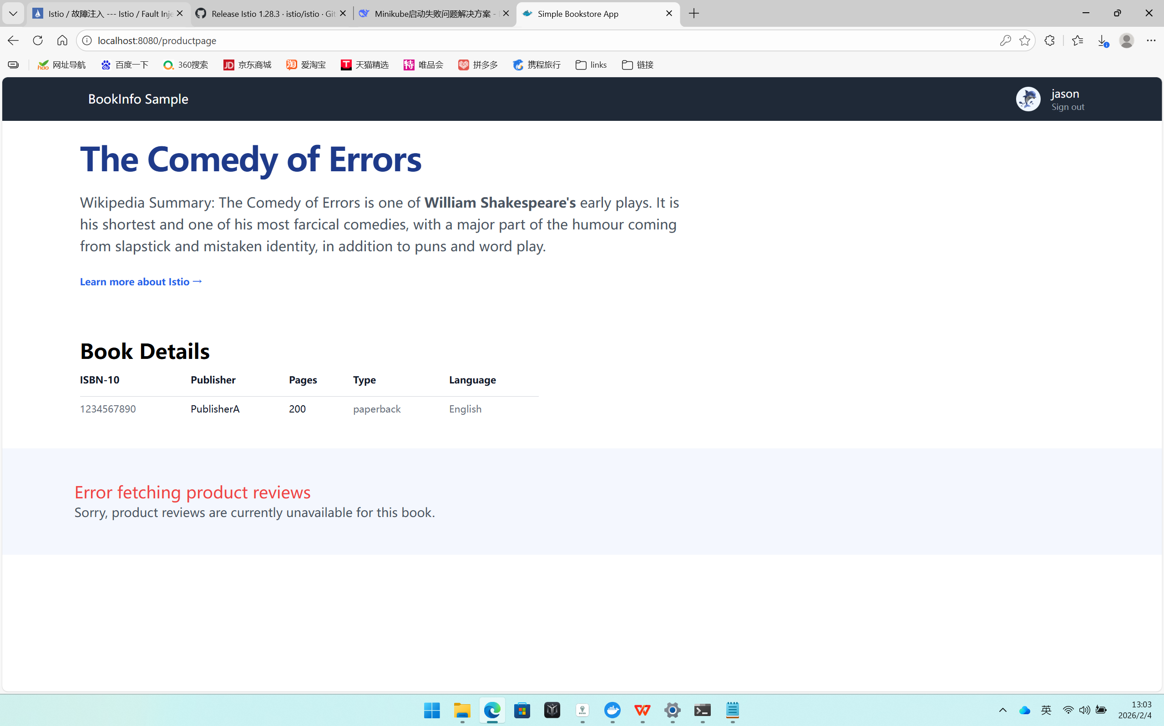

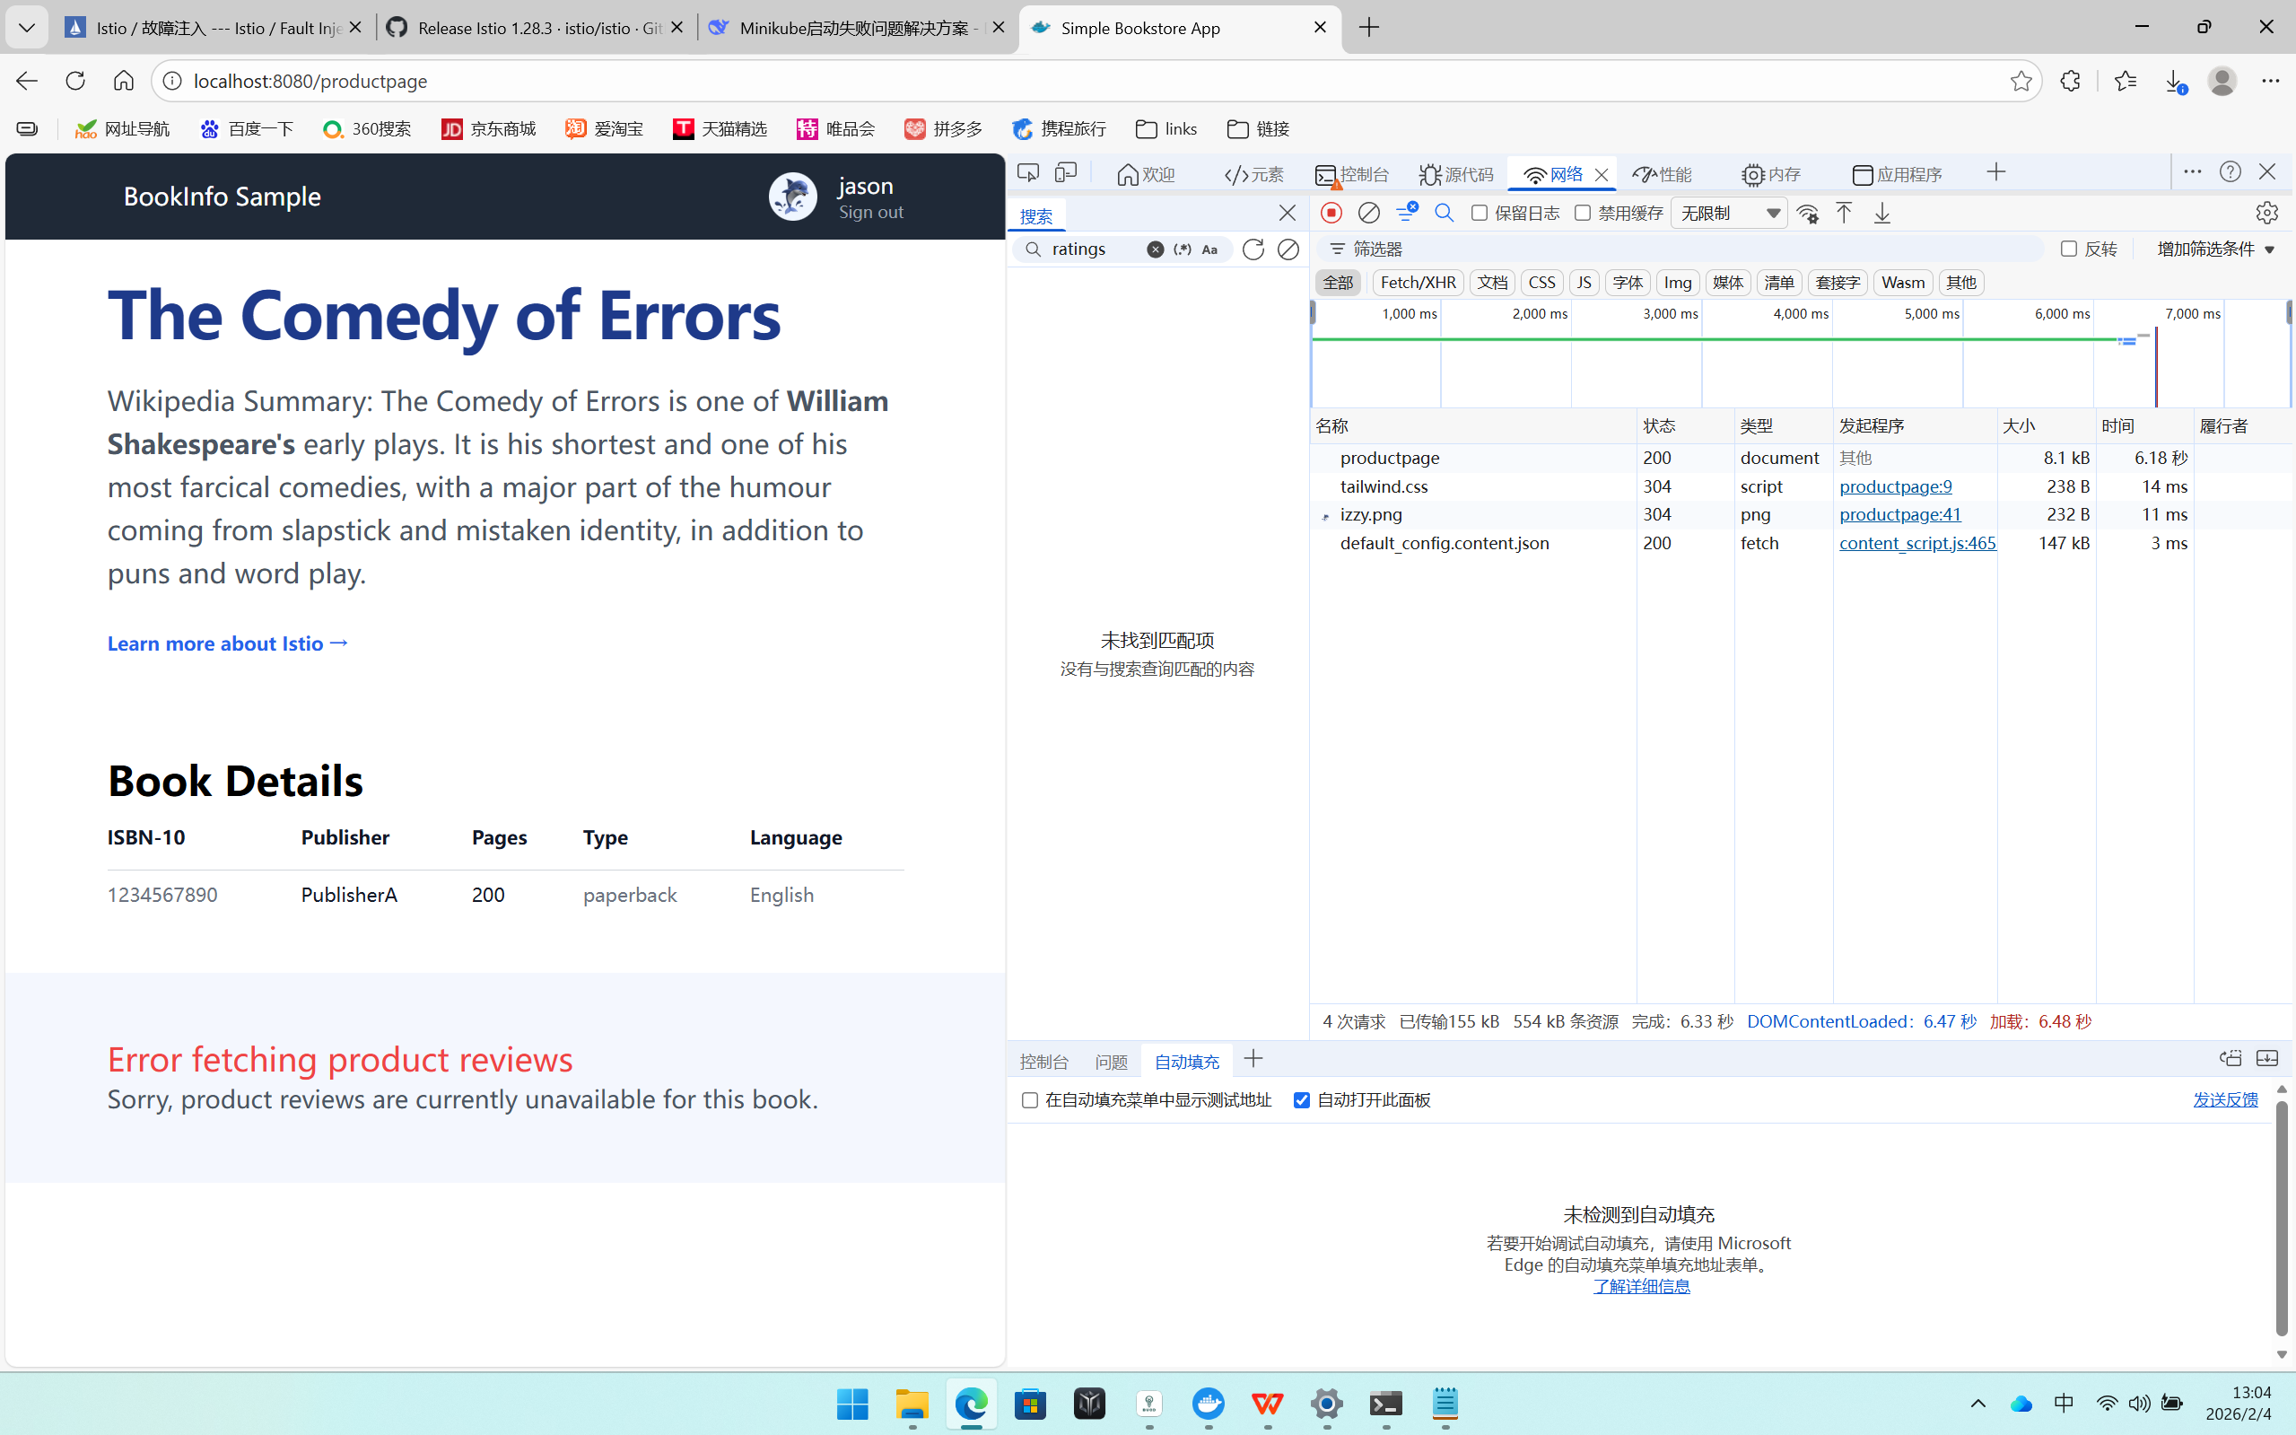
And there’s about a 6s delay when you refresh this page.
You’ve found a bug. There are hard-coded timeouts in the microservices that have caused the reviews service to fail.

As expected, the 7s delay you introduced doesn’t affect the reviews service because the timeout between the reviews and ratings service is hard-coded at 10s. However, there is also a hard-coded timeout between the productpage and the reviews service, coded as 3s + 1 retry for 6s total. As a result, the productpage call to reviews times out prematurely and throws an error after 6s.

Bugs like this can occur in typical enterprise applications where different teams develop different microservices independently. Istio’s fault injection rules help you identify such anomalies without impacting end users.

Injecting an HTTP abort fault:
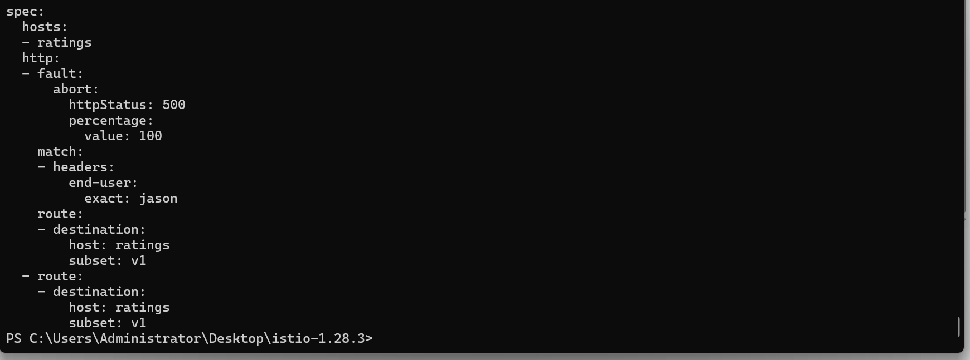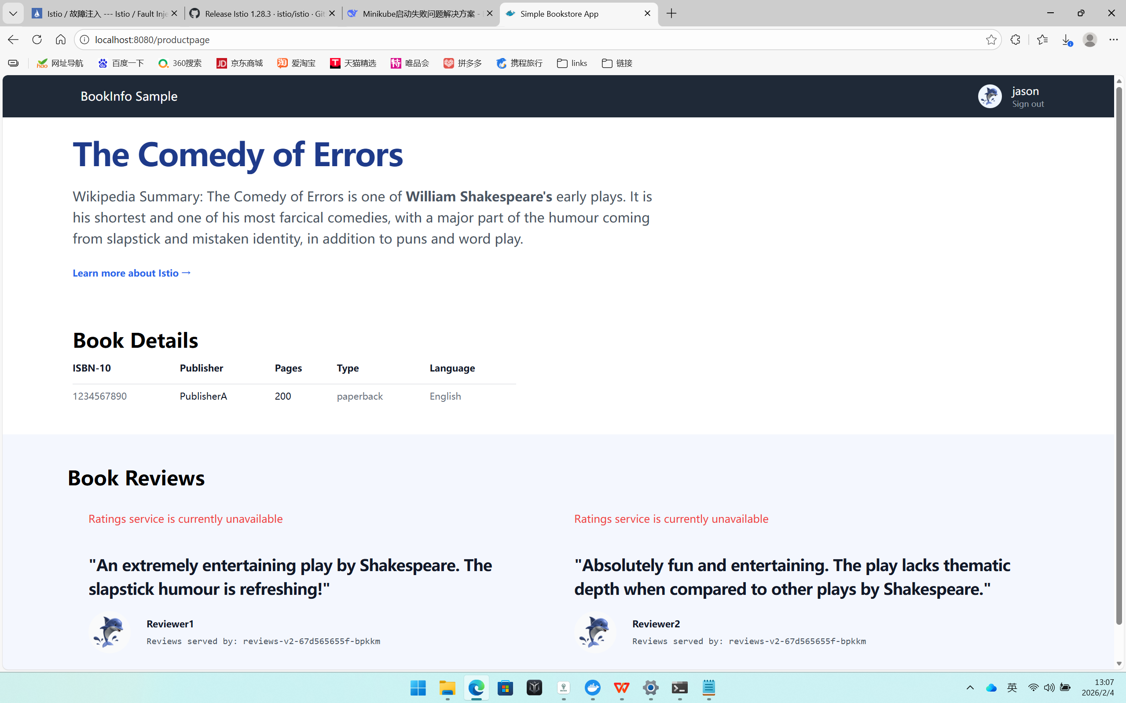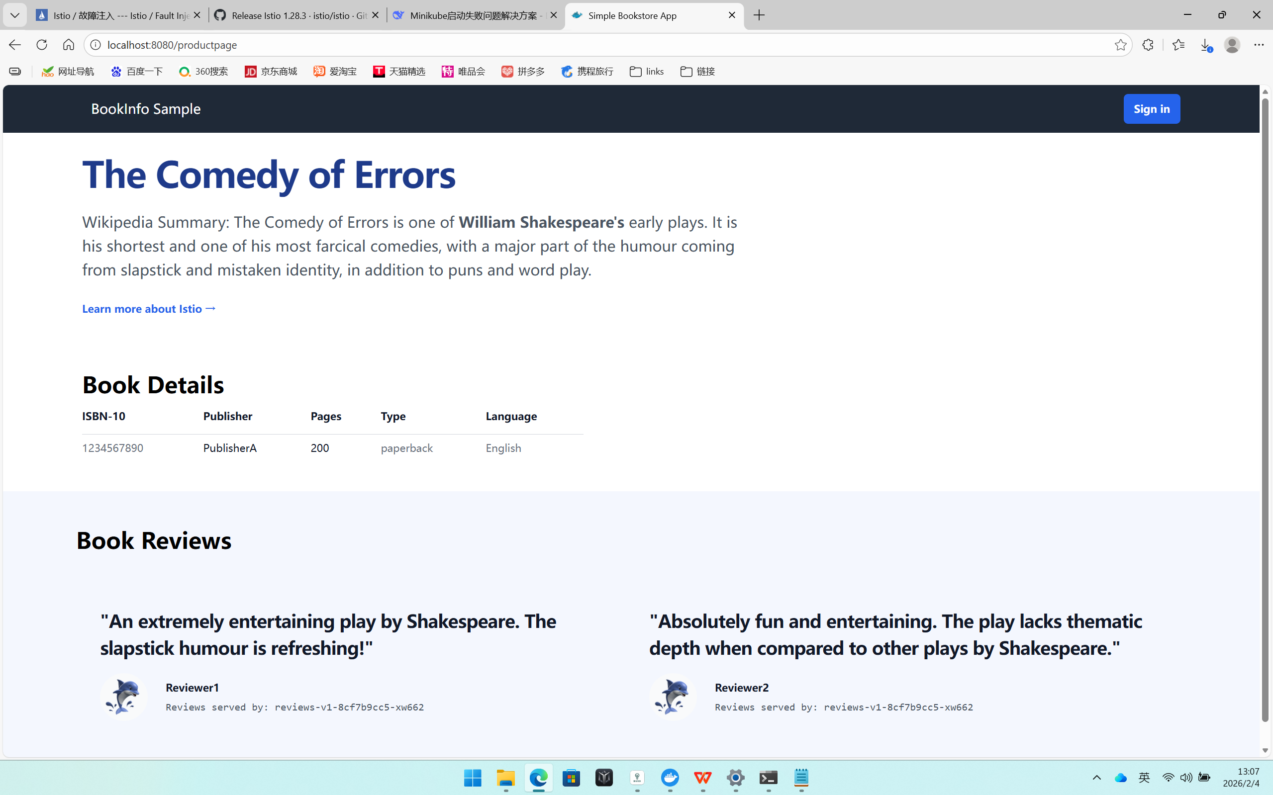
The rating service can’t work only when login as jason.

Circuit Breaking
1. Deploy the httpbin service (for testing circuit breakers)

2. Configuring the circuit breaker
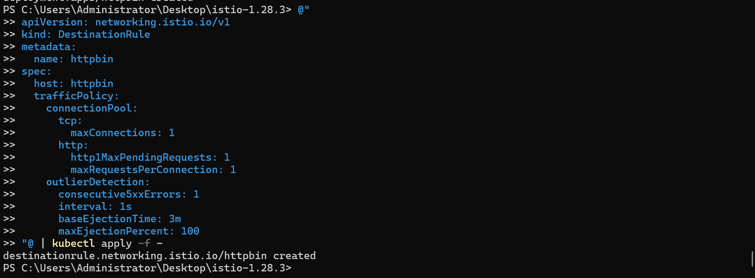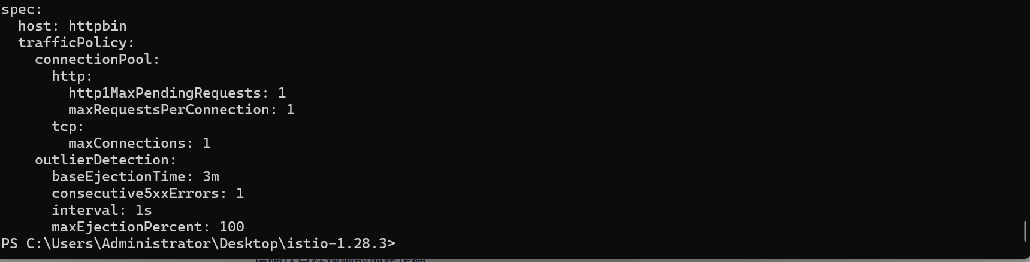

3. Adding a client
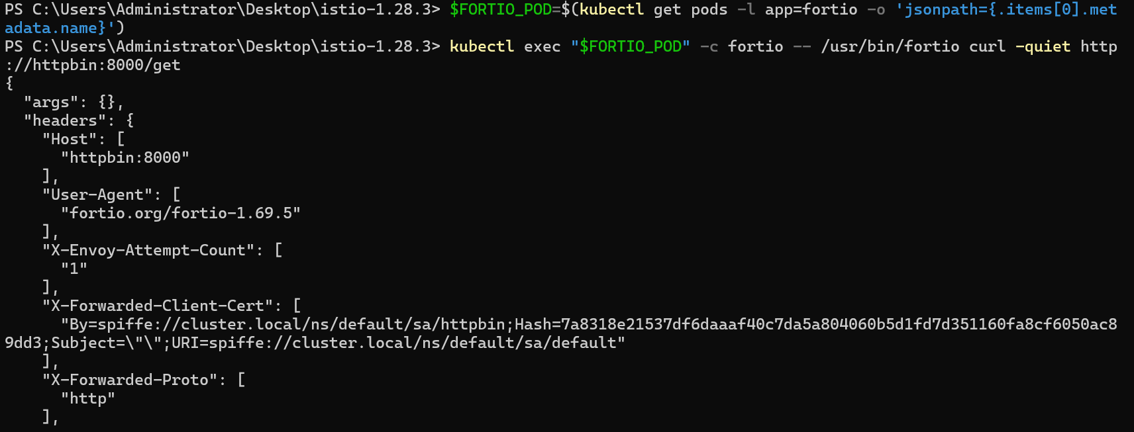

4. Tripping the circuit breaker
