Knative
Install the Knative Serving component
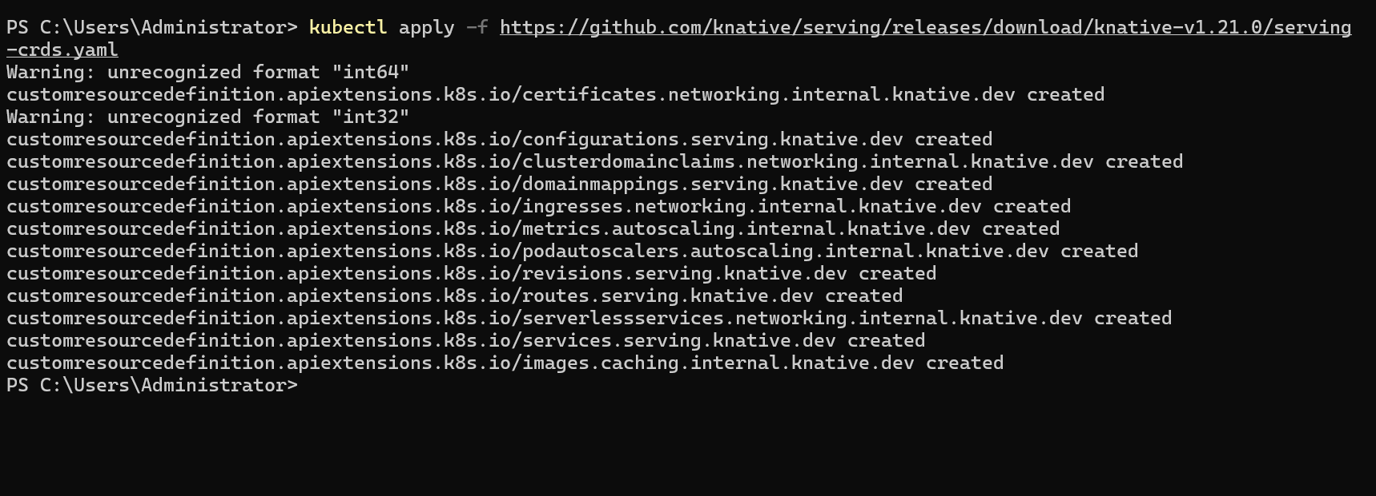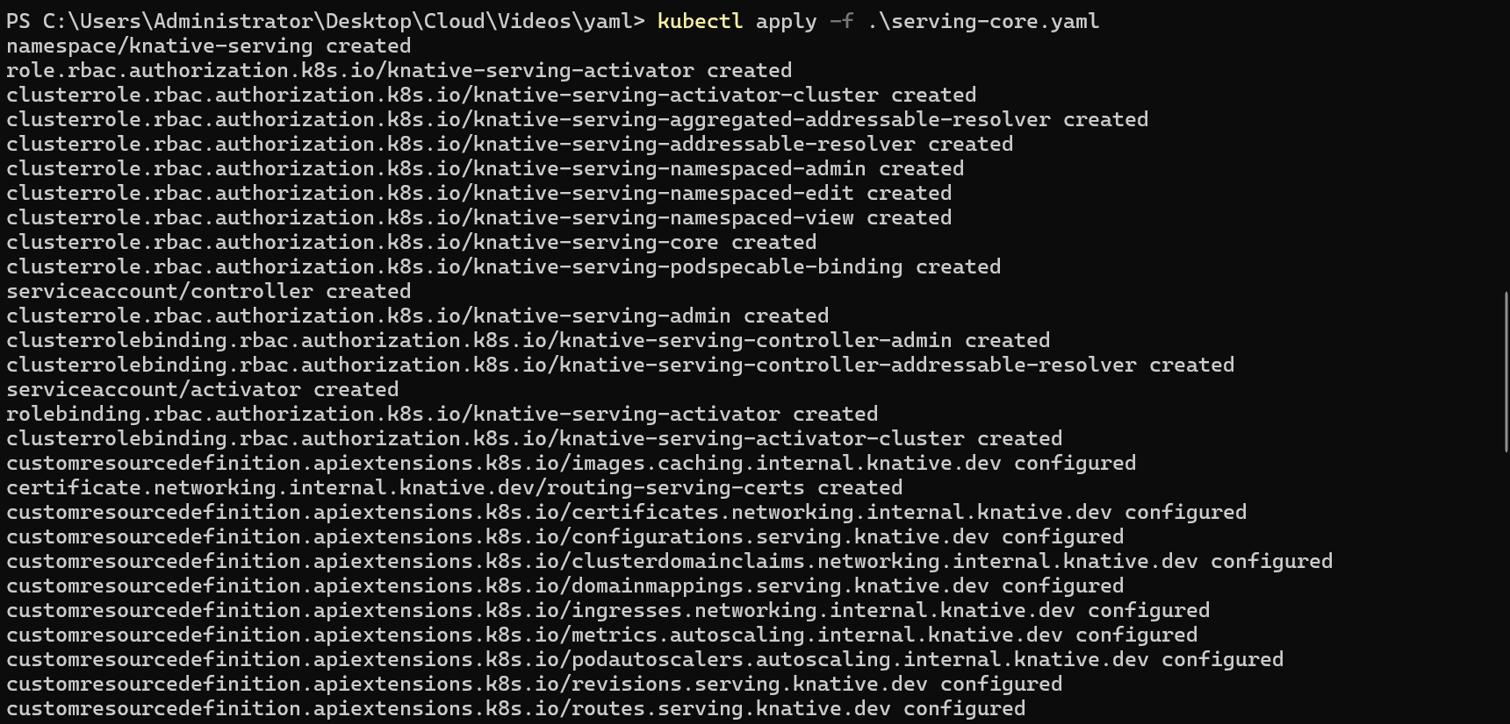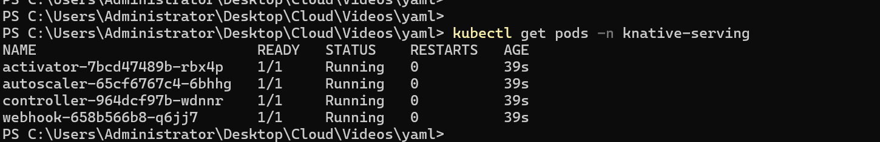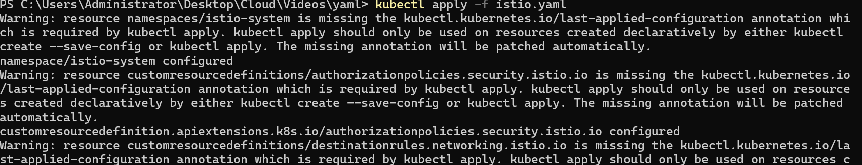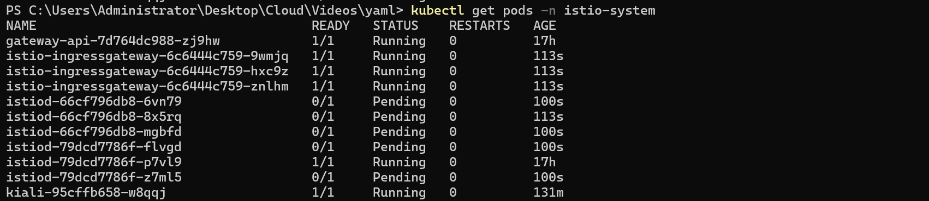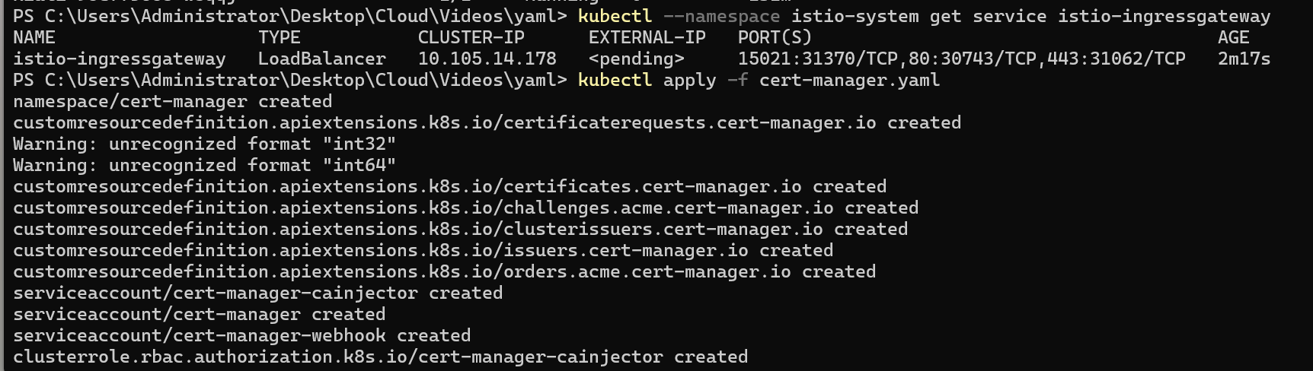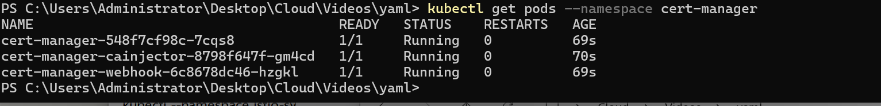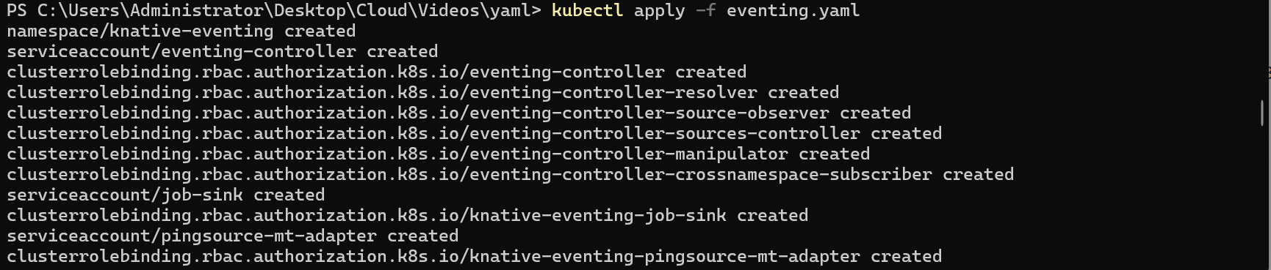

Install the Knative CLI
Download binary file for your system from:
https://github.com/knative/func/releases
https://github.com/knative/client/releases
Here I use windows 11.
And then change the file name to kn.exe and func.exe, then add them to your environment path.

Create a function named hello using go language:
After created, you need to go to the directory of the function to run it.
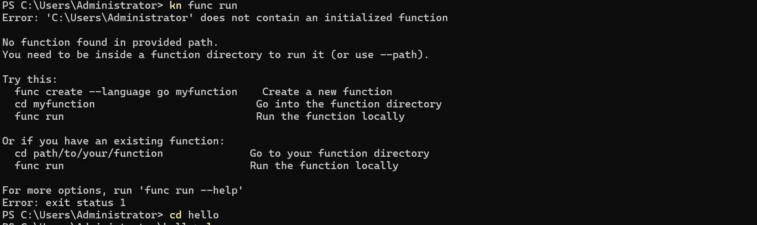
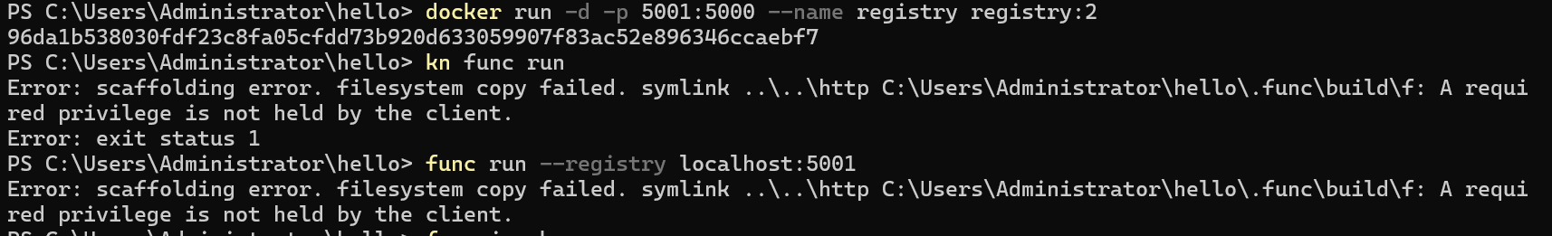
Here, when I ran `func run`, I encountered a permissions issue in the regular PowerShell, so I switched to PowerShell with administrator privileges.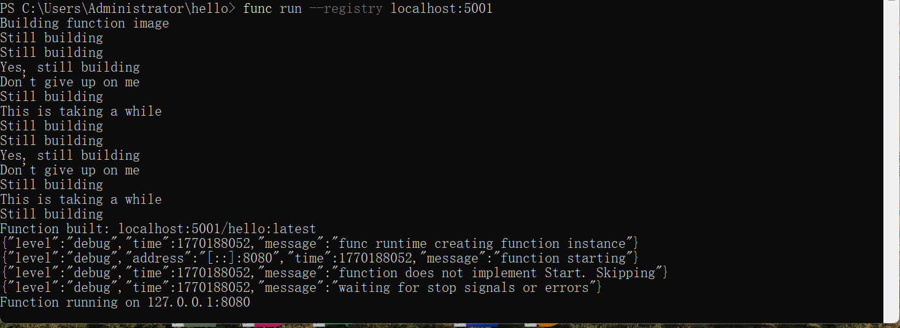
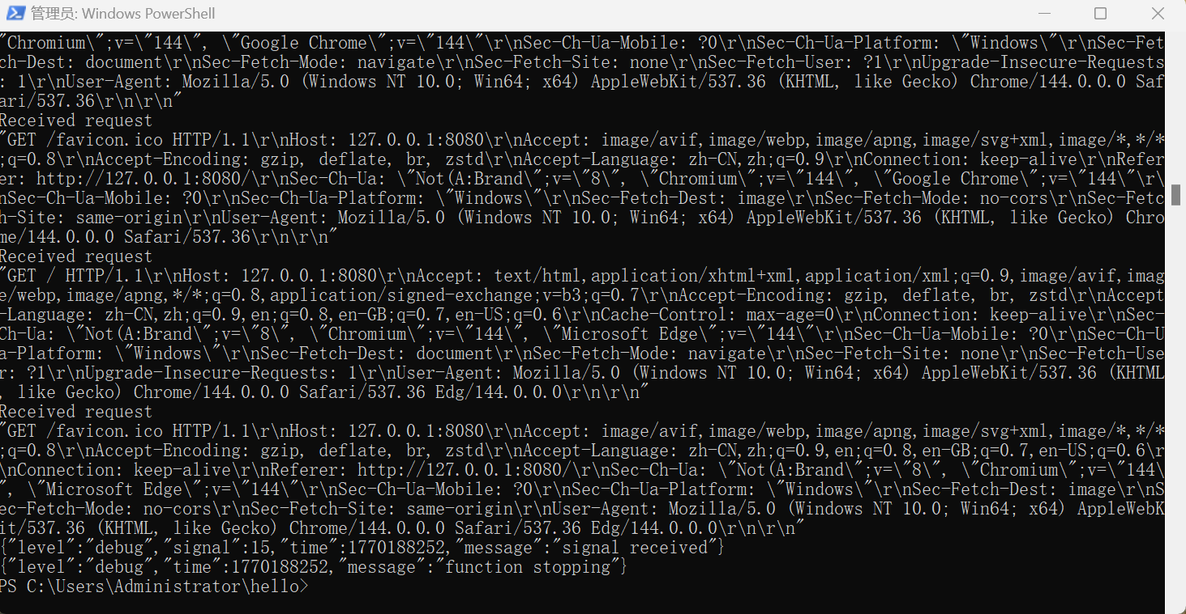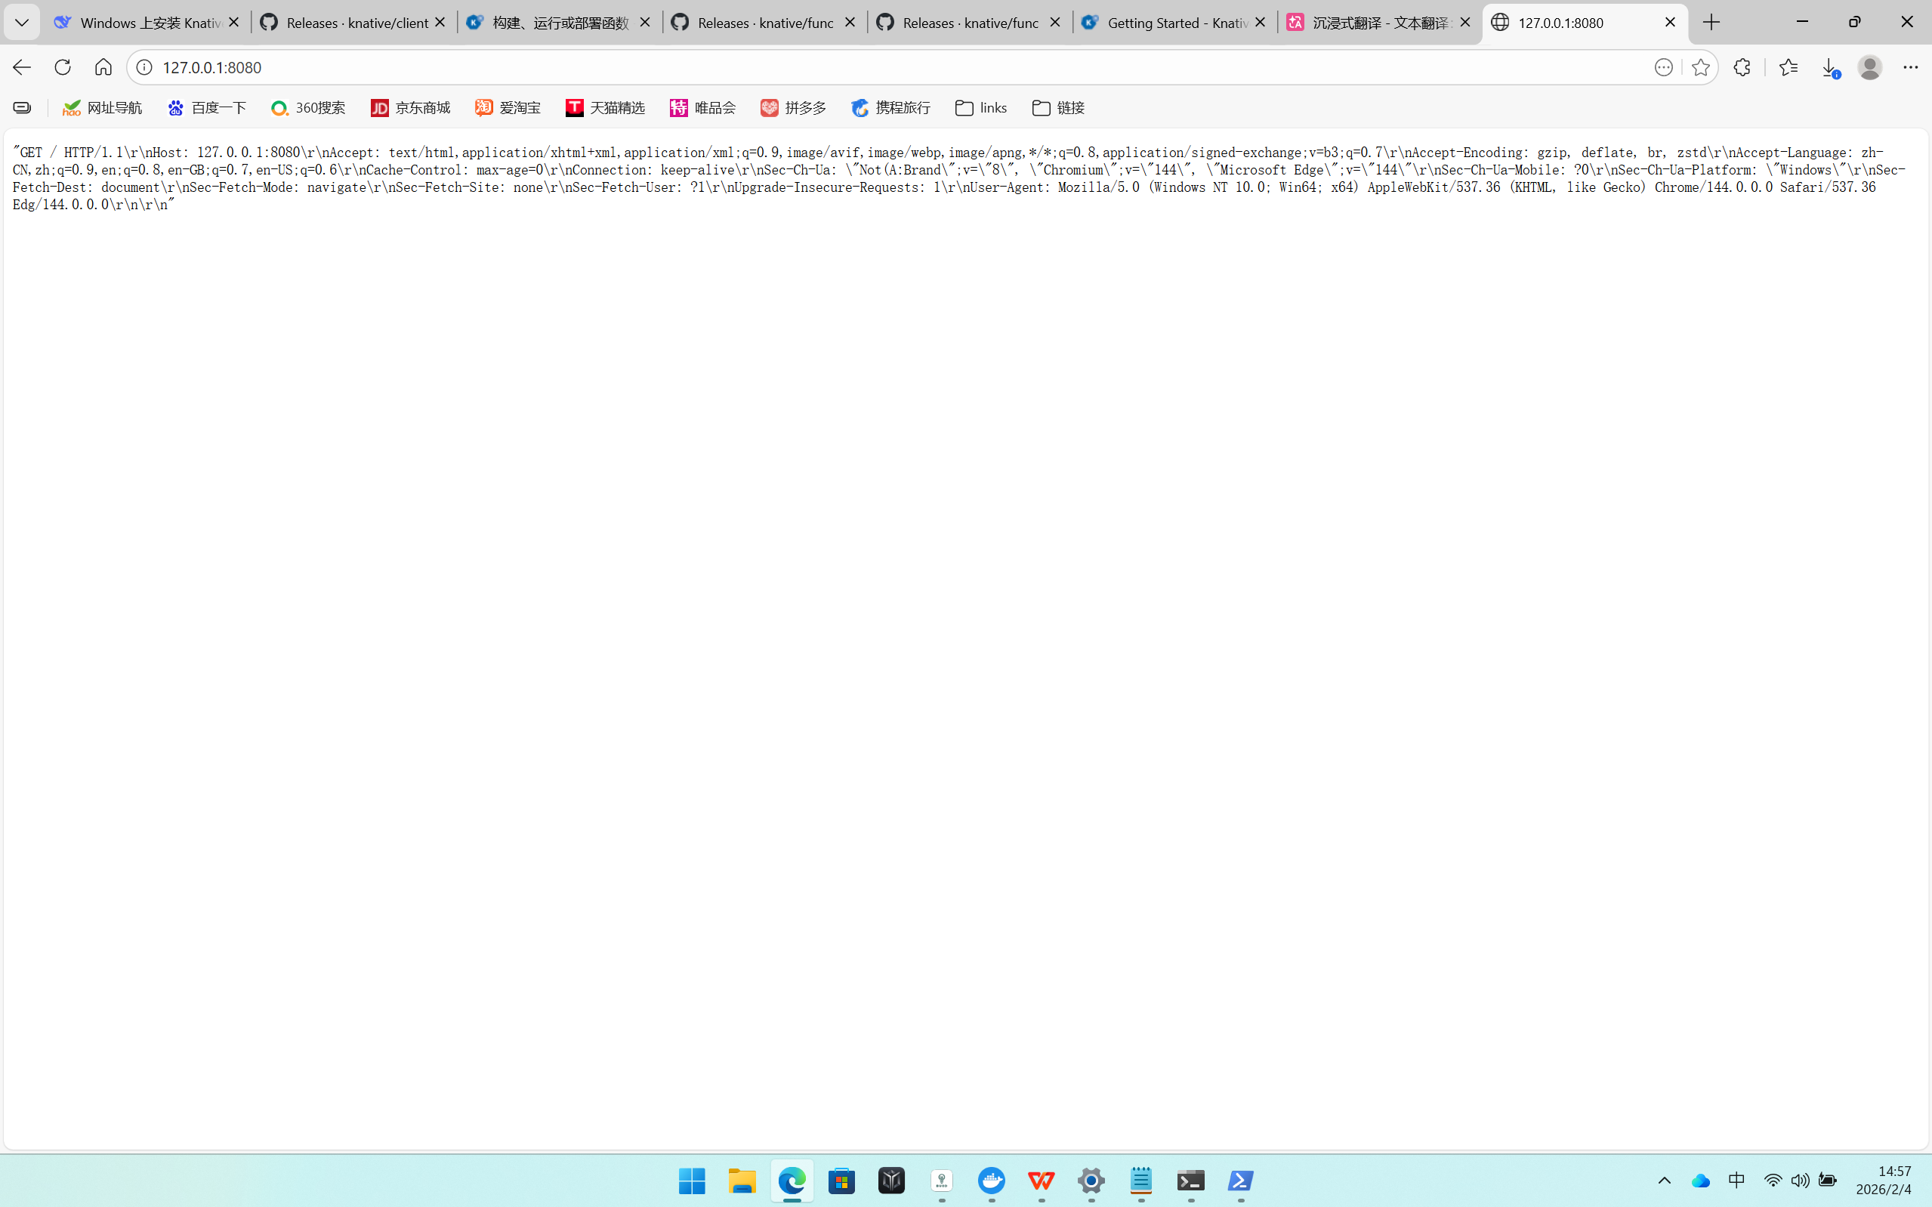
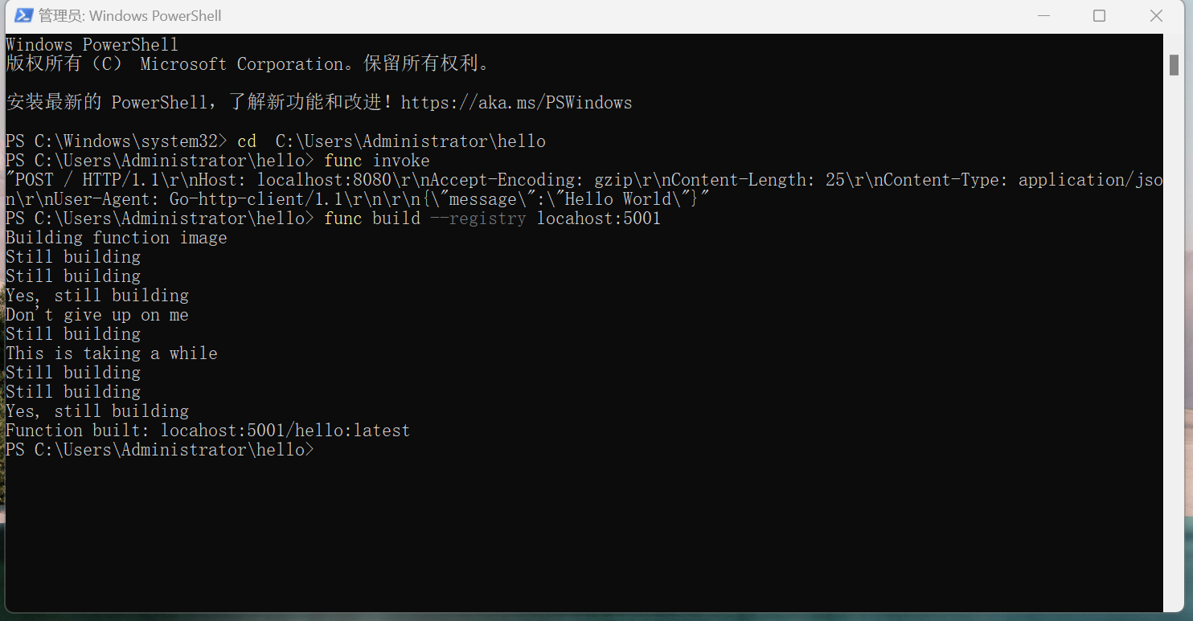

Deploying a Knative Service
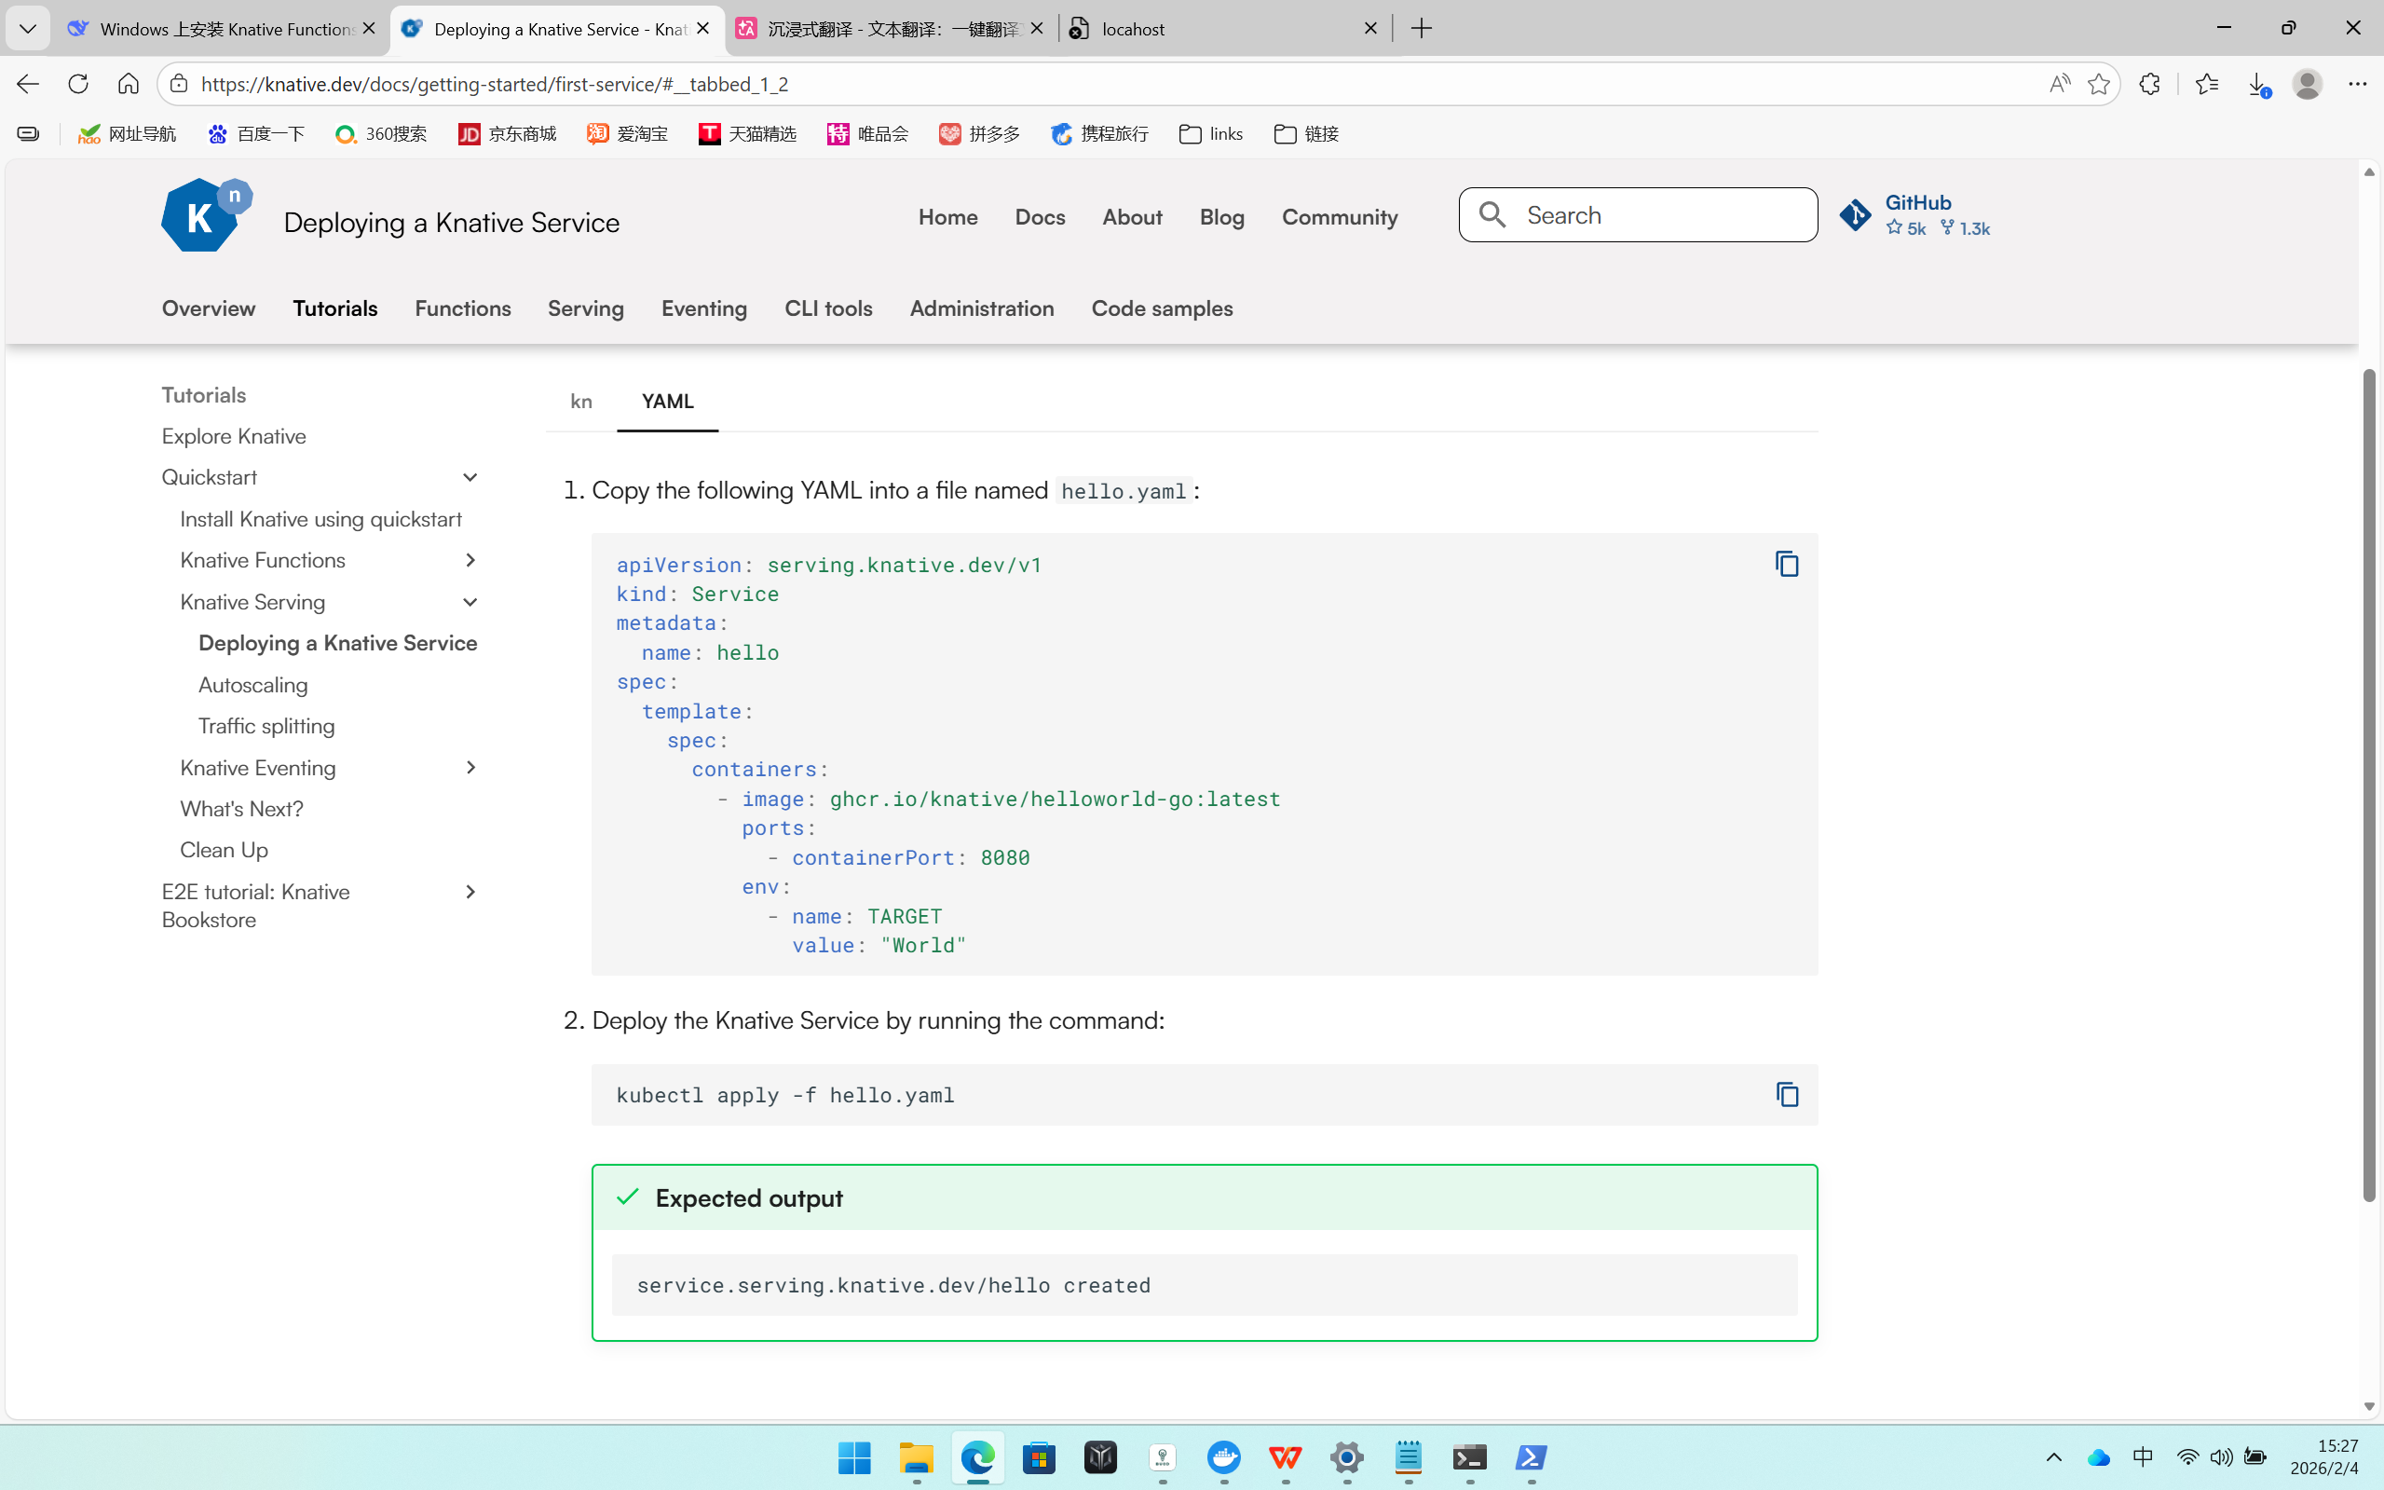
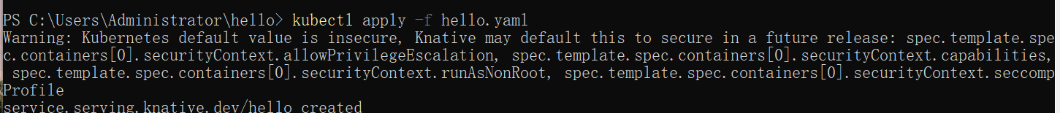

Kn eventing
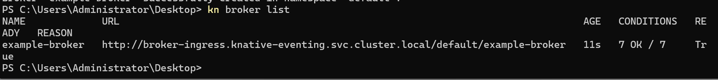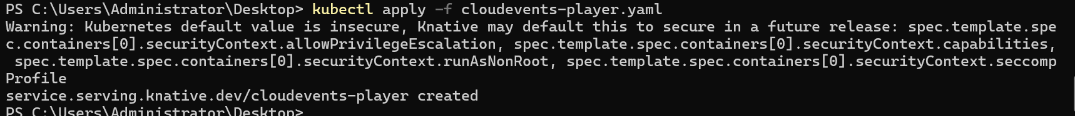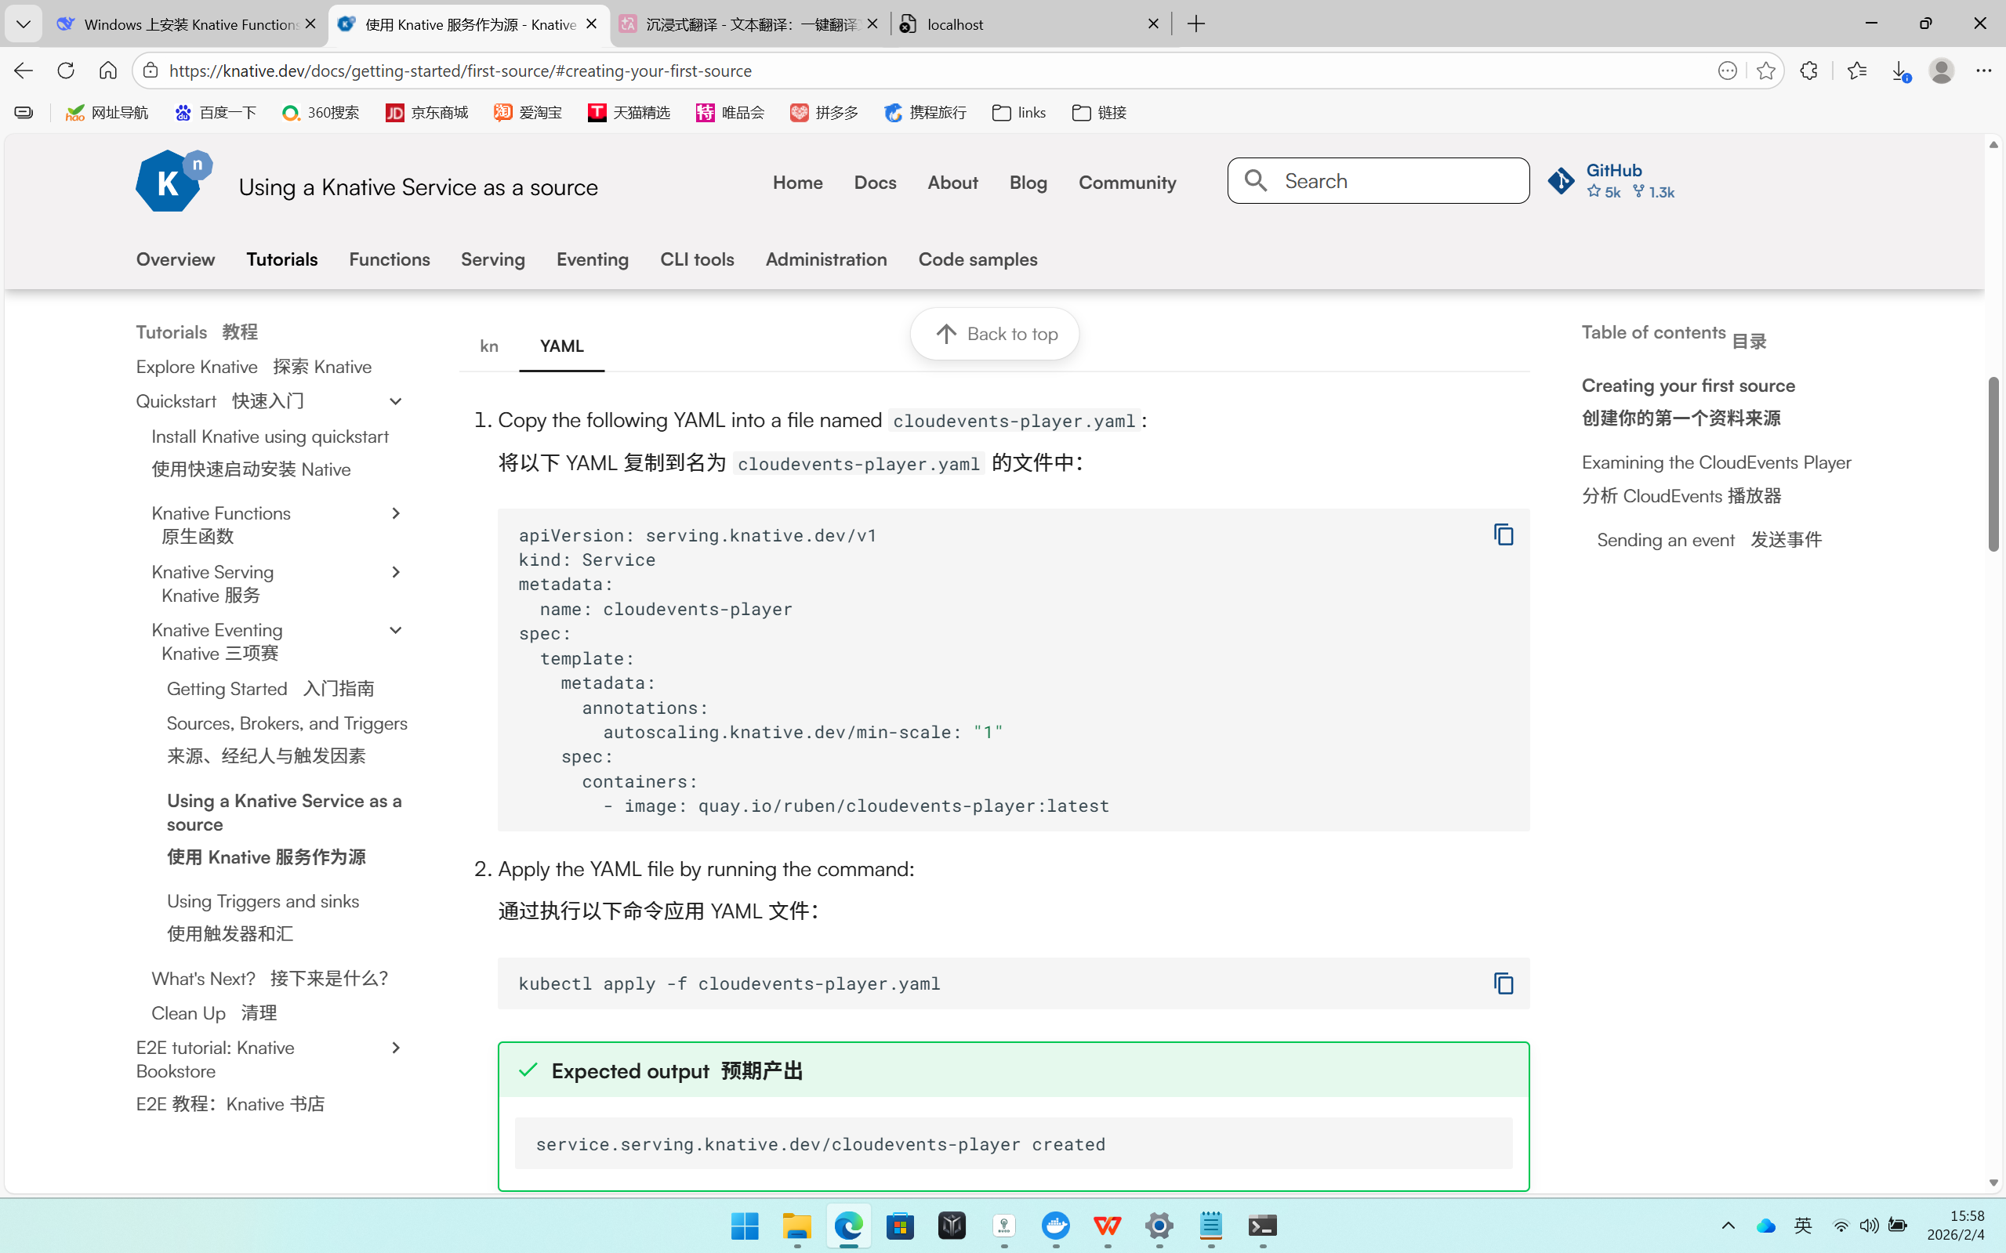
To visit this web, you need to expose the service using minikube tunnel.
