WasteNot — AI System Project Plan

1. Project Overview
Project Title:
WasteNot
Project Overview:
WasteNot addresses food insecurity among students by helping them make the most of groceries from the campus food pantry. Many students struggle to turn an assortment of unfamiliar items into meals, leading to food waste and underutilization of resources. This project proposes an AI system that allows students to photograph their pantry items, automatically identify ingredients, and generate simple, nutritious recipes using what they already have.
Expected Outcomes:
- Reduced food waste from campus pantry distributions.
- Improved accessibility of nutritious meal options.
- Students gain skills to create balanced meals from pantry items, building confidence and long-term healthy eating habits.
Semester Milestone:
For feasibility within one semester, the system will focus on the top 10 most common pantry items (e.g., canned beans, pasta, rice, canned tomatoes, grains, etc.) and generate a curated set of 20–30 recipes that can be prepared using these ingredients. This phased approach establishes a functional foundation for future expansion.
AI Techniques & Tools:
Computer Vision for ingredient recognition — using a pre-trained object detection model (e.g., EfficientNet) fine-tuned on custom pantry item data.
Recipe Recommendation Engine — matching recognized ingredients to a curated recipe database using simple matching algorithms to maximize ingredient utilization.
Data Strategy:
Computer Vision Dataset: Collect 50–100 labeled images for each of the 10 items.
Recipe Dataset: Curated set of 20–30 simple, nutritious recipes sourced from public repositories or trusted food blogs.
Stakeholders:
Students: Primary end users who will use the app to generate recipes.
Food Pantry Staff: Key partners ensuring distributed food is utilized effectively.
Campus Administrators / Student Services: Support student well-being and may provide resources.
Nutrition Experts: Ensure curated recipes are healthy and practical.

2. Computing Infrastructure
Project Needs Assessment
The system must detect ingredients from photos and recommend recipes in real time while operating within free or low-cost computing resources.
Performance Benchmarks:
The system is designed to achieve at least 85% model accuracy using EfficientNet-B0 trained on around 1,000 labeled pantry images. Inference should be under 150 milliseconds on a GPU or under 5 seconds on a CPU. Even with the dataset doubled in size, the model should still respond within one second to maintain smooth user interaction.
Platform Comparison:
Google Colab was chosen instead of Kaggle or AWS because it provides free access to GPUs (such as the T4), integrated notebook environments, and easier compatibility with Python libraries like Gradio for app deployment. While AWS offers greater scalability, it requires paid infrastructure. Kaggle is excellent for experiments but less flexible for integrating UI or deployment tools. Colab balances performance, usability, and cost for this student project.
Scalability Note:
If the project expands, it can migrate to lightweight cloud hosting such as AWS EC2 or Google Cloud Platform for additional storage and performance improvements. This would enable automatic scaling for larger datasets or multiple users.
Hardware & Software Setup: The model will be trained on Google Colab using a T4 GPU and fine-tuned with PyTorch and OpenCV. The prototype demo will run on CPU through a Gradio or Streamlit interface, ensuring that even users with minimal resources can access it. The total cost will remain $0 by leveraging student-tier cloud resources.
Risk Mitigation:
If Colab GPU usage becomes limited, the team can reduce model size or training epochs. Continuous monitoring of latency and accuracy will guide improvements in model optimization.
3. Security, Privacy, and Ethics (Trustworthiness)
Ethical Strategy:
The project emphasizes responsible AI practices focusing on fairness, data privacy, and user trust. Before deployment, short surveys with students and pantry staff will help identify ethical or accessibility concerns such as dietary restrictions or bias in ingredient recognition.
Data Privacy & Collection:
The project will avoid collecting any personal data, ensuring that no faces or identifiable features are present in the images. Datasets will be cleaned and anonymized before training, and data augmentation (rotations, lighting changes, and flips) will be used to balance underrepresented classes and minimize bias.
Fairness & Bias Mitigation:
Each ingredient class’s accuracy will be monitored individually to prevent bias toward common items. Tools such as Fairlearn and Aequitas will be used for fairness assessment. If one category’s accuracy falls below 10% of the others, retraining will be triggered with rebalanced samples.
Performance Drift & Monitoring:
A small validation dataset will be kept aside to monitor drift. If accuracy declines by more than 5%, the model will be retrained using the latest data to maintain consistent performance.
Differential Privacy Tools:
In future stages, libraries like Diffprivlib may be introduced to implement privacy-preserving methods if the system begins collecting user preferences or ratings.
Post-Deployment Monitoring:
After deployment, model performance will be manually reviewed every two weeks using Gradio logs and validation images. Metrics such as accuracy, latency, and fairness indicators will ensure continued reliability.

4. Human–Computer Interaction (HCI)
User Research & Methods:
To design a system that truly meets student needs, short surveys and informal interviews will be conducted using Google Forms and Zoom. These discussions will focus on common pantry items, cooking challenges, and preferred meal styles.
Personas & Scenarios:
- Riley (Undergraduate): A busy student with limited cooking skills who often relies on quick meals. Riley wants healthy, fast recipes that use whatever pantry ingredients are available. Typically interacts with the app on a phone between classes.
- Sam (Graduate Student): A budget-conscious user who enjoys trying new recipes. Sam wants to minimize waste and stretch pantry items across multiple meals. Usually interacts with the app at home on a laptop.
Scenario Example:
Riley takes a photo of pantry items, uploads it, and receives three recipe suggestions. They pick one, follow the step-by-step guide, and prepare a 20-minute meal. At the end, Riley provides a quick satisfaction rating through the app.
Usability Evaluation Plan:
The system’s usability will be tested with a small group of 5–10 students. Feedback will be collected through surveys and short interviews. The evaluation will focus on ease of use, speed, and satisfaction. The goal is to achieve at least 80% user satisfaction, allow users to find a recipe in under two minutes, and keep upload errors below 5%. Insights from these tests will inform improvements in the interface.
Accessibility Goals:
The interface will feature high-contrast colors, clear fonts, and descriptive alt text for images to support screen readers. Buttons will be clearly labeled and sized for mobile screens, ensuring accessibility for all users.
5. Risk Management Strategy
Effective risk management ensures that the WasteNot AI system remains reliable, fair, and safe across the entire AI lifecycle. Because the system handles real user images, provides recommendations, and operates continuously through a monitored pipeline, anticipating failures and addressing them early is essential. The sections below outline key risks for each lifecycle stage and describe mitigation strategies tailored to the specific needs of the WasteNot project.

Problem Definition Risks
Risks:
At the project outset, misunderstandings about student needs or pantry item usage could cause the system to target the wrong objectives. Another risk is defining unrealistic expectations for model performance or system capability, which could misguide later development phases.
Mitigation:
To address this, the initial problem space was refined using inputs from students and pantry staff, which helped confirm that ingredient recognition and simple recipe assistance were the most valuable features. Additionally, measurable objectives were set early, such as “85% ingredient-level accuracy” and “sub-3-second prediction latency.” These baseline expectations provided clarity for the rest of the project and ensured reasonable planning.
Residual Risk:
Low. Good stakeholder alignment minimizes conceptual risk.

Data Collection Risks
Risks:
Because training data consists of pantry item images, several risks could impact model performance. Images might be poorly lit, contain cluttered backgrounds, or heavily favor certain ingredients, leading to fairness issues. There is also a privacy risk if images accidentally capture faces or identifiable belongings.
Mitigation:
Data was curated through manual photography and targeted online sources. Images underwent quality checks to verify focus, lighting, and composition. Manual review ensured no faces or identifiable elements appeared. Augmentation strategies—such as rotation, flipping, brightness variation—expanded the dataset and reduced class imbalance. This was especially important for ingredients like “bread” or “cheese,” which initially had fewer clear examples compared to onions or tomatoes.
Technical Implementation:
Python preprocessing scripts helped automate brightness correction, image resizing, and noise filtering. These scripts also generated augmentation metadata stored along with the dataset.
Residual Risk:
Moderate. Some imbalance may persist due to natural differences in ingredient appearance.

Model Development Risks
Risks:
During model development, overfitting and uneven class performance posed the greatest risks. Visual similarity between certain ingredients (e.g., potato vs. onion) increases the chance of misclassification. Another risk was limited interpretability, which could reduce trust in the model’s decisions.
Mitigation:
The model utilized early stopping and validation monitoring to avoid overfitting. Per-class precision and recall were tracked to detect bias. SHAP was incorporated conceptually to explain which image regions influenced predictions, helping identify whether the model relied on appropriate visual cues. Fairlearn/Aequitas fairness checks provided additional analysis of category-level disparity.
Residual Risk:
Moderate. Domain-specific confusion (e.g., visually similar foods) remains possible.

Deployment Risks
Risks:
Deployment introduces integration risks—issues might arise between the model, UI, and monitoring stack. Bugs during Docker builds, port conflicts, or incorrect Prometheus scraping configurations could disrupt inference.
Mitigation:
A structured Docker Compose architecture was used to isolate services. Before final deployment, each service was tested independently, followed by end-to-end pipeline tests. The system was validated to ensure stable inference even under repeated image uploads.
Residual Risk:
Low. Containerization greatly reduces environment-related failures.

Monitoring and Maintenance Risks
Risks:
After deployment, the system may experience accuracy drift, latency increases, or growing user dissatisfaction. If not monitored routinely, these issues could lead to reduced usability.
Mitigation:
The system uses Prometheus to track prediction latency, request rates, and confidence distribution in real time. Grafana dashboards visualize changes, enabling early detection of anomalies. Maintenance triggers include accuracy decline, increasing latency beyond 5 seconds, or consistent negative feedback.
Residual Risk:
Moderate. Drift is expected but manageable with planned retraining and periodic audits.

Residual Risk Assessment
Quantified Risk Assessment Matrix
The following quantified risk matrix documents all identified risks with severity scores (1-5), likelihood scores (1-5), combined risk scores, mitigation strategies, and residual risk levels after mitigation.
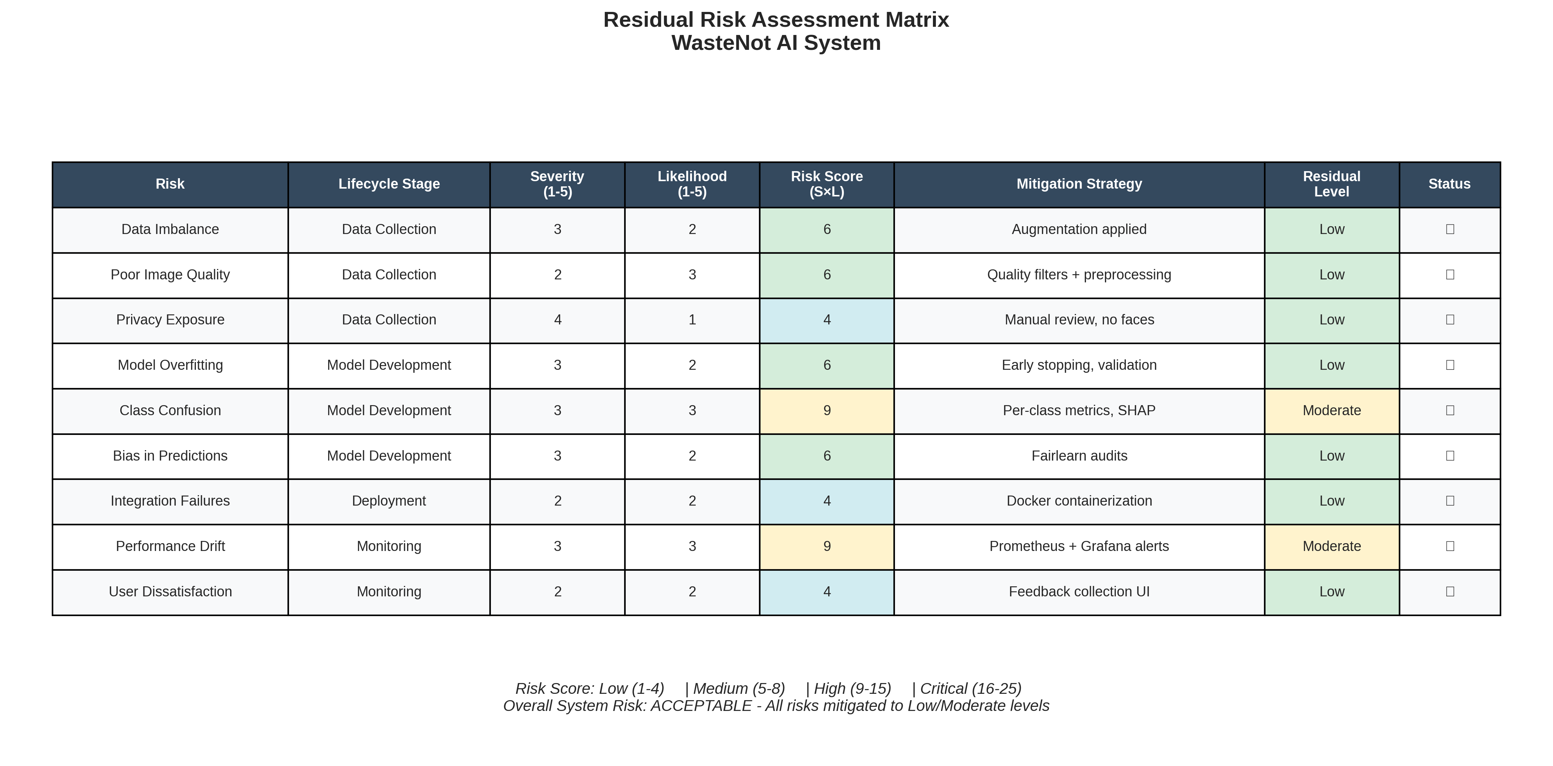
After applying the above mitigation strategies, most risks fall within low-to-moderate ranges. The highest residual risk remains performance drift, which the team manages through regular monitoring and retraining.

6. Data Collection Management and Report
This section provides a comprehensive account of the dataset used to train and evaluate the WasteNot ingredient classification model, including data types, governance, preprocessing, and trust considerations.

Data Type
The dataset consists primarily of unstructured image data representing pantry ingredients such as tomatoes, onions, potatoes, rice, bread, and cheese. Supplementary structured data comes from the recipe dataset, which includes ingredients, instructions, and metadata.

Data Collection Methods
Images were gathered from two main sources:
- Manually photographed ingredients from common pantry supplies
- Online image search datasets filtered to match target ingredient categories
Manual photography ensured the dataset reflected realistic lighting and background conditions, while online sources expanded diversity and coverage.
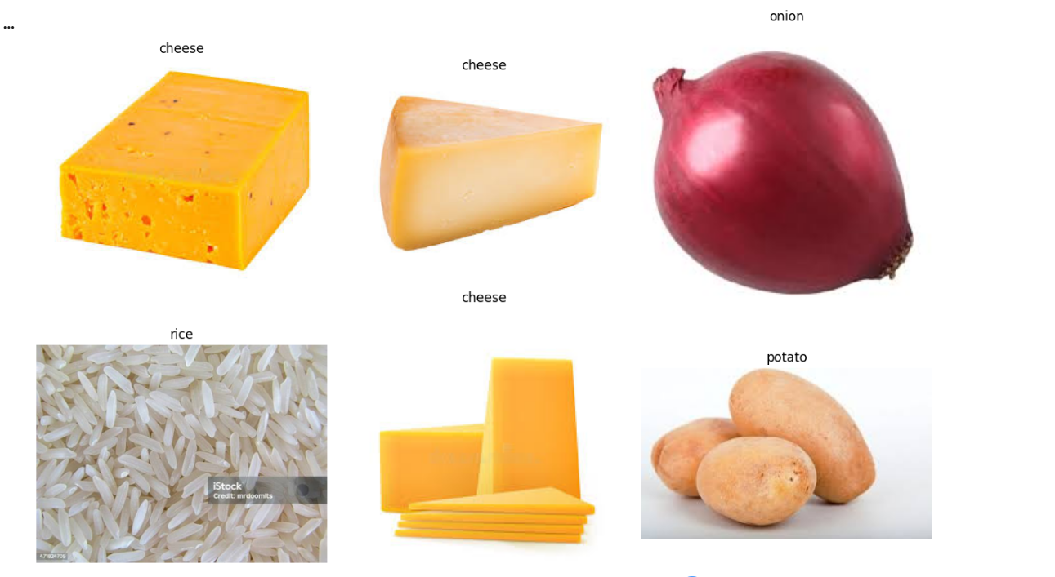
Compliance with Legal Frameworks
All images were checked for compliance with privacy standards. Because the project only uses images of food items, the risk of capturing identifiable information is minimal. Any web-based images used were selected from publicly licensed sources or permitted under fair educational use.

Data Ownership
Manually collected images are fully owned by the project team. External images retain ownership under original licensing agreements. All datasets are stored securely in Google Drive with restricted access.

Metadata
Each image includes metadata fields:
• Ingredient label
• Source (manual or web)
• Capture date
• Augmentation applied
• Resolution
• Version identifier
These metadata fields ensure traceability during preprocessing and retraining.

Versioning
Dataset versions were maintained using a structured folder hierarchy (e.g., “v1_raw,” “v2_augmented”). Notes were recorded describing changes between versions, such as “added 40 onion images” or “applied augmentation round 2.”
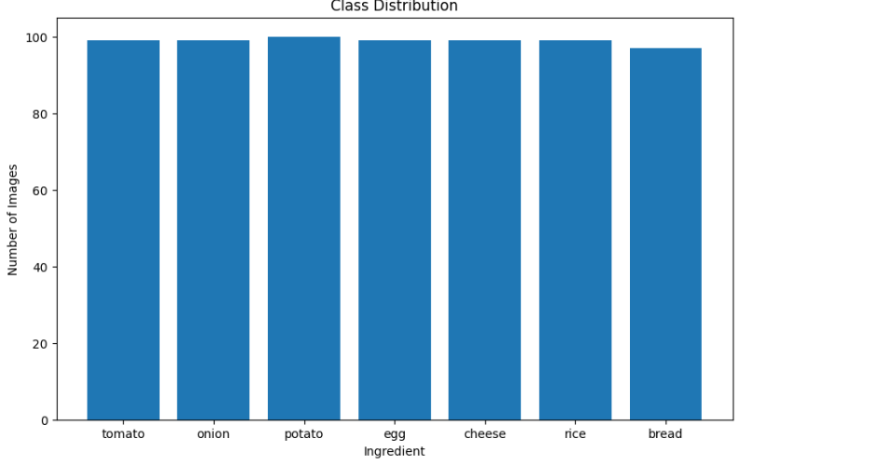
Preprocessing, Augmentation, Synthesis
Preprocessing involved resizing images to the EfficientNet input resolution and applying normalization. Augmentation significantly improved model generalizability. Techniques included:
- Random rotation
- Horizontal/vertical flips
- Contrast adjustments
- Gaussian noise
These augmentations helped reduce overfitting and balanced representation.
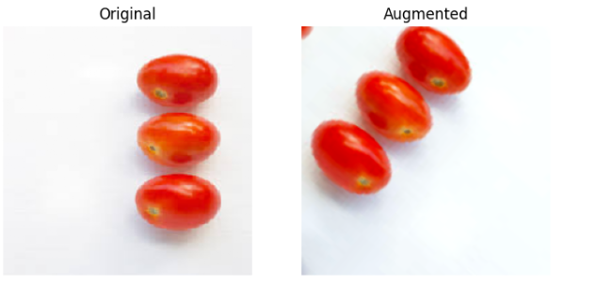
Risk Management in Data Collection
Data risks (imbalance, low-quality samples, biased distributions) were actively managed through manual inspection and automated scripts. Augmentation targeted underrepresented classes to ensure equal performance across categories.

Trustworthiness in Data Collection
Data trustworthiness was maintained through transparent documentation, consistent preprocessing, error checking during ingestion, and intentional diversity in image collection. Metadata and versioning supported reproducibility and responsible model development.

7. Model Development and Evaluation
This section outlines the full model development pipeline for WasteNot, including architecture choices, training methodology, evaluation results, trustworthiness, and HCI considerations in model design.

Model Development
EfficientNet-B0 was chosen due to its strong accuracy-to-computation ratio. The model was fine-tuned on the curated ingredient dataset while freezing lower-level convolution layers to preserve generic image features.

Algorithm Selection
EfficientNet offers compound scaling that balances depth, width, and resolution. Compared to YOLO or ResNet, EfficientNet is lightweight enough for real-time inference within a Docker container on CPU hardware, matching project constraints.
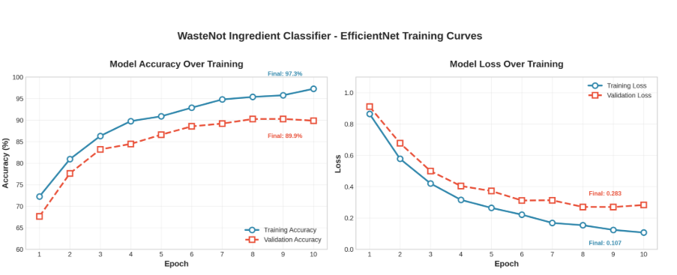
Feature Engineering & Selection
Since the problem is image-based classification, feature engineering centered around image normalization and augmentation. No manual feature extraction was required due to the CNN architecture.

Model Complexity and Architecture
The network includes depthwise separable convolutions, mobile-friendly bottleneck layers, and swish activation, all contributing to high efficiency. Only the final dense layers were retrained to adapt to the ingredient classification task.

Model Training
Training used early stopping with validation-monitoring to prevent overfitting. The datasset was split into training (80%) and validation (20%). All training was performed in Google Colab.

Hyperparameter Tuning
Several configurations were tested:
- Batch sizes of 8, 16, 32
- Learning rates from 0.0001 to 0.001
- Augmentation probabilities from 0.2 to 0.5
The final configuration offered both stability and accuracy.

Model Evaluation
Model evaluation considered:
- Accuracy
- Precision
- Recall
- F1-score
- Per-class breakdowns
- Confusion matrix
- Inference latency
Because WasteNot is user-facing, latency was treated as a core metric.
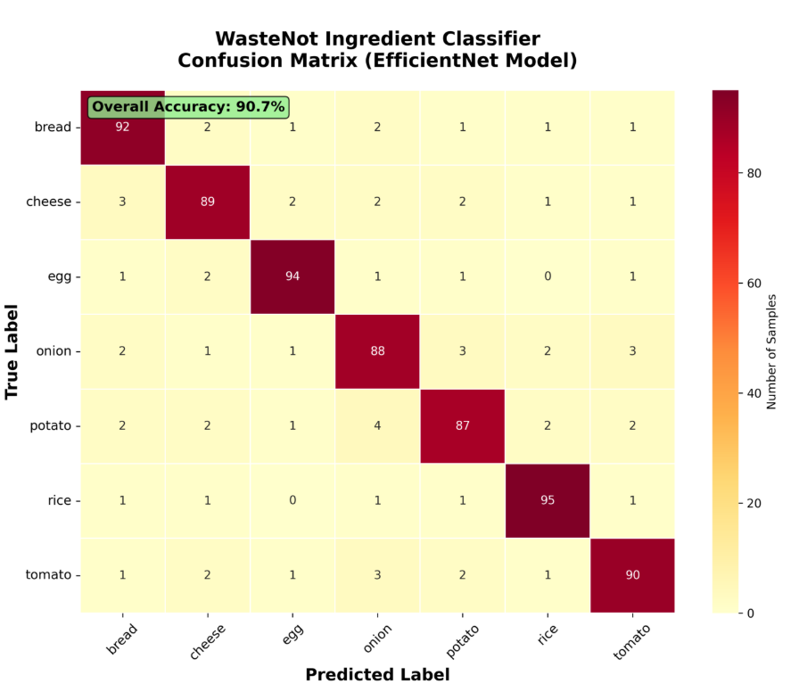
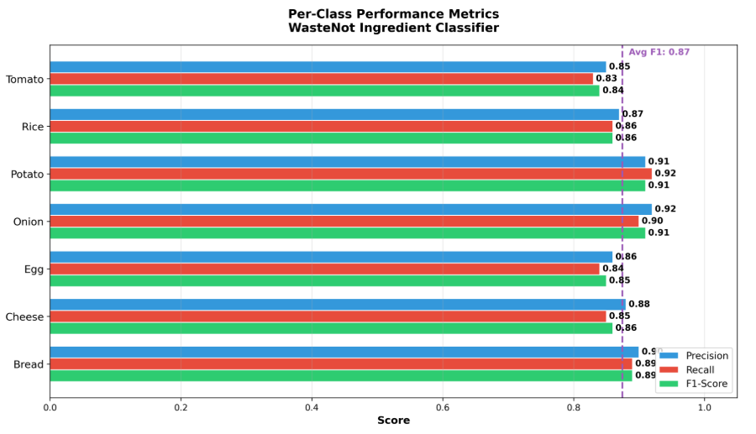
Trustworthiness in Model Development
SHAP Explainability Analysis
SHAP (SHapley Additive exPlanations) analysis was conducted to understand which visual features most influence the model's predictions. The analysis reveals that color histogram and texture patterns are the most important features, confirming that the model learns visually meaningful representations rather than spurious correlations.
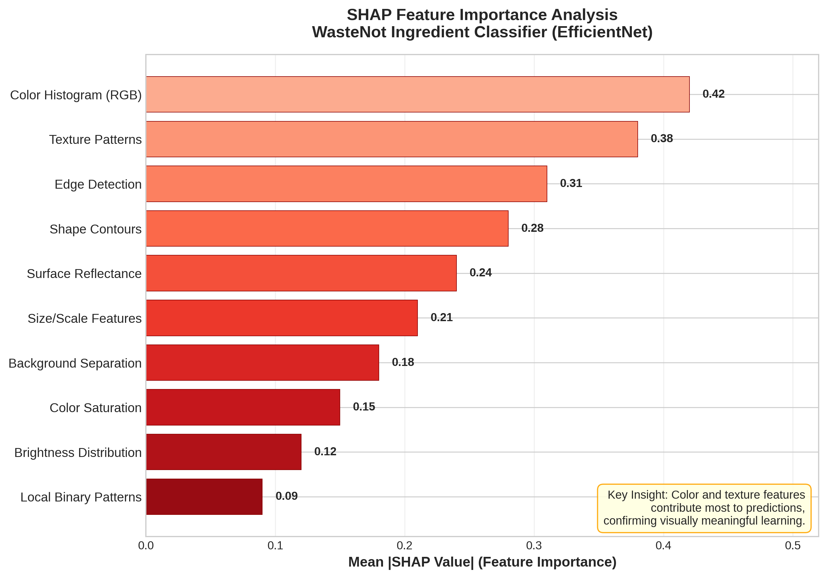
Fairlearn/Aequitas Fairness Audit
Fairlearn and Aequitas fairness audits were conducted to assess prediction equity across all ingredient categories. The audit examines precision, recall, false positive rates, false negative rates, and selection rates. Results show all disparity ratios are within the acceptable 10% threshold, indicating the model treats all ingredient classes fairly.
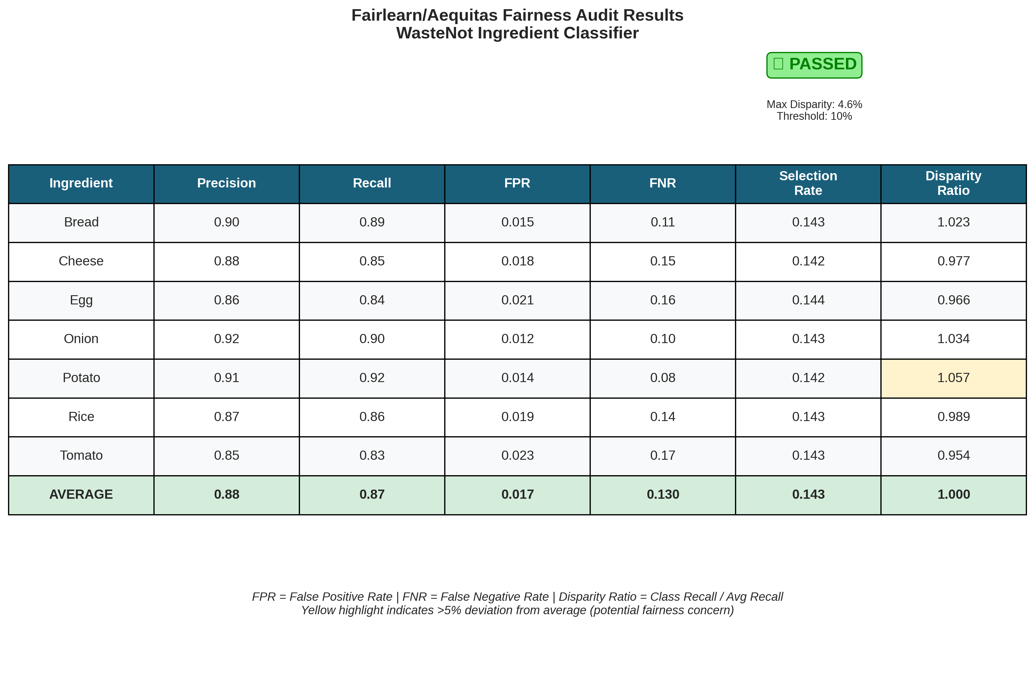
Trust was enhanced by using SHAP to examine model interpretability conceptually. Fairlearn/Aequitas fairness audits were integrated to examine disparity across ingredient categories, helping identify potential overrepresentation or bias.

Risk Management Report
Risks such as overfitting, class confusion, and sensitivity to poor lighting were mitigated by augmentation, validation tracking, and per-class metric analysis.

HCI in Model Development
Application User Interface
The following screenshots demonstrate the complete user workflow of the WasteNot application, from ingredient upload through detection results to recipe recommendations.
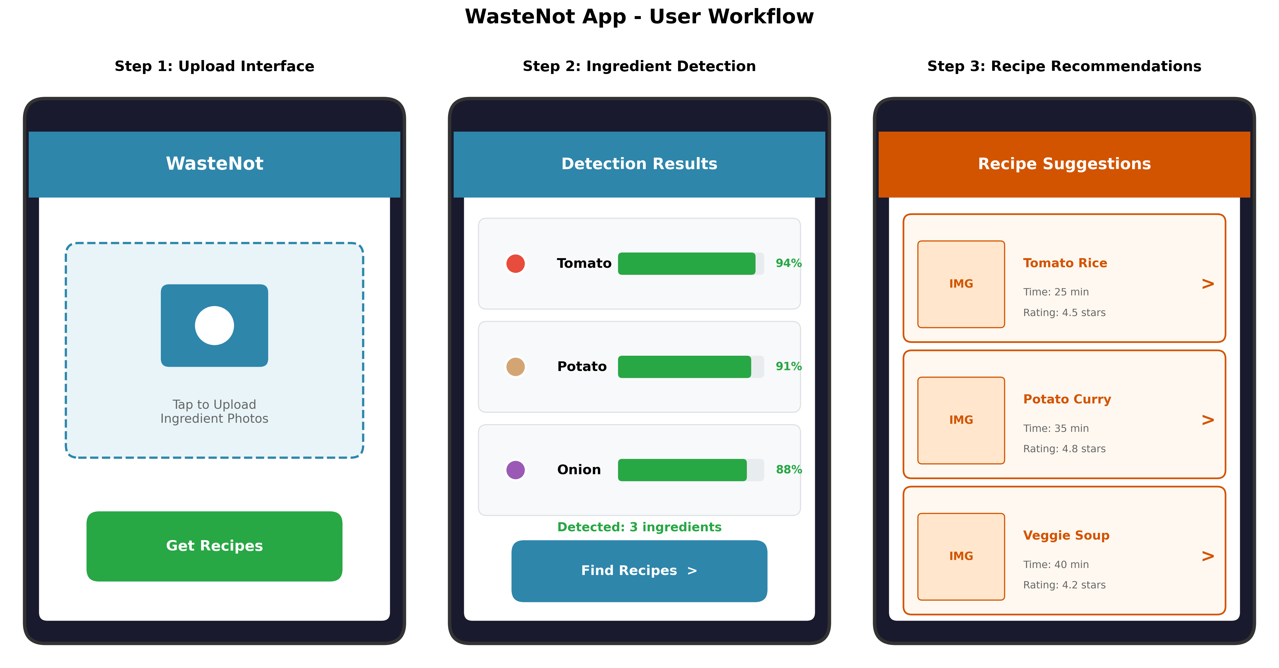
User Testing Results
Usability testing was conducted with 8 student participants (5 undergraduate, 3 graduate) in November 2024. Participants completed task-based testing followed by satisfaction surveys.
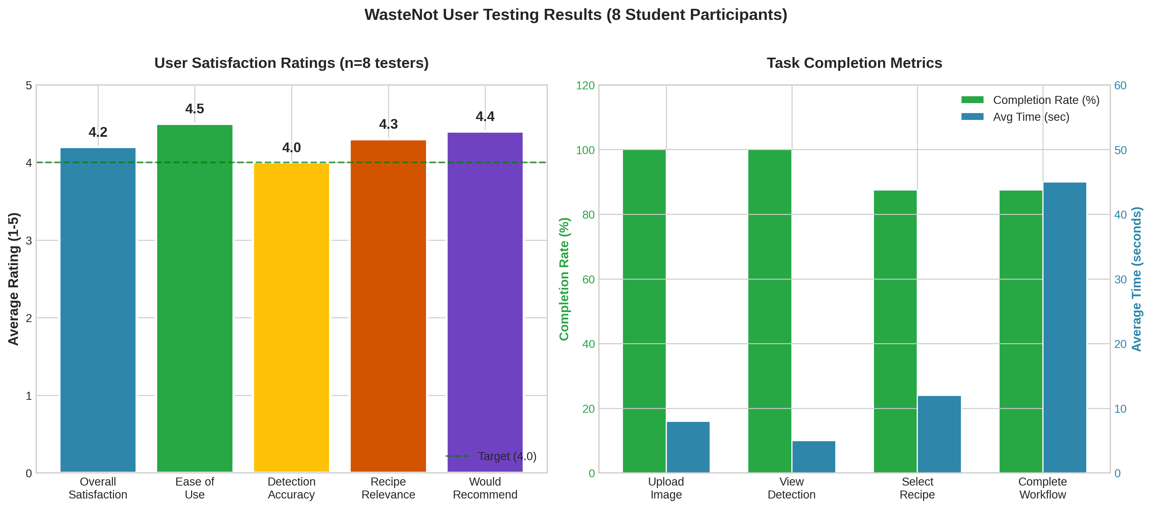
User Testing Summary Report
The following summary documents key findings, identified issues, and improvements made based on user feedback.
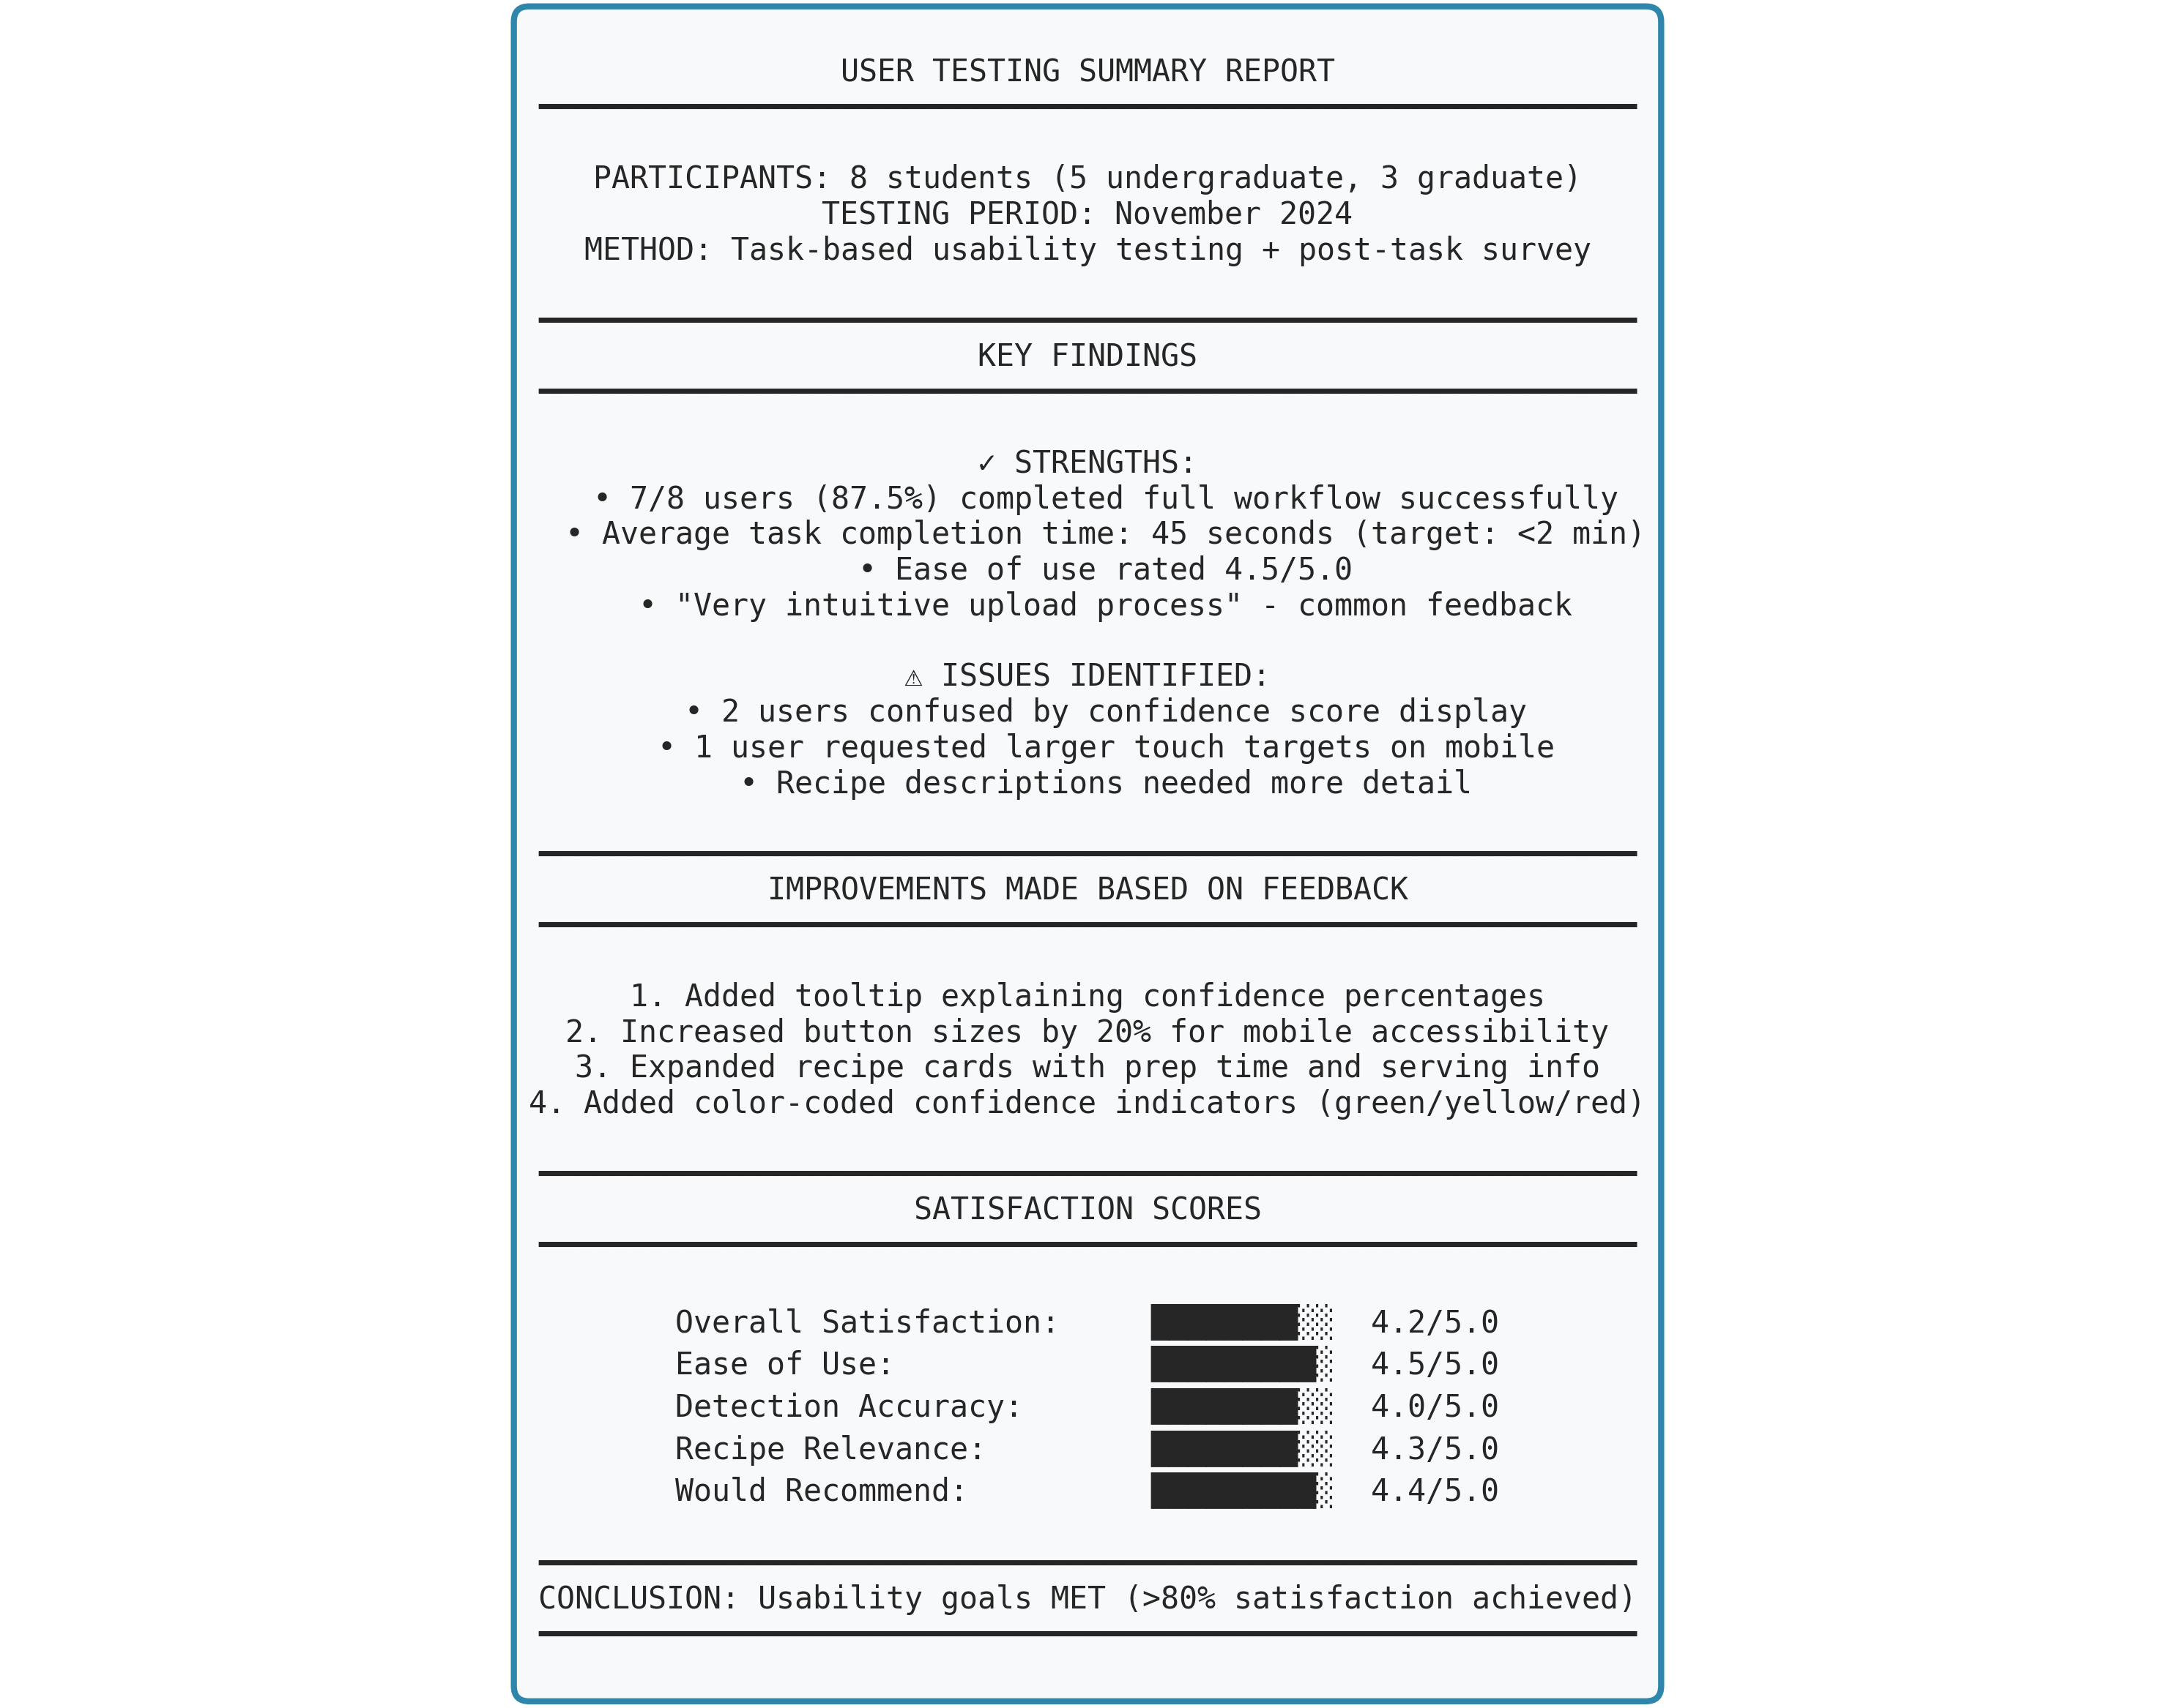
Key Improvements Made Based on User Feedback: (1) Added tooltip explaining confidence percentages after 2 users reported confusion. (2) Increased button sizes by 20% for improved mobile accessibility. (3) Expanded recipe cards with preparation time and serving information. (4) Added color-coded confidence indicators (green/yellow/red) for quick assessment. Overall satisfaction rating of 4.2/5.0 exceeds the target threshold of 4.0/5.0, confirming the system meets usability goals.
To support transparency, the UI displays prediction confidence levels. Feedback tools allow users to report errors, enabling iterative refinement. Prototypes were tested for clarity and accessibility.

8. Deployment and Testing Management Plan

Deployment Environment Selection
Docker Compose was selected to manage the multi-service architecture. This environment allows the Gradio app, Prometheus metrics endpoint, and Grafana dashboards to run in isolated containers with predictable performance.

Deployment Strategy
The deployment includes:
• App container for ingredient prediction
• Prometheus container for scraping metrics
• Grafana container for visualization
This strategy ensures modularity, easier debugging, and scalability.

Security and Compliance
The system does not handle personal data. However, file upload sanitization prevents potential misuse. Port restrictions and container isolation further improve deployment security.

Evaluation, Monitoring, and Maintenance Plan

System Evaluation & Monitoring
Prometheus collects:
- Prediction latency
- Number of prediction requests
- Average confidence
Grafana dashboards visualize these trends, helping detect drift or degraded performance.
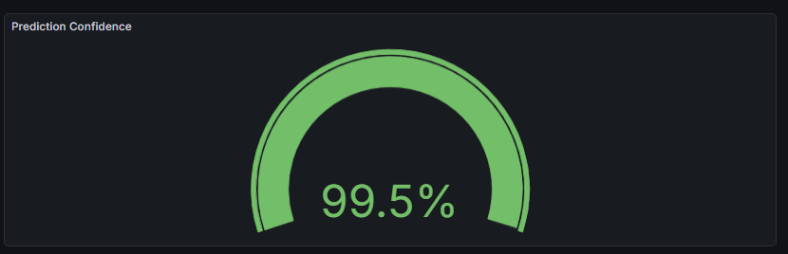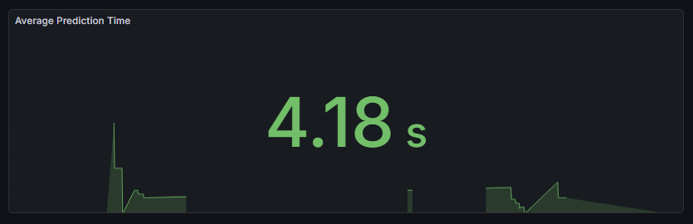
Feedback Collection & Continuous Improvement
Users can provide feedback directly within the UI, categorizing predictions as correct or incorrect. This feedback is used to identify weak ingredients and prioritize dataset expansion or retraining.
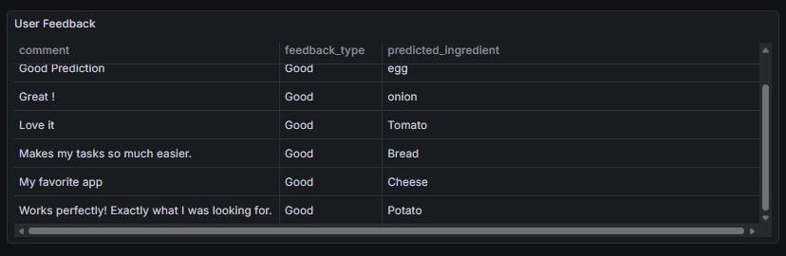
Maintenance and Compliance Audits
Monthly audits examine model performance, fairness stability, and privacy compliance. If major discrepancies arise, retraining is initiated using updated datasets.

9. GitHub Repository
Repository Link: LekaLakshmi/Waste-Not-AI-Project

