4/11/2022

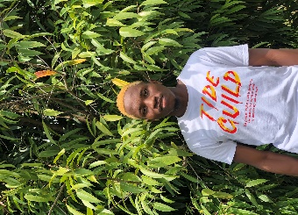

Alabi Olalekan Emmanuel

+234 8101853701

alabilekanemmanuel@gmail.com

Lagos, Nigeria

https://lekanjoy.github.io/My-Portfolio/

Objectives

I’m a resourceful and inquisitive person who is always eager to learn. I’m focused on learning more to become a world-class Frontend Engineer who will proffer solution to various world problems in my field.

Education

* Federal University of Agriculture, Abeokuta

**B. Agric**

**2017-2022**

* AltSchool Africa Software Engineering

**2022-2023**

Achievement

* Self-taught Developer
* Completed Sololearn JavaScript course
* Built a Temperature Converter using pure JavaScript
* Built a Password Strength Validator
* Completed Sololearn Responsive web design course
* Completed W3Schools HTML and CSS course

Experience

Frontend Engineer ***2022*** – present

Remote |

Skills

* HTML5
* CSS3
* JAVASCRIPT