CMPG 325
COMPUTER NETWORKS
INDIVIDUAL PROJECT

MILESTONE 1 — CLIENT DESIGN REVIEW

Name | Lekgalake Gift
Surname | Makanatleng
Module Code | CMPG 325
Project | Kgwebo Grain & Feed — Klerksdorp
Submission | Milestone 1: Client Design Review

Project period: 14 August 2026 – 16 October 2026

1. Client Requirements

1.1 Client Overview
Kgwebo Grain & Feed, located in Klerksdorp, operates within the agriculture industry. The organisation requires a reliable computer network to support communication, access to network services, Internet connectivity, and the exchange of data between authorised devices. The proposed network must be designed and simulated using Cisco Packet Tracer and must provide a working and testable implementation that satisfies the client's specified requirements.

1.2 Network Requirements
Requirement | Description
Reliable connectivity | Provide appropriate connectivity between authorised network devices and users within the organisation.
Network services | Provide the necessary network services required for the assigned scenario and support normal organisational operations.
IP addressing | Use the assigned address block 10.20.0.0/16 as the basis for the network's IP addressing plan.
Network segmentation | Separate appropriate network groups to support security, management and traffic control requirements.
Internet access | Provide Internet connectivity for the organisation, with particular consideration for the management requirement.
Management access | Management must retain Internet access even when the Staff network is restricted.
Loop prevention | Implement Spanning Tree Protocol (STP) to prevent Layer 2 switching loops and provide a controlled root-switch design.
Future expansion | Accommodate the planned branch office through the network's addressing/design structure without implementing a second physical site.
Testing | The completed network must support end-to-end connectivity testing and verification of the STP implementation.
Simulation | Produce a working Cisco Packet Tracer implementation that can be opened and reproduced for assessment.
Documentation | Document important design decisions, configurations, testing results, troubleshooting and evidence in the GitHub portfolio.

1.3 Specific Client Constraints
Management Internet Access: Management requires Internet access even when the Staff network is restricted. Therefore, Management and Staff must be appropriately separated so that restrictions applied to Staff do not prevent Management from accessing the Internet.
STP Requirement: The assigned technical challenge is STP Loop Prevention & Root Design. The network therefore includes a redundant switching topology where STP can be configured and demonstrated. The implementation must allow verification of the selected STP root bridge, forwarding paths, redundant/blocked paths, prevention of Layer 2 loops, and STP behaviour during a topology change.
Future Branch Office: Under CR6, the planned branch office is accommodated through the addressing and design structure only. No second-site topology is implemented in Packet Tracer.

1.4 Addressing Requirement
The assigned addressing block is 10.20.0.0/16. The addressing plan is derived from this block and provides separate networks for Management, Staff, Servers, Network Management, and the reserved future branch office.

2. Physical Topology
The physical topology for Kgwebo Grain & Feed uses a hierarchical network design consisting of one router, two distribution switches, two access switches, servers, end-user computers, and an Internet connection. Redundant connections between switches provide network resilience and create the required environment for demonstrating STP loop prevention and root-switch selection.
Devices included:
- 1 × Router
- 2 × Distribution switches
- 2 × Access switches
- End-user computers
- Server(s)
- Internet connection
PHYSICAL TOPOLOGY 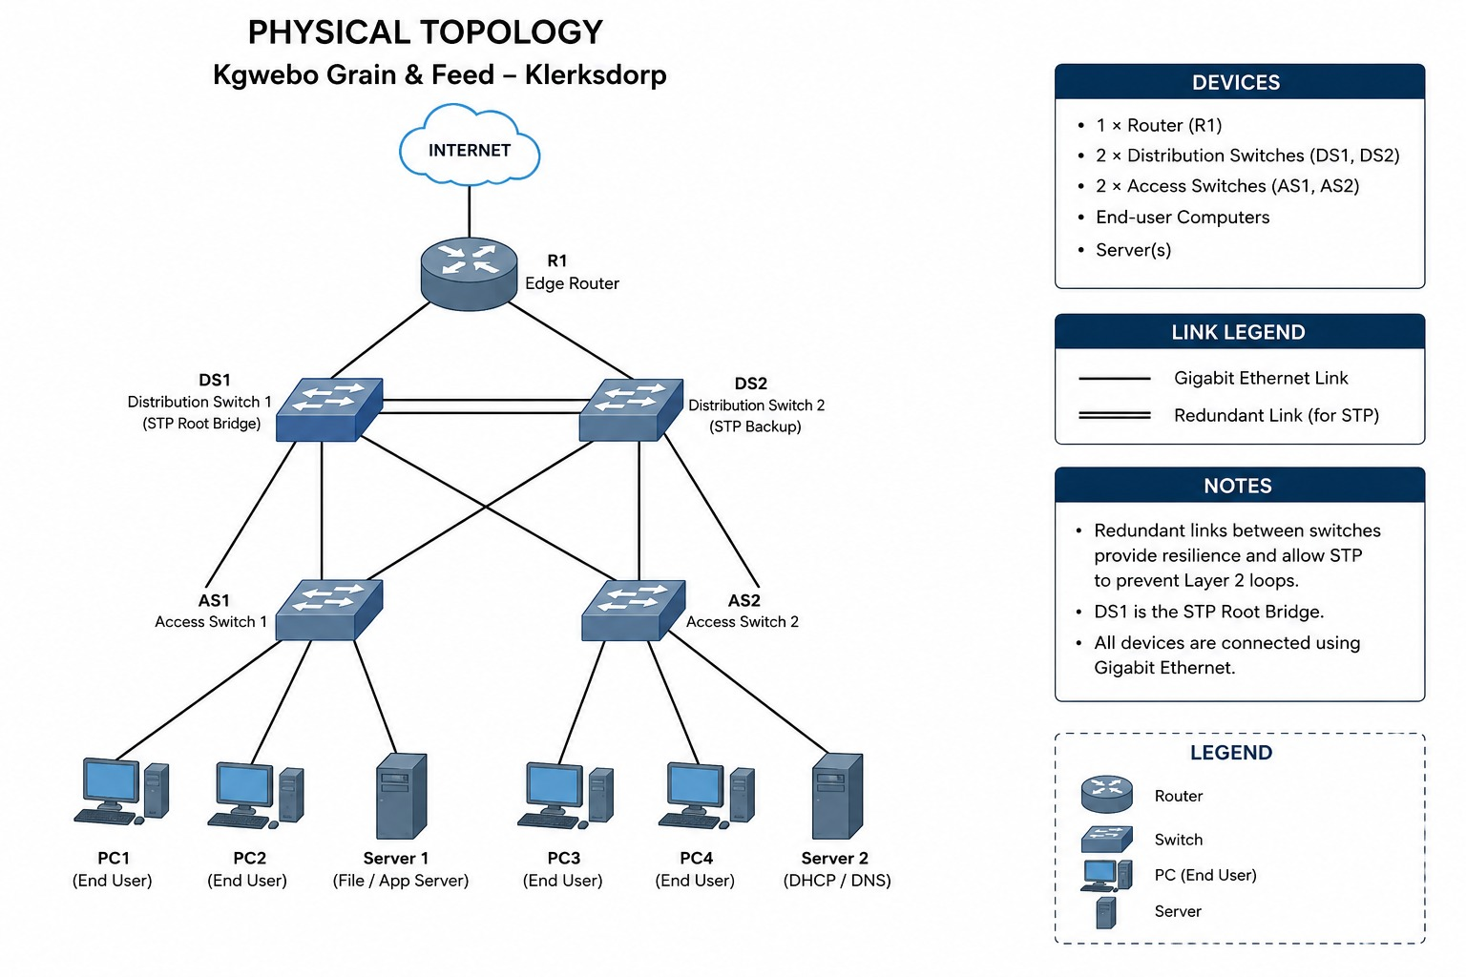

3. Logical Topology
The logical topology separates network users and services into VLANs. This supports traffic management and allows different access policies to be applied to Management and Staff. The distribution switches participate in STP, with a designated root bridge controlling preferred Layer 2 forwarding paths and preventing switching loops.
LOGICAL TOPOLOGY DIAGRAM 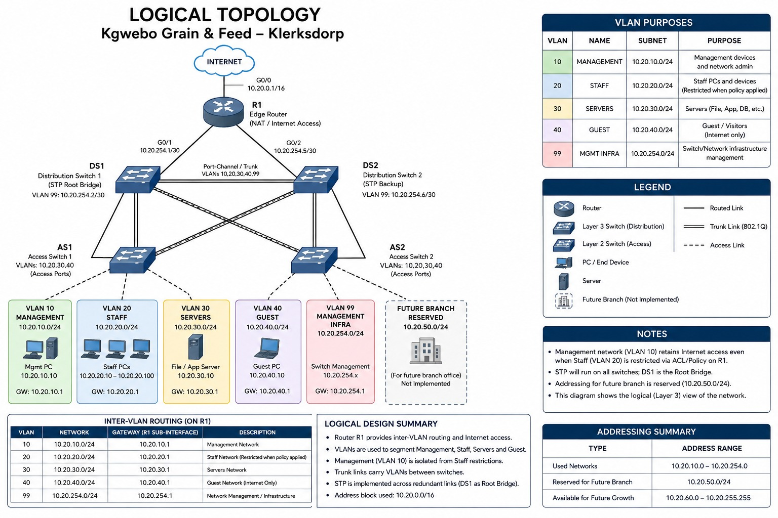

4. IP Addressing Plan
The IP addressing plan is based on the assigned 10.20.0.0/16 address block. The address space is divided into separate subnets for network segmentation, management, staff, servers, and future expansion.
Network Segment | VLAN | Network Address | Subnet Mask | Default Gateway
Management | 10 | 10.20.10.0/24 | 255.255.255.0 | 10.20.10.1
Staff | 20 | 10.20.20.0/24 | 255.255.255.0 | 10.20.20.1
Servers | 30 | 10.20.30.0/24 | 255.255.255.0 | 10.20.30.1
Network Management | 99 | 10.20.99.0/24 | 255.255.255.0 | 10.20.99.1
Future Branch Office | Reserved | 10.20.100.0/24 | 255.255.255.0 | Reserved

Addressing Allocation
- Management: 10.20.10.0/24
- Staff: 10.20.20.0/24
- Servers: 10.20.30.0/24
- Network Management: 10.20.99.0/24
- Future Branch: 10.20.100.0/24
The remaining address space within 10.20.0.0/16 remains available for future expansion. The 10.20.100.0/24 network is reserved for the planned branch office in accordance with CR6; the branch office is not physically implemented in Packet Tracer.

5. Initial GitHub Repository
An initial GitHub repository will be used as the project portfolio for the network design. For Milestone 1, the repository should contain the client requirements, physical topology, logical topology, IP addressing plan, and the initial project documentation. Later milestones will add the working Packet Tracer file, configurations, screenshots, testing evidence, troubleshooting records and reflections.
GITHUB REPOSITORY LINK / SCREENSHOT — https://github.com/Lekgalake/CMPG325-2026-038-Kgwebo-Grain-Feed.git
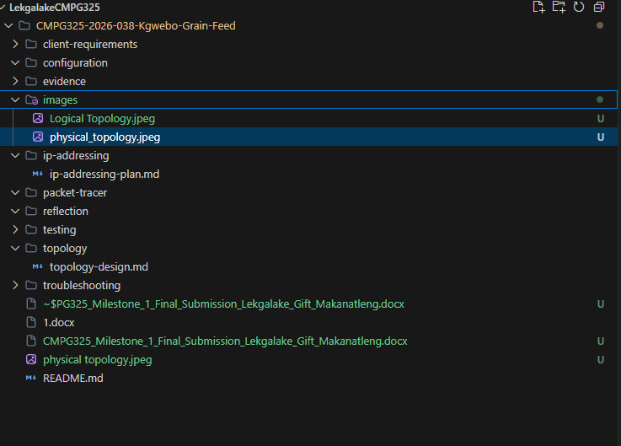

6. Milestone 1 Scope
This submission is limited to Milestone 1 — Client Design Review. The focus is the initial network design and planning stage rather than full implementation and testing. The Milestone 1 deliverables covered in this document are:
- Client requirements
- Physical topology
- Logical topology
- IP addressing plan
- Initial GitHub repository

END OF MILESTONE 1 SUBMISSION

