Name | Lekh Nayak
UID no. | 2023800068
Experiment No. | 5

AIM: | Demonstrate the use of two-dimensional arrays to solve a given problem
Program 1
PROBLEM STATEMENT : | Write a program to perform Matrix Addition, Subtraction
ALGORITHM: | 1. Start  2. Define a void function read with the arguments : dimensions m and n of a 2D array ,array.  a. Declare variables i and j.  b. Iterate i from 0 to m-1 and iterate j from 0 to n-1:  - - Display "Enter the value of arr[i][j]: ".  - - Read the value of arr[i][j] using scanf.  3. Define the function print with the arguments : dimensions m and n of a 2D array and the array itself.  a. Declare variables i and j.  b. Iterate i from 0 to m-1 and iterate j from 0 to n-1:  - - Print the value of arr[i][j] followed by a tab.  - - If j equals n-1, print a newline.  4. Define the function addMatrice with the arguments : dimensions m and n of two 2D arrays and their elements, and a third array for storing the result.  a. Declare variables i and j.  b. Iterate i from 0 to m-1 and iterate j from 0 to n-1:  - - Calculate the sum of corresponding elements of arr1 and arr2 and store it in res[i][j].  c. Display "result: ".  d. Call the print function with parameters m, n, and res.  5. Define the function subtractMatrix with the arguments : dimensions m and n of two 2D arrays and their elements, and a third array for storing the result.  a. Declare variables i and j.  b. Iterate i from 0 to m-1 and iterate j from 0 to n-1:  - - Calculate the difference of corresponding elements of arr1 and arr2 and store it in res[i][j].  c. Display "result: ".  d. Call the print function with parameters m, n, and res.  6. Define the main function.  a. Declare integer variables m, n, and choice.  b. Display "rows: " and read the value of m using scanf.  c. Display "columns: " and read the value of n using scanf.  d. Declare 2D arrays arr1, arr2, and res, each with dimensions m x n.  e. Display "Enter elements first:" and call the read function with parameters m, n, and arr1.  f. Display "Enter elements second:" and call the read function with parameters m, n, and arr2.  g. Display "First matrix is:" and call the print function with parameters m, n, and arr1.  h. Display "Second matrix is:" and call the print function with parameters m, n, and arr2.  i. Display the menu options for addition and subtraction.  j. Read the value of choice using scanf.  k. Using a switch-case statement, perform the chosen operation based on the user's choice.  l. Return 0 to indicate successful execution.  7. End
PROGRAM: | #include <stdio.h>  void read (int m,int n, int arr[m][n])  {  int i,j;  for (i=0;i<m;i++)  {  for (j=0;j<n;j++)  {  printf("Enter the value of arr[%d][%d]: ",i,j);  scanf("%d",&arr[i][j]);  }  }  }  void print(int m,int n, int arr[m][n])  {  int i,j;  for (i=0;i<m;i++)  {  for (j=0;j<n;j++)  {  printf("%d\t",arr[i][j]);  }  printf("\n");  }  }  void addMatrice(int m, int n ,int arr1[m][n],int arr2[m][n],int  res[m][n])  {  int i,j;  for (i=0;i<m;i++)  {  for (j=0;j<n;j++)  {  res[i][j]=arr1[i][j]+arr2[i][j];  }  }  printf("result: \n");print(m,n,res);  }  void subtractMatrix(int m, int n ,int arr1[m][n],int  arr2[m][n],int res[m][n])  {  int i,j;  for (i=0;i<m;i++)  {  for (j=0;j<n;j++)  {  res[i][j]=arr1[i][j]-arr2[i][j];  }  }  printf("result: \n");  print(m,n,res);  }  int main()  {  int m,n;  printf(" rows: ");  scanf("%d",&m);  printf(" columns: ");  scanf("%d",&n);  int arr1[m][n],arr2[m][n],res[m][n];  printf("Enter elements first : \n");  read(m,n,arr1);  printf("Enter elements second : \n");  read(m,n,arr2);  printf("first matrix is: \n");  print(m,n,arr1);  printf(" second matrix is: \n");  print(m,n,arr2);  printf("1. Add\n2. Subtract\n");  printf("Enter your choice: ");  int choice;  scanf("%d",&choice);  switch(choice){  case 1: printf("addition of matrix is: \n");  addMatrice(m,n,arr1,arr2,res);  break;  case 2:printf("subtraction of matrix is: \n");  subtractMatrix(m,n,arr1,arr2,res);  break;  default: printf("Invalid choice");  }  return 0;  }
RESULT:
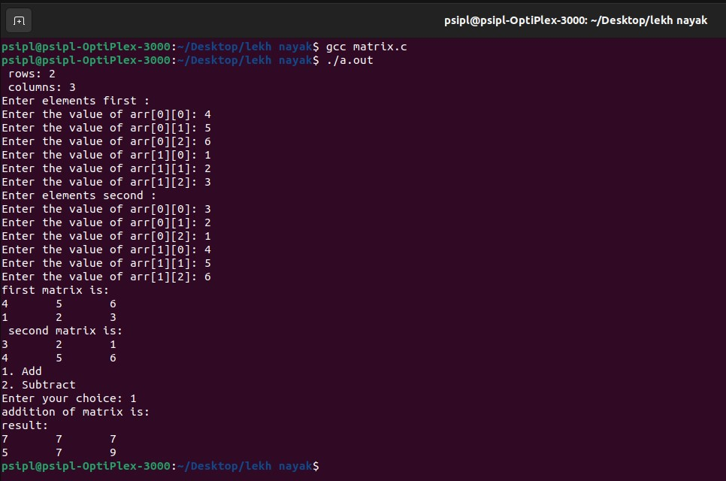
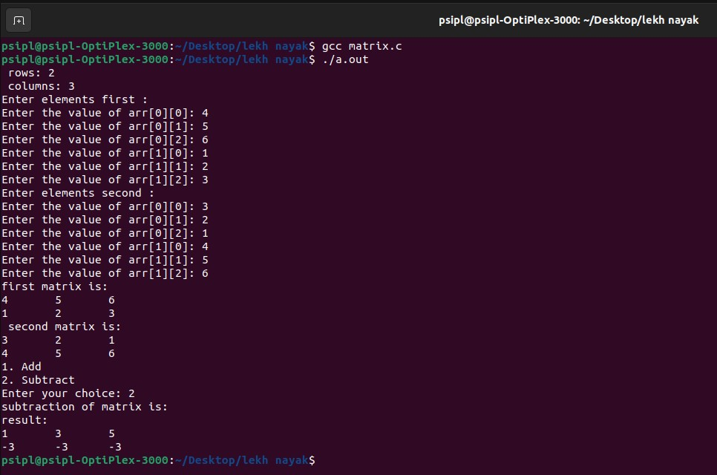
Program 2
PROBLEM STATEMENT : | Write a program to perform Matrix Multiplication
ALGORITHM: | 1. Start  2. Define a void function read with the arguments : dimensions m and n of a 2D array , array.  a. Declare variables i and j.  b. Iterate i from 0 to m and iterate j from 0 to n,incrementing i and j by 1 each iteration:  - - Read the value of arr[i][j] using scanf.  3. Define the function print with the arguments : dimensions m and n of a 2D array ,array.  a. Declare variables i and j.  b. Iterate i from 0 to m and iterate j from 0 to n,incrementing i and j by 1 each iteration:  - - Print the value of arr[i][j] followed by a tab. - print a newline.  4. Define a void function multiplyMatrices with the arguments : dimensions m, n, p, and q of two 2D arrays and their elements, result array.  a. Iterate i from 0 to m,incrementing i by 1 each iteration:  b. Iterate j from 0 to n ,incrementing j by 1 each iteration:  - - result[i][j] =0.  - - Iterate k from 0 to n,incrementing k by1 each iteration:  - - Update result[i][j] by adding the product of A[i][k] and B[k][j].  c. Print "Resultant matrix:".  d. Call the print function with parameters m, n, and result.  5. Define the main function.  a. Declare integer variables m, n, p, and q.  b. Print "row column for 1st:" and read the values of m and n using scanf.  c. Print "row column for 2:" and read the values of p and q using scanf.  d. If the number of columns in the first matrix is not equal to the number of rows in the second matrix: - - Print "error"  e. Declare 2D arrays A, B, and res, each with dimensions m x n, p x q, and n x p, respectively.  f. Print "Enter elements first:" and call the read function with parameters m, n, and A.  g. Print "Enter elements second:" and call the read function with parameters p, q, and B.  h. Print "First matrix is:" and call the print function with parameters m, n, and A.  i. Print "Second matrix is:" and call the print function with parameters p, q, and B.  j. Call the multiplyMatrices function with parameters m, n, p, q, A, B, and res.  6. End
PROGRAM: | #include <stdio.h>  void read (int m,int n, int arr[m][n])  {  int i,j;  for (i=0;i<m;i++)  {  for (j=0;j<n;j++)  {  printf("Enter the value of arr[%d][%d]: ",i,j);  scanf("%d",&arr[i][j]);  }  }  }  void print(int m,int n, int arr[m][n])  {  int i,j;  for (i=0;i<m;i++)  {  for (j=0;j<n;j++)  {  printf("%d\t",arr[i][j]);  }  printf("\n");  }  }  void multiplyMatrices( int m, int n, int p,int q,int A[m][n],  int B[p][q], int result[n][p])  {  for (int i = 0; i < m; i++){  for (int j = 0; j < n; j++)  {  result[i][j] = 0;  for (int k = 0; k < n; k++)  {  result[i][j] += A[i][k] * B[k][j];  }  }  }  printf("Resultant matrix:\n");  print(m,n,result);  }  int main()  {  int m, n, p, q;  printf("row column for 1st: ");  scanf("%d %d", &m, &n);  printf("row column for 2: ");  scanf("%d %d", &p, &q);  if (n != p)  {  printf("error\n");  return 1;  }  int A[m][n], B[p][q], res[n][p];  printf("Enter elements first : \n");  read(m,n,A);  printf("Enter elements second : \n");  read(m,n,B);  printf("first matrix is: \n");  print(m,n,A);  printf(" second matrix is: \n");print(m,n,B);  multiplyMatrices(m,n,p,q,A,B,res);  return 0;  }
RESULT:
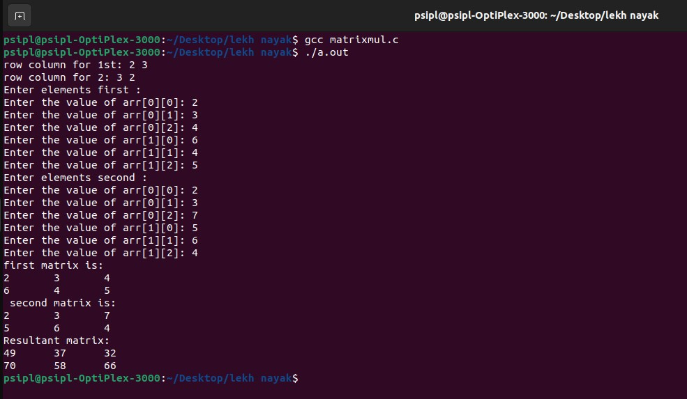
Program 3
PROBLEM STATEMENT: | Write a program to perform Transpose of Matrix
ALGORITHM: | STEP 1: Start  STEP 2: Declare row,col of the matrices and take the input  from the user.  STEP 3: Declare two arrays a[row][col]  STEP 4: Call the function arreleinput()  STEP 5: Declare array c[col][row]  STEP 6: Call the transpose() function  STEP 7: Call the arrprint() function  STEP 8: Stop  Algorithm for arreleinput():  STEP 1: Take arguments row ,col,a[row][col]  [START OF OUTER FOR LOOP]  STEP 2: int i=0;i<row  [START OF INNER FOR LOOP]  Int j=0;j<col  Take a[i][j] as input  j=j+1  [END OF INNER FOR LOOP]  i=i+1  [END OF OUTER FOR LOOP]  Algorithm for arrprint():  STEP 1: Take arguments row , col ,a[row][col]  [START OF OUTER FOR LOOP]  STEP 2: int i=0; i<row  [START OF INNER FOR LOOP]  Int j=0; j<col  PRINT a[i][j]  j=j+1  [END OF INNER FOR LOOP]  i=i+1  [END OF OUTER FOR LOOP]  Algorithm for tranpose():  STEP 1:Take row ,col ,a[row][col], c[col][row] as arguments  [START OF OUTER FOR LOOP]  STEP 2: : int i=0; i<row  [START OF INNER FOR LOOP]  Int j=0; j<col  c[j][i]=a[i][j]  j=j+1  [END OF INNER FOR LOOP]  i=i+1  [END OF OUTER FOR LOOP
PROGRAM: | #include<stdio.h>  void read(int m,int n, int arr[m][n]){  for(int i=0;i<m; i++){  for(int j=0; j<n; j++){  scanf("%d",&arr[i][j]);  }  }  }  void print(int m, int n,int arr[m][n]){  for(int i=0; i<m; i++){  for(int j=0; j<n; j++){  printf("%d" , arr[i][j]);  }  printf("\n");  }  }  void transpose(int m, int n, int arr1[m][n], int arr2[n][m]){  for(int i=0;i<m;i++){  for(int j=0;j<n;j++){  arr2[j][i]=arr1[i][j];  }  }  }  int main(){  int m,n;  printf("Enter the dimensions of the matrix:");  scanf("%d%d",&m,&n);  int arr1[m][n];  int arr2[n][m];  printf("The first array is:-\n");  read(m, n, arr1);  transpose(m, n, arr1, arr2);  printf("Transpose of matrix is:-\n");  print(m, n, arr2);  }
RESULT: 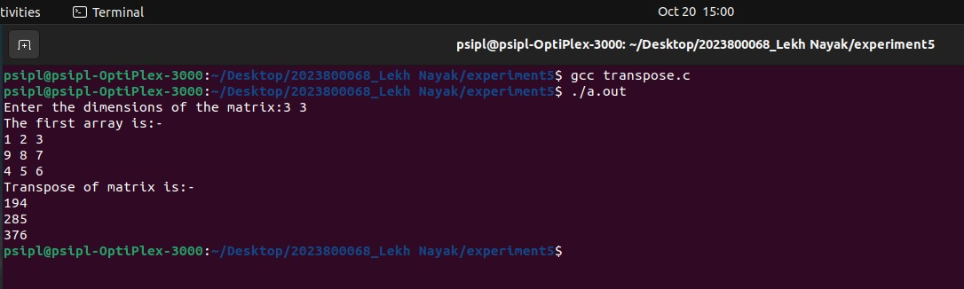
CONCLUSION: | In this experiment I learnt the use of two dimensional arrays to solve a given problem

