Name | Lekh Sanatan Nayak
UID no. | 2023800068
Experiment No. | 6

AIM: | Apply the concept of recursion to solve a given problem.
Program 1
PROBLEM STATEMENT : | Write a recursive function to multiply 2 numbers
ALGORITHM: | - Start  - Declare a function “mul” which takes two integer values ‘a’ and ‘b’ as arguments.  - Define a variable “ans” which will store the product of the two numbers.  - If ‘b’ is equal to 0, return 0(this is our base case)  - Else perform the following for the recursive case  - Subtract 1 from the value of ‘b’ (b-1), and call “mul” funtion with arguments ‘a’ and ‘b-1’ (repeat untill b=0)  - Add the value of the recursive steps to ‘a’ and then store the value in ‘ans’  - Return the value of ‘ans’.  - Declare a function “main”  - Define variables ‘a’ and ‘b’  - Take user input for the values of ‘a’ and ‘b’  - Call the function “mul” with arguments ‘a’ and ‘b’  - End
PROGRAM: | #include<stdio.h>  int mul(int a, int b){  int ans;  if(b==0){  return 0;  }  else{  ans = a + mul(a,b-1);  }  return ans;  }  int main(){  int a,b;  scanf("%d%d",&a,&b);  int ans = mul(a,b);  printf("%d",ans);  return 0;  }
RESULT:
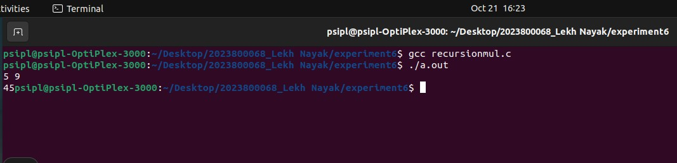
Program 2
PROBLEM STATEMENT : | Write a recursive function to find the factorial of a number and test it.
ALGORITHM: | - Start  - Declare a function “factorial” with one integer argument ‘a’.  - Define a variable ‘ans’  - If a=1 or a=0, then return 1(this is our base case)  - Else perform the following for the recursive case  - Subtract 1 from ‘a’ (a-1) and call the function “factorial” recursively with arguments(a-1)  - Multiply the result of the recursive step(factorial of a-1) with ‘a’ and store it in ‘ans’  - Return the value of ‘ans’  - Declare a function “main”  - Define a variable ‘a’  - Take user input for the value of ‘a’  - Call the function “factorial” with integer argument ‘a’  - End
PROGRAM: | #include<stdio.h>  int factorial(int a){  int ans;  if(a==1 || a==0){  return 1;  }  else{  ans=a*factorial(a-1);  }  }  int main(){  int a;  scanf("%d",&a);  int ans=factorial(a);  printf("factorial is %d",ans);  return 0;  }
RESULT:
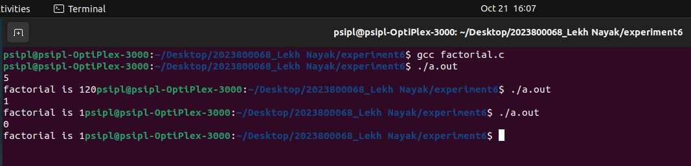
Program 3.A
PROBLEM STATEMENT: | Write a recursive function which returns the nth term of the fibonacci series.
ALGORITHM: | 1. Start  2. Declare a funtion “fibbo” that takes 1 integer value ‘n’ as argument.  3. Define a variable ans and initialize it to 0  4. If the value of n is 1 or 2 then return 1 to the function(this is our base case)  5. Else perform the following for recursive cases  - Subtract 1 and 2 from ‘n’ i.e. (n-1) and (n-2) and call the function “fibbo” recursively with arguments (n-1) and (n-2).  - Call the function “fibbo” twice with arguments (n-1)(n-2)and add them both and store their sum in ‘ans’ variable.  6. Return the value of ans  7. Declare a function “main”  8. Define a variable ‘input’  9. Take user input for the value of ‘input’ and print it  10. Call the function fibbo with ‘input’ as argument and store it in a variable ‘ans’  11. Return 0 to the function  12. End
PROGRAM: | #include<stdio.h>  int fibbo(int n){  int ans=0;  if(n==1 || n==2){  return 1;  }  else{  ans=fibbo(n-2)+fibbo(n-1);  }  return ans;  }  int main(){  int input;  printf("no. of term to be found:-");  scanf("%d",&input);  int ans = fibbo(input);  printf("%d term is %d",input,ans);  return 0;  }
RESULT:
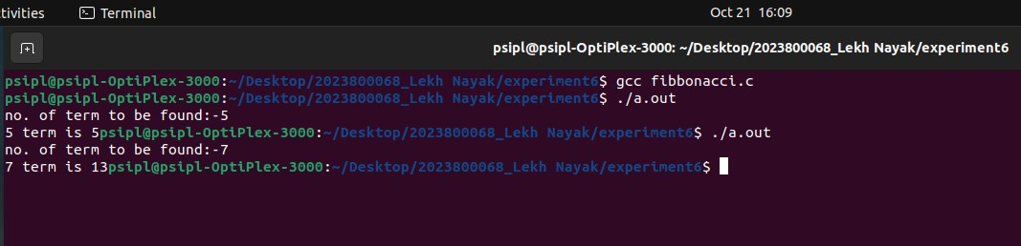
Program 3.B
PROBLEM STATEMENT: | Call it from main() to find the 1st n numbers of the fibonacci series.
FLOWCHART: | 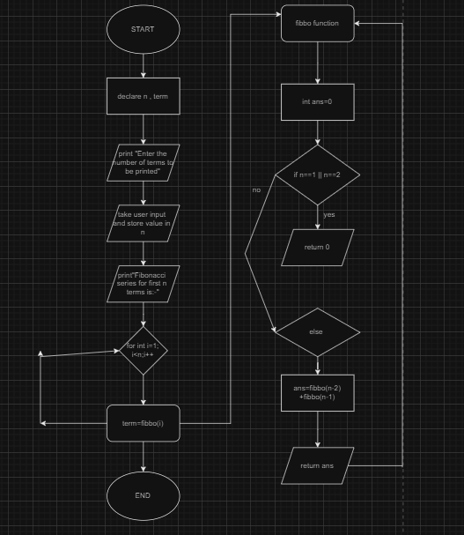
ALGORITHM: | 1. Start  2. Declare a funtion “fibbo” that takes 1 integer value ‘n’ as argument.  3. Define a variable ans and initialize it to 0  4. If the value of n is 1 or 2 then return 1 to the function(this is our base case)  5. Else perform the following for recursive cases  - Subtract 1 and 2 from ‘n’ i.e. (n-1) and (n-2) and call the function “fibbo” recursively with arguments (n-1) and (n-2).  - Call the function “fibbo” twice with arguments (n-1)(n-2)and add them both and store their sum in ‘ans’ variable.  6. Return the value of ans  7. Declare a function “main”  8. Define variables ‘n’ and ‘term’.  9. Print the statement “Enter the number of terms to be printed:’  10. Take user input for the number of terms to be printed  11. Create a ‘for’ loop and initialize integer variable ‘i’ to 1, define the condition ‘i<n’ for executing the code block, and set the statement 3 to ‘i++’.  12. Call the function “fibbo” and store its value in ‘term’ variable and print the value of ‘term’ inside the “for” loop.  13. Return 0 to show that the program has executed itself .  14. End.
PROGRAM: | #include<stdio.h>  int fibbo(int n){  int ans=0;  if(n==1 || n==2){  return 1;  }  else{  ans = fibbo(n-2) + fibbo(n-1);  }  return ans;  }  int main(){  int n, term;  printf("Enter the number of terms to be printed:-");  scanf("%d",&n);  printf("fibonacci series for first %d terms is:-", n);  int i;  for(i=1; i<n ;i++){  term = fibbo(i);  printf("%d ",term);  }  return 0;  }
RESULT:
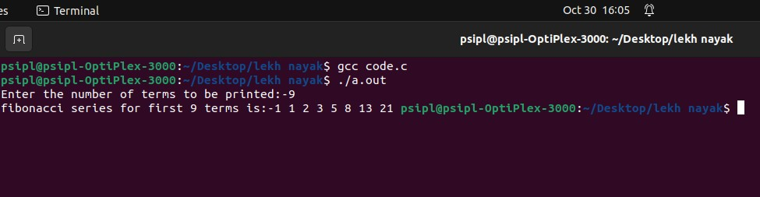
Program 4
PROBLEM STATEMENT: | Given a room of area L x B. You have an infinite number of tiles of size 2n x 2n , where n = 0, 1,2,... so on. The task is to find the minimum number of square tiles required to fill the given area with tiles.  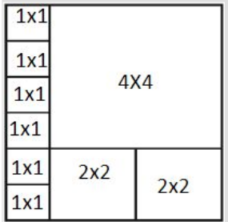
ALGORITHM: | - Declare a function “tile” that takes two parameters, l for the length and b for the breadth of the floor.  - Initialize a variable ‘ans’ to 0, which will store the minimum number of tiles required.  - Check if either the length ‘l’ or breadth ‘b’ is 0. If either of them is 0, return 0, indicating that no tiles are needed.  - Check if both l and b are even numbers. If they are, recursively call the tile function with half of l and half of b and assign the result to ans.  - If both l and b are odd numbers, calculate l + b - 1, which represents the minimum number of tiles required to cover the floor diagonally, and then recursively call the tile function with half of l and half of b. Add this result to ans.  - If l is even and b is odd, add l to ‘ans’ and recursively call the tile function with half of l and half of b.  - If l is odd and b is even, add b to ‘ans’ and recursively call the tile function with half of l and half of b.  - Finally, return the ‘ans’ as the minimum number of tiles required to cover the entire floor.  - Declare a function “main”  - Take user input for the values of ‘l’ and ‘b’  - Call the function tile with arguments l and b and store the value in ‘ans’ variable  - Print ‘ans’  - End
PROGRAM: | #include<stdio.h>  int tile(int l,int b){  int ans=0;  if(l==0 || b==0){  return 0;  }  else if(l%2==0 && b%2==0){  ans= tile(l/2,b/2);  }  else if(l%2==1 && b%2==1){  ans= l+b-1+tile(l/2,b/2);  }  else if(l%2==0 && b%2==1){  ans= l+tile(l/2,b/2);  }  else if(l%2==1 && b%2==0){  ans= b+tile(l/2,b/2);  }  return ans;  }  int main(){  int l,b;  printf("length=");  scanf("%d",&l);  printf("\nbreath=");  scanf("%d",&b);  int ans=tile(l,b);  printf("\nmin tiles= %d",ans);  return 0;  }
RESULT: 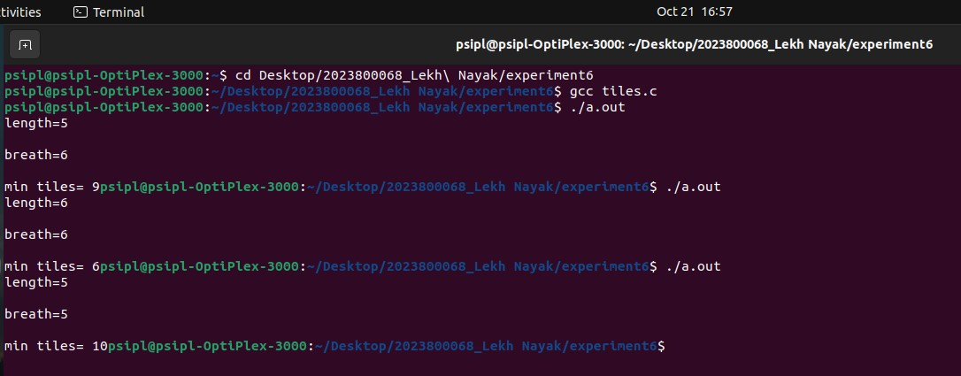
CONCLUSION: | In this experiment I learnt the application of recursive functions to solve a given problem

