Name | Lekh Sanatan Naayak
UID no. | 2023800068
Experiment No. | 9

AIM: | Demonstrate the use of pointers to solve a given problem.
Program 1
PROBLEM STATEMENT : | Write a program to reverse the position of all elements in the array using  pointers.
PROGRAM: | #include<stdio.h>  void reverse_arr(int n, int a[]){  for(int i=0; i<n/2; i++){  int temp=*(a+i);  *(a+i) = *(a+n-1-i);  *(a+n-1-i)= temp;  }  }  void print_arr(int n, int a[])  {  for(int i=0; i<n; i++){  printf("%d,", *(a+i));  }  }  int main(){  int a[] = {10,20,30,40,50};  reverse_arr(5,a);  print_arr(5,a);  return 0;  }
RESULT:
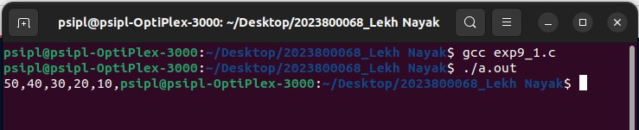
Program 2
PROBLEM STATEMENT : | Write a program to perform matrix addition using pointers.
PROGRAM: | #include<stdio.h>  void mat_add(int m, int n, int mat1[][n], int mat2[][n], int res[][n]){  for(int i=0; i<m; i++)  for(int j=0;j<n;j++)  *(*(res+i)+j) = *(*(mat1+i)+j)+*(*(mat2+i)+j);  }  void mat_print(int m, int n, int mat[][n]){  for(int i=0; i<m; i++){  for(int j=0;j<n;j++)  printf("%d ", *(*(mat+i)+j));  printf("\n");  }  }  int main(){  int a[][3] = {{1,2,3}, {4,5,6}};  int b[][3] = {{4,5,6}, {1,2,3}};  int c[2][3];  mat_add(2,3,a,b,c);  mat_print(2,3,c);  return 0;  }
RESULT:
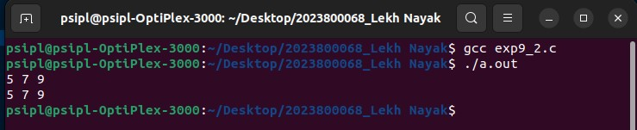
CONCLUSION: | In this experiment I learnt about the use of pointers to solve a given problem

