Name | Lekh Sanatan Nayak
UID no. | 2023800068
Experiment No. | 4

AIM: | Demonstrate the use of one-dimensional arrays to solve a given problem
Program 1
PROBLEM STATEMENT : | Write a C Program which contains a function to perform search of a particular element on an array. Create an array in main () and call the function to test it.
ALGORITHM: | - Start  - Declare variable ‘a’ and ‘size’.  - Take user input to enter the size of array and read the size of user input.  - Use a or loop to read ‘size’ integers from the user and store them in ‘a’.  - Print the elements of the array  - Take user input to search the number required.  - Call the iselementpresent functio with array’a’, its size and the search number as its arguments  - Inside the iselementpresent function, use a loop to iterate through the elements of the array  - For each element in the array, check if it is equal to the search number.  - If the number is found return 1 to indicate that the element is present.  - If the number is not found return 0 to indicate that the element is absent.  - In the main function, if the return value of iselementpresent is 1 print “Element found!” and is the return value is 0 print “Element not found. Better luck next time”  - End
PROGRAM: | #include <stdio.h>  int iselementpresent(int a[],int size,int num) {  for(int i=0;i<size;i++) {  if (num==a[i]){  return 1;  }  }  return 0;  }  int main() {  int size,search;  printf("Enter the size of the array: ");  scanf("%d",&size);  int a[size];  for (int i=0;i<size;i++) {  scanf("%d",&a[i]);  }  printf("The array is: ");  for (int i=0;i<size;i++) {  printf("%d, ",a[i]);  }  printf("\n");  printf("Type the number you want to search: ");  scanf("%d",&search);  if(iselementpresent(a,size,search)==1){  printf("Element found!");  }  else {  printf("Element not found\nBetter luck next time");  }  return 0;  }
RESULT: 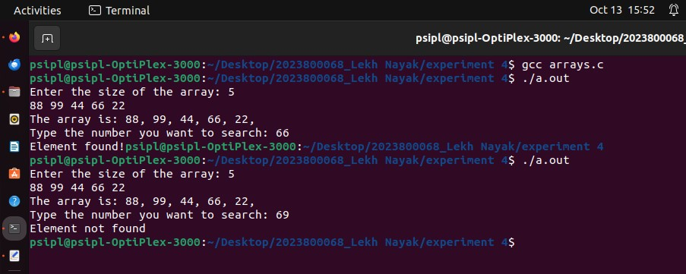
Program 2
PROBLEM STATEMENT : | Write a C Program which contains a function to sort array using selection sort. Create an array in main() and call the function to test it.
ALGORITHM: | - Define a function “display” and use it to print the elements of an array and define another function “swap” used to swap two integer value.  - Define “selectionsort” function which will perform the selectionsort algorithm to sort the array of elements.  - Define “main” function and prompt the user to enter the size of the array and read the value into the ‘size’ variable.  - Take user input to enter the elements of the array and read them into the array ‘a’ using a loop  - Call the displaay function to print the unsorted array.  - Call the selectionsort function to sort array ’a’ using the selection sort algorithm.  - In function “selectionsort” initialize a variable min_index and set it to the first element  - Start an outer loop that iterates through the array from the first element to the n-1.  - Inside the outer loop create a inner loop to find the index of the minimum element in the unsorted part of the array (from i+1 to size-1)  - Compare each element with the element at min_index, and if you find an element smaller than the current minimum, update min_index to the index of he smaller element.  - After the inner loop if the element at a[i] is greater than the element in a[min_index], swap the two elements using the “swap” function.  - Continue this process untill the smallest unsorted element moves to its correct position.  - After the outer loop completes the array is sorted in ascending order.  - Print “SORTED” to indicate that the array is now sorted.  - Call the “display” function again to print the sorted array.  - end
PROGRAM: | #include<stdio.h>  void display(int a[], int size){  printf("array is -{");  for (int i=0;i<size;i++){  printf("%d ,",a[i]);  }  printf("}");  }  void swap(int *a,int *b){  int temp;  temp=*a;  *a=*b;  *b=temp;  }  void selectionsort(int a[],int size){  int min_index;  for(int i=0;i<size;i++){  min_index=i;  for(int j=i+1;j<size;j++){  if(a[j]<a[min_index])  {  min_index=j;  }  }  if(a[i]>a[min_index]){  swap(&a[i],&a[min_index]);  }  }  }  int main(){  int size;  printf("Enter size-");  scanf("%d",&size);  int a[size];  printf("Enter elements-");  for(int i=0;i<size;i++){  scanf("%d",&a[i]);  }  display(a,size);  selectionsort(a,size);  printf("\nSORTED ");  display(a,size);  return 0;  }
RESULT:
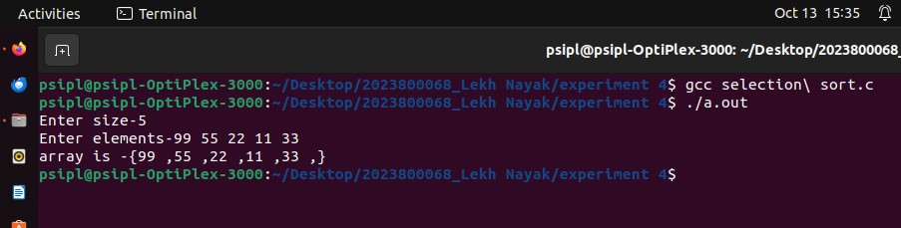
CONCLUSION: | In this experiment we learnt about the use of one-dimensional arrays to solve a given problem

