EX:1 | SETTING UP PYTHON ENVIRONMENT AND LIBRARIES – JUPYTER NOTEBOOK
DATE:

AIM:

To install Python, configure Jupyter Notebook, understand the notebook environment, execute Python programs, create Markdown cells, and use basic Jupyter Notebook features for Data Analytics applications

ALGORITHM:

- Step 1: Download the latest Python installer from the official Python website.
- Step 2: Run the installer, select "Add Python to PATH", and click Install Now.
- Step 3: Verify the Python installation by executing the command python --version in the Command Prompt.
- Step 4: Open the Command Prompt and install Jupyter Notebook using the command pip install notebook.
- Step 5: Launch Jupyter Notebook by executing the command jupyter notebook.
- Step 6: Wait for the browser to automatically open the Jupyter Notebook Dashboard.
- Step 7: Click New → Python 3 (ipykernel) to create a new notebook.
- Step 8: Rename the notebook with an appropriate title.
- Step 9: Create Code cells and Markdown cells as required.
- Step 10: Write and execute the program using Shift + Enter.
- Step 11: Save the notebook and verify that it executes successfully.
- Step 12: End the program

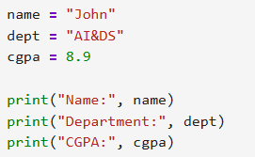
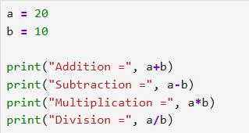
PROGRAM:
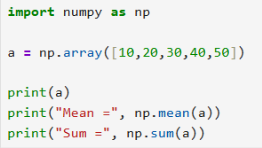

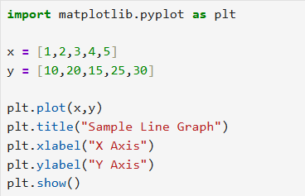
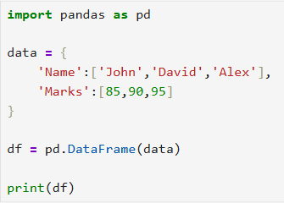

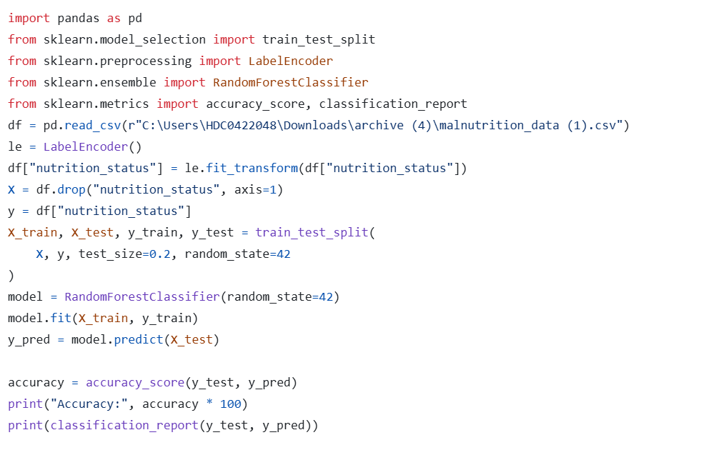

OUTPUT:

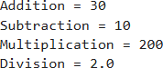
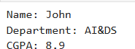
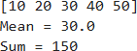
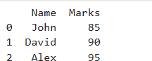

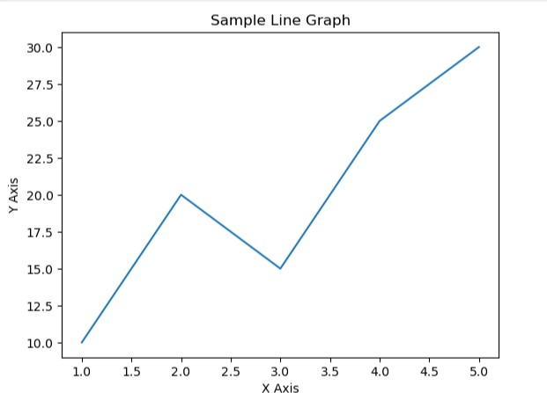
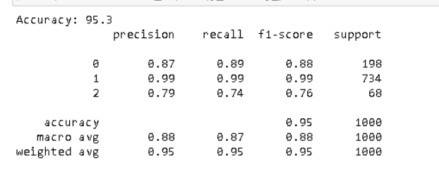

RESULT:
Python and Jupyter Notebook were installed successfully. A new Jupyter Notebook was created, renamed, and executed without errors. Code and Markdown cells were added and run successfully. Thus, the Python programming environment was set up successfully.

