Sri Sivasubramaniya Nadar College of Engineering, Chennai
Department of Computer Science and Engineering
ICS1502 – Introduction to Machine Learning
CAT Assignment 2 – Bank Note Authentication: Written Analysis
Name | Register No. | Programme | Date
Lekha Shree A | 3122247001031 | M.Tech (Integrated) CSE, Sem V (2024–2029) | 1-10-2026

Companion notebook: Bank_Note_Authentication_CAT2.ipynb (all code, outputs and figures). Every number below is taken from that notebook run (random_state = 42).

1. Data and experimental setup
The Bank Note Authentication dataset has 1,372 banknote images described by four wavelet-transform features (variance, skewness, curtosis, entropy) and a binary class. It has no missing values but 24 exact duplicate rows; these were removed so that the same note cannot appear in both train and test, leaving 1,348 rows (738 class 0, 610 class 1 – mildly imbalanced).
A stratified 80/20 split gives 1,078 training and 270 test rows. Features are standardised with a scaler fitted on the training data only. Whenever cross-validation is used, the scaler (and PCA, where applicable) is refitted inside each fold through a pipeline, so no information leaks. Hyper-parameters are chosen by cross-validation on the training data, never on the test set.
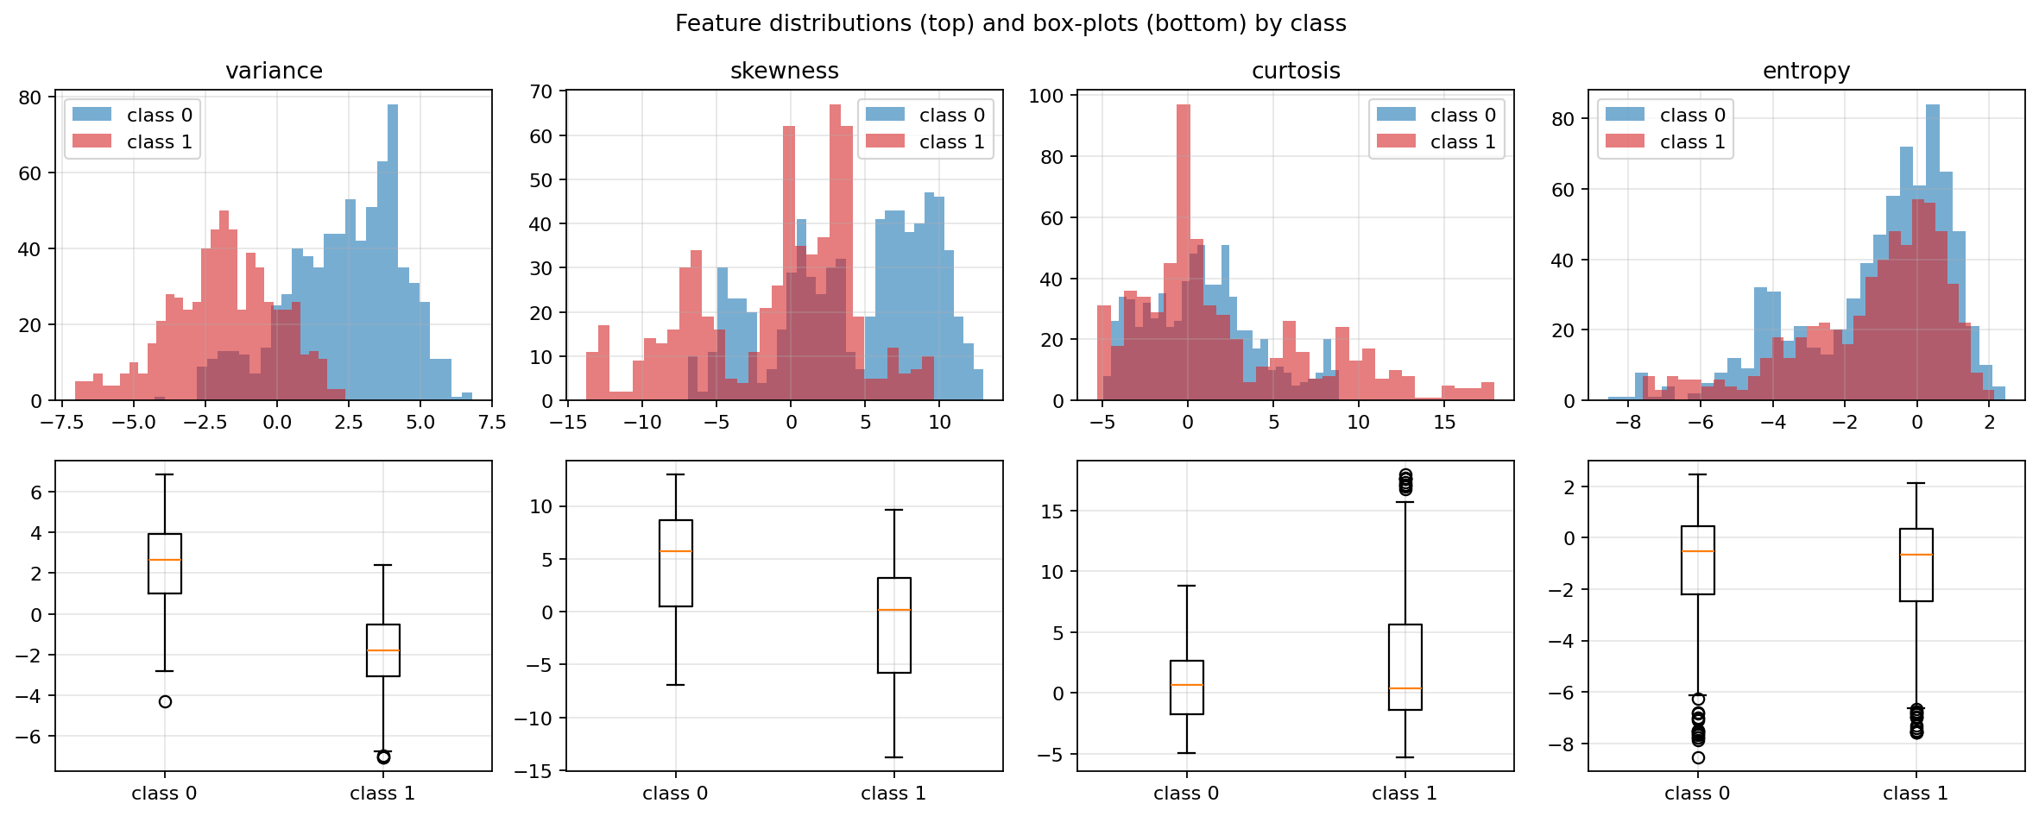
Figure 1. Feature distributions and box-plots by class. Variance and skewness separate the classes best; entropy barely does.

2. Task 1 – Linear baseline with and without L2
Logistic regression models P(y = 1 | x) = σ(wᵀx + b). With L2 regularisation a penalty (λ/2)‖w‖² is added to the log-loss, where scikit-learn’s C = 1/λ. Two models were fitted on the same split: no penalty, and λ = 1.
Model | Train acc | Test acc | 5-fold CV | Precision | Recall | F1 | ‖w‖₂
No regularisation | 99.72 % | 99.26 % | 99.63 % | 98.39 % | 100 % | 99.19 % | 33.8
L2, λ = 1 | 99.44 % | 98.52 % | 99.44 % | 96.83 % | 100 % | 98.39 % | 8.0

- No over-fitting to cure. Both models generalise very well (train–test gap < 1 pp). The data are low-dimensional (4 features, 1,078 rows) and nearly linearly separable.
- L2 shrinks the weights four-fold (33.8 → 8.0) but gives no accuracy gain. At λ = 1 test accuracy is 0.74 pp lower, which is two notes out of 270 – within noise, but certainly not an improvement.
- Why the unregularised weights are huge: when classes are almost separable the optimiser keeps inflating ‖w‖ to push probabilities to 0 or 1. The penalty’s main benefit here is numerical stability and calibrated probabilities, not accuracy.
- Recall is 100 % for both, so every error is a false positive (a class-0 note labelled class 1).

3. Task 2 – Effect of the regularisation strength λ
λ was swept from 10⁻⁴ to 10³ (30 log-spaced values). Training, test and 5-fold CV accuracy were recorded. Because the full dataset is easy, the sweep was repeated on very small training subsets (n = 25, averaged over 40 random draws), where over-fitting is easier to provoke.
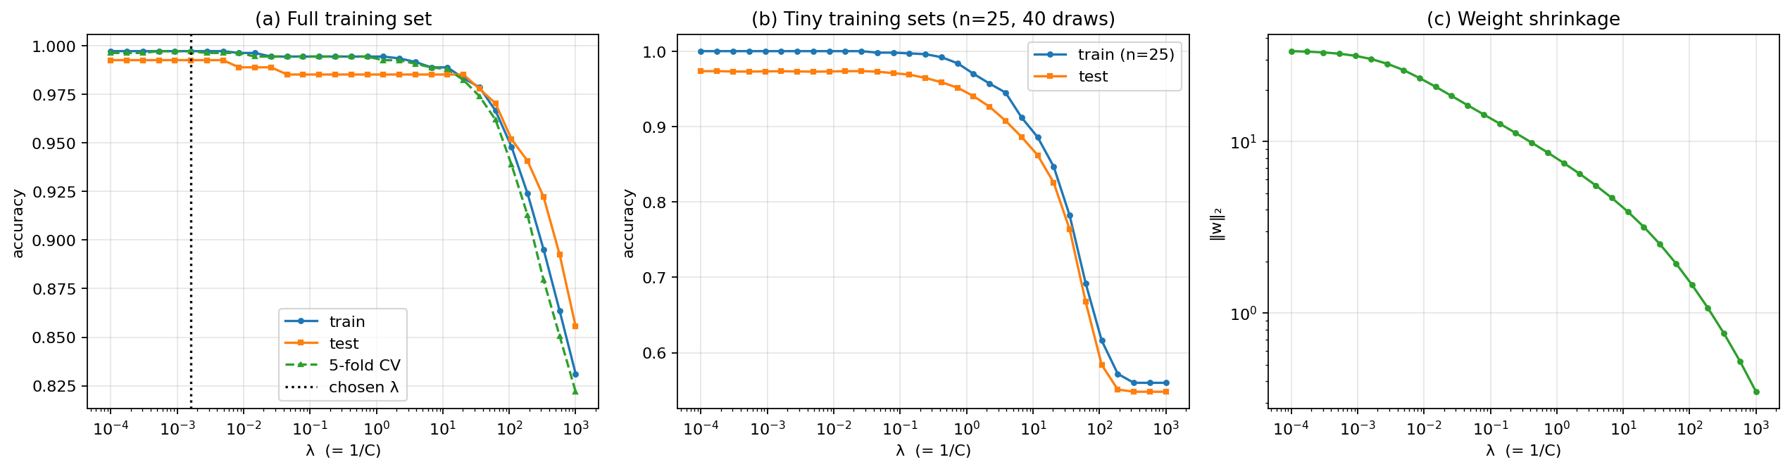
Figure 2. (a) Accuracy vs λ on the full training set; (b) the same on tiny training sets; (c) shrinkage of ‖w‖₂.
- Full data: accuracy is flat (≈ 99.3 % test, 99.6–99.7 % CV) for λ ≤ 10⁻², declines slowly up to λ ≈ 10, and collapses beyond λ ≈ 60 (CV 96.2 % at λ = 62; 87.9 % at λ = 329) because the weights are over-shrunk and the model under-fits. The CV-optimal λ is tiny (≈ 0.0016, C ≈ 620).
- Tiny training sets: training accuracy is 100 % and test accuracy ≈ 97.3 % at small λ, so a small generalisation gap exists – but raising λ lowers both curves (test 92.6 % at λ ≈ 2, 66.7 % at λ ≈ 60). The variance of a 5-parameter linear model is already small; shrinkage mainly adds bias.
- Conclusion: for this problem the best regularisation is weak. Over-fitting is not the main risk; large λ simply under-fits. Regularisation would matter more with many correlated or noisy features.

4. Task 3 – Decision boundary in 3-D
Features were ranked on the training data by ANOVA F-score (variance 1267, skewness 279, curtosis 28, entropy 1.3) and mutual information (entropy ≈ 0). The top three – variance, skewness and curtosis – were used. A logistic regression fitted in this 3-D space has a planar boundary wᵀx + b = 0.
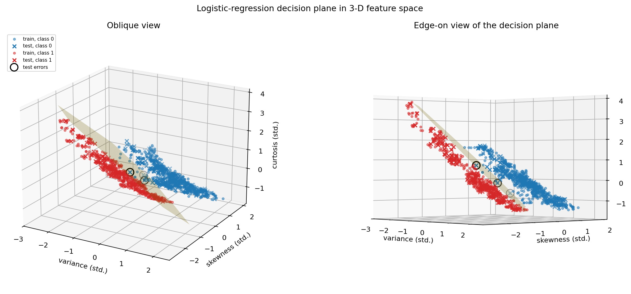
Figure 3. Decision plane in standardised {variance, skewness, curtosis} space; circles mark test errors (left: oblique view, right: edge-on).
- Separability: the 3-feature model reaches 98.52 % test accuracy, identical to the 4-feature model (4 errors in 270), confirming that entropy adds nothing.
- Geometry: the two classes form long, roughly parallel clouds that one plane splits cleanly over most of their length. Mean distance to the plane is 0.75σ (class 0) and 0.44σ (class 1); 21/590 and 74/488 training points lie within 0.25σ of the plane. The test errors sit where the clouds approach each other.
- Silhouette score 0.26 is low only because the clouds are elongated and adjacent; accuracy is the better indicator. Overall the classes are almost, but not perfectly, linearly separable – the thin overlap and slight curvature are where a non-linear model can gain.

5. Task 4 – Neural network vs the linear model
Two networks were compared with the tuned logistic regression: a single-hidden-layer MLP (8 ReLU units) and a two-hidden-layer MLP (16 → 8 ReLU units), trained with Adam and an L2 penalty α = 10⁻³ on the same standardised data.
Model | Test acc | Precision | Recall | F1 | Gap | Repeated-CV acc | Params
Logistic regression (tuned λ) | 99.26 % | 98.39 % | 100 % | 99.19 % | 0.46 pp | 99.63 ± 0.25 % | 5
NN, 1 hidden layer (8) | 98.52 % | 96.83 % | 100 % | 98.39 % | 1.02 pp | 99.54 ± 0.45 % | 49
NN, 2 hidden layers (16, 8) | 99.26 % | 98.39 % | 100 % | 99.19 % | 0.65 pp | 99.72 ± 0.33 % | 225

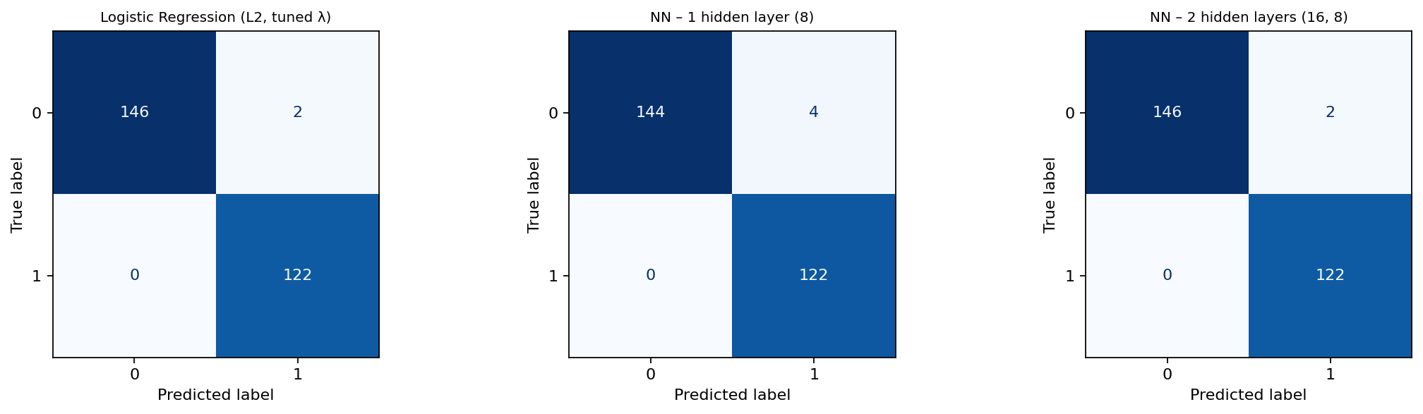
Figure 4. Test-set confusion matrices (all errors are false positives).
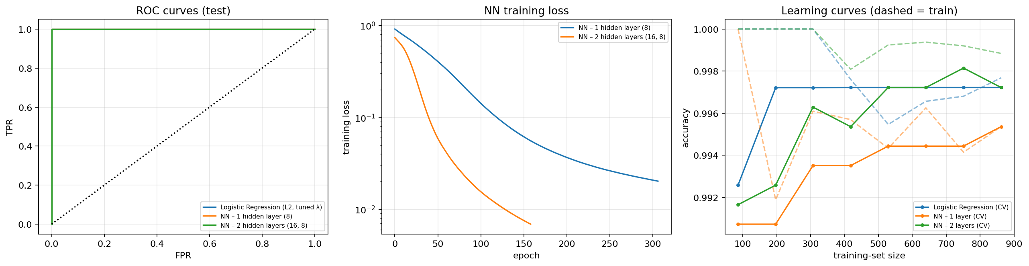
Figure 5. ROC curves (all AUC = 1.00), NN training loss, and learning curves (dashed = training).
Accuracy and generalisation. All three models are practically tied: they differ by at most two notes on the test split, ROC-AUC is 1.00 and recall is 100 % for all. The deeper network is nominally best in CV; the shallow one is nominally worst and the most variable. Every model is above 99 % even with ≈ 85 training rows; logistic regression plateaus by ≈ 200 rows and the networks by ≈ 500, and train/validation curves nearly coincide, so none over-fits.

5.1 Robustness to outliers
Outliers were injected only into the training data (a fraction of rows had one or two features shifted by ±4–8 standard deviations; labels untouched). Scaler and models were refitted on the corrupted data and scored on the clean test set, averaged over 10 contaminations.
Training outliers | 0 % | 2 % | 5 % | 10 % | 20 %
Logistic regression | 99.26 | 98.37 | 97.26 | 92.56 | 90.15
LR + RobustScaler (control) | 99.26 | 98.37 | 97.26 | 92.56 | 90.11
NN, 1 hidden layer | 98.52 | 98.74 | 98.63 | 98.52 | 98.56
NN, 2 hidden layers | 99.26 | 99.78 | 99.70 | 99.67 | 99.74
Test accuracy (%) on clean data.
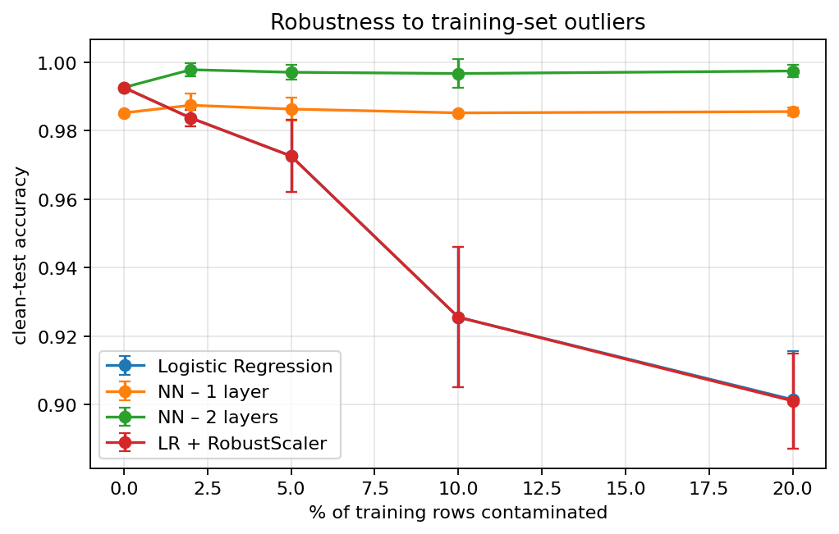
Figure 6. Clean-test accuracy vs fraction of contaminated training rows.
The linear model degrades sharply, while both networks barely move. A RobustScaler (median/IQR) does not help, so the weakness is the model, not the scaling: the logistic loss grows linearly with the size of a margin violation, so a few extreme points drag the single hyperplane off the true boundary, whereas a network can fit local pockets around them. This is a synthetic stress test with label-consistent leverage points; real contamination may differ.

5.2 Interpretability
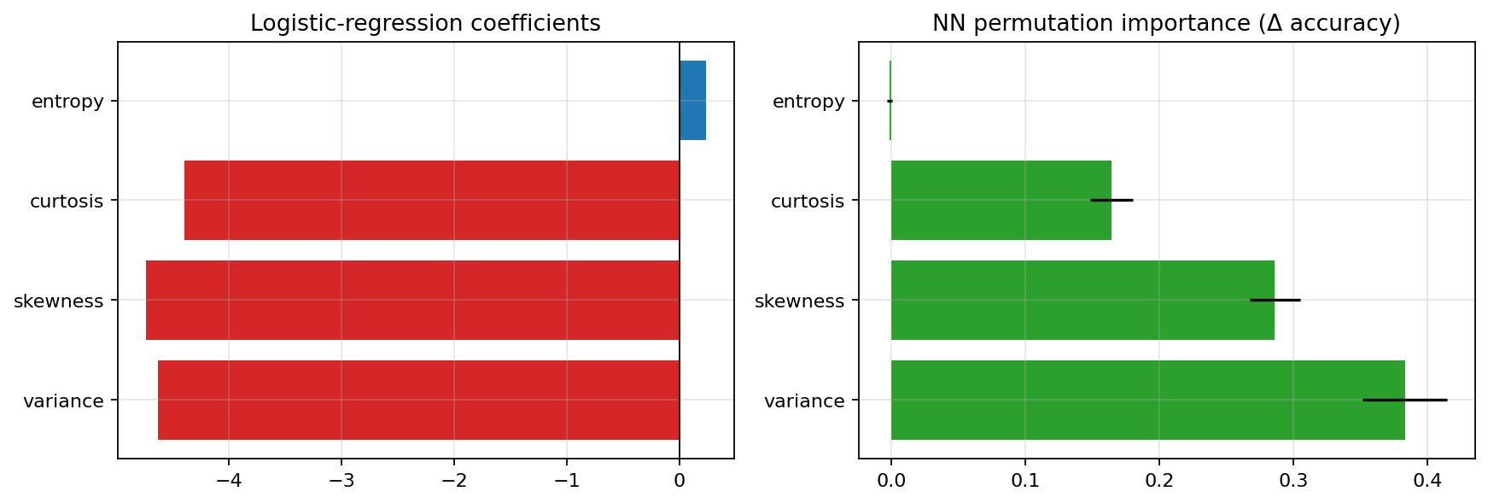
Figure 7. Logistic-regression coefficients (λ = 1) and NN permutation importances.
Logistic regression is directly readable: a +1σ increase in variance, skewness or curtosis multiplies the odds of class 1 by roughly 0.009–0.012 (all push towards class 0), and entropy has a negligible effect. The network’s 49–225 weights have no direct meaning; permutation importance reproduces the same ranking (variance > skewness > curtosis ≫ entropy), which is reassuring, but it is only a global, post-hoc approximation.

6. Task 5 – PCA
PCA was fitted on the standardised training data inside a pipeline. Explained variance is 54.6 %, 32.1 %, 9.0 % and 4.3 % for PC1–PC4 (cumulative 54.6, 86.8, 95.7, 100 %). PC1 contrasts skewness (+0.64) with curtosis (−0.62) and entropy (−0.37); PC2 is mostly variance (+0.74) and entropy (+0.66).
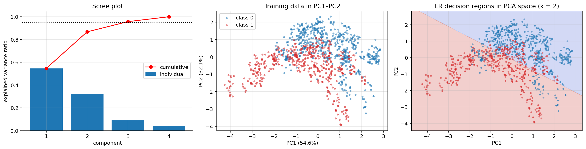
Figure 8. Scree plot, training data in PC1–PC2, and the logistic-regression decision regions in the 2-D PCA space.
PCs kept | Variance kept | LR – test | LR – CV | NN – test | NN – CV
1 | 54.6 % | 61.1 % | 62.4 % | 60.4 % | 62.3 %
2 | 86.8 % | 77.0 % | 77.5 % | 78.9 % | 80.8 %
3 | 95.7 % | 91.5 % | 91.2 % | 94.1 % | 92.3 %
4 (no reduction) | 100 % | 99.3 % | 99.6 % | 98.5 % | 99.5 %

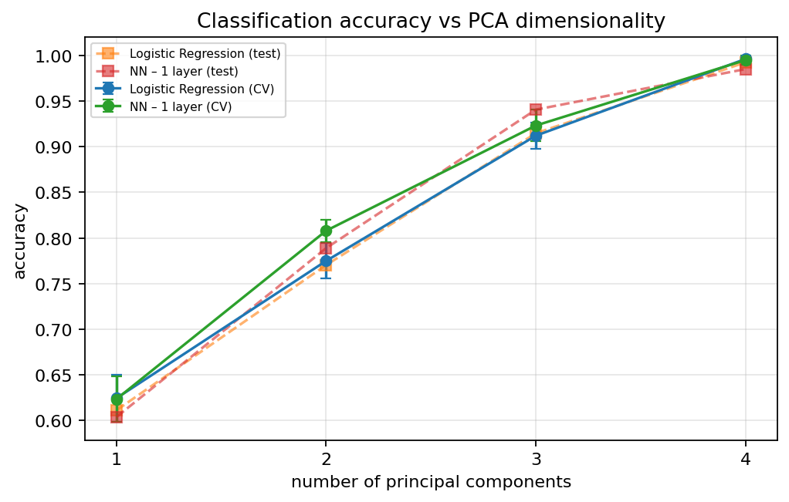
Figure 9. Accuracy vs number of principal components.
- Reduced spaces are clearly worse. Even the 95 %-variance choice (3 PCs) loses about 8 pp for logistic regression and 7 pp for the network. Four components are only a rotation of the original space and match its accuracy exactly.
- Why: PCA is unsupervised – it keeps directions of large variance, not large class separation. The discriminative information lives in a low-variance direction: PC4 holds 4.3 % of the variance but lifts accuracy from ≈ 91 % to ≈ 99.6 %. Mixing the uninformative entropy feature into the leading PCs makes it worse; the PC1–PC2 scatter shows heavily overlapping classes.
- Does PCA improve effectiveness? No. With only four features there is no dimensionality problem to solve. The network recovers about 3 pp more than LR at 2 PCs because it can bend the boundary, but not enough to matter. If a smaller input is wanted, supervised selection (dropping entropy) is the better route.

7. Task 6 – Friedman test and one-way ANOVA
Six models were evaluated on identical folds of 5-fold stratified CV repeated 6 times (30 folds); accuracy per fold is the response. The folds act as blocks for the Friedman test and as replicates for ANOVA. Post-hoc tests (α = 0.05): Nemenyi after Friedman, Tukey HSD after ANOVA. The six models are LR (no reg.), LR (L2), NN (8), NN (16, 8), LR + PCA(2) and NN + PCA(2).
Model | Mean acc | Std | Mean F1 | Mean rank (1 = best)
NN (16, 8) | 99.84 % | 0.30 | 99.82 % | 1.38
LR (L2) | 99.43 % | 0.41 | 99.37 % | 2.63
LR (no reg.) | 99.41 % | 0.44 | 99.35 % | 2.67
NN (8) | 99.27 % | 0.43 | 99.20 % | 3.32
NN + PCA(2) | 80.44 % | 2.48 | 78.61 % | 5.05
LR + PCA(2) | 76.84 % | 2.47 | 73.36 % | 5.95

Test | Statistic | p-value | Effect size
One-way ANOVA (6 models) | F(5, 174) = 1640 | 2.6 × 10⁻¹⁴⁴ | η² = 0.98
Friedman (6 models) | χ²(5) = 134.4 | 2.8 × 10⁻²⁷ | Kendall’s W = 0.90
One-way ANOVA (4 full-feature models) | F(3, 116) = 11.3 | 1.5 × 10⁻⁶ | η² = 0.23
Friedman (4 full-feature models) | χ²(3) = 49.7 | 9.4 × 10⁻¹¹ | Kendall’s W = 0.55

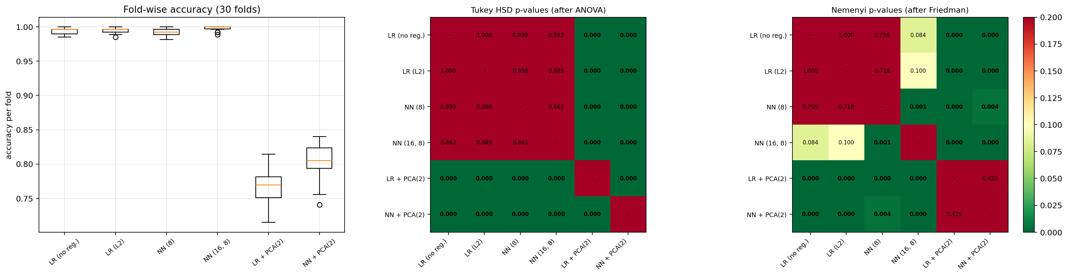
Figure 10. Fold-wise accuracy, Tukey HSD p-values and Nemenyi p-values (bold = p < 0.05).
Six-model result. Both tests reject the null: the models are not equivalent. Post-hoc, the four full-feature models are significantly better than both PCA(2) models, and the PCA(2) models are the two worst (Nemenyi critical difference 1.38 rank units). This is the statistical confirmation of Task 5.
Assumption check. Shapiro–Wilk rejects normality for four models (accuracy is bounded near 100 % and discrete) and Levene rejects equal variances (p < 0.001, driven by the PCA models). With η² = 0.98 the ANOVA conclusion is not in doubt, but the Friedman test is the more appropriate omnibus test here. Repeating everything with F1 gives the same ordering and conclusions.
Linear vs neural – the question that matters. Without the PCA models, Friedman and ANOVA are still significant, and the uncorrected post-hoc tests single out NN (16, 8) as better than both logistic regressions (Nemenyi p ≈ 0.001, Tukey p < 0.001) and than NN (8). But CV folds share about 75 % of their training data, so these tests are over-confident. With the Nadeau–Bengio corrected resampled t-test and Holm adjustment:
Pair (A vs B) | Mean Δ acc (B − A) | Corrected t | p (Holm) | Significant?
LR (no reg.) vs LR (L2) | +0.02 pp | 0.30 | 1.000 | No
LR (no reg.) vs NN (8) | −0.14 pp | −0.51 | 1.000 | No
LR (no reg.) vs NN (16, 8) | +0.43 pp | 1.60 | 0.537 | No
LR (L2) vs NN (8) | −0.16 pp | −0.69 | 1.000 | No
LR (L2) vs NN (16, 8) | +0.41 pp | 1.66 | 0.537 | No
NN (8) vs NN (16, 8) | +0.57 pp | 2.94 | 0.038 | Yes

So the deeper network’s 0.4 pp edge over logistic regression (about 5 of 1,348 notes) is not reliable evidence of superiority; only the gain over the shallow network survives correction.
Practical implications. (i) Never use PCA(2) here – it is statistically and practically the worst choice. (ii) On clean data, LR, LR + L2 and the networks are interchangeable, so a 5-parameter, auditable linear model suffices. (iii) Compute does not differentiate them: scoring 1,000 notes takes about 0.08 ms (LR) versus 0.14 ms (NN-2). (iv) The remaining 0.2–0.6 % errors should be costed (on the held-out test split every error was a false positive, i.e. a class-0 note labelled class 1), and a large representative hold-out set would be needed to confirm any real gain from the network.

8. Verdict – linear model or neural network?
Criterion | Linear (logistic regression) | Neural network (16, 8) | Edge
Accuracy, clean data | 99.4 % (CV) | 99.8 % (CV) | NN nominally; not significant after correction
Precision / recall / F1 | 98.4 / 100 / 99.2 % | 98.4 / 100 / 99.2 % | Tie
Generalisation (train–test gap) | 0.5 pp | 0.7 pp | Tie
Robustness to training outliers | 92.6 % (10 %), 90.2 % (20 %) | ≥ 99.6 % under 2–20 % contamination | NN
Interpretability | 5 signed, readable weights | 225 weights, post-hoc only | Linear
Cost and maintenance | Trivial | Small but non-zero | Linear

The classes are almost linearly separable, so logistic regression is already an effective and defensible solution: statistically indistinguishable from the best network on clean data, fully interpretable, and with L2 regularisation needed only for numerical stability (λ best kept small). The two-layer network is justified only when the training data may contain gross feature outliers (a few percent or more); there its robustness is a large, real advantage (about 7–10 pp).
Recommendation: deploy logistic regression on curated data with an input data-quality check, and switch to the (16, 8) network – or put robust outlier filtering in front of the linear model – if contamination cannot be controlled. PCA should not be used.

