**FREENAS- WEBDAV**

Sharing> WebDAV > Add WEBDAV Share

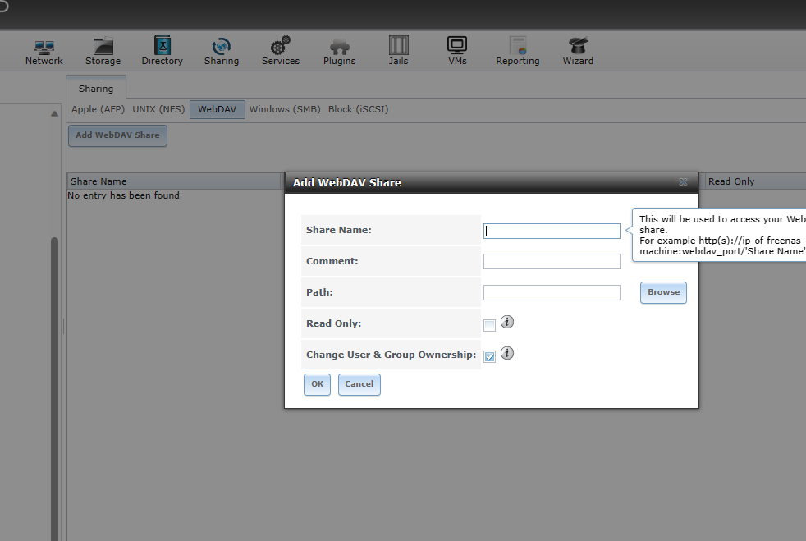

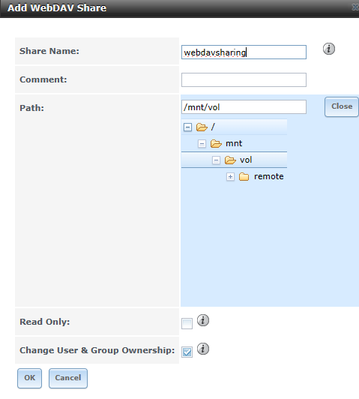

Settings of webdav > HTTP Auth > No authentication

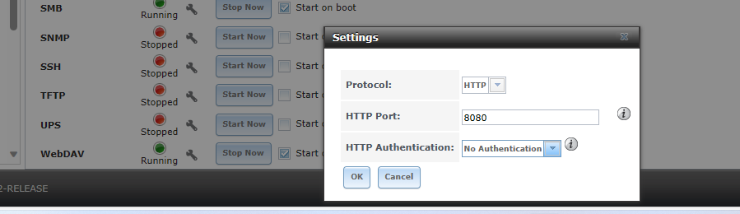

Go to browser:

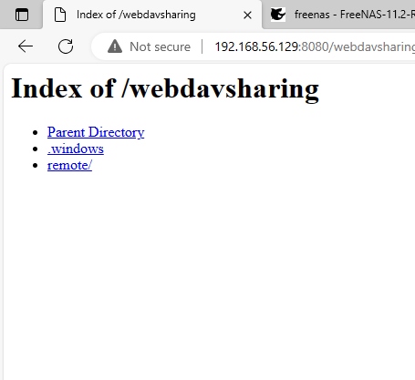

FOR DIGEST AUTHENCATION:

Webdav settings > HTTP Auth > Digest Authentication

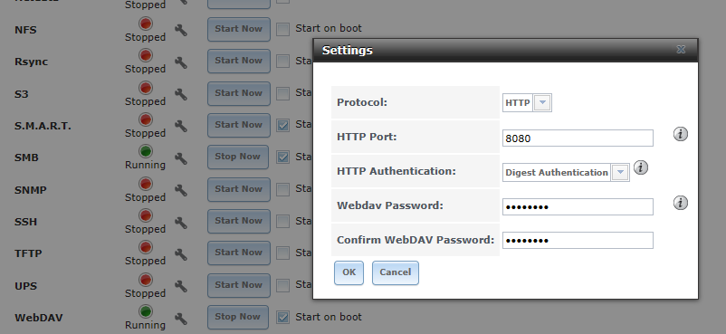

Back to browser > Refresh

