Week-3 Assignment
Objective: Analyze sales data using SQL by applying Subqueries, CTEs, and Window Functions to solve business queries. Steps: Load Superstore dataset into a table (superstore_raw). Create tables (customers, orders, products) from the dataset. Insert data into these tables using SELECT DISTINCT. Apply subqueries to filter data (above average sales, highest order per customer). Use CTEs to compute aggregations (total sales per customer). Apply window functions (ROW_NUMBER, RANK) for ranking and analysis. Combine JOIN + CTE + Window Functions for final result (customer, total sales, rank). Solve business queries (top customers, low customers, single-order customers, above-average sales). Output: SQL script / Notebook + query results + brief insights.
Dataset: Superstore Dataset
Tool: MySQL WorkBench
Tasks
Step-1 Load Superstore dataset into a table (superstore).
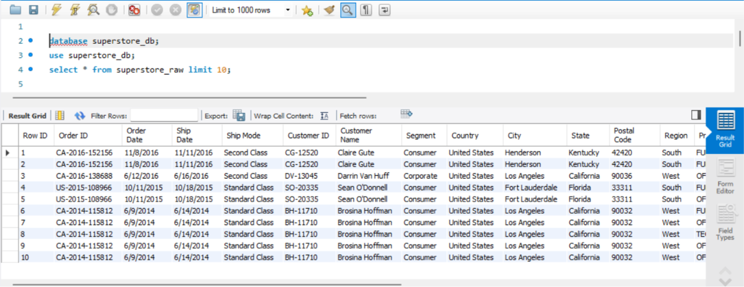
The Superstore dataset was loaded into the database as a raw table. This serves as the base dataset for further transformation and analysis.
Step-2 Create tables (customers, orders, products) from the dataset.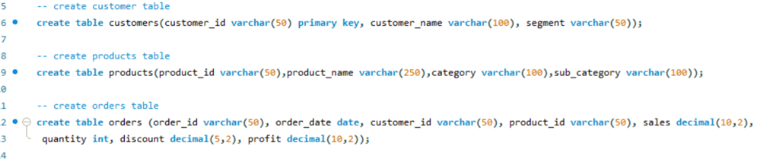

a.Inserting into Customers Table
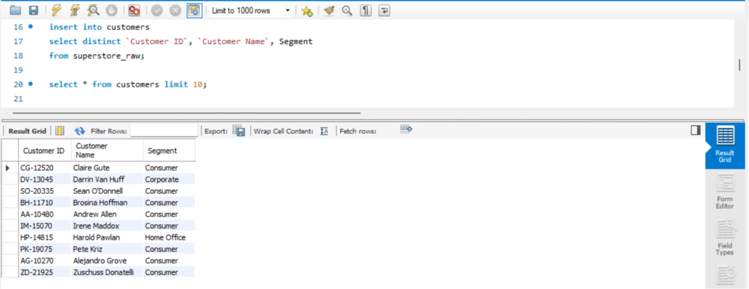b.Inserting into products Table
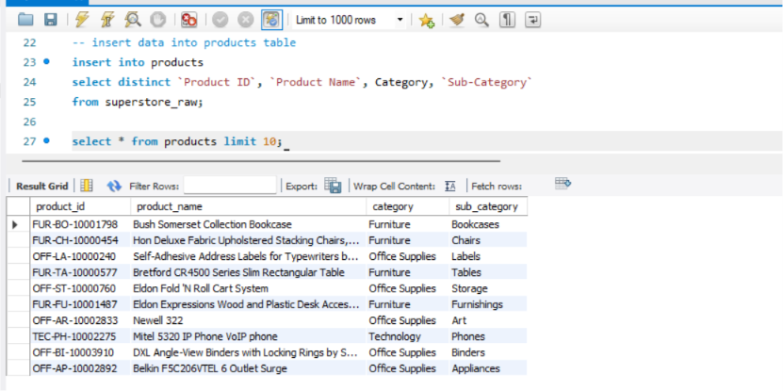
c.Inserting into orders Table
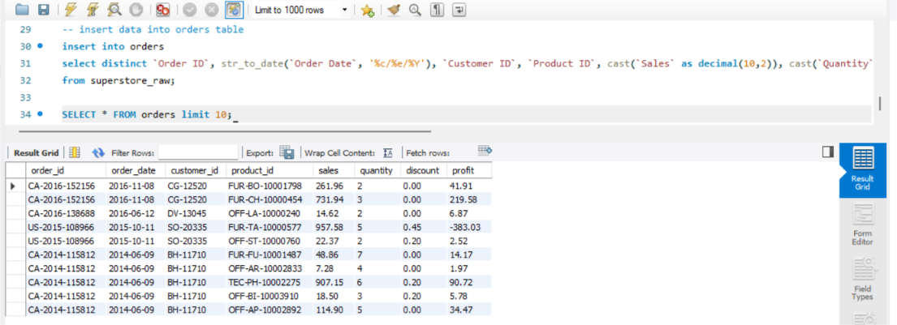

Step-3 Apply subqueries to filter data (above average sales, highest order per customer).
- Customers with Above Average Sales
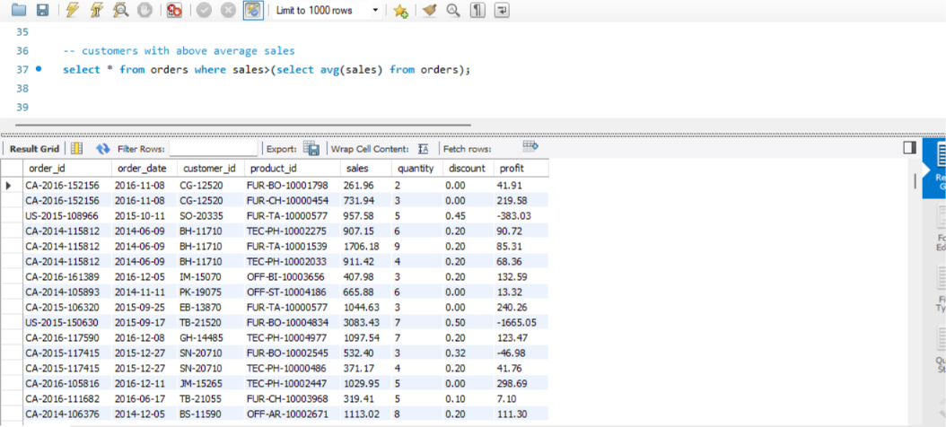
Insight:
This query filters orders where sales are greater than the overall average sales value. It helps identify high-value transactions that contribute more than typical orders to total revenue.
- Highest order value per customer
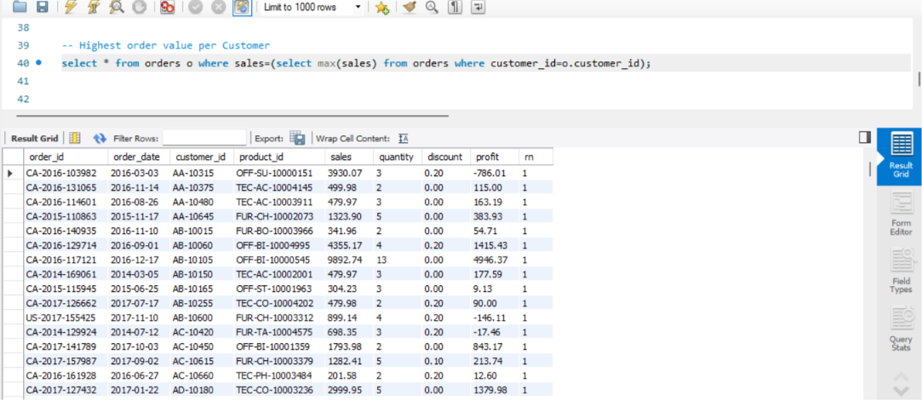Insight:
This query finds the maximum sales order for each customer using a correlated subquery. It helps identify each customer’s peak purchase behavior and major transactions.

Step-3 Use CTEs to compute aggregations (total sales per customer)
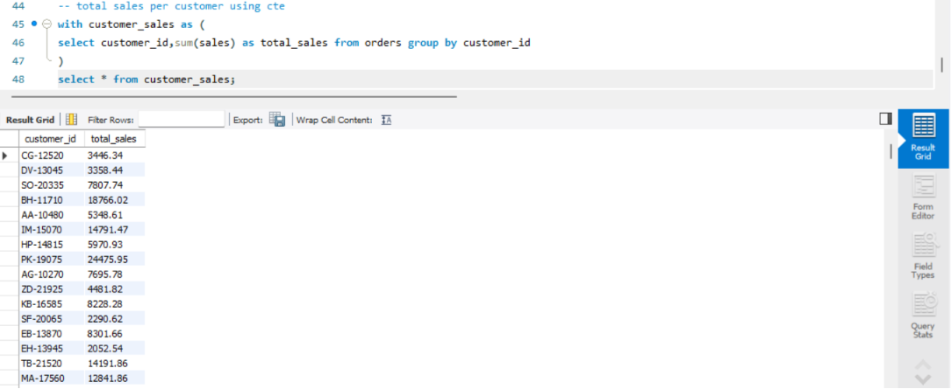Insight:
This query uses a CTE to calculate the total sales for each customer by grouping all their orders. It provides a summarized view of customer contribution, helping identify overall spending behavior and high-value customers.
Customers above average total sales using CTE
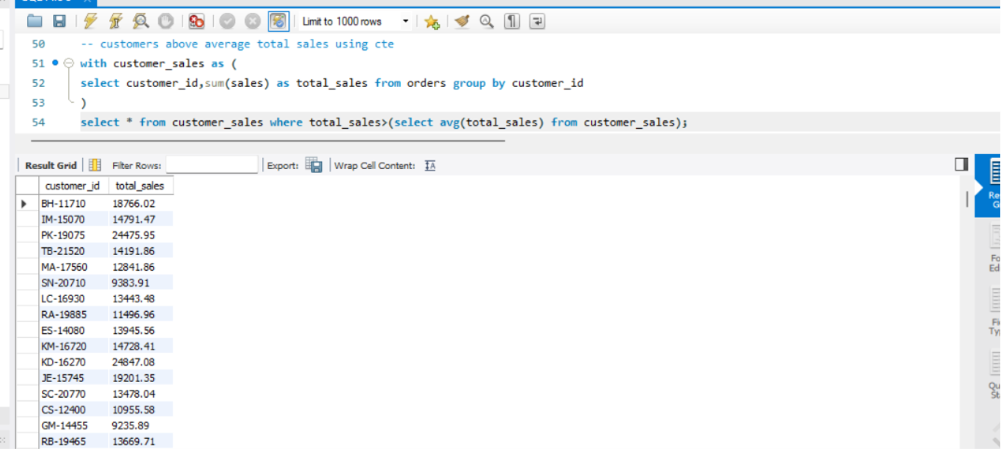Insight:
This query first calculates total sales per customer using a CTE, then filters customers whose total spending is greater than the average customer sales. It helps identify high-value customers who contribute more than the typical customer.

Step-4: Apply window functions (ROW_NUMBER, RANK) for ranking and analysis.
- ROW_NUMBER based ranking
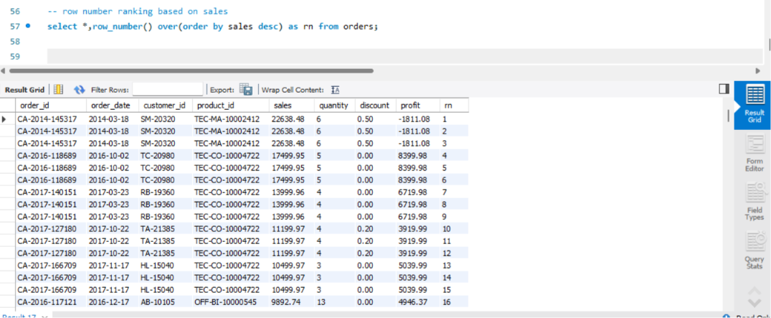Insight:
This assigns a unique sequential number to each order based on highest sales first. It helps in ordering transactions without ties.
2. RANK based on sales
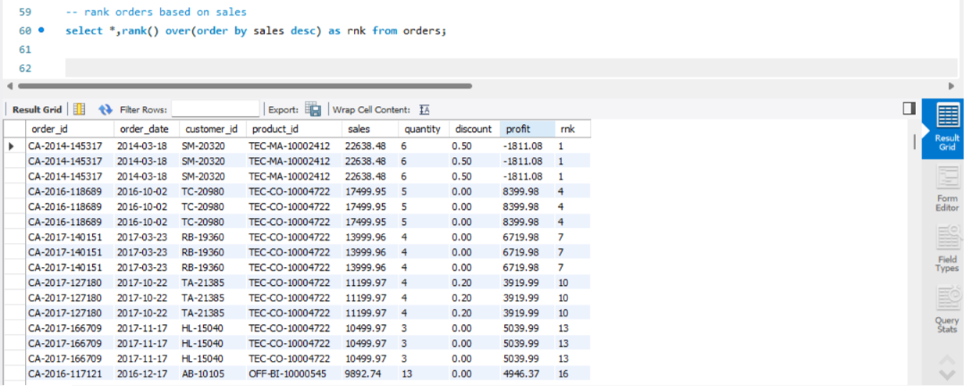Insight:
This ranks orders based on sales value. If two records have the same sales, they get the same rank, and gaps appear in ranking.
3. Dense Rank Order by Sales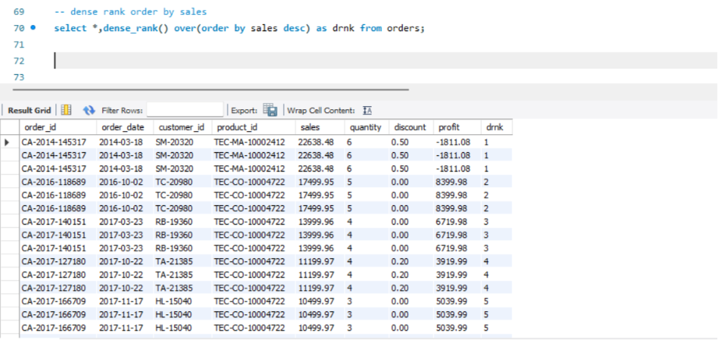
Step-5 Combine JOIN + CTE + Window Functions for final result (customer, total sales, rank)
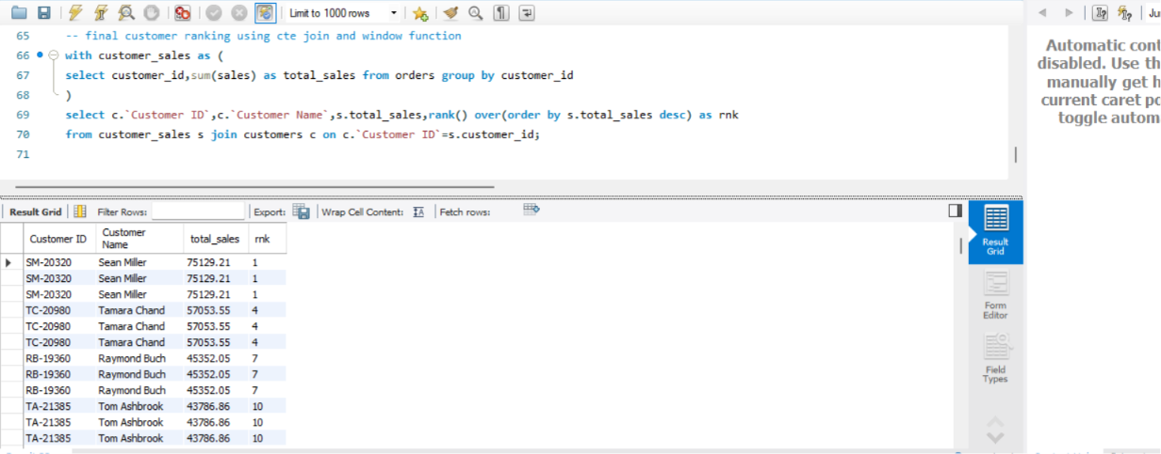Insight:
This query combines a CTE, JOIN, and window function to calculate total sales per customer and rank them based on performance. It uses the correct column names from the customers table to ensure accurate mapping between customer details and sales data.

Step-6 Solve business queries (top customers, low customers, single-order customers, above-average sales)
- Top 10 Customers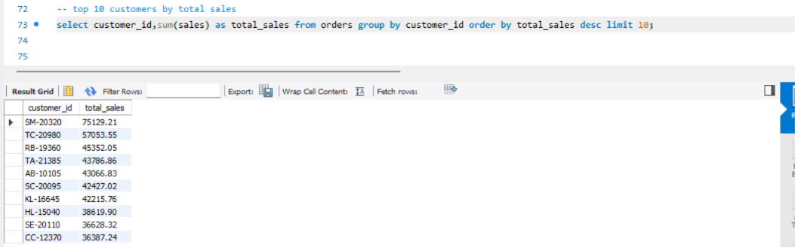Insight:
This query identifies the highest revenue-generating customers. It highlights the small group of customers contributing the most to overall sales.
- Lowest 10 Customers
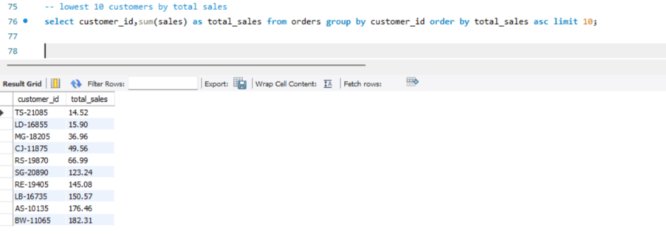Insight:
This query finds customers with the least spending. It helps identify low-value or inactive customers for improvement strategies.

- Single-order customers
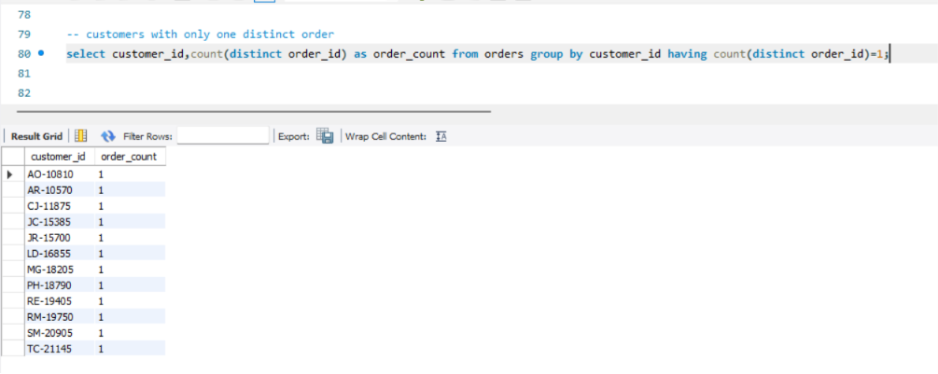
Insight:
This query finds customers who placed only one order, which may represent new or inactive customers with low engagement.
- Above Average Total Sales Customers
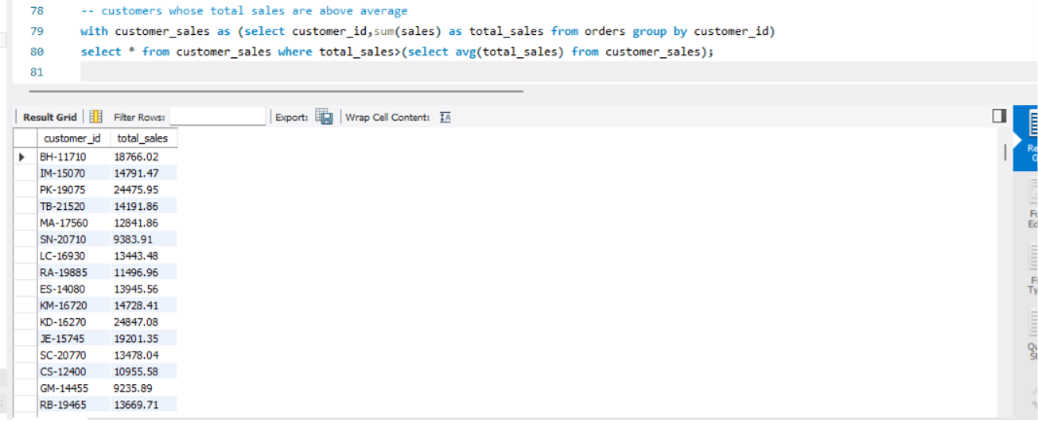 Insight:
This query filters customers whose total spending exceeds the average customer spending, helping identify high-value customers for business targeting.

