CREATING A TABLE NAMED OLYMPICS AND LOADING THE GIVEN DATA

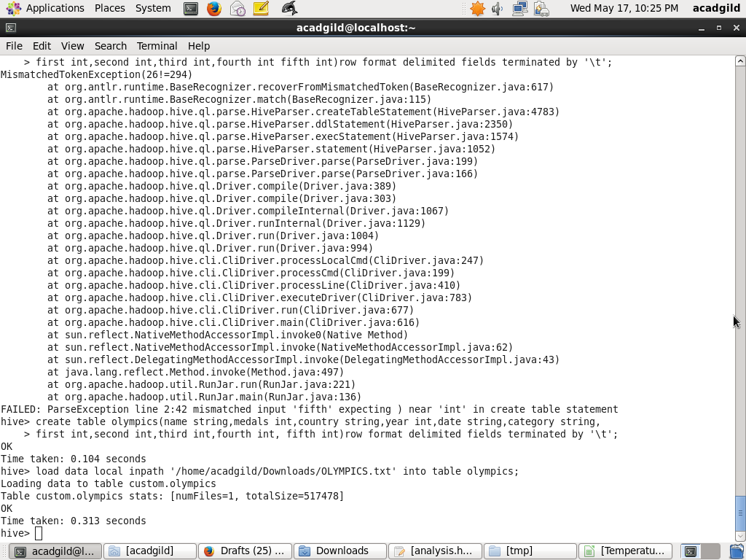

Hive program to find the number of medals won by each country in

swimming.

select country,sum(medals) from olympics where category='Swimming' group by country;

*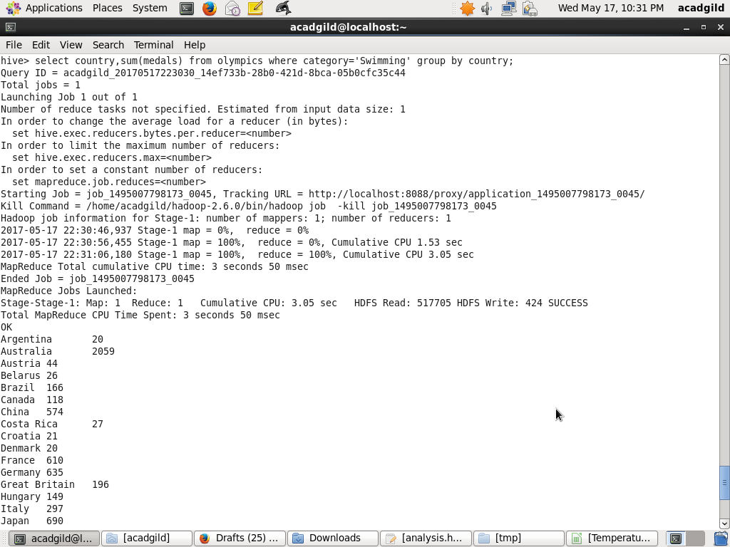*

Hive program to find the number of medals that India won year wise.

select year,sum(medals) from olympics where country='India' group by year;

