IMPORTING ACADGILD 64-BIT VM

- CLICK ON FILE
- CLICK ON IMPORT APPLIANCE

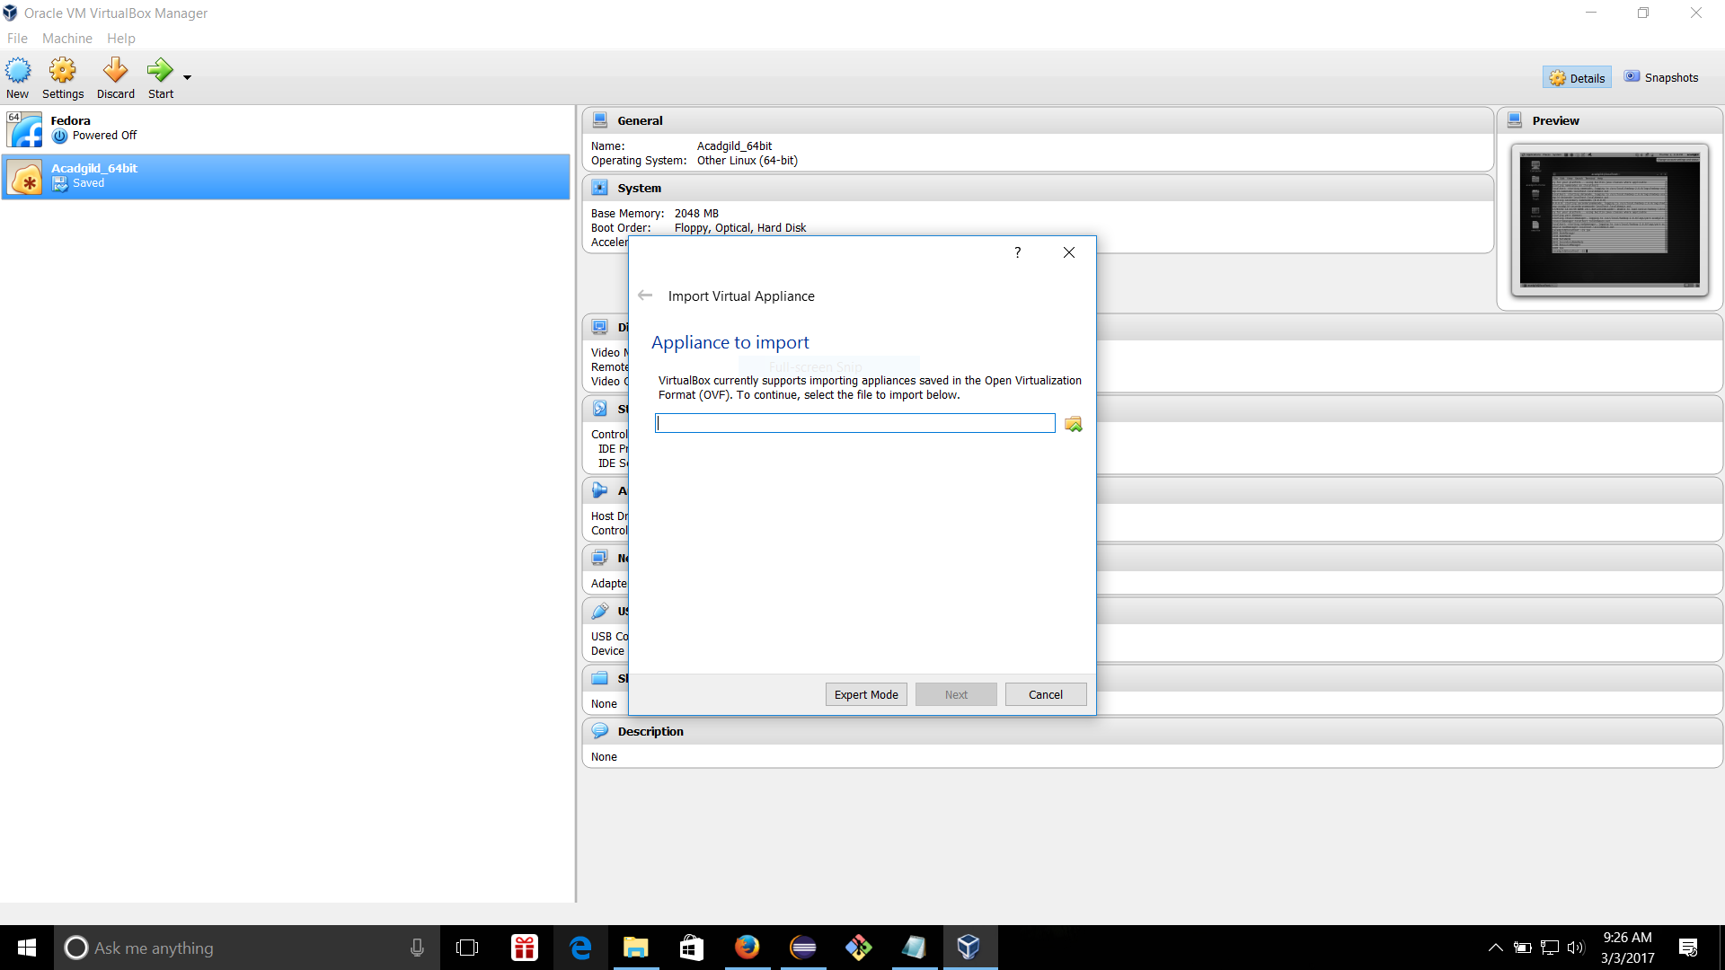

- AFTER IMPORTING ACADGILD WILL GET APPEAR IN THE LEFT OF SCREEN

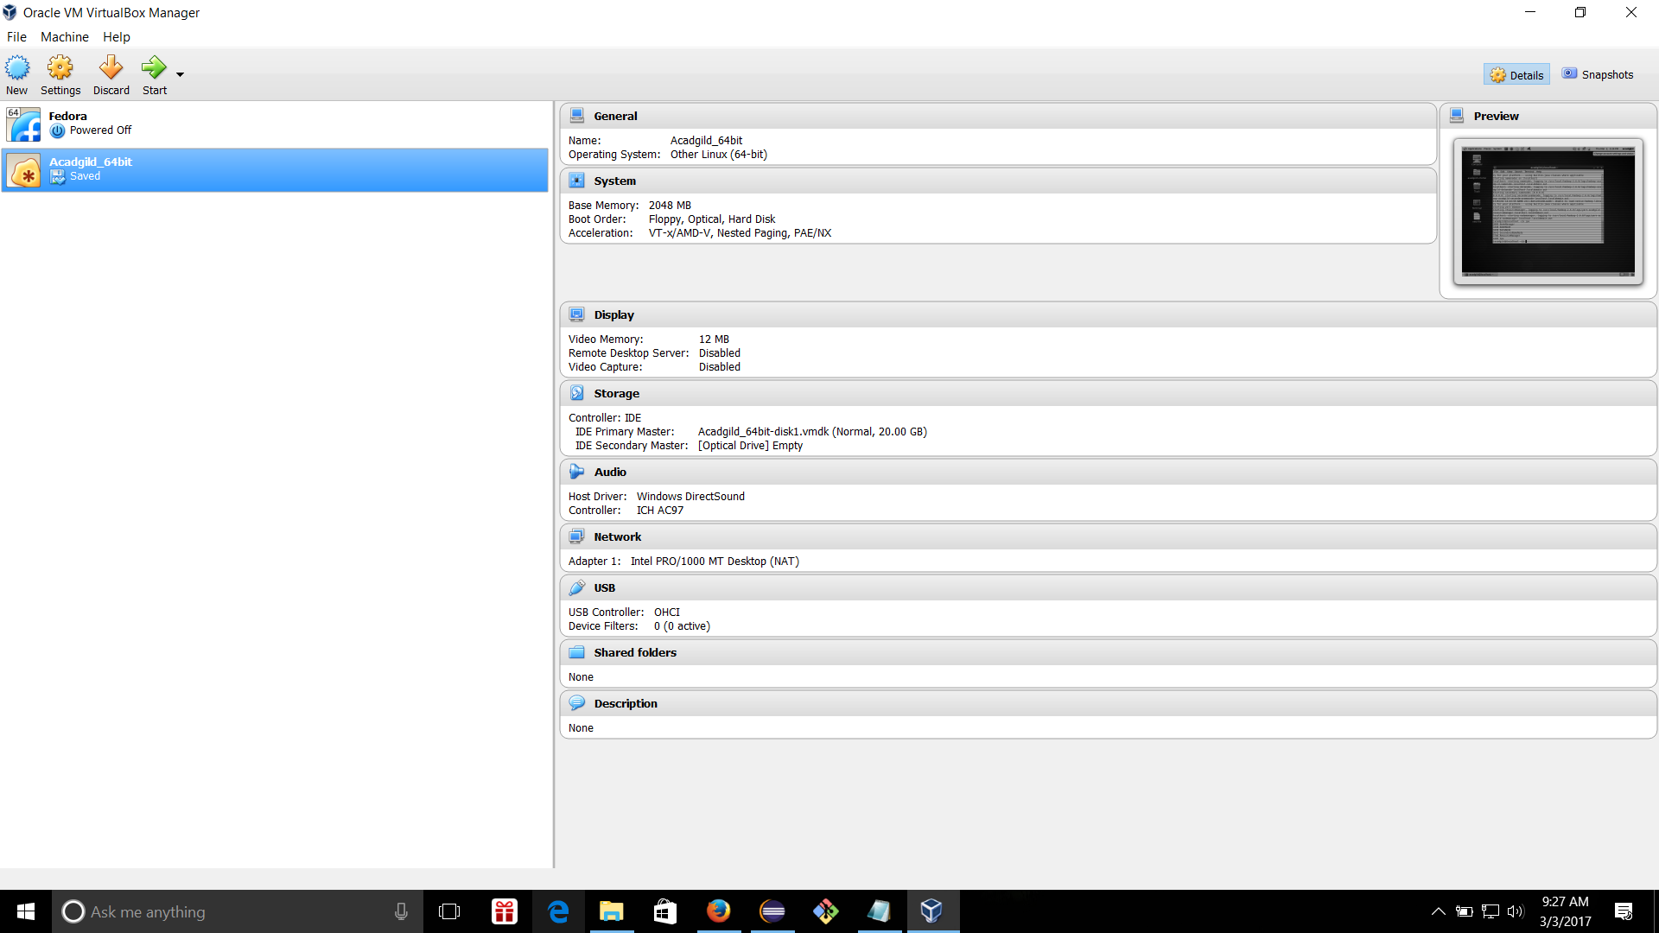

- CLICK ON THAT THEN ACADGILD VIRTUAL MACHINE WILL GET LOADED
