Creating a table named travels and loading the given data

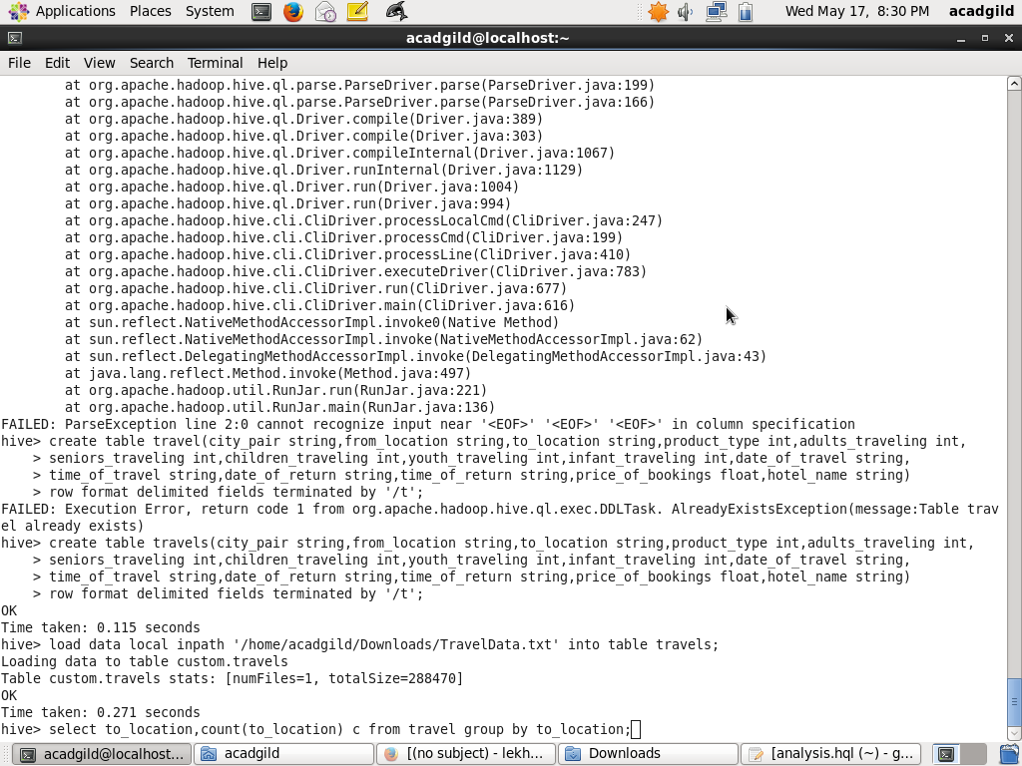

hive query to find the top 20 destination people travel the most

select to_location,count(to_location) c from travel group by to_location order by c desc limit 20;

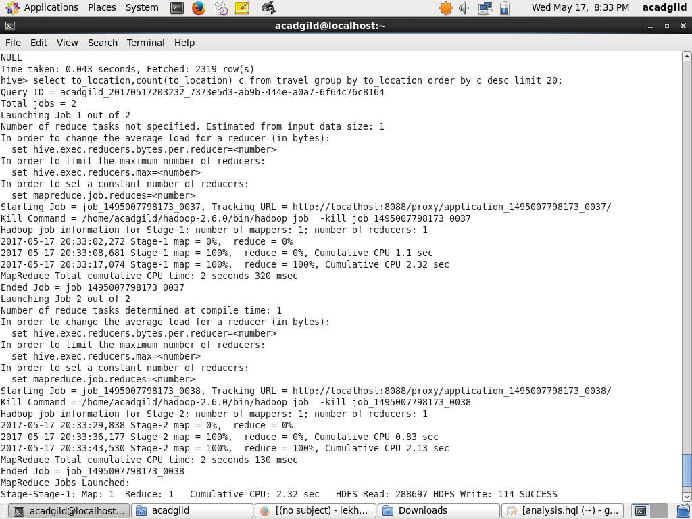

hive query to find the top 20 locations from where people

travel the most

select from_location,count(to_location) c from travel group by from_location order by c desc limit 20;

