Creating a table named temps and loading the given data

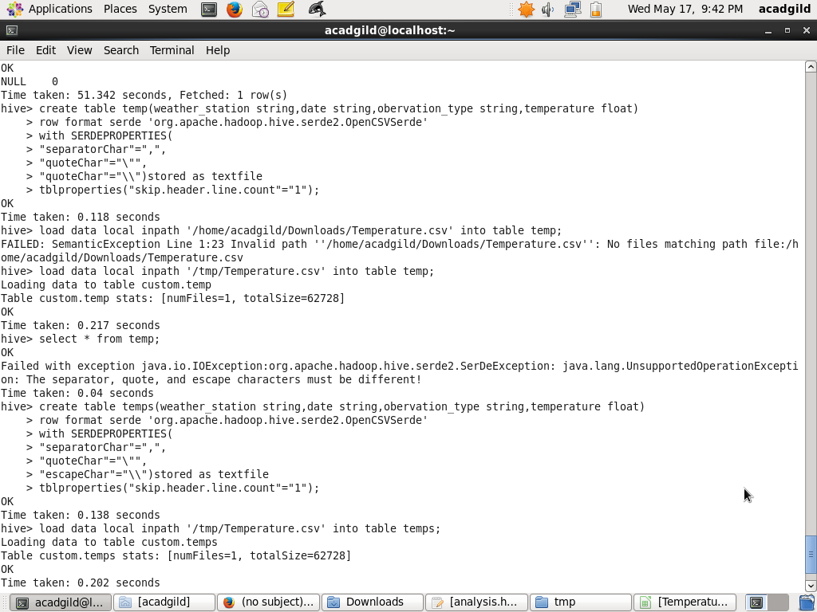

1. hive query to find the minimum temperature observed in a given weather station in a particular year.

select min(temperature) from temps where date='18000101' and weather_station='ITE00100554';

1. hive query to find the maximum temperature observed in a given weather station in particular year.

select max(temperature) from temps where date='18000101' and weather_station='ITE00100554';

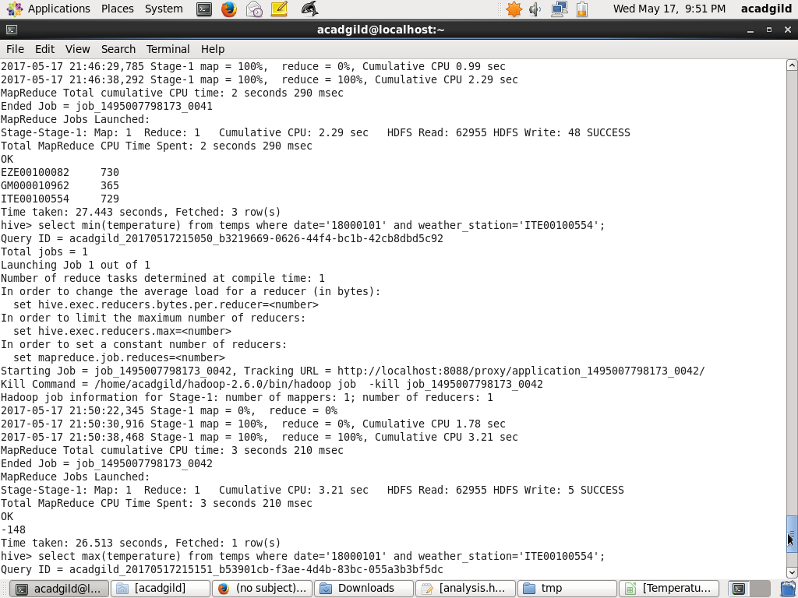

3)Write a hive query

to find the number of readings given by each weather station

select weather_station,count(temperature) from temps group by weather_station;

