**Integrate Hive with Hbase. Creating a table in Hbase and store some data in it and creating a hive table pointing to that hbase table.**

**Creation of the hbase table**

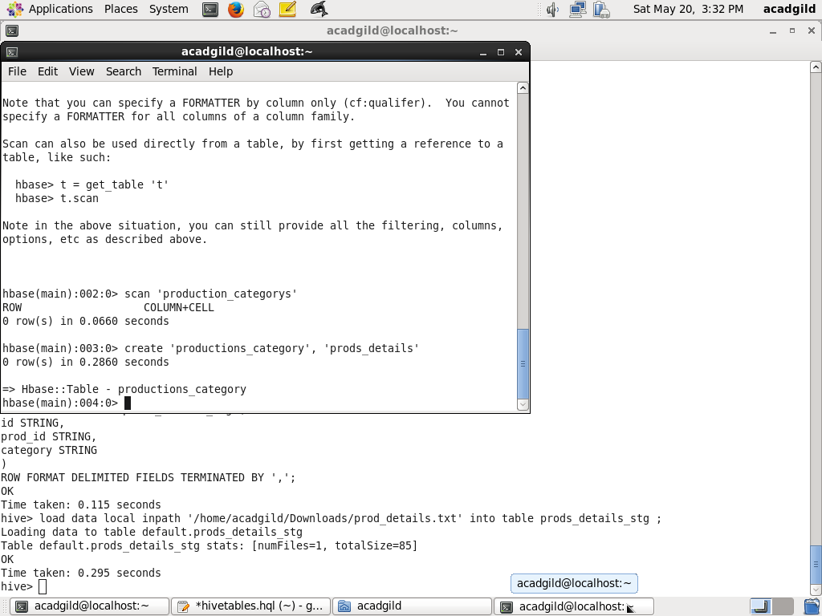

**Creation of the hive external table prods_details it has the reference to hbase table productions_category and inserting data into it**

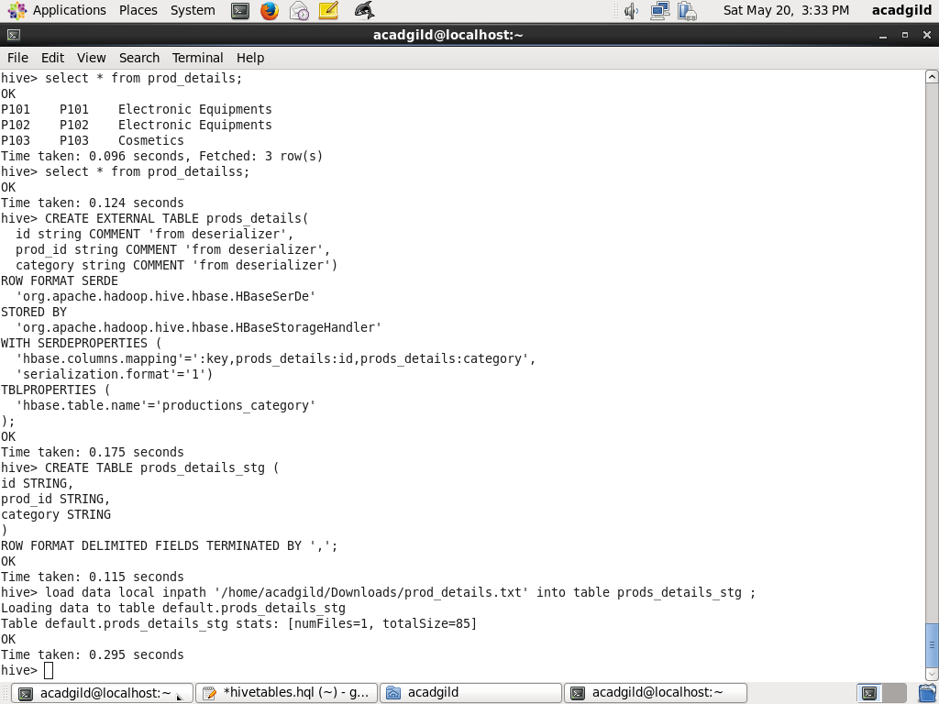

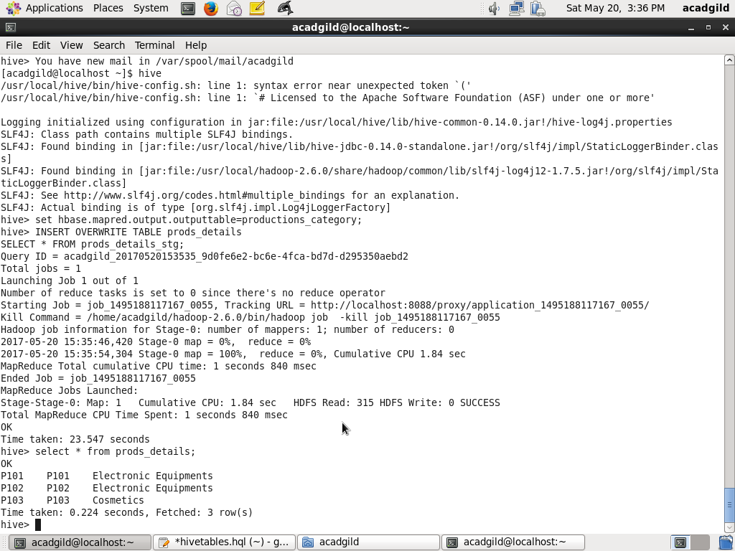

Data in hbase table

