**Visualizing hive data using zeppelin**

**Running zeppelin server and starting hive metastore**

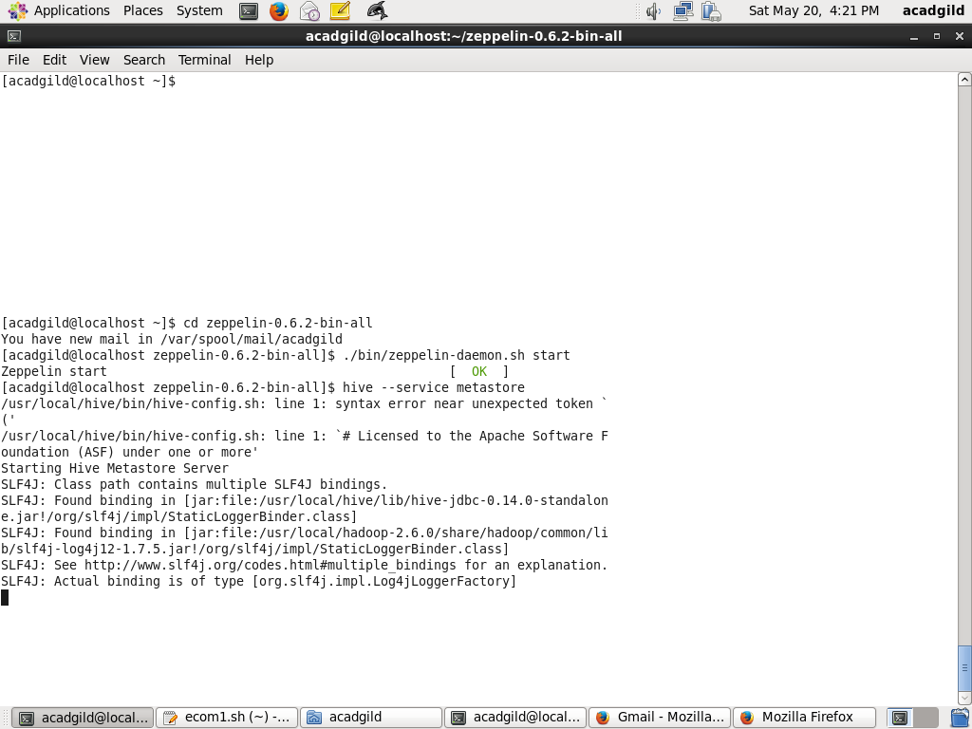

**Starting hive server2**

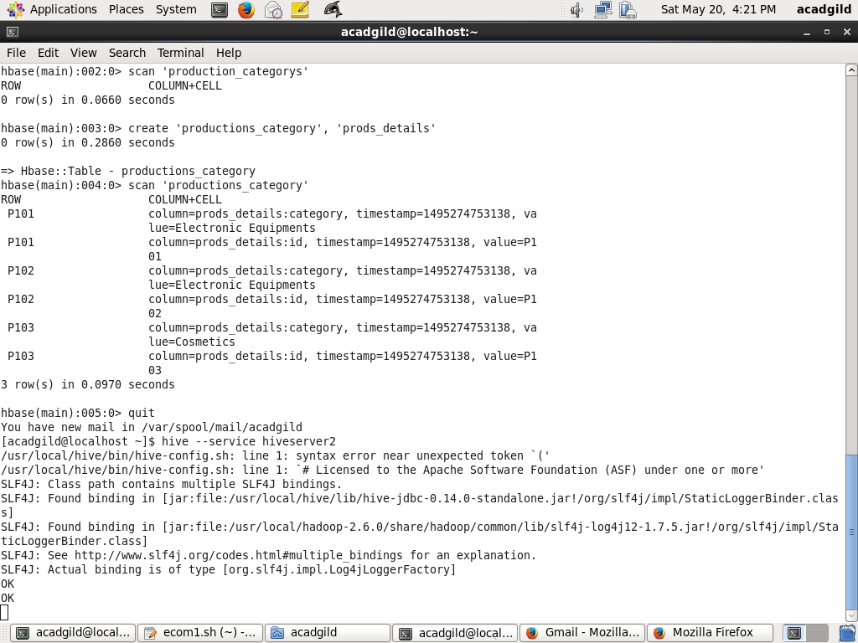

**Opening zeppelin page**

