**Load command:**

Loads data from the file system.

Ex = load ‘/user/acadgild/max-temp.txt’ using PigStorage(‘,’) as (date,temp);

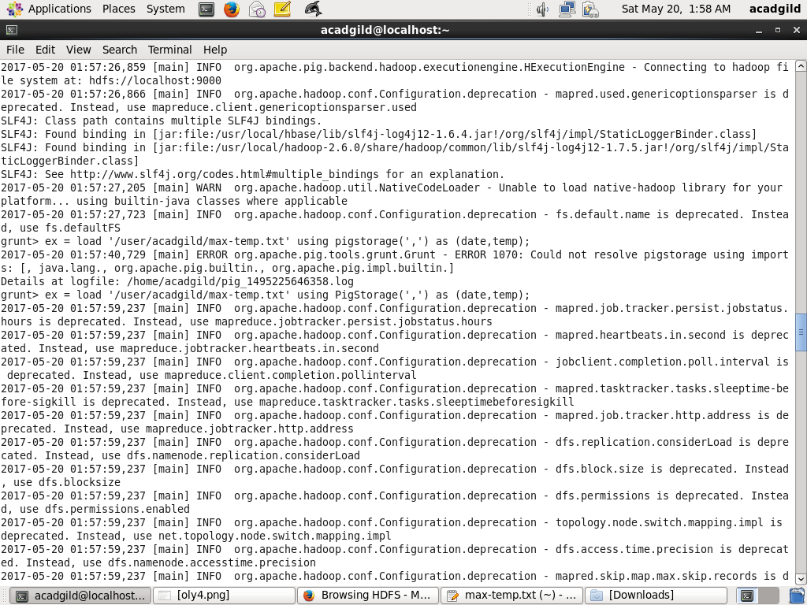

**Stores command:**

Stores or saves results to the file system.

Store ex into ‘/user/acadgild/exdemooo;

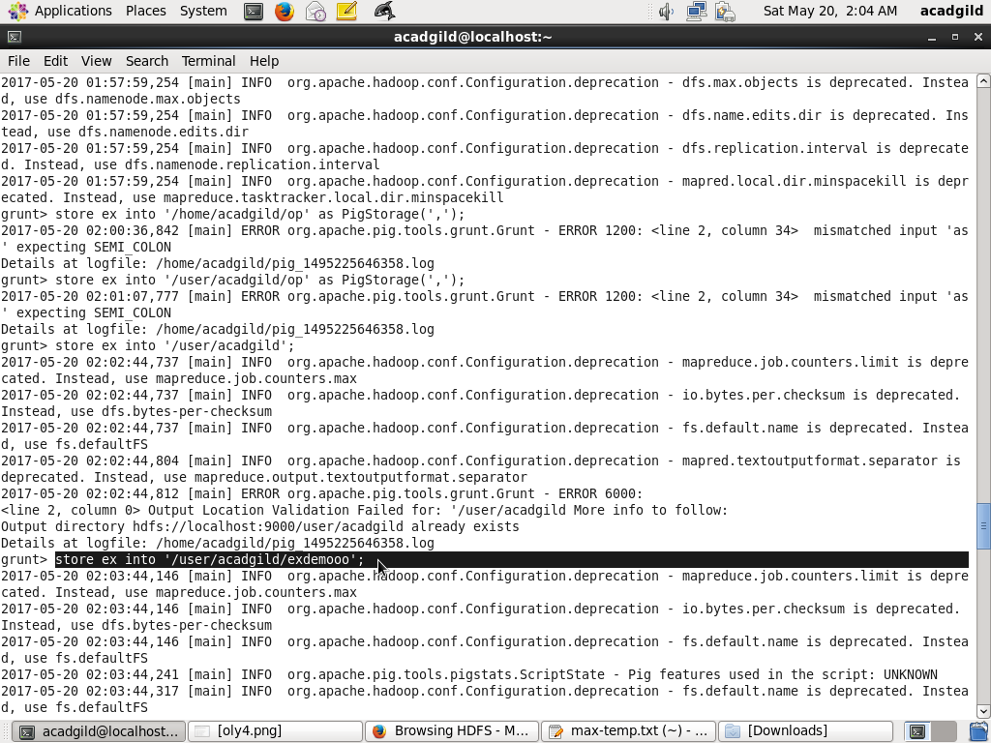

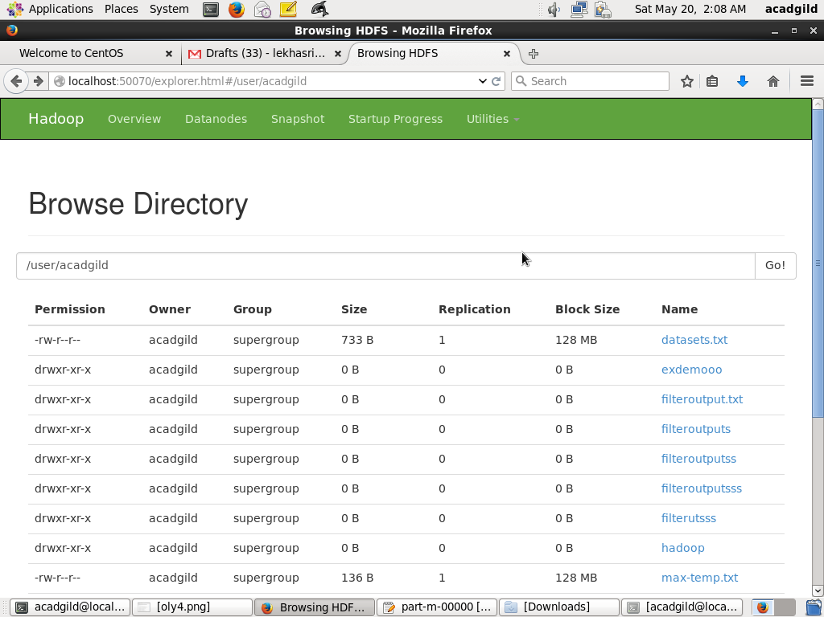

**Dump:**

Used to display the content of the relation

Dump ex;

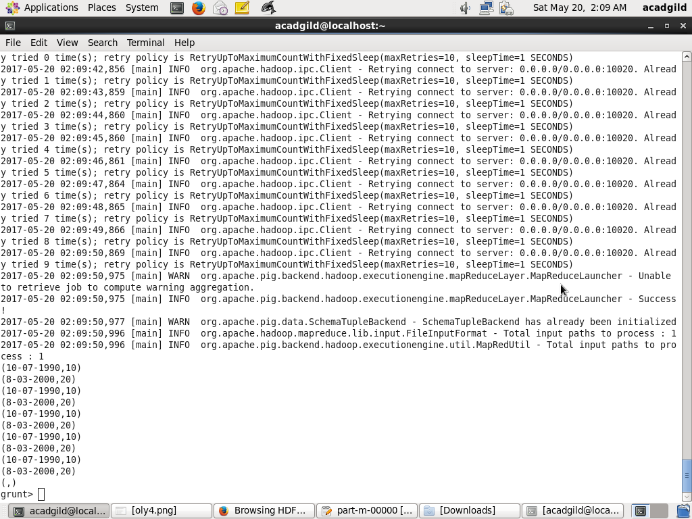

**Foreach:**

Generates data transformations based on columns of data.

X=foreach ex generate temp;

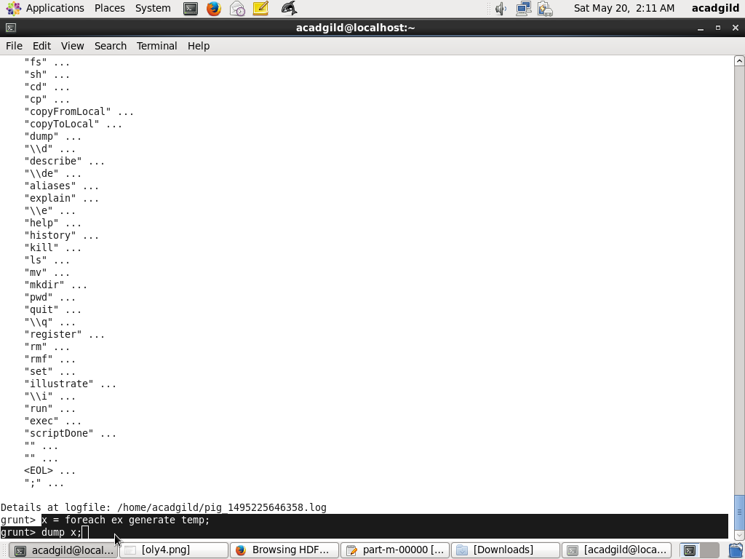

Dump x;

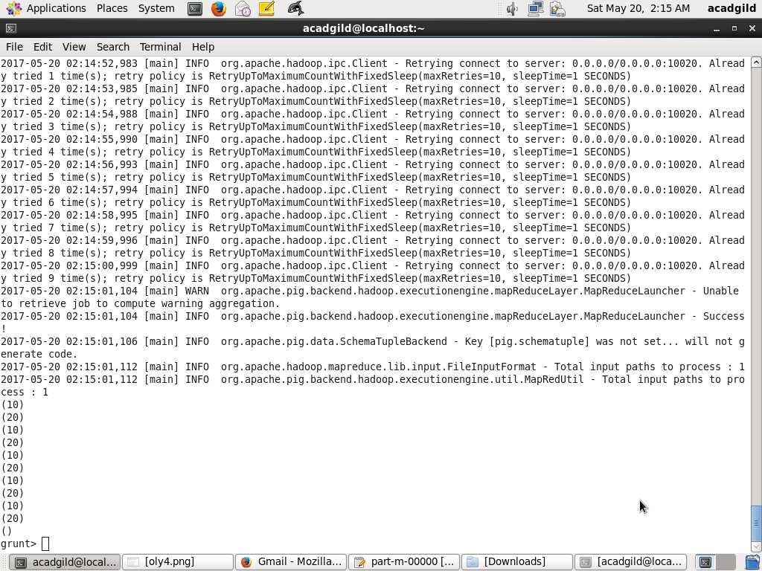

**Filter:**

Selects tuples from a relation based on some condition.

Y = filter ex by temp==10;

**Group by:**

Groups the data in one or multiple relations. GROUP is the same as [COGROUP](https://pig.apache.org/docs/r0.7.0/piglatin_ref2.html#COGROUP). For readability, programmers usually use GROUP when only one relation is involved and COGROUP with multiple relations are involved.

Z = group ex by temp;

**Order by:**

Sorts a relation based on one or more fields.

a = order ex by temp;

**Describe:**

Use the DESCRIBE operator to review the schema of a particular alias.

Describe a; 