**Total amount of petrol in volume sold by every distributor**

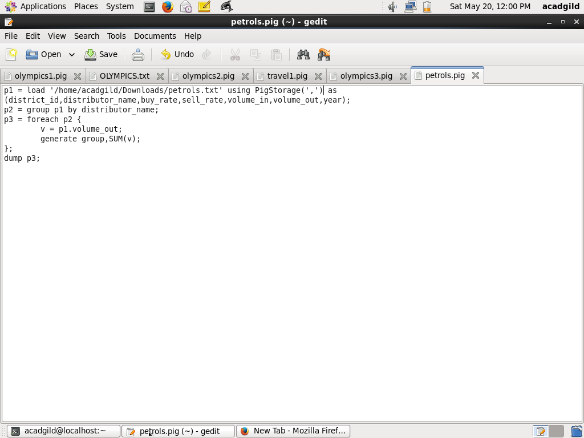

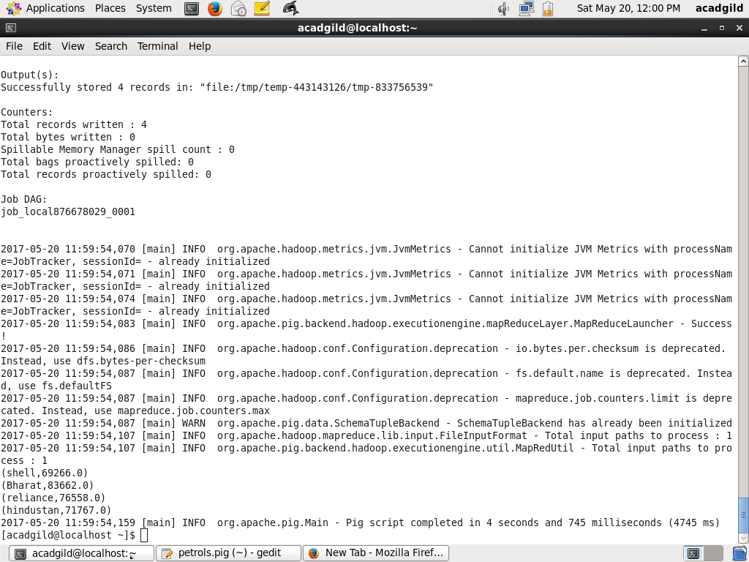

**Top 10 distributors id's for selling petrol? Also display the amount of petrol sold in volume**

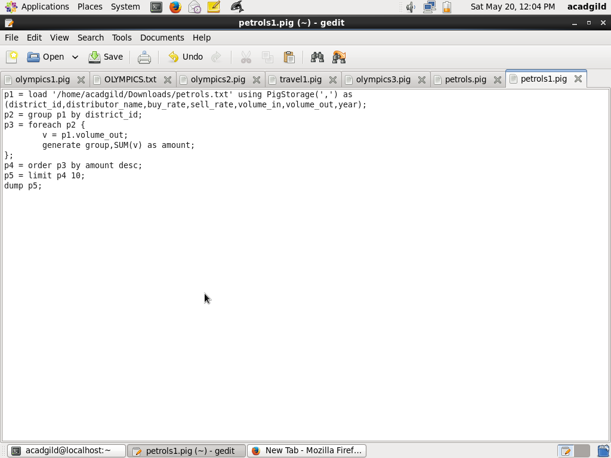

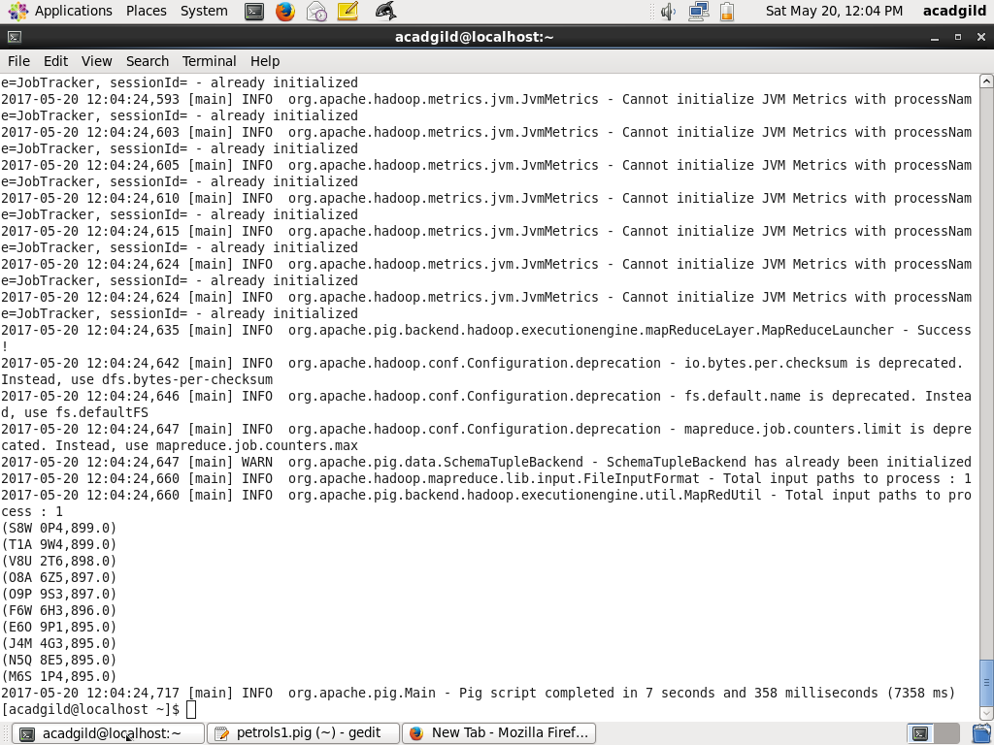

**List 10 years where consumption of petrol is more with the distributer id who sold it.**

