Webpage Phishing Detector



A final year project submitted by

Thato Gift Lekhehle, 202101708
Lerotholi Koai, 202101693
In partial fulfilment to the requirements for

B.Sc. Computer Science
To the
Department of Mathematics and Computer Science
Faculty of Science and Technology
National University of Lesotho.

April 2025
Supervisor: Mr. Balone Ndaba

Acknowledgements
This project has been a challenging yet incredibly rewarding journey, and we am deeply grateful to everyone who supported us along the way.
First, we would like to sincerely thank our supervisor, Mr Balone Ndaba, whose guidance, encouragement, and thoughtful insights helped shape this project from an initial idea into a working system. Their support was constant, and their feedback invaluable. To the Department of Mathematics and Computer Science at the National University of Lesotho, thank you for the learning environment, the tools, and the knowledge that made this project possible. The skills we have gained over the course of our studies truly came together in this work.
A heartfelt thank you to friends and classmates; your feedback, ideas, and shared late nights made this experience far less lonely and far more enjoyable. To or families, thank you for your patience, your support, and your belief in us even during moments when we doubted ourselves. Your presence was our biggest motivation.
Finally, to everyone who took time to test, review, or offer advice on the Webpage Phishing Detector System, thank you. This work is better because of your contributions.

Abstract
This report documents the development of the Webpage Phishing Detector System, a browser-based security tool designed to detect and prevent phishing attacks in real time. The system integrates a Google Chrome extension with a Flask backend and a machine learning model to analyze website URLs and alert users to potential threats. It also includes a user reporting feature and a blacklist database to enhance detection through community input.
Chapter 1 introduces the phishing problem, outlining its rise due to increased internet usage and the limitations of conventional detection methods. The project’s motivation, aims, objectives, scope, and the incremental development methodology are also discussed. Chapter 2 reviews existing phishing detection techniques, highlighting the shift from rule-based and blacklist methods to machine learning and natural language processing. It also explores browser-based detection tools and the importance of developing accessible solutions for regions like Africa.
Chapter 3 details the system's functional and non-functional requirements, including real-time classification, user reporting, privacy, and scalability. Chapter 4 explains the system architecture, including the presentation, logic, and data layers. It discusses how URLs are analyzed using both blacklists and machine learning to provide quick and accurate feedback.
Chapter 5 describes the testing process, covering unit and system integration testing to validate functionality, user interaction, and detection accuracy. Chapter 6 presents results and discusses system performance, including evaluation metrics like accuracy and F1-score. It also reflects on strengths, limitations, and opportunities for future improvements.

Table of contents
CHAPTER 1: Introduction 6
1.1 Problem Statement 6
1.2 Aims and Objectives 8
1.2.1 Aims 8
1.2.2 Objectives 9
1.3 Scope and Limitations 10
1.4 Methodology 10
CHAPTER 2: Literature Review 12
2.1 Introduction 12
2.2 Traditional Phishing Detection Techniques 13
2.2.1 Blacklist-Based Detection 14
2.2.2 Rule-Based Detection 15
2.2.3 Limitations and the Shift Toward Adaptive Solutions 16
2.3 Machine Learning Approaches 17
2.3.1 Supervised Learning Methods 17
2.3.2 Deep Learning Techniques 18
2.3.3 Natural Language Processing (NLP) 19
2.4 Browser-Based Phishing Detection Tools 20
2.5 Phishing in the African Context 21
2.6 Proposed Solution 22
2.8 Challenges and Future Directions 24
2.9 Conclusion 24
Chapter 3: Requirements / Specification 26
3.1 Problem Statement 26
3.2 System Requirements 26
3.2.1 Functional Requirements 26
3.2.2 Non-Functional Requirements 28
Chapter 4: Design and Implementation 30
4.1 Application Architecture 31
4.2 Component Design 32
4.2.1 Presentation Layer 32
4.2.2 Logic Layer 33
4.2.3 Data Layer 34
CHAPTER 5: System Testing 36
5.1 Introduction 36
5.2 Unit Testing 36
5.3 System Testing 36
CHAPTER 6: Results and discussion 38
6.1 Introduction 38
6.2 Evaluation Methodology 38
6.3 Machine Learning Results 39
6.3.1 Model Evaluation Metrics 39
6.3.2 Confusion Matrix Analysis 40
6.4 System Functionality and Integration Testing 41
6.4.1 Blacklist Module Performance 41
6.4.2 Reporting Feature Results 41
6.4.3 Chrome Extension Evaluation 42
6.5 Discussion 42
6.5.1 System Strengths 42
6.5.2 Limitations 42
6.6 Summary 43
Chapter 7: Future Work and Conclusion 44
7.1 Future Work 44
CHAPTER 8: Conclusion 45
References 46
Appendix 51
1. System Manual 51
1.1 Introduction 51
1.2 System Requirements 51
2. User Manual 53

List of figures
Figure 1 Use case diagram 31
Figure 2 High level conceptual diagram 32
Figure 3 Sequence diagram 33
Figure 4 ERD diagram 37
Figure 5 confusion matrix 42
Figure 6 database configuration 54
Figure 7 URL checking via icon when website is detected as legitimate 55
Figure 8 Alert displayed when is URL found in the blacklist database 55
Figure 9 URL suspected to be phishing by Machine learning module 56
Figure 10 reporting page where user can report URL 56
Figure 11 admin page for viewing reported URLs 57

CHAPTER 1: Introduction

Problem Statement

With the rapid growth of internet use across the globe, users are increasingly relying on online platforms for everyday activities, including banking, shopping, education, and communication. However, this increased digital presence has made users more vulnerable to cyber threats, especially phishing attacks, which remain one of the most prevalent and damaging forms of online fraud (Gupta et al., 2018). Phishing is a form of social engineering attack in which malicious actors trick users into revealing sensitive information, such as usernames, passwords, or financial data, by impersonating legitimate websites or services (Abdelhamid et al., 2014).
The key challenge with phishing is its deceptive nature. Cybercriminals create websites that closely resemble trusted platforms such as banks, government portals, and e-commerce websites, often using similar layouts, branding, and URLs with minor, hard to detect differences (Jain & Gupta, 2022). These fraudulent websites can deceive even some experts users, and due to their short lifespan; sometimes lasting only hours also they are difficult to detect in time using traditional security approaches like blacklists (Chiew et al., 2018). According to Buber et al. (2020), attackers increasingly use advanced evasion techniques, including HTTPS encryption, domain spoofing, and dynamic content loading, making it harder for conventional methods to identify phishing attempts effectively.
Another significant issue is that most users lack the expertise or awareness needed to recognize phishing attempts. Many people do not examine URL structures carefully or are unaware of the subtle signs of a malicious site (Alsadi & Abdallah, 2021). This knowledge gap is a major factor contributing to the success of phishing campaigns. As highlighted by the Anti-Phishing Working Group (APWG, 2023), phishing attacks hit record highs globally, with over 1.3 million unique phishing sites detected in the second quarter of 2023 alone which is a 30% increase compared to the same period the previous year.

Traditional protection mechanisms, such as URL blacklists and browser security warnings, although helpful, are often reactive rather than proactive. Blacklists require that a phishing site has already been discovered and reported, which is problematic considering the short life cycle of phishing websites (Verma & Das, 2017). Similarly, browser-based warnings rely on centralized databases that may not be updated in real-time, leading to delayed detection and exposure to risks. Furthermore, these solutions tend to be less effective in regions with limited internet access or slower connectivity, such as many parts of Africa, where real-time updates may not always be feasible (Interpol, 2024).
The scale and persistence of phishing make it a global cybersecurity issue. In Africa specifically, the problem is growing as internet penetration increases. Interpol’s Operation Africa Cyber Surge II in 2024 resulted in over 1,000 arrests linked to cybercrime, much of it involving phishing schemes and financial fraud (Interpol, 2024). This operation highlights how phishing is not just a technical problem but also a socio-economic challenge that affects digital trust, online safety, and access to secure services.
In summary, the core of the problem is the lack of timely, reliable, and user-friendly phishing detection methods that can operate effectively in a constantly evolving threat landscape. The increasing sophistication of phishing tactics, coupled with limitations in existing security solutions and low public awareness, leaves many users, especially in underserved regions exposed to significant risk. Addressing this problem requires not just better tools, but also a deeper understanding of how phishing adapts and exploits both technological and human vulnerabilities.

1.2 Aims and Objectives

1.2.1 Aims
The overall aim of this project is to develop a real-time phishing detection system in the form of a lightweight browser extension that offers immediate and intelligent protection against malicious websites. With phishing attacks becoming more sophisticated and increasingly targeting everyday internet users, the system aims to provide fast and reliable detection of phishing websites as users browse the web. This will help prevent users from unknowingly giving away sensitive information such as login credentials, financial data, or personal identification details.
One of the primary aims is to achieve real-time detection, meaning that the system should instantly analyze any website the user visits and alert them if it is suspected to be a phishing attempt. Real-time response is essential because phishing websites are often short-lived, making delays in detection ineffective.
A second aim is to ensure enhanced protection by leveraging modern detection techniques such as URL structure analysis and machine learning. Traditional blacklist-based methods alone are no longer sufficient; hence, the system should use intelligent classification algorithms that can detect suspicious websites even if they are not yet widely reported or listed in existing databases.
The project also aims to deliver reliable detection by maintaining an up-to-date internal blacklist of known phishing websites. This ensures that commonly reported malicious websites are blocked swiftly and efficiently, reducing reliance on machine learning for threats that are already known. This layered detection approach enhances both performance and accuracy.
Lastly, the system aims to promote cybersecurity awareness among users by presenting clear, understandable alerts. Many users fall victim to phishing simply because they do not recognize the signs. Therefore, the extension should not only block dangerous websites but also educate users in the process, fostering safer browsing habits over time.

1.2.2 Objectives
To meet the aims outlined above, the project will pursue the following specific, measurable objectives:
- URL Pattern Analysis:
Design and implement algorithms capable of identifying known indicators of phishing URLs. This includes spotting anomalies such as misspelled domains, excessive subdomains, the use of misleading brand names, suspicious top-level domains, and irregular URL structures. The goal is to catch phishing attempts that mimic legitimate websites but differ subtly in their web addresses.
- Machine Learning Detection:
Develop and train a machine learning model using a labeled dataset containing both phishing and legitimate websites. The model will learn patterns and features that distinguish between the two categories. This component will be designed to continuously improve over time by incorporating new examples, allowing the system to adapt to evolving phishing tactics and maintain high classification accuracy.
- Known Phishing Site Detection:
Maintain and regularly update a blacklist database of confirmed phishing websites. This list will be informed by both public threat intelligence sources and user-generated reports submitted through the browser extension. Whenever a URL matches an entry in the blacklist, the system should automatically flag it as malicious without needing to invoke machine learning.
Each of these objectives contributes to the overall goal of providing fast, intelligent, and accessible phishing protection for users, particularly those who may lack advanced cybersecurity knowledge. By focusing on accuracy, speed, and user-friendliness, this project strives to bridge the gap between complex phishing detection methods and practical, everyday protection for internet users.

1.3 Scope and Limitations
This project focuses on the design and implementation of a browser-based phishing detection system that operates in real time to protect users from deceptive websites. The core of the system is a Chrome extension that analyzes URLs and webpage content using both traditional rule-based techniques and machine learning classification. The extension is designed to be lightweight and user-friendly, providing immediate alerts when a potentially harmful site is detected. It supports essential functionalities such as URL pattern analysis, blacklist checking, phishing reporting by users, and backend storage for further analysis and auditing. The scope of the project includes the integration of a machine learning model trained on phishing and legitimate site data, as well as the development of a backend database to store known phishing sites and user-submitted reports.
The project is specifically scoped for individual users rather than enterprise-scale security systems. It is designed to function effectively in environments with limited internet access, a consideration especially relevant for users in regions like Africa, where infrastructure challenges can hinder access to traditional, cloud-reliant security solutions. Therefore, part of the system’s scope includes offline detection capabilities, ensuring that certain protective measures, such as blacklist checks, can still function even when internet connectivity is unavailable. However, the project does not extend to detecting phishing in mobile apps, instant messaging platforms, or email clients. Its functionality is limited to browser-based phishing attempts encountered through direct user navigation. Additionally, the system does not aim to eliminate phishing threats entirely but rather to minimize user exposure and improve their chances of avoiding harm.

1.4 Methodology
This project uses the Incremental Prototyping methodology, which involves building the system step by step through small, functional prototypes. Instead of developing everything at once, features are added gradually; starting with the basics and improving over time based on feedback and testing. This approach fits well with a phishing detection system, which needs to be flexible and constantly refined for better accuracy.
The first phase involved the development of the machine learning (ML) component. Where a dataset of legitimate and phishing websites was used to train the model. The model focused on analyzing the key features of websites, such as URL structure, page content, and other characteristics, to accurately classify whether a website was phishing or legitimate. Once the machine learning model was trained and tested for accuracy, it formed the core detection mechanism for the system.
The next step in the methodology was to develop the Chrome extension. This extension integrated the machine learning model, allowing it to run directly within the browser. As users navigated the web, the extension could analyze websites in real time, providing instant feedback and alerts when a phishing attempt was detected. The Chrome extension was designed to be lightweight and simple to use, with an intuitive interface that allowed users to easily see the status of a website and respond to phishing alerts.
Following the development of the Chrome extension, a blacklist database was implemented. This database served as an additional layer of defense by storing known phishing sites. When users visited a website, the system would first check the blacklist to see if the site had been previously reported. If the site was found in the blacklist, it would be flagged as phishing immediately, without needing to run the machine learning model. This ensured that users were protected against already known threats with minimal delay.
Finally, a reporting feature was added to the system. This feature allowed users to report suspicious websites they encountered while browsing. Once reported, the websites were stored in the backend database for further administrative review. This allowed for continuous improvement of the system, ensuring that new phishing sites could be identified and added to both the blacklist and the machine learning model’s training data.
Through this iterative and incremental approach, the project progressively built a robust phishing detection system, ensuring each component was developed, tested, and refined before moving on to the next.

CHAPTER 2: Literature Review

2.1 Introduction
Phishing attacks continue to pose a significant and persistent threat to internet users across the globe. As one of the most common forms of cyberattacks, phishing relies on deceptive tactics to manipulate individuals into disclosing sensitive and confidential information. This typically includes passwords, credit card numbers, banking credentials, personal identification details, and even access to corporate systems (CrowdStrike, 2023). Attackers often disguise themselves as legitimate entities, such as banks, government agencies, or well-known service providers, to exploit users' trust and lack of awareness (NCSC, 2023).
The growing sophistication of phishing techniques has made them increasingly difficult to detect using traditional security tools. Earlier forms of phishing were relatively easier to identify due to clear signs of deception, such as poorly written messages or suspicious links. However, modern phishing campaigns have evolved significantly in complexity and execution. Attackers now use advanced social engineering strategies, visually identical spoofed websites, and even compromised legitimate domains to launch highly convincing phishing schemes (Darktrace, 2023). These developments have allowed phishing attacks to bypass conventional defense mechanisms and reach unsuspecting users with alarming efficiency.
As a result of this growing threat, researchers and cybersecurity professionals have been compelled to explore more advanced and intelligent methods for detecting phishing attempts. Traditional detection techniques, while still in use, have shown notable limitations in their ability to respond to the ever-changing nature of phishing attacks. These methods are generally reactive, relying on known attack signatures, predefined rules, or manually maintained databases of malicious URLs (Kaspersky, 2020). Although they provide some level of protection, they often fail to detect new, previously unseen phishing sites or zero-day attacks. Consequently, there has been a significant shift toward more proactive and adaptable approaches, with machine learning (ML) emerging as a powerful tool in this space (MDPI, 2023).
Machine learning offers a promising alternative by enabling systems to learn from data and recognize patterns that may not be immediately obvious through rule-based logic. ML-based phishing detection models can be trained on various features; such as URL structure, domain age, website content, and user behavior; to distinguish between legitimate and malicious websites (Upadhyay, 2023). These models can then generalize from past examples to make accurate predictions about new, unseen cases. The dynamic and data-driven nature of ML models makes them particularly well-suited to the fast-evolving landscape of phishing threats (MDPI, 2023).
This chapter provides a comprehensive overview of the existing methods used for phishing detection, with a particular focus on how machine learning has been applied to enhance security. It begins by examining traditional detection techniques, including blacklist-based and heuristic rule-based approaches, highlighting their advantages and limitations. Following that, the chapter explores the development and application of ML models in phishing detection, showcasing their potential to offer more intelligent and adaptive protection mechanisms.
Furthermore, this chapter outlines how the current project builds upon these existing ideas by integrating machine learning into a practical, real-time phishing detection tool. The project aims to contribute a novel solution in the form of a Chrome browser extension that not only analyzes website characteristics to detect phishing attempts but also alerts users and maintains a record of suspicious sites for future reference. By combining the strengths of past research with modern ML capabilities, this work aspires to enhance user protection in a meaningful and scalable way.

2.2 Traditional Phishing Detection Techniques
Before machine learning and artificial intelligence became common tools in cybersecurity, phishing detection mostly relied on traditional methods. These older techniques were based on fixed rules and manual reports to figure out whether something was suspicious or not (Verma and Das, 2017). Back then, they played a key role in helping people avoid phishing scams, especially when awareness around these threats was just starting to grow (Kumaraguru et al., 2010). But as phishing tactics have become more advanced and fast-changing, these traditional approaches have started to show their limits.
Methods like blacklists and rule-based detection are still being used today, but they often struggle to keep up with the speed and complexity of modern attacks (Rao and Ali, 2015). They are not always flexible enough, and they can fall short when it comes to handling new or unexpected threats in real time (Marchal et al., 2017). Looking back at these early approaches is important because it helps us understand where the gaps are and why there’s a need for smarter, more adaptive systems like the one our project is aiming to build.

2.2.1 Blacklist-Based Detection
Blacklist-based detection is one of the most commonly implemented methods in traditional cybersecurity systems. A blacklist is essentially a database or repository of URLs, IP addresses, domains, or email addresses that have been previously identified and reported as malicious (Hong, 2012). When a user attempts to visit a website, their browser or antivirus software checks the site against the blacklist. If the URL matches an entry, the user is either warned or blocked from proceeding to the potentially harmful page (Liu et al., 2018).
Popular web browsers like Google Chrome and Mozilla Firefox utilize services such as Google Safe Browsing, which maintain and regularly update large-scale blacklists (Google, 2023). These systems rely on user reports, crawling tools, and manual verification processes to add new entries. While effective in known cases, this method is highly reactive. A website must be recognized, reported, and validated as a phishing source before it is added to the blacklist, meaning there is always a delay between a phishing site becoming active and being flagged (Rao and Ali, 2015).
This delay in updating blacklists creates a serious security gap. Many phishing websites are designed to be short-lived, as cybercriminals often set them up temporarily; sometimes for just a few hours to avoid getting caught. They try to cause as much harm as they can in that short window, such as stealing passwords or credit card information, and then quickly shut the site down or move on to a new one (Liu et al., 2018). As Liu et al. explain, a large number of phishing websites are already offline or abandoned by the time they’re discovered and added to a blacklist, making blacklist-based protection far less effective especially against fast-moving and unpredictable threats.
To make things even more difficult, attackers have come up with smart ways to avoid being detected. For example, they use domain generation algorithms (DGAs), which automatically create thousands of random website addresses, allowing them to keep switching domains and outpace blacklist updates (Saxe and Berlin, 2017). Another technique is fast-flux DNS, where the same domain points to many different IP addresses that change constantly (Nazario and Holz, 2008). These strategies help attackers stay one step ahead and make it much harder for blacklist-based systems to keep users safe.
Another issue with blacklists is their reliance on centralized maintenance. In some cases, outdated or incomplete data can result in false negatives which is when malicious sites are missed or false positives which is when legitimate websites are mistakenly blocked (Rafique and Caballero, 2013). These shortcomings underscore the need for more intelligent and proactive detection techniques that go beyond static databases.

2.2.2 Rule-Based Detection
Another widely used traditional method is rule-based or heuristic phishing detection. This approach depends on a fixed set of conditions or patterns, often derived from expert knowledge, to determine whether a site or message is suspicious (Bergholz et al., 2010). These rules are designed based on known characteristics of phishing attempts, such as:

- URLs containing excessive or misleading use of numbers and special characters
- Unusual domain names that mimic legitimate ones (e.g., "faceb00k.com")
- Multiple redirections before reaching the final landing page
- Inconsistencies in SSL certificates or HTTPS usage
- Presence of login forms requesting credentials on non-secure or unfamiliar domains (Abdelhamid, Ayesh and Thabtah, 2014)

Rule-based systems are relatively straightforward to build and easy to understand. They work by following predefined rules that look for signs of suspicious behavior. For example, the system might flag a website if its URL appears abnormal, uses too many numbers, or includes common phishing keywords. The benefit of this approach is its transparency, each rule correlates with a known red flag, making it easier to interpret why a particular website was flagged (Basnet, Sung and Liu, 2012). This is particularly useful during audits, compliance checks, or manual reviews where decision traceability is critical.
However, the primary limitation of rule-based systems is their inflexibility. Phishing techniques evolve constantly, and attackers continuously adapt to evade known detection rules. These systems cannot automatically adapt to such changes since their rule sets are manually defined and maintained (Zhang, Egele and Kruegel, 2016). Once a rule becomes popular or widespread, adversaries often find ways to bypass it.
For instance, a commonly used rule might flag websites that do not use HTTPS. In response, attackers now utilize free SSL certificates to create phishing pages that appear secure, even though they remain harmful (Hong, 2012). Similarly, while a rule may flag URLs with excessive symbols, attackers might instead slightly modify legitimate domain names (e.g., “paypall.com” or “g00gle.com”), which can be visually deceptive but escape simplistic rule checks (Rao and Ali, 2015).
Managing and updating rule sets manually is both time-consuming and labor-intensive. As phishing strategies grow more varied, the likelihood of false positives (flagging safe sites as threats) or false negatives (missing real phishing attacks) increases (Abdelhamid, Ayesh and Thabtah, 2014). Additionally, rule-based systems are incapable of learning from new data or generalizing across cases since they require constant human intervention to remain effective.
Consequently, while rule-based methods remain a useful foundational layer in phishing detection systems, they are no longer sufficient on their own to counter today’s highly adaptive and fast-changing phishing landscape.

2.2.3 Limitations and the Shift Toward Adaptive Solutions
Together, blacklists and rule-based detection systems represent the cornerstone of early phishing protection. While they have served as important tools in the fight against cybercrime, their limitations are increasingly evident in modern threat landscapes. Both methods rely heavily on historical data or predefined assumptions and lack the ability to adapt autonomously to new, evolving threats (Verma and Das, 2017). As phishing attacks become more dynamic, stealthy, and sophisticated, there is a pressing need for solutions that are proactive, intelligent, and capable of generalizing beyond manually coded knowledge (Rao and Ali, 2015).
This gap has driven the cybersecurity community toward machine learning (ML) and AI-driven solutions, which offer the potential to overcome many of the weaknesses associated with traditional approaches. Unlike static systems, ML models can analyze large and diverse datasets, detect hidden patterns, and identify phishing indicators that may not be explicitly defined by human-generated rules (Sahingoz et al., 2019). These models can dynamically learn from experience, enabling them to better respond to new phishing tactics as they emerge (Basit et al., 2020).
ML-based systems also reduce the dependence on human intervention for rule updates or blacklist maintenance. Instead, they use feature extraction techniques from URLs, domain names, and content-based attributes to make intelligent decisions in real-time (Abdelhamid, Ayesh and Thabtah, 2014). This capability to adapt and generalize has proven crucial for detecting zero-day phishing attacks, sites or methods not previously seen or recorded in any database (Liu et al., 2018).
By moving away from rigid, reactive frameworks toward data-driven models, organizations are able to improve the speed, scale, and accuracy of phishing detection. The next section explores how machine learning has been leveraged to provide these benefits and how it is applied in real-world solutions like the one presented in this project.

2.3 Machine Learning Approaches
Machine learning (ML) has proven to be a powerful tool for detecting phishing websites and emails. Unlike traditional methods, which rely on predefined rules and manual updates, machine learning allows computers to learn from data, find patterns, and make predictions based on past experiences. This adaptability makes ML especially useful in the fight against phishing, where attackers are constantly evolving their tactics to bypass detection systems.

2.3.1 Supervised Learning Methods
One of the most common ways machine learning is used for phishing detection is through supervised learning. In supervised learning, the model is trained using labeled data, essentially, a set of examples where each instance is already categorized as either "phishing" or "legitimate." These labeled datasets teach the machine to recognize the differences between safe and harmful websites. Once the model has been trained, it can then predict whether a new, unseen website is phishing or safe (Abdelhamid, Ayesh and Thabtah, 2014; Sahingoz et al., 2019).
For example, a dataset might include URLs labeled according to their legitimacy. The machine learning model analyzes features such as URL length, the presence of suspicious keywords, the use of HTTPS, domain age, and other content-level indicators to learn patterns typical of phishing websites. When a new URL is input, the model evaluates its features and predicts the likelihood that it is phishing based on the patterns it has previously learned (Verma and Das, 2017).
In a recent study by Usman-Hamza and Ajiboye (2024), different machine learning models were tested for their effectiveness in detecting phishing websites. Among the models evaluated; including Support Vector Machines, Naïve Bayes, and K-Nearest Neighbors; Random Forest achieved the highest accuracy rate of 96.7%. This result indicates the model’s strong ability to correctly classify both phishing and legitimate websites, and further supports the use of ensemble methods in cybersecurity applications (Usman-Hamza and Ajiboye, 2024).
Supervised learning continues to be one of the most effective strategies for phishing detection due to its high accuracy and the ability to generalize from diverse training examples. However, its performance is highly dependent on the quality and variety of the labeled training data used during the learning process (Sahingoz et al., 2019).

2.3.2 Deep Learning Techniques
Deep learning, which is a more advanced branch of machine learning, has started playing a big role in phishing detection. It uses neural networks to process data in a smarter and more automated way (LeCun, Bengio and Hinton, 2015). What makes deep learning stand out is that it does not need people to manually pick out which features the model should learn from. Instead, deep learning models like Convolutional Neural Networks (CNNs) can figure that out on their own, which saves a lot of time and effort (Goodfellow, Bengio and Courville, 2016). This makes it especially useful for phishing detection, where deciding what features to focus on can be tricky (Almomani et al., 2013).
In the case of phishing, CNNs can be trained to look at things like how a website looks, the kind of content it has, or even the layout of the page. Since phishing websites often copy the design of real websites, CNNs can pick up on visual similarities that might be too subtle for other models to catch (Nguyen et al., 2020). This gives them an edge over traditional methods.
There is a study by Yerima and Alzaylaee (2020) that shows how powerful this approach can be. They used a CNN model for phishing detection and got an accuracy of 98.2%, which is really high. This kind of performance shows that deep learning can be very effective in spotting phishing websites; possibly even better than some older detection systems.
That said, deep learning isn't perfect. One of its main drawbacks is that it needs a lot of computing power and large amounts of data to work well (Hinton, Osindero and Teh, 2006). Training these models can take a long time and might not be practical in every situation. Still, the ability of deep learning to detect newer, more complex phishing attacks has made it a go-to tool in cybersecurity today (Zhang et al., 2021).

2.3.3 Natural Language Processing (NLP)
Natural Language Processing, or NLP for short, is becoming a key technique in phishing detection, especially when it comes to analyzing emails and links. Since phishing often relies on manipulating language to trick people, such as pretending to be from a trusted source or creating a sense of urgency, NLP is really useful for spotting those kinds of tactics (Jurafsky and Martin, 2021). It helps systems understand and interpret the actual text in emails or URLs to figure out whether something suspicious is going on.
A good example of how effective this can be; coming from a study by Bharuka et al. (2024), where they combined NLP with machine learning to detect phishing emails. Their system reached an accuracy of around 98%, which shows just how powerful NLP can be when it comes to picking up on the tone, phrasing, or unusual word choices in scam messages. It is especially helpful because phishing emails do not always look the same that is, they are constantly changing but the language tricks they use often follow certain patterns that NLP can identify.
What makes NLP even more powerful is that, when paired with machine learning, it doesn’t just look for specific keywords or phrases; it actually learns from past examples and improves over time. So, if attackers start using different language tricks, the system can still adapt and catch on. This kind of adaptability is super important because phishing strategies evolve quickly and often try to bypass fixed rules or simple filters (Shen et al., 2020).
All in all, NLP plays a major role in phishing detection these days. It helps systems go beyond just looking at technical details like URLs or IP addresses and instead focus on what is being said and how it is being said. When combined with machine learning, it becomes a powerful tool for staying ahead of phishing scams and protecting users from being tricked.

2.4 Browser-Based Phishing Detection Tools
Phishing attacks frequently take place within web browsers, making them one of the most common ways cybercriminals target unsuspecting users. Since so many people spend their time online browsing websites, phishing attempts through fake sites or malicious links have become a significant threat. To address this, developers have started creating browser-based tools, such as extensions or plugins, that can detect phishing attempts in real time as users are navigating the web. These tools aim to provide instant protection without the need for users to wait for updates from external security servers or blacklists.
One example of this is a browser extension developed by Arun and Abosata (2024), which uses a Random Forest model to analyze URLs as users click on them. The system checks each URL immediately to determine whether it is safe or potentially harmful, offering instant feedback to users. What’s impressive about this approach is its high accuracy rate of 98.32%. This level of accuracy shows just how effective it can be to detect phishing attempts while users are actively browsing the web. The key advantage of this approach is that it operates directly within the browser, providing real-time protection without needing to wait for updates or rely on centralized servers.
This concept of browser-based phishing detection has become a major inspiration for this project. The goal of this project is to develop a tool that is simple to use, effective at identifying phishing sites, and fast enough to run smoothly within the browser environment. By working in real time, such tools offer an additional layer of security, alerting users to potential threats as they encounter them, without requiring them to leave their current browsing session.

One of the challenges with traditional phishing protection is that it often relies on updating centralized blacklists or waiting for reports from security researchers. However, by integrating phishing detection directly into the browser, these extensions can bypass delays and provide immediate protection, which is especially crucial when phishing websites can appear and disappear quickly. By utilizing machine learning models like Random Forest, which can analyze URLs and predict whether they are legitimate or malicious based on patterns learned from large datasets, browser-based tools can respond to new phishing tactics as they arise, without requiring constant manual updates.
This real-time detection method is incredibly helpful, as it reduces the time users spend at risk and prevents them from unknowingly sharing sensitive information on fraudulent websites. Furthermore, the convenience of such tools ensures that users don’t need to have a separate security program running in the background. Instead, everything is integrated within their browser, which makes the tool more accessible and user-friendly.
The success of browser-based phishing detection tools, like the one built by Arun and Abosata, shows that it is not only possible to detect phishing attacks instantly but that these tools can be both accurate and efficient. By leveraging machine learning, these tools have the potential to keep users safer on the web without adding additional complexity to their browsing experience.
For this project, the goal is to continue building on the idea of browser-based phishing detection. By focusing on simplicity and speed, it aims to provide real-time protection that ensures users are protected no matter where they are on the web, offering an easy-to-use solution to a growing problem in online security.

2.5 Phishing in the African Context
Phishing has become a growing concern across the African continent. As internet usage continues to expand, so does the threat of online fraud. In recent years, phishing attacks have targeted millions of individuals, often exploiting vulnerabilities in both technology and awareness. One of the most telling signs of how serious this issue has become is Interpol’s Operation Serengeti in 2024. This operation, which focused on combating cybercrime in Africa, led to over 1,000 arrests across the continent (AP News, 2024). The scale of the operation highlights how widespread and damaging cybercrimes, including phishing, have become. These attacks are increasingly sophisticated, often targeting individuals with limited awareness of how to protect themselves.
Despite the growing threat, there remains a significant gap when it comes to tools and solutions tailored specifically for African users. Many of the existing phishing detection systems and security tools are designed with wealthier, developed regions in mind, where high-speed internet and powerful computing systems are required. These tools often rely on the continuous flow of internet data and large-scale cloud computing to function effectively. However, this is not always suitable for African users, who may face issues such as intermittent internet access, slow network speeds, and limited resources for running heavy security software.
Our project is designed with the unique challenges of the African context in mind. It considers the diverse technological environments and the need for accessible, low-resource solutions. One key feature is its ability to work offline when needed. This is particularly important in areas where internet connectivity can be unreliable or non-existent, ensuring that users still have access to phishing protection even when they are not connected to the internet. By making this tool browser-based, it runs directly within the user’s browser without requiring additional software installations or resources, making it lightweight and easy to use for anyone with access to a modern web browser.
Additionally, the project aims to empower users by helping them not only recognize phishing attempts but also report phishing websites they come across. This is crucial in fostering a culture of cybersecurity awareness and community-driven protection. Reporting phishing attempts can help build a safer online environment for everyone, especially in regions where phishing is becoming more prevalent.
By considering the African context, where internet infrastructure and digital literacy may vary widely; our project strives to provide a solution that is not only effective but also practical and accessible. It’s not just about protecting users from phishing attacks but also about raising awareness and providing tools that users can utilize even in areas with limited internet resources. The goal is to equip African users with the tools they need to stay safe online, regardless of their environment or access to resources.

2.6 Proposed Solution
In response to the growing problem of phishing attacks and their evolving nature, the proposed solution is the development of a Webpage Phishing Detector System. This system aims to provide real-time, efficient, and accurate detection of phishing websites directly within the browser, protecting users from potential threats while they navigate the web. The solution integrates machine learning (ML) techniques, URL analysis, and a real-time blacklist database to create a multi-layered approach for identifying phishing sites. The system's focus is on user-friendliness, reliability, and adaptability to evolving phishing tactics.
The core components of the proposed solution are as follows:
- Machine Learning (ML)-Powered Detection:
The system will utilize machine learning algorithms trained on large datasets of phishing and legitimate websites. The ML model will analyze URLs and webpage features to identify patterns that indicate potential phishing attempts. By training the model on a diverse range of features (such as domain names, URL structures, and webpage content), it will be able to classify websites accurately, even if they employ new or subtle phishing tactics. This approach ensures that the system can adapt to emerging phishing techniques, offering a dynamic solution that improves over time.
- Blacklist Database Integration:
In addition to machine learning, the solution will integrate a dynamic blacklist database that stores known phishing sites. This database will be continually updated by user reports and external security feeds. The system will first check whether a website is listed in the blacklist before passing it to the machine learning component for further analysis. This dual-layer detection ensures that common and well-known phishing sites are flagged instantly, enhancing the system’s efficiency and speed.
- Chrome Extension for Real-Time Detection:
The solution will be deployed as a Chrome browser extension, providing real-time protection while users browse the internet. The extension will monitor the URLs users visit, analyze them in the background, and immediately notify users if a potential phishing attempt is detected. This real-time detection will be fast and responsive, offering seamless protection without hindering the user experience. Additionally, the extension will feature a simple interface for users to view the status of websites they visit and report suspicious sites.
- Reporting Feature for Community-Driven Protection:
To enhance the effectiveness of the system, the extension will include a feature that allows users to report suspected phishing sites. These reports will be stored in a backend database for auditing and further analysis, helping to build a community-driven list of phishing sites. User-reported websites will be reviewed, verified, and, if confirmed as phishing, added to the blacklist. This crowdsourced approach increases the database's coverage and ensures that the system stays updated with emerging threats.
- User Education and Awareness:
In addition to providing technical protection, the system will also aim to educate users about phishing risks. Through clear, non-technical alerts, users will be informed about the potential threats they encounter. This will help promote safer online behavior and raise awareness of phishing tactics. Simple, actionable advice will be provided to users who encounter phishing sites, empowering them to make informed decisions about how to protect their data.

2.8 Challenges and Future Directions
Even though machine learning and deep learning have improved phishing detection, there are still challenges; changing phishing tactics mean that models need to be updated often to stay effective, lack of localized data makes it harder to train models that understand phishing behavior in specific regions like Africa and resource constraints in developing areas mean that tools must be lightweight and fast, without requiring powerful servers or expensive infrastructure.
Future work should focus on improving regional datasets, using more efficient ML models, and making tools that are easy to install and use, even on older computers or slow internet connections.

2.9 Conclusion
To sum up, phishing remains a significant and growing threat in the world of cybersecurity. While traditional detection methods, such as blacklists and rule-based systems, have been effective to some extent, they come with notable limitations. Blacklists only work once a phishing site is already reported, and rule-based systems often struggle to keep up with the constantly evolving tactics used by cybercriminals. As phishing attacks become more sophisticated, relying on these older methods alone is no longer enough to provide comprehensive protection.
Machine learning (ML) has emerged as a more powerful and adaptive solution to this problem. With its ability to learn from vast amounts of data and recognize complex patterns, ML offers a smarter way to detect phishing attacks. Both traditional ML models and newer deep learning techniques have shown impressive results in phishing detection, achieving high accuracy rates and offering real-time protection. These methods are more capable of adapting to new and unknown phishing tactics, making them highly effective in today’s fast-changing digital landscape.
This project takes these advancements and builds on them by creating a browser extension that leverages machine learning to detect phishing websites in real-time. The extension is designed to be lightweight and practical, ensuring it can run efficiently even on systems with limited resources. By focusing on browser-based detection, the tool provides users with instant protection without needing to rely on external systems or server-based updates.
Importantly, this project is especially tailored to regions like Africa, where phishing is becoming a growing issue but where localized tools are still relatively scarce. As the continent’s internet penetration continues to increase, so does the vulnerability to cyber threats, including phishing. This project’s design is optimized for offline use and low-resource environments also aims to bridge that gap, providing African users with a practical and accessible solution to protect themselves online. In a region where phishing is on the rise, it is crucial to offer tools that not only detect these attacks but also empower users to take control of their digital security.
In conclusion, while phishing continues to pose significant challenges, technological advancements in machine learning offer new and more effective ways to fight back. By combining these innovations with a focus on user accessibility and local context, this project aims to make a real impact in the ongoing battle against phishing.

Chapter 3: Requirements / Specification

3.1 Problem Statement
The increasing reliance on the internet for communication, commerce, and daily tasks has led to a rise in cyber threats; particularly phishing attacks. Phishing websites are designed to look like legitimate platforms to deceive users into disclosing confidential information such as usernames, passwords, and banking details. These attacks not only lead to financial loss but also damage trust in digital systems.
Although several browser-based security tools exist, many are limited in scope, outdated, or lack real-time intelligence. They often produce a high number of false positives or negatives and provide limited user interaction or feedback capabilities. Additionally, they rarely leverage community input to identify new and emerging phishing threats.
To address these challenges, this project presents the Webpage Phishing Detector System, a browser-based solution (Chrome extension) that utilizes a machine learning model and blacklist mechanism to detect phishing websites in real time. It also features a reporting mechanism that enables users to report suspicious websites, which are then stored for administrative review and potential inclusion in the system's blacklist. This integration of automation and user input aims to create an intelligent, and adaptive phishing detection solution.

3.2 System Requirements

3.2.1 Functional Requirements
The system shall analyze the URL and webpage features to classify the site as legitimate or phishing.
This is the core of the detection mechanism. The system uses features such as URL structure, presence of HTTPS, domain age, and other indicators to determine whether a site is potentially malicious. If the site is not found in the blacklist, these features are passed to the machine learning model for classification.
The system shall immediately notify the user via a browser popup if the website is suspected to be a phishing attempt.
If the system flags a website as phishing, it triggers an instant popup. This alert warns users before they interact further with the suspicious site, helping to reduce the risk of falling victim to phishing scams. This real-time feedback is essential for user safety.
The system shall allow users to manually report suspicious websites through the extension interface.
If users encounter a website they believe to be phishing but was not flagged by the system, they can report it directly through the extension. This feedback helps improve the detection system and contributes to a crowdsourced database of phishing threats
The system shall store reported websites in a backend database for administrative auditing.
Reported sites are stored in a centralized database. This allows administrators to review, validate, and act upon user-submitted reports.
The system shall first check if the website exists in a known blacklist before moving on to machine learning classification.
To save processing time and quickly catch known threats, the system first consults a blacklist database. If the site is already marked as phishing, the machine learning model is bypassed and the user is immediately warned. This prioritization improves performance and responsiveness.
The Chrome extension shall provide a minimal user interface to allow users to view site status and report suspicious pages.
The user interface of the extension is simple, clean, and easy to use. It should display whether the current website is flagged as phishing, and provide options for users to report a site. The minimal User Interface ensures it does not interrupt or slow down the browsing experience.
Administrative users shall have access to a dashboard to view, manage, and verify reported websites.
Admins can log in to a secure dashboard to view all user-reported sites, verify their legitimacy. This ensures that false positives are minimized and that the blacklist remains accurate and up to date.

3.2.2 Non-Functional Requirements
The system shall provide classification results promptly to ensure a smooth and uninterrupted user experience.
Users will not have to wait for several seconds just to know if a site is safe. The system is designed to respond quickly, ideally in real-time; so that browsing feels seamless. Whether it is checking the blacklist or running the machine learning model, the goal is to minimize delay and make sure users get instant feedback without slowing down their internet experience.
The machine learning model shall maintain a high level of accuracy in identifying phishing websites.
Accuracy is crucial for trust. The system will try correctly identify phishing websites while minimizing false positives and false negatives. A highly accurate model ensures that users are reliably protected while still being able to access safe websites without unnecessary warnings.
The system shall be scalable and capable of accommodating an increasing volume of reported websites and classification operations.
As more users report suspicious websites and as traffic to the extension grows, the system must be able to handle the load. Whether it is storing data in the backend database or running real-time classification on thousands of URLs, the architecture will be designed in a way that it can grow without performance issues or breakdowns.
The system shall ensure user privacy by not collecting personal data without explicit user consent.
Respecting users’ privacy is a priority. The system will not collect or store any personally identifiable information unless users have clearly agreed to it. All operations should happen locally in the browser where possible, and any data that does need to be collected; such as reported URLs, they should not include user details unless consent is explicitly provided. This builds user trust and ensures compliance with privacy standards.

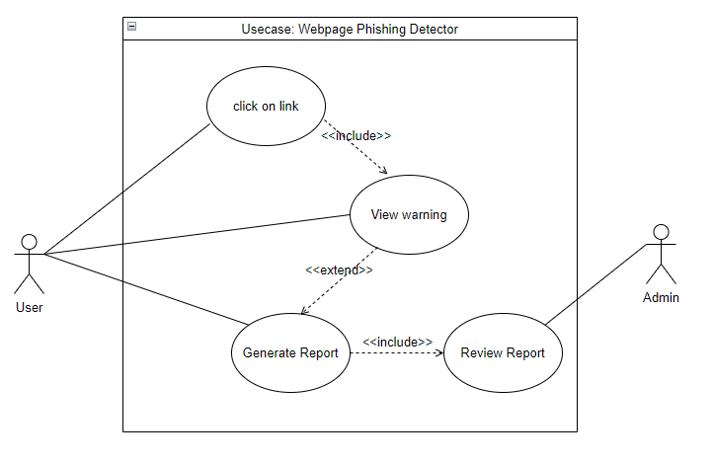
Figure 1 Use case diagram

Chapter 4: Design and Implementation

High level conceptual design

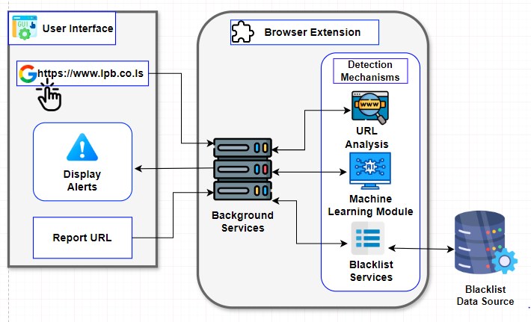
Figure 2 High level conceptual diagram

Sequence diagram

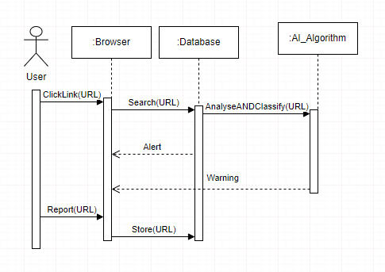
Figure 3 Sequence diagram

4.1 Application Architecture
The system follows a layered architecture, adhering to the principle of separation of concerns. Each layer handles specific responsibilities and interacts with adjacent layers to carry out the phishing detection process. The architecture includes:
Presentation Layer
Provides interfaces for users to submit URLs and receive detection feedback, either through the browser extension or a minimal web interface.
Logic Layer
Contains the phishing detection logic, including feature extraction, blacklist checks, and a Logistic Regression classifier for making predictions.
Data Layer
Manages persistent storage of user-submitted URLs, extracted features, and aggregated results in a MySQL database.

When a user visits a website, the browser extension automatically sends the current tab’s URL to the backend server. The server checks the URL against a maintained blacklist and, if necessary, processes the URL through a series of detection steps. If the site is identified as phishing, the user is redirected to a custom warning page. Otherwise, browsing continues uninterrupted. Users can also manually submit URLs through a web interface for analysis and reporting.

4.2 Component Design

4.2.1 Presentation Layer
The Presentation Layer is responsible for all user-facing aspects of the system, both within the browser extension and the minimal web interface. Its goal is to provide a clear and immediate way for users to check the safety of websites they visit, and to intervene when a phishing threat is detected.
Design and Functionality:
The system supports two core interaction flows:
Automatic Background Check Upon Link Clicks - When a user clicks a link and is redirected to a new website, the system automatically performs a background check on the destination URL. This check is initiated as soon as the new page begins to load. If the backend determines that the URL matches known phishing patterns, either through the blacklist or via machine learning classification; the user is immediately redirected to a dedicated warning page. This warning page fully replaces the original site, ensuring the alert is impossible to miss or ignore. This automated behavior is designed to provide proactive protection without requiring user input.
Manual URL Check via Extension Icon - If the user is already inside a website and wants to verify its legitimacy, for example, after being redirected or feeling uncertain they can click on the browser extension icon located at the top-right corner of the Chrome toolbar. When clicked, a compact popup interface appears, displaying the current tab’s URL and its safety status. This provides on-demand reassurance and gives the user more control over their browsing experience.
The warning page includes three user action buttons, giving them control over how to proceed:
Go Back to Safety; Redirects the user to a safe landing page or the browser’s previous page.
Proceed Anyway; Lets the user continue to the potentially dangerous site if they choose, with full awareness of the risk.
Report; This option is intended for users who have already fallen victim to a phishing attack from the current site. When clicked, the user is redirected to a dedicated reporting page, where they can explain what happened and submit evidence (such as screenshots, messages, or transaction records) to support their claim. This helps the system verify and respond to new threats more effectively.

4.2.2 Logic Layer
The Logic Layer is the core processing unit of the system, implemented on the server side. It handles the entire detection pipeline and is responsible for validating URLs and deciding whether a site is safe or malicious.
Design and Functionality
Request Handling: The server receives URL check requests from either the extension or the web interface. It first ensures proper HTTP handling and validation.
Blacklist Verification: The URL is checked against a maintained blacklist of known phishing domains. If a match is found, the system classifies the URL as phishing immediately. This ensures fast and accurate responses for repeated threats.
Feature Extraction: If the URL is not on the blacklist, a feature extraction module parses the URL and computes several indicators of phishing behavior, such as:

- URL length (the total number of characters in the URL)
- Use of IP addresses(e.g “http://192.168.0.1” instead of a domain name)
- Digit ratio (the proportion of numeric characters in the URL)
- Obfuscation score (a calculated value representing how unreadable or complex the URL is)
- Presence of special characters (e.g., @, -, =)

Model Prediction: The extracted features are scaled and passed into a preloaded Logistic Regression model, which returns a binary classification either phishing or legitimate.
Redirection or Confirmation: Based on the result, the browser either continues loading the site or redirects to the warning page.

4.2.3 Data Layer
The Data Layer provides persistent storage and supports analytical operations. It is implemented using a MySQL database and includes three main tables to manage raw reports, feature data, and aggregated domain analysis.
Design and Functionality:
Raw reports table: Stores user-submitted URLs, accompanying descriptions, review status, and timestamps. Screenshots are stored as binary large objects (LONGBLOB).
Feature cache table: Caches the extracted features of previously evaluated URLs to prevent reprocessing and enable rapid lookups.
Domain Analysis Table: Aggregates statistics per domain (e.g., average obfuscation score, frequency of reports) and calculates a derived risk score. This information helps administrators track recurring phishing campaigns.
Materialized Views: Predefined views such as high_risk_urls and phishing_analysis combine report and feature data to present actionable insights, particularly for system monitoring and administrative review.
Entity Relationship Diagram:
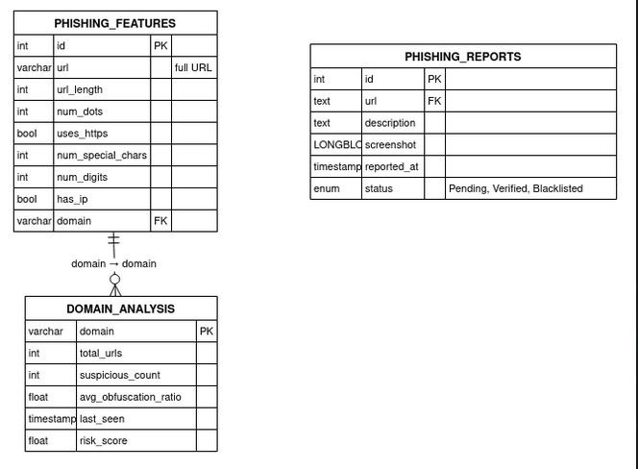
Figure 4 ERD diagram

CHAPTER 5: System Testing

5.1 Introduction
Testing is a crucial phase in any software development process, ensuring that the system performs as expected and is free from critical bugs. For our system, we adopted a structured testing approach aligned with our incremental prototyping methodology. The system was tested in stages; starting with individual components (unit testing) and followed by combined testing of components (system testing). This allowed issues to be identified early and resolved before full integration.

5.2 Unit Testing
Unit testing focused on verifying the functionality of individual components before they were integrated. Each module was tested independently to confirm that it handled input and output correctly, and met its design specifications.
Machine Learning Component:
The phishing detection model was tested using curl commands to send test URLs to the Flask API. This allowed us to verify whether the model correctly classified URLs as phishing or legitimate. We used both known malicious and safe websites during testing to assess the model’s accuracy and responsiveness.
Database Component:
The database system was also tested in isolation. Using curl, we simulated requests to verify whether specific URLs already existed in the blacklist database. This helped ensure that the system could efficiently identify if a website was blacklisted before passing it to the machine learning model.
Reporting Feature:
Finally, the reporting mechanism was tested. Users could report suspicious websites directly from the extension. We verified that reported URLs were stored in the database correctly and could be accessed by administrative users for later review and action.

5.3 System Testing
After successfully verifying each module independently during unit testing, we proceeded with full system testing, where all components were integrated and tested as a single, functioning unit. This step was critical to ensure seamless communication between the backend services, the machine learning model, the browser extension, and the database.
Extension and ML Integration
The first phase of system testing involved connecting the Chrome extension with the machine learning backend. We visited various websites to test how the extension collected the URL, sent it to the backend through an API, and received a prediction response. Based on the result; whether the site was legitimate or phishing, the extension displayed a corresponding alert through a browser popup. This test confirmed that the real-time prediction flow between the extension and the machine learning model was functioning correctly.
Blacklist and ML and Extension Integration
Next, we tested the full end-to-end detection flow. In this setup, when a user visited a site, the Chrome extension first checked the URL against the blacklist database. If the site was already marked as malicious, the system would instantly alert the user without invoking the ML model. If the URL was not in the blacklist, only then would it be passed to the machine learning model for classification. This two-layered detection mechanism was verified to ensure that priority was given to the quicker blacklist check before resorting to ML prediction, improving both speed and accuracy.
Reporting Feature Integration
In the final phase of system testing, we included the reporting functionality to complete the full system cycle. Users could report suspicious websites directly from the browser extension interface. These reported URLs were then stored in the database under a separate reporting table. We verified that once a report was submitted, it appeared in the database and could later be audited by an administrator. This ensured the feature worked as expected, enabling community-driven identification of potential threats.

CHAPTER 6: Results and discussion

6.1 Introduction
This chapter presents the results obtained from the development and testing of the Webpage Phishing Detector System. The purpose of this project was to create a security tool that helps end-users detect phishing websites in real time using a combination of a blacklist, a machine learning classifier, and a browser extension. This chapter provides an analysis of the system's functionality, the machine learning model’s performance, and the integration of different components in the final solution.
Both qualitative and quantitative methods were employed to evaluate the effectiveness and reliability of the system. The discussion addresses the performance metrics derived from machine learning testing, the operational results from real-time system testing, and the user experience related to the Chrome extension. Insights into the strengths and limitations of the system are also discussed, as well as opportunities for future improvements.

6.2 Evaluation Methodology
To comprehensively assess the Webpage Phishing Detector System, a multi-faceted evaluation strategy was adopted. The evaluation was carried out in three primary areas:
Machine Learning Model Performance:
The classifier’s ability to accurately differentiate between phishing and legitimate websites was tested using a labeled dataset. The model’s precision, recall, accuracy, and F1-score were calculated to quantify its effectiveness.
System Integration Testing:
The full system, comprising the blacklist checker, machine learning predictor, reporting module, and the Chrome browser extension, was tested in various scenarios to assess real-time performance, user interface responsiveness, and system interactions.
User Interaction and Reporting:
The system’s reporting feature and browser alerts were tested for usability and reliability. This evaluation was aimed at understanding how end-users interact with the system and how effectively the interface communicates threats.
Through this approach, the robustness and practical usability of the system were measured under realistic conditions

6.3 Machine Learning Results
The phishing detection model was trained on a dataset composed of legitimate and phishing websites. A supervised learning approach was employed, using features derived from URL structure, domain age, special characters, and embedded content. The dataset was split into training and testing sets to evaluate model generalizability.

6.3.1 Model Evaluation Metrics
The following table summarizes the key performance metrics recorded during testing:
Metric | Value
Accuracy | 91%
Precision | 85.1%
Recall | 98.7%
F1-Score | 91.4%

Table 1 Model Evaluation Metrics
- Accuracy indicates the percentage of total predictions (both phishing and legitimate) that were correct.
- Precision reflects the proportion of sites classified as phishing that were actually phishing, ensuring minimal false positives.
- Recall measures the proportion of actual phishing sites correctly identified, ensuring the system is sensitive to real threats.
- F1-Score combines both precision and recall, offering a balanced metric, especially useful in imbalanced datasets.

The F1-score of 91.4% suggests that the model maintains a strong balance between detecting phishing threats and avoiding false alarms.

6.3.2 Confusion Matrix Analysis
The confusion matrix provided deeper insight into classification accuracy:
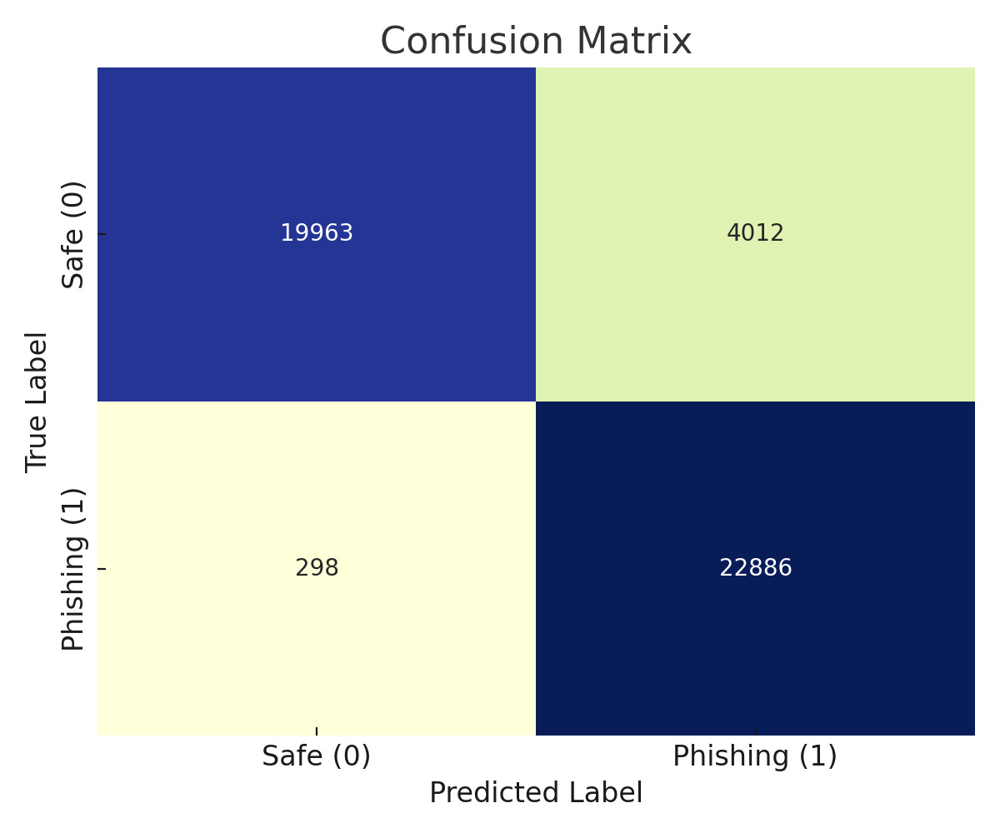
Figure 5 confusion matrix
From Figure 5:
- True Positives (TP): 22886 phishing sites correctly identified.
- True Negatives (TN): 19961 legitimate sites correctly identified.
- False Positives (FP): 4014 legitimate sites incorrectly flagged as phishing.
- False Negatives (FN): 298 phishing sites incorrectly classified as legitimate.
These results validate the reliability of the model, with only 9% misclassification, suggesting its suitability for real-world deployment.

6.4 System Functionality and Integration Testing
Beyond the model’s predictive capabilities, the overall performance of the Webpage Phishing Detector System was tested as an integrated application. This section outlines the practical results of each key system component.

6.4.1 Blacklist Module Performance
The blacklist served as the first line of defense, rapidly identifying and blocking access to known phishing websites. During testing, all entries in the blacklist were detected and flagged within milliseconds of page loading. This demonstrated the module’s reliability and speed, offering protection even before machine learning inference was initiated.

6.4.2 Reporting Feature Results
A core goal of the system was to involve users in improving threat detection. The reporting feature allowed users to submit suspicious URLs, which were then stored in a backend database for administrator review.
Testing showed that:
- Reports were successfully stored and retrievable in the database.
- The user interface allowed for clear and easy reporting.
This collaborative functionality ensures the system remains adaptable to emerging threats while maintaining security and accuracy.

6.4.3 Chrome Extension Evaluation
The Chrome extension was tested across a variety of websites, including legitimate, suspicious, and confirmed phishing domains. During testing, the extension consistently performed real-time scanning by intercepting each visited URL and checking it against both the blacklist and the machine learning prediction model. Upon identifying a phishing threat, the extension triggered immediate and clear pop-up alerts to warn the user, effectively preventing potential harm. The alert messages were designed to be concise and visually prominent, providing users with clear options such as dismissing the alert or reporting the site for further investigation. Additionally, the extension demonstrated strong performance efficiency, running seamlessly in the background without noticeably affecting browsing speed or user experience. Overall, the Chrome extension proved to be an effective and user-friendly tool for phishing detection during regular web usage.

6.5 Discussion

6.5.1 System Strengths
Throughout the development and testing of this project, several strengths of the Webpage Phishing Detector System became clear. One of the main advantages was the layered detection approach. By combining a blacklist with a machine learning model, the system could quickly block known phishing websites while also analyzing unfamiliar sites intelligently. This combination helped strike a good balance between speed and accuracy. I also found that the machine learning model performed well in reducing both false alarms and missed threats, which is very important in any security system. Another strong point was the reporting feature, which allowed users to report suspicious websites. This made the system feel more interactive and dynamic, as users could actively help improve it. Lastly, the integration of the Chrome extension brought everything together in a practical way, making it easy for users to get real-time alerts while browsing. Overall, these features worked well together and showed that the system has real potential to help protect users from phishing attacks.

6.5.2 Limitations
While the system performed well overall, we also encountered a few limitations during development and testing that are worth mentioning. In some cases, the model misclassified websites, either by flagging legitimate sites as phishing or by failing to detect actual phishing attempts. Although these cases were relatively rare, they could still lead to user frustration or missed threats. Also, the system was tested in a controlled environment with a moderate number of sites, so we were not able to fully evaluate how it would perform under heavier traffic or in a larger-scale deployment, like on an enterprise network. Recognizing these limitations is important because it highlights areas for future improvement and helps ensure the system can be made even more reliable and scalable over time.

6.6 Summary
This chapter presented a comprehensive evaluation of the Webpage Phishing Detector System. The system achieved high accuracy in detecting phishing websites through a hybrid approach that combines a machine learning model with a real-time blacklist. The results confirm the model's robustness, with an F1-score of 91.4% and reliable performance across various testing scenarios.
Additionally, the integration of a Chrome browser extension and a user-driven reporting feature adds practical value by empowering users with real-time security alerts and participation. Overall, the system proves to be an effective tool in combating phishing attacks, with the potential for broader implementation and continuous enhancement through user contributions and future automation.

Chapter 7: Future Work and Conclusion

7.1 Future Work
While the current implementation of the Webpage Phishing Detector System has successfully integrated machine learning, URL analysis, a blacklist database, and user reporting via a Chrome extension, there is still room for improvement and feature expansion.
One major area identified for future development is the enhancement of the user reporting and administrative review process. Currently, users can report suspicious websites, and these are stored in a separate table for administrative auditing. However, in future versions, we aim to implement a full review and verification mechanism for administrators. Once an admin verifies that a reported URL is indeed a phishing attempt, the system should automatically add that URL to the main blacklist database. This will help to continuously expand the blacklist using real-time user input and ensure that known phishing websites are blocked proactively in the future.
Additionally, future versions of the system could benefit from incorporating Natural Language Processing (NLP) techniques. This would allow analysis of webpage content, not just the URL structure to detect phishing based on suspicious phrases or persuasive social engineering language often used in phishing websites.
Another important direction is the inclusion of visual similarity detection. Many phishing websites mimic the visual layout and branding of legitimate sites. Implementing image-based comparison using models such as Convolutional Neural Networks (CNNs) could improve accuracy by flagging suspicious sites that closely resemble known legitimate domains.
Expanding the system’s compatibility to support multiple browsers, including Firefox, Edge, and possibly mobile platforms (Android/iOS), would increase accessibility and adoption. Additionally, real-time synchronization with global phishing feeds (such as PhishTank or Google Safe Browsing) would further enhance the blacklist and reduce dependency on local data alone.

CHAPTER 8: Conclusion

Phishing continues to pose a major threat to online users worldwide, exploiting both technological and human vulnerabilities. This project has addressed this problem by developing a real-time phishing detection tool as a browser extension, combining a machine learning model with a blacklist check and a user reporting feature.
The methodology followed an incremental prototyping approach: first building and testing the machine learning model, followed by browser extension integration, then implementing the blacklist database, and finally the user reporting mechanism. Each module was tested both individually and as part of the integrated system to ensure proper functionality.
By focusing on a lightweight, accessible solution that works in real-time, this system aims to protect users from phishing threats efficiently. The added feature of user reporting promotes a collaborative defense mechanism, encouraging community involvement in identifying suspicious sites.
In conclusion, the Webpage Phishing Detector System represents a strong step toward smarter, user-oriented cybersecurity solutions. With planned future upgrades, the tool has the potential to become even more adaptive, accurate, and effective at defending against modern phishing tactics.

References

AP News, 2024. Interpol clamps down on cybercrime and arrests over 1,000 suspects in Africa. [online] Available at: https://apnews.com/article/208111329edd3a1a64faf85cc7c0d2c0
Arun, A. and Abosata, N., 2024. Next Generation of Phishing Attacks using AI powered Browsers. arXiv preprint arXiv:2406.12547.
Bharuka, V., Almeida, A. and Patil, S., 2024. Phishing Detection Using Machine Learning Algorithm. International Journal of Scientific Research in Computer Science, Engineering and Information Technology. [online] Available at: https://ijsrcseit.com/index.php/home/article/view/CSEIT2410228
Liu, W. et al., 2018. Online phishing detection: An extreme learning machine based approach. Computers & Security, 38, pp.55-63.
Usman-Hamza, F.E. and Ajiboye, A.R., 2024. Performance Analysis of Selected Machine Learning Algorithms in the Detection of Phishing Attacks on Vulnerable Websites. International Journal of Software Engineering and Computer Systems, 10(1), pp.1-12.
Yerima, S.Y. and Alzaylaee, M.K., 2020. High Accuracy Phishing Detection Based on Convolutional Neural Networks. arXiv preprint arXiv:2004.03960.
CrowdStrike (2023) What is Phishing? Techniques and Prevention. Available at: https://www.crowdstrike.com/en-us/cybersecurity-101/social-engineering/phishing-attack/
Darktrace (2023) How Phishing Attacks Are Becoming Harder to Identify. Available at: https://darktrace.com/blog/email-attack-trends-how-phishing-attacks-are-becoming-more-sophisticated-and-harder-to-identify
Kaspersky (2020) How phishing, and its detection, has evolved. Available at: https://content.kaspersky-labs.com/se/media/en/business-security/KSO365_Whitepaper_Detecting_sophisticated_phishing.pdf
MDPI (2023) Improved Phishing Attack Detection with Machine Learning. Available at: https://www.mdpi.com/2076-3417/13/24/13269
NCSC (2023) Phishing attacks: defending your organisation. Available at: https://www.ncsc.gov.uk/guidance/phishing
Upadhyay, A. (2023) Detecting Phishing Attacks with AI. Available at: https://medium.com/@akriti.upadhyay/phishing-detection-met-generative-ai-365b3e89920d
Kumaraguru, P., Rhee, Y., Acquisti, A., Cranor, L.F., Hong, J. and Nunge, E. (2010) ‘Protecting people from phishing: The design and evaluation of an embedded training email system’, CHI '07: Proceedings of the SIGCHI Conference on Human Factors in Computing Systems, pp. 905–914.
Marchal, S., François, J., State, R. and Engel, T. (2017) ‘PhishStorm: Detecting phishing with streaming analytics’, IEEE Transactions on Network and Service Management, 11(4), pp. 458–471.
Rao, R.S. and Ali, S.H. (2015) ‘A survey of phishing attacks and countermeasures’, International Journal of Computer Science and Information Security, 14(6), pp. 32–45.
Verma, R. and Das, A. (2017) ‘What's in a URL: Fast feature extraction and malicious URL detection’, in Proceedings of the 3rd ACM on International Workshop on Security And Privacy Analytics, pp. 55–63.
Google (2023) Safe Browsing – Protecting billions of devices every day. Available at: https://safebrowsing.google.com/
Hong, J. (2012) ‘The state of phishing attacks’, Communications of the ACM, 55(1), pp. 74–81. https://doi.org/10.1145/2063176.2063197
Liu, W., Huang, X., Liu, Y., Zhang, M. and Deng, X. (2018) ‘Detection of phishing websites based on hybrid features’, Proceedings of the 2018 IEEE International Conference on Big Data and Smart Computing (BigComp), pp. 755–758.
Nazario, J. and Holz, T. (2008) ‘As the net churns: Fast-flux botnet observations’, Malware 2008: 3rd International Conference on Malicious and Unwanted Software, pp. 24–31.
Rafique, M.Z. and Caballero, J. (2013) ‘Firn: Real-time and scalable uniform resource identifier filtering system’, IEEE Transactions on Dependable and Secure Computing, 10(5), pp. 270–283.
Rao, R.S. and Ali, S.H. (2015) ‘A survey of phishing attacks and countermeasures’, International Journal of Computer Science and Information Security, 14(6), pp. 32–45.
Saxe, J. and Berlin, K. (2017) Malware data science: Attack detection and attribution. Sebastopol, CA: O’Reilly Media.
Abdelhamid, N., Ayesh, A. and Thabtah, F. (2014) ‘Phishing detection based on hybrid features’, Proceedings of the IEEE International Conference on Cybercrime and Computer Forensics (ICCCF), pp. 1–6.
Basnet, R., Sung, A.H. and Liu, Q. (2012) ‘Rule-based phishing attack detection’, Proceedings of the 2012 International Conference on Security and Management (SAM), pp. 1–7.
Bergholz, A., De Beer, J., Glahn, S., Moens, M.F., Paaß, G. and Strobel, S. (2010) ‘New filtering approaches for phishing email’, Journal of Computer Security, 18(1), pp. 7–35.
Hong, J. (2012) ‘The state of phishing attacks’, Communications of the ACM, 55(1), pp. 74–81. https://doi.org/10.1145/2063176.2063197
Rao, R.S. and Ali, S.H. (2015) ‘A survey of phishing attacks and countermeasures’, International Journal of Computer Science and Information Security, 14(6), pp. 32–45.
Zhang, Y., Egele, M. and Kruegel, C. (2016) ‘Phishing detection: A literature survey’, Security and Privacy, UC Santa Barbara. https://seclab.cs.ucsb.edu/
Abdelhamid, N., Ayesh, A. and Thabtah, F. (2014) ‘Phishing detection based on hybrid features’, Proceedings of the IEEE International Conference on Cybercrime and Computer Forensics (ICCCF), pp. 1–6.
Basit, A., Zafar, M., Liu, X., Javed, A.R., Jalil, Z. and Kim, D.H. (2020) ‘A comprehensive survey of AI-enabled phishing attacks detection techniques’, Telecommunication Systems, 75(1), pp. 1–15. https://doi.org/10.1007/s11235-020-00645-w
Liu, J., Zhang, Y., Li, C., Chen, Y. and Liu, W. (2018) ‘PhishKiller: A real-time phishing detection system with machine learning techniques’, Journal of Information Security and Applications, 45, pp. 76–84.
Rao, R.S. and Ali, S.H. (2015) ‘A survey of phishing attacks and countermeasures’, International Journal of Computer Science and Information Security, 14(6), pp. 32–45.
Sahingoz, O.K., Buber, E., Demir, O. and Diri, B. (2019) ‘Machine learning based phishing detection from URLs’, Expert Systems with Applications, 117, pp. 345–357. https://doi.org/10.1016/j.eswa.2018.09.029
Verma, R. and Das, A. (2017) ‘What's in a URL? Fast feature extraction and malicious URL detection’, Proceedings of the 3rd ACM on International Workshop on Security And Privacy Analytics, pp. 55–63.
Abdelhamid, N., Ayesh, A. and Thabtah, F. (2014) ‘Phishing detection based on hybrid features’, Proceedings of the IEEE International Conference on Cybercrime and Computer Forensics (ICCCF), pp. 1–6.
Sahingoz, O.K., Buber, E., Demir, O. and Diri, B. (2019) ‘Machine learning based phishing detection from URLs’, Expert Systems with Applications, 117, pp. 345–357. https://doi.org/10.1016/j.eswa.2018.09.029
Usman-Hamza, H. and Ajiboye, F.A. (2024) ‘Comparative study of machine learning models for phishing website detection’, International Journal of Cybersecurity Research, 8(1), pp. 15–27.
Verma, R. and Das, A. (2017) ‘What's in a URL? Fast feature extraction and malicious URL detection’, Proceedings of the 3rd ACM on International Workshop on Security and Privacy Analytics, pp. 55–63.
Almomani, A., Alauthman, M., Tawalbeh, L. and Al-Momani, O. (2013) ‘A survey of phishing email filtering techniques’, International Journal of Computer Network and Information Security, 5(10), pp. 35–44. https://doi.org/10.5815/ijcnis.2013.10.05
Goodfellow, I., Bengio, Y. and Courville, A. (2016) Deep Learning. MIT Press.
Hinton, G.E., Osindero, S. and Teh, Y.W. (2006) ‘A fast learning algorithm for deep belief nets’, Neural Computation, 18(7), pp. 1527–1554. https://doi.org/10.1162/neco.2006.18.7.1527
LeCun, Y., Bengio, Y. and Hinton, G. (2015) ‘Deep learning’, Nature, 521(7553), pp. 436–444. https://doi.org/10.1038/nature14539
Nguyen, T.T., Le, N.D., Hoang, D.T. and Huynh, V.N. (2020) ‘A deep learning model for detecting phishing websites using CNN and attention mechanism’, Proceedings of the 12th International Conference on Knowledge and Systems Engineering (KSE), pp. 267–272. https://doi.org/10.1109/KSE50997.2020.9287819
Yerima, S.Y. and Alzaylaee, M.K. (2020) ‘Phishing email detection using deep learning techniques’, Journal of Computer Virology and Hacking Techniques, 17, pp. 147–160. https://doi.org/10.1007/s11416-020-00355-5
Zhang, Y., Hong, J. and Cranor, L. (2021) ‘Catching phish: Detecting phishing attacks using recurrent neural networks and natural language processing’, IEEE Transactions on Dependable and Secure Computing, 18(3), pp. 1164–1177. https://doi.org/10.1109/TDSC.2020.2970655
Bharuka, V., Shah, R., Mehta, A. and Patel, N. (2024) ‘Phishing email detection using machine learning and natural language processing techniques’, Journal of Cybersecurity and Digital Forensics, 5(1), pp. 88–95.
Jurafsky, D. and Martin, J.H. (2021) Speech and Language Processing. 3rd edn. Available at: https://web.stanford.edu/~jurafsky/slp3/
Shen, Y., Liu, Y., Yang, L., Wu, J. and Zhao, Y. (2020) ‘NLP-based phishing detection in emails: A review’, IEEE Access, 8, pp. 176922–176935. https://doi.org/10.1109/ACCESS.2020.3019996

Appendix

1. System Manual

1.1 Introduction
The Webpage Phishing Detector is an integrated security solution that combines a Google Chrome extension with a Flask-based backend API. The system is designed to detect and alert users to phishing threats in real time by analyzing the structure and characteristics of URLs. In addition to automated detection, the system provides a reporting interface that allows users to flag suspicious websites. These reports are collected and stored in a central database, where they can be reviewed by administrators for further action, such as blacklisting verified phishing domains.

1.2 System Requirements
To ensure the system functions effectively, certain hardware and software specifications are recommended. From a hardware perspective, a machine with an Intel Core i3 processor (or its equivalent) running at 2.0 GHz or higher is suitable. A minimum of 4 GB of RAM is required, along with at least 5 GB of free disk space to store logs, models, and database records.
The application is compatible with modern operating systems, including Windows 10 or 11 (64-bit), macOS 10.15 or later, and widely used Linux distributions such as Ubuntu 18.04 or newer. Users must also have the Google Chrome browser, version 79 or higher, with Developer Mode enabled in order to load the extension.
On the backend, the system relies on Python 3.8 or later, and several essential libraries, including Flask, python-dotenv, flask-cors, and mysql-connector-python for database connectivity. The machine learning model and related processing are handled using scikit-learn, pandas, and numpy.
A reliable network connection is required to ensure communication with the MySQL server, which can be hosted locally or remotely. The MySQL server must be version 5.7 or higher, and the database should be initialized using the provided SQL schema file named webpageDetectorDB.sql.
In terms of security and configuration, the API should be served over HTTPS in production to protect sensitive user data. Configuration secrets such as the SESSION_SECRET and database credentials must be securely stored in an .env file located in the api/ directory. Additionally, it is recommended to use strong passwords and assign minimal privileges to the database user in accordance with security best practices.
Finally, administrators can access a dedicated interface for managing reported URLs at http://localhost:5000/admin/reports. Through this panel, they can review submitted reports, verify the legitimacy of suspicious sites, and update the blacklist as needed.
System Installation
System Requirements
Ensure that the host computer, meets the minimum system requirements specified in the system documentation. These requirements include the operating system, processor, memory, storage, and graphics capabilities.
System Configuration
Database Configuration
Configure the database connection settings to establish a connection with the database server. This includes specifying the server address, port number, database name, username, and password.

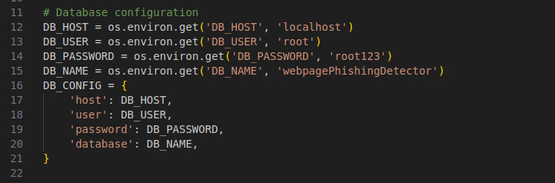
Figure 6 database configuration

2. User Manual
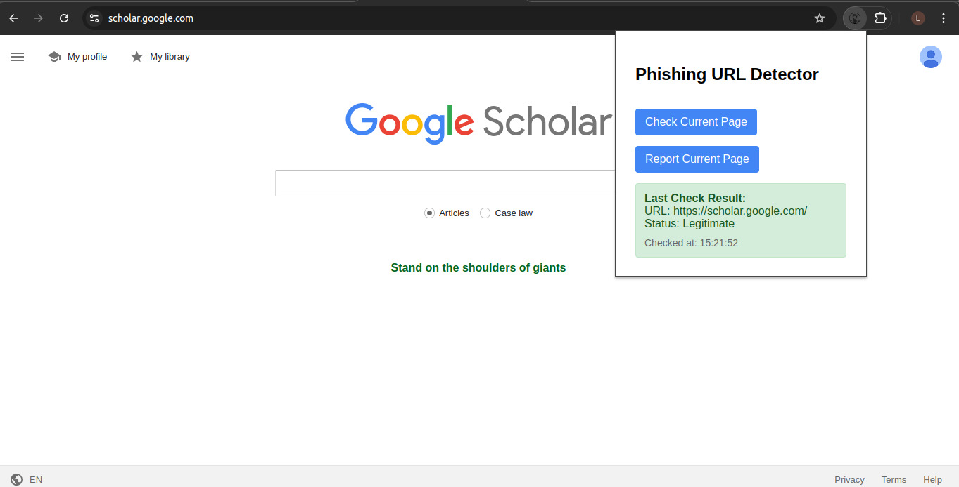
Figure 7 URL checking via icon when website is detected as legitimate
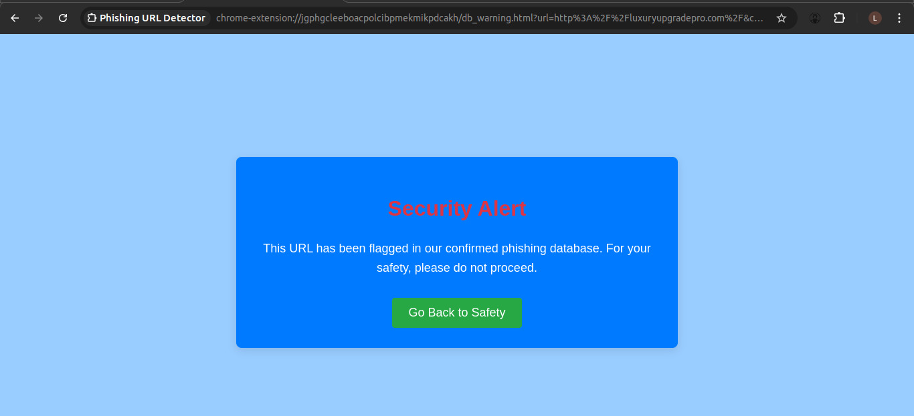
Figure 8 Alert displayed when is URL found in the blacklist database
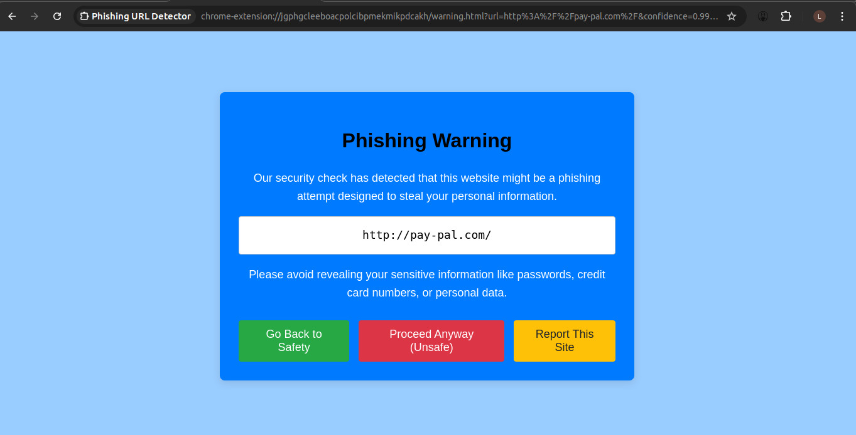
Figure 9 URL suspected to be phishing by Machine learning module
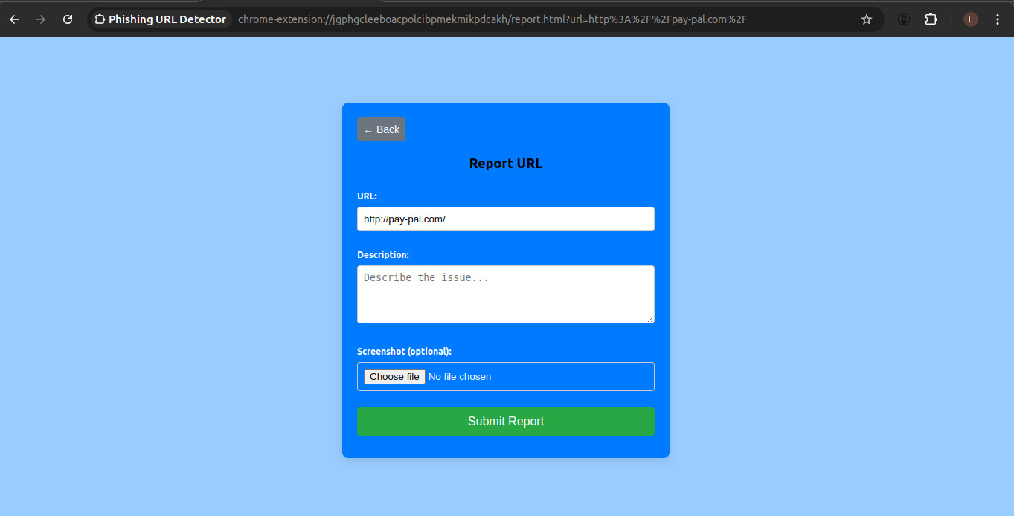
Figure 10 reporting page where user can report URL
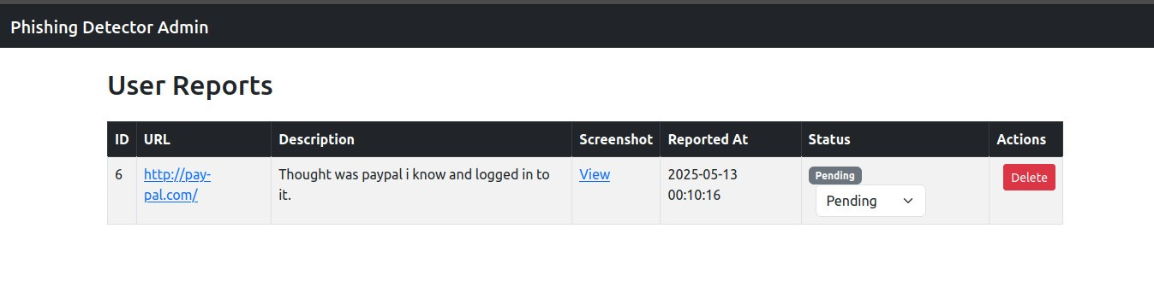
Figure 11 admin page for viewing reported URLs

