CENTRAL UNIVERSITY OF TECHNOLOGY, FREE STATE
Faculty of Engineering, Built Environment and Information Technology
WORK-INTEGRATED LEARNING
Module Code: ITC327W | Diploma in Information Technology (DP_ITC / EX_ITC)
SOFTWARE REQUIREMENTS SPECIFICATION (SRS)
Merged Working Document — Phase 1 (Activities 1.1–1.3) + Phase 2 (System Architecture and Design)
Nama Nameng: A Mobile and Web-Based Ordering, Payment and Queue Management System for Nama Nameng
External Stakeholder: Nama Nameng (Chisa Nyama) — Owner: Doja
# | Full Name | Student Number
1 | Neo Lekhelebana | 221000484
2 | Lesedi Ramolahloane | 219015068
3 | Charmaine Mogotsi | 221023182
4 | Portia Nkotseng Sefatsa | 220007164
5 | Tshepang Morake | 222075924
6 | Hlayiseka Matsimbi | 221027400

Table of Contents
- 1. Cover Page and Group Members
- 2. Project Title
- 3. Problem Statement
- 4. Purpose, Aim and Objectives
- 5. Project Scope
- 6. Deliverables and Acceptance Criteria
- 7. Exclusions, Constraints and Assumptions
- 8. Stakeholders and User Groups
- 9. Current Process and Diagram
- 10. Product Perspective
- 11. Main Flutter, ASP.NET and Supabase Functions
- 12. Functional Requirements
- 13. Non-Functional Requirements
- 14. System Requirements
- 15. Integration Requirements
- 16. Requirements Prioritisation
- Requirements Change Log
- Refined Project Scope
- Feasibility Study
- Project Risk Register
- SWOT Analysis
- 17. Appendices: Stakeholder Evidence (A–G)
- 18. Phase 2: System Architecture and Design (Addendum)
- 19. System Architecture Diagram — PLACEHOLDER
- 20. Sequence Diagrams — PLACEHOLDER
- 21. Entity Relationship Diagram (ERD) — PLACEHOLDER
- 22. Flutter Interface Designs — PLACEHOLDER
- 23. ASP.NET Interface Designs — PLACEHOLDER
- 24. Phase 2 Completion & Gap Tracker

1. Cover Page and Group Members
The cover page of this document identifies the institution, module, project title, external stakeholder and the group members responsible for this Work-Integrated Learning (WIL) project. Full names, student numbers and individual roles of all group members are recorded in the table on the cover page.

2. Project Title
Nama Nameng: A Mobile and Web-Based Ordering, Payment and Queue Management System for Nama Nameng
The project title reflects the core purpose of the system: connecting customers digitally to a chisa nyama business that currently relies entirely on in-person, walk-up ordering.

3. Problem Statement

3.1 Stakeholder and Organisation
Nama Nameng is a local chisa nyama that prepares and sells grilled meat and accompanying sides to walk-in customers in the surrounding community.

3.2 Current Situation
Nama Nameng currently operates using a fully manual, in-person process. Customers must physically travel to the premises, join a queue, and wait to reach the counter before they can even place an order. There is no app or web-based ordering option available; they only take orders using the owner's personal WhatsApp. The business has no website, no online menu, and no digital presence beyond informal word-of-mouth recommendations from existing customers.

3.3 The Problem
- Customers experience long, visible physical queues, especially during peak trading times (weekends, lunch hours and paydays).
- There is no way for a customer to place an order in advance, browse the menu remotely, or check what is currently available before arriving.
- The business has no digital record of orders, sales trends, or customer preferences, making it difficult to plan stock or staffing.
- Marketing relies entirely on word-of-mouth, which limits the business's ability to reach new customers outside its immediate local network.
- Order-taking is manual and verbal, which increases the risk of miscommunication, forgotten items and incorrect orders.

3.4 Affected Users
- Walk-in and repeat customers of Nama Nameng, who lose time standing in queues.
- The owner/manager of Nama Nameng, who cannot track orders, sales or customer demand digitally.
- Kitchen/braai staff, who receive orders verbally with no queue or ticketing system.
- Potential new customers in the surrounding area who are unaware of the business due to its reliance on word-of-mouth marketing.

3.5 Consequences and Need for Improvement
If the current manual process continues unchanged, Nama Nameng risks losing customers to competitors who offer more convenient ordering options, continues to miss opportunities to grow its customer base beyond its immediate community, and remains unable to make data-informed decisions about its menu, stock and staffing. A digital ordering and queue management solution is needed to reduce queuing time, extend the business's reach, and provide the owner with visibility over orders and sales.

4. Purpose, Aim and Objectives

4.1 Purpose
The purpose of this project is to design and develop a digital ordering and queue management solution for Nama Nameng, replacing the current fully manual, word-of-mouth-driven process with a mobile application for customers and a web-based management dashboard for the business, supported by a shared cloud backend.

4.2 Aim
To reduce customer queuing time and improve order accuracy at Nama Nameng by enabling customers to browse the menu and place orders digitally, while giving the business owner a simple, reliable way to manage orders, menu items and basic sales information online.

4.3 Objectives
- To develop a cross-platform mobile application (Flutter) and a web-based management dashboard (ASP.NET) that allows customers to view the menu, place and pay for orders, and track order status remotely, and allows the Owner/staff to manage the menu, view and update incoming orders, and view basic order/sales history.
- To implement a shared backend (Supabase) that stores menu, order and user data, and synchronises data in real time between the mobile app and the web dashboard.
- To reduce physical queuing by allowing customers to place orders ahead of arrival and receive a notification or status update when their order is ready.
- To provide the business with a basic digital record of orders that can support future marketing and stock-planning decisions.

5. Project Scope
This initial SRS defines the scope of the Nama Nameng system as it will be developed for the WIL project prototype. The scope focuses on ordering, menu management and queue-visibility functionality that directly addresses the problems identified with Nama Nameng.

5.1 In Scope
- A cross-platform mobile application (Flutter) and a web-based management dashboard (ASP.NET) allowing customers to view the menu, place and pay for orders, and track order status remotely, and allowing Owner/staff to manage the menu, view and update incoming orders, and view basic order/sales history.
- A shared Supabase backend providing the database, authentication and real-time synchronisation between the mobile app and web dashboard.
- Basic digital queue/ticket visibility so customers know their order position or estimated wait.
- Basic order history and simple sales overview for the owner.

6. Deliverables and Acceptance Criteria
Deliverable | Acceptance Criteria | Owner
Flutter mobile app & ASP.NET web app | Allows customers to view the menu, place and pay for orders, and track order status remotely; allows Owner/staff to manage the menu, view/update incoming orders and view basic order/sales history. | Group
Supabase backend (database & auth) | All order, menu and user data is stored centrally, and changes made from either app sync correctly and promptly across both platforms. | Group
Digital menu | Menu items, descriptions and prices are accurate, current, and reflect what Nama Nameng actually offers, as confirmed by the stakeholder. | Group
Order status / queue visibility | Customer can see their order's current status (e.g. Received / Preparing / Ready) after placing it. | Group
Initial and final SRS documentation | SRS accurately reflects stakeholder-confirmed requirements and is approved/acknowledged by the stakeholder. | Group

7. Exclusions, Constraints and Assumptions

7.1 Exclusions
- Integration with third-party delivery platforms (e.g. Uber Eats, Mr D Food) is excluded from this initial prototype.
- Integrated card/online payment gateway processing is excluded from the initial prototype; payment recording will be simulated or limited to cash-on-collection/manual confirmation unless the stakeholder confirms otherwise.
- Loyalty/rewards programmes, advanced analytics and multi-branch support are excluded from this version.
- Native iOS-specific and Android-specific features beyond what Flutter provides by default are excluded.

7.2 Constraints
- The project must be completed within the academic semester timeframe set by the ITC327W module.
- Development is limited to the technology stack specified by the module: Flutter (mobile), ASP.NET (web), and Supabase (backend/database).
- Access to the stakeholder for requirement confirmation is limited to arranged visits/meetings and is dependent on the stakeholder's business operating hours.

7.3 Assumptions
- Nama Nameng has, or is willing to obtain, basic internet connectivity (Wi-Fi/mobile data) at the premises to run the staff web dashboard.
- Customers placing orders through the mobile app have access to a smartphone and mobile data.
- The stakeholder will remain available for periodic feedback and requirement confirmation throughout the project.
- The menu and pricing information provided by the stakeholder during initial engagement is accurate and will be confirmed before final development.

8. Stakeholders and User Groups
Stakeholder / User Group | Description | Interest / Involvement
Nama Nameng (Owner/Manager) | Primary external stakeholder; owns and operates the chisa nyama business. | Provides requirements, confirms scope, approves menu content and system behaviour.
Kitchen/Braai Staff | Prepares food and currently receives orders verbally. | Will use the order-status/queue features of the web & app dashboard.
Customers (Walk-in & Repeat) | Community members who purchase food from Nama Nameng. | End users of the Flutter mobile app & ASP.NET web app; primary beneficiaries of reduced queuing.
Project Group (Students) | WIL project team responsible for design, development and delivery. | Gathers requirements, designs and builds the Flutter, ASP.NET and Supabase system.
ITC327W Module Facilitator | Assessor of the WIL project. | Reviews and assesses project deliverables, including this SRS.

Stakeholder needs
The following needs were identified directly through engagement with Doja (Nama Nameng owner) during the initial stakeholder meeting (see Appendix A) and confirmed as accurate for this project (see Appendix B). These needs directly inform the functional and non-functional requirements in Sections 12 and 13.
- Reduce the time customers spend standing in physical queues, particularly during peak periods (weekends, lunch hours, paydays).
- Provide a way for customers to see the menu and place an order before or without needing to be physically present at the counter.
- Reduce order-taking errors caused by verbal, in-person communication between customers, counter staff and the kitchen/braai area.
- Give the owner a simple way to manage the menu (add, edit, remove items and prices) without needing technical assistance.
- Give the owner visibility of incoming orders and the ability to update order status so customers know when their food is ready.
- Keep the solution simple and low-cost to operate, given the business's current reliance on informal, low-tech processes (WhatsApp, verbal ordering) and limited digital literacy among staff.
- Retain flexibility around payment — the business currently operates on a cash/in-person payment basis, and a full online payment gateway is not a priority need at this stage.
- Build a basic digital record of orders over time, to support future decisions on stock and staffing (a need the business cannot currently meet at all).

9. Current Process and Diagram

9.1 Current Process Description
Nama Nameng's current ordering process is entirely manual and in-person, as illustrated in Figure 1 below.
- A customer physically arrives at the premises; there is no remote ordering option.
- The customer joins a physical queue and waits their turn to reach the counter.
- Once at the counter, the customer verbally tells a staff member what they would like to order.
- The staff member relays the order to the kitchen/braai area verbally, with no ticket or digital queue reference.
- Food is prepared with no visibility to the customer of their position in the preparation queue.
- The customer pays at the counter (cash or card) and waits for the food to be ready.
- The customer receives their food and leaves; word-of-mouth sharing is currently the business's only form of marketing.
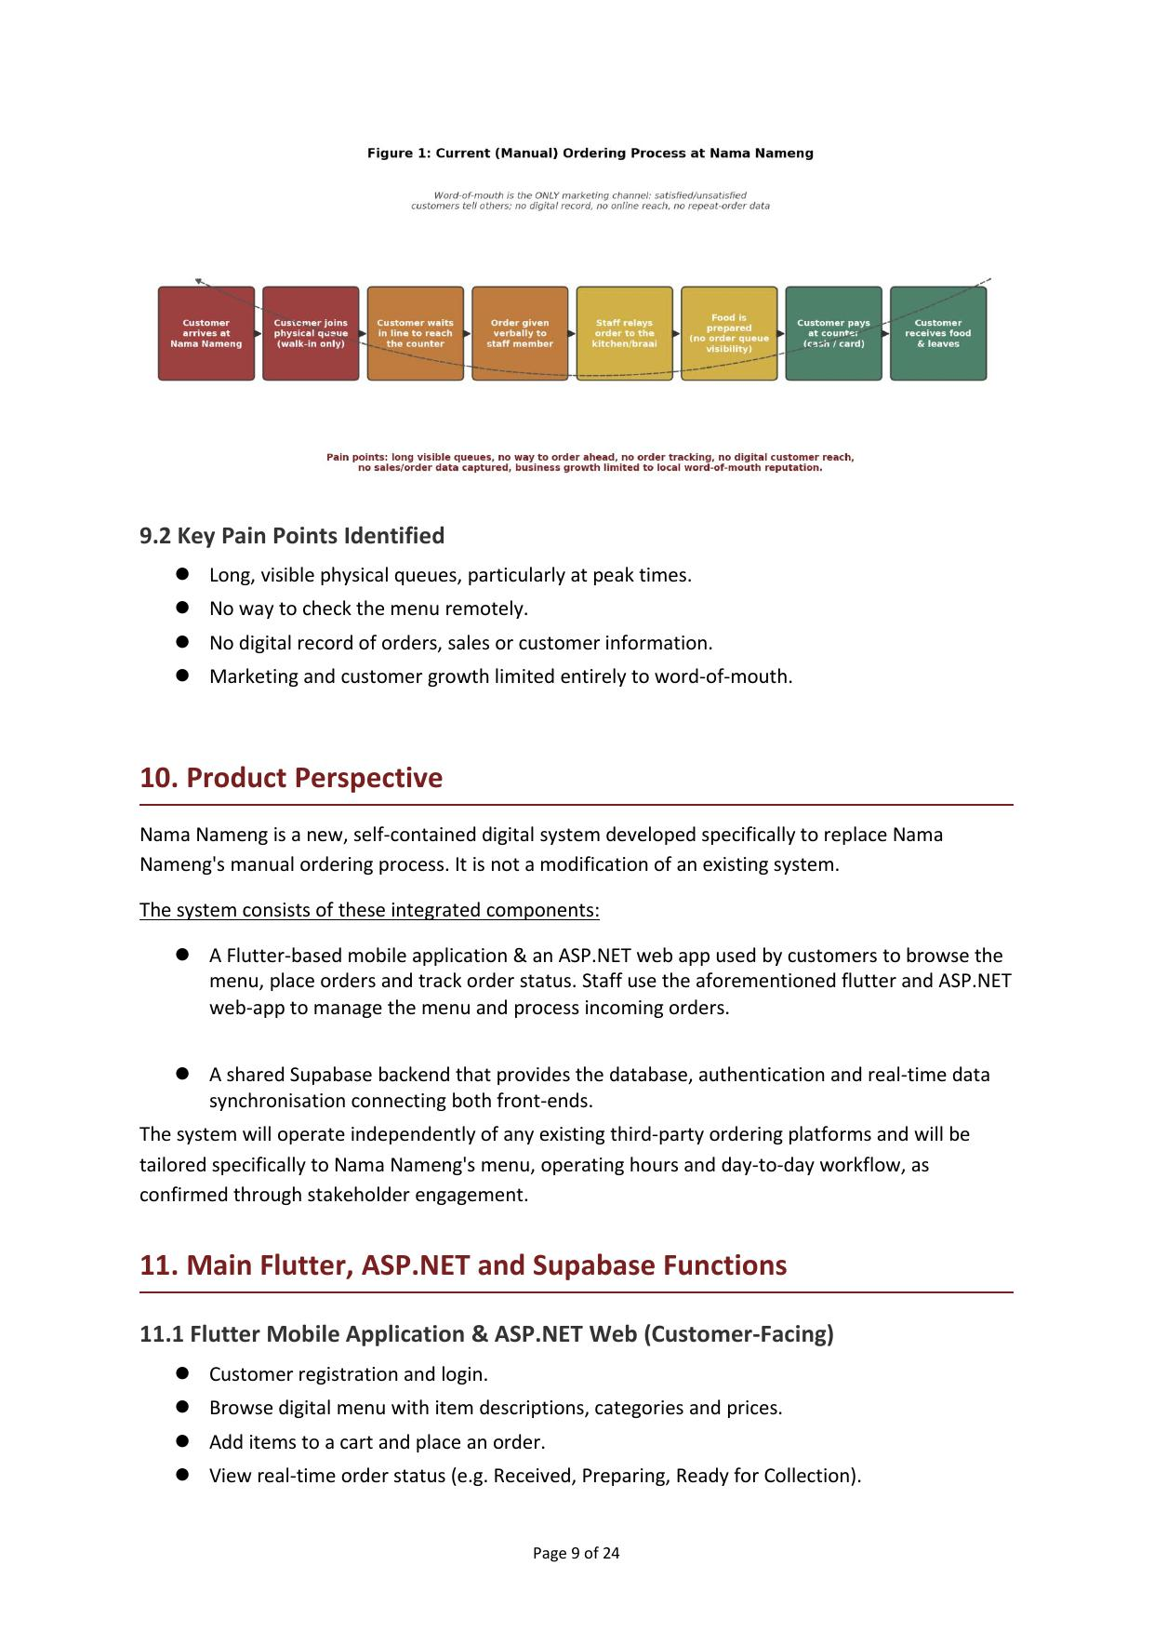
Figure 1: Current (Manual) Ordering Process at Nama Nameng — reproduced from the Final Phase 1 SRS

9.2 Key Pain Points Identified
- Long, visible physical queues, particularly at peak times.
- No way to check the menu remotely.
- No digital record of orders, sales or customer information.
- Marketing and customer growth limited entirely to word-of-mouth.

10. Product Perspective
Nama Nameng is a new, self-contained digital system developed specifically to replace Nama Nameng's manual ordering process. It is not a modification of an existing system. The system consists of these integrated components:
- A Flutter-based mobile application & an ASP.NET web app used by customers to browse the menu, place orders and track order status. Staff use the same Flutter and ASP.NET web-app to manage the menu and process incoming orders.
- A shared Supabase backend that provides the database, authentication and real-time data synchronisation connecting both front-ends.
The system will operate independently of any existing third-party ordering platforms and will be tailored specifically to Nama Nameng's menu, operating hours and day-to-day workflow, as confirmed through stakeholder engagement.

11. Main Flutter, ASP.NET and Supabase Functions

11.1 Flutter Mobile Application & ASP.NET Web (Customer-Facing)
- Customer registration and login.
- Browse digital menu with item descriptions, categories and prices.
- Add items to a cart and place an order.
- View real-time order status (e.g. Received, Preparing, Ready for Collection).
- View basic order history for the logged-in customer.
- Receive in-app notifications/status updates on order progress.

11.2 Flutter Mobile Application & ASP.NET Web Dashboard (Owner/Staff-Facing)
- Staff/owner authentication and secure login.
- Add, edit, and remove menu items, categories and prices.
- View incoming orders in real time as they are placed.
- Update order status so customers see live progress in the mobile app.
- View a basic list/history of past orders and simple daily sales overview.

11.3 Supabase Backend
- Central relational database storing users, menu items, orders and order status.
- Authentication service for both customer & staff (Flutter & ASP.NET) accounts.
- Real-time subscriptions so order status changes on the web dashboard reflect instantly in the mobile app, and new orders reflect instantly on the dashboard.
- Storage for menu item images.
- Row-level security rules to ensure customers can only view/edit their own orders and staff-only data is protected.

12. Functional Requirements
ID | Requirement Description | Linked Stakeholder Need | Priority
FR-01 | Allow a customer to register and log into the mobile & web app. | Remote/self-service access | High
FR-02 | Allow a customer to view the current digital menu with prices. | Browse menu before arriving | High
FR-03 | Allow a customer to add items to a cart and submit an order. | Order ahead of arrival | High
FR-04 | Allow a customer to view the real-time status of their order. | Reduce uncertainty/queue time | High
FR-05 | Allow staff/owner to log into the web & app dashboard securely. | Business data security | High
FR-06 | Allow staff/owner to add, edit and remove menu items and prices. | Keep menu accurate/current | High
FR-07 | Allow staff/owner to view all incoming orders in real time. | Reduce miscommunication | High
FR-08 | Allow staff/owner to update the status of an order. | Inform customer of progress | High
FR-09 | Notify/update the customer when their order status changes. | Reduce physical waiting | Medium
FR-10 | Store completed order history accessible to the customer. | Reorder convenience | Medium
FR-11 | Provide the owner with a basic overview/list of past orders. | Business insight/planning | Medium
FR-12 | Synchronise order and menu data in real time between the mobile app and the web dashboard via Supabase. | Consistent, accurate information | High

13. Non-Functional Requirements
Category | ID | Requirement Description
Usability | NFR-01 | The mobile app shall be simple and intuitive enough for first-time customers with limited technical experience to place an order without assistance.
Performance | NFR-02 | The system shall reflect a new order on the staff dashboard within a few seconds of the customer submitting it.
Security | NFR-03 | Customer and staff accounts shall be protected using secure authentication, and customers shall only be able to access their own order data.
Availability | NFR-04 | The system shall be available during Nama Nameng's normal trading hours, with minimal planned downtime.
Reliability | NFR-05 | The system shall accurately save and display order and menu data without data loss under normal operating conditions.
Scalability | NFR-06 | The system shall be able to support a growing number of customers and orders as the business's digital reach expands, without major redesign.
Maintainability | NFR-07 | The codebase shall be structured and documented so that future developers/students can understand, maintain and extend it.
Compatibility | NFR-08 | The Flutter mobile app shall function on common Android and iOS smartphone devices used by the target customer base.

14. System Requirements

14.1 Client-Side (Mobile - Customer)
- Smartphone running Android 8.0+ or iOS 13+.
- Active internet connection (Wi-Fi or mobile data).

14.2 Client-Side (Web - Staff/Owner)
- A device (PC, laptop or tablet) with a modern web browser (Chrome, Edge, Firefox or Safari).
- Active internet connection at the Nama Nameng premises.

14.3 Development Environment
- Flutter SDK and Dart for mobile application development.
- .NET SDK (ASP.NET Core) for the web dashboard.
- Supabase account/project for the backend database, authentication and real-time services.
- Git and a GitHub repository for source control and collaboration.
- Code editor: Visual Studio Code & Visual Studio.

14.4 Server/Backend Requirements
- Cloud-hosted Supabase project (PostgreSQL database, authentication, storage and real-time services).
- Sufficient storage for menu images and order data within Supabase's free/available tier for the prototype.

15. Integration Requirements
The Flutter mobile application, ASP.NET web dashboard and Supabase backend must operate as a single, integrated solution rather than three separate systems.
- The Flutter app shall communicate with Supabase directly (via the Supabase client SDK) for authentication, data reads/writes and real-time order updates.
- The ASP.NET web dashboard shall communicate with Supabase (via REST/API calls or the appropriate .NET client) to manage menu data and retrieve/update orders.
- Both the Flutter app and ASP.NET dashboard shall share the same underlying Supabase database schema for users, menu items and orders, ensuring a single source of truth.
- Real-time subscriptions shall be used so that an order placed on the Flutter app appears immediately on the ASP.NET dashboard, and a status update made on the dashboard is reflected immediately in the Flutter app.
- Authentication tokens issued by Supabase shall be used consistently across both the mobile and web applications to secure access to data.

16. Requirements Prioritisation
The MoSCoW method was used to prioritise the functional requirements listed in Section 12, based on stakeholder input on what is essential to solving the core problem versus what would add value later.
Priority | Requirements
Must Have | FR-01, FR-02, FR-03, FR-04, FR-05, FR-06, FR-07, FR-08, FR-12 — core registration, ordering, menu management, order visibility and real-time synchronisation.
Should Have | FR-09, FR-10, FR-11 — order notifications, order history and basic sales overview, which improve the experience but are not strictly required for the core problem to be solved.
Could Have | Digital queue position/estimated wait time indicator; ratings/reviews on completed orders.
Won't Have (this version) | Third-party delivery integration, online payment gateway processing, loyalty/rewards programme, multi-branch support (see Section 7.1 Exclusions).

Requirements Change Log
Change ID | Requirement Affected | Change Description | Reason for Change | Date
CL-01 | FR-04 / NFR-02 | Order status update target relaxed from "instant" to "within a few seconds". | Technical feasibility review found Supabase real-time sync on the free tier is fast but not guaranteed instantaneous. | 26 Aug 2026
CL-02 | Section 7.1 Exclusions | Online/card payment gateway integration confirmed as fully excluded from this prototype. | Economic and schedule feasibility analysis showed it would add cost, compliance and testing overhead the group cannot absorb this semester. | 27 Aug 2026
CL-03 | FR-09 (notifications) | In-app status notification confirmed as sufficient; push/SMS notifications excluded. | Schedule feasibility — additional third-party integration and testing time not available. | 28 Aug 2026
CL-04 | Section 5.1 Scope | Digital queue position/estimated wait time moved from "in scope" to "Could Have". | Risk analysis (R-03) identified this as higher-complexity and a schedule threat if mandatory. | 29 Aug 2026

Refined Project Scope

Confirmed In Scope (Baseline for Design)
- Customer registration and login (Flutter mobile app).
- Digital menu browsing with categories, descriptions and prices.
- Order placement (cart and submit) from the mobile app.
- Order status visibility (Received / Preparing / Ready) updated within a few seconds via Supabase real-time sync.
- Owner/staff menu management (add, edit, remove items and prices) via the ASP.NET web dashboard.
- Owner/staff order management — view incoming orders and update order status.
- Basic order history for customers and a simple sales overview for the owner.
- Shared Supabase backend providing the database, authentication and real-time synchronisation.

Confirmed Out of Scope (This Version)
- Online/card payment gateway integration — payment remains cash-on-collection/manual confirmation.
- Third-party delivery platform integration.
- Push/SMS notifications — in-app status updates only.
- Loyalty/rewards programme, advanced analytics, and multi-branch support.

Deferred (Could Have, Time Permitting)
- Digital queue position / estimated wait time indicator.
- Ratings or reviews on completed orders.

Feasibility Study

Technical Feasibility
The group has working knowledge of Flutter, ASP.NET and Supabase from module coursework, all freely available with strong documentation. Real-time synchronisation across three components is the main technical challenge; achievable via Supabase's real-time subscriptions but should be prototyped/spiked early. Conclusion: technically feasible, provided real-time integration is prototyped and validated early.

Operational Feasibility
The solution addresses confirmed pain points and the stakeholder is willing to adopt it. Success depends on owner/staff comfort with the dashboard and customer smartphone access. Conclusion: operationally feasible, provided basic orientation/training is given.

Economic Feasibility
No formal budget; all tools are free and Supabase's free tier suffices for prototype scale. Main cost is the group's time. Conclusion: economically feasible, no material cost to the stakeholder.

Schedule Feasibility
Tight but workable within the semester. MoSCoW prioritisation gives a realistic path; this is the highest-rated risk (R-07) and must be actively monitored. Conclusion: feasible provided Must Have requirements are prioritised and the schedule is followed.

Legal Feasibility
Row-level security (NFR-03) will protect customer data; no unnecessary personal data collected; no credentials uploaded to the public GitHub repo. Conclusion: legally feasible, provided data minimisation and access control are followed.

Ethical Feasibility
Stakeholder participates voluntarily and understands this is a student learning exercise. Conclusion: ethically feasible, provided transparent, respectful engagement continues.

Overall Feasibility Decision
The Nama Nameng project is considered FEASIBLE WITH CHANGES. The core prototype is realistic within the semester timeframe and the group's current skills, provided (1) real-time integration between Flutter, ASP.NET and Supabase is prototyped early, and (2) the group strictly follows MoSCoW prioritisation, descoping Should/Could Have features if necessary.

Project Risk Register
Risks were rated on a 1–5 Likelihood × Impact scale (scores ≥15 = High).
ID | Risk | L | I | Score | Level | Mitigation
R-01 | Doja has limited availability due to trading hours, delaying confirmation. | 3 | 3 | 9 | Medium | Schedule meetings around trading hours; use WhatsApp for quick confirmations.
R-02 | A group member becomes unavailable/under-contributes. | 3 | 5 | 15 | High | Track tasks weekly via Progress Tracker and GitHub; short weekly check-ins.
R-03 | Real-time integration (Flutter/ASP.NET/Supabase) proves more complex than expected. | 3 | 5 | 15 | High | Build a small technical spike of real-time sync early, before full feature development.
R-04 | Limited prior experience with Supabase/ASP.NET slows development. | 3 | 3 | 9 | Medium | Allocate dedicated learning time; pair programming; official docs/tutorials.
R-05 | Stakeholder requests features beyond agreed scope. | 3 | 3 | 9 | Medium | Communicate confirmed exclusions; confirm scope in writing.
R-06 | Unreliable Wi-Fi/data at the premises affects dashboard usability. | 2 | 3 | 6 | Medium | Confirm connectivity during site visits; test with mobile data as backup.
R-07 | The semester timeframe is not enough to complete all planned features. | 5 | 5 | 25 | High | Follow MoSCoW strictly; track progress against Microsoft Project weekly.
R-08 | Customer/stakeholder data mishandled, stored insecurely, or exposed. | 2 | 5 | 10 | Medium | Apply Supabase RLS; avoid unnecessary personal data; never upload credentials to GitHub.
R-09 | Code/documentation lost or overwritten due to poor version control. | 2 | 3 | 6 | Medium | Commit to GitHub regularly with clear messages; use branches for major features.
R-10 | Miscommunication within the group causes duplicated/conflicting work. | 3 | 3 | 9 | Medium | Weekly check-ins; shared Progress Tracker; clear task ownership in Microsoft Project.
Three Highest-Rated Risks: R-07 (Score 25) — schedule constraint; R-02 (Score 15) — team member unavailability; R-03 (Score 15) — real-time integration complexity. These are actively monitored at each stakeholder/group check-in.

SWOT Analysis — Nama Nameng Ordering & Queue Management System
 | Helps | Hurts
Internal | Strengths: solves real stakeholder-confirmed pain points; team knows Flutter/ASP.NET/Supabase; free-tier tools; Supabase real-time sync; MoSCoW protects the core deliverable. | Weaknesses: real-time sync across three components is technically complex and unproven; no online payment gateway; very tight semester timeframe (R-07); stakeholder access limited to trading hours; no post-module support plan.
External | Opportunities: digital order/sales record opens future stock/staffing decisions; extends reach beyond word-of-mouth; clear path to loyalty/analytics/notifications later; model could adapt to other small food vendors. | Threats: team unavailability (R-02); real-time integration harder than expected (R-03); customer adoption assumes smartphone/data access; Supabase free-tier limits; a competitor could adopt digital ordering first.

17. Appendices: Stakeholder Evidence
This section contains the evidence gathered during stakeholder engagement for Activities 1.1–1.3, confirming that the problem statement, requirements and scope are based on actual stakeholder input rather than group assumptions, as required by the module. Pages are reproduced from the Final Phase 1 SRS.

Appendix A: Interview Notes
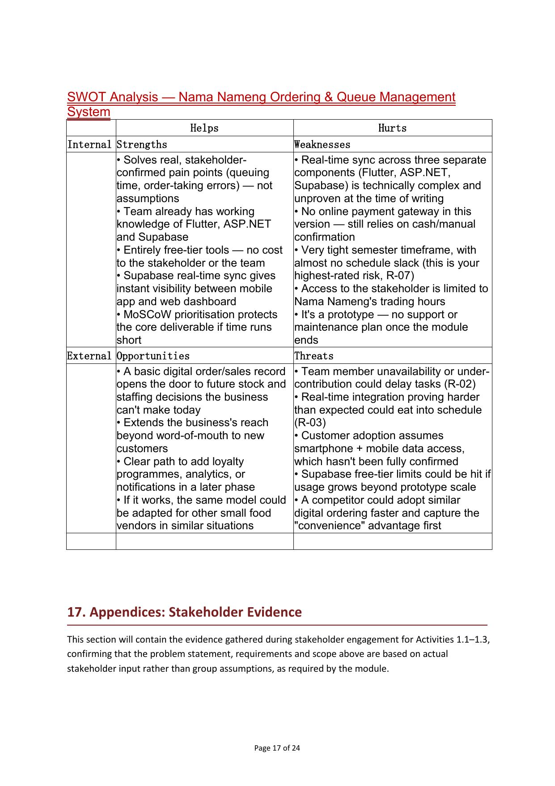
Appendix A — Stakeholder Requirements Questionnaire and Interview Notes

Appendix B: Requirements Confirmation Evidence
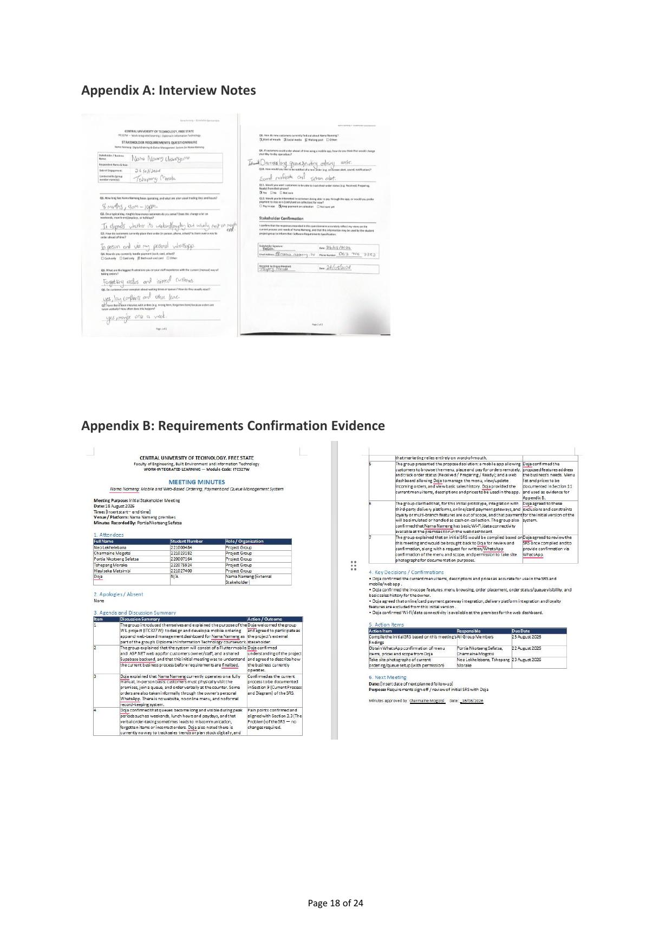
Appendix B — Meeting Minutes, Initial Stakeholder Meeting (18 August 2026)

Appendix C: Site Visit / Photographic Evidence
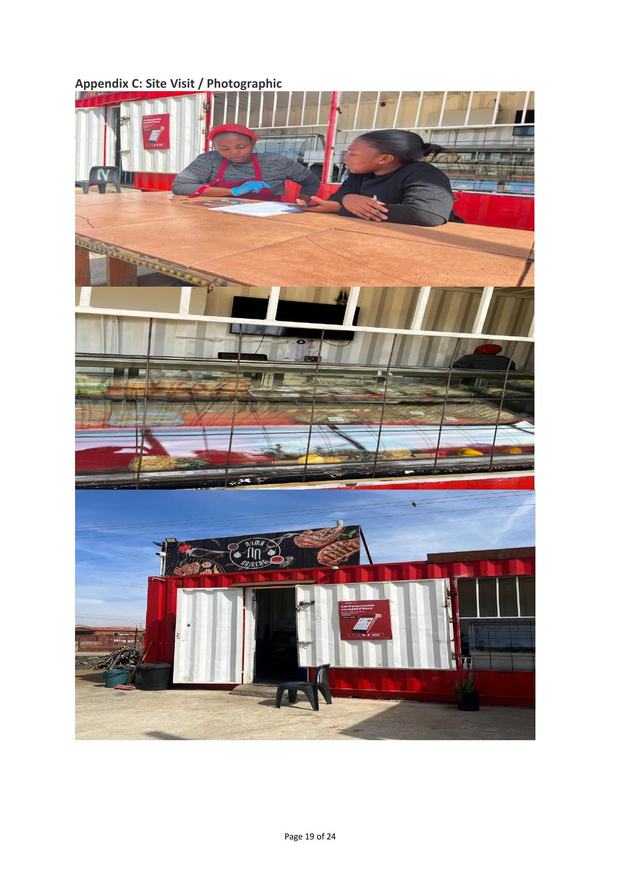
Appendix C — Site visit photographs at Nama Nameng premises

Appendix D: Communication Log (Phase 1)
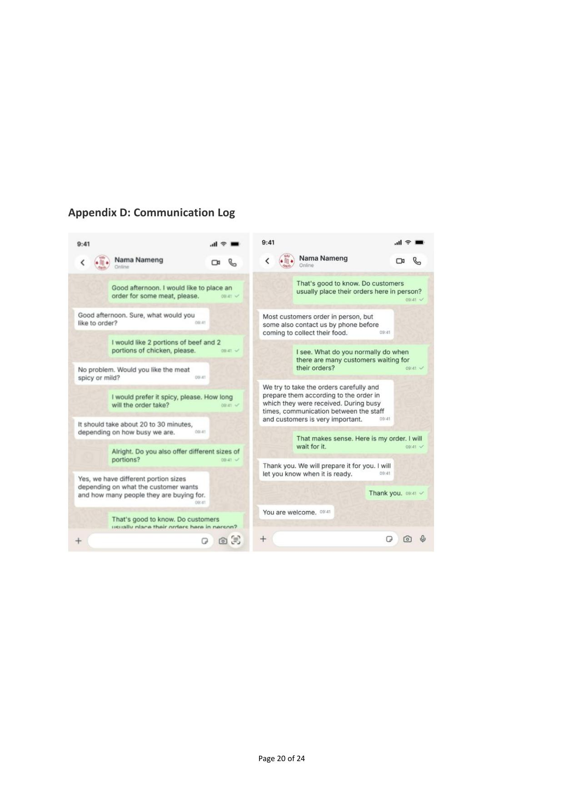
Appendix D — WhatsApp communication log with Doja (Phase 1). See Section 18.4 / Section 24 of this document: this appendix still needs a Phase 2 design-review counterpart.

Appendix E: Supabase Setup
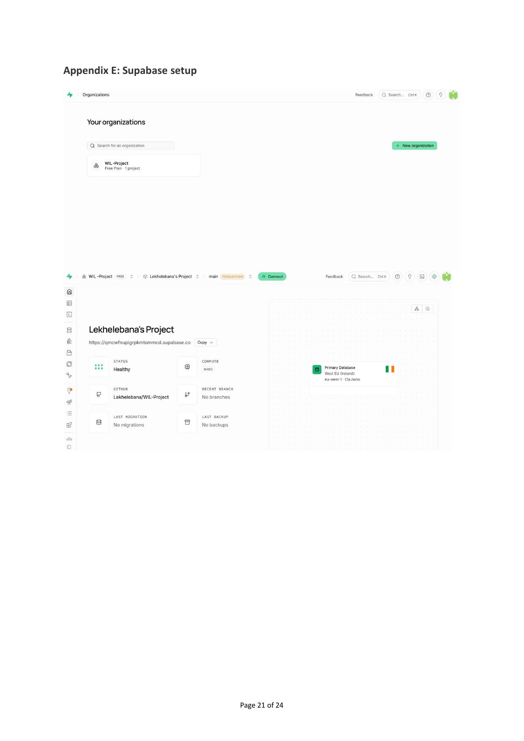
Appendix E — Supabase project setup, page 1
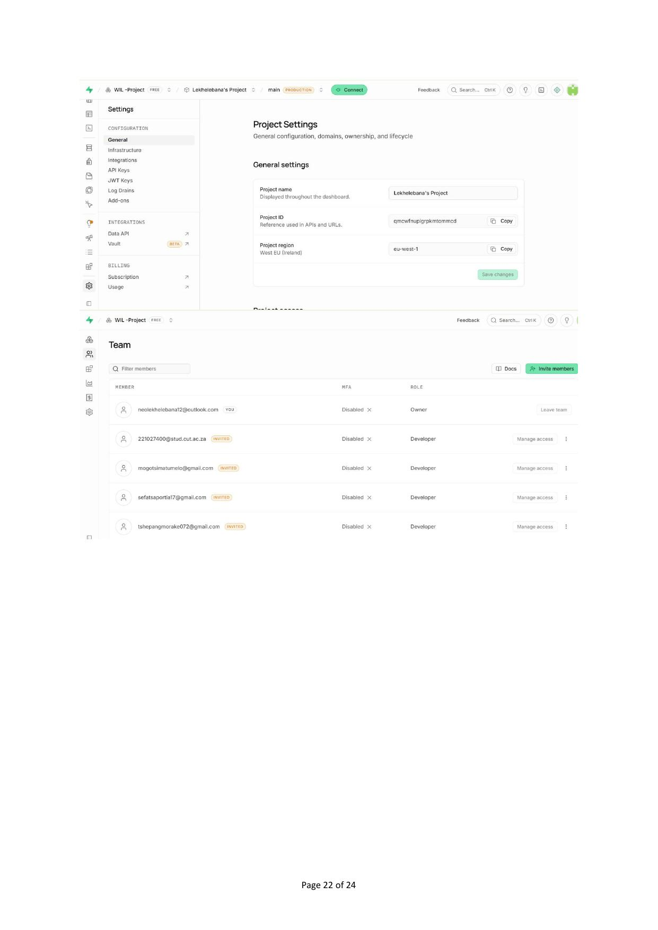
Appendix E — Supabase project setup, page 2 (Team access)

Appendix F: Microsoft Project Plan
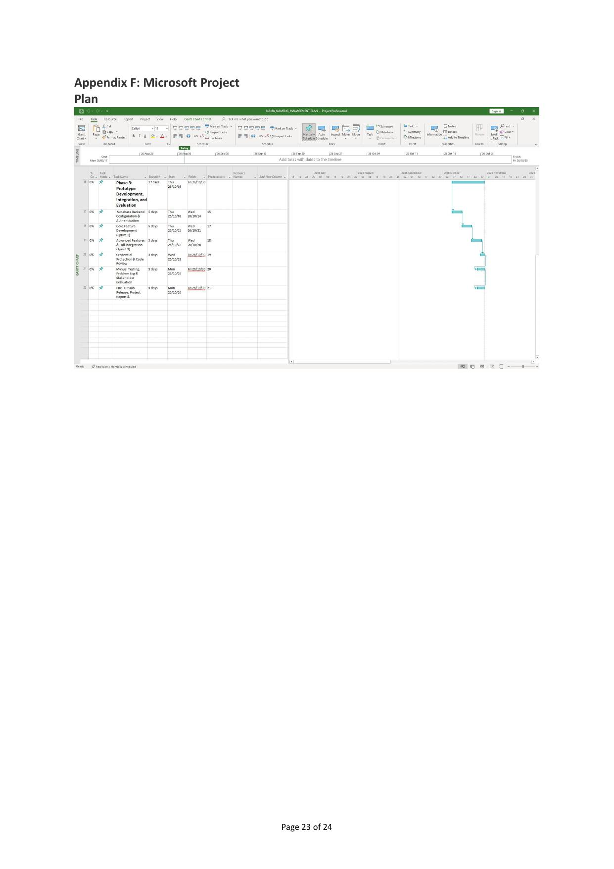
Appendix F — Microsoft Project Gantt chart, Phase 3
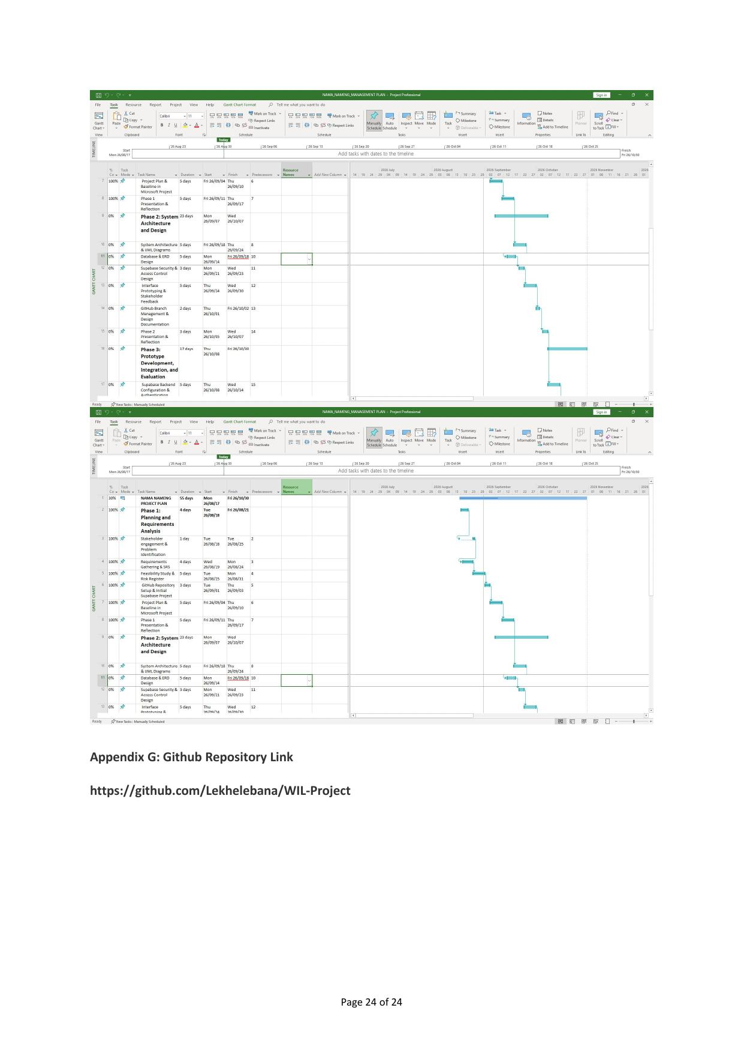
Appendix F — Microsoft Project Gantt chart, Phases 1–2

Appendix G: GitHub Repository Link
https://github.com/Lekhelebana/WIL-Project

18. Phase 2: System Architecture and Design

18.1 Use Case Diagram
The Use Case Diagram below identifies four actors — Guest, Customer, Staff and Manager — drawn directly from the actors already used in the four sequence diagrams. Two generalisation relationships are used, both reflecting real behaviour confirmed in the sequence diagrams rather than notation for its own sake: Customer generalises Guest, because the Guest sequence diagram shows that browsing, ordering and receiving status updates work identically whether or not the person registers — Customer simply adds Register/Login and order history on top of what a Guest can already do. Manager generalises Staff for the same reason: the Manager sequence diagram explicitly inherits every Staff use case and adds only menu management and the sales overview.
Two <<include>> relationships are used because the included behaviour always executes as part of the base use case: Place Order always includes Browse Digital Menu and Add to Cart (an order cannot exist without them, per the Guest and Customer sequence diagrams), and Update Order Status always includes Notify Customer (every status save is immediately followed by a push notification in all four sequence diagrams). Two <<extend>> relationships are used for Register Account and Login against Place Order, because the sequence diagrams state registration and login are optional add-ons available at any point during ordering, not mandatory steps.
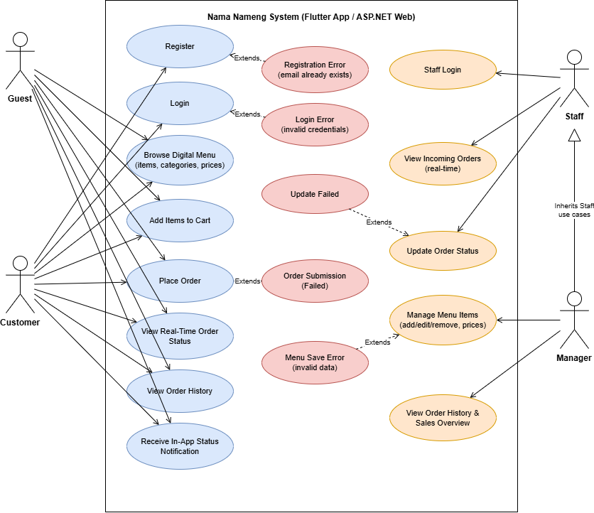
Figure 18.1: Nama Nameng Use Case Diagram

18.2 Requirements Traceability / Alignment Check
The table below is the alignment check called for in the Phase 2 checkpoint, tracing every functional requirement from Section 12 through to a use case, a sequence diagram, an ERD table, and an interface screen.
Requirement | Use Case | Sequence Diagram | ERD | Interface
FR-01 Register / login | Register Account; Login | Guest sequence (Register/Login); Customer sequence (Login) | profiles | Welcome Back / Getting Started screens
FR-02 Browse menu | Browse Digital Menu | Guest & Customer sequences (Browse digital menu) | menu_items, menu_categories | Menu / Home screen
FR-03 Add to cart & place order | Add to Cart; Place Order | Guest & Customer sequences (Add items to cart, Place order) | orders, order_items | Checkout Summary screen
FR-04 View real-time order status | View Order Status | Customer sequence (View real-time order status) | orders.status, order_status_history | Track Order screen
FR-05 Staff/customer secure login | Login | Staff & Manager sequences (Staff login) | profiles.role | Portal Login screen
FR-06 Manage menu items | Manage Menu Items | Manager sequence (Manage menu items) | menu_items | ASP.NET menu management screen
FR-07 View incoming orders | View Incoming Orders | Staff & Manager sequences (View incoming orders) | orders | ASP.NET orders dashboard
FR-08 Update order status | Update Order Status | Staff & Manager sequences (Update order status) | orders.status, order_status_history | ASP.NET order detail screen
FR-09 Notify customer of status change | Notify Customer (<<include>> of Update Order Status) | All four sequences (push in-app status notification) | order_status_history | Track Order screen status banner
FR-10 Store order history | View Order History | Customer sequence (View order history) | orders (customer_id) | Profile / order history screen
FR-11 Owner sales overview | View Sales Overview & Order History | Manager sequence (View order history & sales overview) | orders, order_items | ASP.NET sales overview screen
FR-12 Real-time sync (Supabase) | Cross-cutting — supported by all use cases above | All four sequences (push new order / push status) | Whole schema — Supabase Realtime on orders & order_status_history | Live updates on Track Order & Orders Dashboard

18.3 Navigation Flow Diagram

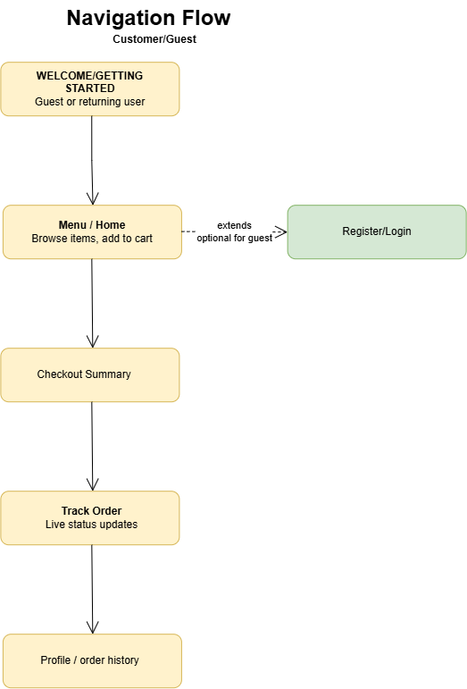

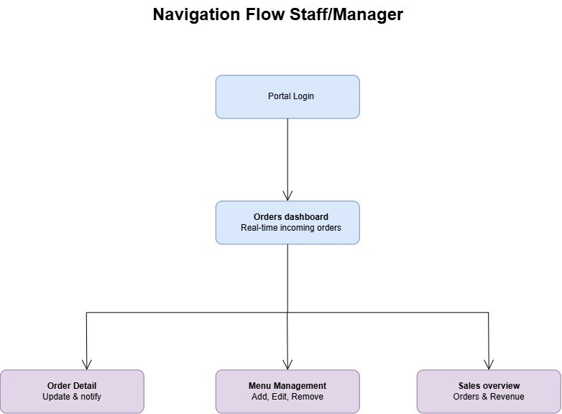

18.4 Phase 2 Stakeholder Design Review

Field | Details
Date and attendees | 20 September 2026  All members were present
What was shown to Doja | System Architecture Diagram, Use Case Diagram, Interface Screens
Doja's feedback | Doja was pleased with the progress made and is eager to see the final product.
Changes requested | N/A
Changes made in response | N/A

19. System Architecture Diagram
Flutter, ASP.NET and Supabase as one integrated system, with relevant users, connections and data flows.
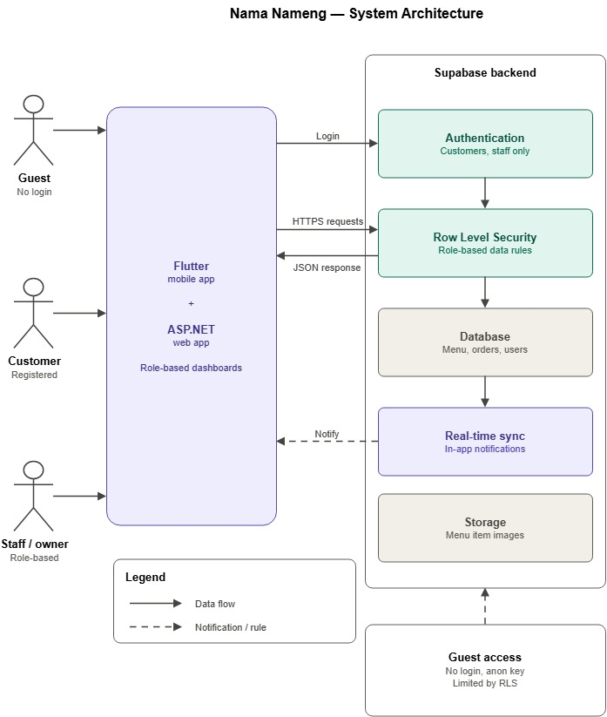

20. Sequence Diagrams
The Phase 2 addendum and Project Progress Tracker (Task U2-03) reference four sequence diagrams — Guest, Customer, Staff and Manager. One representing an important Flutter process and one an important ASP.NET process, with clear lifelines, correctly ordered messages, and each matching a use case from Section 18.1.

20.1 Guest Sequence Diagram

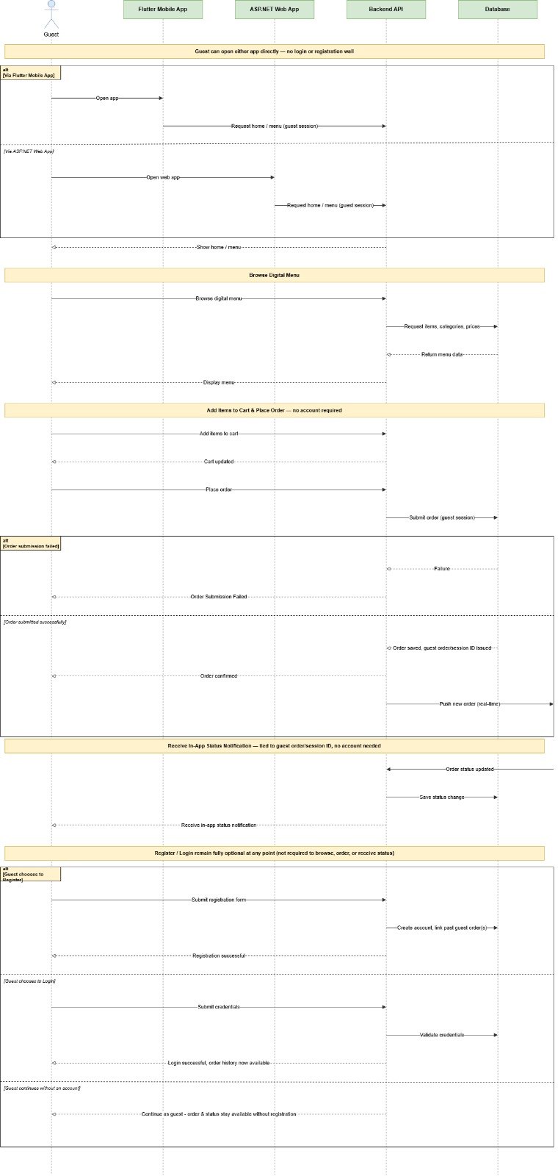

20.2 Customer Sequence Diagram

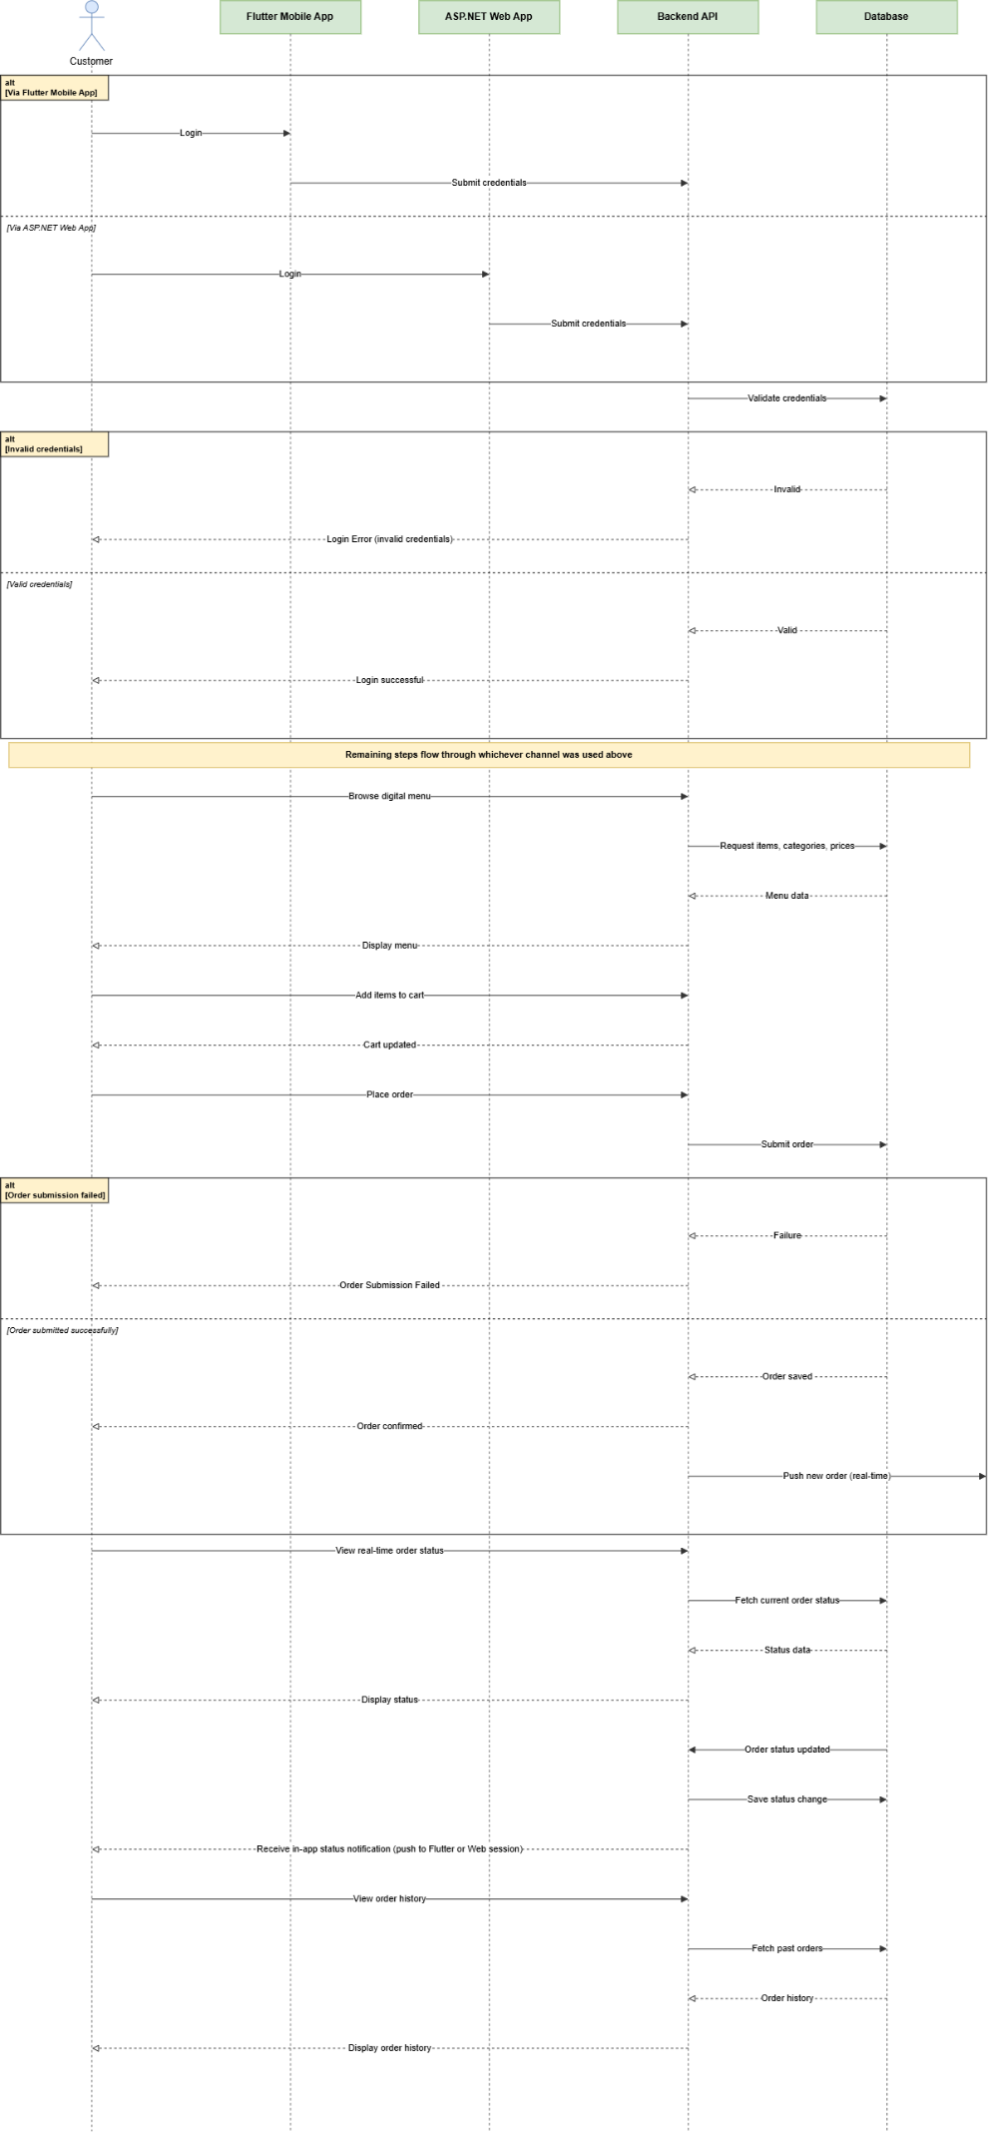

20.3 Staff Sequence Diagram

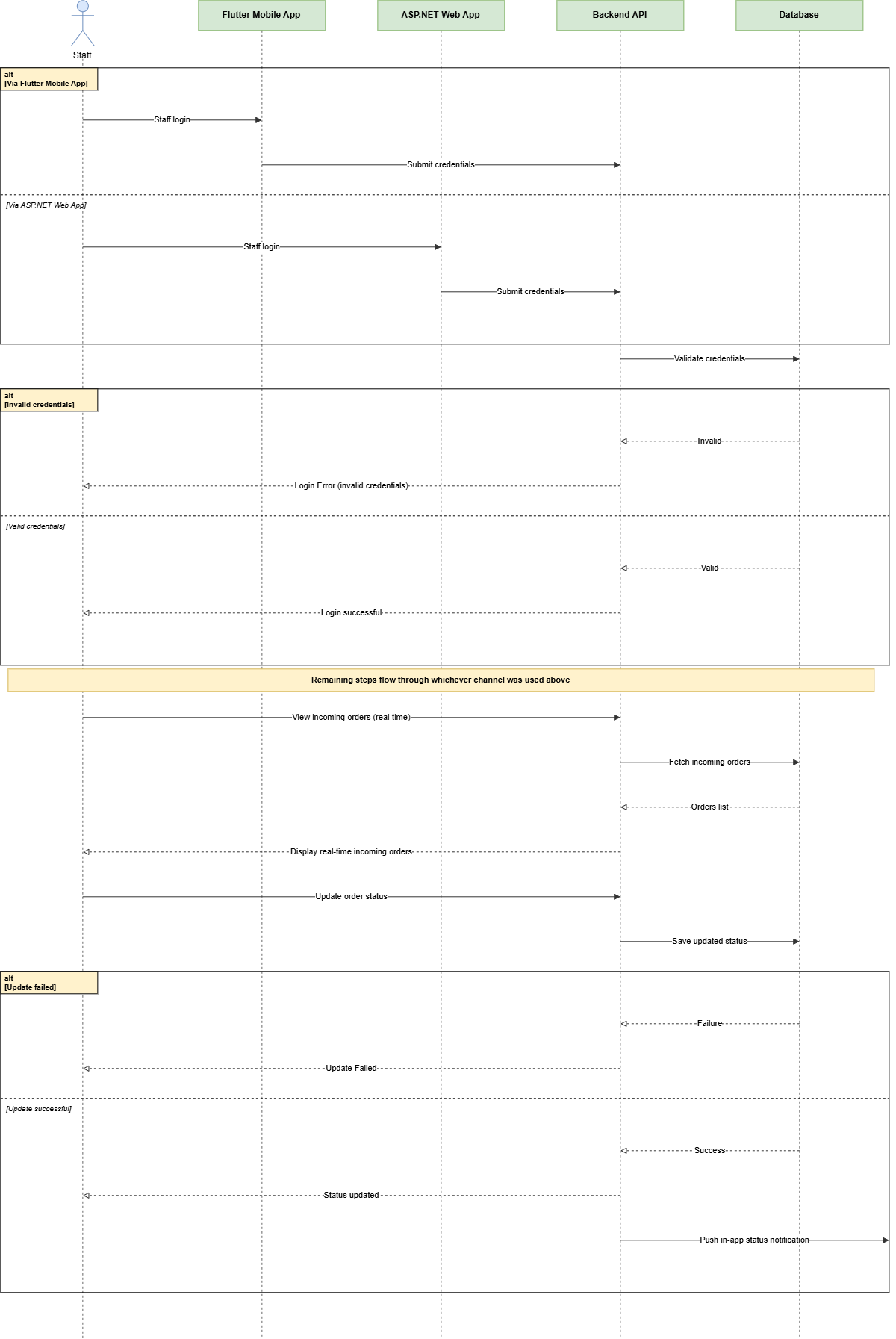

20.4 Manager Sequence Diagram

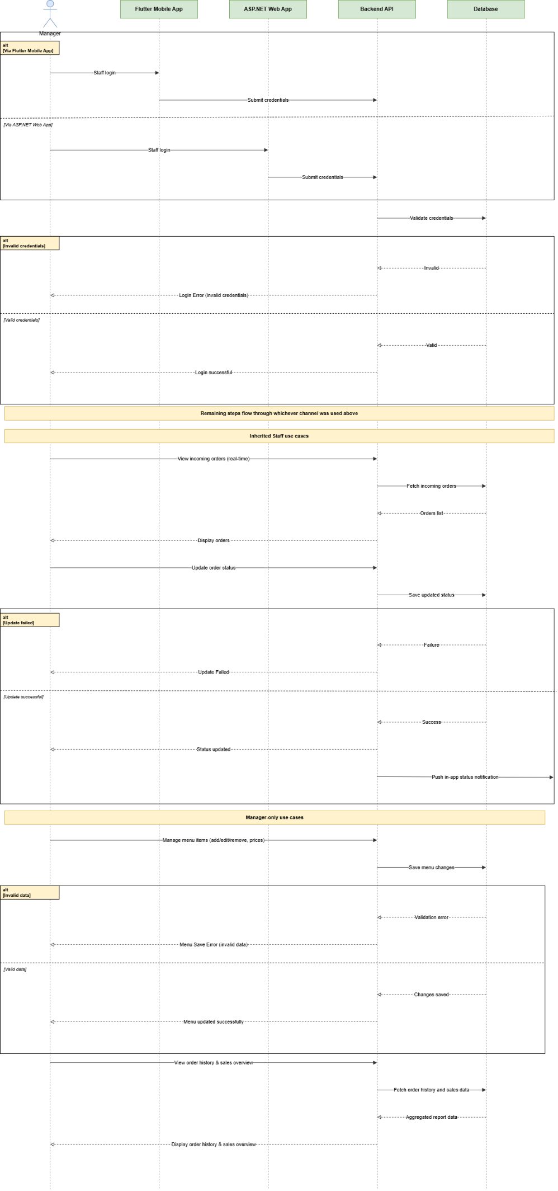

21. Entity Relationship Diagram (ERD)
The checkpoint requires entities/tables, important attributes/fields, primary keys, foreign keys, relationships and correct cardinality, supporting the data referenced throughout Section 18.2 (profiles, menu_items, menu_categories, orders, order_items, order_status_history).
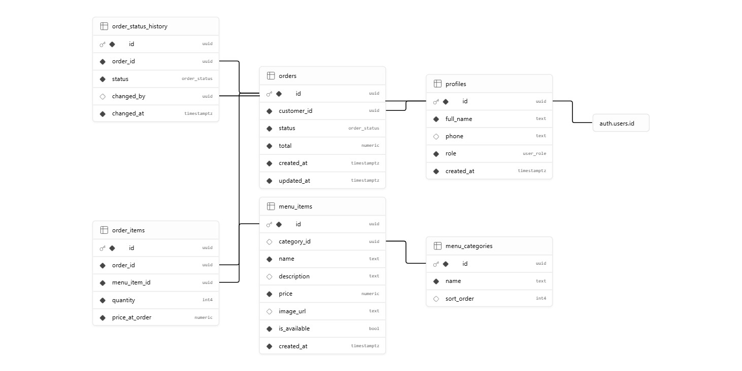

22. Flutter Interface Designs
Main mobile screens for the customer-facing app and the staff/manager app, matching the screens named in Section 18.2 (Welcome Back / Getting Started, Menu / Home, Checkout Summary, Track Order, Profile / order history).
STAFF/MANAGER FLUTTER APP
https://www.figma.com/design/tVj3ozN921e90wa2N6ZQO5/Untitled?node-id=0-1&m=dev&t=IX5ploP32oKyDjJB-1

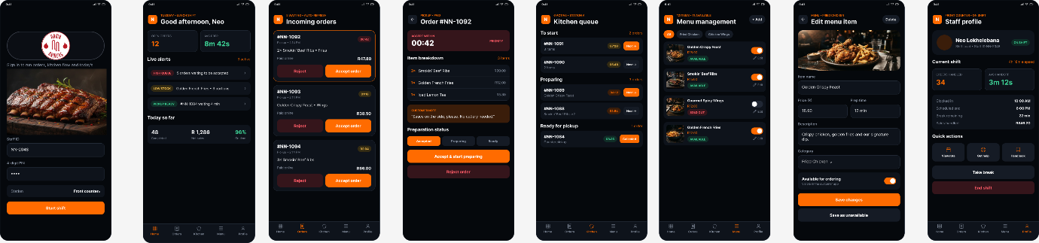

CUSTOMER/GUEST FLUTTER APP
https://www.figma.com/design/5N5aljGZvRRWxidTQu8vF2/Final-Flutter-Customer?node-id=0-1&t=anBYrWINvvFZuD5g-1

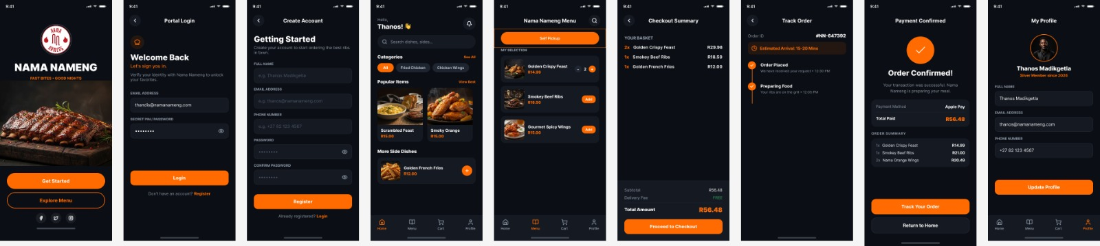

23. ASP.NET Interface Designs
Main web screens for the customer-facing web app and the staff/owner dashboard, matching the screens named in Section 18.2 (Portal Login, ASP.NET menu management, ASP.NET orders dashboard, ASP.NET order detail, ASP.NET sales overview).
STAFF/MANAGER WEB APP
https://www.figma.com/design/kEfxKbTQmIpcMNZVW7iUfO/ASP.NET-staff?node-id=0-1&p=f

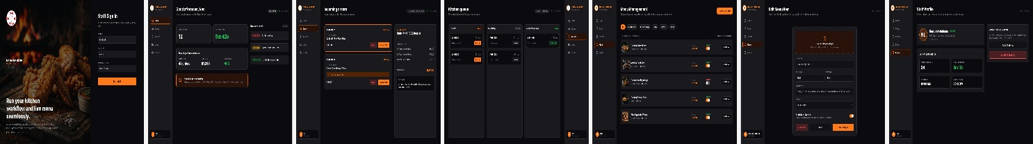

CUSTOMER/GUEST WEB APP

https://www.figma.com/design/amXSFjyoYmmCv5mB5wU4E9/Customer-Web-App?node-id=0-1&t=DjQmHhyRcpoze1MQ-1

