**EXPERIMENT 1 - Analyze the problem and come with the entities in it. Identify what data has to be persisted in the databases. (E-R Model)**

The following are the entities and relationships:

Customers(Entity) Product(Entity)

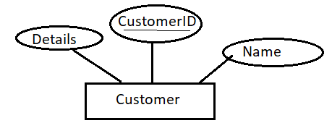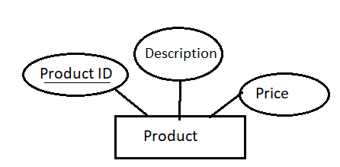

Order(Entity)

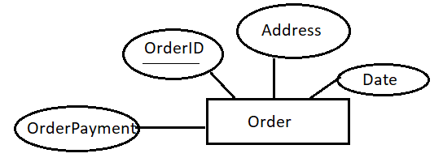

Delivery(Entity)

