**EXPERIMENT 4 – 5 : Practicing DDL Commands (Data Definition Language)**

**• Create table command**

**• Alter table command**

**• Truncate table command**

**• Drop table command**

create table employees(emp_id numeric(11) primary key, DOB date, f_name varchar(20), l_name varchar(20), hire_date date);

desc employees;

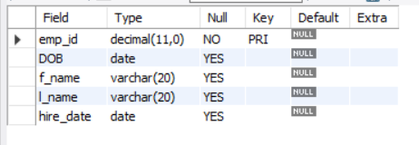

drop table employees;



create table employees(emp_id numeric(11) primary key, DOB date, f_name varchar(20), l_name varchar(20),gender varchar(1), hire_date date);

alter table employees add email varchar(20);

truncate employees;

