RENT EASE – HOUSE HUNT SYSTEM
Online Property Rental & Sale Management System
Project Description:
In today’s rapidly evolving digital world, the real estate industry is undergoing significant transformation. The traditional process of house hunting involves physical visits, reliance on brokers, limited property information, paperwork complexities, and time-consuming negotiations. These conventional methods often lack transparency, accessibility, and efficiency, creating inconvenience for both property owners and potential renters or buyers.
With the advancement of web technologies and increasing internet accessibility, there is a strong need for a centralized digital platform that simplifies the property rental and sales process. RentEase – House Hunt System is developed to address these challenges by providing a secure, scalable, and user-friendly web-based solution for property listing and searching.
The primary objective of the RentEase system is to bridge the gap between property owners and users (renters or buyers) by offering a digital ecosystem where property transactions can begin efficiently and transparently. The platform enables property owners to upload detailed property information, including location, property type, pricing, availability status, and high-quality images. On the other hand, users can browse available properties, apply filters, and view complete property details without the need for intermediaries.
Unlike traditional listing platforms that only display basic information, RentEase provides:
- Secure user authentication and role-based access
- Real-time property search and filtering
- Structured database-driven storage
- Image upload functionality
- Owner contact visibility
- Admin-level monitoring and management
- Modular and scalable backend architecture
The system follows a modern full-stack development approach using React for the frontend interface, Node.js and Express for backend API handling, and MongoDB for database management. This architecture ensures separation of concerns, better performance, and easier maintainability.
One of the key strengths of the RentEase system is its role-based access mechanism. The application supports three primary user roles:
- Admin – Responsible for managing users and overseeing platform operations.
- Owner – Can add, update, and manage property listings.
- Renter/User – Can browse, search, and view properties.
By implementing secure authentication using JSON Web Tokens (JWT) and password encryption using bcrypt, the system ensures user data confidentiality and protection against unauthorized access.
The system is also designed with scalability in mind. As the number of users and property listings increases, the backend structure and database organization allow smooth handling of larger datasets without performance degradation.
Furthermore, the filtering functionality enhances user experience by allowing property searches based on:
- Address
- Property type (Residential, Apartment, House, etc.)
- Advertisement type (Rent or Sale)
- Availability status
This ensures that users can quickly find properties that match their preferences.
In addition to functional efficiency, the system emphasizes usability and interface design. The frontend is built using a component-based architecture, enabling responsive layouts and reusable UI components. The design ensures smooth navigation, intuitive user interaction, and minimal complexity.
Overall, RentEase – House Hunt System demonstrates a practical implementation of full-stack web development concepts, including:
- RESTful API design
- MVC architecture
- Database modeling
- Authentication & authorization
- File handling (image upload)
- Client-server communication
- Modular project structuring
The project showcases how modern web technologies can be leveraged to create a reliable, scalable, and secure real-world application that simplifies the property rental and sale process.
Technical Architecture:
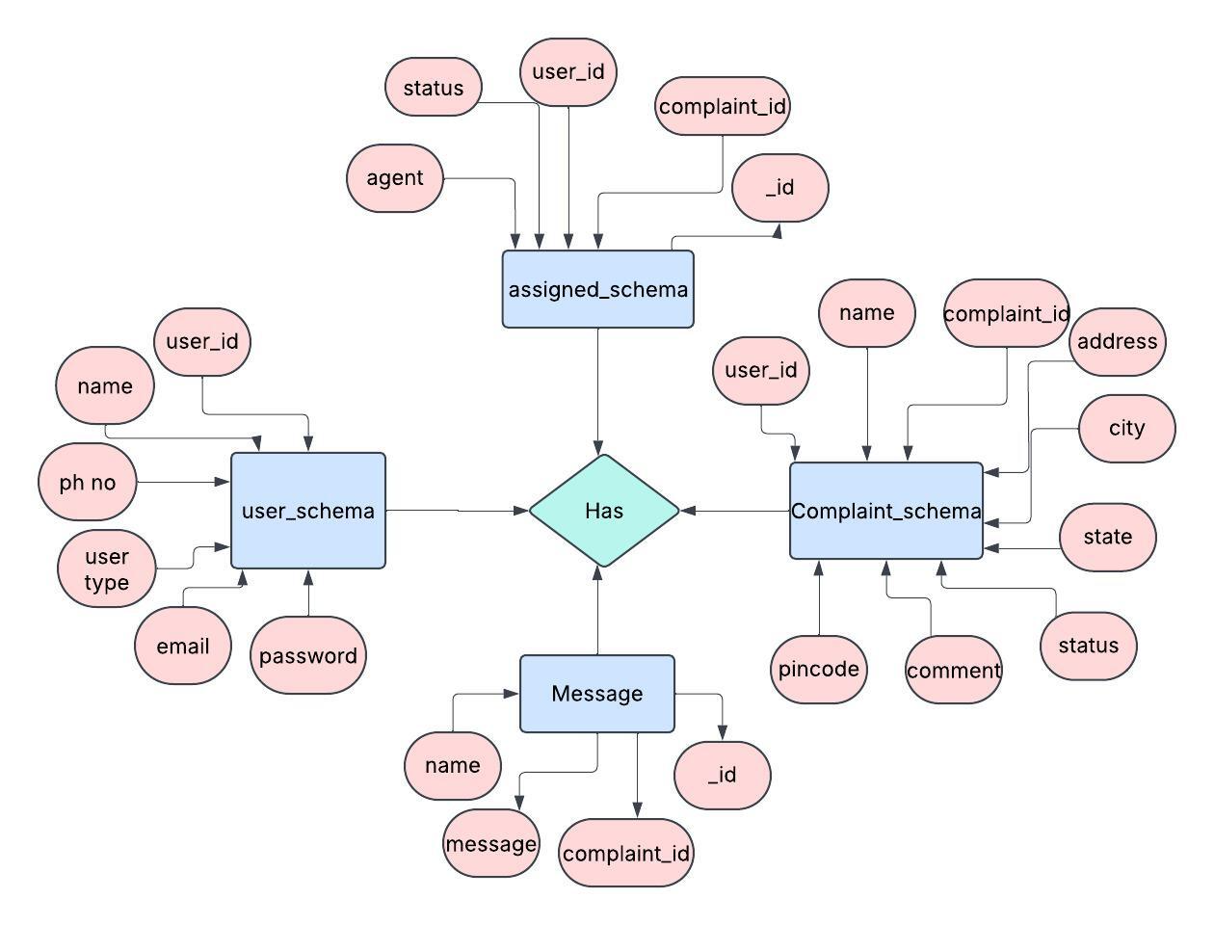

Pre requisites:
To successfully develop, test, and deploy the RentEase – House Hunt System, certain software tools, programming knowledge, and packages are required. These prerequisites ensure smooth development, proper backend–frontend integration, database connectivity, and secure authentication implementation.

🖥️ Software Required
1️⃣ Node.js
Node.js is a JavaScript runtime environment used to execute JavaScript code outside the browser. It is used to build the backend server for handling API requests, authentication, and database communication.
- Enables server-side scripting
- Supports asynchronous programming
- Handles concurrent requests efficiently
- Required for running Express server

2️⃣ MongoDB
MongoDB is a NoSQL database used to store application data in JSON-like BSON format.
- Stores user and property details
- Supports flexible schema design
- Provides high performance and scalability
- Integrates easily with Node.js using Mongoose

3️⃣ Visual Studio Code (VS Code)
VS Code is the primary code editor used for writing frontend and backend code.
Recommended extensions:
- ES7+ React Snippets
- Prettier (Code Formatter)
- MongoDB for VS Code
- ESLint
- REST Client

4️⃣ Postman
Postman is used for testing backend APIs.
- Sends GET, POST, PUT, DELETE requests
- Validates API responses
- Helps debug server-side issues
- Tests authentication tokens

5️⃣ Git
Git is used for version control.
- Tracks code changes
- Enables collaboration
- Supports branching and merging
- Maintains project history

6️⃣ Web Browser (Chrome Recommended)
Used for frontend testing and debugging.
- Developer Tools for inspecting API calls
- Console for debugging JavaScript
- Network tab for monitoring requests

📦 Backend Dependencies
The backend is developed using Node.js and Express, with the following packages installed via npm:

1️⃣ express
Express.js is a lightweight web framework for Node.js.
- Handles routing
- Manages middleware
- Simplifies REST API development

2️⃣ mongoose
Mongoose is an ODM (Object Data Modeling) library for MongoDB.
- Defines schemas
- Enforces validation rules
- Manages database relationships
- Simplifies CRUD operations

3️⃣ jsonwebtoken (JWT)
Used for secure authentication.
- Generates authentication tokens
- Verifies user sessions
- Protects private routes

4️⃣ bcrypt
Used for password hashing.
- Encrypts passwords before storing in database
- Prevents plain-text password storage
- Enhances data security

5️⃣ dotenv
Used to manage environment variables.
- Stores sensitive data like:
  - Database URI
  - JWT Secret Key
  - Server Port
- Keeps credentials secure

6️⃣ multer
Middleware for handling file uploads.
- Uploads property images
- Stores images in uploads folder
- Manages file size and format validation

7️⃣ cors
Enables Cross-Origin Resource Sharing.
- Allows frontend and backend communication
- Prevents CORS errors

8️⃣ nodemon (Development Dependency)
Automatically restarts server when code changes.
- Improves development speed
- Avoids manual server restart

9️⃣ express-validator
Used for input validation.
- Validates user inputs
- Prevents invalid data submission
- Enhances API reliability

🔟 helmet
Adds security headers to HTTP responses.
- Protects against common vulnerabilities
- Improves API security

📦 Frontend Dependencies
Frontend is developed using React with the following dependencies:

1️⃣ react
Core library for building user interfaces.
- Component-based architecture
- Virtual DOM for fast rendering
- Reusable UI components

2️⃣ react-router-dom
Used for navigation and routing.
- Manages multiple pages
- Enables protected routes
- Improves SPA (Single Page Application) experience

3️⃣ axios
Used for making HTTP requests to backend APIs.
- Sends GET, POST, PUT, DELETE requests
- Handles JSON data
- Supports token-based authentication headers

4️⃣ bootstrap / CSS
Used for styling and responsive design.
- Grid system
- Predefined UI components
- Mobile-friendly layouts

5️⃣ react-icons
Provides scalable icons.
- Enhances UI design
- Improves user interaction

6️⃣ react-toastify
Displays notifications and alerts.
- Success messages
- Error alerts
- Login confirmation messages

7️⃣ formik / react-hook-form (Optional)
Used for form handling and validation.
- Simplifies form state management
- Reduces boilerplate code

8️⃣ redux / context API (Optional for advanced version)
Used for global state management.
- Manages authentication state
- Stores user data globally
- Improves scalability

Prior Knowledge:
You must have prior knowledge of the following topics to complete this project.

● Full Stack Development Concepts
o Frontend Development (React Basics):
https://react.dev/learn
o Components, Props & State Management:
https://react.dev/learn/passing-props-to-a-component
o React Hooks (useState, useEffect):
https://react.dev/reference/react
o React Router:
https://reactrouter.com/en/main/start/tutorial
o Axios (API Integration):
https://axios-http.com/docs/intro

● Backend Development (Node.js & Express)
o Node.js Basics:
https://nodejs.org/en/docs
o Express.js Framework:
https://expressjs.com/en/starter/installing.html
o REST API Concepts:
https://restfulapi.net/
o Middleware in Express:
https://expressjs.com/en/guide/using-middleware.html
o MVC Architecture:
https://www.geeksforgeeks.org/mvc-design-pattern/

● Database Concepts (MongoDB)
o MongoDB Basics:
https://www.mongodb.com/docs/manual/introduction/
o Mongoose (ODM):
https://mongoosejs.com/docs/
o CRUD Operations:
https://www.mongodb.com/docs/manual/crud/
o Schema Design & Validation:
https://mongoosejs.com/docs/guide.html

● Authentication & Security
o JWT (JSON Web Token):
https://jwt.io/introduction
o Password Hashing using bcrypt:
https://www.npmjs.com/package/bcrypt
o Role-Based Access Control:
https://auth0.com/docs/manage-users/access-control/rbac

● Additional Concepts
o HTTP Methods & Status Codes:
https://developer.mozilla.org/en-US/docs/Web/HTTP/Methods
o JSON Data Format:
https://www.json.org/json-en.html
o File Upload using Multer:
https://www.npmjs.com/package/multer
o Git & Version Control:
https://git-scm.com/docs

Project Objectives:
By the end of this project, you will:
• Understand the fundamentals of full-stack web application development.
• Gain practical knowledge of frontend development using React.js.
• Learn how to design and implement RESTful APIs using Node.js and Express.
• Develop the ability to design and manage a MongoDB database using Mongoose.
• Understand how to implement secure authentication using JWT and password hashing.
• Learn how to build role-based access control (Admin, Owner, Renter).
• Implement CRUD (Create, Read, Update, Delete) operations for property management.
• Develop dynamic property search and filtering functionality.
• Learn how to upload and manage images using Multer middleware.
• Understand the integration between frontend and backend using Axios.
• Gain experience in modular project structuring using MVC architecture.
• Learn how to test APIs using Postman.
• Improve debugging and error-handling skills.
• Understand how to deploy and maintain a scalable web application.
• Develop real-world problem-solving skills through practical implementation.
Project Flow:
- The user interacts with the UI to enter the input.
- Entered input is analyzed by the model which is integrated.
- The predictions made by the model are showcased on the UI
To accomplish this, we have to complete all the activities listed below,
- Data collection
* Collect the dataset or create the dataset
- Data pre-processing
- Removing unnecessary columns
- Checking for null values
- Visualizing and analyzing data
- Univariate analysis
- Bivariate analysis
- Descriptive analysis
- Model building
- Handling categorical values
- Dividing data into train and test sets
- Import the model building libraries
- Comparing the accuracy of various models
- Hyperparameter tuning of the selected model
- Evaluating the performance of models
- Save the model
- Application Building
- Create an HTML file
- Build python code

Project Structure:
Create the Project folder which contains files as shown below

HOUSEHUNT-MAIN
│
├── backend
│ ├── config
│ ├── controllers
│ ├── middlewares
│ ├── routes
│ ├── schemas
│ ├── uploads
│ ├── .env
│ ├── index.js
│ ├── package.json
│
├── frontend
│ ├── public
│ ├── src
│ ├── package.json
│
└── README.md

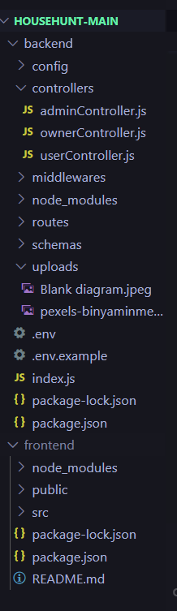
Backend Folder:
The backend folder contains all server-side logic and API implementations.
● config folder
Contains database configuration and environment setup files.
● controllers folder
Contains business logic files such as:
- userController.js
- ownerController.js
- adminController.js
● middlewares folder
Contains authentication and authorization middleware such as:
- JWT verification
- Role-based access control
● routes folder
Defines REST API endpoints such as:
- /api/users
- /api/properties
- /api/admin
● schemas folder
Contains Mongoose models such as:
- User Schema
- Property Schema
- Booking Schema
● uploads folder
Stores property images uploaded by owners.
● .env file
Stores environment variables such as:
- MongoDB URI
- JWT Secret
- Server Port
● index.js
Main entry file of backend server. It connects database and starts Express server.

Frontend Folder:
The frontend folder contains React application files.
● public folder
Contains static files and index.html.
● src folder
Contains React components and pages such as:
- Login Page
- Registration Page
- Property Listing Page
- Add Property Page
- Admin Dashboard
● package.json
Contains frontend dependencies and scripts.
Milestone 1: Requirement Analysis
Software development begins with proper requirement analysis. In this phase, the system requirements are identified, analyzed, and documented clearly.
Activity 1: Identifying System Requirements
The RentEase – House Hunt System must support the following features:
• User Registration and Login
• Role-Based Access (Admin / Owner / Renter)
• Property Listing Management
• Property Search and Filtering
• Property Image Upload
• Secure Authentication
• Admin Monitoring
Activity 2: Functional Requirements
• Users must be able to register and log in securely.
• Owners must be able to add, update, and delete properties.
• Renters must be able to search and filter properties.
• Admin must be able to manage users and properties.
• Images must be uploaded and stored properly.
Activity 3: Non-Functional Requirements
• System must be secure.
• System must be scalable.
• Response time must be fast.
• UI must be user-friendly.
• System must handle multiple users simultaneously.

Milestone 2: Backend Development
After requirement analysis, backend development is initiated.
Activity 1: Project Setup
• Install Node.js
• Initialize npm project
• Install required dependencies
• Configure environment variables
Activity 2: Database Connection
• Install MongoDB
• Configure Mongoose
• Connect database to backend server
• Handle connection errors
Activity 3: Creating Schemas
Create Mongoose schemas for:
• User Schema
• Property Schema
• Booking Schema
Each schema defines fields, validation rules, and data types.
Activity 4: Implementing Authentication
• Hash passwords using bcrypt
• Generate JWT tokens
• Create login and registration APIs
• Protect private routes using middleware
Activity 5: Building REST APIs
Implement CRUD operations:
• POST → Add property
• GET → Fetch properties
• PUT → Update property
• DELETE → Remove property
Activity 6: Image Upload
• Configure Multer middleware
• Store images in uploads folder
• Validate file type and size

Milestone 3: Frontend Development
After backend APIs are ready, frontend development begins.
Activity 1: Create React Application
• Setup React project
• Install required dependencies
• Configure routing
Activity 2: Design User Interface
Develop the following pages:
• Home Page
• Login Page
• Registration Page
• Property Listing Page
• Add Property Page
• Admin Dashboard
Activity 3: API Integration
• Use Axios to connect backend APIs
• Send authentication tokens in headers
• Display dynamic property data
Activity 4: Implement Filtering
• Create filter form
• Send filter parameters to backend
• Display filtered results dynamically

Milestone 4: Testing & Debugging
Testing ensures the system works correctly.
Activity 1: Backend Testing
• Test APIs using Postman
• Verify authentication
• Validate error handling
Activity 2: Frontend Testing
• Test form validation
• Verify UI responsiveness
• Check routing functionality
Activity 3: Integration Testing
• Ensure frontend and backend communication
• Validate token-based authentication
• Confirm database operations

Milestone 5: Deployment & Finalization
Activity 1: Code Optimization
• Remove unnecessary code
• Optimize queries
• Improve UI responsiveness
Activity 2: Deployment Preparation
• Configure environment variables
• Prepare production build
• Test final application
Activity 3: Documentation
• Prepare project report
• Add screenshots
• Create architecture diagrams
• Final review and submission
Application Screens & Output Explanation
1️⃣ User Registration Page (Sign Up Interface)
The first image represents the User Registration (Sign Up) Page of the RentEase system.
This page allows new users to create an account by entering:
• Full Name (Renter / Owner Name)
• Email Address
• Password
• User Type (Owner / Renter)
Functional Explanation:
- The user enters personal details.
- The system validates the input fields.
- Email format validation is performed.
- Password is securely hashed using bcrypt before storing.
- Upon successful registration, user data is stored in MongoDB.
- User is redirected to login page.
Security Features Implemented:
• Password hashing using bcrypt
• Duplicate email validation
• Role-based registration
• Server-side validation
This page ensures that only authorized users can access system functionalities.
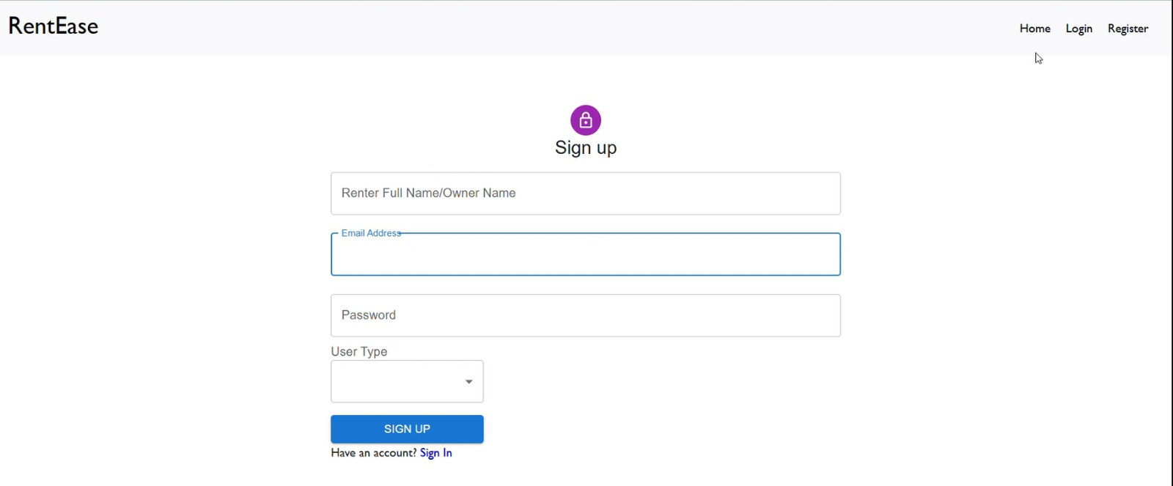

2️⃣ Property Listing & Filtering Page
The second image represents the Property Listing Dashboard where users can view available properties.
Features Available:
• View all listed properties
• Filter properties by:
- Address
- Ad Type (Rent / Sale)
- Property Type
• Display property details such as:
- Location
- Property Type
- Advertisement Type
- Owner Contact
- Availability
- Property Amount
Functional Flow:
- When the page loads, the frontend sends a GET request to fetch properties.
- Backend retrieves property data from MongoDB.
- Data is returned in JSON format.
- React dynamically renders property cards.
Filtering Mechanism:
- User selects filter criteria.
- Filter parameters are sent to backend.
- Backend applies query conditions.
- Filtered results are returned and displayed instantly.
This improves user experience by allowing quick and efficient property search.
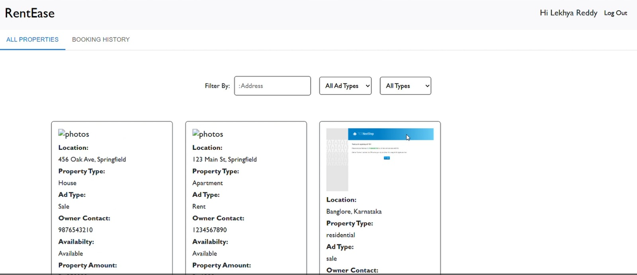

3️⃣ Add Property Page (Owner Dashboard)
The third image represents the Owner Property Upload Dashboard.
This page is accessible only to users with “Owner” role.
Property Details Collected:
• Property Type (Residential / Apartment / House)
• Property Ad Type (Rent / Sale)
• Property Full Address
• Property Images
• Owner Contact Number
• Property Amount
• Additional Details
Functional Flow:
- Owner fills property form.
- Images are uploaded using Multer middleware.
- Form data is sent to backend via POST request.
- Backend validates data.
- Property details are stored in MongoDB.
- Property becomes visible on listing page.
Validation Implemented:
• Required field validation
• Image format validation
• Numeric validation for price
• Authentication check before submission
This module ensures structured and secure property management.
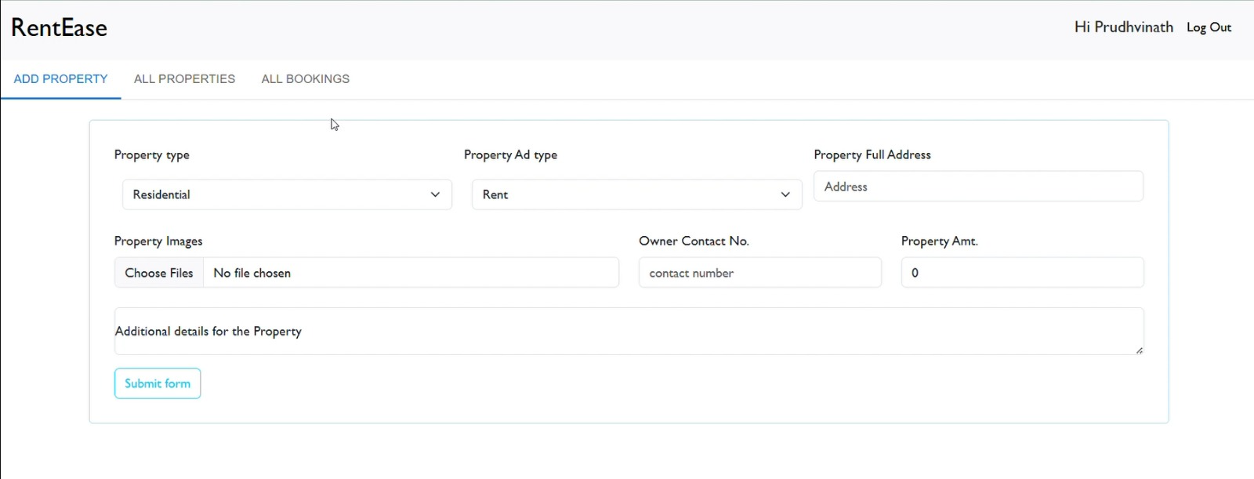

UI Design & User Experience
The interface follows a clean and minimal design:
• Simple navigation bar (Home, Login, Register)
• Responsive layout
• Clearly structured forms
• Card-based property display
• Organized dashboard for owners
The design ensures:
• Ease of use
• Smooth navigation
• Reduced user confusion
• Fast loading

System Output Summary
The system successfully demonstrates:
• Secure user authentication
• Real-time property listing
• Dynamic filtering functionality
• Role-based dashboard
• Image upload & storage
• Database-driven data rendering
The screenshots prove that the system is fully functional and integrates frontend, backend, and database effectively.

