Student Management Microservices on Azure

1. Project Flow
- Develop Student and Course Spring Boot microservices.
- Connect the services to Azure Database for PostgreSQL and create student_db and course_db.
- Test Student CRUD APIs with Postman.
- Containerize the services with Docker.
- Build and push the Docker image to Azure Container Registry using GitHub Actions.
- Attempt AKS deployment and configure the node pool.
- Document the Azure for Students subscription limitation that prevents the AKS node pool from being created.
- Create the User-Assigned Managed Identity and prepare the Azure RBAC/security layer that can be configured independently.
- Microsoft Entra Workload Identity, Pod deployment, Key Vault integration, and AKS monitoring remain planned because they require a working AKS cluster.

2. Screenshots Already Taken

1. Azure PostgreSQL deployment completed
Evidence that PostgreSQL Flexible Server was deployed successfully in student-management-rg.
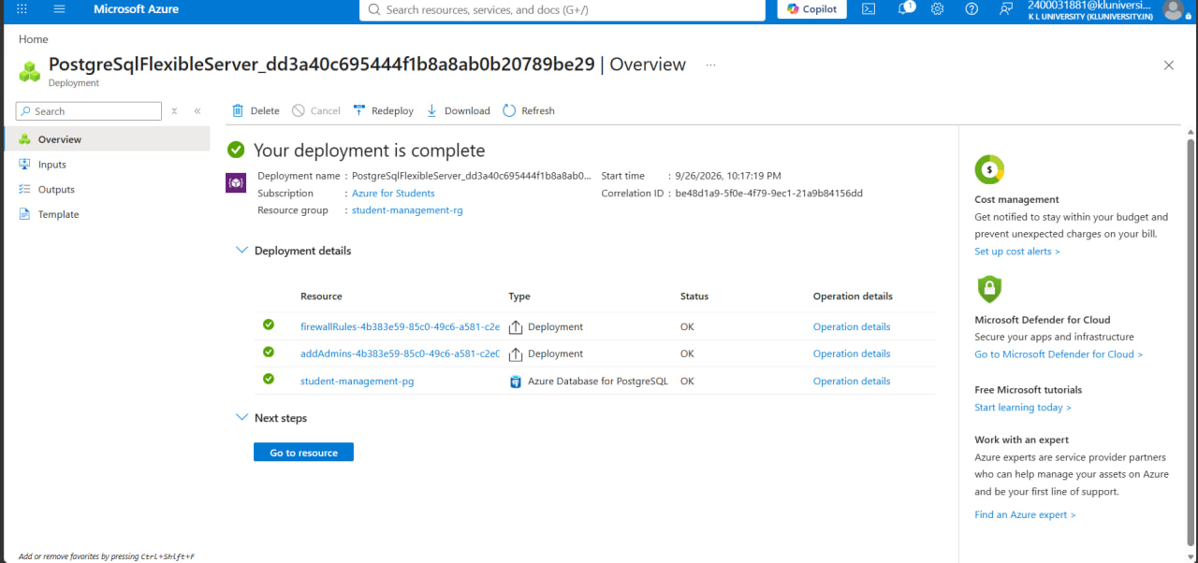
Figure 1: Azure PostgreSQL deployment completed

2. Azure PostgreSQL databases
Shows student_db and course_db on the PostgreSQL server.
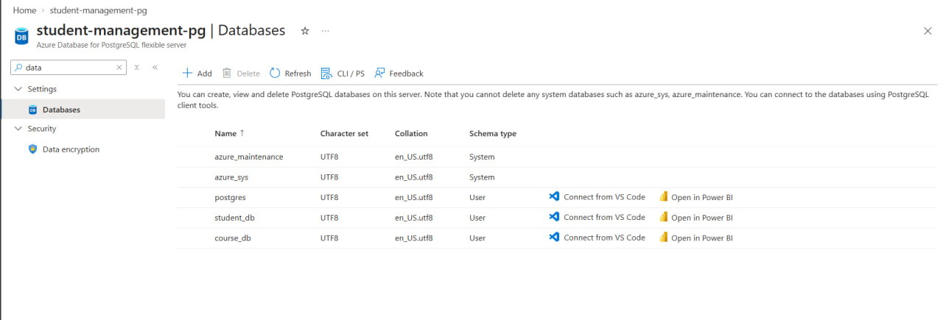
Figure 2: Azure PostgreSQL databases

3. Azure Container Registry deployment completed
Evidence that the Azure Container Registry was deployed successfully.
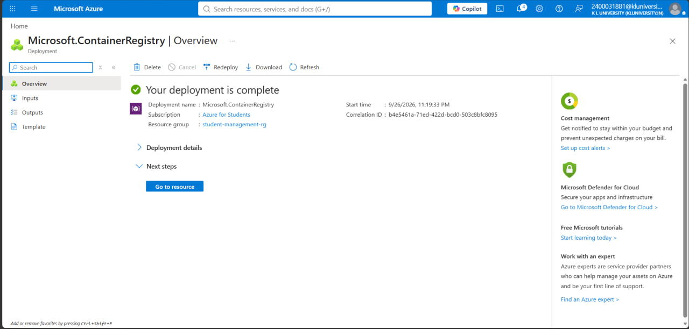
Figure 3: Azure Container Registry deployment completed

4. ACR repository: student-service
Shows the student-service repository in ACR. A separate tag screenshot for 1.0 is still recommended.
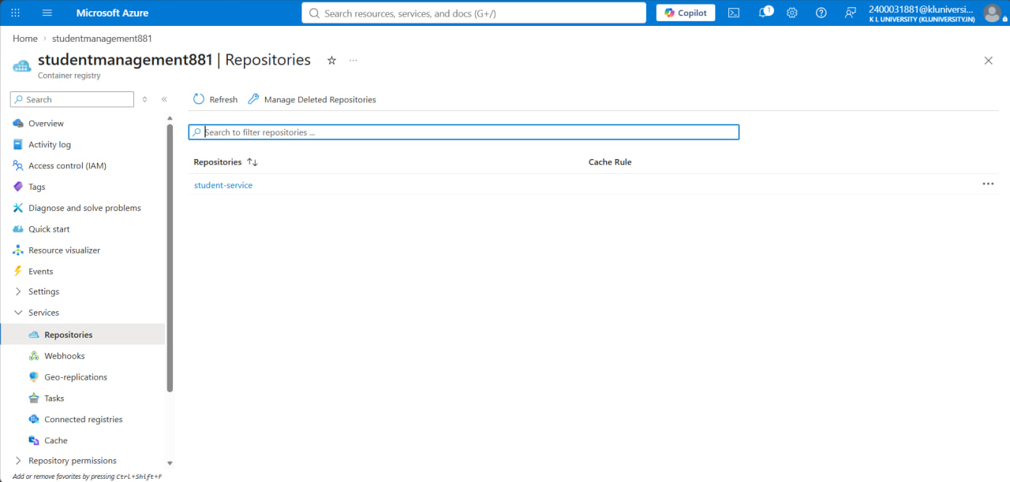
Figure 4: ACR repository: student-service

5. AKS cluster creation – Basics
Shows the attempted AKS configuration using the Azure for Students subscription and Central India.
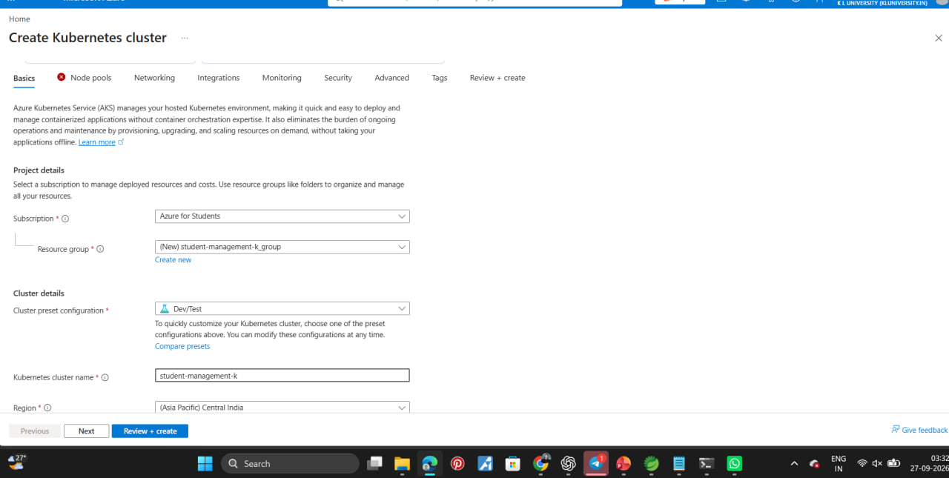
Figure 5: AKS cluster creation – Basics

6. AKS node pool – VM size unavailable
Shows the AKS node-pool blocker: the selected VM size is unavailable for this subscription in Central India.
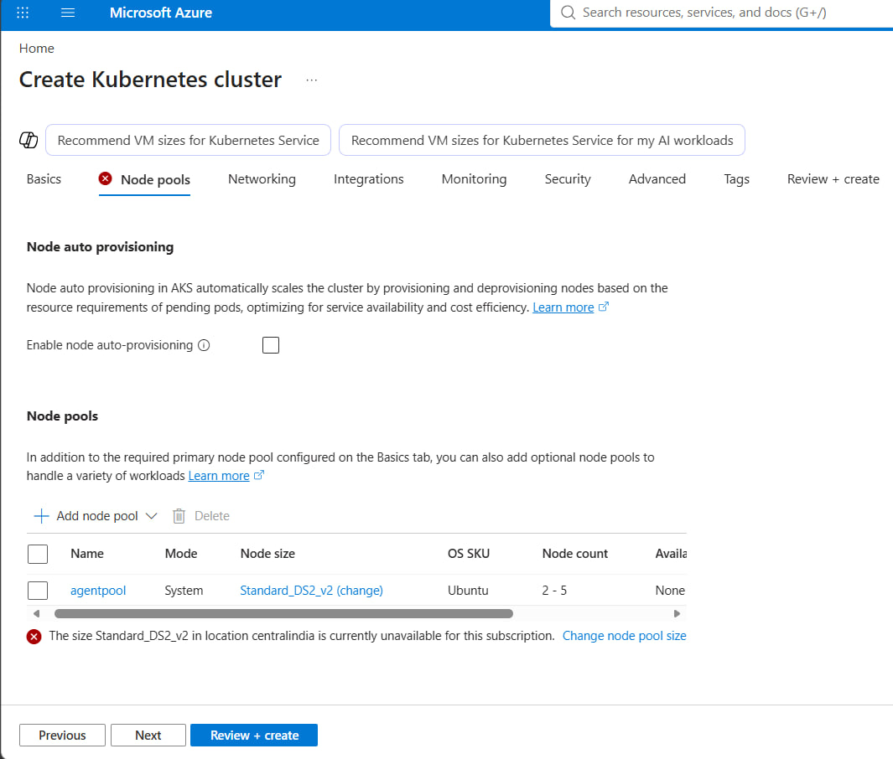
Figure 6: AKS node pool – VM size unavailable

7. User-Assigned Managed Identity deployment completed
Shows that student-management-identity was successfully created.
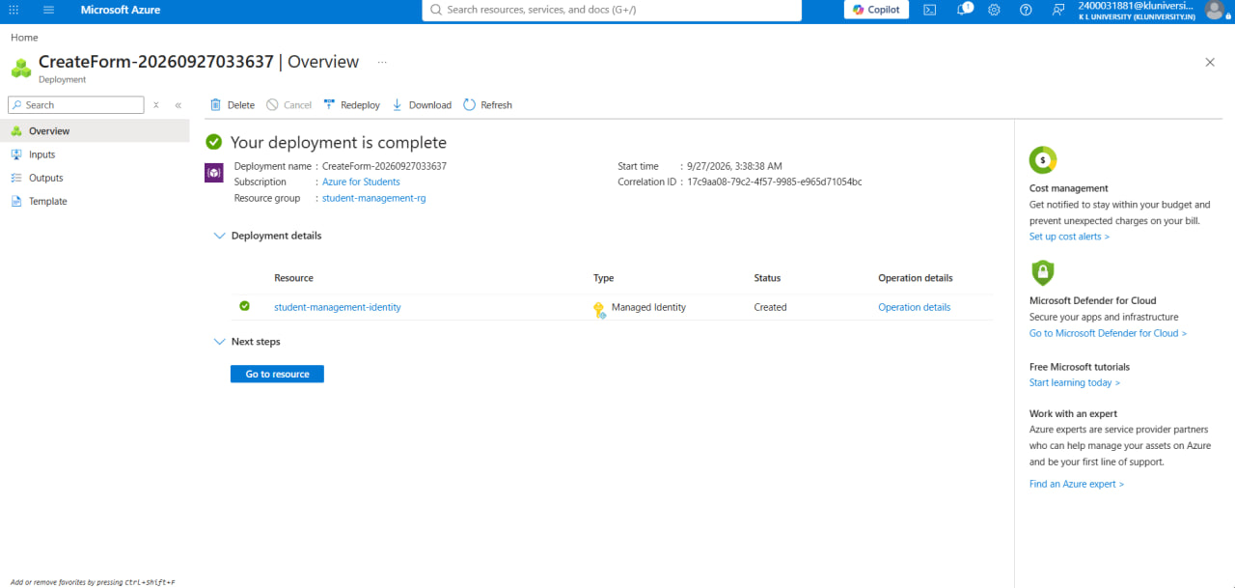
Figure 7: User-Assigned Managed Identity deployment completed

8. Managed Identity – Azure RBAC Role Assignment:
The screenshot shows student-management-identity with the AcrPull role assigned through Azure RBAC at the student-management-rg resource-group scope.
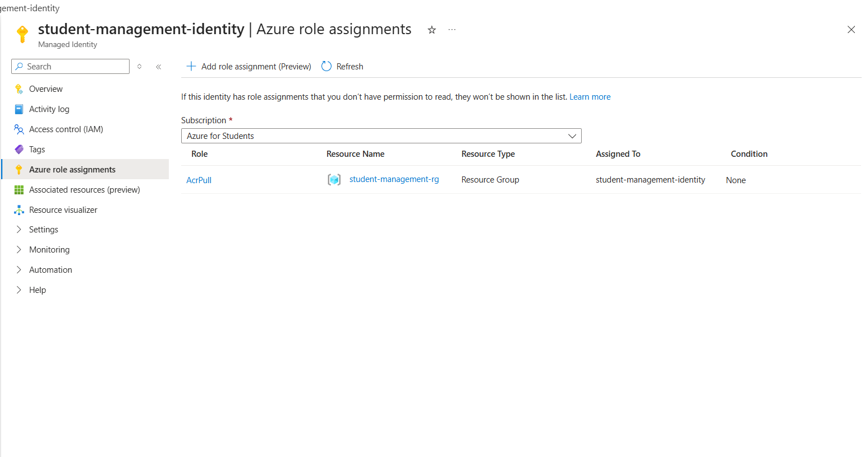

9. Azure Key Vault – Deployment
The screenshot shows the successful deployment of the Azure Key Vault (student-management-kv881) in the student-management-rg resource group. The deployment status is shown as OK.
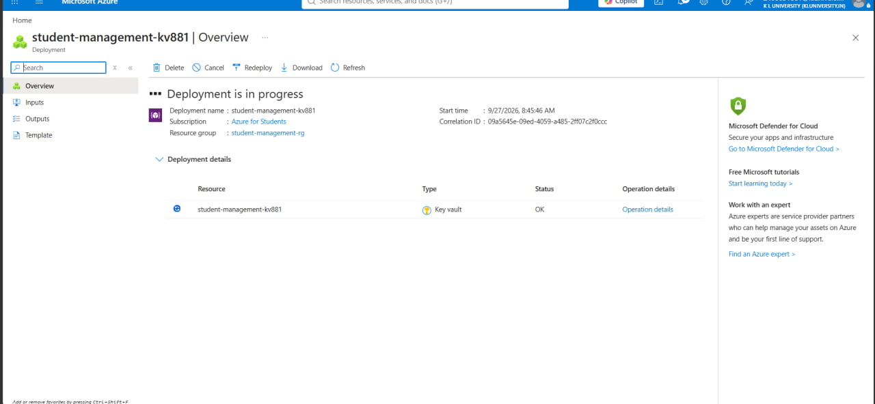

10. Azure Monitor – Monitoring Overview
The screenshot shows the Azure Monitor Overview page, providing monitoring capabilities such as Application Insights, Container Insights, VM Insights, Metrics, Alerts, Logs, and Workbooks for observing Azure resources and application performance.
