Software Design Specification

For

Find Sell Give

Table of Contents

1. Introduction 3

1.1. Purpose 3

1.2. Scope 3

1.3. Definitions: 3

2. Architectural Description 4

1 Interface Description 4

1.1 User Interface 4

2 Login Design 6

2.1 User interface 6

2.2 Login 6

2.3 Register 6

3 Display products design 7

3.1 User interface: 7

3.2 Diagram of the products module: 7

4 Display wishlist design 8

4.1 User interface: 8

4.2 Categories design: 9

4.3 Posts design: 9

4.4 Comments design: 10

5 My collection design: 10

5.1 User interface: 10

5.2 My collection design: 11

6 My Profile design: 12

6.1 User interface: 12

6.2 My profile design: 13

6.3 Edit profile design: 13

6.4 New Product design: 14

6.5 New Wishlist design: 14

6.6 Inbox chat design: 14

# Introduction

# Purpose

The purpose of this document is to present a detailed description of the software architecture Find-Sell-Give Mobile application. It will explain the components of this architecture and how they interact with each other.

# Scope

The Find-Sell-Give software is a mobile application. It is designed to give the users the opportunity to find the products they wish to have. This can be done through purchasing them from other users who put products on sale, getting them for free from users who want to give them away or by putting them in your which list and wait for other users to contact you. The user can also offer some product to sell or to give.

The app is an intermediary between the users to facilitate the transactions and the acquirement of the products. It is an android application, connected to a firebase NoSQL database and authentication system.

# Definitions:

* The activity provides the window in which the app draws its UI.
* The Fragment is a piece of an application's user interface or behavior that can be placed in an activity.
* The Adapter is a bridge between UI component and data source that helps us to fill data in UI component.
* A ViewHolder describes an item view that holds data so it can be used by an Adapter.

# ArchitecturalDescription

This app follows the Model View Presenter (MVP) architecture, this pattern separates the data model, from a view through a presenter. It is represented as follows:

PRESENTER

MODEL

VIEW

Adapters, Holders

Model

Activities, Fragments

# Interface Description

This section will define the different interfaces and the interactions between them.

## User Interface

The cinematic of the user interfaces is described in this diagram:

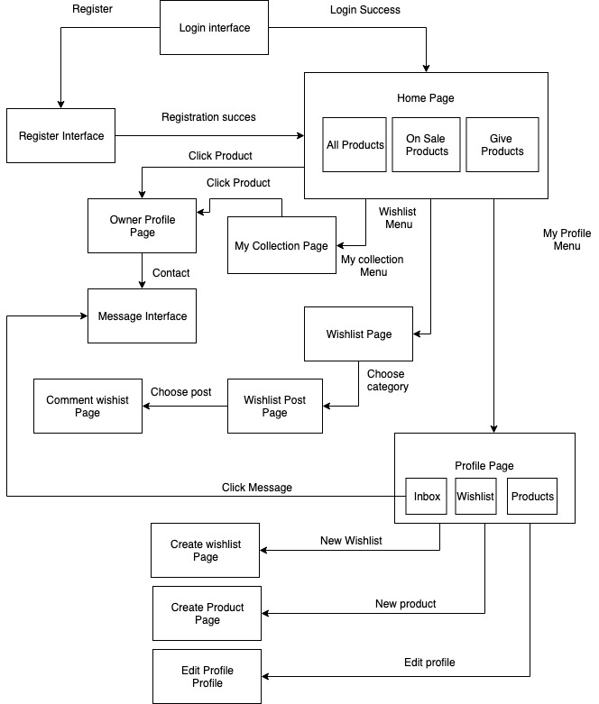

# Login Design

## User interface

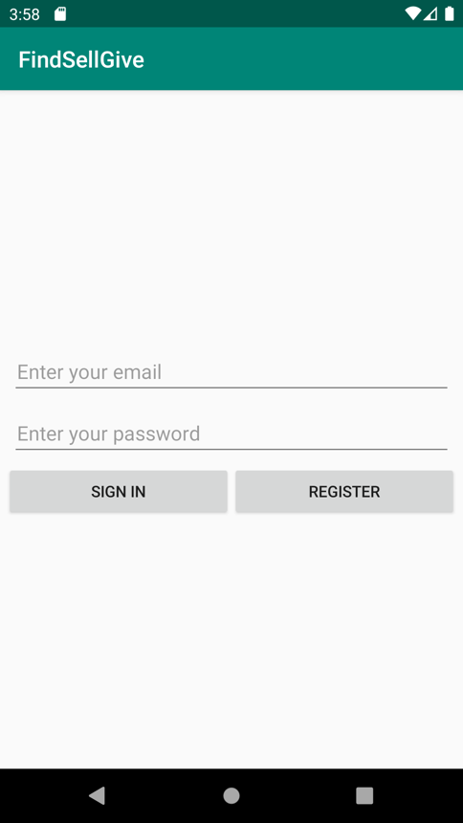 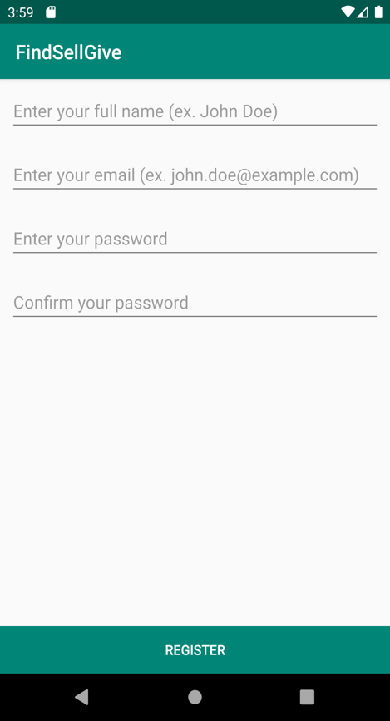

## Login

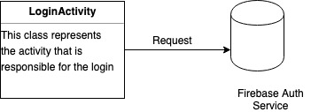

## Register

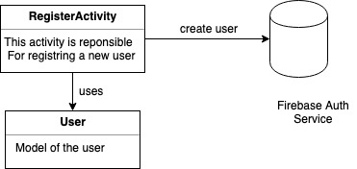

# Display productsdesign

## User interface:

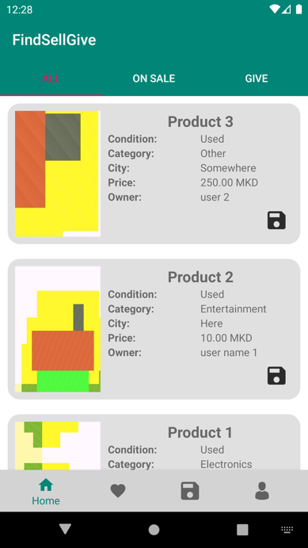The user interface for the display of products is the following:

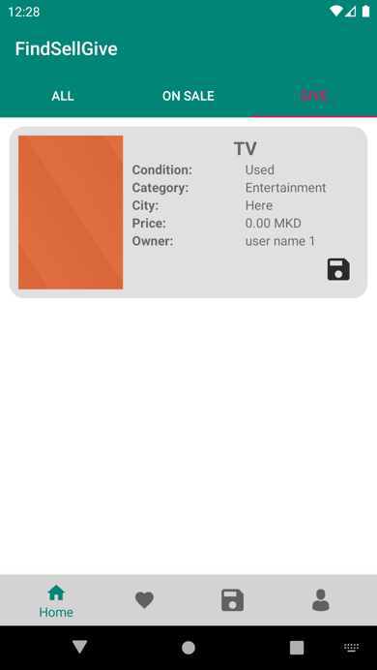  
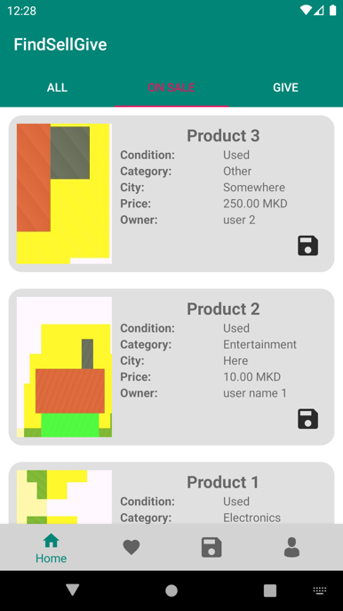

## Diagramof the products module:

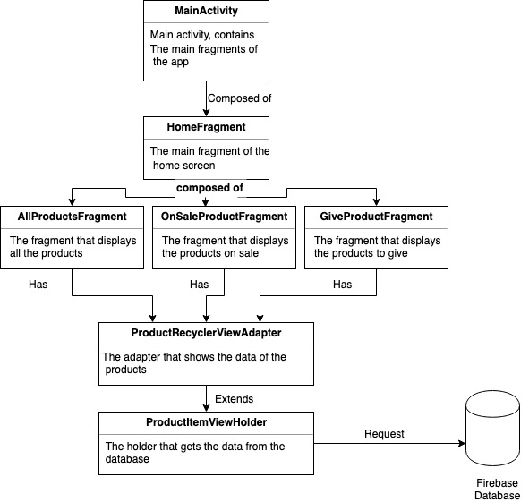

# Display wishlist design

## User interface:

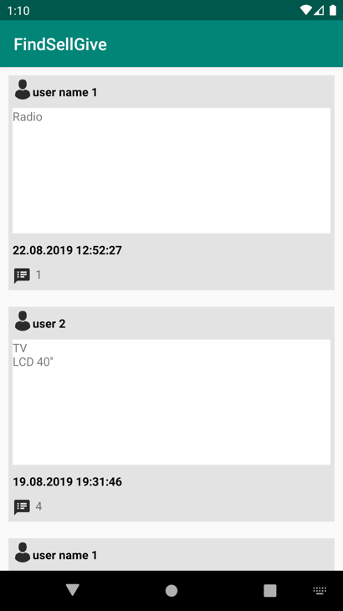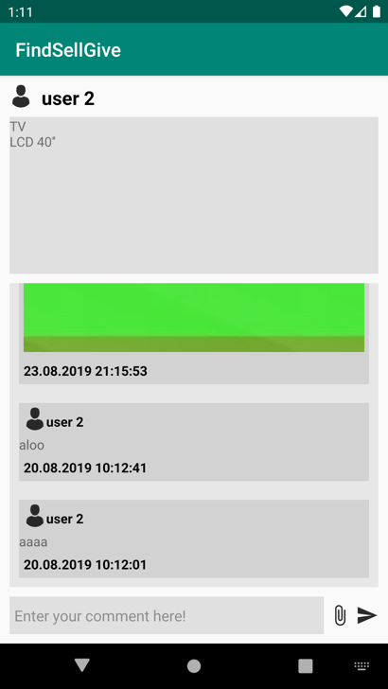

## Categories design:

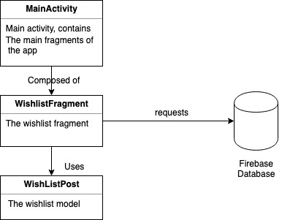

## Posts design:

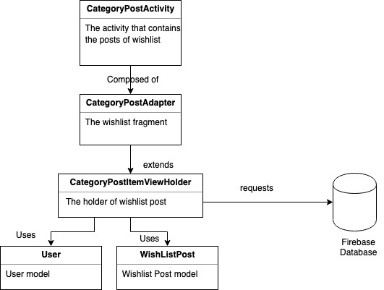

## Comments design:

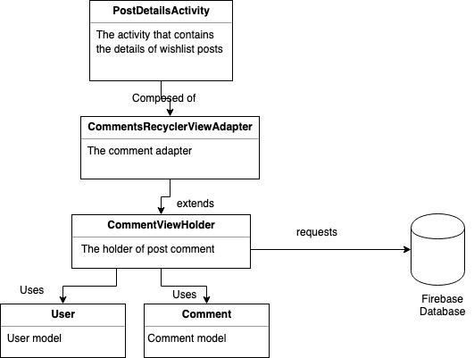

# My collection design:

## Userinterface:

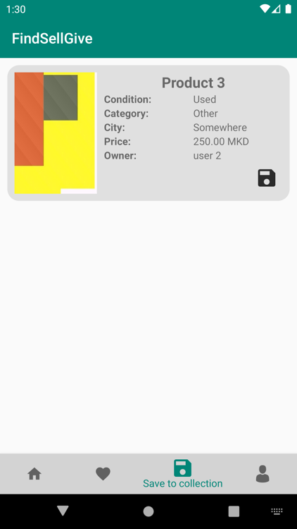

## My collectiondesign:

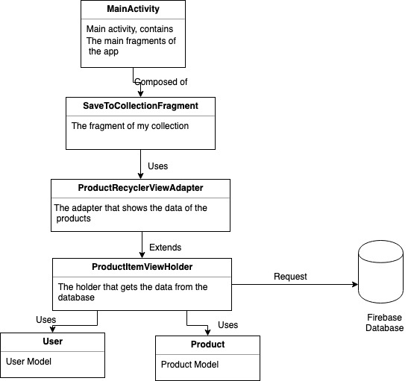

# My Profile design:

## User interface:

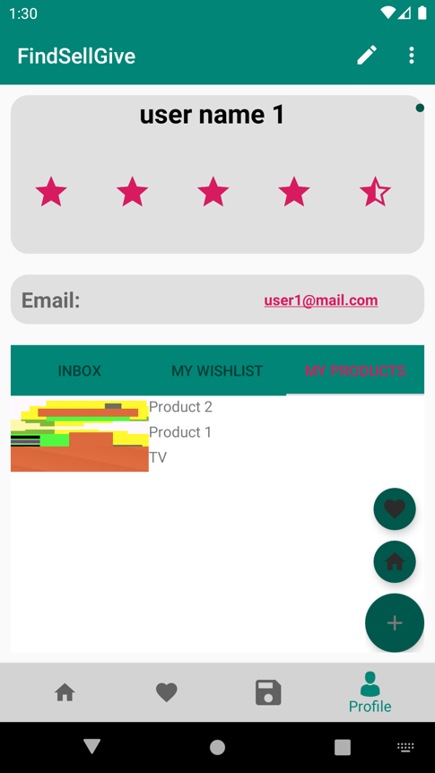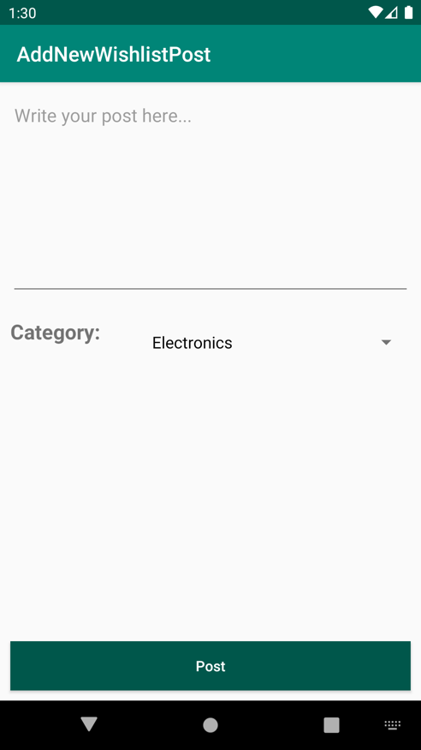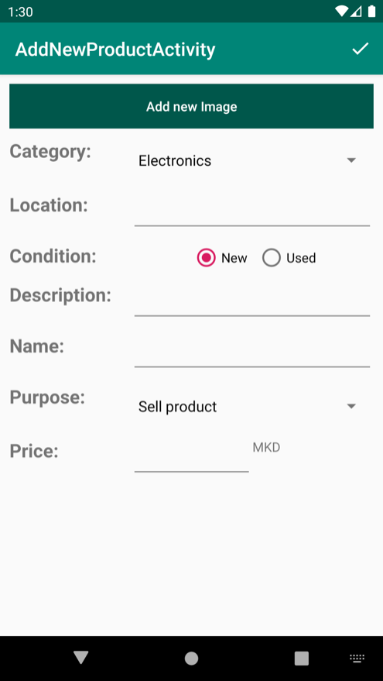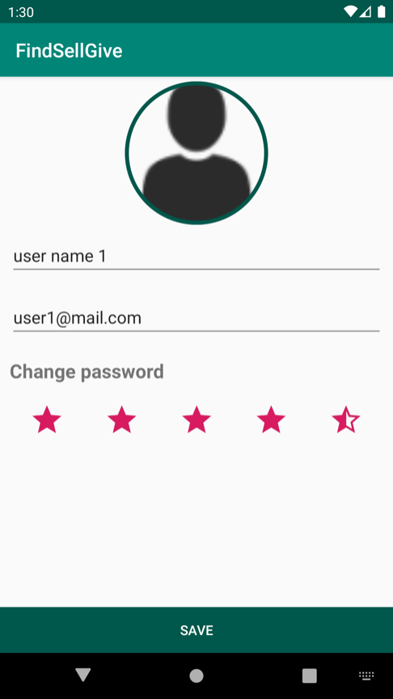

## My profile design:

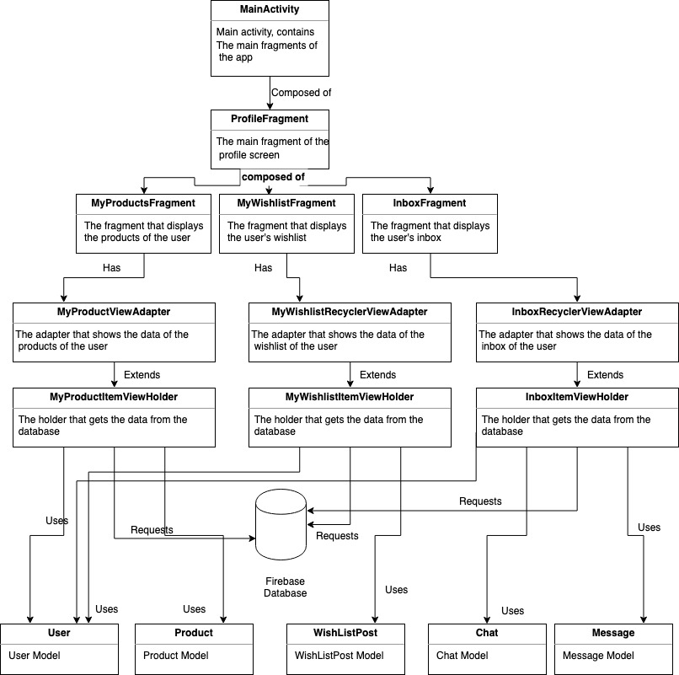

## Edit profile design:

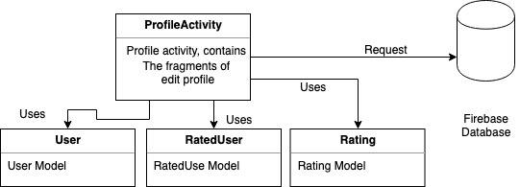

## New Product design:

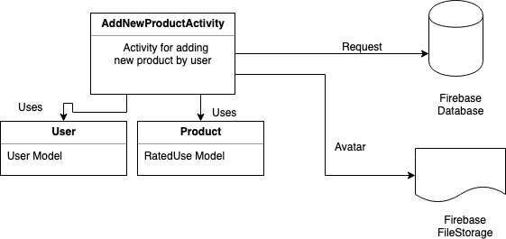

## New Wishlist design:

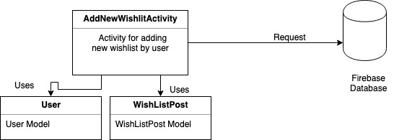

## Inbox chat design:

