Assignment 8

Student ID: 21F1001276
Assignment Objective :
Integrate data poisoning for IRIS using randomly generated numbers at various levels(5%,10%,50%) and explain the validation outcomes when trained on such data using MLFlow
Give your thoughts on how to mitigate such a poisoning attacks and how data quantity requirements evolve when data quality is affected

Environment Setup:

In vpc networks, “Firewall policies”, add new policy for accessing the MLflow UI

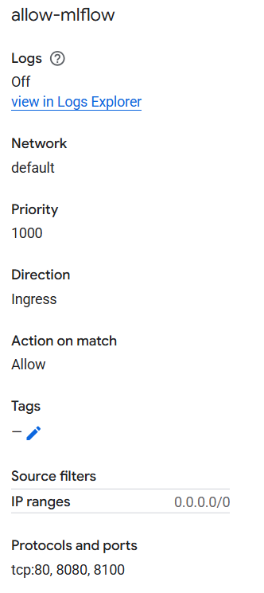

Run below code to create the virtual env and install all packages in terminal
python3 -m venv .env
source .env/bin/activate
pip install mlflow scikit-learn pandas numpy matplotlib

In SSH, run the below command to run the mlflows ui

mlflow ui \
--host 0.0.0.0 \
--port 5000 \
--backend-store-uri file:///home/jupyter/mlflow_store \
--default-artifact-root file:///home/jupyter/mlflow_store \
--allowed-hosts="*" \
--cors-allowed-origins="*"

For accessing MLFlow UI, use MLflow

Code for running the experiment with poisoned data is give here

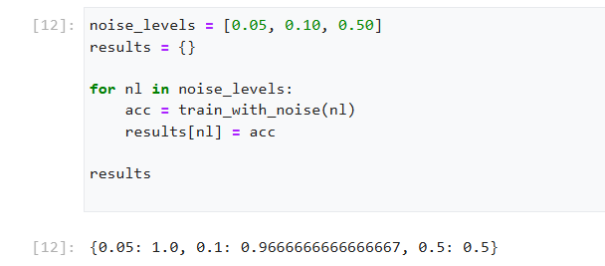

In the UI we can see the history of the run

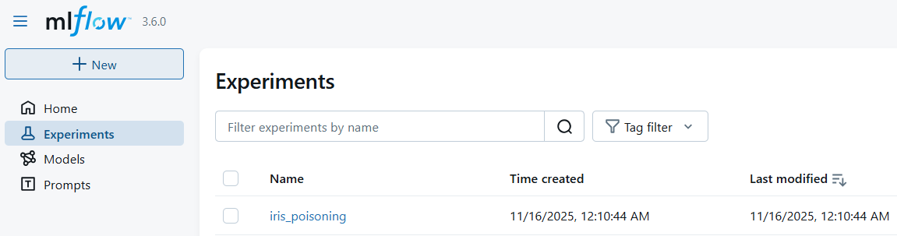

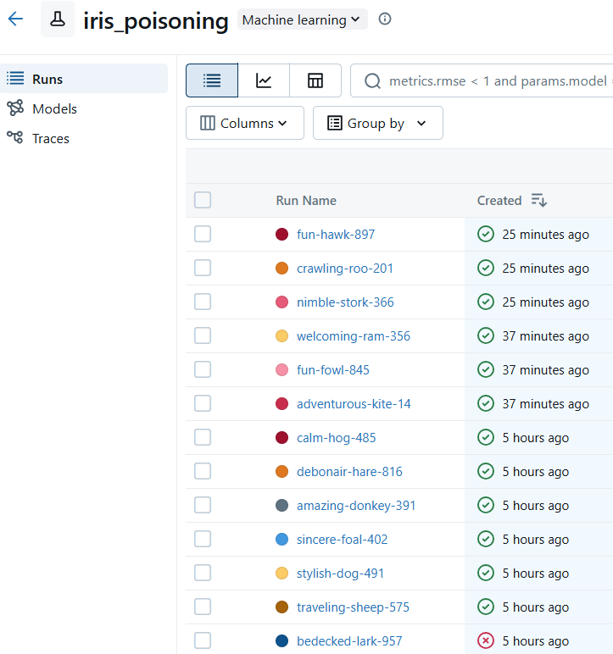

Comparison of metrics

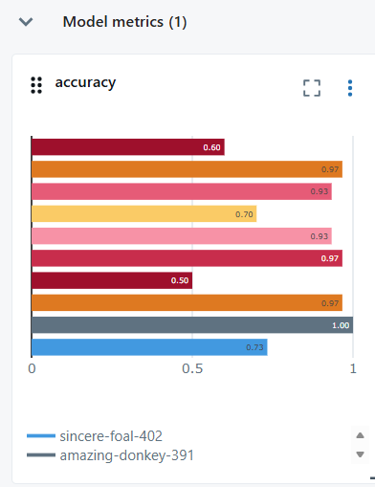

1. Interpretation of Validation Outcomes
At 5% Noise → Accuracy = 1.0
The dataset is small but highly structured; small poisoning has almost no effect.
At 10% Noise → Accuracy ≈ 0.97
RandomForest is resilient to moderate noise because it averages many decision trees and dataset is still too easy
At 50% Noise → Accuracy = 0.50
Once poisoning exceeds the model’s robustness threshold, performance collapses. Half of dataset is now noise
2. Use of MLFlow - With MLFLow we can run each experiment by noise level. This makes it easy to visualize poisoning impact and detect anomalies.
3. How to Mitigate Poisoning Attacks
Poisoning attacks occur when an attacker intentionally injects misleading training examples.
Défense strategies fall into 3 categories:
A. Data-Level Defences
1. Remove samples with Unusual feature values (feature noise) and Inconsistent label patterns (label noise)
2. Ensure Dataset authenticity
B. Model-Level Defences
1. Use Noise-Robust Algorithms like Gradient boosting with noise reduction, Robust SVM
2. Loss Functions which are robust to Outliers Mean Absolute Error (MAE), Huber loss
C. Training Pipeline Defences
1. Larger datasets make poisoning harder.
2. Monitor distribution drift of Features, Labels
4. How Data Quantity Requirements Change When Data Quality Drops
- As poisoning increases, the amount of additional clean data needed rises sharply.
- Severe poisoning (50%) may require order-of-magnitude more data to recover performance.

Issues faced:

MLFlow UI was not pointing to the correct experiments I had triggered. So had to explicitly make it work with the below code
mlflow ui \
--host 0.0.0.0 \
--port 5000 \
--backend-store-uri file:///home/jupyter/mlflow_store \
--default-artifact-root file:///home/jupyter/mlflow_store \
--allowed-hosts="*" \
--cors-allowed-origins="*"

Assignment 7

Student ID: 21F1001276

Assignment Objective :
- Extend existing Github CI/CD workflow to stress test the deployment
- Use wrk to stimulate the scenario of high number(>1000) of requests after successful deployment
- Demonstrate Kubernetes auto scaling with max_pods : 3 and default pod availability of 1
- Observe bottlenecks when auto scaling is restricted to 1 pod and request concurrency increased from 1000 to 2000

Environment Setup:

Create the VM –

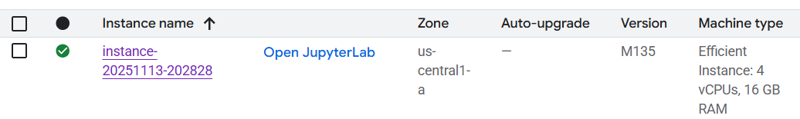

Take the VM instance and take the SSH session and run the below commands

Enable services in VM

gcloud services enable artifactregistry.googleapis.com container.googleapis.com

Create Artifact Registry repository -

gcloud artifacts repositories create iris-api-repo \
--repository-format=docker \
--location=us-central1 \
--description=" Iris API container images”

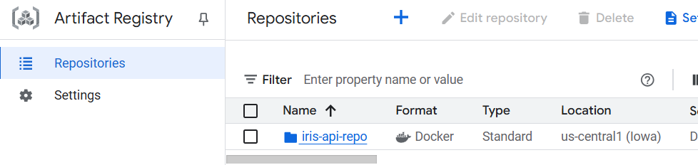

Create Service account –

gcloud iam service-accounts create github-deployer \
--display-name="GitHub CD Service Account"

Create a small GKE cluster with 1 node located in zone us-central1-c

gcloud container clusters create iris-cluster \
--zone=us-central1-c \
--num-nodes=1 \
--service-account=858135612327-compute@developer.gserviceaccount.com \
--scopes=https://www.googleapis.com/auth/cloud-platform \
--machine-type=e2-standard-2 \
--enable-autoscaling \
--min-nodes=1 \
--max-nodes=3 \
--enable-ip-alias

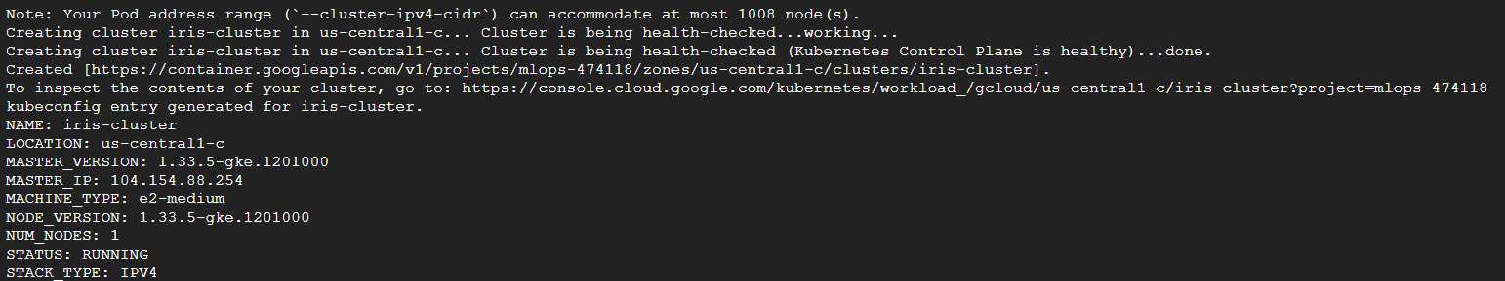

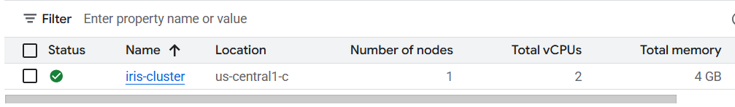

Enable Permissions for service account –

gcloud projects add-iam-policy-binding mlops-474118 \
--member="serviceAccount:github-deployer@mlops-474118.iam.gserviceaccount.com" \
--role="roles/artifactregistry.writer"

gcloud projects add-iam-policy-binding mlops-474118 \
--member="serviceAccount:github-deployer@mlops-474118.iam.gserviceaccount.com" \
--role="roles/container.admin"

Create and download key
gcloud iam service-accounts keys create key.json \
--iam-account=github-deployer@mlops-474118.iam.gserviceaccount.com

This will create the Key and it will be downloaded as json in the working folder

GitHub repo → Settings → Secrets → Actions → Add

GCP_PROJECT_ID mlops-474118
GCP_SA_KEY=<contents of key.json>
GCP_REGION us-central1
GKE_CLUSTER iris-cluster
GKE_ZONE us-central1-c

Get latest files from repo:
Repo link - LekshmiSuseela/IrisKBSDocker
python3 -m venv .env
source .env/bin/activate

git clone https://github.com/LekshmiSuseela/IrisKBSDocker.git
cd IrisKBSDocker/

Authenticate GKE:

gcloud container clusters get-credentials iris-cluster --zone us-central1-c --project mlops-474118

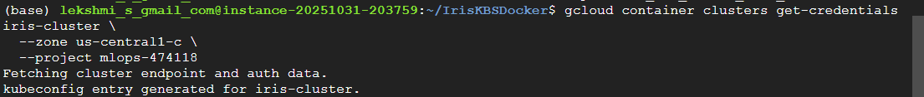

Authenticating kubectl with GKE using the new GCP authentication mechanism:
sudo apt-get install google-cloud-cli-gke-gcloud-auth-plugin

Rebuild the image:
sudo docker build -t us-central1-docker.pkg.dev/mlops-474118/iris-api-repo/iris-api:latest .
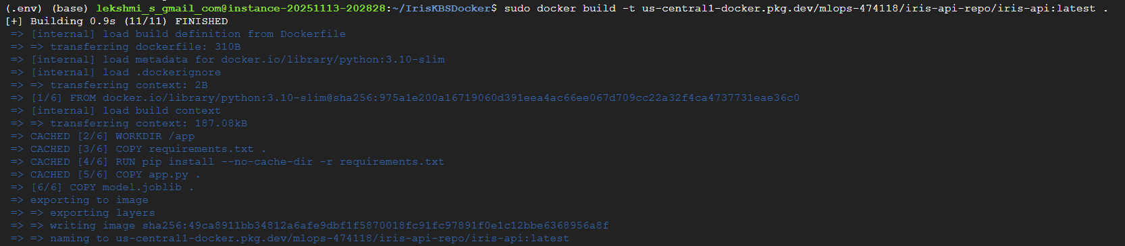

Push the new image to Artifact Registry:
gcloud auth configure-docker us-central1-docker.pkg.dev

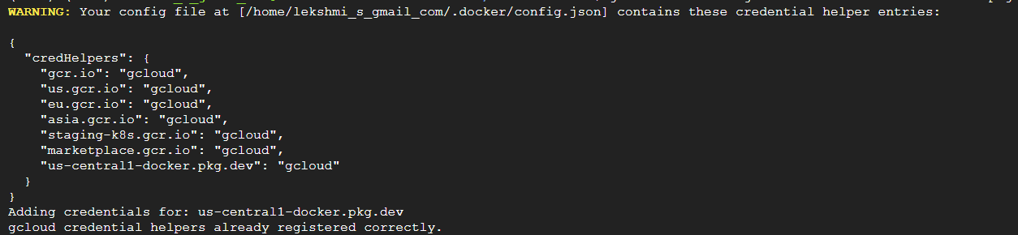

Update the Kubernetes deployment
kubectl set image deployment/iris-api iris-api=us-central1-docker.pkg.dev/mlops-474118/iris-api-repo/iris-api:latest

To check rollout status:
kubectl rollout status deployment/iris-api

Confirm pods are running
kubectl get pods

To g get the external IP of your service (LoadBalancer) using kubectl
kubectl get svc iris-api -o jsonpath='{.status.loadBalancer.ingress[0].ip}'
o/p 34.122.136.18

Test the API, send a POST request to check the new model:
curl -X POST http://34.122.136.18/predict \
-H "Content-Type: application/json" \
-d '{"features": [5.1, 3.5, 1.4, 0.2]}'

Deploy to GKE
kubectl create deployment iris-api \
--image=us-central1-docker.pkg.dev/mlops-474118/iris-api-repo/iris-api:latest
Expose it:
kubectl expose deployment iris-api --type=LoadBalancer --port 80 --target-port 5000

sudo docker build --no-cache -t test-iris .

Deploy the manifests from repo:

kubectl apply -f k8s/deployment.yaml

kubectl apply -f k8s/service.yaml

Check the deployment:

kubectl get pods

kubectl get services

Installs Metrics Server:

kubectl apply -f https://github.com/kubernetes-sigs/metrics-server/releases/latest/download/components.yaml

It downloads the latest official components.yaml manifest for the Metrics Server.
It applies it to the cluster (kubectl apply = create or update resources).
The server gets deployed into the kube-system namespace.

This checks the Service object named iris-api in your cluster.
A Service in Kubernetes exposes your Deployment (pods) to the network — either inside the cluster or externally (via LoadBalancer, NodePort, or ClusterIP).

NAME- The service name (iris-api)
TYPE- How it’s exposed — LoadBalancer (external access via public IP)
CLUSTER-IP Internal IP for cluster-only access
EXTERNAL-IP The public IP (only appears for LoadBalancer type)
PORT(S) Port mapping — container port and node/external port
AGE How long the service has existed

kubectl describe svc iris-api

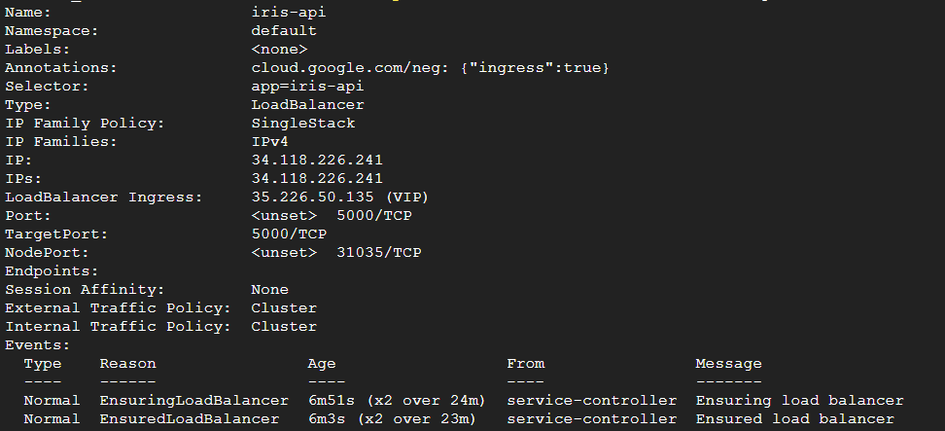

Model will load successfully and it will return the prediction
curl -X POST http://34.122.136.187:80/predict \
-H "Content-Type: application/json" \
-d '{"features":[5.1,3.5,1.4,0.2]}'

o/p [0]

Create a Lua script for POST requests
- wrk is a very fast HTTP benchmarking tool.
- By default, wrk sends HTTP GET requests to the target URL.
- wrk has a scripting feature using Lua, we can define custom requests, including:
cat <<'EOF' > post.lua
wrk.method = "POST"
wrk.body = '{"features": [5.1, 3.5, 1.4, 0.2]}'
wrk.headers["Content-Type"] = "application/json"
EOF

Run a stress test with 1000 concurrent connections
wrk -t8 -c1000 -d30s -s post.lua http://34.122.136.187/predict

Enable Kubernetes Horizontal Pod Autoscaler (HPA)
Create HPA YAML
minReplicas: 1
maxReplicas: 3
metrics:
- type: Resource
resource:
name: cpu
target:
type: Utilization
averageUtilization: 70

Apply the HPA
kubectl apply -f hpa.yaml
kubectl get hpa

Run the stress test again with 1500 connections to observe auto-scaling:
wrk -t8 -c1500 -d60s -s post.lua http://34.122.136.187/predict
kubectl get pods -o wide
kubectl get hpa

Observe Bottlenecks When Scaling is Restricted:
Disable HPA
kubectl delete hpa iris-api-hpa
Fix deployment to 1 pod
kubectl scale deployment iris-api --replicas=1
Stress test with 2000 concurrent connections

Files and folders in repo
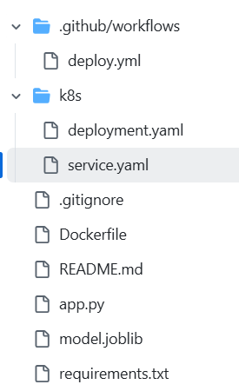

Code of the files -
https://drive.google.com/file/d/1roofUro4KWgz6v41XEmosXOrxq-AlPiq/view?usp=sharing

Output:
Added metric server installation · LekshmiSuseela/IrisKBSDocker@c16f5f2

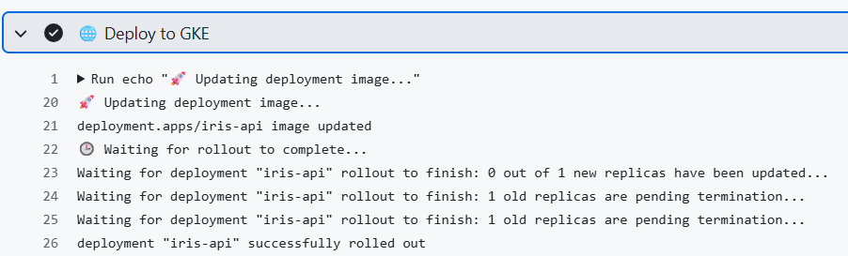

Commit id - c16f5f2

Installing wrk for stress testing
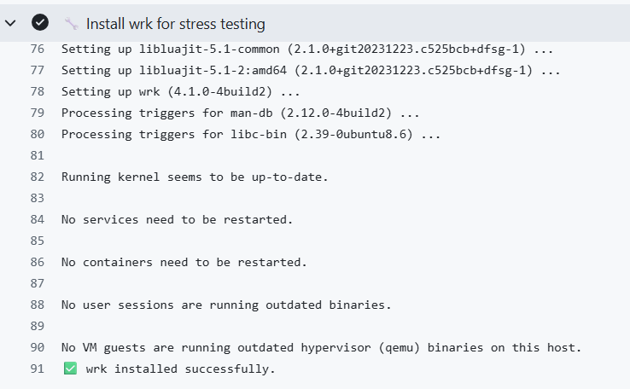

Running test for 1000 concurrent request to /predict
Here 2214 requests are processed in 30s

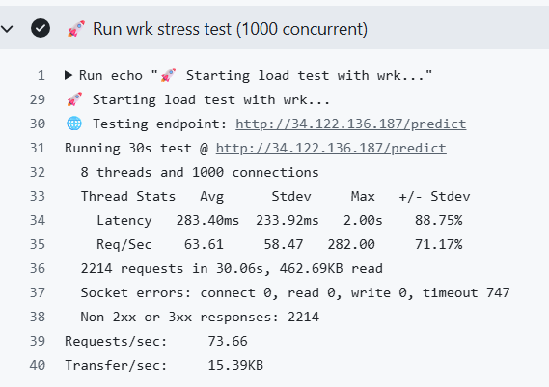
- HPA (Horizontal pod Autoscalar) automatically scales the number of pods based on CPU utilization. If CPU usage >70%, new pods are created (up to 3 total).If load decreases, pods scale down to 1.
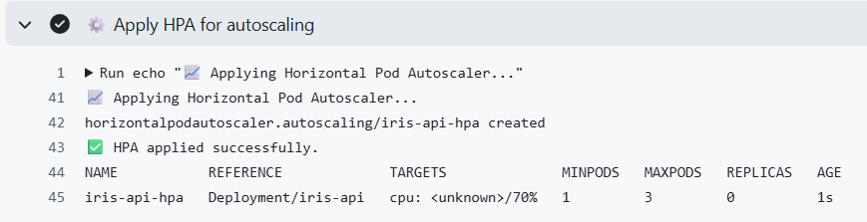

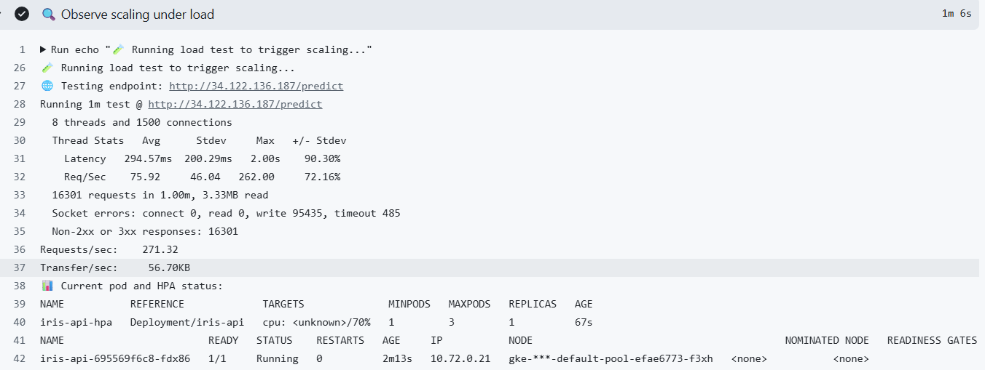

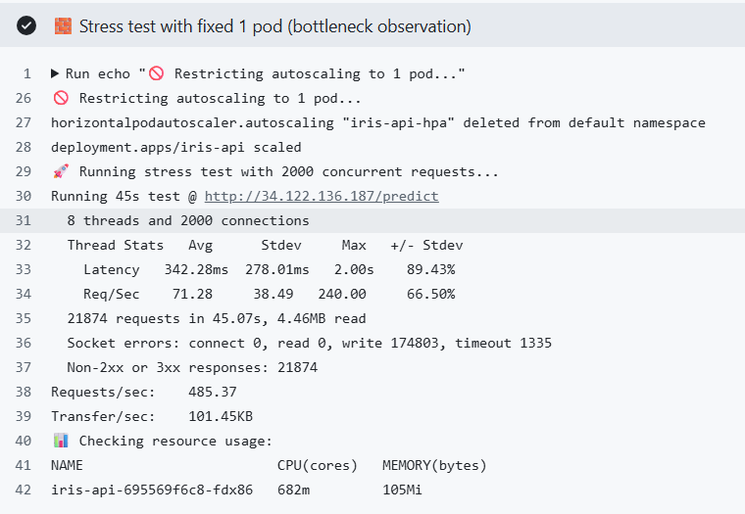

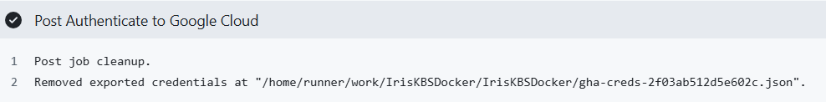

Issues faced:
- Model was not loading correctly, debug multiple things, then finally had to restart everything by creating VM, regitry and cluster
- Had to debug and install in docker multiple times, stop and delete containers
- Container port mismatch between 80 and 5000

