**SMART STREET LIGHT MONITORING**

**AND CONTROLLING**

A PROJECT REPORT

Submitted by:

**SREENA**

**VR**

**LLMC17MCA030**

*to*

*The APJ Abdul Kalam Technological University*

*in partial fulfillment of the requirements for the award of the Degree*

*of*

*Master of*

*Computer Applications*

**Department of Computer Applications**

LOURDES MATHA COLLEGE OF SCIENCE AND TECHNOLOGY

KUTTICHAL, THIRUVANANTHAPURAM 695574

MAY 20

20



# SMART STREET LIGHT MONITORINGN &

**CONTROLLING**

A PROJECT REPORT

Submitted by:

## SREENA V R

### LLMC17MCA030

*to*

*The APJ Abdul Kalam Technological University*

*in partial fulfillment of the requirements for the award of the Degree*

*of*

*Master of Computer Applications*



### Department Of Computer Applications

LOURDES MATHA COLLEGE OF SCIENCE AND TECHNOLOGY

KUTTICHAL, THIRUVANANTHAPURAM 695574

MAY 2020

## DEPARTMENT OF COMPUTER APPLICATIONS LOURDES MATHA COLLEGE OF SCIENCE AND TECHNOLOGY KUTTICHAL, THIRUVANANTHAPURAM



## CERTIFICATE

This is to certify that the report entitled ‘**Smart street light monitoring & controlling’** submitted by **Sreena V R** to the APJ Abdul Kalam Technological University in partial fulfillment of the requirements for the award of the Degree of Master of Computer Applications is a bonafide record of the project work carried out by him under my guidance and supervision.

Prof. Neethu Mohan

(Internal Supervisor)

|  |  |
| --- | --- |
|  |  |
| Prof. Justin G Russel | Prof. Selma Joseph |
| (Project Co-ordinator) | (Head of the Dept.) |

## DECLARATION

I undersigned hereby declare that the project report ‘Smart street light monitoring & controlling ’ submitted for partial fulfillment of the requirements for the award of degree of Master of Computer Applications of the APJ Abdul Kalam Technological University, Kerala is a bonafide work done by me under supervision of Prof. Neethu Mohan. This submission represents my ideas in my own words and, I have adequately and accurately cited and referenced the original sources. I also declare that I have adhered to ethics of academic honesty and integrity and have not misrepresented or fabricated any data or idea or fact or source in my submission. I understand that any violation of the above will be a cause for disciplinary action by the institute and/or the University.

|  |  |
| --- | --- |
| Place: Trivandrum | Signature |
| Date: 30/05/2019 | Sreena V R |

CONTENTS

ACKNOWLEDGEMENT i

ABSTRACT ii

Chapter 1. Introduction

1.1 General Background 01

1.2 Objective 01

Chapter 2. Literature Survey

2.1 Study of similar work 02

2.1.1 Existing System 03

2.1.2 Drawbacks of Existing System 03

Chapter 3. Overall Description

3.1 Proposed System 04

3.2 Features of Proposed System 04

3.3 Functions of Proposed System 05

3.4 Requirements Specification 05

3.5 Feasibility Analysis 06

3.5.1 Technical Feasibility 07

3.5.2 Operational Feasibility 07

3.5.3 Economical Feasibility 08

3.5.4 Behavioural Feasibility 08

Chapter 4. Operating Environment

4.1 Hardware Requirements 09

4.2 Software Requirements 09

4.3 Tools and Platforms 10

4.3.1 Android Language 10

4.3.2 Python Language 10

4.3.3 Windows 7 11

4.3.4 Raspberry pi 11

Chapter 5. Design

5.1 System Design 12

5.1.1 Data Flow Diagram 13

5.1.2 Project DFD 15

5.2 Database Design 16

5.3 Input Output Design 17

5.4 Program Design 18

Chapter 6. Functional and Non-Functional Requirements

6.1 Functional requirements 20

6.1.1 Image based evaluation on face recognition 20

6.1.2 Owner based application 20

6.2 Non-Functional Requirements 21

Chapter 7. Testing

7.1 Testing Strategies 22

7.2 Unit Testing 23

7.3 Integration Testing 24

7.4 User Acceptance Testing 24

7.5 Data Validation Testing 24

7.6 White Box Testing 25

7.7 Black Box Testing 25

7.8 Output Testing 25

7.9 Testing Result 26

Chapter 8. Results and Discussion

8.1 Results 28

8.2 Screen Shots 28

Chapter 9. Conclusion

9.1 System Implementation 31

9.2 Conclusion 31

9.3 Future Enhancement 32

Bibliography I

* + 1. Books
    2. Website

Appendices II

* + 1. SCRUM Board
    2. List of Tables
    3. List of Figures
    4. Abbreviations and Notation
    5. Coding

# ACKNOWLEDGEMENT

The project was successful only with advice and support of many well-wishers. I wish to place on record my profound gratitude to all those who have contributed directly or indirectly to make this project work a success.

At the very onset, I express my gratitude to God Almighty, who sheltered me under his protective wings and showered on innumerable blessings throughout the period of this Master of Computer Application Course.

We would like to express our great and sincere gratitude for supporting this project to our Rev. Dr.Tomy Joseph Padinjareveettil, Director and Prof. Dr. P.P. Mohanlal, Principal, Lourdes Matha College of Science and Technology for permitting to do this project with the fullest spirit.

Bearing in mind I am using this opportunity to express my deepest gratitude and special thanks to the Mrs. Selma Joseph, Head of the Department of Computer Applications, Lourdes Matha College of Science and Technology, for being our inspiration throughout the course and for her valuable guidance and support for our project.

I express my sincere thanks to Prof. Justin G Russel, Project Coordinator Department of Computer Applications, Lourdes Matha College of Science And Technology Kuttichal for his valuable guidance, support and advices that aided in the successful completion of my project.

We are highly debited and obliged to express our heartful thanks and gratefulness especially to our internal guide Mrs. Neethu Mohan Associate Professor who in spite of being extraordinarily busy with her duties, took time out to hear, guide and keep us on the correct path and allowing us to carry out our project and also thankful to all staffs of department of computer applications for their endless support to our project.

We thank our parents and colleagues who provided insight and expertise that greatly assisted our project to its successful completion.

# ABSTRACT

The project entitled “IOT based Smart Street Light Monitoring and Controlling” is developed for automatic street light monitoring to ensure, low power consumption, consumption monitoring, instant faulty light detection and light dimming as per external lighting conditions and also light dimming through motion detection.

The application is designed in such a way that we place light sensors in all street light circuits, which is responsible for switching off and on automatically. Once the lights are switched on current sensors placed at every street light are responsible to report problem status to the centralized system with help of Wi-Fi module attached with the circuit. It also provides dim and bright technology by detecting motion of humans and vehicles while. The status of each light is available in this system the workman can easily locate the particular light to take care so that can minimize the time to search the light and repair.

# CHAPTER 1 INTRODUCTION

## 1.1 GENERAL BACKGROUND

A well-designed, street lighting system should permit users to travel at night with good visibility, in safety and comfort, while reducing many malfunctions occurs during night and enhancing the appearance of the neighborhood. Poorly designed lighting systems can lead to poor visibility which may not be helpful for pedestrian and who are passing by that street. Quite often, street lighting is poorly designed and inadequately maintained and uses obsolete lighting technology, thus consuming large amounts of energy and financial resources.

## 1.2 OBJECTIVE

The Smart street light monitoring and controlling system is designed in such a way that we place light sensors in all the street lights circuit and which are responsible to switch on and off automatically. Once the lights are switched on, current sensors placed at every light pole are responsible to report problem status to centralized system, the help of GSM module attached with the circuit. With the status available in centralized system, the workman now can easily locate the particular light. The system is also provided with dim and bright technology with help of Motion Detection sensors so that the consumption of energy can be reduced and increase the life time of street lights.

# CHAPTER 2 LITERATURE SURVEY

## 2.1 STUDY OF SIMILAR WORKS

### 2.1.1 Existing System

Street light is poorly designed and inadequately maintained, there are large number of burned out lamps which leads to insecurity. There is a complaint register in every zonal office street light section. It is being maintained by the line inspector. The complaint received from public, councilors and corporation officials either over phone is in person being recorded in the complaint register. The complaint thus entered is being handed over to the fieldwork man so as to rectify the complaints, the field staff will have the rounds in the respective areas twice in a week and the complaints about non burning are also being attended then and there. But this is not the immediate remedy on complaints and has many disadvantages like the repair work takes days/even months instead of taking few hours which results in delay, telephone line may be busy, sometimes no response.

### 2.1.2 Drawbacks of Existing System

* Manual Switching off/on of Street Lights
* More Energy Consumption
* High Expense
* More Manpower

# CHAPTER 3 OVERALL DESCRIPTION

## 3.1 PROPOSED SYSTEM

Existing methods like registering the complaint, switching on/off the light manually is time consuming & requires man power. The new method automatic ON/OFF and fault detection without human intervention is easier when compared to the existing system.Our Smart Street Light Controlling and Monitoring consists of smart street lights that have external light sensing that automatically turns on at desired intensity based on amount of lighting needed. The system also allows the controller/monitoring person to check estimate power consumptions as per current intensity of light as well as predict monthly power consumption. Also each of the unit has load sensing functionality that allows it to detect if the light has a fault. It then automatically flags that light is faulty and this data is sent over to the IOT monitoring system so that action can be taken to fix it. The Smart Street Light Controlling and Monitoring also aim to achieve individual faults repaired within few working hours instead of taking days/even months’ time spent in current system where a staff actually goes on “light patrols” six/eight times a year to check for such faulty lamps. Generally, they rely on residents or other municipal employees to report active lights (in other words, faulty street lights). The system is also provided with dim and bright technology with help of Motion Detection sensors so that the consumption of energy can be reduced and increase the life time of street lights.

Automatic Street Light Control System Using Microcontroller aims at designing and executing the advanced development in embedded systems for energy saving of street lights. Nowadays, human has become too busy, and is unable to find time even to switch the lights wherever not necessary. Smart Street Light Monitoring and Controlling gives the best solution for electrical power wastage. Also, the manual operation of the lighting system is completely eliminated. In here three sensors are used which are Light Dependent Resistor LDR sensor to indicate a day/night time and the PIR sensors to detect the movement on the street and ACS712 current sensor used for sensing the total consumption of current. The microcontroller 328 is used as brain to control the street light system, where the programming language used for developing the software to the microcontroller is C-language. Intelligent Street Lighting System Using GSM, Conventional street lighting systems in areas with a low frequency of passers are by online most of the night without purpose. The consequence is that a large amount of power is wasted meaninglessly. With the broad availability of flexiblelighting technology like light-emitting diode lamps and everywhere available wireless internet connection, fast reacting, reliably operating, and power-conserving street lighting systems become reality. The purpose of this work is to describe the Intelligent Street Lighting (ISL) system, a first approach to accomplish the demand for flexible public lighting systems. GSM based smart street light monitoring and control system, it is an automated system designed to increase the efficiency and accuracy of an industry by automatically timed controlled switching of street lights they are basically two modules which include the client side and the server side. The client side consists of GSM modem which is further connected to the microcontroller which is further connected to the relay circuit; the server side consists of GSM modem connected to the Monitoring and Control Application with a database ThingSpeak where it is used as both Frontend and Backend.

The motion sensing circuit is also an important part of this system, as it contributed directly to reducing the power consumption in the main circuit. Depending on the amount of traffic on the street, there could be times where no vehicles are passing by especially during late night or early morning hours, when traffic is usually minimal. During these times, there is usually no need for street lights to be on, as there is no use for them, which is why a motion sensor circuit would provide lots of savings in power. The motion sensing circuit consists mainly of a Passive Infrared (PIR) motion sensor, and a relay module.

Smart street lights can transform the way municipalities manage cities, while delivering enormous savings. With street lighting accounting for nearly 40 percent of many cities’ total energy costs, local governments and utility providers are seeking new ways to decrease energy usage and reduce costs. Switching from halogen to LED luminaires can help achieve that goal by delivering immediate savings of 50 to 80 percent through reduced energy use. Moreover, installing smart LEDs can generate an additional 10 to 20 percent savings by adjusting output to ambient light levels, dimming or brightening as needed.1 They can also be set to turn on only when they detect motion, and then dim or turn off after a specific amount of time. In addition to saving money, cities gain enhanced capabilities and functionalities. By using existing brackets and poles, cities and utility providers can cost-effectively add a wide variety of equipment and sensors. Smart street lights can help monitor energy flow, fault light detection, complaint register, or atmospheric changes. They can be equipped with speakers to alert people to dangerous situations or conditions, or with cameras to help police solve crimes or to verify trash collection and other activities. With these capabilities, cities can improve operational efficiency, increase citizen satisfaction, and decrease costs.

## 3.2 FEATURES OF PROPOSED SYSTEM

* Auto Switching of Lights
* Maintenance Cost Reduction
* Reduction in Co2 Emission
* Reduction in Light pollution
* Wireless Communication
* Energy Saving
* Reduction of manpower

3.2.1 Reduction of Co2 Emission

Half of the carbon emissions created are generated from the production of electricity. Lighting alone creates 17% of carbon emissions. Every 1KW of electricity generates 830 grams of carbon equivalents. LEDs normally use less power for a given application compared to traditional halogen and fluorescent sources. As such, the overall kW/hr consumption per year is less, this helps reduce the overall CO2 emissions.

3.2.2 Reduction of Light pollution

In Smart Street Light Controlling and Monitoring, we have installed a motion sensor. Lights come on as people and moving objects approach, illuminating an area in advance, therefore reducing the amount of wasted light emitted from the street. Control and define light levels for a specific streetlight. Boost light levels to improve safety and visibility as the situation demands, or reduce the light levels to save energy, thereby cut carbon emissions and lower light pollution.

## 3.3 FUNCTIONS OF PROPOSED SYSTEM

* Dim and Bright Technology
* Fault Light Detection
* Current Consumption
* Automatically Switching ON/OFF of Lights

## 3.4 REQUIREMENTS SPECIFICATION

System analyst tasks to a variety of persons to gather details about the business process and their opinions of why things happen as they do and their ideas for changing the process. These can be done through questionnaires, details investigation, observation, collection of samples etc. As the details are collected, the analyst studies the requirements data to identify the features the new system should have, including both the information the system produces and operational features such as processing controls, response times, and input output methods.

Requirement specification simply means, “Figuring out what to make before you make it”. It determines what people need before you start developing a product for them. Requirement definition is the activity of translating the information gathered in to a document that defines a set of requirements. These should accurately reflect what consumer wants. It is an abstract description of the services that the system should provide and the constraints under the system must operate. This document must be written for that the end user and the stake holder can understand it.

The notations used for requirements definition should be based on natural languages, forms and simple intuitive diagrams. The requirements fall into two categories: functional requirements and non-functional requirements.

The requirements of specification of the Smart Street Light Monitoring and Controlling system are as follows:

* Arduino C++
* Embedded C

## 3.5 FEASIBILITY ANALYSIS

The feasibility study concern with the considerations made to verify whether the system fit to be developed in all terms. Main objective of feasibility study is to test the technical, social and economic feasibility of developing a system. This is done before developing a system. This is done by investigating the existing system in the area under investigation and generating ideas about the new system. The feasibility study to be conducted for this project involves:

* Technical Feasibility
* Operational Feasibility
* Economic Feasibility
* Behavioral Feasibility

### 3.5.1Technical Feasibility

The system must be evaluated from the technical view point first. The assessment of this feasibility must be based on an outline design of the system requirement in terms of input, output, programs, procedure and staff. Having identified the outline of the system, the investigation must go on to suggest the type of equipment, required method of developing the system, and the method of running the system.

The existing system uses Switch ON/OFF technique while ‘Smart Street Light System’ is developed by using front end as Embedded C and back end as Bling database. It is technically feasible and has lots of features. It is currently implemented in the windows 10 platform. But it is also feasible to work in the Linux platform. We use the Embedded IOT (GUI) which is a package and environment manager, which use channels without using command line commands. It also includes different kinds of hardware sensors like LDR, PIR, and Current sensor. The main reason to prefer Embedded C language is that because it has long history of making devices do what people need and it also simpler tools to allow these programmers to write code without plugging into low level hardware. And also it simple to embed programs to micro controllers and needs only short period of time to execute operations.

### 3.5.2Operational Feasibility

It is mainly related to human organizational and political aspects. This test of feasibility asks if the system will work when it is developed and implemented. It also measures how well a proposed system solves the problems, and takes advantage of the opportunities identified during scope definition and how it satisfies the requirements identified in the requirements analysis phase of system development. There is no difficulty in implementing the system.

The ‘Smart Street Light Controlling and Monitoring’ is effective and user friendly. To ensure success, desired operational outcomes must be imparted during design and development. These include such design-dependent parameters such as reliability, maintainability, supportability, usability and others.

### 3.5.3Economic Feasibility

In the economic feasibility the development cost of the system is evaluated weighting it against the ultimate benefit derived from the new system. It is found that the benefit, from the new system would be more than the cost and time involved in its development. This project

‘Smart Street Light Controlling and Monitoring’ is economically feasible because IDE used for developing the software is free of cost.

The proposed system uses Embedded C as the front end which is a free and open source software therefore it can be downloaded easily from the internet. Also, the Embedded GUI and all the other datasets are downloaded from the internet with free of cost. And some hardware objects are bought online which has limited cost and long term life.

#### 3.5.4 Behavioral Feasibility

The behavioral feasibility depends upon whether the system performed in the expected way or not. Behavioral Feasibility study is a test of system proposal according to it workability, impact on organization, ability to meet user’s need and effective use of resources. However, a feasibility study provides a useful starting point for full analysis. ‘Smart Street Light

Controlling and Monitoring’ is behaviorally feasible because of the effective use of the resources and also the system satisfies user needs and is user friendly.

The database used will increase the systems performance and makes is more effective. The user will be able to identify the faulty light and monthly power consumption

# CHAPTER 4

**OPERATING ENVIRONMENT**

## 4.1 HARDWARE REQUIREMENTS

Processor : Dual Core or above

RAM : 4GB

Hard Disk : 500GB

Microcontroller : NODE MCU ESP8266 Current Sensor : ACS712 30A

Motion Sensor : PIR

Resistor : LDR

Device Switching : Relay

## 4.2 SOFTWARE REQUIREMENTS

|  |  |  |  |
| --- | --- | --- | --- |
| Operating System | : |  | Windows 10 |
| Language | : |  | C++, Embedded C |
| DB | : |  | Cloud ThingSpeak |
| Server | : |  | ThingSpeak |
| IDE | : |  | NodeMCU |

## 4.3 TOOLS AND PLATFORM

### EMBEDDED C

**4.3.1 Embedded C** is a set of language extensions for the [C programming language](https://en.wikipedia.org/wiki/C_(programming_language)) by the [C Standards Committee](https://en.wikipedia.org/wiki/ISO/IEC_JTC_1/SC_22) to address commonality issues that exist between C extensions for different [embedded systems.](https://en.wikipedia.org/wiki/Embedded_system) Embedded C programming typically requires nonstandard extensions to the C language in order to support enhanced [microprocessor](https://en.wikipedia.org/wiki/Microprocessor) features such as [fixed-point arithmetic,](https://en.wikipedia.org/wiki/Fixed-point_arithmetic) multiple distinct [memory banks,](https://en.wikipedia.org/wiki/Memory_bank) and basic [I/O](https://en.wikipedia.org/wiki/I/O) operations. In 2008, the C Standards Committee extended the C language to address such capabilities by providing a common standard for all implementations to adhere to. It includes a number of features not available in normal C, such as fixed-point arithmetic, named address spaces and basic I/O hardware addressing. Embedded C uses most of the syntax and semantics of standard C, e.g., main() function, variable definition, datatype declaration, conditional statements (if, switch case), loops (while, for), functions, arrays and strings, structures and union, bit operations, macros, etc.

Embedded Systems consists of both Hardware and Software. If we consider a simple Embedded System, the main Hardware Module is the Processor. The Processor is the heart of the Embedded System and it can be anything like a Microprocessor, Microcontroller, DSP,

CPLD (Complex Programmable Logic Device) and FPGA (Field Programmable Gated Array). All these devices have one thing in common: they are programmable i.e. we can write a program (which is the software part of the Embedded System) to define how the device actually works. Embedded Software or Program allow Hardware to monitor external events (Inputs) and control external devices (Outputs) accordingly. During this process, the program for an Embedded System may have to directly manipulate the internal architecture of the

Embedded Hardware (usually the processor) such as Timers, Serial Communications

Interface, Interrupt Handling, and I/O Ports

#### 4.3.2 Node MCU

The [NodeMCU](http://www.nodemcu.com/index_en.html) (Node Microcontroller Unit) is an open source software and hardware development environment that is built around a very inexpensive System-on-a-Chip (SoC) called the [ESP8266.](https://en.wikipedia.org/wiki/ESP8266) The ESP8266, designed and manufactured by [Espressif Systems,](https://espressif.com/en/products/hardware/esp8266ex/overview) contains all crucial elements of the modern computer: CPU, RAM, networking (wifi), and even a modern [operating system and SDK](https://bbs.espressif.com/)

* An open source ESP8266 [firmware](https://github.com/nodemcu/nodemcu-firmware) that is built on top of the chip manufacturer’s proprietary SDK. The fir[mware prov](https://github.com/nodemcu/nodemcu-firmware)ides a simple programming environment based on [eLua](http://www.eluaproject.net/) (embedded [Lua)](https://www.lua.org/), which is a very simple and fast scripting language with an established developer community. For new comers, the Lua scripting language is easy to learn.
* A [DEVKIT board](https://github.com/nodemcu/nodemcu-devkit) that incorporates the ESP8266 chip on a standard circuit board. The board has a built-in USB port that is already wired up with the chip, a hardware reset button, wifi antenna, LED lights, and standard-sized GPIO (General Purpose Input Output) pins that can plug into a bread board. Figure 1 shows the DEVKIT board, and Figure 2 shows the schema of its pins.

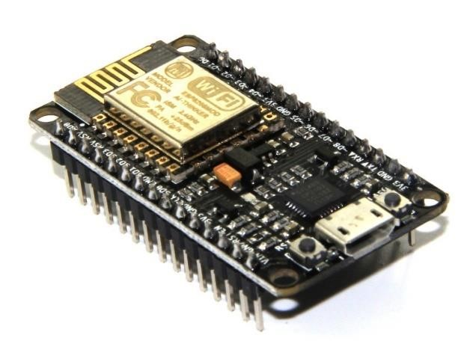

**4.3.3 LDR input:**

It automatically switches ON **lights** when the sunlight goes below the visible region of our eyes.. It automatically switches OFF **lights** when Sunlight fall on it e.g. in morning, by using a sensor called **LDR** which senses the **light** just like our eyes. A Light dependent resistor (LDR) also termed as a photo resistor is advice whose resistivity factor is a function of the electromagnetic radiation. Hence, they are light sensitive devices which are similar to that of human eyes. They are also named as photoconductors, conductive cells or simply photocells. They are made up of semiconductor materials with high resistance.

**Working:** A LDR works on the principle of photo conductivity. Photo conductivity is an optical phenomenon in which the materials conductivity gets reduced when light is actually absorbed by the material. However, when light shines onto the LDR its resistance falls and current flows into the base of the first transistor and then the second transistor. The preset 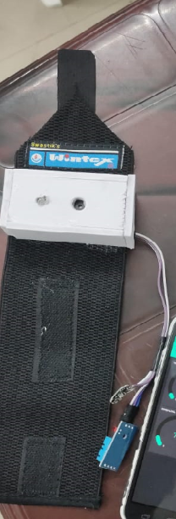resistor can be turned up or down to increase or decrease resistance, in this way it can make the circuit more or less sensitive. LDR send response to Arduino.

**Applications of LDR**

* The LDR is used for automatic contrast and brightness control in television receivers.
* The LDR is used in the infrared astronomy.
* The LDR is used in optical coding.
* Used in light activated control circuits.
* Used in light failure alarm circuits and used in light meter.
* The LDR used in smoke detectors.
* Used in the security alarm.
* The LDR also used in street light control circuits.

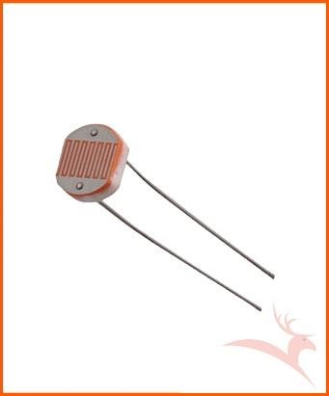

**4.3.4 PIR senor:**

A passive **infrared** sensor (PIR sensor) is an electronic sensor that measures **infrared** (IR) light radiating from objects in its field of view. They are most often used in PIR-based motion detectors. PIR sensors are commonly used in security alarms and automatic lighting applications. Passive Infrared **Sensor** can be **used** to detect presence of human beings in its proximity. This version has a large lens which can support long range and wide angle. The output can be **used** to control the **motion** of door. A **PIR sensor** detects the infrared light radiated by a warm object.

**Working:** The PIR sensors are more complicated than the other sensors as they consists of two slots. These slots are made of a special material which is sensitive to IR. The Fresnel lens is used to see that the two slots of the PIR can see out past some distance. When the sensor is inactive, then the two slots sense the same amount of IR. The ambient amount radiates from the outdoors, walls or room, etc. When a human body or any animal passes by, then it intercepts the first slot of the PIR sensor. This causes a positive differential change between the two bisects. When a human body leaves the sensing area, the sensor generates a negative differential change between the two bisects. The infrared sensor itself is housed in a hermetically sealed metal to improve humidity/temperature/noise/immunity. There is a window which is made of typically coated silicon material to protect the sensing element.

#### Applications of PIR

* Presence Detection
* Contactless hygienic switches of sanitary facilities
* Automatic illuminating devices
* Alarm and Security system

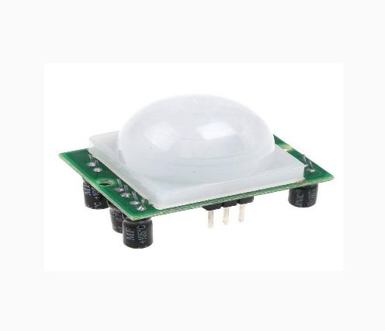

**4.3.5 Current sensor:**

A **current sensor** is a device that detects [electric current](https://en.wikipedia.org/wiki/Electric_current) in a wire, and generates a signal proportional to that current. The generated signal could be analog voltage or current or even a digital output. The generated signal can be then used to display the measured current in an ammeter, or can be stored for further analysis in a data acquisition system, or can be used for the purpose of control.

**Working:** Current Sensor detects the current in a wire or conductor and generates a signal proportional to the detected current either in the form of analog voltage or digital output. [Current Sensing](https://www.elprocus.com/current-sensor/) is done in two ways – Direct sensing and Indirect Sensing. In Direct sensing, to detect current, Ohm’s law is used to measure the voltage drop occurred in a wire when current flows through it. ACS712 Current Sensor uses Indirect Sensing method to calculate the current. To sense current a liner, low-offset Hall sensor circuit is used in this IC. This sensor is located at the surface of the IC on a copper conduction path. When current flows through this copper conduction path it generates a magnetic field, which is sensed by the Hall effect sensor. A voltage proportional to the sensed magnetic field is generated by the Hall sensor, which is used to measure current.

#### Applications of ACS712

* ACS712 is used in many industrial, commercial and communication applications. This IC is applicable for Automobile applications. Some of the typical applications of this IC can be found in motor control circuits, for load detection and management, SMPS, overcurrent fault protection circuit.
* This IC can measure current for high voltage loads operating at 230V AC mains. To read the values it can be easily interfaced with the ADC of a microcontroller. What would be the value of output voltage provided by ACS712 when a DC load current is applied to it.

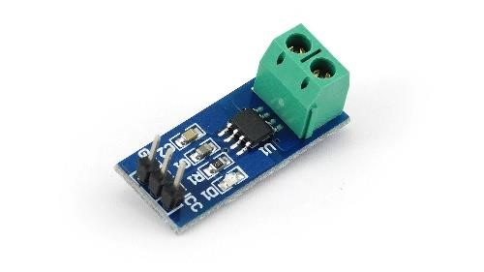

### 4.3.6 RELAY

The relay module is a separate hardware device used for remote device switching. With it you can remotely control devices over a network or the Internet. Devices can be remotely powered on or off with commands coming from Clock Watch Enterprise delivered over a local or wide area network. You can control computers, peripherals or other powered devices from across the office or across the world. The Relay module can be used to sense external On/Off conditions and to control a variety of external devices. The PC interface connection is made through the serial port.

The Relay module houses two SPDT relays and one wide voltage range, optically isolated input. These are brought out to screw-type terminal blocks for easy field wiring. Individual

LED’s on the front panel monitor the input and two relay lines. The module is powered with an AC adapter.

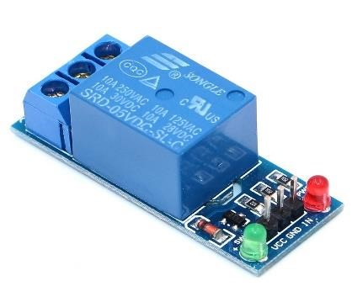

#### 4.3.7 ThingSpeak

ThingSpeak is an IoT analytics platform service that allows you to aggregate, visualize and analyze live data streams in the cloud. ThingSpeak provides instant visualizations of data posted by your devices to ThingSpeak. With the ability to execute MATLAB code in ThingSpeak you can perform online analysis and processing of the data as it comes in. ThingSpeak is often used for prototyping and proof of concept IoT systems that require analytics.

ThingSpeak allows you to aggregate, visualize and analyze live data streams in the cloud. Some of the key capabilities of ThingSpeak include the ability to:

* Easily configure devices to send data to ThingSpeak using popular IoT protocols.
* Visualize your sensor data in real-time.
* Aggregate data on-demand from third-party sources.
* Use the power of MATLAB to make sense of your IoT data.
* Run your IoT analytics automatically based on schedules or events.
* Prototype and build IoT systems without setting up servers or developing web software.

**4.3.8 Blynk:**

**Blynk** is a new platform that allows you to quickly build interfaces for controlling and monitoring your hardware projects from your iOS and Android device. After downloading the **Blynk** app, you can create a project dashboard and arrange buttons, sliders, graphs, and other widgets onto the screen. Blynk app, you can create a project dashboard and arrange buttons, sliders, graphs, and other widgets onto the screen. Using the widgets, you can turn pins on and off or display data from sensors.

Whatever your project is, there are likely hundreds of tutorials that make the hardware part pretty easy, but building the software interface is still difficult. With Blynk, though, the software side is even easier than the hardware. Blynk is perfect for interfacing with simple projects like monitoring the temperature of your fish tank or turning lights on and off remotely.

# CHAPTER 5 DESIGN

## 5.1 SYSTEM DESIGN

System design is a reduction of an entire system by studying the various operations performed and their relationships within the system and the requirements of its success. One aspect of design is defining the boundaries of the system and determining whether or not the candidate system should consider other related system.

System can be defined, as an orderly grouping of interdependent components can be simple or complex. The most creative and challenging phase of the system life cycle is system design. The term design describes a final system and the process by which it is developed. It refers to the technical specifications that will be applied in implementing the candidate system. It also includes the construction of programs and program testing.

The first step in the system design is to determine how the output is to be produced and in what format. Samples of the output and the inputs are also presented. In the second step, input data and master files are to be designed to meet requirement of the proposed output .The processing phase’s system’s objectives and complete documentation.

System design has two phases:

* Logical
* Physical

The logical design reviews the present physical system, prepares the input and output and also prepares a logical design walk- through. We have to deal with how to take entries required and whether and how to process the user data. Also we have to deal with how to present the data in an informative and appealing format. This design also involves the methodology to store, modify and retrieve data from the data base as per the requirement. Physical design maps out the details of the physical system, plans the system implementation, devices a test and implementation plan and new hardware and software. We have to decide how and where to store the input data and how to process it so as to present it to the user in an easy, informative and attractive manner.

**5.1.1 BLOCK DIAGRAM/ UML**

### I. Block Diagram

A block diagram is a [diagram o](https://en.wikipedia.org/wiki/Diagram)f a [system i](https://en.wikipedia.org/wiki/System)n which the principal parts or functions are represented by blocks connected by lines that show the relationships of the blocks. They are heavily used in engineering in [hardware design*,*](https://en.wikipedia.org/wiki/Hardware_architecture)[electronic design*,*](https://en.wikipedia.org/wiki/Electronic_design)[software design,](https://en.wikipedia.org/wiki/Software_design) and [process flow diagrams.](https://en.wikipedia.org/wiki/Process_flow_diagram) Block diagrams are typically used for higher level, less detailed descriptions that are intended to clarify overall concepts without concern for the details of implementation. Contrast this with the [schematic diagrams a](https://en.wikipedia.org/wiki/Schematic_diagram)nd [layout diagrams u](https://en.wikipedia.org/wiki/Integrated_circuit_layout)sed in electrical engineering, which show the implementation details of electrical components and physical construction.

### II. Flowchart

A flowchart is a type of [diagram t](https://en.wikipedia.org/wiki/Diagram)hat represents a [workflow o](https://en.wikipedia.org/wiki/Workflow)r [process.](https://en.wikipedia.org/wiki/Process) A flowchart can also be defined as a diagrammatic representation of an [algorithm, a](https://en.wikipedia.org/wiki/Algorithm) step-by-step approach to solving a task. The flowchart shows the steps as boxes of various kinds, and their order by connecting the boxes with arrows. This diagrammatic representation illustrates a solution model to a given [problem.](https://en.wikipedia.org/wiki/Problem_solving) Flowcharts are used in analyzing, designing, documenting or managing a process or program in various fields.

### III. UML Use case diagram

A [use case](https://searchsoftwarequality.techtarget.com/definition/use-case) is a methodology used in system analysis to identify, clarify, and organize system requirements. The purpose of use case diagram is to capture the dynamic aspect of a system. However, this definition is too generic to describe the purpose, as other four diagrams (activity, sequence, collaboration, and State chart) also have the same purpose. Use case diagrams are used to gather the requirements of a system including internal and external influences. These requirements are mostly design requirements. Hence, when a system is analyzed to gather its functionalities, use cases are prepared and actors are identified.

In brief, the purposes of use case diagrams can be said to be as follows

* Used to gather the requirements of a system.
* Used to get an outside view of a system.
* Identify the external and internal factors influencing the system.
* Show the interaction among the requirements are actors.

Use case diagrams are employed in [UML](https://searchsoftwarequality.techtarget.com/definition/Unified-Modeling-Language) (Unified Modeling Language), a standard notation for the modeling of real-world objects and systems. System objectives can include planning overall requirements, validating a [hardware](https://searchnetworking.techtarget.com/definition/hardware) design, testing and [debugging](https://searchsoftwarequality.techtarget.com/definition/debugging) a [software](https://searchapparchitecture.techtarget.com/definition/software) product under development, creating an online help reference, or performing a consumer-service-oriented task.

### 5.1.1.1 BASIC ELEMENTS IN USE CASE DIAGRAM

**Use case:** A use case in a use case diagram is a visual representation of a distinct business functionality in a system.

**Actors:** An actor portrays any entity (or entities) that perform certain roles in a given system. The different roles the actor represents are the actual business roles of users in a given system. An actor in a use case diagram interacts with a use case.

**System boundary:** A system boundary defines the scope of what a system will be. A system cannot have infinite functionality. The system boundary is shown as a rectangle spanning all the use cases in the system.

**Include:** When a use case is depicted as using the functionality of another use case in a diagram, this relationship between the use cases is named as an *include* relationship.

**Extend:** In an *extend* relationship between two use cases, the child use case adds to the existing functionality and characteristics of the parent use case. An extend relationship is depicted with a directed arrow having a dotted shaft, similar to the include relationship.

### 5.1.1.2 COMPONENTS OF USE CASE DIAGRAM

**System :**

**Relationships :**

**Use cases :**

**Actor :**

**5.1.2 PROJECT BLOCK DIAGRAM/ UML**

#### i. Block Diagram

**AC Blub**

**PIR**

**-**

**Passive Infrared Sensor**

**LDR**

**-**

**Light Dependent Resistor**

**LDR**

**MC**

**-**

**Micro Controller**

**CS**

**-**

**Current Sensor**

**LS**

**-**

**Light Sensor**

**AC**

**-**

**Alternating Cu**

**rrent**

**328**

**MC**

**PIR**

**Relay**

**CS**

**L**

**S**

**Monitoring**

**Station**

Figure 5.1: Block diagram

#### ii. UML Daigram

Initialize Sensors

Determine

light

intensity

Detect

Motion

Dim/ Bright light

Figure 5.2: Use case diagram

#### iii. Flow Chart

Off

START

Initialization of ports

Details of PIR

and LDR

detection

Send the data to

Thing

S

peak

Check

intensity

of light

Put ON light

**Night**

**Day**

STOP

Figure 5.3: Flow Chart

## 5.1 INPUT DESIGN

Input designing is the basic theory to be considered during system study. The input media used in the system is the keyboard. Details are entered in the system through different data entry screens. The system is designed in a user-friendly manner. Appropriate error messages are displayed when a false data is entered. Design of the system is web-oriented and is highly interactive to the users. The user interface design is very important for any application. The interface design defines how the software communicates within itself, to system that interpreted with it and with human who use it. The interface design is very good; the user will fall into an interactive software application.

The input design is the process of converting the user-oriented description of inputs into a programmer-oriented specification. The objective of input design is to create an input layout that is easy to follow and prevents the user from committing errors. It covers all phases of input, right from the creation of initial databases to the actual data entry into the system. The input design is the link that ties the system into the world of its users. Hence, lays its importance in the design phase. The input design makes sure that while entering data, the end-users understand the format in which the data is to be entered so that it is accepted by the system, the data values that are mandatory for the system to function, the order in which transactions need to be processed etc.

## 5.2 OUTPUT DESIGN

Output is the most important one to the user. A major form of the output is the display of the information gathered by the system and the servicing the user requests to the system. Output generally refers to the results or information that is generated by the system. It can be in the form of operational documents and reports. Since some of the users of the system may not operate the system, but merely use the output from the system to aid them in decision- making, much importance is given to the output design.

Output generation hence serves two main purposes, providing proper communication of information to the users and providing data in a form suited for permanent storage to be used later on. The output design phase consists of two stages, output definition and output specification. Output definition takes into account the type of outputs, its contents, formats, its frequency and its volume. The output specification describes each type of output in detail.

The objective of the output design to covey the information of all the past activities, current status and emphasize important a quality output is one, which meets the requirements of the end user and presents the information clearly.

|  |  |  |
| --- | --- | --- |
| **Process** | **Input Design** | **Output Design** |
| Detection of LDR for intensity of natural light | Provides the signal to the LDR sensor. | If proper signals receive it will switch on the bulb. |
| Detecting Motion | PIR activated. | It will detect the motion and emits dim/ bright light. |

## 5.4 PROGRAM DESIGN

### • LDR Sensor

Step 1: If the application is active, the LDR sensor will detect the intensity of the obtained natural light.

Step 2: If the value detected, it sends to the Current sensor.

Step 3: Otherwise, go to step 1.

### • PIR Sensor

Step 1: If the application is active, the PIR sensor will detect the Motion.

Step 2: If motion detected the light will automatically brighten itself.

Step 3: Otherwise turn light to dim.

# CHAPTER 6 FUNCTIONAL AND NON-FUNCTIONAL REQUIRMENTS

## 6.1FUNCTIONAL REQUIREMENTS

In software engineering, a functional requirement defines a function of a software system or its component. A function is described as a set of inputs, the behavior, and outputs. Functional requirements may be calculations, technical details, data manipulation and processing and other specific functionality that define what a system is supposed to accomplish. Generally, functional requirements are expressed in the form "system must do requirement ".

Functional requirements for each of the cases described below:

* The system shall have options for the user to detect both dim facility and faulty light.
* The system shall provide auto switching functionality to the user.
* The system provides accurate details of the location of fault light.

## 6.2 NON-FUNCTIONAL REQUIREMENTS

A non-functional requirement is a requirement that specifies criteria that can be used to judge the operation of a system, rather than specific behaviours. Non-functional requirements are “system shall be requirement ". Non-functional requirements are often called qualities of a system. Other terms for non-functional requirements are "constraints", "quality attributes”, “quality goals", "quality of service requirements" and "non-behavioural requirements.

Some of the non-functional requirements are mentioned below:

* **Usability**: The system shall have clean interface with only needed features and tool tips wherever necessary. Warnings or alerts shall be specified in clear way.
* **Efficiency**: The system shall respond to different lights being tested.
* **Portability**: The system shall be independent to some of the specific technological platform used to implement it.
* **Reliability**: Reliability defined as a measure of the time between failures occurring in a system (measure show frequently the system fails), so that the system shall operate without any failure for a particular period of time.
* **Availability**: Availability measures the percentage of time the system is in its operational state so that the system shall be available for use 24 hours per day and 365days per year.

# CHAPTER 7 TESTING

Hardware testing is critical element of hardware quality assurance and represents the ultimate review of specifications, design and code implementation. System testing is the stage of implementation, it is aimed for ensuring that the system works accurately and efficiently before live operations commences.

Testing is a purpose of executing a programmed with intend of finding errors.

* Preparing a test case that has high probability of finding undiscovered errors.
* Testing to erase out all kinds of bucks from the program.

Before going for testing, first we have to decide the type of test. For this impact system, unit testing is carried out. And the following things are taken to consideration.

* To ensure that information properly places in and out of the program.
* To ensure that the module operates properly at boundaries established to limit or restrict processing.
* To find out whether all statements in module have been executed at least once.
* To find out whether error handling paths are working correctly.

## 7.1 TESTING STRATEGIES

A strategy for software testing integrates software test case design methods in to a well-planned series of steps that results in the successful construction of the software. The strategy provides a road map that describes the step to be conducted as part of testing, when these steps are planned and undertaken, and how much effort, time and resources will be required. Therefore any testing strategy must incorporate test planning, test case, design, test execution and resultant data collection and evaluation. A software testing strategy should be flexible enough to promote customized testing approach. At the same time, it must be rigid enough to promote reasonable planning and management tracking as the project processes. The project manager, software engineer and testing specialists develop a strategy for software testing. The general characteristics of software testing strategy are:

1. Testing begins at the component level and works “outward” toward the integration of the entire computer system.
2. Different testing techniques are appropriate at different point in time. A strategy for software testing must accommodate low-level testis that are necessary to verify a small source code segment has been correctly implemented as well as high level testing that validate major system function against customer requirements.

## 7.2 UNIT TESTING

Unit test comprises of a set test performed by an individual programmer prior to the integration of the unit into large system. Program unit is usually small enough that the programmers who developed and can it in great detail and certainly in greater than will possible when the unit is integrated into evolving software project. Unit testing should be an exhaustive as possible. In this system, each module was tested individually to ensure that every representation in the module meets the requirements.

## 7.3 INTEGRATION TESTING

Integration testing is a system technique for constructing the program structure while at the same time conducting test to uncover errors associated with interfacing. The objective is to take unit testing modules and build a program structure that has been dictated by design. Bottom-up integration is the traditional strategy used to integrate the components of a software system into functioning whole.

Bottom-up integration consists of a unit test followed by testing of the entire system. Subsystem consists of several modules that communicated with other defined interface.

The errors were isolated and corrected to produce a fully functional system. Top-down integration method is an incremental approach to the construction of the program structure. The project was tested to ensure that every representation meets the requirements.

## 7.4 USER ACCEPTANCE TESTING

This testing is generally performed when the project is nearing its end. This test mainly qualifies the project and decides if it will be accepted by the users of the system. The users or the customers of the project are responsible for the test.

## 7.5 DATA VALIDATION TESTING

Data validation is the process of testing the accuracy of data; a set of rule you can apply to a control to specify the type and range of data that can enter. It can be used to display error alert when users enter incorrect values into a form. In this project data validation testing carried out on all input form pages to test the accuracy.

## 7.6 WHITE BOX TESTING

White box testing strategy deals with the internal logic and structure of the code. White box testing is also called as glass, structural, open box or clear box testing. The tests written based on the white box testing strategy incorporate coverage of the code written, branches, paths, statements and internal logic of the code etc. In this project there was many code errors occurred in many web forms, all errors were corrected through debugging.

## 7.7 TESTING RESULTS

|  |  |  |  |  |
| --- | --- | --- | --- | --- |
| **Sl.No** | **Test Case** | **Input** | **Expected Output** | **Pass or Fail** |
| 1 | PIR determination | Check for Motion | PIR information | Pass |
| 2 | LDR detection | Check for Natural light | Detect day or night light on/off | Pass |

Table 7.4: Testing results

**CHAPTER 8**

### RESULTS AND DISCUSSION

Results of our experiments show that the device, i.e. transmitter section and receiver section had been designed and the programs were burned into the NodeMCU ESP8266 microcontroller. The project is successfully tested for all the commands and it also detected all fault light with the help of a PIR sensor. Once the pir is detected, the light will brighten. The current sensor will help in finding how much current it is being taken so far and it can be used for future analysis. The results can be viewed as a graph with the help of Thingspeak.

## 8.1 RESULTS

The proposed system incorporated with the following features.

* Quick and appropriate action can be taken easily.

* Human effort can be reduced.

* Improved efficiency.

* Security enhanced for human life.

* Can detect fault lights more easily.

* Give proper information to the user.

## 8.2 SCREENSHOTS

### 1. ThingSpeak Login Page

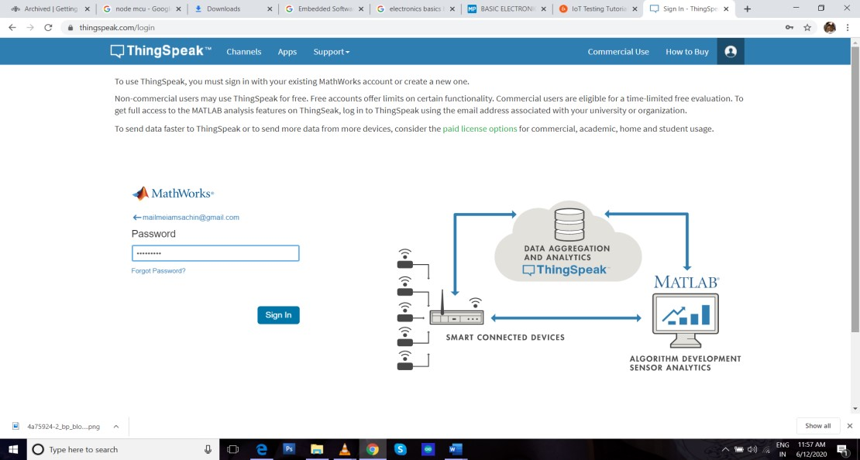

### 2. My Channel ThingSpeak

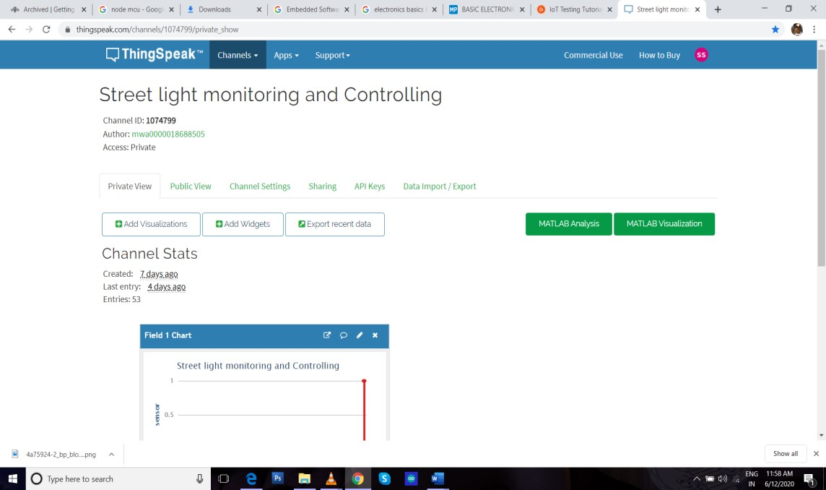

### 3. Blynk



### 4. Blynk Gauge

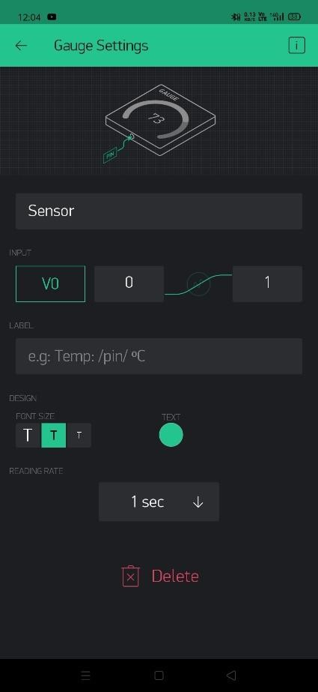

### 5. GitHub

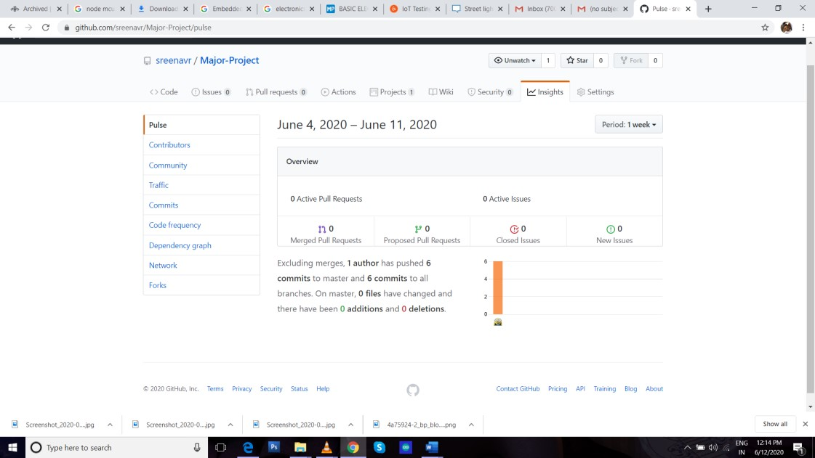

### 6. NodeMCU Pin Schema

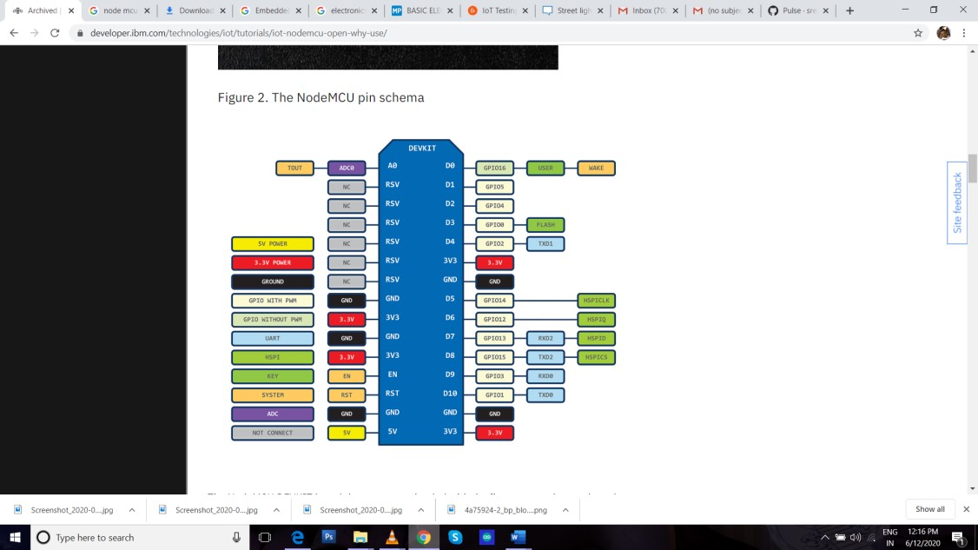

# CHAPTER 9

## CONCLUSION

**9.1 SYSTEM IMPLEMENTATION**

System Implementation is the stage in the project where the theoretical design is turned into a working system. The implementation phase constructs, installs and operates the new system. The most crucial stage in achieving a new successful system is that it will work efficiently and effectively. The final and important phase in the system in the life cycle is the implementation of the new system.

The term implementation has different meanings ranging from the conversion of a basic application to a complete replacement of a system. The procedure however, is virtually the same. Implementation includes all those activities that take place to convert from old system to new. The new system may be totally new replacing an existing system manual or automated or it may be major modification to an existing system.

The system monitors the motion of the human or vehicles which is used to Dim/Bright light. System takes value of how much current is being consumed and store in online database ThingSpeak. By using Smart street light monitoring and controlling system we can easily find out which light is not working.

## BIBLIOGRAPHY

### 1. BOOKS

1. **Elecia white,** “Making Embedded System”.
2. **Kia Qian** (2009). Embedded Software Development with C
3. **Kamakhia Prasad** Basic Electronics(2017)
4. **Woo-Hyun Park, Yun-Gyung Cheong** (2017) IOT Smart light notification system: Design and Implementation IEEE

### 2. JOURNAL

#### 1Abdul Latif Saleem, 2Raja Sagar R, 3Sachin Datta N S, 4Sachin H S, 5Usha M S

**(Associate Professor and HOD)**, International Journal of Engineering and Techniques - Volume 1 Issue2, Mar – Apr 2015

### 3. WEBSITES

<https://www.guru99.com/iot-testing-challenges-tools.html>https://www.blynk.com [http://www.w3schools.com](http://www.w3schools.com/) [http://www.wikipedia.com](http://www.wikipedia.com/)

[https://stackoverflow.com](https://stackoverflow.com/)

https://www.robu.com

I

APPENDICES

**1.** SCRUM MODEL

#### i. Git

Git is a version-control system for tracking changes in computer files and coordinating work on those files among multiple people. It is primarily used for source-code management in software development, but it can be used to keep track of changes in any set of files. As a distributed revision-control system, it is aimed at speed, data integrity, and support for distributed, non-linear workflows.

#### ii. Git Repositories

A Git repository contains the history of a collection of files starting from a certain directory. The process of copying an existing Git repository via the Git tooling is called cloning. After cloning a repository the user has the complete repository with its history on his local machine.

Of course, Git also supports the creation of new repositories.

If you want to delete a Git repository, you can simply delete the folder which contains the repository. If you clone a Git repository, by default, Git assumes that you want to work in this repository as a user. Git also supports the creation of repositories targeting the usage on a server.

#### iii. Scrum

Scrum is an agile way to manage a project, usually software development. Agile software development with Scrum is often perceived as a methodology; but rather than viewing Scrum as methodology, think of it as a framework for managing a process. In the agile Scrum world, instead of providing complete, detailed descriptions of how everything is to be done on a project, much of it is left up to the Scrum software development team. This is because the team will know best how to solve the problem they are presented.

II

In the agile Scrum world, instead of providing complete, detailed descriptions of how everything is to be done on a project, much of it is left up to the Scrum software development team. This is because the team will know best how to solve the problem they are presented.

Within agile development, Scrum teams are supported by two specific roles. The first is a Scrum Master, who can be thought of as a coach for the team, helping team members use the Scrum process to perform at the highest level. The product owner (PO) is the other role, and in Scrum software development, represents the business, customers or users, and guides the team toward building the right product.

#### iv Git History

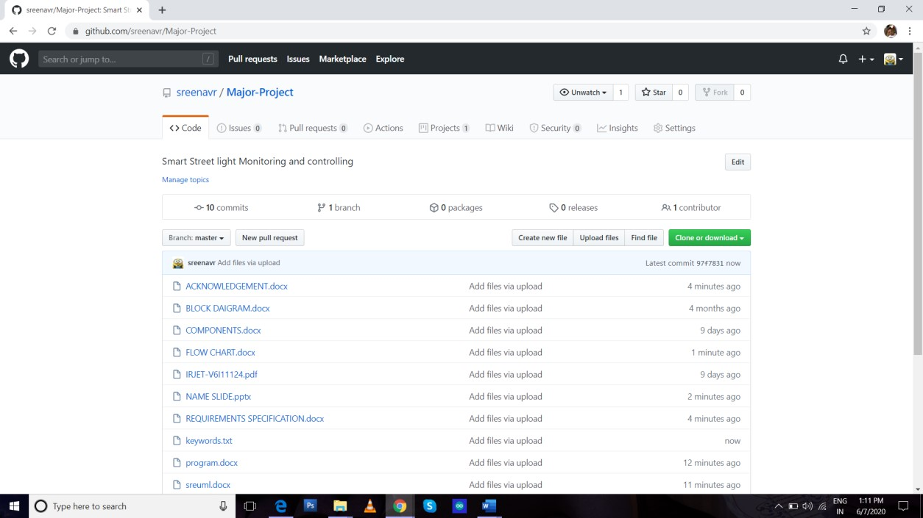

# CODING

## i. Blynk

#include <ESP8266WiFi.h>

#include <BlynkSimpleEsp8266.h> BlynkTimer timer; char auth[] = "OoN-g4Mk6lEDkFEp_ZAGbVjkoGO-UF4K"; char ssid[] = "realme XT"; char pass[] = "9876543210";

void sendSensor()

{

int Sen=analogRead(A0); Blynk.virtualWrite(V0,Sen); if(Sen>580)

{

// Blynk.email("iamsreena@gmail.com", "");

Blynk.notify("Alert");

}

} void setup()

{

Serial.begin(9600); Blynk.begin(auth, ssid, pass); timer.setInterval(1000L, sendSensor);

}

void loop() {

Blynk.run(); timer.run();

}

## ii. ThingSpeak

#include <ESP8266WiFi.h> // ESP8266WiFi.h library

const char* ssid = "realme XT";// replace subscribe with your WiFi SSID(Name) const char* password = "9876543210";//replace with Your Wifi Password name const char* host = "api.thingspeak.com";

const char* writeAPIKey = "X25OB85HA3JWTO2E"; //copy yout ThingSpeak channel API Key.

void setup() { pinMode (D1,INPUT); Serial.begin(115200); delay(1000);

Serial.println("Connecting to ");

Serial.println(ssid);

WiFi.begin(ssid, password); while (WiFi.status() != WL_CONNECTED) { delay(500);

Serial.print(".");

}

Serial.println("");

Serial.println("WiFi connected");

} void loop() { int Sen=digitalRead(D1); WiFiClient client; const int httpPort = 80; if (!client.connect(host, httpPort)) { return;

}

String url = "/update?key="; url+=writeAPIKey; url+="&field1="; url+=String(Sen);

url+="\r\n";

// Request to the server client.print(String("GET ") + url + " HTTP/1.1\r\n" +

"Host: " + host + "\r\n" +

"Connection: close\r\n\r\n");

Serial.print("sensor:");

Serial.print(Sen);

Serial.print("\n");

Serial.println("Send to ThingSpeak.\n"); client.stop();

Serial.println("Wait for 15 sec to update next datapack in thingSpeak"); delay(1000);

}

