4.3.2 ARDUINO

Arduino is a prototype platform (open-source) based on an easy-to-use hardware and software. It consists of a circuit board, which can be programed (referred to as a microcontroller) and a ready-made software called Arduino IDE (Integrated Development Environment), which is used to write and upload the computer code to the physical board.

Arduino provides a standard form factor that breaks the functions of the micro-controller into a more accessible package.

Arduino is a prototype platform (open-source) based on an easy-to-use hardware and software. It consists of a circuit board, which can be programed (referred to as a microcontroller) and a ready-made software called Arduino IDE (Integrated Development Environment), which is used to write and upload the computer code to the physical board.

The key features are –

* Arduino boards are able to read analog or digital input signals from different sensors and turn it into an output such as activating a motor, turning LED on/off, connect to the cloud and many other actions.
* You can control your board functions by sending a set of instructions to the microcontroller on the board via Arduino IDE (referred to as uploading software).
* Unlike most previous programmable circuit boards, Arduino does not need an extra piece of hardware (called a programmer) in order to load a new code onto the board. You can simply use a USB cable.
* Additionally, the Arduino IDE uses a simplified version of C++, making it easier to learn to program.
* Finally, Arduino provides a standard form factor that breaks the functions of the micro-controller into a more accessible package.

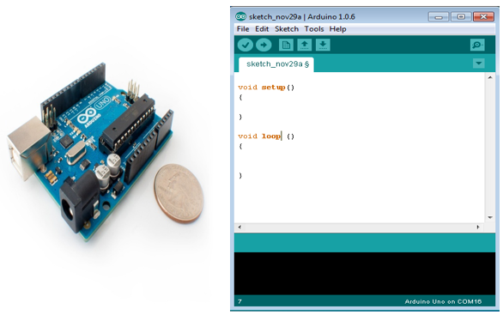

Board Types

Various kinds of Arduino boards are available depending on different microcontrollers used. However, all Arduino boards have one thing in common: they are programmed through the Arduino IDE.

The differences are based on the number of inputs and outputs (the number of sensors, LEDs, and buttons you can use on a single board), speed, operating voltage, form factor etc. Some boards are designed to be embedded and have no programming interface (hardware), which you would need to buy separately. Some can run directly from a 3.7V battery, others need at least 5V.

Here is a list of different Arduino boards available.

**Arduino boards based on ATMEGA328 microcontroller**

|  |  |  |  |  |  |  |  |
| --- | --- | --- | --- | --- | --- | --- | --- |
| **Board Name** | **Operating Volt** | **Clock Speed** | **Digital i/o** | **Analog Inputs** | **PWM** | **UART** | **Programming Interface** |
| Arduino Uno R3 | 5V | 16MHz | 14 | 6 | 6 | 1 | USB via ATMega16U2 |
| Arduino Uno R3 SMD | 5V | 16MHz | 14 | 6 | 6 | 1 | USB via ATMega16U2 |
| Red Board | 5V | 16MHz | 14 | 6 | 6 | 1 | USB via FTDI |
| Arduino Pro 3.3v/8 MHz | 3.3V | 8MHz | 14 | 6 | 6 | 1 | FTDI-Compatible Header |
| Arduino Pro 5V/16MHz | 5V | 16MHz | 14 | 6 | 6 | 1 | FTDI-Compatible Header |
| Arduino mini 05 | 5V | 16MHz | 14 | 8 | 6 | 1 | FTDI-Compatible Header |
| Arduino Pro mini 3.3v/8mhz | 3.3V | 8MHz | 14 | 8 | 6 | 1 | FTDI-Compatible Header |
| Arduino Pro mini 5v/16mhz | 5V | 16MHz | 14 | 8 | 6 | 1 | FTDI-Compatible Header |
| Arduino Ethernet | 5V | 16MHz | 14 | 6 | 6 | 1 | FTDI-Compatible Header |
| Arduino Fio | 3.3V | 8MHz | 14 | 8 | 6 | 1 | FTDI-Compatible Header |
| LilyPad Arduino 328 main board | 3.3V | 8MHz | 14 | 6 | 6 | 1 | FTDI-Compatible Header |
| LilyPad Arduino simple board | 3.3V | 8MHz | 9 | 4 | 5 | 0 | FTDI-Compatible Header |