**A SECURE IOT BASED MODERN HEALTHCARE SYSTEM**

**USING BODY SENSOR NETWORK**

**A Project Report**

***Submitted by:***

**LEKSHMI S R**

**LLMC17MCA020**

*in partial fulfilment of the requirements for the award of the degree in*

**MASTER OF COMPUTER APPLICATIONS**

*at*

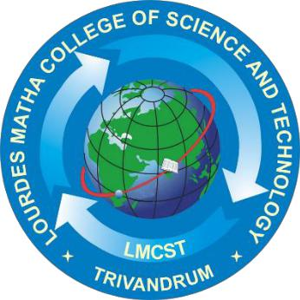

**Department of Computer Applications**

**(Affiliated To APJ Abdul Kalam Technological University, Kerala)**

**Lourdes Matha College of Science and Technology**

**(Managed By Archdiocese Of Changanacherry)**

**Kuttichal, Thiruvananthapuram-695574**

**MAY 2020**

**Lourdes Matha College of Science and Technology**

**(Managed By Archdiocese Of Changanacherry)**

**(Affiliated To APJ Abdul Kalam Technological University, Kerala)**

**Kuttichal, Thiruvananthapuram-695574**

**Department of Computer Applications**



**Certificate**

**This is to certify that the project work entitled “A SECURE IOT BASED MODERN HEALTHCARE SYSTEM USING BODY SENSOR NETWOR” is a bonafide record of the work done by Ms LEKSHMI S R, Reg No LLMC17MCA020, student of Department Computer of Applications, Lourdes Matha College of Science & Technology, Kuttichal, Thiruvananthapuram, affiliated to APJ Abdul Kalam Technological University, Kerala during the academic year 2019-2020 from January 2020 to May 2020 in partial fulfilment of the requirements for the award of the degree of Master of Computer Applications from APJ Abdul Kalam Technological University, Kerala.**

**Internal Guide** **Date:** **Head of the Department**

**Internal Examiner** **External Examiner**

**ACKNOWLEDGEMENT**

At the outset I like to mention that a project report of this magnitude could not have been possible to make without the support, assistance and guidance of some distinguished personalities.

I am greatly indebted to all those who helped and guided me to make this report without which it would not have been possible for me to do this work.

First of all, I like to express my sincere thanks to **Rev.Dr.. Tomy Joseph Padinjareveetil**, Director of Lourdes Matha College of Science and Technology and our principle **Prof. Dr. Mohanlal PP** for granting permission to do this project and giving necessary guidance and assistance.

**Prof. Anjana J** has always been at her best to help me to the right path which was a great factor of encouragement.

I like to extend my sincere gratitude to **Prof.Selma Joseph, Head** Of the department of Computer Application. she was always approachable and gave correct advice to go ahead with the project

Let me also take this opportunity to extend gratitude to our esteemed institution Lourdes Matha College of Science and Technology.

My parents who held my hand throughout in my endeavour to do this project need a special mention.

I also like to thank my friends who helped me abundantly in the successful completion of this project report.

Any omission in acknowledgement may be pardoned as it is not intentional.