**BSN-CARE**

**Bill of Material**

**1)Wrist Band**

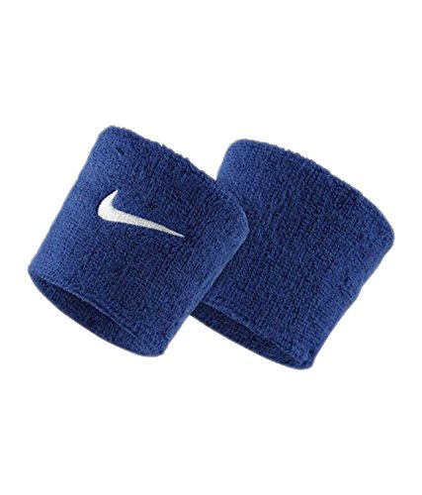

**2)NODE MCU**

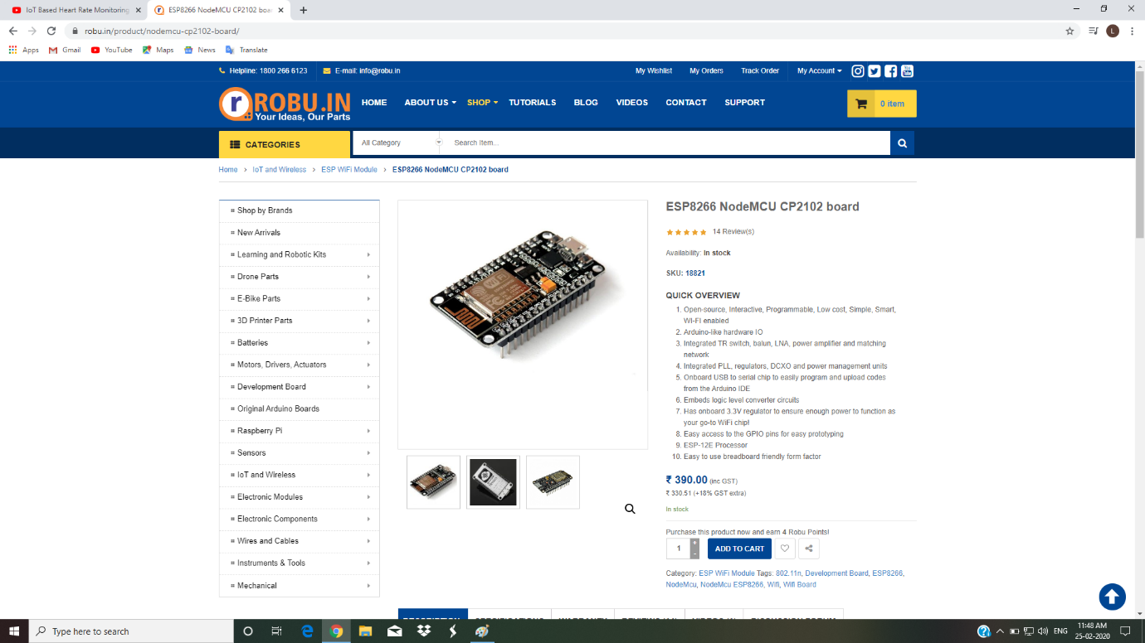

**3)Temperature Sensor**

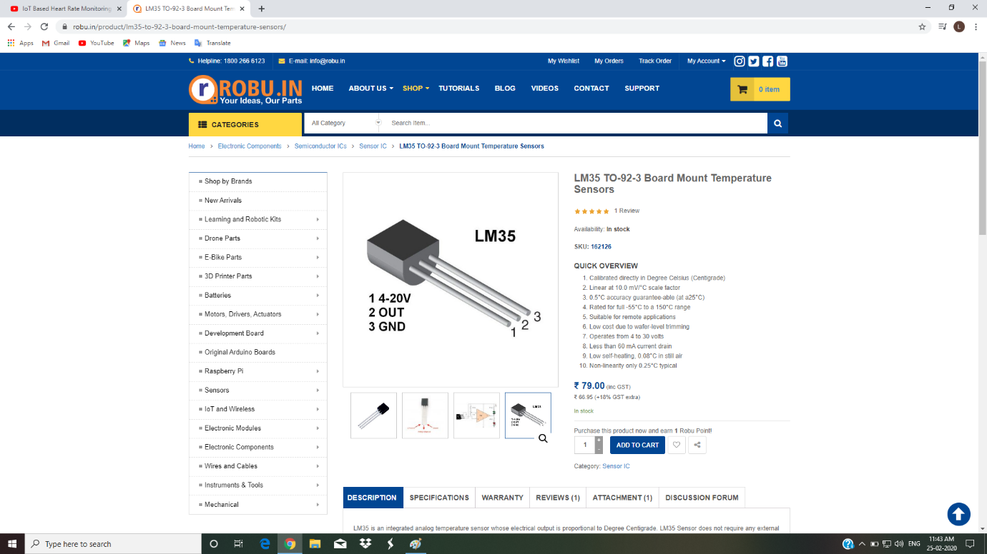

4)**Heart Beat Pulse Sensor Amped**

