4.3.5 NODE MCU

The NodeMCU board is based on an ESP8266-12 but features a built-in serial over USB interface and other amenities like 2 buttons and 2 LEDs. The board is compact and fits on a breadboard. The board can be programmed using the Wiring / Arduino framework as the other ESP8266 boards.

Block diagram

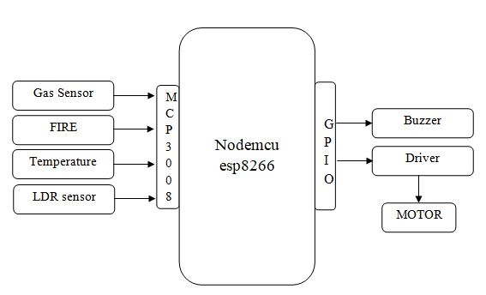

NodeMCU Development Kit/Board consist of ESP8266 wifi chip. ESP8266 chip has GPIO pins, serial communication protocol, etc. features on it.

**ESP8266** is a low-cost [Wi-Fi](https://en.wikipedia.org/wiki/Wi-Fi) chip developed by Espressif Systems with TCP/IP protocol. For more information about ESP8266, you can refer [ESP8266 WiFi Module](http://www.electronicwings.com/sensors-modules/esp8266-wifi-module).

The features of ESP8266 are extracted on NodeMCU Development board. NodeMCU ([LUA](https://www.lua.org/start.html) based firmware) with Development board/kit that consist of ESP8266 (wifi enabled chip) chip combines NodeMCU Development board which make it stand-alone device in IoT applications.

Let’s see 1st version of NodeMCU Dev Kit and its pinout as shown in below images.

